Supplementary material for the verified curved tactile simulation framework

Note S1 Verification and data provenance
The verification chain distinguishes saved mechanical fields, geometric path validity, independently checked area derivatives, full-frame reintegration and raw-array replay. Numerical agreement is reported for the exact finite scope of each check; the levels are not pooled into a claim of complete physical calibration.
Forty-eight additional refractive branches give a maximum relative analytic-versus-automatic-differentiation difference of 1.867019095007×10−12. Nine registered states complete full-frame reintegration with an empty failure list. Independent replay covers 96 fixed conditions, with maximum scalar difference 3.330669073875×10−16.
The primary morphology source contains 12,960 conditional detector records and 3,240 paired summaries. The exported primary subset fixes same-pale reflectance, all8_tilt00 and global normalized energy: 15 morphologies × four regions × three approach depths × four sensor conditions = 720 rows. These are conditional evaluations of 180 mechanical loading fields, not 720 independent physical states.
Source identity of paired_summaries.json: SHA-256 338de8a6bdc8e782c0d6638e1207d0effa1e89a0036d55aa096888dedf71bdbd. The accompanying CSV is a deterministic export of saved condition entries. Morphology identifiers, approach depth, PSF width and full-well capacity are retained.
Q16 and Q1024 identify contact quadrature, SS1 and SS4 identify pixel integration, and neither denotes mesh refinement. The Q1024 diagnostic loaded scene is near side, 0.30 mm, LED4 at 34°. Its corrected same-pale pixel is 0.327347942089 DN and its unchanged frame maximum is 285.214270 DN.
Geometric screening encompasses 180 independently solved candidate loading fields and 195 boundary scenes. Saved mesh identities define the compared discrete geometries. Exact reconstruction requires the corresponding layout and optical implementation versions, in addition to the common model parameters stated in the manuscript.

Fig S1 Region and depth detection matrix
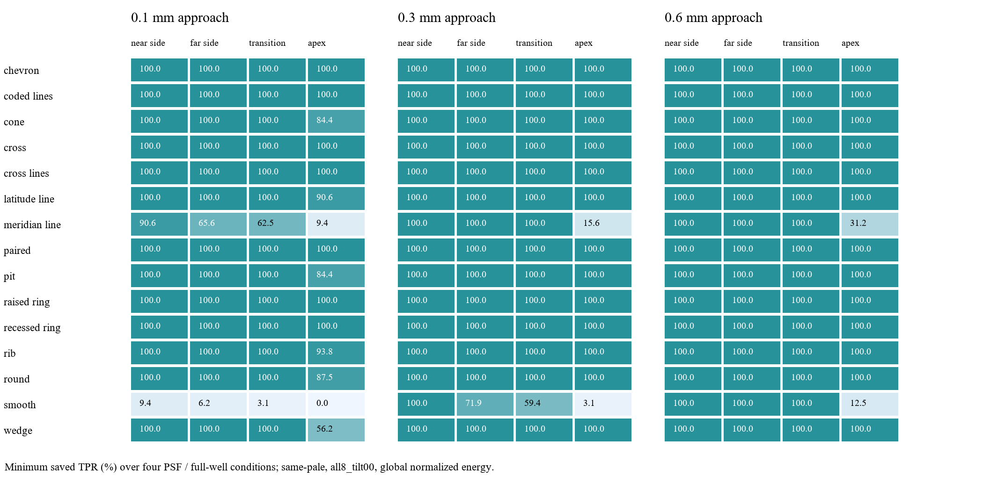
Note. Values are the saved minimum TPR over the four PSF–full-well conditions. The complete rates and FPR values are supplied in Table S1. The three panels use common color and numeric scales.

Table S1 Condition resolved primary results
The machine-readable table A_Table_S1_region_depth.csv contains 720 rows. Columns are case_id, region, command_depth_mm, PSF_px, full_well_e, saved_TPR and saved_FPR. Rates are proportions in [0,1]. Approach depth is a command label, while the image derives from the candidate's saved equilibrium field.

Fig S2 Diagnostic frame and local magnifications
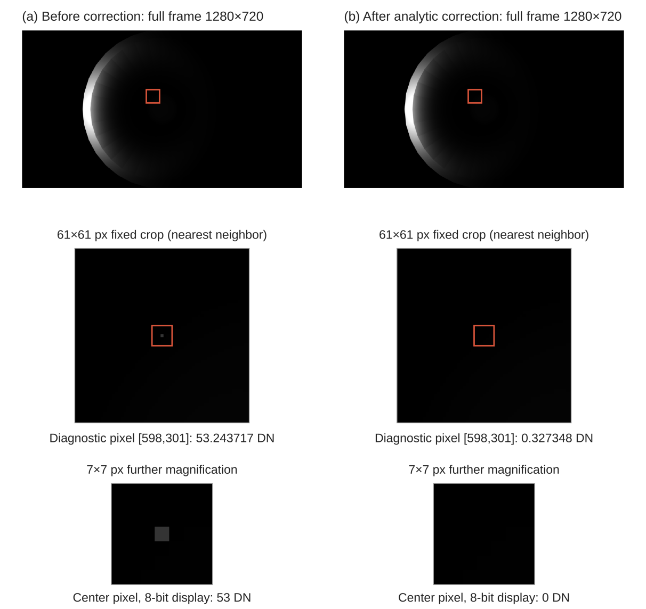
Note. The original diagnostic frame graphic is reproduced from Fig. 6 for the Q1024 near-side 0.30 mm, same-pale, LED4 34° scene. The full frame and fixed crops share a linear 0–255 DN display; displayed clipping and quantization do not replace the raw floating-point checks.

Table S2 Complete saved condition comparisons
A_all_saved_condition_comparisons.csv preserves all 12,960 saved condition entries underlying the 3,240 paired summaries, including all registered reflectance, illumination and detector settings. The interactive morphology view permits these settings to be changed while retaining the source case and region–depth identity.

Extended visual resources
The ABC platform includes all registered existing visual tools, including unpublished existing resources. The searchable library covers 129 parameter layouts, saved camera versions and lighting, reference and loaded meshes, displacement fields and numerical convergence records. The article's controlled study is joined to its exact 15 case identifiers; additional resources retain their own source and model versions.

