Location-Grouped Evaluation of Illumination and Learning in Curved Tactile Sensing
[Author names, affiliations including city/province/country, corresponding author* and email — to be completed by the authors]
Abstract: Simulation-driven tactile-sensor selection requires recognition results that separate physical coverage from repeated noise and optimization runs. We establish a nested evaluation protocol grouped by physical location and compare illumination direction, model and training budget on curved tactile observations. The dataset contains 12 representative locations in four regions and 24 loading fields. Evaluation jointly reports detection, false alarms, unconditional localization and success requiring detection within a specified localization error. Under single-LED illumination at 60°, median convolutional neural network detection falls to 7.81–12.50% in all regions, compared with 92.19–100% at 0°, 12° and 34°. Model effects depend on region: under axial illumination, H05 error is 16.585 mm for the image network and 3.748 mm for the feature model. Nested selection changes five of 12 configurations; the other seven produce 21 byte-identical output pairs across seeds. Independent recomputation agrees exactly with saved errors over 18,432 frames per stage. The contribution is a traceable evaluation baseline connecting condition design, location grouping and output identity. It supports subsequent recognition-method research while revealing illumination failures and region-dependent representation effects.
Keywords: Curved tactile sensing; Location grouping; Nested evaluation; Illumination; Reproducible baseline
1. Introduction
The performance of a vision-based tactile sensor is jointly determined by mechanical transmission, optical observation and task inference (Shimonomura, 2019; Li et al., 2020). Illumination layout is a core element of such sensors: GelSight recovers surface geometry with multi-colored directional light (Yuan et al., 2017), GelSight Wedge and round fingertip sensors redesign the optical path for compact or curved structures (Wang et al., 2021; Romero et al., 2020), and Minsight and AllSight compare illumination and elastomer configurations in fingertip-scale curved structures and achieve curved-surface force estimation and real-time manipulation (Andrussow et al., 2023; Azulay et al., 2024). For task inference, deep networks have become the main means of estimating contact location and force from tactile images (LeCun et al., 2015; Sun et al., 2022; Do et al., 2023); the distribution and information encoding of markers also change the representational complexity required for learning (Sferrazza and D’Andrea, 2019; Tang and Nanayakkara, 2026).
For curved sensors, the number of contact locations is limited while each location has many noise frames and loading repeats, so evaluation results are easily overestimated. Common problems include reporting only the highest detection rate while ignoring the false-alarm rate (Fawcett, 2006); repeatedly selecting illumination or hyperparameters on locations already used for development, which causes model-selection bias (Varma and Simon, 2006; Cawley and Talbot, 2010); treating noise repeats as independent contact locations and ignoring the hierarchical structure of the data (Roberts et al., 2017); ignoring performance fluctuations caused by random seeds (Henderson et al., 2018; Bouthillier et al., 2021); and excluding missed detections when computing the localization error. These problems can make “more light sources”, “larger models” or “longer training” appear universally beneficial.
We use existing curved-sensor simulations to establish a reproducible recognition baseline for simulation-driven design selection. The first contribution is a location-grouped evaluation protocol with separate training, threshold calibration and independent no-touch evaluation roles, reporting detection and unconditional localization jointly. The second is a paired analysis showing a consistent 60° illumination failure alongside region-dependent differences between image and feature models. The third is an output-identity audit: when nested selection reproduces the original deterministic configuration, byte-identical predictions are recognized as reused evidence. Together, these results explain which condition changes matter within the registered study and provide an auditable starting point for subsequent recognition methods.
2. Methods
2.1. Reference observation data
The reference dataset comprises four regions denoted by the registration labels S04, S06, H01 and H05, each with three development locations, giving 12 locations; each location has two loading fields (0.30 mm and 0.60 mm normal indentation), giving 24 loading fields. All loaded and noise frames of the same physical location are assigned to the same group. The illumination comprises 8 single LEDs (identified by number, e.g., LED0 and LED4) × 4 directions (0°, 12°, 34° and 60°) plus 4 equal-total-power eight-LED modes, i.e., 36 modes; the 24 loading fields × 36 modes form 864 loading–illumination conditions.
The observation protocol is as follows: 1280×720 full frames, 2×2 image supersampling (SS2), a full well of 20,000 e−, a read noise of 3 e−, a point-spread function (PSF) standard deviation of 1.2 pixels and linear 8-bit quantization; the common exposure is 1996.1886908754632 (model units), and the total source power is normalized to 1. The noise model combines Poisson photon noise and Gaussian read noise (Healey and Kondepudy, 1994; Foi et al., 2008). Each group uses 16 static reference frames, 64 no-touch frames for setting the threshold and another 64 independent no-touch frames for evaluation, and 64 noise frames are saved for each loading field. The main parameters are listed in Table 1. All these values are simulation-protocol parameters and have not been calibrated against hardware. The reference observations are a saved, pre-existing data version and are not mixed with the full candidate images generated later with the analytic area Jacobian; the conclusions of this paper are limited to this data version.
The same-pale and black–white material comparisons reuse the same geometry and mechanical fields and change only the ideal surface reflectance; the same-pale background and end caps are treated as opaque Lambertian surfaces with a reflectance of 0.8. The new illumination modes and the retained LED4 mode use different noise streams; illumination comparisons are paired in physical fields and conditions but are not guaranteed to share identical noise realizations. The training inputs are 64-frame loaded shards (uint8, native resolution 720×1280). The held-out outer locations are isolated simultaneously across the four regions and both loads; static reference images are retained as common calibration inputs, and held-out loaded images take no part in training normalization or location selection.
The reproducibility archive also organizes pre-existing input and label families, scalar18 and scalar38 representations, multi-marker inputs and later feature-model diagnostics. Each branch retains its own observation version, grouping and target definition. The full original and nested CNN condition tables and 72 prediction-file identities are provided together, enabling the representative comparisons below to be checked against all saved runs.
Table 1. Observation and learning parameters
Item | Setting
Locations and loads | 12 development locations; 24 loading fields (0.30/0.60 mm normal indentation)
Illumination | 8 single LEDs × 4 directions + 4 eight-LED modes = 36
Image integration; PSF | SS2; σ = 1.2 px
Full well; read noise | 20,000 e⁻; 3 e⁻ root mean square
Quantization; reference frames | Linear 8-bit; 16 static calibration frames
CNN | Three derived channels at native resolution; convolution + spatial attention; detection and coordinate heads
Original training | 64 epochs; Adam, learning rate 0.001; batch size 8
Inner-loop candidates | 64/128/256 epochs; learning rate 0.001/0.0003
Optimization repeats | 3 seeds; not selected by outer results
2.2. Feature representations and network architecture
The lightweight baselines use saved scalar features and multi-marker image representations with a multilayer perceptron (MLP). The extended scalar-input baseline is denoted MLP38. The original 18-dimensional cache and the 38-dimensional extended representation are separate inputs with separately preserved source identities. The 38-dimensional representation adds image-peak locations, window scales, nominal surface mappings, validity indicators and reference-marker anchors to the original statistics; it is not interchangeable with an 18-column cache. The multi-marker representation encodes locally whitened image projections. These mappings use a predeclared rest-state calibration, and no window is selected using the true loaded contact location. Supplementary Note S1 specifies the formulas, feature ordering and baseline configuration.
The convolutional neural network (CNN) (LeCun et al., 2015) takes the native 1280×720 full frame as input, with three channels: the normalized reference image, the standardized difference image clipped to ±10, and its absolute value (Fig. 1). The encoder consists of four 3×3 convolutional layers with 12, 16, 24 and 16 channels, stride 2 in the second and third layers, and sigmoid-weighted linear unit (SiLU) activation (Elfwing et al., 2018). A 1×1 attention layer produces spatial weights through a spatial softmax (Levine et al., 2016); the 16-dimensional weighted features and the response strength are fed to the detection head, and the weighted features and the two-dimensional attention position are fed to an 18→32→3 regression head (Tanh hidden activation). The network outputs a contact score and three-dimensional coordinates.
For observed digital-number (DN) image I and the 16-frame mean reference R, the declared difference variance combines shot, read and quantization terms. The input is constructed before the shared encoder:
$$v = [max(R,0)·255/20000 + (3·255/20000)² + 1/12]·(1 + 1/16)$$
$$D = clip\left(\frac{I − R}{\sqrt{v}}, −10, 10\right); X = \left[\frac{R}{255} , D , \left|D\right|\right]$$
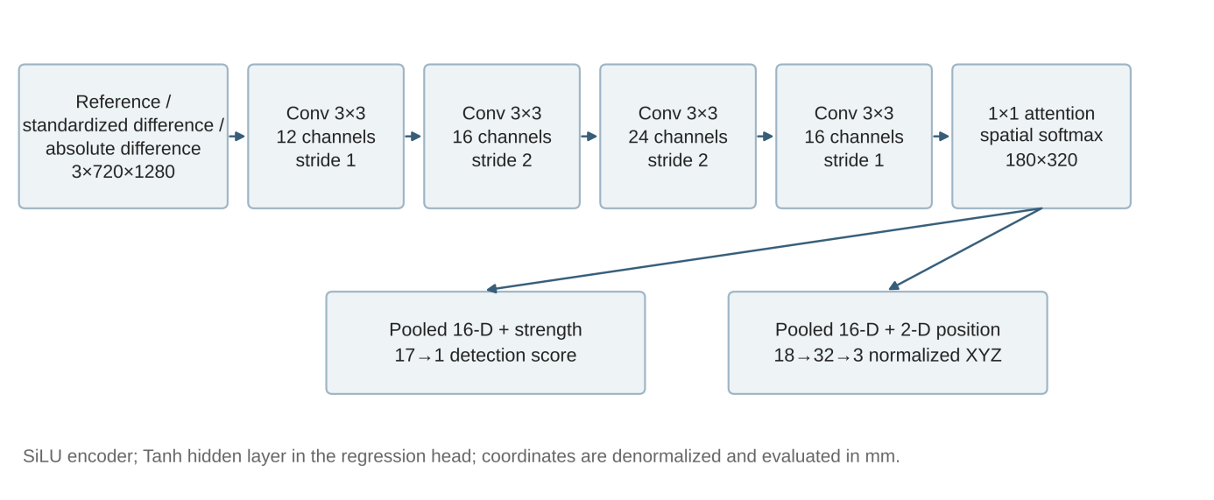
Fig. 1. Native full-frame convolutional network
Note. Architecture of the native full-frame CNN. Drawn from the saved implementation. The inputs are three derived channels (static reference, standardized difference and absolute difference; not RGB); after attention pooling, the features enter the detection head and the normalized-coordinate regression head.
2.3. Location-grouped nested training and selection
The original CNN was trained for a fixed 64 epochs with the Adam optimizer (Kingma and Ba, 2015), a learning rate of 10−3, a batch size of 8 and a gradient-norm limit of 5; float32 was used throughout, automatic mixed precision (AMP) and TF32 were disabled, and deterministic algorithms were enabled.
The nested stage keeps the same encoder, input data and seed set. To avoid the optimistic bias of selecting parameters and evaluating on the same data, nested cross-validation (Varma and Simon, 2006; Cawley and Talbot, 2010) was used with the physical location as the grouping unit (Roberts et al., 2017). The outer loop splits the locations into three groups by coordinate index, each group holding out one location from each of the four regions; the remaining two groups alternate as training and validation sets in the inner loop (Fig. 2). The inner candidates form a finite grid of learning rates {0.001, 0.0003} and budgets {64, 128, 256} epochs (Bergstra and Bengio, 2012), with seeds 1701, 1702 and 1703. The budget and learning rate are selected by the sum of the balanced binary cross-entropy (BCE) and the training-normalized XYZ loss over two inner splits and three seeds; after selection, all seeds are retained for outer evaluation. Optimizer states, random-number states, weights and component loss curves are saved separately for the inner and outer loops. The training objective is
Selection averages the validation objective over two inner location splits and three seeds. Ties are resolved by the smaller epoch budget and then the smaller learning rate. The selected configuration is reinitialized for each outer seed. Registered budgets are selection checkpoints; threshold values come from calibration scores rather than outer loaded outcomes. Algorithm S1 gives the full sequence.
 | $$L=L_{BCE}^{bal}+L_{MSE}^{pos}$$ | (1)
The detection loss is balanced binary cross-entropy (BCE). For a batch of m samples, weights are N/(2N+) and N/(2N0), using the positive and no-touch counts of the training set. The regression contribution is the sum of positive-sample squared coordinate errors divided by 3m(N+/N), as implemented; it is not normalized by the realized number of positives in that batch. Targets use training-only coordinate means and standard deviations, each standard deviation floored at 10−6 mm. This distinction makes the saved training objective reproducible (Supplementary Note S1).
The original budgets of the lightweight model were 300, 600, 1200 and 2400 steps, and the additional experiment only added a predefined checkpoint at 4800 steps. The 187 groups at the inner budget boundary correspond to 4488 finite continuation runs, and the subsequent 432 outer folds and 1296 joint models keep their paired identities. Cases in which the inner loop still selected 4800 steps are marked as “budget boundary” and are not automatically extended to 9600 steps (Prechelt, 1998).
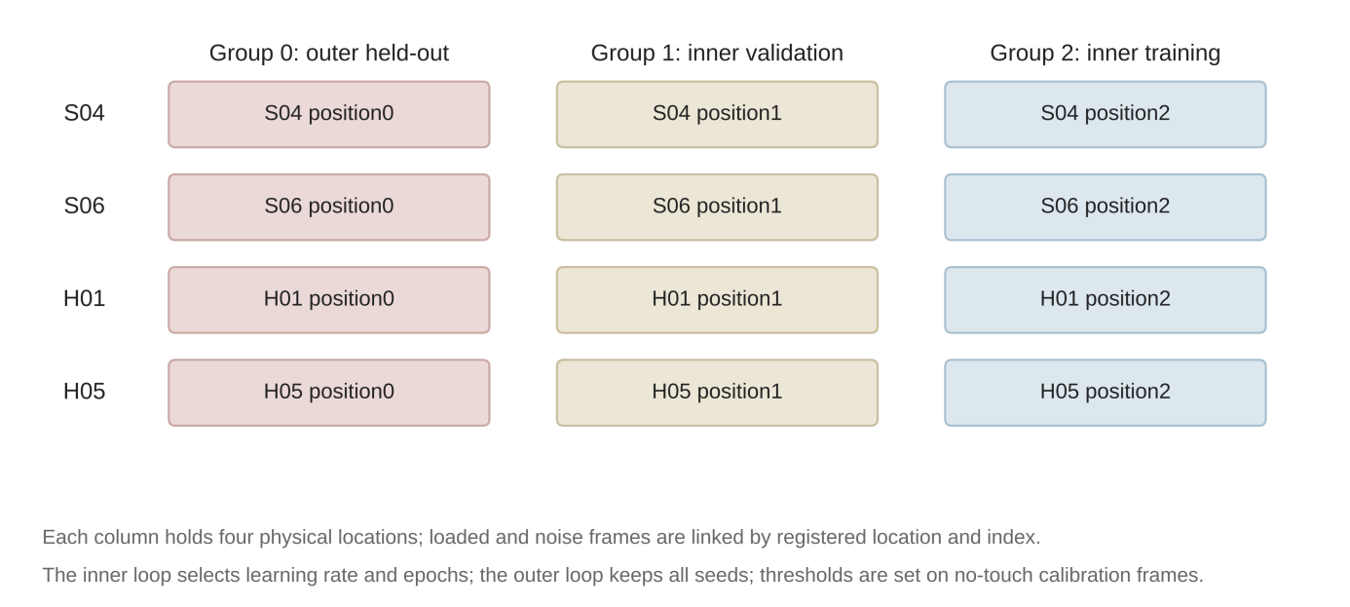
Fig. 2. Location-grouped nested split
Note. Example of the nested split organized by physical location. The outer loop holds out group 0; the inner loop validates on group 1 and trains on group 2, and swapping the two gives the other inner split. Each group contains one location from each of the four regions, and loaded and noise frames are grouped with their location; the test locations are still development locations.
2.4. Metrics and statistical units
The threshold τ is the 95th percentile of the dedicated calibration no-touch scores, with detection defined by s > τ. In the original and outer-refit protocols, no-touch indices 0–31 supply training negatives, indices 32–63 supply threshold calibration, and a separate set of 64 no-touch observations supplies evaluation. Inner training uses indices 0–15 and validation uses 16–31; threshold calibration remains separate. The true-positive rate (TPR) counts detected loaded noise frames and the false-positive rate (FPR) counts detected independent no-touch frames. Localization is the Euclidean chord error over all loaded frames, including missed detections. The joint metric J(r) requires both detection and localization error at most r:
 | $$e={∥y_{pred}−y_{ref}∥}_{2}, J\left(r\right)=mean\left[1\left(s>τ\right)⋅1\left(e≤r\right)\right]$$ | (2)
where s is the contact score, τ is the detection threshold, and r = 1, 2, 5 and 10 mm. The chord error, projected surface distance and predicted off-surface error are saved separately; none of them is equivalent to spatial resolution.
The location is the spatial inference unit; seeds are optimization repeats; noise frames are conditional repeats under fixed mechanical fields and camera assumptions. Each region–direction summary consists of 3 locations × 2 loads × 3 seeds = 18 conditions and reports descriptive medians and ranges; the Wilson intervals of the noise conditions (Wilson, 1927; Brown et al., 2001) describe only conditional repeats, not the spatial population. Parameter selection does not use outer results. The complete 288-row results by location, load, direction and seed are given in Supplementary Data S1.
2.5. Independent recomputation of prediction files and output-identity checks
For 4 directions × 3 outer groups × 3 seeds, the 36 prediction files of each of the two stages were read, and file identity was checked against the SHA-256 recorded in the metadata. Each file contains three-dimensional predictions and thresholds for 8 held-out loading conditions with 64 noise frames each. The predictions were denormalized, Euclidean distances to the target coordinates in the data manifest were computed, and these were compared element by element with the saved chord errors. Prediction files of the two stages with the same direction, outer group and seed were compared pairwise by SHA-256 to identify byte-identical outputs. An earlier independent check of the full budget and material matrices covered 2592 saved prediction files, 31,104 source metrics, 10,368 budget pairs, 5,184 material pairs and 864 summaries.
3. Results
3.1. Illumination direction and region
The CNN experiments used the four tilt directions of the single LED4. Table 2 summarizes the detection rate, false-alarm rate, J(5 mm) and median chord error of the original and nested CNN by region and illumination direction. At 0°, 12° and 34°, the median detection rate was 92.19%–100% in every region; at 60°, it fell to 7.81%–12.50%, at the same level as the false-alarm rate in that direction (6.25%–9.38%), and J(5 mm) did not exceed 5.47%. This failure occurred consistently in all four regions and both training stages; all three 60° groups switched to a learning rate of 0.0003 in the nested stage (Table 3), yet the detection rate did not improve, suggesting that the problem stems mainly from the observations in this direction rather than from the training configuration.
Region also played a decisive role: H05 had median errors above 16 mm in every direction and J(5 mm) no greater than 5.47%; S04 had a median error of 6.508 mm and a J(5 mm) of 39.06% at 12°, versus 2.714 mm and 89.06% at 34°.
Table 2. Conditional results of the original and nested CNN by region and illumination direction (medians of 18 conditions)
Region | Direction (°) | Orig. TPR (%) | Orig. FPR (%) | Orig. J(5) (%) | Orig. error (mm) | Nested TPR (%) | Nested FPR (%) | Nested J(5) (%) | Nested error (mm)
S04 | 0 | 100.00 | 4.69 | 100.00 | 2.713 | 100.00 | 6.25 | 100.00 | 2.701
S04 | 12 | 100.00 | 3.12 | 39.06 | 6.508 | 100.00 | 3.12 | 39.06 | 6.508
S04 | 34 | 100.00 | 9.38 | 89.06 | 2.714 | 100.00 | 9.38 | 89.06 | 2.714
S04 | 60 | 9.38 | 9.38 | 0.00 | 27.675 | 10.94 | 6.25 | 0.00 | 27.477
S06 | 0 | 100.00 | 4.69 | 81.25 | 3.326 | 100.00 | 6.25 | 81.25 | 3.516
S06 | 12 | 100.00 | 3.12 | 89.84 | 3.759 | 100.00 | 3.12 | 86.72 | 3.844
S06 | 34 | 100.00 | 9.38 | 85.94 | 2.962 | 100.00 | 9.38 | 85.94 | 2.962
S06 | 60 | 12.50 | 9.38 | 0.78 | 4.993 | 9.38 | 6.25 | 5.47 | 4.962
H01 | 0 | 100.00 | 4.69 | 59.38 | 3.495 | 100.00 | 6.25 | 59.38 | 3.369
H01 | 12 | 97.66 | 3.12 | 84.38 | 3.226 | 98.44 | 3.12 | 85.16 | 3.276
H01 | 34 | 92.19 | 9.38 | 59.38 | 3.019 | 92.19 | 9.38 | 59.38 | 3.019
H01 | 60 | 10.16 | 9.38 | 0.00 | 10.905 | 10.94 | 6.25 | 0.00 | 11.265
H05 | 0 | 100.00 | 4.69 | 5.47 | 16.585 | 100.00 | 6.25 | 4.69 | 16.585
H05 | 12 | 100.00 | 3.12 | 0.78 | 17.051 | 100.00 | 3.12 | 0.00 | 17.511
H05 | 34 | 100.00 | 9.38 | 3.12 | 16.512 | 100.00 | 9.38 | 3.12 | 16.512
H05 | 60 | 7.81 | 9.38 | 0.00 | 24.554 | 7.81 | 6.25 | 0.00 | 24.581
3.2. Single-LED versus eight-LED illumination
In the predeclared axial illumination comparison, the detection rate of the S06 multi-marker representation was 97.66% under LED4 and 56.25% under equal-total-power eight-LED illumination; the false-alarm rates were 4.69% and 3.12%, and the localization error summaries were 2.599 mm and 2.622 mm, respectively. The corresponding detection rates for H01 were 89.84% and 26.56%. Equal-total-power eight-LED illumination reduced false alarms but reduced detection even more, revealing a clear trade-off between the two.
3.3. CNN versus lightweight model
On the same observations, the comparison between the original CNN and MLP38 differed by region (Fig. 3): under axial conditions, the error summaries were 2.713 mm and 4.582 mm for S04 but 16.585 mm and 3.748 mm for H05. The advantage of the CNN at S04 did not carry over to H05, where the error of the lightweight model was less than one quarter of that of the CNN. Because the two models differ in both architecture and loss, this comparison shows that which model performs better depends on the region and cannot be generalized to either model being universally superior.
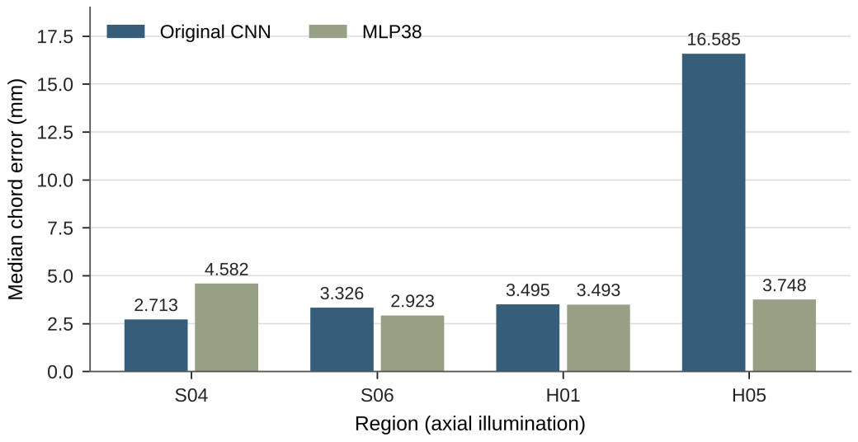
Fig. 3. Regional model comparison
Note. Regional error summaries of the original CNN and MLP38 under axial illumination. Bar heights are descriptive medians of 18 conditions, not confidence intervals for the spatial population.
3.4. Nested selection and output identity
Table 3 lists the inner-selected configurations of all 12 groups: nine selected 64 epochs, two selected 128 epochs and one selected 256 epochs; nine used a learning rate of 0.001 and three used 0.0003. Seven groups (outer groups 0 and 1 at 0° and 12°, and all three groups at 34°) selected the same configuration as the original training (learning rate 0.001, 64 epochs), and only five changed the configuration. In these seven groups, the SHA-256 hashes of the outputs of all 21 model pairs across the three seeds were identical, whereas the remaining 15 pairs all differed; with deterministic algorithms enabled, identical configurations produced identical outputs.
Table 3. All 12 inner-loop selected configurations
Illumination direction (°) | Outer coordinate group | Learning rate | Epochs
0 | 0 | 0.001 | 64
0 | 1 | 0.001 | 64
0 | 2 | 0.001 | 128
12 | 0 | 0.001 | 64
12 | 1 | 0.001 | 64
12 | 2 | 0.001 | 128
34 | 0 | 0.001 | 64
34 | 1 | 0.001 | 64
34 | 2 | 0.001 | 64
60 | 0 | 0.0003 | 256
60 | 1 | 0.0003 | 64
60 | 2 | 0.0003 | 64
The paired changes in median chord error for all 288 conditions are shown in Fig. 4: 168 conditions had zero change, corresponding exactly to the 21 identical output pairs above (8 held-out conditions per pair), and the other 120 conditions came from the five groups with changed configurations. The axial S06 error summary changed from 3.326 mm to 3.516 mm and the FPR from 4.69% to 6.25%; H05 was about 16.585 mm in both stages. Fig. 5 compares the errors of the two stages under the same conditions, and Fig. 6 shows both the detection rate and the joint success rate of “detected with an error ≤ 5 mm”, indicating that a high detection rate is not equivalent to successful localization.
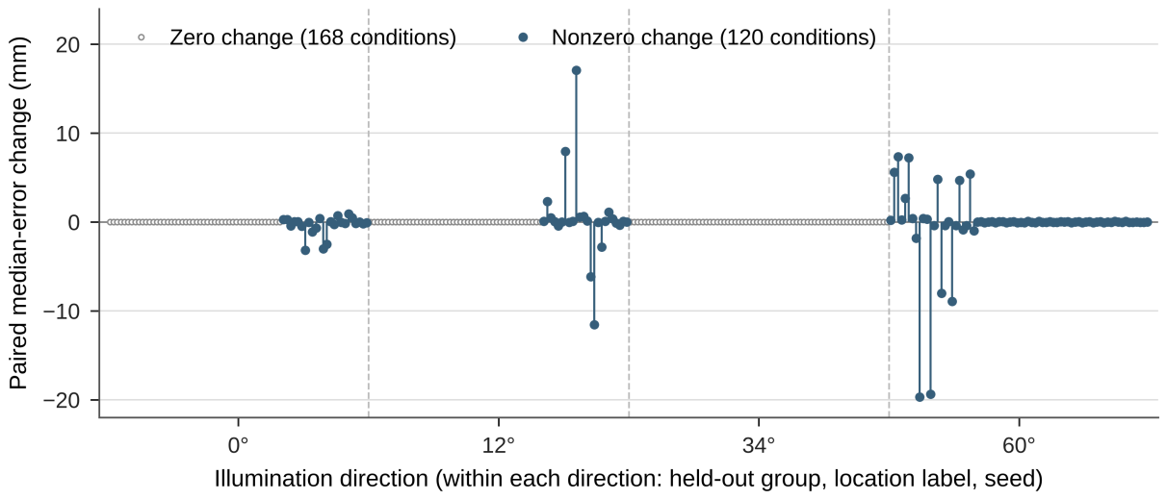
Fig. 4. Paired localization error changes
Note. Paired median-error changes for all 288 conditions (nested − original). Sorted by direction, held-out group, location label and seed; positive values indicate a larger error in the nested stage. Open gray circles are the 168 conditions with zero change (identical outputs in both stages), and filled circles are the other 120 conditions; dashed lines separate the four illumination directions.
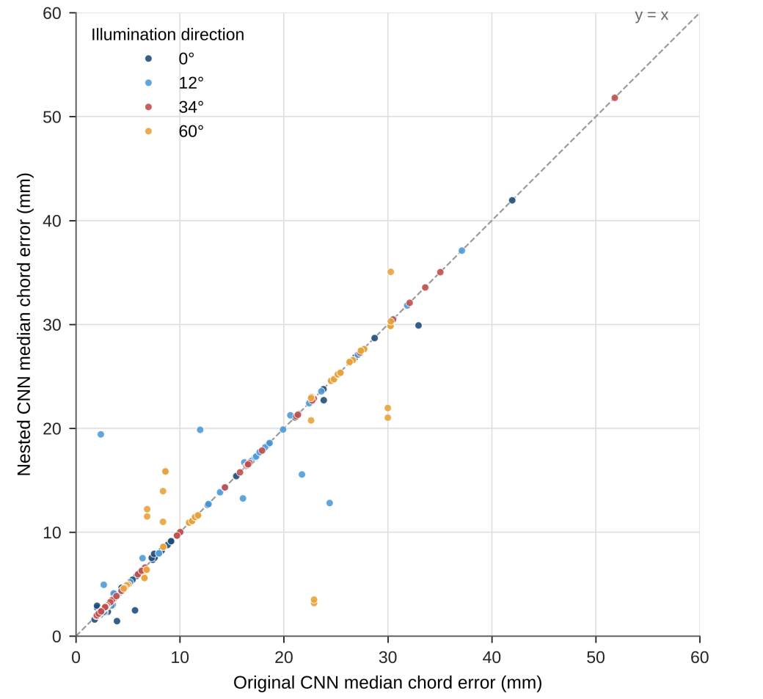
Fig. 5. Original and nested localization errors
Note. Median chord errors of original and nested training under identical conditions. All 288 saved conditions. The dashed line is the y = x reference, with no regression fit; colors distinguish the four illumination directions.
(a) Original CNN (b) Nested CNN
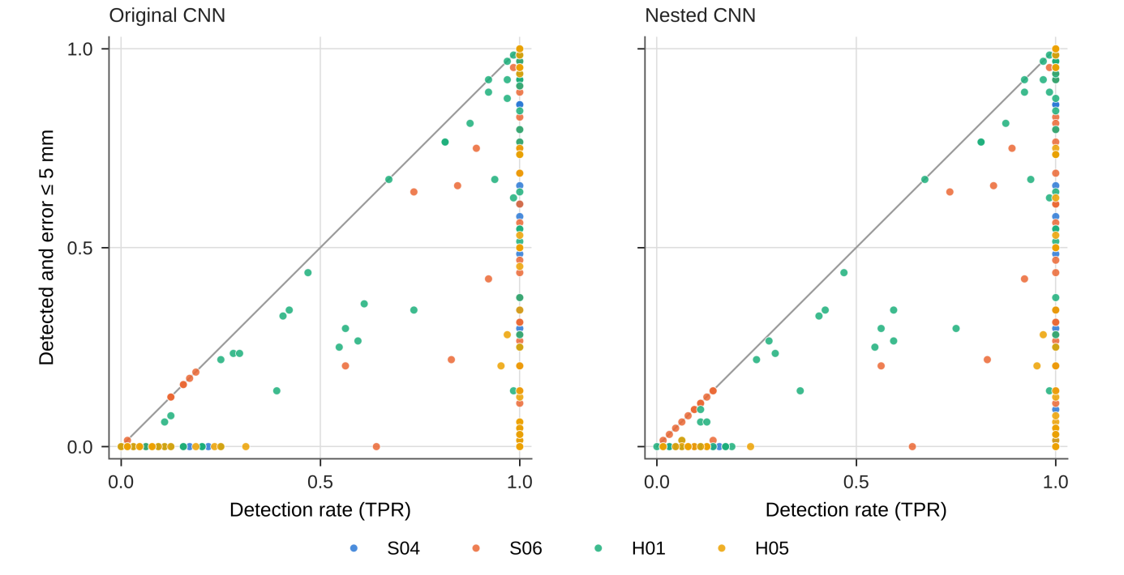
Fig. 6. Detection and joint localization success
Note. (a) Original CNN. (b) Nested CNN. Detection rate and joint localization success rate. Left: original CNN; right: nested CNN; each with all 288 conditions. The vertical axis requires both detection and a chord error ≤ 5 mm; the gray line is the y = x reference; colors distinguish regions.
3.5. Finite additional budget for the lightweight model
Under scalar38, black–white material and LED0 axial conditions, the additional budget reduced the error summary of S04 from 3.973 mm to 3.552 mm, increased that of S06 from 6.785 mm to 7.089 mm, and reduced those of H01 from 6.827 mm to 6.361 mm and of H05 from 4.148 mm to 3.676 mm, whereas the paired changes in the joint ≤ 5 mm metric were all zero. The additional budget changed the errors but not the outcome of the joint task.
3.6. Recomputation of prediction files
All 72 prediction files passed the identity check; for the 288 conditions and 18,432 frames of each stage, the recomputed errors agreed element by element with the saved values, with a maximum absolute difference of 0 mm.
4. Discussion
4.1. Illumination direction as the primary factor
In all four regions and both training stages, the 60° direction reduced the detection rate to the false-alarm level, whereas the detection rates at 0°, 12° and 34° were generally close to 100%. For this geometry and these models, the illumination direction largely determines whether the observations contain usable contact information, and its influence exceeds that of adjusting the model or the training budget; the 60° direction should not be used alone for contact detection. The single- versus eight-LED comparison further shows that an illumination scheme that lowers false alarms may sacrifice detection by a larger margin. As receiver operating characteristic (ROC) analysis emphasizes, detection and false-alarm rates trade off against each other and a single operating point does not represent detection performance (Fawcett, 2006); comparisons of illumination schemes should therefore report both.
4.2. Limited roles of model and budget
Model choice and training budget have different effects. H05 localization is substantially better for the feature model than for the image CNN under axial illumination, so the poor CNN result at that region cannot be assigned to an absence of all usable information. In contrast, the 60° direction fails consistently for the reported image-network configurations, including nested-selected budgets. The lightweight budget extension changes chord errors without changing the joint ≤5 mm outcome. The practical implication is to compare illumination, representation and optimization separately, retaining regional failures rather than expecting one model or a larger budget to improve every condition.
4.3. Elements of reproducible evaluation
Location grouping, unconditional localization and the joint metric avoid treating noise repeats as independent samples, excluding missed detections, or substituting a high detection rate for successful localization. Output-identity checks are equally necessary: under deterministic training, the outputs of the seven groups in which inner selection reproduced the original configuration were byte-identical, and counting them again under different stage names would treat the same result as new evidence. Previous studies have shown that the variance due to random seeds, data splits and hyperparameter choices can be comparable to the differences between methods (Henderson et al., 2018; Bouthillier et al., 2021); recording the output identity of every model should therefore be part of reproducible evaluation. A finite-budget comparison answers how the results change within the registered range, and budget boundaries should be reported as such.
4.4. Limitations
(1) The results describe the registered pre-existing SS2 simulation version. Version identity is retained separately from later analytic-Jacobian morphology images, allowing the benchmark to be reproduced and further simulation conditions to be evaluated on their own terms.
(2) Statistical inference is bounded by the 12 development locations, with only three per region, and the test locations are still development locations; noise and seed repeats do not add independent spatial samples.
(3) Of the 36 illumination modes, only the predeclared comparisons and the CNN results for the four single-LED directions are reported.
(4) The present study establishes representative-location, static-image baselines. Denser spatial coverage, more demanding deformation targets, condition transfer and new recognition methods form subsequent simulation research.
5. Conclusions
We establish a physically grouped nested evaluation baseline for contact detection and nominal localization in curved tactile simulations. The protocol separates training, threshold calibration and evaluation; retains missed detections in localization; and audits saved prediction identity. In the reported image-network experiments, 60° illumination reduces median detection to 7.81–12.50%, close to false-alarm levels. Regional representation effects are distinct: the feature model reduces axial H05 error from the CNN's 16.585 mm to 3.748 mm. Nested selection changes five of 12 configurations, while the remaining seven yield 21 byte-identical seed-paired outputs. These results provide condition-resolved evidence for sensor and baseline selection and a reproducible foundation for subsequent recognition-method development. The conclusions are limited by 12 development locations and the registered simulation version; noise and seed repeats do not increase physical coverage. Future work should expand spatial and condition coverage, investigate difficult regions and shallow contact, and compare detection, location, magnitude and deformation-distribution recognition using the same source-aware evaluation principles.
Data availability: The reproducibility package provides the observation and split specification, preprocessing and feature definitions, nested-selection pseudocode, baseline configurations, selected historical source files and exported saved result tables. Supplementary Note S1 documents the input and evaluation roles and Supplementary Data S1 provides the available result and identity tables. The bilingual portal separates this benchmark from the simulation-framework study and subsequent recognition research. Repository and persistent-release identifiers will be added at public release.
CRediT authorship contribution statement: [To be completed]
Funding: [To be completed]
Acknowledgments: [To be completed]
Declaration of competing interest: [To be completed]
References
I. Andrussow, H. Sun, K. J. Kuchenbecker, et al. (2023). “Minsight: A fingertip-sized vision-based tactile sensor for robotic manipulation,” Advanced Intelligent Systems, vol. 5, no. 8, Art. no. 2300042, doi: 10.1002/aisy.202300042.
O. Azulay, N. Curtis, R. Sokolovsky, et al. (2024). “AllSight: A low-cost and high-resolution round tactile sensor with zero-shot learning capability,” IEEE Robotics and Automation Letters, vol. 9, no. 1, pp. 483–490, doi: 10.1109/LRA.2023.3333701.
J. Bergstra and Y. Bengio (2012). “Random search for hyper-parameter optimization,” Journal of Machine Learning Research, vol. 13, pp. 281–305.
X. Bouthillier, P. Delaunay, M. Bronzi, et al. (2021). “Accounting for variance in machine learning benchmarks,” in Proc. Machine Learning and Systems 3 (MLSys 2021), pp. 747–769.
L. D. Brown, T. T. Cai, and A. DasGupta (2001). “Interval estimation for a binomial proportion,” Statistical Science, vol. 16, no. 2, pp. 101–133, doi: 10.1214/ss/1009213286.
G. C. Cawley and N. L. C. Talbot (2010). “On over-fitting in model selection and subsequent selection bias in performance evaluation,” Journal of Machine Learning Research, vol. 11, pp. 2079–2107, 2010.
W. K. Do, B. Jurewicz, and M. Kennedy (2023). “DenseTact 2.0: Optical tactile sensor for shape and force reconstruction,” in Proc. 2023 IEEE Int. Conf. Robotics and Automation (ICRA), London, U.K., pp. 12549–12555, doi: 10.1109/ICRA48891.2023.10161150.
S. Elfwing, E. Uchibe, and K. Doya (2018). “Sigmoid-weighted linear units for neural network function approximation in reinforcement learning,” Neural Networks, vol. 107, pp. 3–11.
T. Fawcett (2006). “An introduction to ROC analysis,” Pattern Recognition Letters, vol. 27, no. 8, pp. 861–874, doi: 10.1016/j.patrec.2005.10.010.
A. Foi, M. Trimeche, V. Katkovnik, et al. (2008). “Practical Poissonian-Gaussian noise modeling and fitting for single-image raw-data,” IEEE Transactions on Image Processing, vol. 17, no. 10, pp. 1737–1754, doi: 10.1109/TIP.2008.2001399.
D. F. Gomes, P. Paoletti, and S. Luo (2021). “Generation of GelSight tactile images for Sim2Real learning,” IEEE Robotics and Automation Letters, vol. 6, no. 2, pp. 4177–4184, doi: 10.1109/LRA.2021.3063925.
G. E. Healey and R. Kondepudy (1994). “Radiometric CCD camera calibration and noise estimation,” IEEE Transactions on Pattern Analysis and Machine Intelligence, vol. 16, no. 3, pp. 267–276.
P. Henderson, R. Islam, P. Bachman, et al. (2018). “Deep reinforcement learning that matters,” in Proc. AAAI Conf. Artificial Intelligence, New Orleans, LA, USA, vol. 32, no. 1, pp. 3207–3214, doi: 10.1609/aaai.v32i1.11694.
D. P. Kingma and J. Ba (2015). “Adam: A method for stochastic optimization,” in Proc. Int. Conf. Learning Representations (ICLR), San Diego, CA, USA.
Y. LeCun, Y. Bengio, and G. Hinton (2015). “Deep learning,” Nature, vol. 521, no. 7553, pp. 436–444, doi: 10.1038/nature14539.
S. Levine, C. Finn, T. Darrell, et al. (2016). “End-to-end training of deep visuomotor policies,” Journal of Machine Learning Research, vol. 17, no. 39, pp. 1–40.
Q. Li, O. Kroemer, Z. Su, et al. (2020). “A review of tactile information: Perception and action through touch,” IEEE Transactions on Robotics, vol. 36, no. 6, pp. 1619–1634, doi: 10.1109/TRO.2020.3003230.
L. Prechelt (1998). “Early stopping—but when?,” in Neural Networks: Tricks of the Trade, G. B. Orr and K.-R. Müller, Eds. Berlin, Germany: Springer, pp. 55–69, doi: 10.1007/3-540-49430-8_3.
D. R. Roberts, V. Bahn, S. Ciuti, et al. (2017). “Cross-validation strategies for data with temporal, spatial, hierarchical, or phylogenetic structure,” Ecography, vol. 40, no. 8, pp. 913–929.
B. Romero, F. Veiga, and E. Adelson (2020). “Soft, round, high resolution tactile fingertip sensors for dexterous robotic manipulation,” in Proc. 2020 IEEE Int. Conf. Robotics and Automation (ICRA), Paris, France, doi: 10.1109/ICRA40945.2020.9196909.
C. Sferrazza and R. D’Andrea (2019). “Design, motivation and evaluation of a full-resolution optical tactile sensor,” Sensors, vol. 19, no. 4, Art. no. 928, doi: 10.3390/s19040928.
K. Shimonomura (2019). “Tactile image sensors employing camera: A review,” Sensors, vol. 19, no. 18, Art. no. 3933, doi: 10.3390/s19183933.
H. Sun, K. J. Kuchenbecker, and G. Martius (2022). “A soft thumb-sized vision-based sensor with accurate all-round force perception,” Nature Machine Intelligence, vol. 4, no. 2, pp. 135–145, doi: 10.1038/s42256-021-00439-3.
T. Tang and T. Nanayakkara (2026). “Marker information efficacy: Guiding marker design through deformation information encoding in vision-based tactile sensing,” npj Robotics, vol. 4, Art. no. 50, doi: 10.1038/s44182-026-00115-x.
S. Varma and R. Simon (2006). “Bias in error estimation when using cross-validation for model selection,” BMC Bioinformatics, vol. 7, Art. no. 91, doi: 10.1186/1471-2105-7-91.
S. Wang, Y. She, B. Romero, et al. (2021). “GelSight Wedge: Measuring high-resolution 3D contact geometry with a compact robot finger,” in Proc. 2021 IEEE Int. Conf. Robotics and Automation (ICRA), Xi’an, China, doi: 10.1109/ICRA48506.2021.9560783.
E. B. Wilson (1927). “Probable inference, the law of succession, and statistical inference,” Journal of the American Statistical Association, vol. 22, no. 158, pp. 209–212.
W. Yuan, S. Dong, and E. H. Adelson (2017). “GelSight: High-resolution robot tactile sensors for estimating geometry and force,” Sensors, vol. 17, no. 12, Art. no. 2762, doi: 10.3390/s17122762.

