ClaudeClaw OS v2
Project Architecture Brief
Architecture, interfaces, current features, and roadmap expectations
Generated from the current repository state: /Users/googs/Projects/Googs-Claude-Claw

1. Executive Summary
ClaudeClaw OS v2 is a local-first personal AI assistant. It runs on a Mac/Linux machine, receives commands from phone and browser channels, applies security controls, enriches requests with persistent memory, routes work to specialized agents, and executes through the Claude Agent SDK or configured fallback providers.
The project is currently in a mid-upgrade state: the core TypeScript build passes, several v2 capabilities are implemented, and some advanced features such as the Pipecat War Room and Pikastream meeting bot are scaffolded but still need production hardening and hardware/API validation.
- Primary language/runtime: TypeScript on Node.js 20+, with a Python War Room voice server scaffold.
- Primary control plane: Telegram bot, with optional Dashboard, Slack, WhatsApp, scheduler, and War Room voice controls.
- Primary state boundary: local SQLite database via better-sqlite3 and src/db.ts.
- Primary AI runtime: @anthropic-ai/claude-agent-sdk with Claude Code tool access; OpenRouter and Ollama fallback paths exist for non-Claude providers.
- Primary architectural style: modular adapters around a local orchestration core, with all persistent state centralized in SQLite.

2. System Context
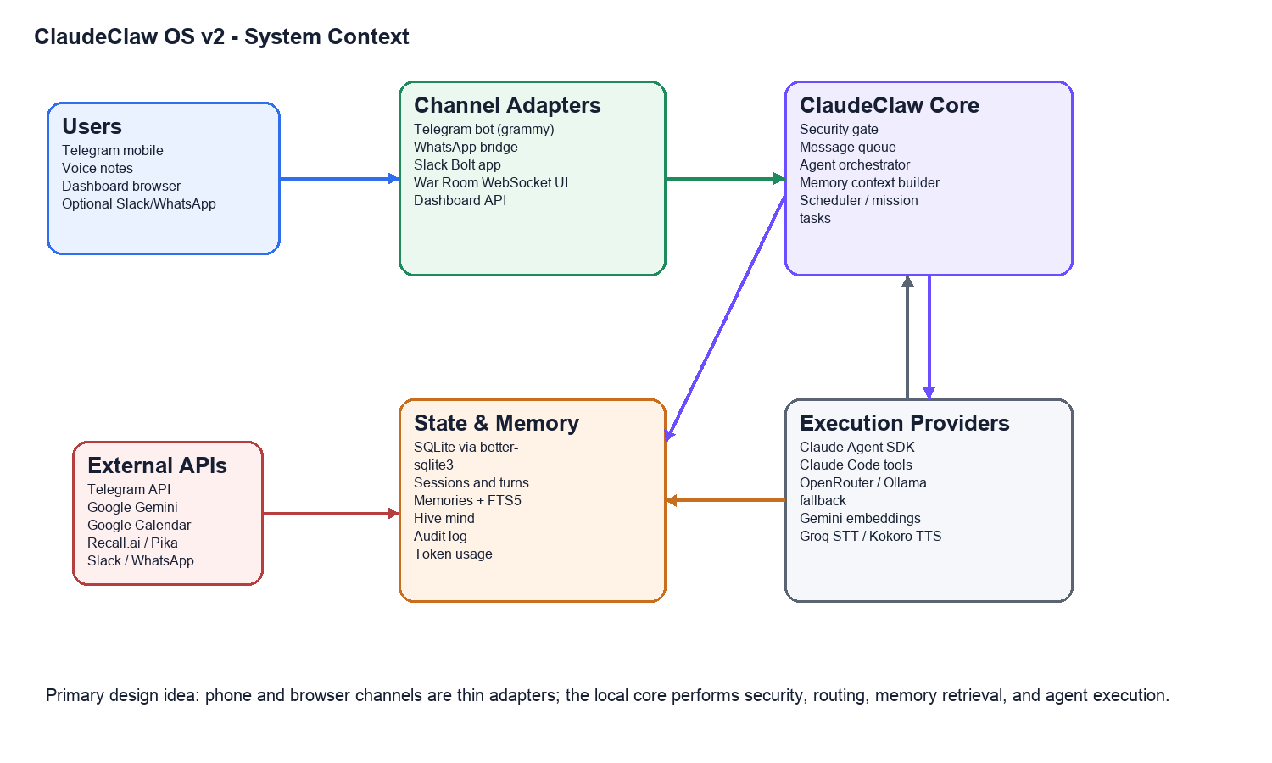
ClaudeClaw is designed as a local remote-control layer for AI work. Messaging and browser channels remain thin. They normalize input into a chat id, user id, prompt, and optional agent target. The core then owns security, routing, memory retrieval, task orchestration, execution, persistence, and response delivery.

3. Logical Architecture Layers
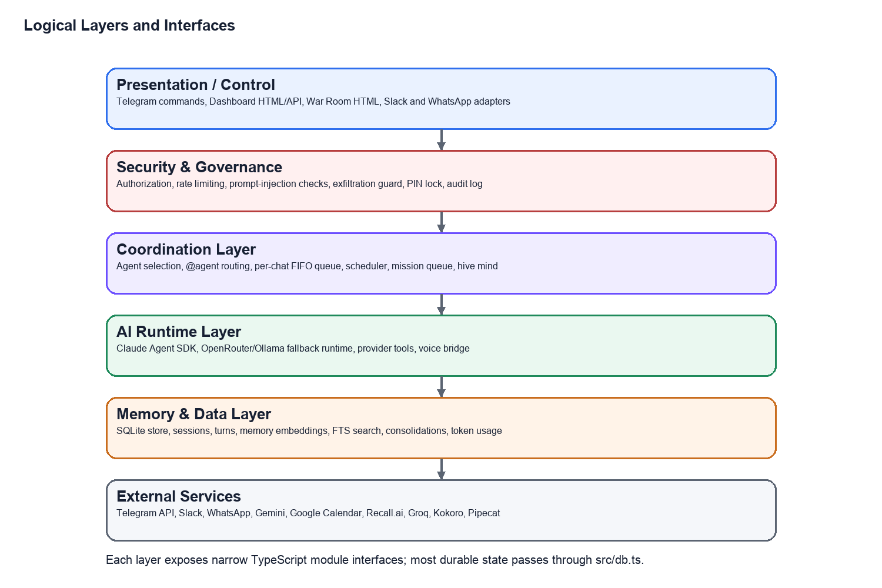
Layer | Main Modules | Responsibilities | Primary Interfaces
Presentation / Control | src/bot.ts, src/dashboard.ts, src/dashboard-html.ts, src/warroom-html.ts, src/slack.ts, src/whatsapp.ts | Accept user commands, render operational UI, expose HTTP endpoints, bridge external chat platforms. | Telegram updates, Hono HTTP routes, Slack events, WhatsApp message events, WebSocket UI.
Security & Governance | src/security.ts, src/exfiltration-guard.ts, src/db.ts audit helpers | Authorization, rate limiting, prompt-injection checks, secret scanning, PIN lock, emergency kill phrase, encryption helpers, audit logging. | isAuthorized, checkRateLimit, validateMessageContent, checkPromptInjection, encryptField, logAuditEvent.
Coordination | src/orchestrator.ts, src/queue.ts, src/scheduler.ts, src/mission-cli.ts, src/schedule-cli.ts, src/state.ts | Route prompts to agents, serialize per-chat work, run recurring tasks, maintain chat-level selected agent state, log hive mind activity. | runWithContext, delegateToAgent, globalChatQueue.enqueue, createScheduledTask.
Agent Runtime | src/agent.ts, src/agent-config.ts, agents/agent.yaml | Load agent configs, build prompts, execute Claude Agent SDK, support OpenRouter/Ollama fallbacks and scoped provider tools. | createAgentRuntime, runAgent, getAgentConfig, getAllAgents.
Memory & Persistence | src/db.ts, src/memory.ts, src/memory-ingest.ts, src/memory-consolidate.ts, src/embeddings.ts | Store sessions, turns, memory entries, FTS index, consolidations, token usage, tasks, integrations, audit logs. | buildMemoryContext, saveMemory, searchMemories, startConsolidationLoop, generateEmbedding.
Voice & Media | src/voice.ts, src/media.ts, src/agent-voice-bridge.ts, warroom/warroom_pipecat.py | Speech-to-text, text-to-speech, media validation, War Room bridge and Pipecat voice server scaffold. | speechToText, textToSpeech, validateMedia, initWarRoomBridge.

4. Component Interface Map
Component | Consumes | Produces | Notes
Telegram Bot | Telegram updates, voice files, commands, selected-agent state | Replies, conversation turns, orchestrator calls | Uses grammy. Supports commands such as /start, /help, /status, /memory, /tasks, /dashboard, /warroom, and inline @agent routing.
Dashboard API | HTTP requests from embedded dashboard UI | Stats, memory lists, task CRUD, agent lists, War Room lifecycle | Hono server on DASHBOARD_PORT, default 3141. Serves / and /warroom.
Slack Adapter | Slack app mentions, DMs, slash commands | Slack messages and stored encrypted logs | Uses globalChatQueue to preserve per-channel FIFO ordering.
WhatsApp Adapter | whatsapp-web.js incoming messages and media | WhatsApp replies and stored encrypted logs | Optional integration gated by WHATSAPP_ENABLED.
Security Layer | User id, platform id, message content | Allow/deny decisions, audit events, lock state | PIN state syncs to /tmp/warroom-pin.json for War Room IPC.
Orchestrator | chatId, prompt, agentId, memory flag | AgentResult and hive mind entries | Builds memory context before calling runtime. Supports delegation and broadcast.
Agent Runtime | Runtime config, prompt messages, provider env | Content, token usage, tool-call count, duration | Claude path uses Claude Agent SDK with Claude Code preset and bypassPermissions.
Memory System | Conversation turns, query text, embeddings | Context blocks, memories, consolidations, FTS results | Current schema supports FTS5, salience, pinning, supersession, and consolidation.
Scheduler | Cron expressions and task definitions | Due task execution via orchestrator | Runs polling loop; stores next_run, last_run, last_result, status, priority, and agent_id.
War Room | Browser WebSocket commands and local audio | Voice status, transcript events, delegated tasks | Pipecat server is present but needs dependency and hardware validation.
Meeting Bot Skill | Meeting URL, Recall/Pika env, Google context hooks | meet_sessions rows, bot id, briefing | Current implementation mocks briefing unless external APIs are configured.

5. Runtime Request Flow
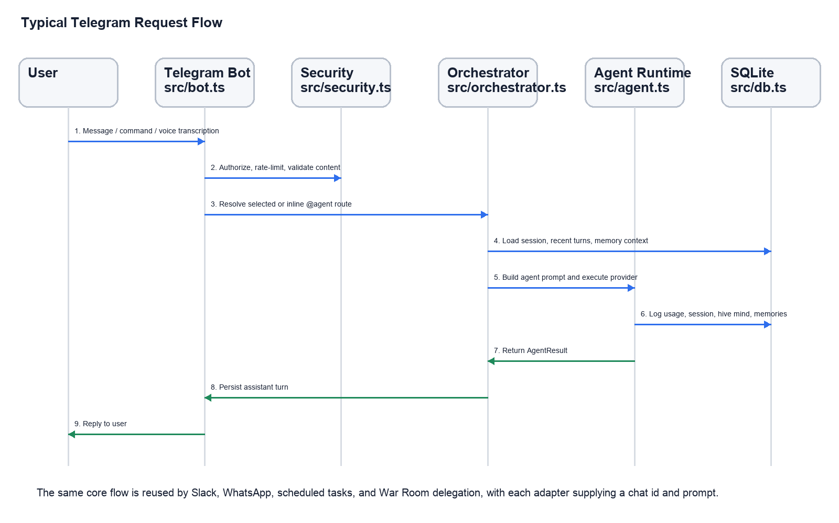
- A user sends a Telegram message, voice note, Slack command, WhatsApp message, dashboard action, or scheduled-task trigger.
- The adapter extracts platform metadata and normalizes the input into a chat id, prompt, user id, and optional agent hint.
- Security checks authorization, rate limits, suspicious content, prompt injection, and potential secret leakage.
- The coordination layer resolves the target agent from selected state, routing rules, or inline syntax such as @research summarize this.
- The memory layer builds contextual recall using stored turns, memories, FTS search, embeddings, recent memories, and consolidation insights.
- The agent runtime calls the configured provider. Claude provider uses the Claude Agent SDK and may invoke local Claude Code tools.
- The result is persisted to the conversation log, memory ingestion/consolidation pipeline, hive mind, token usage, and audit tables as applicable.
- The adapter sends the response back over the original channel.

6. Persistent Data Architecture
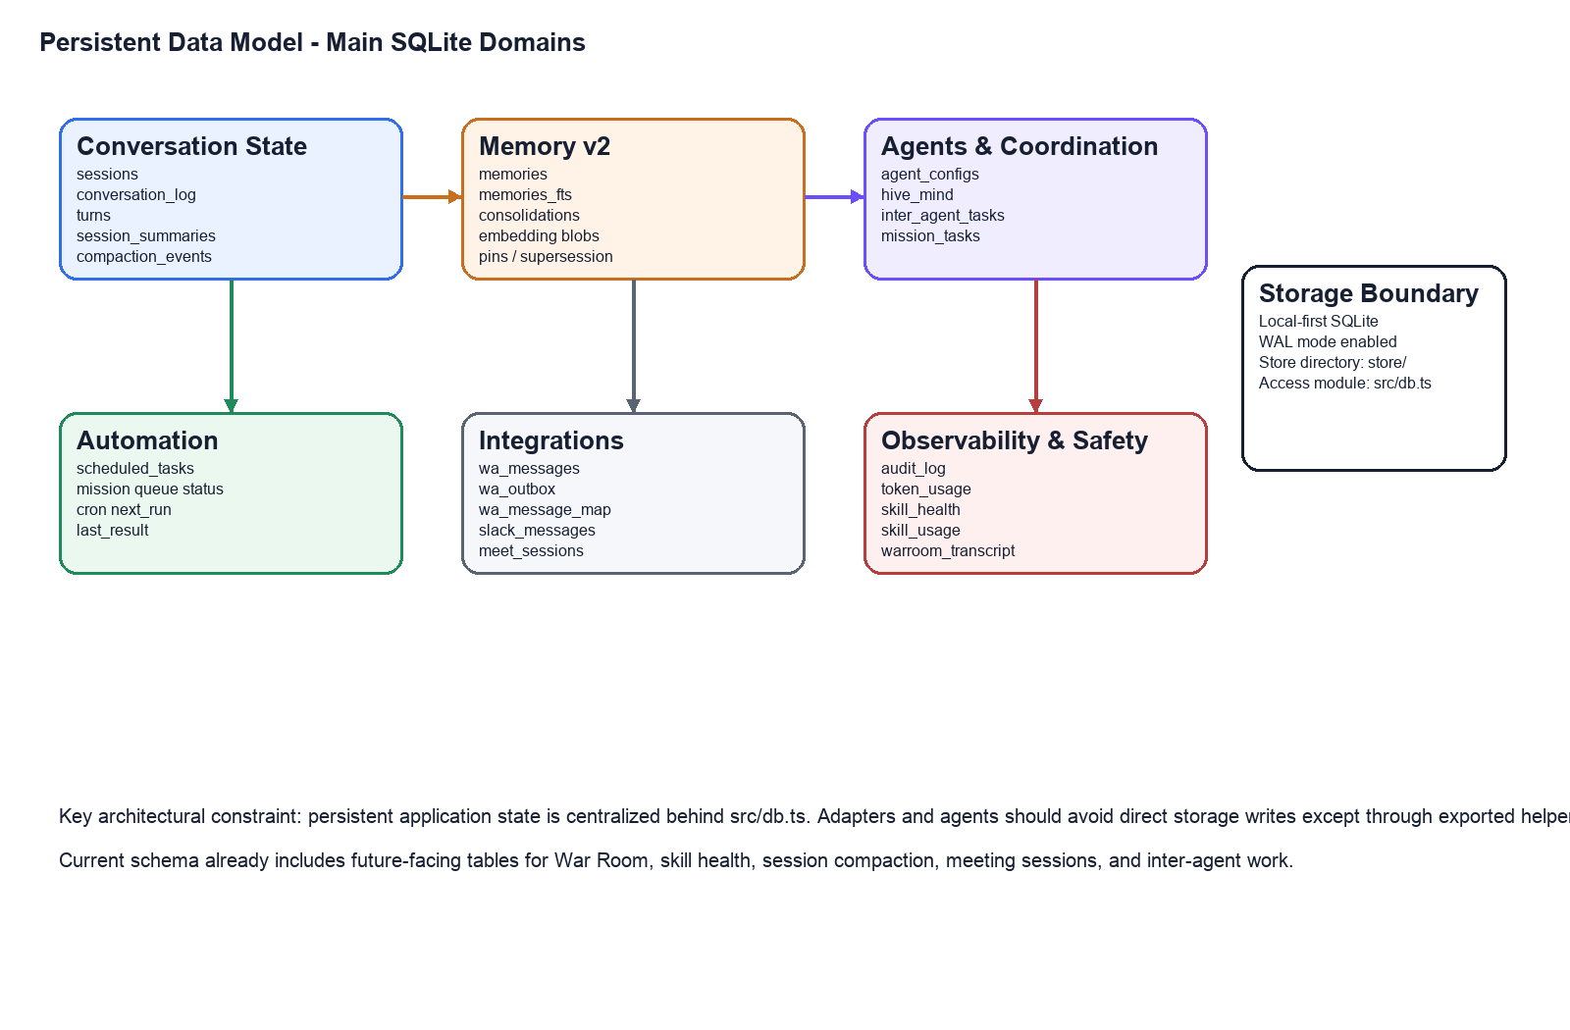
Domain | Representative Tables | Purpose
Session continuity | sessions, conversation_log, turns | Maintain chat and agent-specific continuity, recent history, and conversation replay.
Memory v2 | memories, memories_fts, consolidations | Store extracted facts, embeddings, full-text index, salience, pinning, supersession, and cross-memory insights.
Agent coordination | agent_configs, hive_mind, inter_agent_tasks | Persist dynamic agents, shared agent activity, and handoff tasks.
Automation | scheduled_tasks, mission_tasks | Support recurring jobs and one-shot queued missions with priority, status, and assigned agent.
Integrations | wa_messages, wa_outbox, wa_message_map, slack_messages, meet_sessions | Track external channel interactions and meeting-bot sessions.
Safety and observability | audit_log, token_usage, warroom_transcript, skill_health, skill_usage | Provide accountability, usage/cost tracking, voice transcripts, and skill operational health.

7. Deployment and Runtime Model
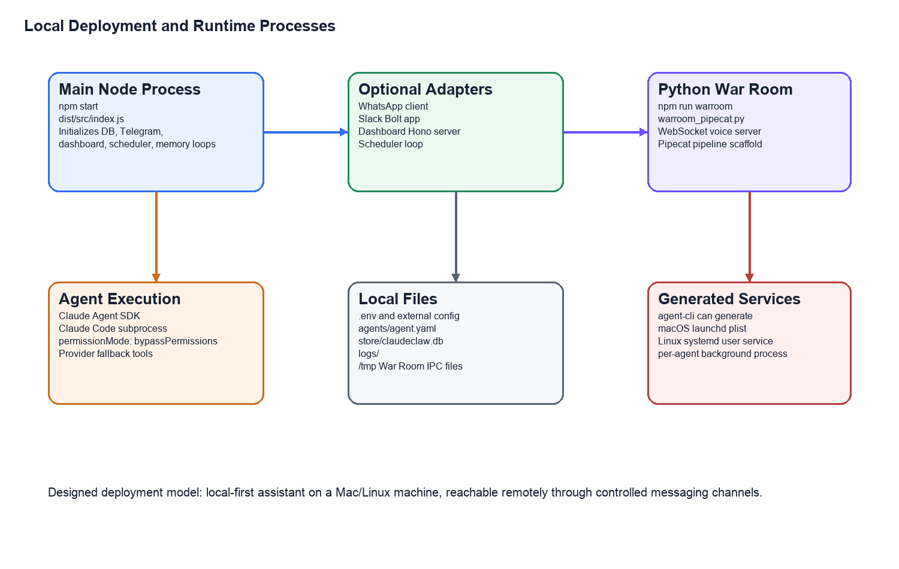
- npm run build compiles TypeScript into dist/src and dist/skills because tsconfig rootDir is the repository root.
- npm start runs node dist/src/index.js and initializes the full local assistant.
- npm run dashboard starts only the dashboard server via tsx src/dashboard.ts.
- npm run warroom starts python3 warroom/warroom_pipecat.py.
- src/agent-cli.ts can generate macOS launchd or Linux systemd user service files for agent processes.
- Runtime config is read from .env, external CLAUDECLAW_CONFIG/.env when configured, and process.env overrides.
- The database should live under store/claudeclaw.db at the project root.

8. Current Feature Inventory
Feature | Status | Design / Implementation Notes
Telegram bot control | Implemented | Core phone control channel using grammy. Handles text, commands, and voice transcription path.
Multi-agent routing | Implemented / evolving | agents/agent.yaml defines main, comms, content, ops, research, and fullstack. Inline @agent routing exists in Telegram, Slack, and WhatsApp adapters.
Agent execution through Claude Code | Implemented | src/agent.ts uses @anthropic-ai/claude-agent-sdk with Claude Code tools and bypassPermissions for autonomous operation.
Provider fallback runtime | Implemented | OpenRouter and Ollama paths exist with scoped file/tool helpers, calendar scheduling helper, and schedule tool support.
Persistent SQLite store | Implemented | Centralized in src/db.ts. Uses WAL mode and schema initialization on startup.
Memory v2 foundations | Implemented / evolving | Memories table, FTS5, embeddings wrapper, ingestion, consolidation, salience, pinning, and supersession hooks exist.
Dashboard | Implemented / evolving | Hono API and embedded HTML UI. Provides stats, memory search/delete, tasks, agents, hive mind, War Room controls, and SSE ping channel.
Scheduler | Implemented | Cron parser, scheduled task CRUD, polling loop, due task execution through orchestrator.
Mission control CLI | Implemented | CLI for one-shot mission tasks and task listing/updating based on db mission_tasks helpers.
Slack integration | Optional implemented | Slack Bolt app handles mentions, DMs, slash commands, authorization, FIFO queueing, and encrypted storage when key configured.
WhatsApp integration | Optional implemented | whatsapp-web.js client with QR auth, queueing, inline agent routing, authorization, and encrypted message storage.
Voice input/output | Implemented / environment dependent | STT/TTS helpers exist. Groq/Kokoro configuration required for full operation.
War Room voice interface | Scaffolded | Dedicated HTML UI and Pipecat Python server exist. Needs Pipecat dependencies, browser/audio validation, and production routing/tool implementation.
PIN lock and kill phrase | Implemented / needs UI polish | Security functions lock/unlock, idle auto-lock, kill phrase, and /tmp/warroom-pin.json sync are present.
Exfiltration guard | Implemented / evolving | Prompt-injection checks plus direct, Base64, and URL-encoded secret scanning.
Meeting bot / Pikastream | Scaffolded | Skill exists and meet CLI calls it. Recall.ai call is implemented, briefing is currently mocked pending Gmail/Calendar integration.
Agent creation/service generator | Implemented / partial | Interactive agent CLI validates Telegram tokens and writes launchd/systemd service files. Main process agent-start mode still needs completion.
Media handling | Implemented | Media validation and storage path helpers exist for images, audio, video, and documents.

9. Architecturally Significant Requirements
Requirement | Current Design Response | Architectural Concern
Local-first operation | Node/TypeScript process runs locally, SQLite store is local, Claude Code tools execute on host. | Host access is powerful; authorization, audit, and permission boundaries are critical.
Remote phone control | Telegram is the primary control plane. | Bot credentials and allowed Telegram IDs must be strongly configured.
Multi-agent specialization | Agents are configured through agents/agent.yaml and DB agent_configs. | Need final process lifecycle and per-agent isolation strategy.
Persistent memory | Memory tables, embeddings, FTS, and consolidation are present. | Need clear retention, deletion, privacy, and backup policies.
Secure integrations | Encryption helpers exist for Slack/WhatsApp stored messages. | Key rotation, migration of existing plaintext rows, and field-level coverage should be specified.
Voice interaction | War Room and STT/TTS modules exist. | Real-time voice requires dependency pinning, hardware testing, and failure-mode design.
Automation | Scheduler and mission tasks route work through orchestrator. | Need concurrency limits, retries, and stuck-task recovery policies.
Observability | Audit log, token usage, skill health, dashboard stats exist. | Need structured dashboards, health checks, and alerting for long-running deployment.

10. Expected Future Features and Roadmap
Future Capability | Expected Design Direction | Prerequisites / Risks
Production War Room | Replace scaffold with full Pipecat/Gemini Live or legacy Deepgram/Cartesia pipeline, with real agent routing and transcript storage. | Python dependency lock, audio hardware tests, browser client hardening, robust process supervision.
Agent process mode | Add --agent or npm run agent:start support so each agent can run as an independent Telegram bot process. | Index.ts lifecycle changes, per-agent env/token resolution, service restart testing.
Agent creation wizard hardening | Create directory templates, CLAUDE.md templates, token validation, config validation, and dashboard integration. | Network validation, secrets handling, duplicate ID prevention, max-agent enforcement.
Dashboard real-time sync | Use SSE /api/events to push memory/task/agent updates instead of ping-only heartbeat. | Event bus abstraction, backpressure handling, UI state reconciliation.
Memory quality loop | Tighten relevance feedback, salience decay, consolidation cadence, and duplicate detection. | Gemini API costs, privacy review, better tests around DB migrations and FTS triggers.
Meeting bot production integration | Connect Recall.ai/Pika bot with Google Calendar/Gmail and memory briefing. | OAuth setup, consent, meeting-provider testing, fallback behavior.
Security hardening | Key rotation, encrypted migrations, stricter allowlist defaults, audit export, admin unlock UI. | Migration plan for stored messages, security review, incident procedures.
Daemonization and operations | Generate and manage launchd/systemd services for main process, dashboard, War Room, and agents. | Log rotation, health checks, restart policies, config directory conventions.
Provider abstraction cleanup | Formalize interfaces for Claude, OpenRouter, Ollama, Gemini embedding, and voice providers. | Reduce scattered env reads, add capability matrix, improve error handling.
Test coverage | Add unit and integration tests for routing, scheduler, security, DB migrations, and adapters. | Current Vitest config has no test files. Need fixtures and provider mocks.

11. Known Gaps / Review Points
- The repository is mid-upgrade and has a dirty worktree; architects should distinguish committed baseline from current local changes.
- The TypeScript build passes, but Vitest currently reports no test files found.
- War Room server compiles syntactically but requires Pipecat dependencies and audio hardware validation.
- Dashboard SSE is present but currently sends heartbeat pings rather than domain events.
- Meeting bot briefing is mocked until Google Workspace integration is implemented.
- Dynamic agent JSON scaffolding exists in the dashboard, while the main agent loader primarily expects YAML directories or DB configs; this should be reconciled.
- Generated services now point to dist/src/index.js, but full per-agent process boot mode needs final implementation.
- Security encryption helpers exist, but key management and plaintext migration require an explicit operational plan.

12. Appendix: Key Files and Scripts
Area | Files / Scripts
Entrypoints | src/index.ts, package.json scripts: start, dev, dashboard, warroom, mission, schedule, meet
Adapters | src/bot.ts, src/slack.ts, src/whatsapp.ts, src/dashboard.ts, src/warroom-html.ts
Core orchestration | src/orchestrator.ts, src/agent.ts, src/agent-config.ts, src/queue.ts, src/state.ts
Memory | src/memory.ts, src/memory-ingest.ts, src/memory-consolidate.ts, src/embeddings.ts
Persistence | src/db.ts, store/claudeclaw.db
Security | src/security.ts, src/exfiltration-guard.ts
Automation | src/scheduler.ts, src/schedule-cli.ts, src/mission-cli.ts
Voice and media | src/voice.ts, src/media.ts, src/agent-voice-bridge.ts, warroom/warroom_pipecat.py
Meeting bot | src/meet-cli.ts, skills/pikastream-video-meeting/index.ts
Docs and prompts | AGENTS.md, CLAUDE.md, claudeclaw_v2_progress_report.md, plans/claudeclaw_v2_assessment.md, prompts/*.md

End of architecture brief.

13. Production Hardening Enhancements Completed
This section documents the concrete hardening work completed after the initial architecture brief. The goal of this pass was to close the highest-risk implementation gaps that would block stable production operation or future feature development.

13.1 Summary of Enhancements
Gap / Risk | Enhancement Completed | Architectural Impact
Test command had no test suite | Added Vitest tests for agent-id validation, aggregate agent discovery, and per-chat FIFO queue ordering. | npm test now provides a real regression signal for core routing and queue behavior instead of failing with no tests found.
Aggregate agents were partially invisible | Updated agent discovery to load every entry from agents/agent.yaml instead of a hard-coded subset. | The fullstack agent and future aggregate YAML agents are now visible consistently in bot and dashboard views.
Dashboard agent scaffolding wrote orphan JSON | Changed dashboard scaffold endpoint to validate IDs, enforce the 20-agent limit, create agents/{id}/agent.yaml and CLAUDE.md, and persist config to the DB. | New agents are created in the same shape the runtime already loads, reducing configuration drift.
Dashboard SSE emitted heartbeat only | Added a publishDashboardEvent event bus and domain events for memory deletion, task creation/deletion, agent scaffolding, and War Room lifecycle. | The dashboard now has a production-ready event stream foundation for real-time UI sync.
Per-agent process boot was incomplete | Added --agent / --agent=<id> startup parsing and set CLAUDECLAW_AGENT_ID/AGENT_ID before runtime initialization. | Generated per-agent services can start a focused agent process without also starting dashboard, scheduler, Slack, WhatsApp, War Room, or memory background loops by default.
Agent Telegram token resolution was single-bot only | Telegram initialization now resolves token from DB agent config, {AGENT_ID}_TELEGRAM_TOKEN, or TELEGRAM_BOT_TOKEN fallback. | Per-agent Telegram bots are now supported by the runtime token-resolution path.
Dashboard and War Room relied on current working directory | Dashboard War Room process launch now resolves from PROJECT_ROOT. | Service execution is less fragile when launched from a different working directory.
Configuration constants ignored env ports | DASHBOARD_PORT and WARROOM_PORT constants now honor .env/process env. | Runtime configuration is more predictable across local, service, and external config deployments.

13.2 Files Changed in This Hardening Pass
File | Purpose of Change
src/agent-config.ts | Added validateAgentId and dynamic aggregate-agent loading from agents/agent.yaml.
src/bot.ts | Switched agent listings to getAllAgents, added per-agent Telegram token resolution, and respected process-level agent mode.
src/config.ts | Made dashboard and War Room port constants environment-aware.
src/dashboard.ts | Added dashboard SSE event publishing, production-aligned agent scaffolding, root-safe War Room launch paths, and domain event notifications.
src/index.ts | Added --agent startup parsing and disabled singleton/background services by default in per-agent process mode.
tests/agent-config.test.ts | Added tests for safe agent IDs and complete aggregate agent loading.
tests/queue.test.ts | Added tests proving same-chat FIFO ordering and cross-chat independent progress.

13.3 Verification Completed
Verification | Result
npm run build | Passed. TypeScript compilation succeeded after the hardening changes.
npm test | Passed. 2 test files, 4 tests.
Previous Python syntax check for War Room | Passed after fixing json.dumps in warroom/warroom_pipecat.py.
Root resolution check | Previously verified compiled PROJECT_ROOT resolves to /Users/googs/Projects/Googs-Claude-Claw rather than dist/.

13.4 Remaining Production Readiness Work
- Add integration tests around the dashboard API, scheduler task execution, and Telegram command handlers using mocked providers.
- Complete production War Room implementation with pinned Pipecat dependencies, browser audio transport validation, real tool registration, and transcript persistence tests.
- Implement encrypted-field migration for any existing Slack/WhatsApp plaintext rows and define key rotation procedures.
- Add service health checks, log rotation, and operational runbooks for launchd/systemd deployments.
- Finish Google Calendar/Gmail preflight briefing implementation for the meeting bot and add provider failure fallback behavior.
- Connect dashboard UI state to the new domain SSE events so memory/task/agent panels update without manual refresh.
Document updated after hardening pass on 2026-04-28.

14. Feature Completion Batch: Dashboard, Agent Runtime, and Operations
This section documents the next feature-completion batch after the production hardening pass. These changes focus on making already-designed capabilities usable from the dashboard and command line, while adding operations documentation and regression tests.

14.1 Completed Enhancements
Feature Area | Enhancement Completed | Why It Matters
Dashboard real-time sync | Wired the dashboard UI to named Server-Sent Events: memory.deleted, task.created, task.deleted, agent.scaffolded, warroom.started, and warroom.stopped. | The dashboard no longer treats /api/events as a placeholder. It refreshes relevant panels when domain events arrive.
Dashboard agent creation | Changed the Agents Directory button from an alert to the real scaffold flow, with prompts for name, token, description, and model. | Architects and operators can create agents from the UI path that the backend now supports.
Memory rendering robustness | Updated dashboard memory rendering to support content, summary, raw_text, type, memory_type, or source fields. | The UI now matches the current SQLite memory schema and avoids blank memory cards.
Agent lifecycle scripts | Added npm run agent:create and npm run agent:start scripts. | Agent setup and per-agent runtime are now discoverable through package scripts instead of hidden TypeScript files.
Dashboard API testability | Exported the Hono app from src/dashboard.ts and added dashboard API tests. | Local API behavior can now be tested without starting a network server.
War Room operations | Added warroom/requirements.txt and docs/operations.md with build, dashboard, agent, and War Room procedures. | The voice stack now has a documented setup path, even while full hardware/API validation remains future work.
Environment template | Expanded .env.example with DEFAULT_AGENT_ID, per-agent tokens, War Room port, security PIN/encryption settings, OpenAI key, and meeting-bot provider variables. | New deployments have clearer configuration guidance and fewer hidden environment assumptions.

14.2 Verification Completed
Verification | Result
npm run build | Passed after dashboard UI, API export, script, env, and operations changes.
npm test | Passed: 3 test files, 7 tests.
Dashboard API tests | Covered /health, /api/agents, and /api/events stream startup.

14.3 Newly Added / Updated Files
File | Purpose
src/dashboard-html.ts | Real dashboard SSE listeners, scaffold-agent UI wiring, and schema-safe memory rendering.
src/dashboard.ts | Exported Hono app for tests; still publishes domain events from API mutations and War Room lifecycle.
package.json | Added agent:create and agent:start package scripts.
.env.example | Expanded production configuration template for agents, security, War Room, and meeting bot providers.
warroom/requirements.txt | Python dependency list for the current Pipecat War Room scaffold.
docs/operations.md | Operator runbook for build/test, main runtime, agent runtime, dashboard, and War Room.
tests/dashboard.test.ts | Dashboard API and SSE stream regression tests.

14.4 Remaining Feature Work
- Complete the full browser audio transport for War Room instead of relying on local audio transport only.
- Implement dashboard forms as structured modals instead of prompt() dialogs for agent creation.
- Add pause/resume/trigger controls for scheduled tasks in the dashboard UI.
- Add integration tests for scheduler execution, Telegram command routing, and dashboard scaffold endpoint using isolated test storage.
- Finish live Google Calendar/Gmail preflight briefing for meeting bot sessions.
- Add encrypted-field migration and key-rotation tooling for Slack/WhatsApp stored messages.
Document updated after feature-completion batch on 2026-04-28.

15. Production Readiness Batch: Security, Doctor, Backup and Restore
This section documents an additional production-readiness batch focused on deploy-time checks, dashboard API protection, and operational recovery. These changes improve the system posture before enabling additional feature development.

15.1 Completed Enhancements
Area | Enhancement Completed | Production Impact
Dashboard API security | Added optional DASHBOARD_AUTH_TOKEN enforcement for dashboard API routes and SSE stream access. | Operators can protect dashboard APIs before exposing the service outside a trusted localhost environment.
Configuration doctor | Added src/doctor.ts and npm run doctor to validate Node version, project root, store writability, Telegram config, allowlist, dashboard auth, encryption key length, agent registry, and optional integration settings. | Deployments now have a repeatable preflight check instead of manual configuration inspection.
Backup and restore | Added src/backup-cli.ts plus npm run backup, npm run backup:list, and npm run restore. | SQLite state can now be backed up and restored through supported commands.
Git hygiene | Added backups/ to .gitignore. | Database backups are kept out of source control by default.
Operations runbook | Updated docs/operations.md with dashboard auth and backup/restore procedures. | Architects and operators have a clearer deployment and recovery path.
Environment template | Added DASHBOARD_AUTH_TOKEN to .env.example. | New environments surface the dashboard security control during setup.
Regression coverage | Added doctor tests for dashboard-auth warning and encryption-key length failure. | Production checks now have test coverage for expected warning/failure behavior.

15.2 Verification Completed
Verification | Result
npm run build | Passed.
npm test | Passed: 4 test files, 9 tests.
node dist/src/doctor.js | Passed with one expected warning: DASHBOARD_AUTH_TOKEN is not configured in the current local environment.
node dist/src/backup-cli.js list | Passed and reported no backups found.

15.3 Remaining Operator Inputs
- Set DASHBOARD_AUTH_TOKEN before exposing dashboard API routes outside localhost.
- Decide a production value and storage process for MESSAGE_ENCRYPTION_KEY before enabling encrypted Slack/WhatsApp storage.
- Run npm run backup before migrations or major upgrades once real production state exists.
- Perform physical microphone/speaker validation for War Room before marking voice mode production-ready.
- Provide real Google/Recall/Pika credentials before completing live meeting-bot validation.
Document updated after production-readiness batch on 2026-04-28.

