LiDAR Point-Cloud Segmentation and Completion
Results Overview
Ngo Vi Viet Anh — Master's Thesis · Results through July 17, 2026

Summary
The project has a complete car-detection pipeline on SemanticKITTI (held-out full-sequence F1 0.79, precision 0.90) and, on top of it, a point-cloud completion system with the first quantitative real-data evidence that completion adds value. Three questions were carried to a definitive answer: (1) the ~0.74 recall limit is a hard ceiling of density-based clustering — root-caused to HDBSCAN splitting, confirmed by five negative mitigation studies; (2) the sim-to-real gap for the classifier is total and symmetric, so synthetic pretraining was dropped from production (kept as an ablation); (3) the long-standing “PCN produces blobs on real data” failure was an inference-normalization bug, not a domain-gap dead end — after the fix, completion measurably improves bounding-box estimates (BEV IoU 0.707 → 0.747) and reconstructs 30% of never-observed car surface within 10 cm, 7× a symmetry-mirror baseline, under a newly designed and validated metric.

1. The Pipeline
Per frame: preprocessing (z-filter, denoise, 0.05 m voxel downsample) → RANSAC ground removal → HDBSCAN clustering → geometric filtering → binary car/not-car classifier (dual-branch PointNet) → centroid tracking with track-level filtering → PCN completion of accepted car tracks. Seq 08 is held out from all training and tuning and is the honest evaluation sequence.

2. Detection Results
The pipeline was built up in four measured steps:
- Geometric filter tuning. A per-cluster false-positive analysis (vegetation 38%, buildings 33%, trunks 13%) drove three threshold changes: precision 0.237 → 0.654 at −19% recall. The residual FPs are vegetation clusters that geometrically resemble cars — separable only by shape, which motivated the classifier. The shape thresholds do not limit car recall (they account for ~4% of rejections that touch a GT car; the rest are fragments of split cars, §3).
- Learned classifier. Training on synthetic ShapeNet alone fails completely on real data (0 true positives — the first sign of the domain gap in §4). Mining 550k real clusters from SemanticKITTI with GT purity filtering and training on those lifted pipeline precision 0.654 → 0.969 at a 2-point recall cost. The task was narrowed to binary car/not-car after the 4-class version produced spurious motorcycle detections from 28 bus training samples.
- Evaluation integrity. Seq 00 — the original headline sequence — turned out to be inside the classifier's training set. All headline evaluation moved to held-out seq 08; seq-00 numbers are kept only as a deterministic reference, marked as leaked.
- Track-level filtering. A minimum-track-length + majority-vote filter cuts transient FPs and — unexpectedly — recovers detections that flicker between “car” and “unknown” across frames. Full-sequence F1 0.762 → 0.801.
Evaluation | Precision | Recall | F1 | Mean IoU
Seq 00, 100 frames (leaked; reference) | 0.984 | 0.761 | 0.859 | 0.942
Seq 08, full 4,071 frames (held-out) | 0.903 | 0.699 | 0.788 | 0.895

The system is precision-saturated (~1 FP/frame) and recall-limited. The classifier threshold is not a lever on recall: cars are lost at clustering before the classifier ever sees them (lowering the threshold to 0.30 yields no recall gain), so the F1-optimal operating point is also the recall-maximal one.
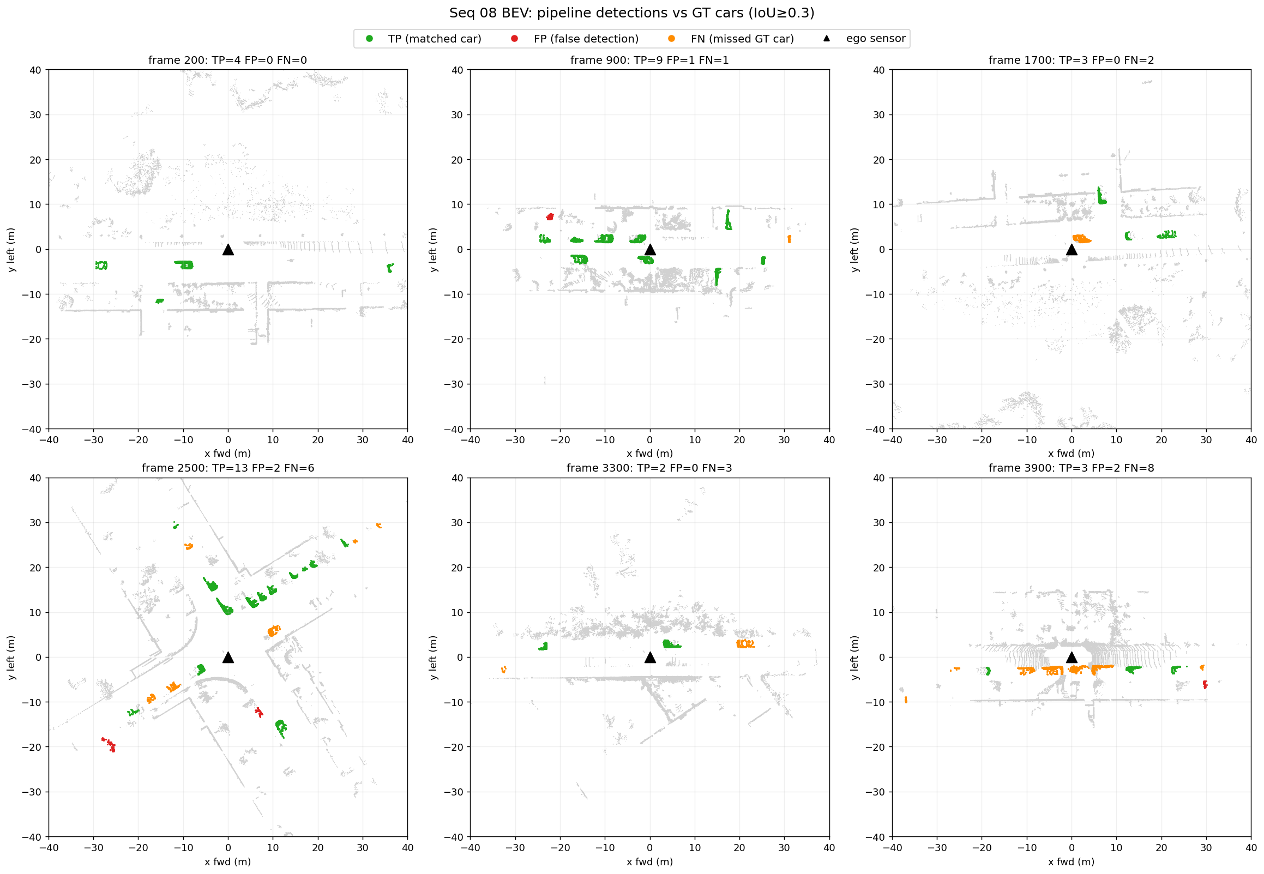
Figure 1 — Bird's-eye-view detections on held-out seq 08.

3. The Recall Ceiling
Recall plateaus near 0.74 in every configuration, and we now know exactly why: 31–37% of GT cars are split across multiple HDBSCAN clusters (66% split rate at close range — large cars have internal density gaps), and the sub-fragments then fail the volume/point-count filters. The recoverable ceiling from cleanly-clustered cars is 63–68% — matching actual recall, i.e. the pipeline already finds essentially every car that clusters cleanly. Five mitigation strategies were implemented and all were negative on held-out data:
Strategy | Outcome
BEV connected-component clustering | F1 0.779 vs 0.844 — 2D projection merges overlapping objects
Larger min_cluster_size | Wins on seq 00, loses on seq 08 — overfits
Post-clustering fragment merge | Absorbs walls/poles; net negative
Distance-adaptive HDBSCAN | Ring-boundary artifacts; worse than global
Temporal point accumulation | F1 collapses to 0.073

Framing for the thesis: this is a structural property of density-based clustering — it makes local decisions with no notion of objectness, so split fragments can never be re-assembled. The pipeline is not recall-competitive with end-to-end detectors; its value is that it needs no 3D box labels (semantic labels only), and it quantifies exactly where learning must take over — which is where the classifier (§2) and completion (§5) enter.

4. Sim-to-Real: Dropping Synthetic Pretraining
Two studies answered the “too-perfect synthetic data” concern. A controlled ablation (retrain from random init) showed the ShapeNet prior contributes nothing once 420k real clusters are available (macro F1 0.9285 scratch vs 0.9225 pretrained). The cross-domain matrix shows why — zero transfer in either direction, and fine-tuning completely forgets the synthetic domain:
Train ↓ / Test → | Synthetic val | Real val (seq 08)
Synthetic only (Stage A) | 0.999 (0.999) | 0.447 (0.000)
Real only (from scratch) | 0.304 (0.000) | 0.929 (0.885)
Synthetic → real fine-tuned | 0.318 (0.000) | 0.923 (0.875)

Cell format: macro F1 (car F1). Note the synthetic-only model scores 0.807 accuracy on real data while finding zero cars — why we report macro F1 and confusion matrices, not accuracy.
After a full-scale re-check (scratch is neutral-to-better: seq 00 F1 0.844 → 0.859, seq 08 identical), the production classifier now trains on real data only. Stage A is kept as the thesis sim-to-real ablation. Synthetic data was only dropped for classification, where real labels are abundant — for completion (§5), where no real ground truth exists, it remains the training data and works once the right partiality pattern is simulated.

5. Point-Cloud Completion

5.1 The “blob” failure, solved
PCN trained on ShapeNet produced shapeless blobs on every real cluster, and three domain-adaptation attempts (noise augmentation, virtual Velodyne ray-casting, sparse-input training) failed — each modelled one mismatch axis (noise, scan geometry, density) but not the real one: the occlusion/partiality pattern. Two fixes resolved it. First, a KITTI-like single-view partial generator (matching real pipeline output) trains a PCN that completes cleanly in-distribution (Chamfer 0.16 m). Second — the actual headline — the blobs were largely an inference bug: the inference path applied PCA alignment and centroid/scale normalization never seen in training, degrading every checkpoint ~3.5×. With the corrected path, real clusters complete into car-shaped clouds. A by-product finding: accumulated-LiDAR pseudo-ground-truth is invalid for evaluating completion (it is itself one-sided, so Chamfer rewards under-completion) — which forced the new metric in §5.4.

5.2 Two supporting results
- Input gate. Bad completions trace back to bad inputs — fragments and merged clusters leaked by clustering (§3). An L-shape-fit gate rejecting them raises plausible-car completion precision 38% → 69%. Cost: completion is attempted on ~64% of detected cars; gated tracks keep their raw points, so detection metrics are unaffected. The gated subset is not just easy cases — completion's largest gains are on the sparsest inputs (§5.3).
- Architecture check. A transformer completer (PoinTr) trained on identical data has a small synthetic edge (~5% Chamfer) but is equivalent on real data (16/26 vs 18/26 plausible). Decoder capacity is not the bottleneck — inference geometry and the partiality gap are. PCN stays in production.

5.3 Completion improves the bounding box
Reference: amodal GT boxes accumulated from 40 well-observed static cars (with viewpoint-coverage and motion guards; dimensions match published car statistics). For 2,075 true-positive detections of these cars, boxes were fitted to the raw partial and to its completion with the same fitter. Per-car medians, Wilcoxon tests, n = 39:
Metric | Raw | Completed | p | Verdict
BEV IoU | 0.707 | 0.747 | 0.0019 | better
|ΔW| (m) | 0.270 | 0.170 | 0.00015 | better
|ΔH| (m) | 0.255 | 0.131 | 1.6e-10 | better
Center error XZ (m) | 0.286 | 0.234 | 2.8e-05 | better
|ΔL| (m) | 0.447 | 0.456 | 0.65 | neutral
Yaw error (deg) | 3.5 | 3.0 | 0.74 | neutral

Completion helps most where the sensor saw least (BEV IoU on < 100-point inputs: 0.461 → 0.599). The one weak spot is length: the network does not extend the unobserved far end (signed ΔL −0.49 raw vs −0.55 completed; conservative bias, never too long). That is the current work item — plan in §6.
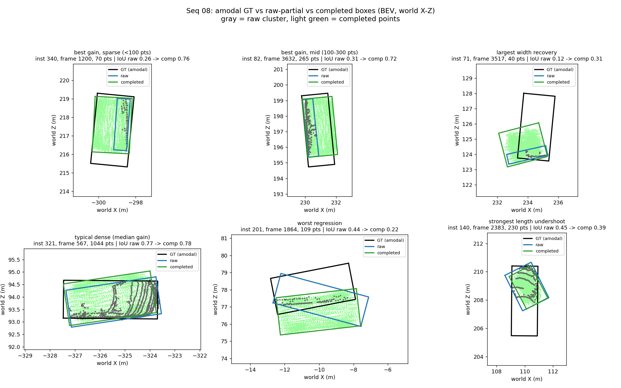
Figure 2 — Amodal GT box (black) vs raw-partial box (blue) vs completed box (green).

5.4 A valid real-data completion metric
Since pseudo-GT Chamfer is invalid (§5.1), a new metric was designed: complete a static car from one frame, then score coverage of donor points — observations of the same car from other frames — that lie ≥ 0.15 m from every input point, i.e. surface the input frame never saw. Baselines: the raw partial and a symmetry-mirrored partial. An out-of-GT-box guard catches hallucination. Same statistical design as §5.3:
Method | Coverage@0.1 m | Median novel-dist (m) | Out-of-box
Raw partial | 0.000 | 0.518 | 0.000
Mirrored partial | 0.043 | 0.332 | 0.008
PCN completed | 0.304 | 0.161 | 0.000

All pairwise p < 1e-6; the metric passed its four pre-registered validation checks. This is the first real-data evidence that the network reconstructs genuinely unseen structure — 30% of never-observed surface within 10 cm, 7× the mirror baseline, with essentially zero hallucination — and it makes the far-end weakness directly measurable (coverage there: 0.133).
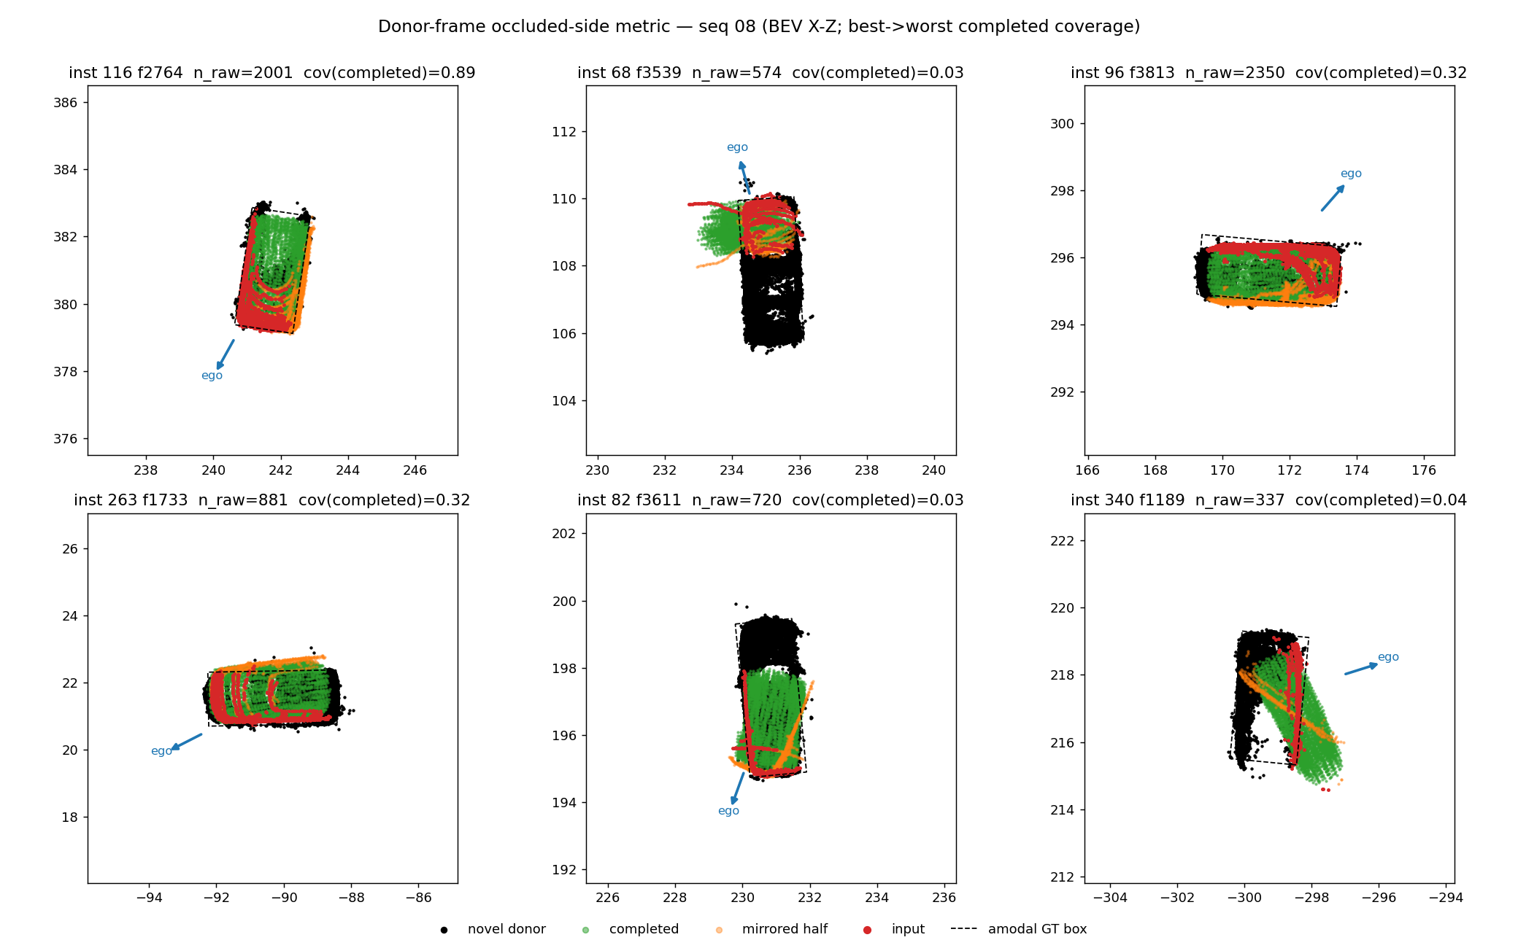
Figure 3 — Donor-frame metric: input partial, never-observed donor points, and method outputs.

6. Next Steps
- Fix the far-end undershoot (active). Ordered by evidence: (1) inference geometry, no retraining — anchor the box at the observed L-shape corner and place the center longitudinally with a car-length prior (the current estimate corrects laterally but not longitudinally); (2) if needed, retrain with a visibility-weighted asymmetric Chamfer loss that makes omitting occluded structure cost more than conservative truncation; (3) contingency: fine-tuning on real partials, now measurable with the donor metric. Architecture changes are ruled out by the PoinTr result. Success criteria: far-end coverage (0.133) and signed ΔL (−0.545 m).
- Amodal GT validity. Cross-validation against official KITTI tracklets is impossible — the raw drive behind seq 08 was never tracklet-annotated (verified on the KITTI download server); that absence is why the pseudo-GT was built. Validity rests on the paired design (both arms share the reference), construction guards, and the dimension sanity check.
- Thesis writing. Pipeline, recall-ceiling, sim-to-real, and completion chapters; pipeline diagram.

Appendix — Where to Find the Details
Every result above is backed by a numbered finding in the repository (docs/findings.md) with hypothesis, commands, and full tables. Mapping:
Report section | Findings
§2 Detection pipeline | #2, #4–#14, #18, #20
§3 Recall ceiling | #21–#24
§4 Sim-to-real | #25, #30, #31
§5.1 Blob failure → fix | #15–#19, #26
§5.2 Gate; PoinTr | #27, #28
§5.3 Box improvement | #29
§5.4 Donor metric | #32

A longer companion document (results_report_2026_07_17_rev2.docx) contains the extended justifications: operating-point analysis, filter validity across vehicle sizes, gate cost accounting, and the full far-end remediation plan.

