LiDAR Point-Cloud Segmentation and Completion
Consolidated Results Report
Ngo Vi Viet Anh — Master's Thesis · Results through July 17, 2026

Executive Summary
The project has produced a complete car-detection pipeline on SemanticKITTI (held-out full-sequence F1 0.79, precision 0.90) and, on top of it, a point-cloud completion system with the first quantitative real-data evidence that completion adds value. Three research questions were carried to a definitive answer: (1) the ~0.74 recall limit is a hard ceiling of density-based clustering — root-caused to HDBSCAN splitting and confirmed by five negative mitigation studies; (2) the sim-to-real domain gap for the classifier is total and symmetric, so synthetic pretraining was dropped from the production pipeline (kept as an ablation); (3) the long-standing “PCN produces blobs on real data” failure was an inference-normalization bug, not a domain-gap dead end — after the fix, completion measurably improves amodal bounding-box estimates (BEV IoU 0.707 → 0.747, p = 0.002) and reconstructs 30% of never-observed car surface within 10 cm, seven times a symmetry-mirror baseline, under a newly designed and validated occluded-surface metric.

1. System Overview
The pipeline processes KITTI-style LiDAR sequences frame by frame: preprocessing (z-filter, denoise, voxel downsample at 0.05 m), RANSAC ground removal, HDBSCAN clustering, ground-plane-relative geometric filtering, a learned binary car/not-car classifier (dual-branch PointNet), a centroid tracker with track-level filtering, and finally PCN-based point completion of accepted car tracks. Evaluation matches detections against SemanticKITTI instance labels; sequence 08 is the held-out evaluation sequence (never used for training or tuning).
Stage | Method | Status
Preprocessing | Z-filter, statistical denoise, 0.05 m voxel downsample | Stable
Ground removal | RANSAC plane fit (deterministic, seeded) | Stable
Clustering | HDBSCAN (dedicated package, ~7.7× faster than sklearn) | Stable; recall ceiling characterized
Geometric filter | Ground-plane-relative height, span, aspect, volume | Tuned via FP analysis
Classification | Dual-branch PointNet, binary car/not-car, real-data training | Production checkpoint (from-scratch Stage B)
Tracking | Centroid tracker + min-length and majority-vote filtering | Stable
Completion | PCN on KITTI-like partials + L-shape input gate | Working; active research focus

2. Building the Detection Pipeline

2.1 Geometric filtering
The initial geometric-only pipeline had high recall but very low precision (0.237 / 0.868 on seq 00). A per-cluster false-positive analysis against ground truth showed the FPs were dominated by vegetation (38%), buildings (33%) and trunks (13%). Three data-driven filter changes (ground-relative center height ≤ 1.5 m, height span ≤ 1.8 m, aspect ratio ≤ 6.0) removed 85% of false positives at a 19% recall cost, reaching precision 0.654. Building and trunk FPs were nearly eliminated; the residual FPs are compact vegetation clusters that geometrically resemble vehicles — separable only by shape, which motivated the learned classifier. A distance-binned analysis confirmed 95% of true positives lie within 40 m and that point density drops ~5× from near to far range.

2.2 Learned classification
The classifier is a dual-branch PointNet (point branch + bounding-box metric features), deliberately simplified from the original architecture (256-d bottleneck, no T-Nets). It was developed through several decisive experiments:
- Synthetic-only training fails completely on real data. A Stage A classifier trained on ShapeNet renders reached val macro F1 0.999 on synthetic data but classified every real LiDAR cluster as “unknown” — 0 true positives in the pipeline. This established the domain gap early and motivated real-data fine-tuning.
- Stage B: real-data training at scale. A mining tool extracted 550k pipeline clusters with GT purity ≥ 0.75 from SemanticKITTI (train: seqs 00–07, 09–10; val: seq 08). Fine-tuning on this data lifted pipeline precision from 0.654 to 0.969 with only a 2-point recall cost. A decision-threshold sweep settled on 0.50 (best F1).
- Binary reformulation. The original 4-class design (car/bus/motorcycle/unknown) suffered from extreme class imbalance (28 bus training samples) and produced spurious motorcycle detections. The task was narrowed to binary car/not-car, matching the thesis scope; Stage B validation macro F1 = 0.93 (car F1 0.885).
- Evaluation integrity. Seq 00 — the original headline sequence — was found to be inside the Stage B training set. All headline evaluation moved to held-out seq 08; seq-00 numbers are retained as a deterministic reference but marked as leaked.

2.3 Track-level filtering
A minimum-track-length (≥ 2 frames) plus majority-class-vote filter over the centroid tracker was hypothesized to improve precision. It did (full seq 00: 5,669 → 3,532 FPs), but the larger effect was unexpected: majority voting recovers detections that flicker between “car” and “unknown” across frames, adding 1,798 true positives. Net effect at full-sequence scale: F1 0.762 → 0.801 (+0.048 precision, +0.032 recall).

2.4 Headline detection metrics
Current production configuration (real-data-only classifier, track filtering, deterministic RANSAC):
Evaluation | Precision | Recall | F1 | Mean IoU
Seq 00, 100 frames (leaked; deterministic reference) | 0.984 | 0.761 | 0.859 | 0.942
Seq 08, full 4,071 frames (held-out) | 0.903 | 0.699 | 0.788 | 0.895

The system is precision-saturated (~1 false positive per frame, flat across the sequence) and recall-limited. Per-frame recall is anti-correlated with GT-car density — crowded scenes split and occlude more.
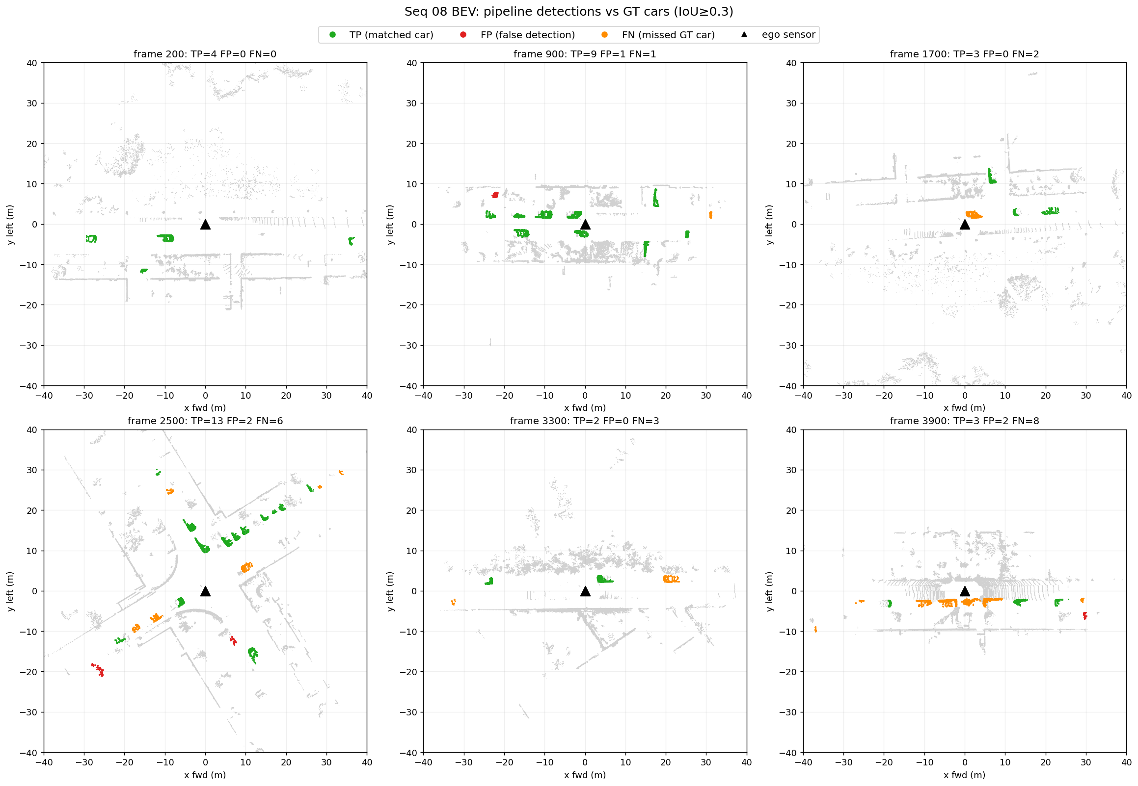
Figure 1 — Bird's-eye-view detections on held-out seq 08: true positives, false positives and missed cars across the full sequence.

3. The Recall Ceiling — a Characterized Hard Limit
Recall plateaued near 0.74 across all configurations. Rather than tune further, the limit was root-caused:
- Splitting, not merging. Per-instance analysis shows 31–37% of GT cars are split across multiple HDBSCAN clusters (66% split rate at 0–10 m — large, close cars split most, as HDBSCAN finds internal density gaps). Merging is negligible (0–0.5%).
- The filters are not the culprit. A first-rejecting-filter ablation shows min_volume and min_points kill 94% of the GT-overlapping rejected clusters — but these are sub-fragments of split cars whose dominant fragment usually survives, not independently missed cars.
- The ceiling matches theory. The recoverable ceiling from cleanly-clustered (single-cluster) GT cars is 63–68%, matching actual recall — the pipeline already recovers essentially every car that clusters cleanly.
Five mitigation strategies were implemented and evaluated; all were negative on held-out data:
Strategy | Outcome (held-out seq 08 unless noted)
BEV connected-component clustering | F1 0.779 vs 0.844 baseline — 2D projection merges overlapping objects
Larger min_cluster_size (MCS 20) | Wins on seq 00 (0.852) but drops to 0.801 on seq 08 — overfits
Post-clustering fragment merge | Absorbs walls/poles; net-negative F1
Distance-adaptive HDBSCAN | Ring-boundary artifacts; worse than global parameters
Temporal point accumulation | F1 collapses to 0.073 (motion smear destroys clusters)

Thesis conclusion: the ~0.74 recall ceiling is a fundamental limit of density-based clustering on voxelized LiDAR without learned object priors. The negative results are documented as findings, and effort was redirected to completion.

4. The Sim-to-Real Domain Gap and Dropping Synthetic Pretraining
Two studies answered the “too-perfect synthetic data” concern raised in supervision, and led to a cleaner production pipeline:
Pretraining ablation. Stage B was retrained from random initialization (no ShapeNet pretraining) under identical settings. Classifier-level performance is statistically tied with the pretrained variant (macro F1 0.9285 vs 0.9225, from-scratch marginally ahead). With 420k real training clusters, the synthetic prior is redundant.
Cross-domain matrix (advisor-requested). Every checkpoint was evaluated on both validation domains. The gap is total and symmetric: car F1 = 0.000 in every off-diagonal cell, and fine-tuning catastrophically forgets the synthetic domain. Notably, the synthetic-only model scores 0.807 accuracy on real data purely via the majority class while finding zero cars — the concrete argument for reporting macro F1 and confusion matrices rather than accuracy.
Train ↓ / Test → | Synthetic val (1,402) | Real val, seq 08 (130,394)
Synthetic only (Stage A) | 0.999 (0.999) | 0.447 (0.000)
Real only (from scratch) | 0.304 (0.000) | 0.929 (0.885)
Synthetic → real fine-tuned | 0.318 (0.000) | 0.923 (0.875)

Cell format: macro F1 (car F1).
Production switch. A full-scale re-evaluation showed the from-scratch checkpoint is neutral-to-better in the pipeline (seq 00 F1 0.844 → 0.859 at identical FP count; seq 08 F1 identical at 0.788). An earlier 100-frame spot-check that suggested a precision edge for the pretrained model was a small-sample effect. The production pipeline now trains the classifier on real SemanticKITTI data only; Stage A is retained as the thesis sim-to-real ablation.

5. Point-Cloud Completion

5.1 The “blob” failure and its resolution
A PCN trained on ShapeNet completes synthetic benchmarks well (val fine Chamfer 0.066) but produced shapeless blobs on every real LiDAR cluster. Three domain-adaptation attempts failed: LiDAR-noise augmentation on depth renders, virtual Velodyne HDL-64E ray-casting, and sparse-input training (32–256 points). Each converged in training but transferred nothing — establishing that the partiality pattern, not point density or noise, was the mismatch.
The resolution came in two parts:
- Training data fixed. A KITTI-like single-view partial generator (single viewpoint, ground-removed, voxelized 0.05 m — matching real pipeline output) trains a PCN that completes cleanly in-distribution: Chamfer 0.16 m, F-score@0.1 m 0.76 — recognizable cars, not blobs.
- The blobs were an inference bug. The inference path applied 3D PCA alignment and partial-centroid/partial-radius normalization never seen in training. This degrades every checkpoint ~3.5× even on in-distribution input. An ablation isolated the components: scale is solved by a calibrated ×1.137 factor; the partial's centroid is the dominant residual error; PCA is pure harm. A corrected path (canonical reorientation, calibrated scale, full-car-center estimation) de-blobs real seq-08 clusters into car-shaped completions.
A methodological by-product with thesis relevance: accumulated-LiDAR pseudo-ground-truth is invalid for evaluating completion. Accumulated scans of a static car are themselves one-sided, so Chamfer distance rewards under-completion — the raw partial scored best on every real example. This motivated the dedicated metric in §5.5.

5.2 Input gating: completion quality is gated by input cleanliness
An A/B study of heading estimators (PCA vs L-shape fitting) on real data was a wash — heading is not the quality lever. The same study revealed what is: every implausible completion traced back to a detectably bad input, namely fragments (< 2.7 m fitted length) and merged clusters (> 2.3 m fitted width) leaked by upstream clustering — consistent with the split/merge analysis of §3. An L-shape-fit input gate rejecting these raises plausible-car completion precision from 38% to 69% while retaining every plausible completion.

5.3 Architecture check: PoinTr vs PCN
To test whether a stronger decoder would help, a transformer completer (PoinTr, 8.9M parameters) was implemented and trained on identical data — a clean one-variable comparison. PoinTr holds a small, consistent synthetic edge (Chamfer 0.153 vs 0.161 m, better on 27/30 samples) but is equivalent on real data (16/26 vs 18/26 plausible completions; the differences are threshold noise). Under GT-free inference both models degrade identically (~0.5 m Chamfer), showing the shared bottlenecks — centroid estimation and the residual partiality gap — dwarf architecture. PCN is retained as production; decoder capacity was never the binding constraint.

5.4 Completion improves the bounding box
The first downstream-value result. Reference: amodal GT boxes built by accumulating 40 well-observed static cars over the full sequence (with viewpoint-coverage and motion guards). For 2,075 true-positive (frame, car) detection pairs on these cars, an oriented box was fitted to the raw partial and to its completion with the same fitter, and both compared against the amodal box. Statistics use per-car medians (frames of a parked car are autocorrelated) with Wilcoxon signed-rank tests, n = 39 cars.
Metric | Raw partial | Completed | Wilcoxon p | Verdict
BEV IoU | 0.707 | 0.747 | 0.0019 | better
|ΔW| (m) | 0.270 | 0.170 | 0.00015 | better
|ΔH| (m) | 0.255 | 0.131 | 1.6e-10 | better
Center error XZ (m) | 0.286 | 0.234 | 2.8e-05 | better
|ΔL| (m) | 0.447 | 0.456 | 0.65 | neutral
Yaw error (deg) | 3.5 | 3.0 | 0.74 | neutral

Completion helps most where the sensor saw least — BEV IoU on sparse inputs (< 100 points) improves 0.461 → 0.599. The width gain holds both for cars whose width the reference truly constrains and the rest, so it is not a reference artifact. Length is the exception: the network does not extend the unobserved far end (signed ΔL −0.49 raw vs −0.55 completed) — logged as the primary geometry target.
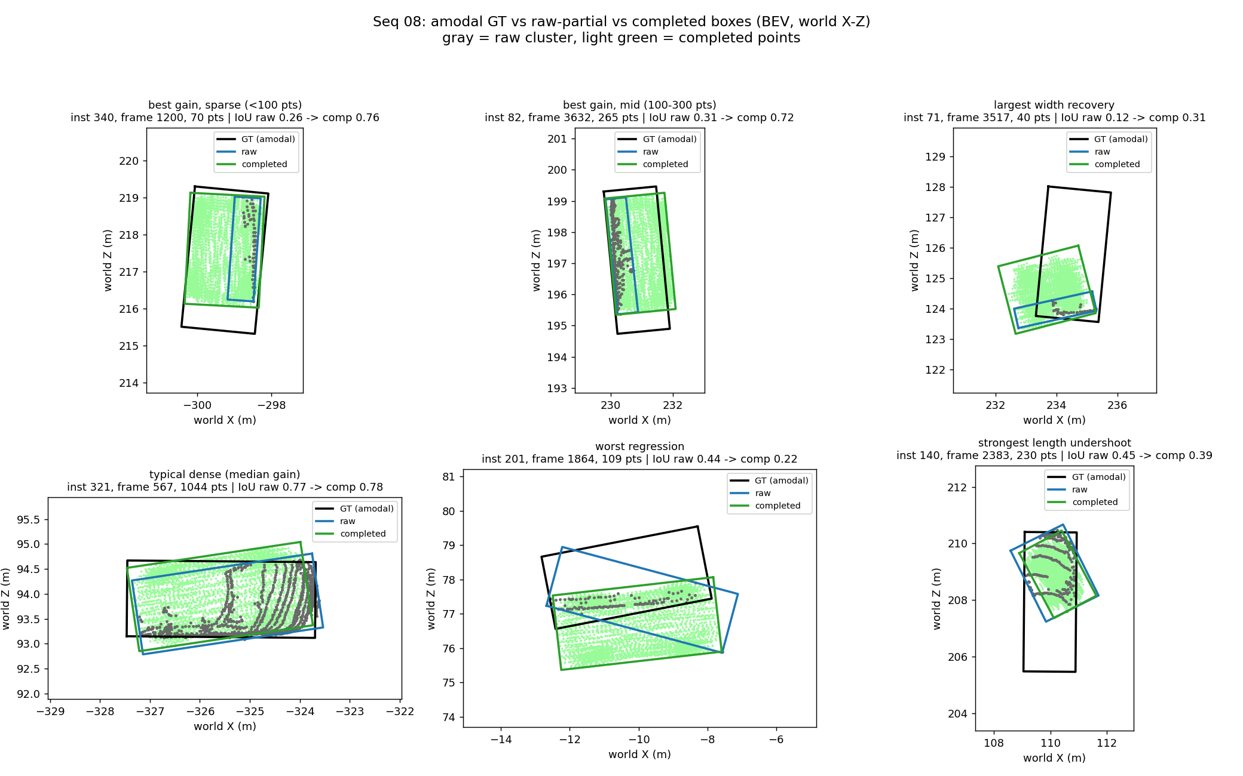
Figure 2 — Amodal GT box (black) vs raw-partial box (blue) vs completed box (green) on representative cars.

5.5 A valid real-data completion metric (donor-frame occluded surface)
With pseudo-GT Chamfer invalid (§5.1), completion had no real-data metric. The new metric uses the frames themselves as ground truth for each other: complete a static car from one frame's cluster, then score coverage of donor points — observations of the same car from other frames — that lie ≥ 0.15 m from every input point (i.e., surface the input frame never saw). Coverage@0.1 m and median distance are reported one-directionally (novel → method), with an out-of-amodal-box hallucination guard, against two baselines: the raw partial and a symmetry-mirrored partial. Same statistical design as §5.4 (2,092 TP pairs, 1,337 gate-passed, per-car medians, n = 39).
Method | Coverage@0.1 m | Median novel-dist (m) | Out-of-box rate
Raw partial | 0.000 | 0.518 | 0.000
Mirrored partial | 0.043 | 0.332 | 0.008
PCN completed | 0.304 | 0.161 | 0.000

All pairwise Wilcoxon p < 1e-6, and the metric passed a four-item pre-registered validation gate (raw ranks last at every threshold; ranking stable across τ ∈ {0.10, 0.15, 0.20}; acceptable per-car spread; hallucination ≤ mirror baseline). This is the first real-data evidence that the network reconstructs genuinely unseen structure: 30% of never-observed surface within 10 cm — 7× the symmetry-mirror baseline — with essentially zero hallucination. Completion is also input-size-robust (coverage 0.30–0.33 from < 100 to ≥ 300 input points) while mirroring collapses on sparse inputs. The weakest region is the car's far end (coverage 0.133), confirming §5.4's length under-completion and making it directly measurable.
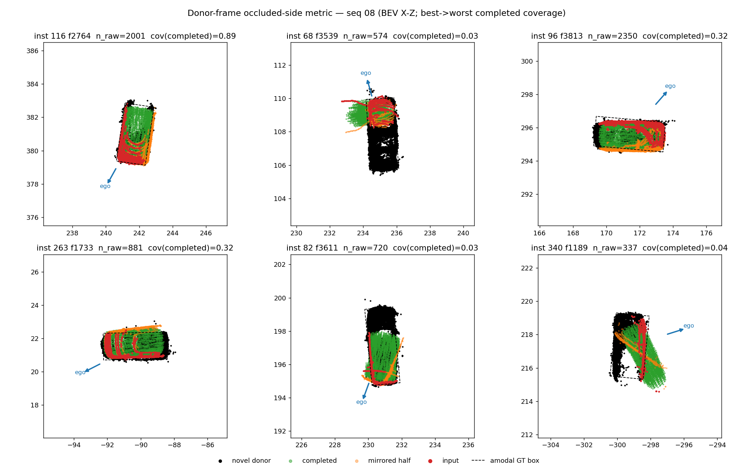
Figure 3 — Donor-frame occluded-surface metric: input partial, donor (never-observed) points, and method outputs with per-region coverage.

6. Current Status and Next Steps
The thesis narrative is in place: a classical detection pipeline characterized to its limits (§2–§3), a definitive sim-to-real study (§4), and a completion system with demonstrated, properly-measured downstream value (§5). Immediate next steps:
- Improve completion geometry (active). Two measurable targets from §5.4/§5.5: far-end under-completion (move far-end coverage from 0.133) and heading/center errors on diagonal or sparse views. Both are now measurable with the donor metric + box metrics.
- Optional hardening. Cross-validate the amodal GT boxes against KITTI raw 3D tracklets for seq 08, if that drive is annotated. The paired experimental design already tolerates reference noise.
- Thesis writing. Pipeline description, recall-ceiling analysis, and completion chapters; pipeline diagram.

Appendix — Section-to-Finding Traceability
Full experimental detail (hypotheses, commands, raw tables, deviations) is version-controlled in the repository under docs/findings.md. Mapping:
Report section | Findings
§2.1 Geometric filtering | #2, #4, #5
§2.2 Learned classification | #6, #7, #8, #9, #10, #11, #12, #18, #20
§2.3 Track-level filtering | #13, #14
§3 Recall ceiling | #21, #22, #23, #24
§4 Sim-to-real domain gap | #25, #30, #31
§5.1 Blob failure resolution | #15, #16, #17, #19, #26
§5.2 Input gating | #27
§5.3 PoinTr vs PCN | #28 (with 2026-07-06 correction)
§5.4 Box improvement | #29
§5.5 Donor-frame metric | #32

