LiDAR Point-Cloud Segmentation and Completion
Consolidated Results Report
Ngo Vi Viet Anh — Master's Thesis · Results through July 17, 2026
Revision 2 — extended with operating-point analysis, filter-validity and gate-cost reporting, recall-ceiling positioning, and the far-end remediation plan

Executive Summary
The project has produced a complete car-detection pipeline on SemanticKITTI (held-out full-sequence F1 0.79, precision 0.90) and, on top of it, a point-cloud completion system with the first quantitative real-data evidence that completion adds value. Three research questions were carried to a definitive answer: (1) the ~0.74 recall limit is a hard ceiling of density-based clustering — root-caused to HDBSCAN splitting and confirmed by five negative mitigation studies; (2) the sim-to-real domain gap for the classifier is total and symmetric, so synthetic pretraining was dropped from the production pipeline (kept as an ablation); (3) the long-standing “PCN produces blobs on real data” failure was an inference-normalization bug, not a domain-gap dead end — after the fix, completion measurably improves amodal bounding-box estimates (BEV IoU 0.707 → 0.747, p = 0.002) and reconstructs 30% of never-observed car surface within 10 cm, seven times a symmetry-mirror baseline, under a newly designed and validated occluded-surface metric.

1. System Overview
The pipeline processes KITTI-style LiDAR sequences frame by frame: preprocessing (z-filter, denoise, voxel downsample at 0.05 m), RANSAC ground removal, HDBSCAN clustering, ground-plane-relative geometric filtering, a learned binary car/not-car classifier (dual-branch PointNet), a centroid tracker with track-level filtering, and finally PCN-based point completion of accepted car tracks. Evaluation matches detections against SemanticKITTI instance labels; sequence 08 is the held-out evaluation sequence (never used for training or tuning).
Stage | Method | Status
Preprocessing | Z-filter, statistical denoise, 0.05 m voxel downsample | Stable
Ground removal | RANSAC plane fit (deterministic, seeded) | Stable
Clustering | HDBSCAN (dedicated package, ~7.7× faster than sklearn) | Stable; recall ceiling characterized
Geometric filter | Ground-plane-relative height, span, aspect, volume | Tuned via FP analysis
Classification | Dual-branch PointNet, binary car/not-car, real-data training | Production checkpoint (from-scratch Stage B)
Tracking | Centroid tracker + min-length and majority-vote filtering | Stable
Completion | PCN on KITTI-like partials + L-shape input gate | Working; active research focus

2. Building the Detection Pipeline

2.1 Geometric filtering
The initial geometric-only pipeline had high recall but very low precision (0.237 / 0.868 on seq 00). A per-cluster false-positive analysis against ground truth showed the FPs were dominated by vegetation (38%), buildings (33%) and trunks (13%). Three data-driven filter changes (ground-relative center height ≤ 1.5 m, height span ≤ 1.8 m, aspect ratio ≤ 6.0) removed 85% of false positives at a 19% recall cost, reaching precision 0.654. Building and trunk FPs were nearly eliminated; the residual FPs are compact vegetation clusters that geometrically resemble vehicles — separable only by shape, which motivated the learned classifier. A distance-binned analysis confirmed 95% of true positives lie within 40 m and that point density drops ~5× from near to far range.
Threshold validity across vehicle sizes. The thresholds were derived from car statistics and could in principle suppress larger vehicles. Two facts bound this risk. First, the evaluated SemanticKITTI car class explicitly includes SUVs and vans with a continuous body, and the first-rejecting-filter ablation (§3) shows the shape thresholds are not what limits recall on this class: among filter-rejected clusters overlapping a GT car, height-span accounts for 1.0% of rejections, center-height 0.2%, and aspect ratio 2.8% — 94% of rejections come from the minimum-volume and minimum-point filters acting on sub-fragments of split cars (§3), not from the shape thresholds. Second, trucks and buses are excluded from both the detection target and the evaluation by the binary thesis scope, so the thresholds cannot silently depress the reported recall through other vehicle classes. A multi-class extension would require re-deriving the span/aspect thresholds per class; the thesis states this as an explicit scope limitation.

2.2 Learned classification
The classifier is a dual-branch PointNet (point branch + bounding-box metric features), deliberately simplified from the original architecture (256-d bottleneck, no T-Nets). It was developed through several decisive experiments:
- Synthetic-only training fails completely on real data. A Stage A classifier trained on ShapeNet renders reached val macro F1 0.999 on synthetic data but classified every real LiDAR cluster as “unknown” — 0 true positives in the pipeline. This established the domain gap early and motivated real-data fine-tuning.
- Stage B: real-data training at scale. A mining tool extracted 550k pipeline clusters with GT purity ≥ 0.75 from SemanticKITTI (train: seqs 00–07, 09–10; val: seq 08). Fine-tuning on this data lifted pipeline precision from 0.654 to 0.969 with only a 2-point recall cost. A decision-threshold sweep settled on 0.50 (best F1).
- Binary reformulation. The original 4-class design (car/bus/motorcycle/unknown) suffered from extreme class imbalance (28 bus training samples) and produced spurious motorcycle detections. The task was narrowed to binary car/not-car, matching the thesis scope; Stage B validation macro F1 = 0.93 (car F1 0.885).
- Evaluation integrity. Seq 00 — the original headline sequence — was found to be inside the Stage B training set. All headline evaluation moved to held-out seq 08; seq-00 numbers are retained as a deterministic reference but marked as leaked.

2.3 Track-level filtering
A minimum-track-length (≥ 2 frames) plus majority-class-vote filter over the centroid tracker was hypothesized to improve precision. It did (full seq 00: 5,669 → 3,532 FPs), but the larger effect was unexpected: majority voting recovers detections that flicker between “car” and “unknown” across frames, adding 1,798 true positives. Net effect at full-sequence scale: F1 0.762 → 0.801 (+0.048 precision, +0.032 recall).

2.4 Headline detection metrics
Current production configuration (real-data-only classifier, track filtering, deterministic RANSAC):
Evaluation | Precision | Recall | F1 | Mean IoU
Seq 00, 100 frames (leaked; deterministic reference) | 0.984 | 0.761 | 0.859 | 0.942
Seq 08, full 4,071 frames (held-out) | 0.903 | 0.699 | 0.788 | 0.895

The system is precision-saturated (~1 false positive per frame, flat across the sequence) and recall-limited. Per-frame recall is anti-correlated with GT-car density — crowded scenes split and occlude more.
Choice of operating point. The 0.50 decision threshold maximizes F1, but the choice is less consequential than it appears, because recall is capped upstream: cars missed by the pipeline are overwhelmingly lost at the clustering stage (§3) and never reach the classifier, so no threshold setting can recover them. The threshold sweep makes this concrete — lowering the threshold to 0.30 does not raise recall (0.695, vs 0.711 at 0.50) while false positives increase:
Threshold | Precision | Recall | F1
0.30 | 0.955 | 0.695 | 0.805
0.50 (chosen) | 0.957 | 0.711 | 0.816
0.80 | 0.989 | 0.638 | 0.776
0.95 | 0.999 | 0.543 | 0.704

The reachable precision–recall curve is truncated at R ≈ 0.71, and the F1-optimal point is simultaneously the recall-maximal point — a recall-weighted objective would select the same operating point. Genuinely higher recall requires fixing the clustering stage, not the threshold (§3). The intended application is offline object extraction and map curation rather than an online driving loop; for a safety-critical online deployment the correct move would be architectural (learned detection with object priors), not a threshold shift, and the thesis states this explicitly.
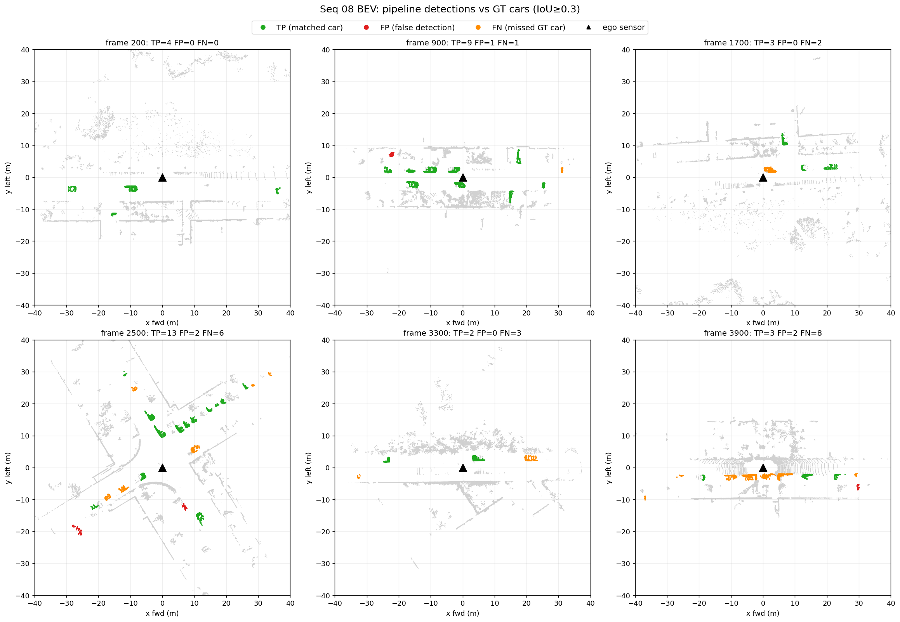
Figure 1 — Bird's-eye-view detections on held-out seq 08: true positives, false positives and missed cars across the full sequence.

3. The Recall Ceiling — a Characterized Hard Limit
Recall plateaued near 0.74 across all configurations. Rather than tune further, the limit was root-caused:
- Splitting, not merging. Per-instance analysis shows 31–37% of GT cars are split across multiple HDBSCAN clusters (66% split rate at 0–10 m — large, close cars split most, as HDBSCAN finds internal density gaps). Merging is negligible (0–0.5%).
- The filters are not the culprit. A first-rejecting-filter ablation shows min_volume and min_points kill 94% of the GT-overlapping rejected clusters — but these are sub-fragments of split cars whose dominant fragment usually survives, not independently missed cars.
- The ceiling matches theory. The recoverable ceiling from cleanly-clustered (single-cluster) GT cars is 63–68%, matching actual recall — the pipeline already recovers essentially every car that clusters cleanly.
Five mitigation strategies were implemented and evaluated; all were negative on held-out data:
Strategy | Outcome (held-out seq 08 unless noted)
BEV connected-component clustering | F1 0.779 vs 0.844 baseline — 2D projection merges overlapping objects
Larger min_cluster_size (MCS 20) | Wins on seq 00 (0.852) but drops to 0.801 on seq 08 — overfits
Post-clustering fragment merge | Absorbs walls/poles; net-negative F1
Distance-adaptive HDBSCAN | Ring-boundary artifacts; worse than global parameters
Temporal point accumulation | F1 collapses to 0.073 (motion smear destroys clusters)

Thesis conclusion: the ~0.74 recall ceiling is not a tuning limit but a structural property of the chosen architecture. Density-based clustering makes hard, local decisions with no notion of objectness, so a car with internal density gaps has no mechanism by which its fragments can be re-assembled; end-to-end voxel/point detectors avoid this failure mode by learning object-level priors, at the cost of requiring 3D bounding-box supervision. The thesis therefore does not present the classical pipeline as recall-competitive with end-to-end detectors. Its positioning is (a) a supervision-light alternative — the entire pipeline trains from semantic labels only, with no 3D box annotation; and (b) a quantified boundary of where geometric methods stop and learning must take over: the classifier (§2.2) and the completion stage (§5) are precisely the two places where learning was inserted, each justified by a measured failure of the geometry-only approach. The five negative results above are the evidence that the boundary is real and not an artifact of insufficient tuning.

4. The Sim-to-Real Domain Gap and Dropping Synthetic Pretraining
Two studies answered the “too-perfect synthetic data” concern raised in supervision, and led to a cleaner production pipeline:
Pretraining ablation. Stage B was retrained from random initialization (no ShapeNet pretraining) under identical settings. Classifier-level performance is statistically tied with the pretrained variant (macro F1 0.9285 vs 0.9225, from-scratch marginally ahead). With 420k real training clusters, the synthetic prior is redundant.
Cross-domain matrix (advisor-requested). Every checkpoint was evaluated on both validation domains. The gap is total and symmetric: car F1 = 0.000 in every off-diagonal cell, and fine-tuning catastrophically forgets the synthetic domain. Notably, the synthetic-only model scores 0.807 accuracy on real data purely via the majority class while finding zero cars — the concrete argument for reporting macro F1 and confusion matrices rather than accuracy.
Train ↓ / Test → | Synthetic val (1,402) | Real val, seq 08 (130,394)
Synthetic only (Stage A) | 0.999 (0.999) | 0.447 (0.000)
Real only (from scratch) | 0.304 (0.000) | 0.929 (0.885)
Synthetic → real fine-tuned | 0.318 (0.000) | 0.923 (0.875)

Cell format: macro F1 (car F1).
Production switch. A full-scale re-evaluation showed the from-scratch checkpoint is neutral-to-better in the pipeline (seq 00 F1 0.844 → 0.859 at identical FP count; seq 08 F1 identical at 0.788). An earlier 100-frame spot-check that suggested a precision edge for the pretrained model was a small-sample effect. The production pipeline now trains the classifier on real SemanticKITTI data only; Stage A is retained as the thesis sim-to-real ablation.
Why synthetic data was set aside — two separate threads, decided on separate evidence. For the classifier, no domain-adaptation campaign was run or needed: with 550k real labelled clusters available from mining, the controlled ablation (scratch ties pretrained) and the cross-domain matrix (zero transfer in either direction, catastrophic forgetting) establish directly that the synthetic prior contributes nothing that survives real-data training — further investment in synthetic realism had no measurable upside. The three domain-adaptation attempts (LiDAR-noise augmentation, virtual Velodyne ray-casting, sparse-input training) belong to the completion thread (§5.1), where no real ground truth exists and synthetic training is unavoidable. They were chosen to span the physically distinct axes of the sim-to-real mismatch — noise statistics, sensor scan geometry, and point density — and each converged on its simulated domain while transferring nothing. The factor all three left unmodelled, the occlusion/partiality pattern of real post-pipeline clusters, was identified later; when it was reproduced (the KITTI-like partial generator, §5.1), synthetic training did transfer. Synthetic data was therefore not abandoned for completion — it was fixed; it was abandoned only for classification, where real labels are abundant.

5. Point-Cloud Completion

5.1 The “blob” failure and its resolution
A PCN trained on ShapeNet completes synthetic benchmarks well (val fine Chamfer 0.066) but produced shapeless blobs on every real LiDAR cluster. Three domain-adaptation attempts failed: LiDAR-noise augmentation on depth renders, virtual Velodyne HDL-64E ray-casting, and sparse-input training (32–256 points). Each converged in training but transferred nothing — establishing that the partiality pattern, not point density or noise, was the mismatch.
The resolution came in two parts:
- Training data fixed. A KITTI-like single-view partial generator (single viewpoint, ground-removed, voxelized 0.05 m — matching real pipeline output) trains a PCN that completes cleanly in-distribution: Chamfer 0.16 m, F-score@0.1 m 0.76 — recognizable cars, not blobs.
- The blobs were an inference bug. The inference path applied 3D PCA alignment and partial-centroid/partial-radius normalization never seen in training. This degrades every checkpoint ~3.5× even on in-distribution input. An ablation isolated the components: scale is solved by a calibrated ×1.137 factor; the partial's centroid is the dominant residual error; PCA is pure harm. A corrected path (canonical reorientation, calibrated scale, full-car-center estimation) de-blobs real seq-08 clusters into car-shaped completions.
A methodological by-product with thesis relevance: accumulated-LiDAR pseudo-ground-truth is invalid for evaluating completion. Accumulated scans of a static car are themselves one-sided, so Chamfer distance rewards under-completion — the raw partial scored best on every real example. This motivated the dedicated metric in §5.5.

5.2 Input gating: completion quality is gated by input cleanliness
An A/B study of heading estimators (PCA vs L-shape fitting) on real data was a wash — heading is not the quality lever. The same study revealed what is: every implausible completion traced back to a detectably bad input, namely fragments (< 2.7 m fitted length) and merged clusters (> 2.3 m fitted width) leaked by upstream clustering — consistent with the split/merge analysis of §3. An L-shape-fit input gate rejecting these raises plausible-car completion precision from 38% to 69% while retaining every plausible completion.
Cost of the gate, stated explicitly. Across the 2,075 true-positive detection pairs of §5.4 the gate rejects 714 fragments and 22 merges, so completion is attempted on 64.5% of detected cars (63.9% on the §5.5 pairs — consistent with the ~35% split rate measured independently in §3). Two clarifications follow. The gate does not reduce detection recall: a gated track keeps its raw points and remains a detection; only the completion step is skipped, so the detection metrics of §2.4 are unaffected. And the completion results of §5.4–§5.5 consequently describe the gated subset — a selection bias that is acknowledged wherever those results are quoted. The subset is not simply the easy cases: within it, completion's largest gains are on the sparsest inputs (< 100 points, §5.4). Recovering the rejected 35% is a fragment re-assembly (clustering) problem whose candidate solutions were evaluated and found negative in §3, not a completion problem.

5.3 Architecture check: PoinTr vs PCN
To test whether a stronger decoder would help, a transformer completer (PoinTr, 8.9M parameters) was implemented and trained on identical data — a clean one-variable comparison. PoinTr holds a small, consistent synthetic edge (Chamfer 0.153 vs 0.161 m, better on 27/30 samples) but is equivalent on real data (16/26 vs 18/26 plausible completions; the differences are threshold noise). Under GT-free inference both models degrade identically (~0.5 m Chamfer), showing the shared bottlenecks — centroid estimation and the residual partiality gap — dwarf architecture. PCN is retained as production; decoder capacity was never the binding constraint.

5.4 Completion improves the bounding box
The first downstream-value result. Reference: amodal GT boxes built by accumulating 40 well-observed static cars over the full sequence (with viewpoint-coverage and motion guards). For 2,075 true-positive (frame, car) detection pairs on these cars, an oriented box was fitted to the raw partial and to its completion with the same fitter, and both compared against the amodal box. Statistics use per-car medians (frames of a parked car are autocorrelated) with Wilcoxon signed-rank tests, n = 39 cars.
Metric | Raw partial | Completed | Wilcoxon p | Verdict
BEV IoU | 0.707 | 0.747 | 0.0019 | better
|ΔW| (m) | 0.270 | 0.170 | 0.00015 | better
|ΔH| (m) | 0.255 | 0.131 | 1.6e-10 | better
Center error XZ (m) | 0.286 | 0.234 | 2.8e-05 | better
|ΔL| (m) | 0.447 | 0.456 | 0.65 | neutral
Yaw error (deg) | 3.5 | 3.0 | 0.74 | neutral

Completion helps most where the sensor saw least — BEV IoU on sparse inputs (< 100 points) improves 0.461 → 0.599. The width gain holds both for cars whose width the reference truly constrains and the rest, so it is not a reference artifact.
Length is the exception and a known regression. The network does not extend the unobserved far end of the car, and the signed length error worsens slightly under completion: median ΔL −0.485 m (raw) vs −0.545 m (completed) on normal-length cars (n = 32); the absolute error is statistically neutral (p = 0.65). The bias is systematically conservative — the box is too short at the far, unobserved end, never too long — which is precisely the wrong direction for a downstream consumer that must trust the far boundary (path planning, collision checking). This is treated as the top open problem of the completion stage, not a footnote: it became directly measurable with the far-end coverage of §5.5 (0.133), and the concrete remediation plan — inference geometry and loss design, in that order — is specified in §6.
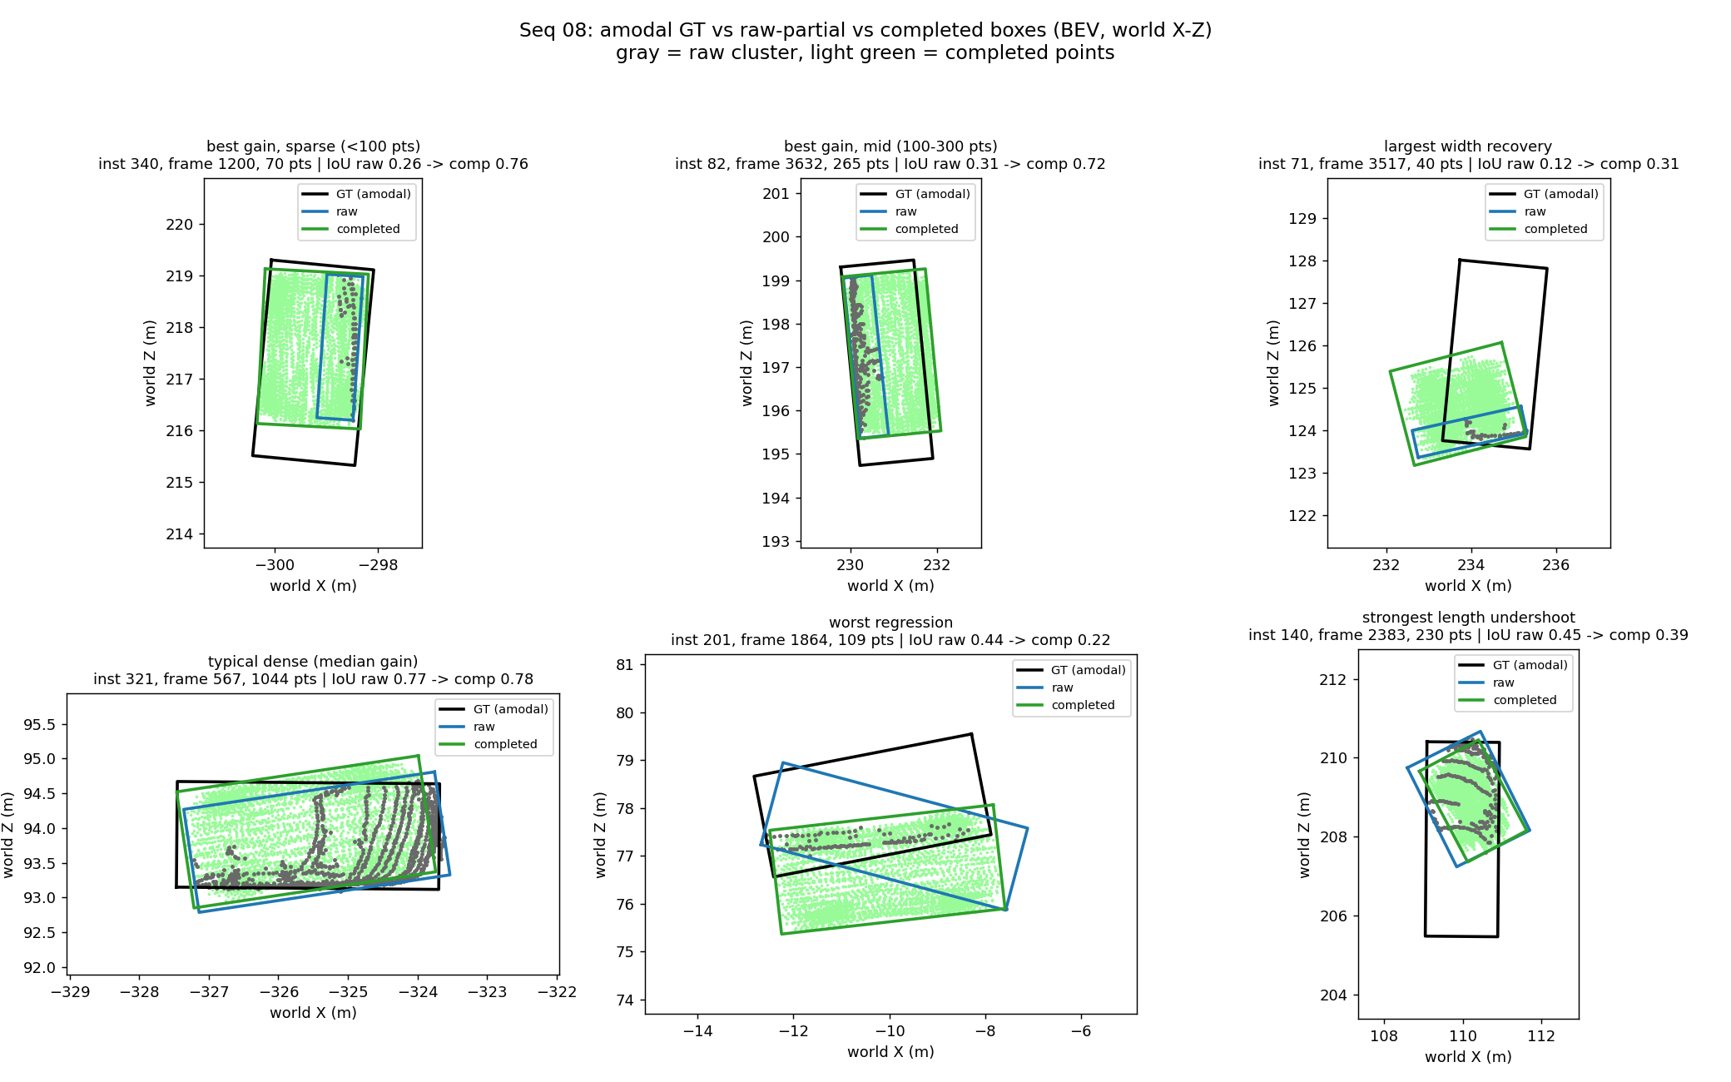
Figure 2 — Amodal GT box (black) vs raw-partial box (blue) vs completed box (green) on representative cars.

5.5 A valid real-data completion metric (donor-frame occluded surface)
With pseudo-GT Chamfer invalid (§5.1), completion had no real-data metric. The new metric uses the frames themselves as ground truth for each other: complete a static car from one frame's cluster, then score coverage of donor points — observations of the same car from other frames — that lie ≥ 0.15 m from every input point (i.e., surface the input frame never saw). Coverage@0.1 m and median distance are reported one-directionally (novel → method), with an out-of-amodal-box hallucination guard, against two baselines: the raw partial and a symmetry-mirrored partial. Same statistical design as §5.4 (2,092 TP pairs, 1,337 gate-passed, per-car medians, n = 39).
Method | Coverage@0.1 m | Median novel-dist (m) | Out-of-box rate
Raw partial | 0.000 | 0.518 | 0.000
Mirrored partial | 0.043 | 0.332 | 0.008
PCN completed | 0.304 | 0.161 | 0.000

All pairwise Wilcoxon p < 1e-6, and the metric passed a four-item pre-registered validation gate (raw ranks last at every threshold; ranking stable across τ ∈ {0.10, 0.15, 0.20}; acceptable per-car spread; hallucination ≤ mirror baseline). This is the first real-data evidence that the network reconstructs genuinely unseen structure: 30% of never-observed surface within 10 cm — 7× the symmetry-mirror baseline — with essentially zero hallucination. Completion is also input-size-robust (coverage 0.30–0.33 from < 100 to ≥ 300 input points) while mirroring collapses on sparse inputs. The weakest region is the car's far end (coverage 0.133), confirming §5.4's length under-completion and making it directly measurable.
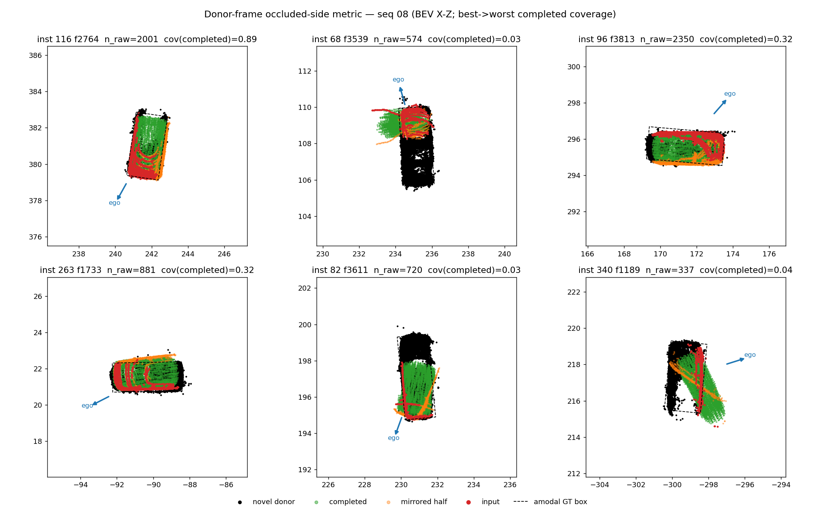
Figure 3 — Donor-frame occluded-surface metric: input partial, donor (never-observed) points, and method outputs with per-region coverage.

6. Current Status and Next Steps
The thesis narrative is in place: a classical detection pipeline characterized to its limits (§2–§3), a definitive sim-to-real study (§4), and a completion system with demonstrated, properly-measured downstream value (§5). Immediate next steps:

6.1 Plan for the far-end length undershoot
The remediation plan is constrained by two established results: decoder capacity is not the lever (the controlled PoinTr comparison, §5.3 — a stronger architecture gains nothing on real data), and full-car-center estimation is the dominant residual error of the inference path (isolated by ablation, §5.1). The interventions are therefore ordered inference geometry first, loss second, architecture not at all; every step is scored on the pre-registered metrics — donor far-end coverage (baseline 0.133), signed ΔL (baseline −0.545 m), and the full §5.4/§5.5 suites with per-car medians and Wilcoxon tests.
- Step 1 — inference geometry (no retraining). Part of the undershoot is a placement error, not a shape error: the current full-car-center estimate corrects the partial's centroid laterally (ego-direction width prior) but not longitudinally, so the predicted car sits biased toward the observed end. Fix: anchor the box at the observed near corner from the L-shape fit and place the center longitudinally with a car-length prior (the analogue of the existing width prior), plus a symmetry-derived center estimate (the mirror plane that best aligns the partial to itself yields both heading and lateral center). Cheap, immediately measurable.
- Step 2 — loss modification, retrained on synthetic data (true GT available). Symmetric Chamfer distance penalizes hallucination and omission equally, so on one-sided partials its optimum is conservative — exactly the observed behavior of truncating the unobserved far end. Fix: a visibility-weighted asymmetric Chamfer — up-weight the GT→prediction direction for GT points distant from the input partial (occluded-region weighting), making omission of unseen structure cost more than conservative truncation. Retrain PCN on the KITTI-like data with this loss; accept only if the synthetic gain transfers to the donor far-end coverage.
- Step 3 — contingency: real-data fine-tuning. If the synthetic-side gain does not transfer, masked-Chamfer fine-tuning on real partials — previously blocked by the absence of a valid real-data metric, now measurable by §5.5.

6.2 Validity of the amodal ground truth
The amodal GT boxes are custom-built from accumulated observations and could in principle carry systemic bias. Cross-validation against the official KITTI raw 3D tracklets is not possible: odometry seq 08 corresponds to raw drive 2011_09_30_drive_0028, and KITTI provides no tracklet annotations for that drive (verified against the official download server; none of the odometry-source residential drives are tracklet-annotated). The absence of official 3D box ground truth on these sequences is exactly why the accumulation-derived pseudo-GT was built. Its validity therefore rests on three documented arguments: (a) the paired experimental design — every raw-vs-completed comparison scores both arms against the same reference, so reference noise attenuates the contrast but cannot manufacture a winner; (b) construction guards — cars enter the reference set only with sufficient viewpoint coverage and verified zero motion; (c) an external sanity check — the resulting box dimensions (median L 4.14 / W 1.75 / H 1.47 m over 40 cars) match published passenger-car statistics. Absolute metric levels (e.g., the IoU and coverage values themselves) inherit reference uncertainty and are presented as such in the thesis; the comparative conclusions do not.

6.3 Thesis writing
Pipeline description, recall-ceiling analysis, sim-to-real study, and completion chapters; pipeline diagram.

Appendix — Section-to-Finding Traceability
Full experimental detail (hypotheses, commands, raw tables, deviations) is version-controlled in the repository under docs/findings.md. Mapping:
Report section | Findings
§2.1 Geometric filtering | #2, #4, #5
§2.2 Learned classification | #6, #7, #8, #9, #10, #11, #12, #18, #20
§2.3 Track-level filtering | #13, #14
§3 Recall ceiling | #21, #22, #23, #24
§4 Sim-to-real domain gap | #25, #30, #31
§5.1 Blob failure resolution | #15, #16, #17, #19, #26
§5.2 Input gating | #27
§5.3 PoinTr vs PCN | #28 (with 2026-07-06 correction)
§5.4 Box improvement | #29
§5.5 Donor-frame metric | #32

