LiDAR Point-Cloud Segmentation and Completion
Results Overview
Ngo Vi Viet Anh — Master's Thesis · Results through July 23, 2026

Summary
The project has a complete car-detection pipeline on SemanticKITTI (held-out full-sequence F1 0.81, precision 0.90) and, on top of it, a point-cloud completion system with the first quantitative real-data evidence that completion adds value. Three questions were carried to a definitive answer: (1) recall (~0.73) is capped by HDBSCAN splitting cars into fragments — five post-hoc repair strategies all failed, but coarsening the clustering resolution (now in production) recovers a meaningful share of the loss, lifting recall 0.70 → 0.73, so the ceiling we first reported as hard was partly a resolution artifact; (2) the sim-to-real gap for the classifier is total and symmetric, so synthetic pretraining was dropped from production (kept as an ablation); (3) the long-standing “PCN produces blobs on real data” failure was an inference-normalization bug, not a domain-gap dead end — after the fix, completion measurably improves bounding-box estimates (BEV IoU 0.718 → 0.739) and reconstructs 30% of never-observed car surface within 10 cm, 6× a symmetry-mirror baseline, under a newly designed and validated metric.

1. The Pipeline
Per frame: preprocessing (z-filter, denoise, 0.05 m voxel downsample) → RANSAC ground removal → HDBSCAN clustering → geometric filtering → binary car/not-car classifier (dual-branch PointNet) → centroid tracking with track-level filtering → PCN completion of accepted car tracks. Seq 08 is held out from all training and tuning and is the honest evaluation sequence.

Inference time
Timing was measured on an AMD Ryzen 7 7800X3D CPU and an NVIDIA RTX 3070 Ti GPU over the full held-out seq 08 (all 4,071 frames; the first 3 excluded as warm-up). As first measured, the detection pipeline took 921 ms per frame (≈ 1.1 frames/s against the sensor's 10 Hz), dominated by two classical CPU stages — HDBSCAN clustering and RANSAC ground removal. A targeted optimization pass — batching the per-cluster classifier calls into one GPU forward pass, parallelising HDBSCAN's core-distance computation, cutting RANSAC iterations 1,000 → 300, and clustering on a 0.10 m re-voxelisation of the object cloud — brought this down to 623 ms per frame (≈ 1.60 frames/s), a 32% reduction. Detection quality was not traded for speed: on the full sequence it improved slightly (F1 0.788 → 0.808, recall 0.699 → 0.730), because the coarser clustering also repairs some of the car-splitting that limits recall (§3). The detection and completion results in §2–§5 reflect this optimized operating point. Runtime still varies with scene density: averaged over ~450-frame segments of the drive it ranges from ≈ 592 to ≈ 697 ms, with clustering the dominant variable cost. Completion cost is incurred per object rather than per frame: ≈ 13 ms per completed car (13,909 completions measured), and ≈ 1.6 ms when the input gate rejects a cluster.
Stage | Before (ms/frame) | After (ms/frame) | Share (after)
Load + preprocessing (z-filter, denoise, voxel) | 136 | 127 | 20%
RANSAC ground removal | 163 | 56 | 9%
HDBSCAN clustering | 502 | 370 | 59%
Geometric filter | 46 | 36 | 6%
Classifier (≈ 45 clusters/frame; GPU) | 74 | 34 | 5%
Centroid tracker | 0.3 | 0.3 | < 0.1%
Total detection | 921 | 623 | 100%
PCN completion (per completed car; GPU) | +19 per car | +13 per car | —
After optimization, HDBSCAN clustering and RANSAC ground removal are still the two dominant costs (68% of the per-frame total together), while the learned components stay cheap: the classifier costs 34 ms per frame and PCN completion 13 ms per car, both on GPU. The remaining distance to real-time is a property of the method on this data, not of the implementation. The post-ground object cloud is already sparse — re-voxelising it from 0.05 m to 0.10 m removes only ~18% of its points — and Python's HDBSCAN retains a ~185 ms floor here in the mutual-reachability MST that the parallel core-distance step cannot touch. Falling below ~400 ms would require GPU clustering (cuML) or a C++ DBSCAN; both are deferred, as real-time operation is out of scope for this thesis. These figures characterise the method rather than a production implementation.

2. Detection Results

Test scenario and evaluation protocol
All detection metrics are aggregated over entire driving sequences, covering many frames and many distinct vehicles. Two test scenarios are used:
- Seq 08, full sequence (headline). 4,071 frames (one frame = one full 360° LiDAR scan, ~120k points), 393 distinct cars, ≈ 34,000 evaluated car appearances. Held out from all training and tuning.
- Seq 00, first 100 frames (deterministic reference; leaked, see below). 41 distinct cars, ≈ 1,600 evaluated car appearances.
Each frame is evaluated independently. Ground truth is every SemanticKITTI car instance with at least 10 points surviving preprocessing; the pipeline’s detections are matched one-to-one to these instances by point-level IoU (greedy, highest IoU first, match threshold 0.3). A matched pair counts as a true positive, an unmatched detection as a false positive, an unmatched ground-truth car as a false negative. Precision, recall and F1 are computed from these counts summed over the whole sequence (seq 08: TP = 25,478, FP = 2,676, FN = 9,444); Mean IoU is averaged over the matched pairs. A car visible in N frames is evaluated N times, so the table below measures per-frame detection performance across the full sequence, not per-vehicle success.
The completion experiments (§5.4–§5.5) deliberately use a different unit: 40 static cars from seq 08, observed in 2,262 true-positive detections. There, per-detection measurements are first reduced to one median per car, and all statistics compare the 40 per-car values — each physical car counts exactly once, no matter how often it was seen.
The pipeline was built up in four measured steps:
- Geometric filter tuning. A per-cluster false-positive analysis (vegetation 38%, buildings 33%, trunks 13%) drove three threshold changes: precision 0.237 → 0.654 at −19% recall. The residual FPs are vegetation clusters that geometrically resemble cars — separable only by shape, which motivated the classifier. The shape thresholds do not limit car recall (they account for ~4% of rejections that touch a GT car; the rest are fragments of split cars, §3).
- Learned classifier. Training on synthetic ShapeNet alone fails completely on real data (0 true positives — the first sign of the domain gap in §4). Mining 550k real clusters from SemanticKITTI with GT purity filtering and training on those lifted pipeline precision 0.654 → 0.969 at a 2-point recall cost. The task was narrowed to binary car/not-car after the 4-class version produced spurious motorcycle detections from 28 bus training samples.
- Evaluation integrity. Seq 00 — the original headline sequence — turned out to be inside the classifier's training set. All headline evaluation moved to held-out seq 08; seq-00 numbers are kept only as a deterministic reference, marked as leaked.
- Track-level filtering. A minimum-track-length + majority-vote filter cuts transient FPs and — unexpectedly — recovers detections that flicker between “car” and “unknown” across frames. Full-sequence F1 0.762 → 0.801. (This ablation was measured at the pre-optimization operating point; it isolates the filter’s contribution — the current endpoint is 0.808 in §2.)
Evaluation | Precision | Recall | F1 | Mean IoU
Seq 00, 100 frames (leaked; reference) | 0.967 | 0.777 | 0.862 | 0.962
Seq 08, full 4,071 frames (held-out) | 0.905 | 0.730 | 0.808 | 0.912

The system is precision-saturated (~1 FP/frame) and recall-limited. The classifier threshold is not a lever on recall: cars are lost at clustering before the classifier ever sees them (lowering the threshold to 0.30 yields no recall gain), so the F1-optimal operating point is also the recall-maximal one.
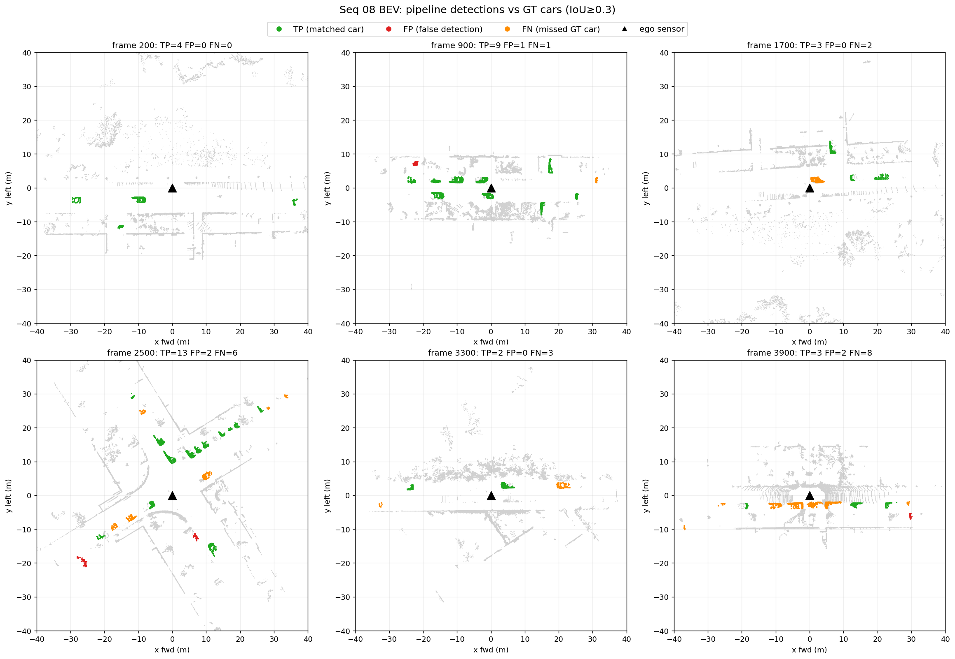
Figure 1 — Bird's-eye-view detections on held-out seq 08.

3. The Recall Ceiling
Recall is limited by clustering, not by the classifier: cars are lost when HDBSCAN splits them into fragments that then fail the volume/point-count filters (lowering the classifier threshold recovers nothing, §2). At the original 0.05 m resolution this splits 31–37% of GT cars — 66% at close range, where large cars have internal density gaps — and held-out recall sat at 0.70. The split rate is essentially the whole story: the fraction of cars that cluster into a single filter-passing piece (~62%) tracks actual recall, so the pipeline already finds almost every car that clusters cleanly. Two kinds of fix were tried. Five post-hoc strategies — reassembling or re-clustering fragments after they form — were all negative on held-out data:
Strategy | Outcome
BEV connected-component clustering | F1 0.779 vs 0.844 — 2D projection merges overlapping objects
Larger min_cluster_size | Wins on seq 00, loses on seq 08 — overfits
Post-clustering fragment merge | Absorbs walls/poles; net negative
Distance-adaptive HDBSCAN | Ring-boundary artifacts; worse than global
Temporal point accumulation | F1 collapses to 0.073
What did work was changing the clustering resolution itself. Coarsening the object cloud to a 0.10 m voxel grid before HDBSCAN (adopted for speed in the runtime optimization, §1) prevents many splits from forming in the first place: on seq 08 the split rate drops 37.7% → 29.9% with zero new merges, the cleanly-clustered fraction rises 62% → 70%, and full-sequence recall improves 0.699 → 0.730 (+1,655 true positives, precision essentially unchanged). This is now the production default and the operating point reported in §2. The earlier “~0.74 hard ceiling” was therefore overstated — a meaningful share of the loss was a resolution artifact, and coarsening recovered it.

A structural limit remains, but it is smaller than first claimed. Density-based clustering makes local decisions with no notion of objectness, so the fragments it still produces cannot be reassembled downstream, and coarsening further would begin merging adjacent cars — recall cannot be pushed to an end-to-end detector’s level this way. That residual gap is the honest framing for the thesis: the approach needs no 3D box labels (semantic labels only), it recovers what clustering resolution allows, and it pinpoints exactly where a learned object prior must take over — which is where the classifier (§2) and completion (§5) enter.

4. Sim-to-Real: Dropping Synthetic Pretraining
Two studies answered the “too-perfect synthetic data” concern. A controlled ablation (retrain from random init) showed the ShapeNet prior contributes nothing once 420k real clusters are available (macro F1 0.9285 scratch vs 0.9225 pretrained). The cross-domain matrix shows why — zero transfer in either direction, and fine-tuning completely forgets the synthetic domain:
Train ↓ / Test → | Synthetic val | Real val (seq 08)
Synthetic only (Stage A) | 0.999 (0.999) | 0.447 (0.000)
Real only (from scratch) | 0.304 (0.000) | 0.929 (0.885)
Synthetic → real fine-tuned | 0.318 (0.000) | 0.923 (0.875)

Cell format: macro F1 (car F1). Note the synthetic-only model scores 0.807 accuracy on real data while finding zero cars — why we report macro F1 and confusion matrices, not accuracy.
After a full-scale re-check (scratch is neutral-to-better: seq 00 F1 0.844 → 0.859, seq 08 identical), the production classifier now trains on real data only. Stage A is kept as the thesis sim-to-real ablation. Synthetic data was only dropped for classification, where real labels are abundant — for completion (§5), where no real ground truth exists, it remains the training data and works once the right partiality pattern is simulated.

5. Point-Cloud Completion

5.1 The “blob” failure, solved
PCN trained on ShapeNet produced shapeless blobs on every real cluster, and three domain-adaptation attempts (noise augmentation, virtual Velodyne ray-casting, sparse-input training) failed — each modelled one mismatch axis (noise, scan geometry, density) but not the real one: the occlusion/partiality pattern. Two fixes resolved it. First, a KITTI-like single-view partial generator (matching real pipeline output) trains a PCN that completes cleanly in-distribution (Chamfer 0.16 m). Second — the actual headline — the blobs were largely an inference bug: the inference path applied PCA alignment and centroid/scale normalization never seen in training, degrading every checkpoint ~3.5×. With the corrected path, real clusters complete into car-shaped clouds. A by-product finding: accumulated-LiDAR pseudo-ground-truth is invalid for evaluating completion (it is itself one-sided, so Chamfer rewards under-completion) — which forced the new metric in §5.5.

5.2 Two supporting results
- Input gate. Bad completions trace back to bad inputs — fragments and merged clusters leaked by clustering (§3). An L-shape-fit gate rejecting them raises plausible-car completion precision 38% → 69%. Cost: completion is attempted on ~67% of detected cars; gated tracks keep their raw points, so detection metrics are unaffected. The gated subset is not just easy cases — completion's largest gains are on the sparsest inputs (§5.4).
- Architecture check. A transformer completer (PoinTr) trained on identical data has a small synthetic edge (~5% Chamfer) but is equivalent on real data (16/26 vs 18/26 plausible). Decoder capacity is not the bottleneck — inference geometry and the partiality gap are. PCN stays in production.

5.3 Completion evaluation metrics
Completion quality is assessed with two complementary real-data metrics; each covers the other's blind spot, and a successful completion must score well on both. Coverage (§5.5) is the primary completion-quality metric: it measures whether the network reconstructs surface it never observed. BEV IoU (§5.4) is the downstream-utility metric: it measures whether the completed cloud serves the pipeline's target task — bounding-box estimation — better than the raw partial does. IoU alone could improve for shallow reasons without genuine new geometry; Coverage alone could be inflated by scattering points indiscriminately, which the out-of-box companion metric penalizes. The metrics are defined as follows:
- Coverage@0.1 m (§5.5). For a static car, complete from a single frame's points. Donor points are observations of the same car from other frames; keep only the novel ones — at least 0.15 m from every input point, i.e. surface the input frame could not see. Coverage@0.1 m is the fraction of those novel points that have a predicted point within 10 cm. The raw input scores exactly 0 by construction, and the symmetry-mirror baseline (0.051) sets the bar that any real completion must beat. Companions: median novel-dist (median distance from novel surface to the nearest predicted point, in metres — same question, threshold-free) and the out-of-box rate (fraction of predicted points outside the amodal GT box — the hallucination guard).
- BEV IoU (§5.4). Fit an oriented bounding box with the same fitter to the raw partial and to its completion, project both onto the ground plane, and compute the footprint's intersection-over-union with the amodal ground-truth box (the box of the whole car, accumulated across frames — not just the visible part). The companion errors |ΔL|, |ΔW|, |ΔH|, centre and yaw localize where the box improves.
- Aggregation (both tables). Per-detection values are reduced to one median per car, and raw vs. completed are compared as pairs over the n = 40 cars (Wilcoxon signed-rank) — each physical car counts once.
- Chamfer distance (§5.1, synthetic only). Mean nearest-neighbour distance between predicted and ground-truth clouds. It needs a complete ground truth, so it is only valid on synthetic data; its accumulated-LiDAR pseudo-GT variant on real data is invalid (§5.1) — that is exactly the gap Coverage was designed to fill.

5.4 Completion improves the bounding box
Reference: amodal GT boxes accumulated from 40 well-observed static cars (with viewpoint-coverage and motion guards; dimensions match published car statistics). For 2,262 true-positive detections of these cars, boxes were fitted to the raw partial and to its completion with the same fitter. Per-car medians, Wilcoxon tests, n = 40:
Metric | Raw | Completed | p | Verdict
BEV IoU | 0.718 | 0.739 | 0.013 | better
|ΔW| (m) | 0.252 | 0.177 | 0.0013 | better
|ΔH| (m) | 0.230 | 0.132 | 1.2e-08 | better
Center error XZ (m) | 0.273 | 0.230 | 6.4e-06 | better
|ΔL| (m) | 0.428 | 0.463 | 0.034 | worse
Yaw error (deg) | 3.3 | 3.3 | 0.23 | neutral

Completion helps most where the sensor saw least (BEV IoU on < 100-point inputs: 0.459 → 0.606). The one metric completion worsens is length: |ΔL| rises 0.428 → 0.463 m (p = 0.034) — the network does not extend, and slightly retracts, the unobserved far end (signed ΔL −0.49 → −0.55 m; the bias stays conservative, never too long). Every other box metric improves; closing this is the current work item — plan in §6.
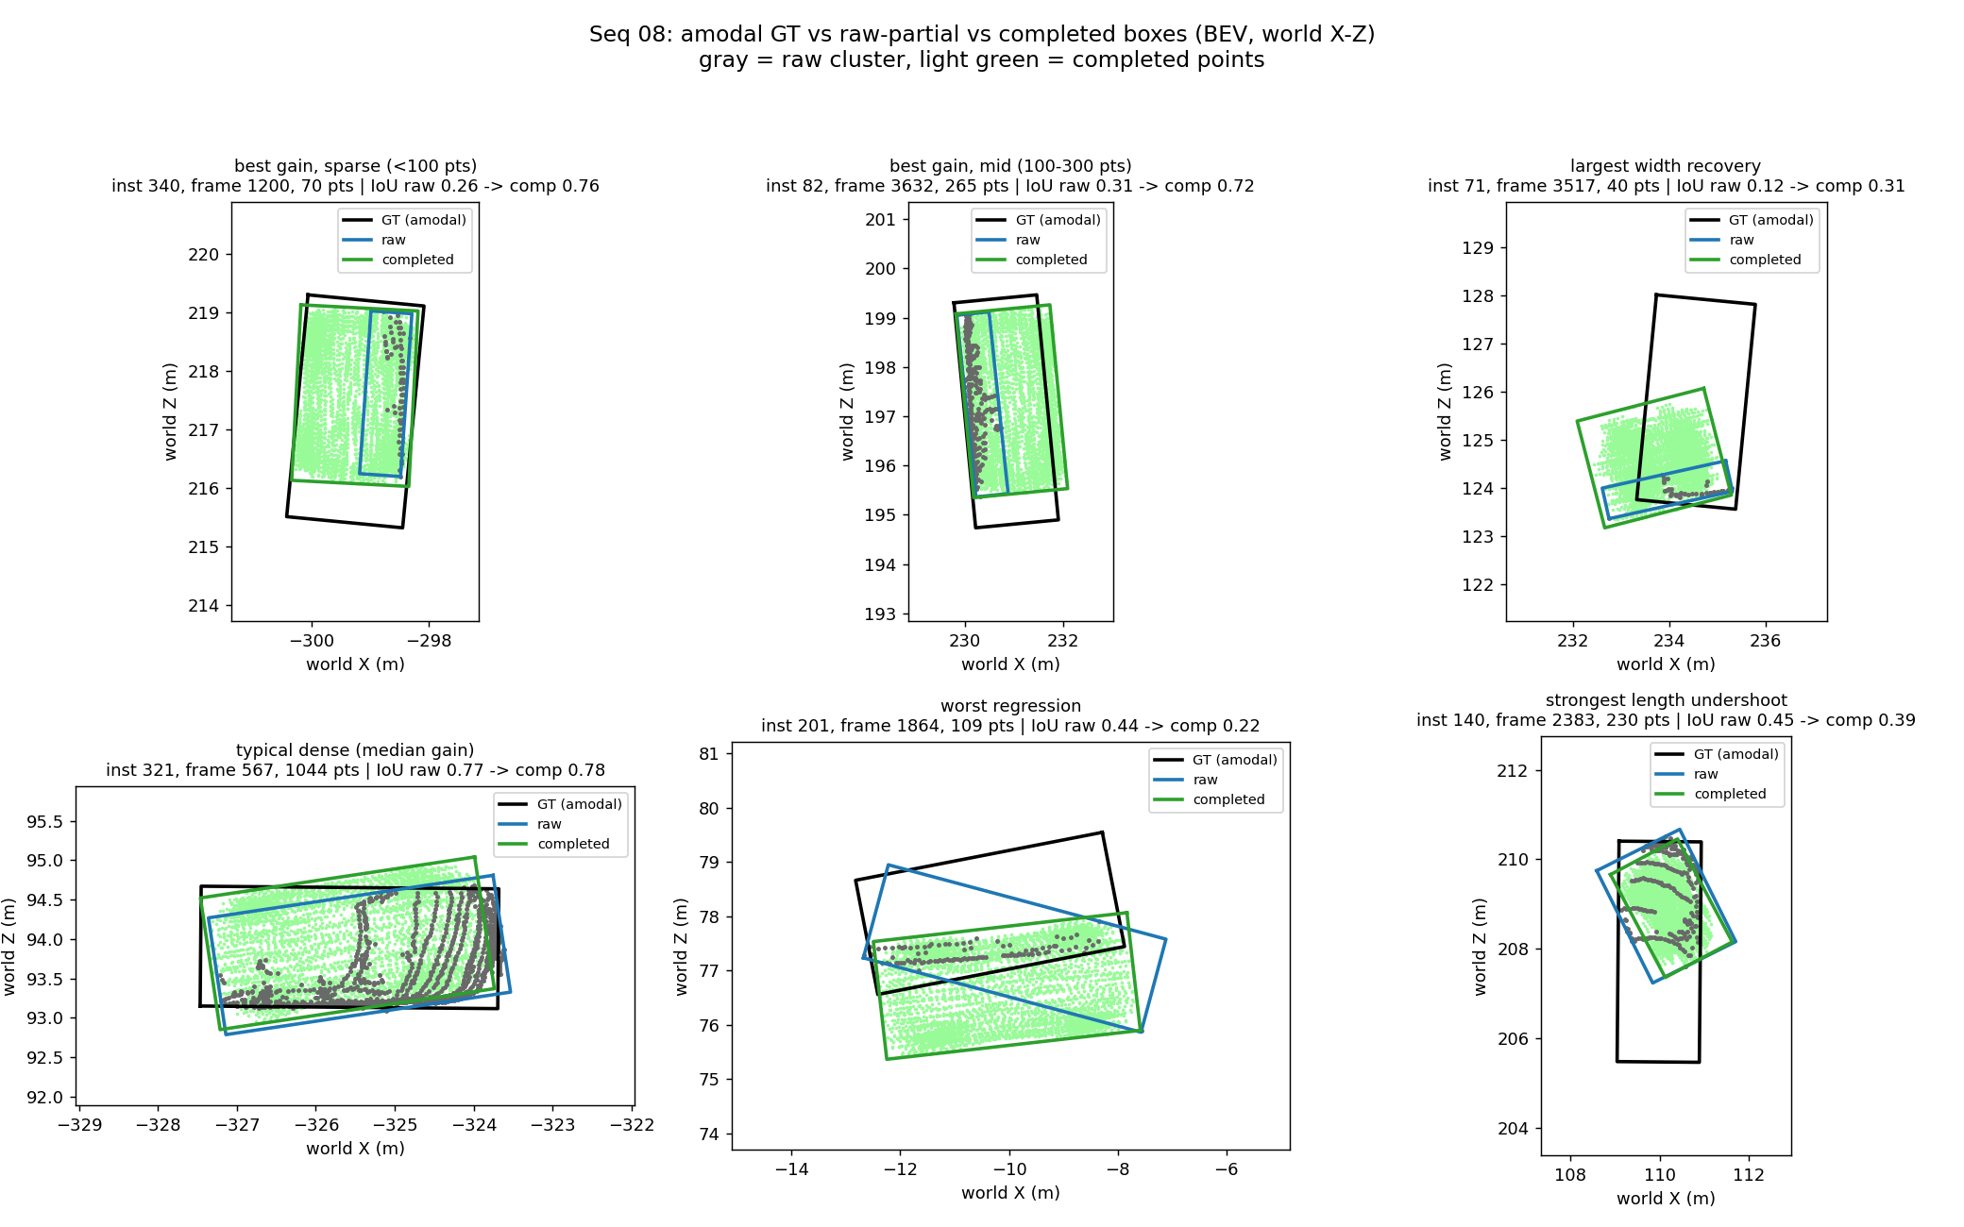
Figure 2 — Amodal GT box (black) vs raw-partial box (blue) vs completed box (green).

5.5 A valid real-data completion metric
Since pseudo-GT Chamfer is invalid (§5.1), a new metric was designed: complete a static car from one frame, then score coverage of donor points — observations of the same car from other frames — that lie ≥ 0.15 m from every input point, i.e. surface the input frame never saw. Baselines: the raw partial and a symmetry-mirrored partial. An out-of-GT-box guard catches hallucination. Same statistical design as §5.4:
Method | Coverage@0.1 m | Median novel-dist (m) | Out-of-box
Raw partial | 0.000 | 0.455 | 0.000
Mirrored partial | 0.051 | 0.313 | 0.011
PCN completed | 0.302 | 0.164 | 0.000

All pairwise p < 1e-6; the metric passed its four pre-registered validation checks. This is the first real-data evidence that the network reconstructs genuinely unseen structure — 30% of never-observed surface within 10 cm, 6× the mirror baseline, with essentially zero hallucination — and it makes the far-end weakness directly measurable (coverage there: 0.125).
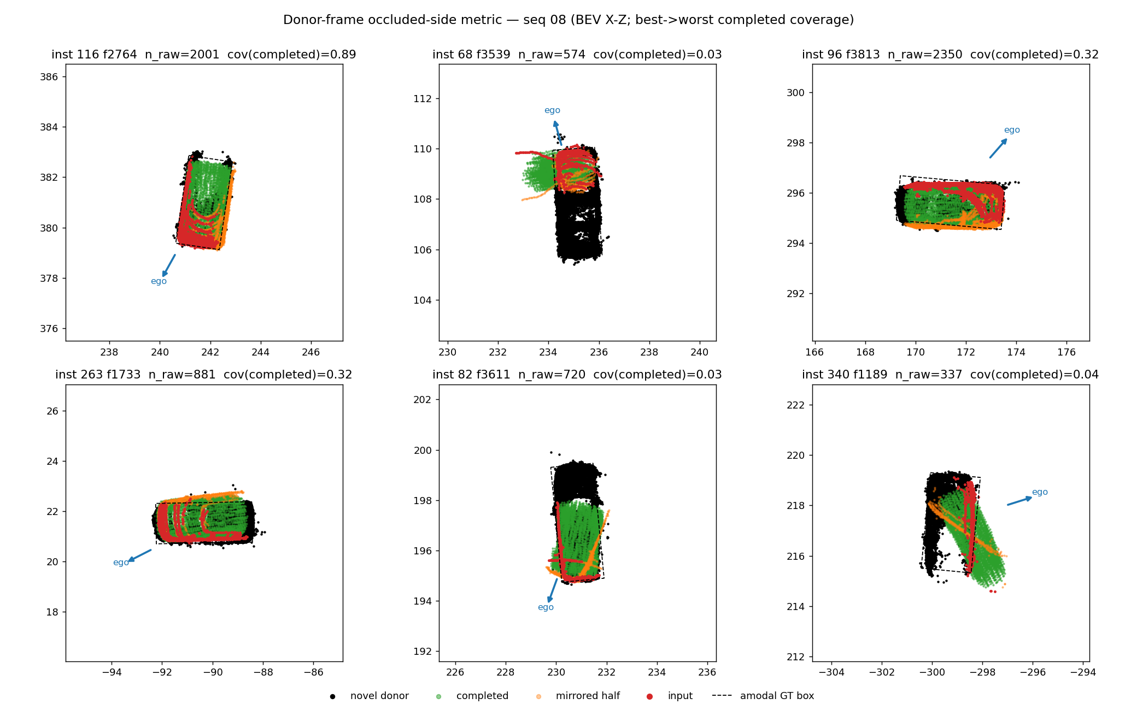
Figure 3 — Donor-frame metric: input partial, never-observed donor points, and method outputs.

6. Next Steps
- Fix the far-end undershoot (active). Ordered by evidence: (1) inference geometry, no retraining — anchor the box at the observed L-shape corner and place the center longitudinally with a car-length prior (the current estimate corrects laterally but not longitudinally); (2) if needed, retrain with a visibility-weighted asymmetric Chamfer loss that makes omitting occluded structure cost more than conservative truncation; (3) contingency: fine-tuning on real partials, now measurable with the donor metric. Architecture changes are ruled out by the PoinTr result. Success criteria: far-end coverage (0.125) and signed ΔL (−0.550 m).
- Amodal GT validity. Cross-validation against official KITTI tracklets is impossible — the raw drive behind seq 08 was never tracklet-annotated (verified on the KITTI download server); that absence is why the pseudo-GT was built. Validity rests on the paired design (both arms share the reference), construction guards, and the dimension sanity check.
- Thesis writing. Pipeline, recall-ceiling, sim-to-real, and completion chapters; pipeline diagram.

Appendix — Where to Find the Details
Every result above is backed by a numbered finding in the repository (docs/findings.md) with hypothesis, commands, and full tables. Mapping:
Report section | Findings
§2 Detection pipeline | #2, #4–#14, #18, #20
§3 Recall ceiling | #21–#24
§4 Sim-to-real | #25, #30, #31
§5.1 Blob failure → fix | #15–#19, #26
§5.2 Gate; PoinTr | #27, #28
§5.4 Box improvement | #29
§5.5 Donor metric | #32

A longer companion document (results_report_2026_07_17_rev2.docx) contains the extended justifications: operating-point analysis, filter validity across vehicle sizes, gate cost accounting, and the full far-end remediation plan.

