# Commodore 64 Power Saver

This project originally conceived by [Ray Carlsen](http://personalpages.tds.net/~rcarlsen/cbm.html)

The original Commodore 64 brick power supply can fail with a dead short across the 5V regulator, damaging its chips.

This circuit can be installed internally in a C64 computer which detects an overvolt condition and disconnects the power supply, preventing harm.

Cut off voltage is around 5.6 volts depending on supply and supply brick

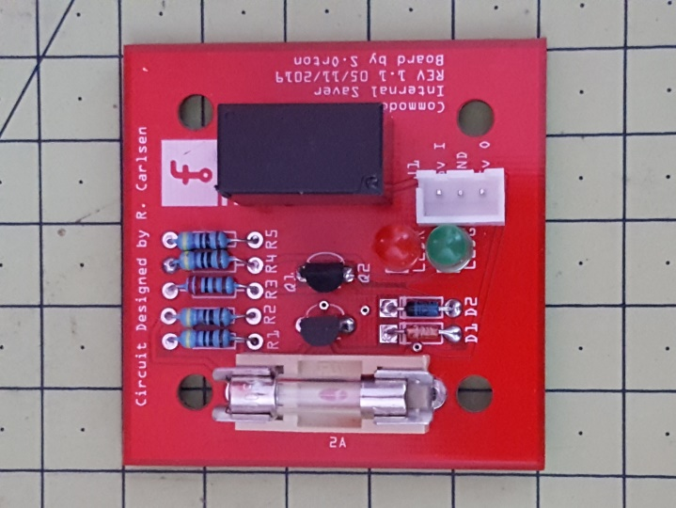

# Bill of Materials: c64 internal saver R1.2

## Assembly List

| Label | Part Type | Properties |
| --- | --- | --- |
| D1 | Zener Diode | power dissipation 0.5W; breakdown voltage 4.7V; package 300 mil [THT]; type Zener; part # 1N4732A |
| D2 | Rectifier Diode | package 300 mil [THT]; type Rectifier; part # 1N4001 |
| Fuse1 | Fuse with Handler | manufacturer Bussmann; datasheet http://www1.cooperbussmann.com/pdf/d5543d84-3b93-45e2-afde-4a74ca0255f9.pdf; size 5 x 20 mm; part # Htc-15m |
| J1 | Generic female header - 3 pins | form ♀ (female); pin spacing 0.1in (2.54mm); hole size 1.0mm,0.508mm; row single; pins 3; package THT |
| LEDG | Generic female header - 2 pins | form ♀ (female); pin spacing 0.1in (2.54mm); hole size 1.0mm,0.508mm; row single; pins 2; package THT |
| LEDR | Generic female header - 2 pins | form ♀ (female); pin spacing 0.1in (2.54mm); hole size 1.0mm,0.508mm; row single; pins 2; package THT |
| Part1 | Schematic Frame | descr Over voltage protection circuit for 5v lines of Commodore 64 etc.; date 1581627141; filename c64 internal saver R1.2.fzz; rev 1.2; sheet 1/1; project C64 Internal Saver |
| Q1 | NPN-Transistor | package TO92 [THT]; type NPN (CBE) |
| Q2 | NPN-Transistor | package TO92 [THT]; type NPN (CBE) |
| R1 | 470Ω Resistor | resistance 470Ω; pin spacing 400 mil; tolerance ±5%; bands 4; package THT |
| R2 | 470Ω Resistor | resistance 470Ω; pin spacing 400 mil; tolerance ±5%; bands 4; package THT |
| R3 | 2.2kΩ Resistor | resistance 2.2kΩ; pin spacing 400 mil; tolerance ±5%; bands 4; package THT |
| R4 | 470Ω Resistor | resistance 470Ω; pin spacing 400 mil; tolerance ±5%; bands 4; package THT |
| R5 | 470Ω Resistor | resistance 470Ω; pin spacing 400 mil; tolerance ±5%; bands 4; package THT |
| RELAY | RELAY | variant pth4; package relay-jzc |

## Shopping List

| Amount | Part Type | Properties |
| --- | --- | --- |
| 1 | Zener Diode | power dissipation 0.5W; breakdown voltage 4.7V; package 300 mil [THT]; type Zener; part # 1N4732A |
| 1 | Rectifier Diode | package 300 mil [THT]; type Rectifier; part # 1N4001 |
| 1 | Fuse with Handler | manufacturer Bussmann; datasheet http://www1.cooperbussmann.com/pdf/d5543d84-3b93-45e2-afde-4a74ca0255f9.pdf; size 5 x 20 mm; part # Htc-15m |
| 1 | Generic female header - 3 pins | form ♀ (female); pin spacing 0.1in (2.54mm); hole size 1.0mm,0.508mm; row single; pins 3; package THT |
| 2 | Generic female header - 2 pins | form ♀ (female); pin spacing 0.1in (2.54mm); hole size 1.0mm,0.508mm; row single; pins 2; package THT |
| 1 | Schematic Frame | descr Over voltage protection circuit for 5v lines of Commodore 64 etc.; date 1581627141; filename c64 internal saver R1.2.fzz; rev 1.2; sheet 1/1; project C64 Internal Saver |
| 2 | NPN-Transistor | package TO92 [THT]; type NPN (CBE) |
| 4 | 470Ω Resistor | resistance 470Ω; pin spacing 400 mil; tolerance ±5%; bands 4; package THT |
| 1 | 2.2kΩ Resistor | resistance 2.2kΩ; pin spacing 400 mil; tolerance ±5%; bands 4; package THT |
| 1 | RELAY | variant pth4; package relay-jzc |

## Board Revision Changes

## Rev 1.0

Incorrect ground planes (Not Working)

## Rev 1.1

Molex connector moved

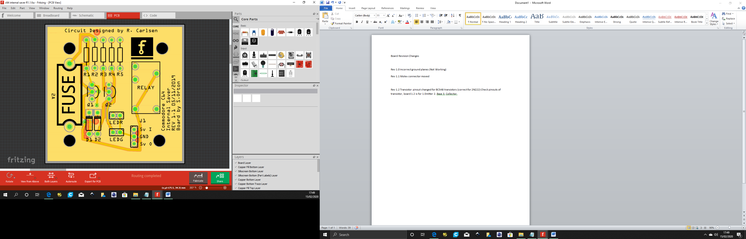 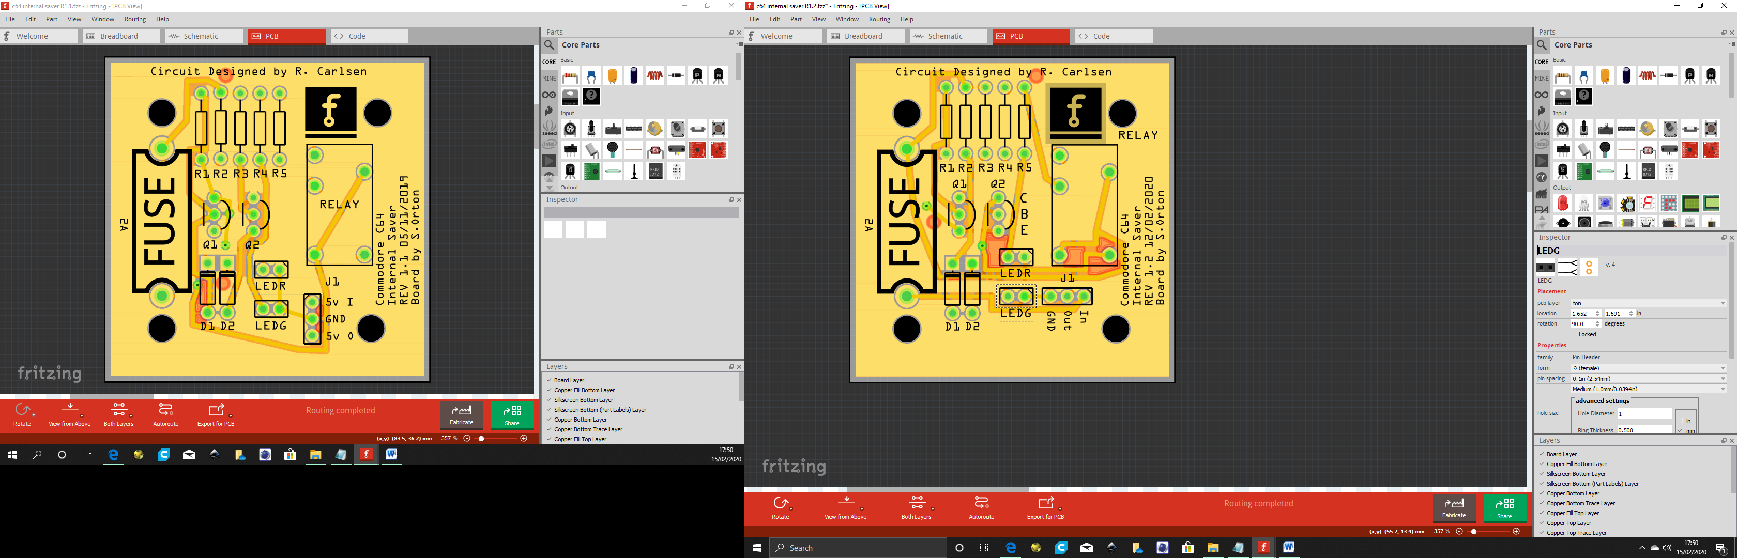

To here

From here

## Rev 1.2

Transistor pinout changed for BC548 transistors (correct for 2N222) Check pinouts of transistor,

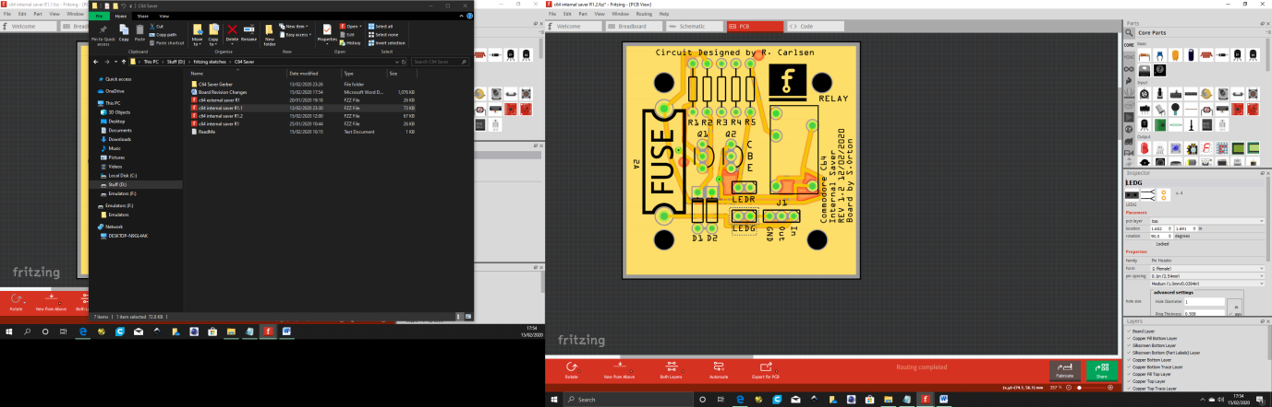 board 1.1 is 1.Emitter 2. Base 3. Collector (2N2222 place BL548 reversed)

board 1.2 is 1. Collector 2. Base 3. Emitter. ID markings added to board (BL548)

# Schematic

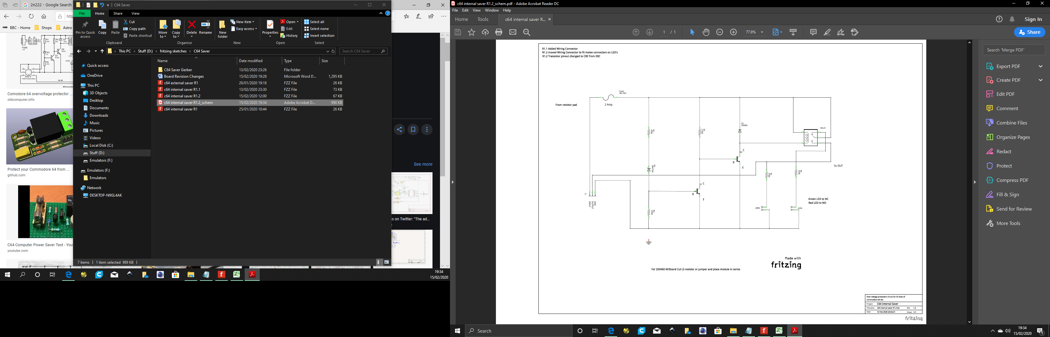

## PCB

