# Commodore 64 to Sega Megadrive Gamepad Safety Adapter

## Introduction

After refurbing a Sega Megadrive recently I wondered it the game pad could be used on the C64. After some research I found they could but could potentially cause damage to the CIA chips by causing 5v from the C64 to directly short via th gamepad when pressing the select button. Some have stated they used the pads without damage and others stated the opposite, so it seems the former may have been lucky.

Further research found the following DIY adapter from an issue of Commodore World

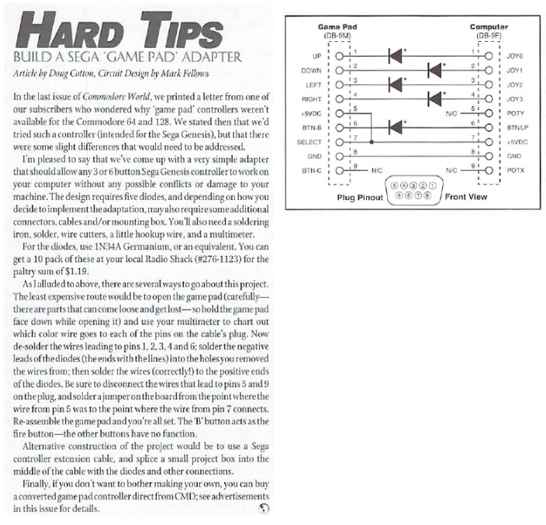

So I set about designing a PCB in Ki-Cad and this is it @ rev 1.0 (See warnings)

## Assembly List

|  |  |  |  |  |
| --- | --- | --- | --- | --- |
| Id | Designator | Package | Quantity | Designation |
| 1 | J2 | DSUB-9_Male_EdgeMount_P2.77mm | 1 | C64 Port |
| 2 | J1 | DSUB-9_Female_EdgeMount_P2.77mm | 1 | MD Plug |
| 3 | D5,D4,D3,D2,D1 | D_5W_P12.70mm 1N4148 Diode | 5 | D |

# PCB

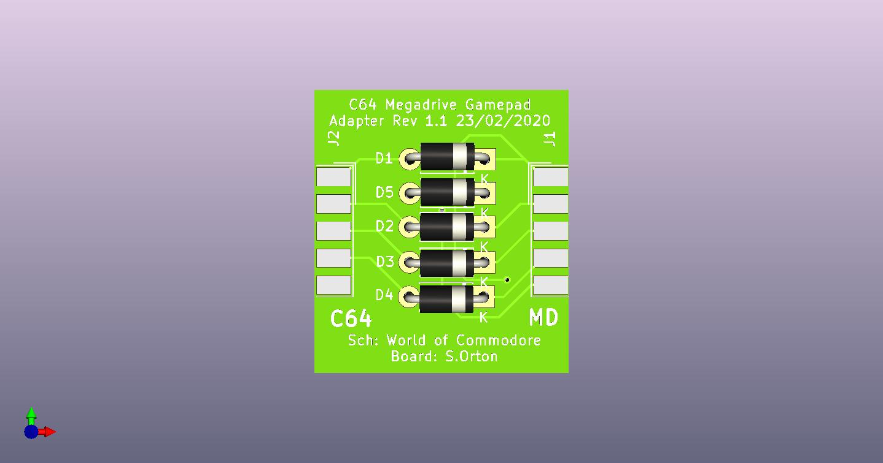

# Schematic

## 

# Board Revision Changes

|  |  |  |
| --- | --- | --- |
| Date | Revision | Change summary |
| 23/03/2020 | Rev 1.0 | First Revision  Rev 1.0 boards have errors due to the connectors being reversed see R1.0 Readme |
| 23/03/2020 | Rev 1.1 | Error corrections from Rev 1.0 |