Kyle ottmann and michael martinez

Runder, LTD





**Table of Contents**

**Introduction………………………………3**

* **The Runder Mission……………...3**

**The Runder Database………………....…4**

* **Entities and Attributes…….............4**
* **Schema…………………….......5**
* **EER Diagram………………........6**

**Challenges………………………………..7**

* **The SQL Query Used…………..….7**

**User-Interface………………………...…8**

**Conclusion……………………………….10**

**Introduction**



Runder is an interactive website that not only allows users to decide which ski runs are the best fit for them, it also gives them information such as chairlifts to take, which resort the runs are at and what type of terrain the runs are located. The is a user-friendly website that is simple to use and is also a great safety tool as users can decide the difficulty without accidentally “running” into a double-black diamond.

Runder was initially created in Microsoft MySQL Workbench which we then transferred to Westminster’s Cerberus server. From there, we completed the user-interface using HTML and PHP in Adobe Dreamweaver.

**The Runder Mission**

**Runder is a company who believes its users deserve to get the best, most thorough information faster than Bode Miller on the last turn. Together, with a vast database of ski and snowboarding runs and a simple, effective user-interactive website, we can ensure users are safely enjoying their time on the mountain. At Runder, we take the stress out of planning your winter trip so you can enjoy more time with your friends, family, or the person you just met on the chairlift.**

**The Runder Database**

Runder was first created by assembling the EER Diagram in Microsoft MySQL Workbench. It was in MySQL where we thought of and constructed each entity while giving them their attributes. From there, we gathered information from over 140 ski runs which included their names, terrains, chairlifts to take and eleveation, and we organized it in a Microsoft Excel spreadsheet where we then forward engineered it into Cerberus. By using Adobe Dreamweaver and using HTML and PHP, we created not only a functional website, but an amazing user experience that looks sleek and professional. While we still want to incorprate more options on the page and even more runs, this is a solid beginning.

**Entities and Attributes:**

Database tables and their attributes are listed below:

**Resort**

**/Users/michaelmartinez/Desktop/Screen Shot 2016-12-13 at 9.38.07 AM.png**MountainID

-MountainName

-address

-city

-state

-elevation

**Runs**

**/Users/michaelmartinez/Desktop/Screen Shot 2016-12-13 at 9.38.07 AM.png**RunID

-Name

-difficulty

-MountainID

-medical

**Difficulty**

**/Users/michaelmartinez/Desktop/Screen Shot 2016-12-13 at 9.38.07 AM.png**rating

-Name

**Terrain**

**/Users/michaelmartinez/Desktop/Screen Shot 2016-12-13 at 9.38.07 AM.png**terrainID

-terrainName

-Resort_MountainID

-BackcountryTerrain_id

**Snowmaking**

**/Users/michaelmartinez/Desktop/Screen Shot 2016-12-13 at 9.38.07 AM.png**snowMachineID

-make

-model

-modelYear

-yearAcquired

**BackcountryTerrain**

**/Users/michaelmartinez/Desktop/Screen Shot 2016-12-13 at 9.38.07 AM.png**idBackcountryTerrain

-backcountryTerrainName

-backcountryGate

Charilift

**/Users/michaelmartinez/Desktop/Screen Shot 2016-12-13 at 9.38.07 AM.png**chairliftID

-chairliftName

**Schema**

The database schema which includes all tables, their keys and datatypes is listed below:

**Resort** {/Users/michaelmartinez/Desktop/Screen Shot 2016-12-13 at 9.38.07 AM.pngMountainID INT, mountainName VARCHAR(45), address VARCHAR(45), city VARCHAR(45), state, VARCHAR(45), elevation INT}

**Runs** {/Users/michaelmartinez/Desktop/Screen Shot 2016-12-13 at 9.38.07 AM.pngRunID INT, Name VARCHAR(45), MountainID INT, medical VARCHAR(45), difficulty_rating INT, BackcountryTerrain_id INT}

**Difficulty** {/Users/michaelmartinez/Desktop/Screen Shot 2016-12-13 at 9.38.07 AM.pngrating INT, Name VARCHAR(45)}

**Terrain** {/Users/michaelmartinez/Desktop/Screen Shot 2016-12-13 at 9.38.07 AM.pngterrainID INT, terrainName VARCHAR(45), Resort_MountainID INT, BackcountryTerrain_id INT}

**Snowmaking** {/Users/michaelmartinez/Desktop/Screen Shot 2016-12-13 at 9.38.07 AM.pngsnowMachineID INT, make VARCHAR(45), model VARCHAR(45), modelYear INT, yearAcquired VARCHAR(45)}

**BackcountryTerrain** {/Users/michaelmartinez/Desktop/Screen Shot 2016-12-13 at 9.38.07 AM.pngidBackcountryTerrain INT, backcountryTerrainName VARCHAR(45), backcountryGate BOOL}

**Charilift** {/Users/michaelmartinez/Desktop/Screen Shot 2016-12-13 at 9.38.07 AM.pngchairliftID INT, chairliftName VARCHAR(45)}

**Below is the EER Diagram we used:**

**EER Diagram**

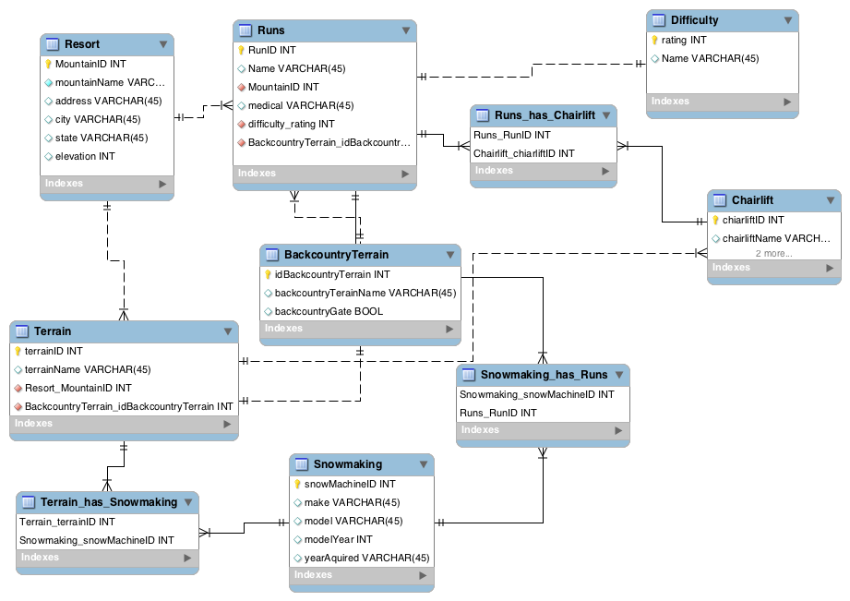

**Challenges**

During Runder’s creation we managed to hit a few rocks under the snow. We uploaded our SQL tables from MySQL Workbench which worked fairly well until we went to upload data. The data upload process came to a halt when we realized we were not uploading data in the correct sequence to please all of the foreign keys in each table. Once we sorted out the order in which data needed to be uploaded, we were successful. Another challenge we were presented with was joining SQL tables in our queries from the PHP page. Joining tables worked perfectly when accessing the database through terminal, but always threw errors when querying it from a PHP webpage. After tuning our skis and SQL join statements, we were able to join the correct tables to allow us to correctly display our data on the website. Although we did not get to finish the link to the Alta ski runs, we would have liked to add the information and make it accessible.

**The SQL Query Used**

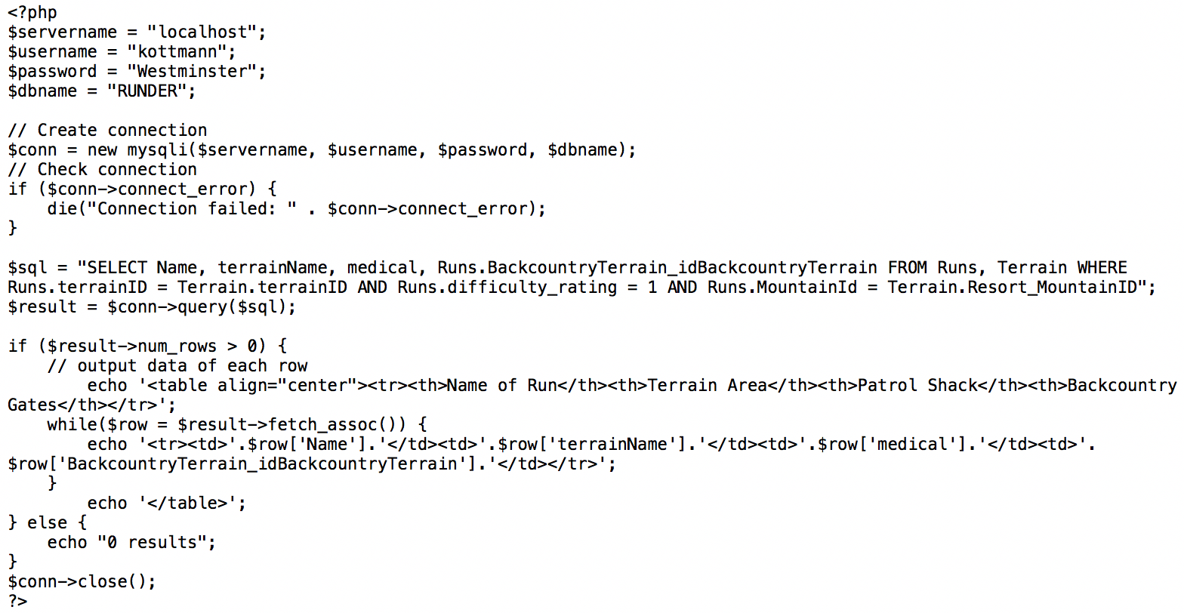

**User Interface**

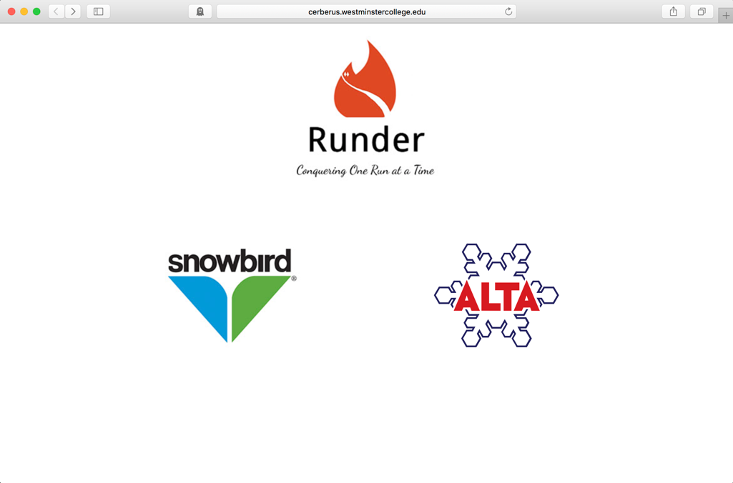

Figure 1. The home page of Runder which features logo links to the mountain of your choice

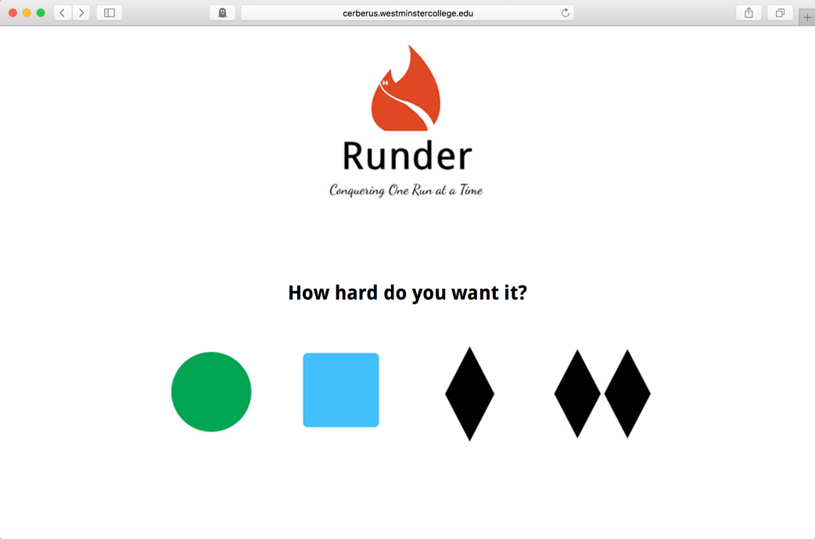

Figure 2. After clicking the mountain on the previous page, you are brought to this page where you can select the level of difficulty which is represented by the universal ski run difficulty logos

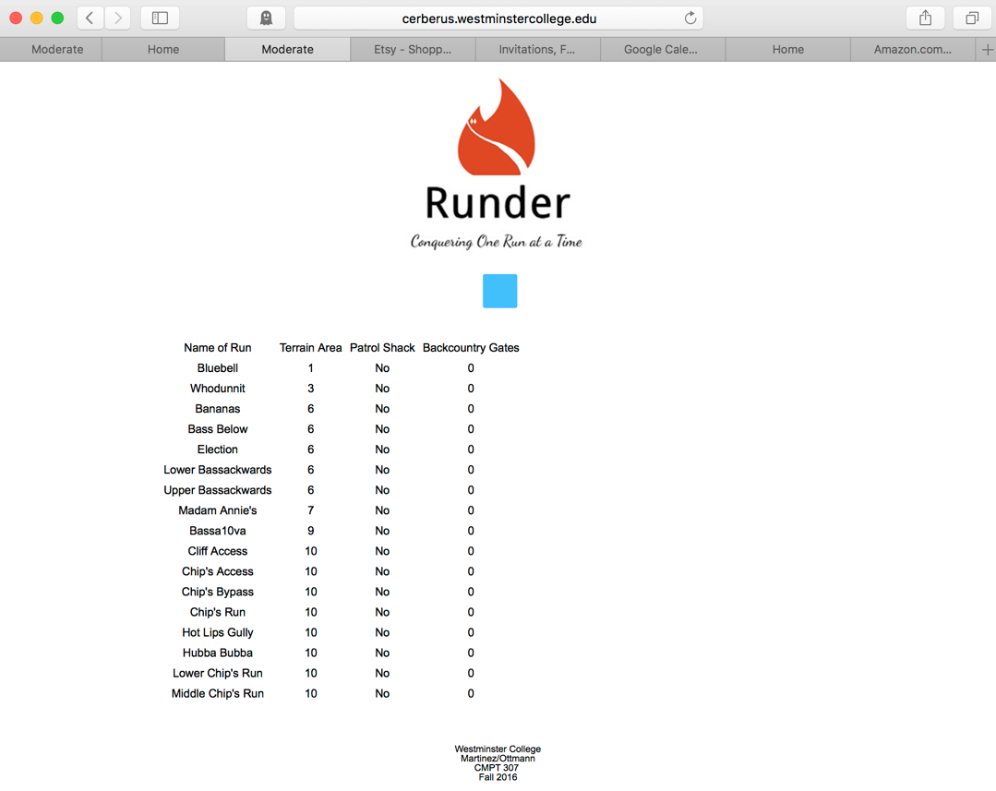

Figure 3. When we click on the moderate difficulty (blue square), it takes us to the runs and some information about the run (We would still like to add more tables)

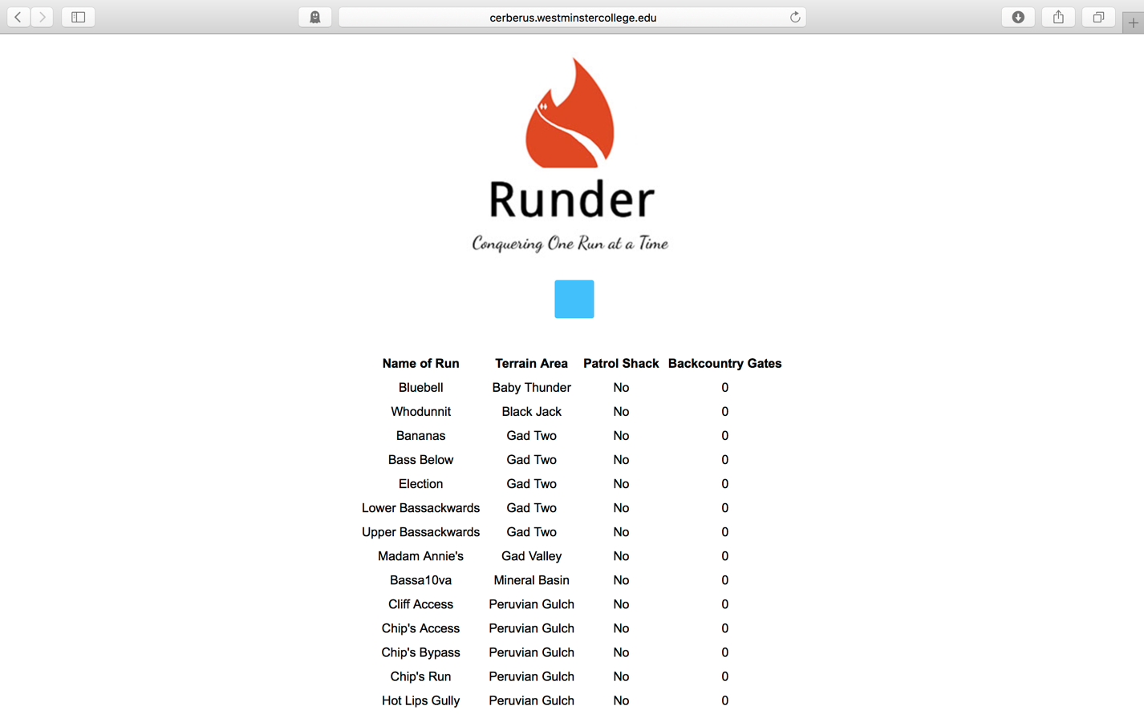

Figure 4. When you want to return to the home screen, simply click on the Runder logo and it will take you back

**Conclusion**

The creation and implementation of Runder proved to be not only demanding but rewarding was well. Given more time, we would have liked to implement all our tables of information we have stored in Cerberus. The chairlifts and snowmaking tables would be useful in real world application to help users decide which run to take. Another element that would be beneficial to users and make the website more user-friendly would be to add individual maps for the runs, including what chairlifts to take to get to the selected run. Who knows, if Vail Resorts decides to purchase Runder, we would definitely add live camera feeds to each of the runs for a more real-time experience.

Although Runder is just a school project at this point, we hope one day it could change the way people navigate mountains all over the world.

Runder………conquering one mountain at a time.