PROJECT REPORT
REAL-TIME FACIAL
EXPRESSION RECOGNITION
USING CONVOLUTIONAL NEURAL NETWORKS (CNN)

Submitted by | ____________________________________________
Roll number / Student ID | ____________________________________________
Department / Programme | ____________________________________________
Institution | ____________________________________________
Project supervisor | ____________________________________________
Submission date | ____________________________________________
A computer-vision prototype for classifying visible facial expressions

Abstract
This project develops a real-time facial-expression recognition prototype using Python, OpenCV, and a convolutional neural network (CNN). The webcam component captures video frames and locates a face. The face image is converted to grayscale, resized to 48 × 48 pixels, and supplied to a trained CNN that predicts one of seven dataset labels: angry, disgust, fear, happy, neutral, sad, or surprise. The dataset contains 28,709 images in the training folder and 7,178 images in the test folder. A 15% validation split is created from the training folder. The evaluated model achieved 36.46% test accuracy, with a weighted F1-score of 0.30. Results show substantial confusion between multiple expression classes, so the system is best presented as an educational prototype and a baseline for further experimentation, not as a high-accuracy or psychologically definitive emotion detector.

1. Introduction
Computer vision enables software to analyse image patterns and make predictions about visual content. Facial-expression classification is one application: a model learns patterns from labelled facial images and predicts the closest expression category for a new image. In this project, OpenCV is used for webcam access and face localisation, while a CNN performs the seven-class classification.

2. Problem Statement
The project aims to build a local application that can locate a visible face in a webcam frame and display a predicted facial-expression label in near real time. The main technical challenges include variations in lighting and pose, similarities between expressions, and imbalance in the number of images available for each class.

3. Objectives
- Load and validate an image dataset organised into seven expression categories.
- Train a CNN using the training folder and monitor performance on a validation split.
- Save the trained model and the class-label order for reuse.
- Integrate the saved CNN with webcam face detection.
- Evaluate test-set performance and document limitations transparently.

4. Scope
The prototype classifies visible facial-image patterns into a fixed set of seven labels. It does not identify people, diagnose health conditions, or determine a person’s true internal emotional state. The current implementation is intended for learning and demonstration purposes.

5. Dataset and Preprocessing
The local dataset is arranged in separate training and test folders. Each folder contains one subfolder per class. The folder counts were checked before training, and both splits contained the same seven class names.
Expression class | Training folder | Test folder
angry | 3,995 | 958
disgust | 436 | 111
fear | 4,097 | 1,024
happy | 7,215 | 1,774
neutral | 4,965 | 1,233
sad | 4,830 | 1,247
surprise | 3,171 | 831

Data split | Images | Purpose
Training subset | 24,403 | Used to update model weights
Validation subset | 4,306 | 15% of training folder; monitoring model training
Test set | 7,178 | Held out for final evaluation

Preprocessing pipeline
- Images are loaded from class-named folders; folder names provide the numeric labels.
- Images are resized to 48 × 48 pixels and converted to grayscale.
- The CNN rescales pixel values from 0–255 to the range 0–1.
- The training folder is divided into 24,403 training images and 4,306 validation images using a 15% validation split.
- The test folder is not used for gradient updates and is reserved for evaluating generalisation.

Class imbalance
The class counts are not balanced. For example, the training folder contains 7,215 happy images but only 436 disgust images. Class weights were used during training to give additional influence to less frequent classes. Weighting alone did not solve the classification errors, particularly for angry, fear, and sad.

6. System Design and Methodology

System workflow
Stage | Description
1. Dataset | Labelled images stored in train/test class folders
2. Preprocessing | Grayscale conversion, resize to 48 × 48, pixel rescaling
3. CNN training | Convolution, batch normalisation, pooling, dropout, dense layers
4. Model saving | Keras model file plus JSON class-label list
5. Webcam inference | OpenCV captures a frame and detects a face; CNN predicts the label
6. Evaluation | Test accuracy, per-class precision/recall/F1 and confusion matrix

CNN architecture
The model is implemented as a sequential Keras network. Convolution layers learn local visual features; max pooling reduces spatial dimensions; batch normalisation supports more stable optimisation; dropout reduces reliance on particular activations; and the final softmax layer produces a score for each of the seven classes.
Component | Configuration
Input | 48 × 48 × 1 grayscale image
Rescaling | Pixel range 0–255 to 0–1
Convolution block 1 | Conv2D: 32 filters, 3 × 3; batch normalisation; 2 × 2 max pooling; dropout 0.15
Convolution block 2 | Conv2D: 64 filters, 3 × 3; batch normalisation; 2 × 2 max pooling; dropout 0.20
Convolution block 3 | Conv2D: 128 filters, 3 × 3; batch normalisation; 2 × 2 max pooling; dropout 0.25
Classifier | Flatten; Dense 128 (ReLU); dropout 0.40; Dense 7 (softmax)
Parameters | 684,423 total; 683,975 trainable

Training configuration
The model was compiled with the Adam optimiser and sparse categorical cross-entropy loss. Training ran for up to 10 epochs with batch size 64. Model checkpointing saved the version with the highest validation accuracy. Early stopping and learning-rate reduction callbacks were included. The run was performed in a native Windows environment where TensorFlow reported that GPU support was unavailable; the training output indicates CPU execution.

7. Results and Evaluation
The saved CNN was evaluated on all 7,178 test images. The report below is from the completed evaluation run. Precision describes the fraction of predictions for a class that were correct; recall describes the fraction of actual samples of that class that were found; F1-score balances precision and recall.
Class | Precision | Recall | F1-score | Support
angry | 0.27 | 0.05 | 0.08 | 958
disgust | 0.13 | 0.55 | 0.22 | 111
fear | 0.26 | 0.09 | 0.13 | 1,024
happy | 0.40 | 0.79 | 0.53 | 1,774
neutral | 0.27 | 0.40 | 0.32 | 1,233
sad | 0.30 | 0.04 | 0.07 | 1,247
surprise | 0.70 | 0.57 | 0.63 | 831

Metric | Result
Test accuracy | 36.46%
Macro average precision / recall / F1 | 0.33 / 0.36 / 0.28
Weighted average precision / recall / F1 | 0.35 / 0.36 / 0.30
Test samples | 7,178

Key findings
- Happy has the highest recall at 0.79; 1,407 of 1,774 happy samples were classified as happy in the confusion matrix.
- Surprise has recall 0.57 and precision 0.70 in this evaluation.
- Recall is low for angry (0.05), fear (0.09), and sad (0.04), indicating that many samples from these categories are missed.
- The model frequently predicts happy for images whose actual labels are angry, fear, neutral, or sad.
- The accuracy and weighted F1-score show that this model is a baseline and needs improvement before reliable use.

8. Confusion Matrix
The confusion matrix compares each test image’s true folder label (rows) with the model’s predicted label (columns). Correct predictions appear on the main diagonal. Large values away from the diagonal show class confusion.
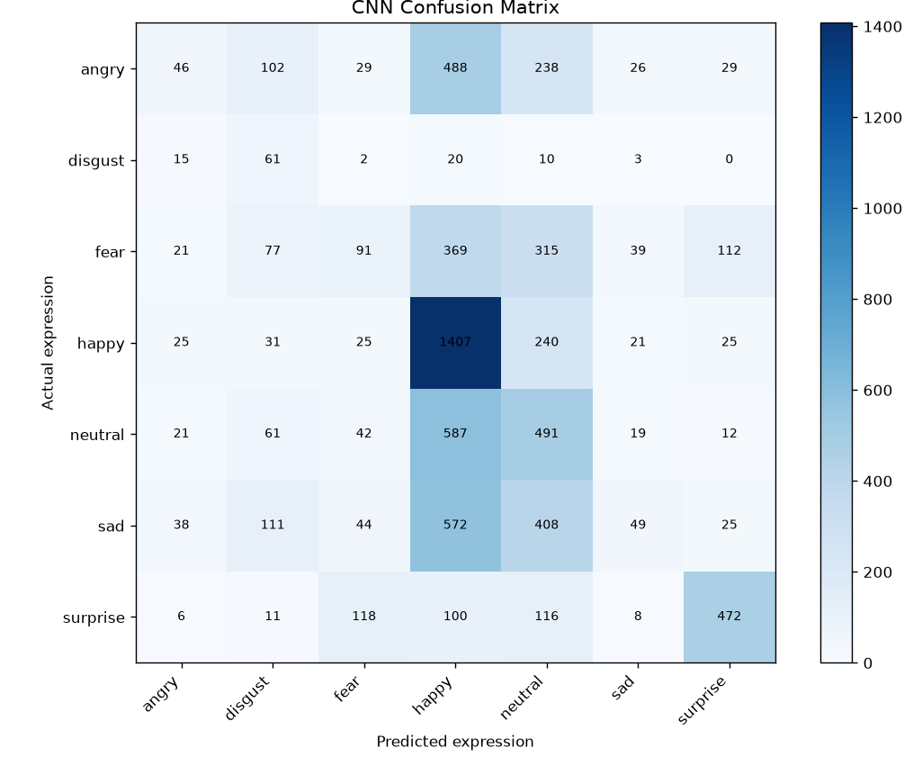
Figure 1. Confusion matrix generated for the CNN test-set evaluation.

Interpretation
The diagonal contains the correct classifications. The happy class has a large diagonal count (1,407), while angry has 46 correct predictions out of 958, fear has 91 out of 1,024, and sad has 49 out of 1,247. The large off-diagonal counts from angry, fear, neutral, and sad into the happy column indicate that the classifier over-predicts happy for these samples. The confusion matrix is therefore consistent with the low recall scores for those classes.
This result illustrates why overall accuracy alone is insufficient for an imbalanced multi-class dataset. Per-class metrics and the confusion matrix reveal the categories that need more attention.

9. Limitations
- Current test accuracy is 36.46%, and the class-wise recall is uneven.
- The class distribution is imbalanced, especially for disgust compared with happy.
- The model may be sensitive to lighting, camera angle, face size, occlusion, and differences between training images and real webcam frames.
- Prediction scores are not calibrated probabilities of a person’s actual emotion.
- The prototype has only been evaluated with the local test split and informal webcam use; broader testing has not been established in this report.
- The report does not claim that the model identifies internal feelings or psychological states.

10. Future Improvements
- Inspect more samples and verify image quality and label consistency.
- Use careful data augmentation and compare experiments on the validation set.
- Compare class-weighting approaches and balanced sampling for under-represented classes.
- Experiment with model depth, learning rate, regularisation, and suitable pretrained feature extractors.
- Track per-class F1-score and confusion matrices after each experiment; select changes based on validation data and reserve the test set for final evaluation.
- Improve temporal smoothing and test under a range of lighting and camera conditions.

11. Conclusion
The project implements a complete baseline workflow for real-time facial-expression classification: dataset validation, CNN training, model saving, webcam integration, and quantitative evaluation. The application demonstrates the use of OpenCV for face localisation and TensorFlow/Keras for image classification. The 36.46% test accuracy and the confusion matrix show that the current model remains limited, especially for angry, fear, and sad. The system is therefore suitable as a learning and demonstration prototype, while improved data handling and model experiments are required before any claim of stronger performance.

References and reproducibility
- TensorFlow API: image_dataset_from_directory — https://www.tensorflow.org/api_docs/python/tf/keras/utils/image_dataset_from_directory
- TensorFlow guide: The Sequential model — https://www.tensorflow.org/guide/keras/sequential_model
- OpenCV documentation: Cascade Classifier — https://docs.opencv.org/4.x/db/d28/tutorial_cascade_classifier.html
- Dataset attribution: Add the exact dataset title, original download page, author/provider, and licence from the source actually used. This information was not present in the project logs used to prepare this report.
Reproduction commands (PowerShell, run from the project directory):
.\.venv\Scripts\python.exe train_model.py
.\.venv\Scripts\python.exe evaluate_model.py
.\.venv\Scripts\python.exe webcam_cnn.py

