#### A

Project Report on

**FITWELLGYM MANAGEMENT SYSTEM**

*submitted in partial fulfillment of the requirements for the award of the degree of*

#### Bachelor of Technology in

#### INFORMATION TECHNOLOGY

*by*

#### Nikhil Deshmukh (20140707)

#### Shankar Jadhav (20150723)

*Under the guidance of*

### Asso. V. N. Patil



DEPARTMENT OF INFORMATION TECHNOLOGY

### DR. BABASAHEB AMBEDKAR TECHNOLOGICAL UNIVERSITY

Lonere-402103, Tal. Mangaon, Dist. Raigad (MH) INDIA 2018-2019

DR. BABASAHEB AMBEDKAR TECHNOLOGICAL UNIVERSITY

Lonere-402103,Tal-Mangaon,dist raigad(MH)INDIA DEPARTMENT OF INFORMATION TECHNOLOGY

**Certificate**

The Project report entitled **FITWELLGYM MANAGMENT SYSTEM** sub- mitted by **Nikhil Deshmukh(20140707), Shankar Jadhav (20150723)** is approved for the partial fulfillment of the requirement for the award of the degree of Bachelor of Technology in Information Technology.

(Asso. V. N. Patil) (Prof. Shivajirao M. Jadhav ) Guide Head

Department of Information Technology Department of Information Technology

Place: Dr. Babasaheb Ambedkar Technological University, Lonere. Date:

**Acknowledgment**

We are pleased to present this project report entitled FITWELLGYM MANAGE- MENT SYSTEM. It is indeed a great pleasure and a moment of immense satisfaction for us to express our sense of profound gratitude and indebtedness towards our guide Mr.

V. N. Patil whose enthusiasm are the source of inspiration for us.

We are extremely thankful for the guidance and untiring attention, which he bestowed on us right from the beginning. His valuable and timely suggestions at crucial stages and above all his constant encouragement have made it possible for us to achieve this work.

We would like to thank the entire Teaching staffs who are directly or indirectly in- volved in the various data collection and software assistance to bring forward this project report. We express our deep sense of gratitude towards our parents for their sustained cooperation and wishes, which have been a prime source of inspiration to take this project work to its end without any hurdles.

Last but not the least, We would like to thank all our B.Tech. colleagues for their co-operation and useful suggestion and all those who have directly or indirectly helped us in completion of this project work.

Place: Dr. Babasaheb Ambedkar Technological University, Lonere. Date:

**Abstract**

Fitwellgym bank management system is a web application that allows to access the whole information about Fitwellgym, readily scalable and adaptable to meet the complex need of Gym management who is the key facilitator for the Gym; it also supports all the functionalities of adding new members manipulating database with admin panel. It is used for maintaining information about the campus. The project includes three main modules admin, and Gym- member and novice members.

The admin module focuses all the information storing and accessing using username and password for that we have used encryption of MD5 algorithm to make it more secure. Admin can see number of people who joined the gym along with the members who paid the fees and who doesn’t and he can edit the user information accordingly.

We also included the various component and equipment available in gym for information if any novice user can get the information regarding specific machine of gym. By this management system gym owner can easily handle the data as well as access it.

Admin have various functionalities like adding members, editing member information, deleting member and all these functions avail within the clicks.

.

**Contents**

1. System 3

1.1 Existing System . . . . . . . . . . . . . . . . . . . . . . . . . . . . . . . . 3

1.2 Proposed System . . . . . . . . . . . . . . . . . . . . . . . . . . . . . . . 4

1. Requirements Specifications 5

2.1 Hardware Specification . . . . . . . . . . . . . . . . . . . . . . . . . . . . 5

2.1.1 Server Side : . . . . . . . . . . . . . . . . . . . . . . . . . . . . . . 5

2.1.2 Client Side : . . . . . . . . . . . . . . . . . . . . . . . . . . . . . . 5

2.2 Software Requirements . . . . . . . . . . . . . . . . . . . . . . . . . . . . 6

2.2.1 Server Side : . . . . . . . . . . . . . . . . . . . . . . . . . . . . . . 6

2.2.2 Client Side : . . . . . . . . . . . . . . . . . . . . . . . . . . . . . . 6

2.3 Functional Requirements . . . . . . . . . . . . . . . . . . . . . . . . . . . 7

2.3.1 ADMIN :- . . . . . . . . . . . . . . . . . . . . . . . . . . . . . . . 7

2.3.2 USER:- . . . . . . . . . . . . . . . . . . . . . . . . . . . 7

2.4 Non Functional Requirements . . . . . . . . . . . . . . . . . . . . . . . . 8

1. Diagrams 9

3.1 DFD Level 0 . . . . . . . . . . . . . . . . . . . . . . . . . . . . . . . . . . 9

* 1. Class Diagram 12
  2. State Chart Diagram 21

1. Snapshots 22
   1. Home : 23
   2. Login : 24
   3. Add Member : 25
   4. Admin Panel : 26
   5. Edit Member detail 27
   6. Delete: 28
   7. Database …………………………………………………………………………………………….29
   8. Log Out : 29

|  |  |  |
| --- | --- | --- |
| **5** | **Conclusion** | **30** |
| **6** | **References** | **31** |

**List of Figures**

3.1 DFD Level 0 diagram . . . . . . . . . . . . . . . . . . . . . . . . . . . . . 9

* 1. Homepage 10
  2. Login 11
  3. Add Member 12
  4. Admin 13
  5. Edit Member 14
  6. Delete Member 15
  7. View paid members 16
  8. View Unpaid 17
  9. View All Members 18
  10. Gym information 19
  11. Log Out 29

BLOOD BANK MANAGMENT SYATEM Dept. of Information Technology

**Introduction**

.

Fitwellgym bank management system is a web application that allows to access the whole information about Fitwellgym, readily scalable and adaptable to meet the complex need of Gym management who is the key facilitator for the Gym; it also supports all the functionalities of adding new members manipulating database with admin panel. It is used for maintaining information about the campus. The project includes three main modules admin, and Gym- member and novice members.

The admin module focuses all the information storing and accessing using username and password for that we have used encryption of MD5 algorithm to make it more secure. Admin can see number of people who joined the gym along with the members who paid the fees and who doesn’t and he can edit the user information accordingly.

**Problem Statement**

The main aim of the project is to effectively manage the Gym members and equipment details. This project enables the admin easily manipulate gym member and instrument information. It avails to add, edit , delete user information from database and categories user accordingly fee paid or not.

**Chapter 1 System**

# Existing System

In existing system the blood bank management system exhibited at a lot of inef- fectiveness and inefficiency that had fetched impact taken by management. The system which was manual that is based on paper card to collect blood donor data, keep record of blood donors and disseminate results to blood donors, had weakness that needed IT based solutions.

The system was characterized by delays and sometimes failure to access historical records; errors were witnessed in entry and manual analysis of results, secrecy and con- fidentiality of records lacked because unauthorized persons could easily access the records.

* Existing system is window Application.
* So much time consuming this application also one machine and one by one record stored.
* Single Blood bank information also no inquiry for directly Blood bank.

# Proposed System

The proposed Blood Bank management system helps the people who are in need of a blood by giving them all details of blood group availability or regarding the donors with the same blood group. Our website work 24x7 so user can get information of blood donor any time. Blood donor can also get registered and save life of other person.

When blood is need in the operation then people have very less ime to get the blood available so if he get the information like who can give him blood in time in his city is life saving.

* Speed and accuracy there is no redundancy of data.
* It will be easily handle .
* The proposed method maintenance of schedule erroneous and it is very easy to operate.
* Reduce the Time spend on the paper work .

**Chapter 2**

**Requirements Specifications**

# Hardware Specification

## Server Side :

* + - 1. Processor: 3.6 GHz
      2. Ram: 2 GB or more
      3. Cache: 1 MB
      4. Hard disk: 80 GB GB(min.)

## Client Side :

* + - 1. Processor: 2.40 GHz
      2. Ram: 1 GB or more
      3. Cache: 1 MB
      4. Hard disk: 20 GB GB(min.)

# Software Requirements

## Server Side :

* + - 1. Operating System: Window Server 2008
      2. Runtime Environment: phpMyAdmin
      3. Web Server: IIS 7.0
      4. Front End: Html,CSS,Bootstrap,Javascript
      5. Back End: PHP

## Client Side :

* + - 1. Operating System: Windows XP or any compatible OS
      2. Web Browser: Internet Explorer 6.0 or any compatible web browser.

BLOOD BANK MANAGMENT SYATEM Dept. of Information Technology

# Functional Requirements

## ADMIN :-

* Manage Registration for user.
* Manage Blood bank information like (update, delete).
* Manage Donor Request for Donor.
* Manage patient Request for needy people.
* Manage Inquiry form for Appropriate Reply.
* Manage feedback for Appropriate Reply.

## BLOOD BANK :-

* Blood bank information view/update.
* View Donor information.
* Manage Patient Blood Request.

## DONOR :-

* Manage Donor information(profile).
* Add new Donation for Blood.

## PATIENT :-

* Manage patient information(profile).
* Give the Request for patient for blood

# 2.4 Non Functional Requirements

* Reliability: Database updating should follow transaction processing to avoid data inconsistency.
* Security: We have implemented a lot of security mechanism.
* Maintainability: It is very easy to maintain the system.
* Portability: Yes this system is portable.

**Chapter 3 Diagrams**

# DFD Level 0

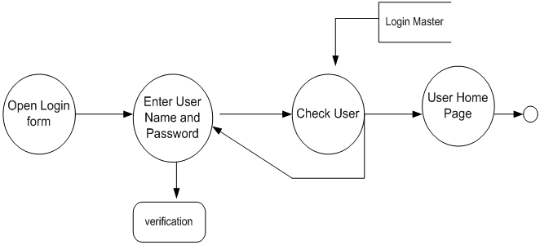

Figure 3.1: DFD Level 0 diagram

# DFD Level 1

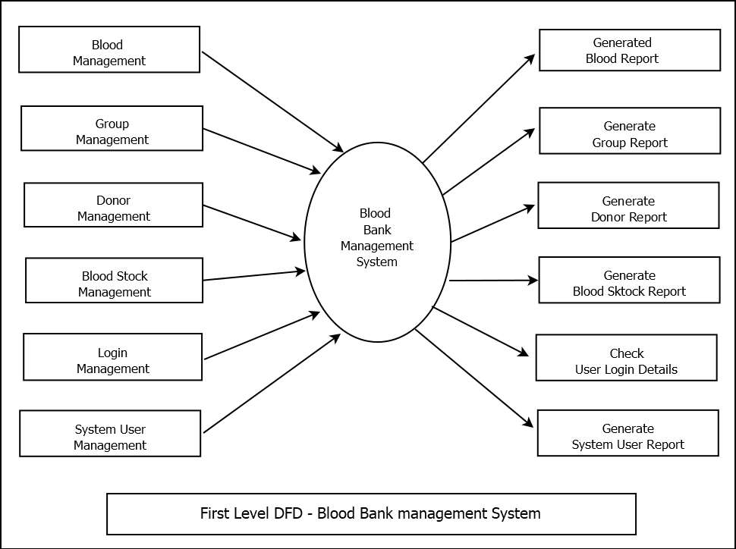

Figure 3.2: DFD Level 1 diagram

# ER Diagram

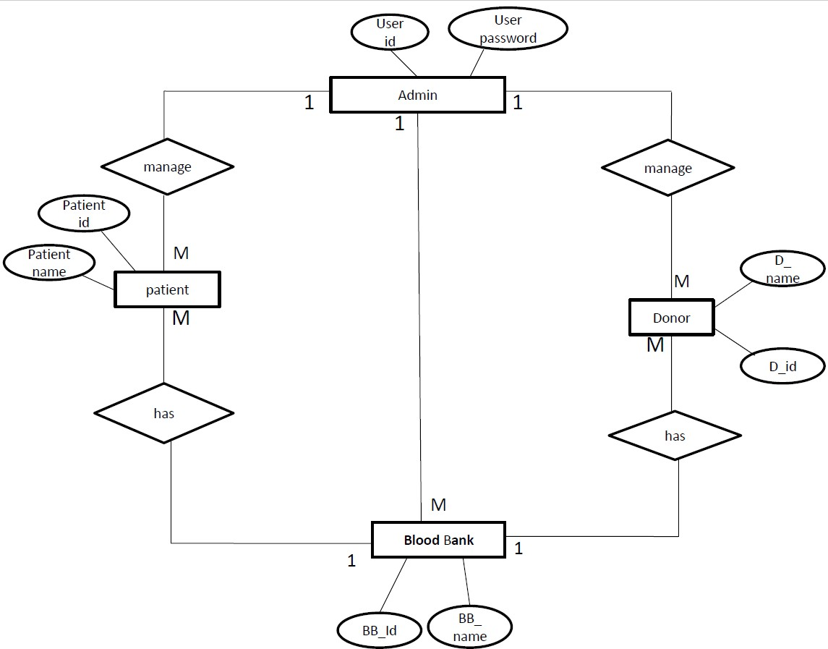

Figure 3.3: ER diagram

# Class Diagram

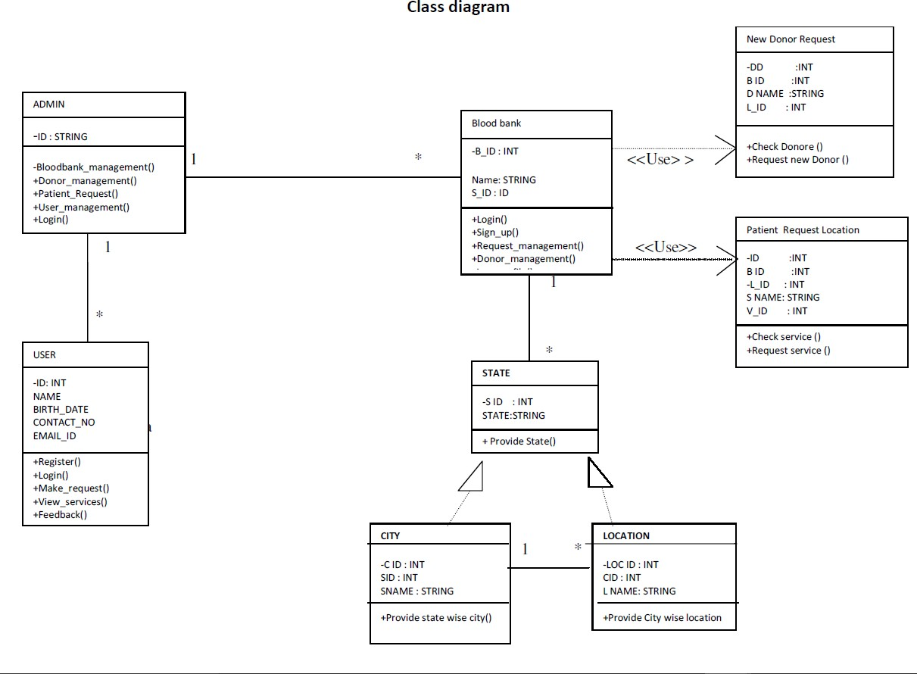

Figure 3.4: Class diagram

# Use Case Diagram

## Admin :

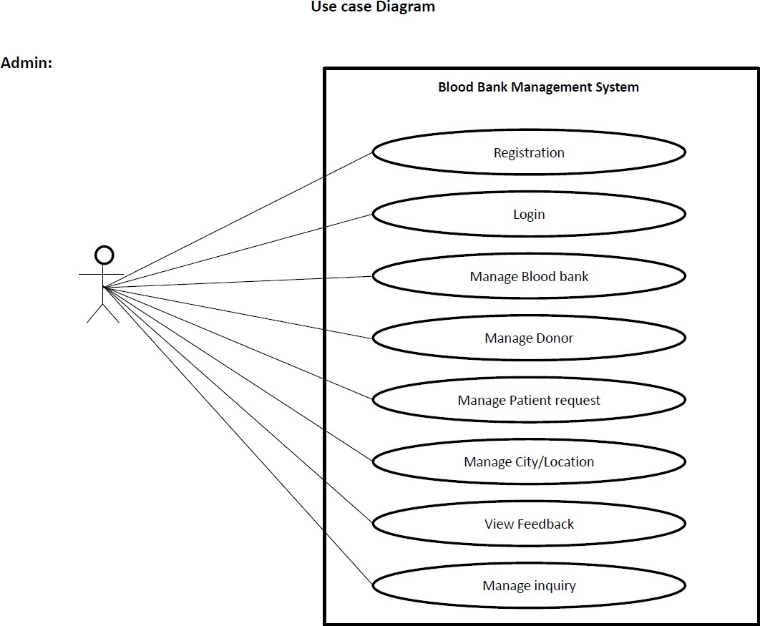

Figure 3.5: Use case Diagram

## Blood Bank :

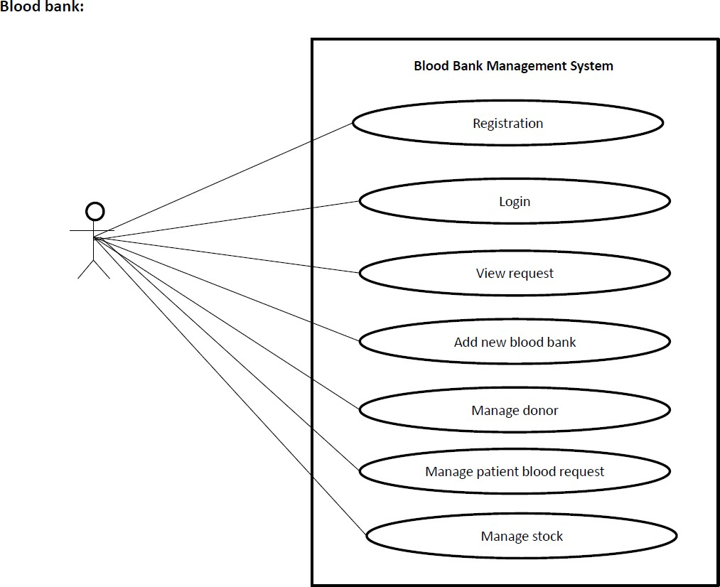

Figure 3.6: Use case Diagram

## Donor :

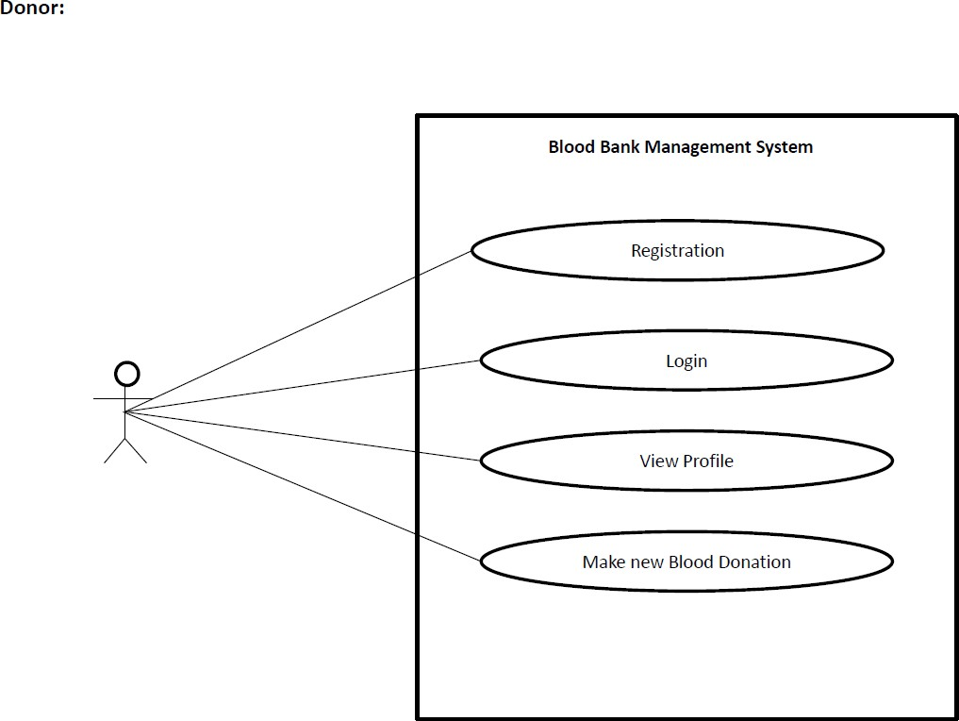

Figure 3.7: Use case Diagram

## Patient :

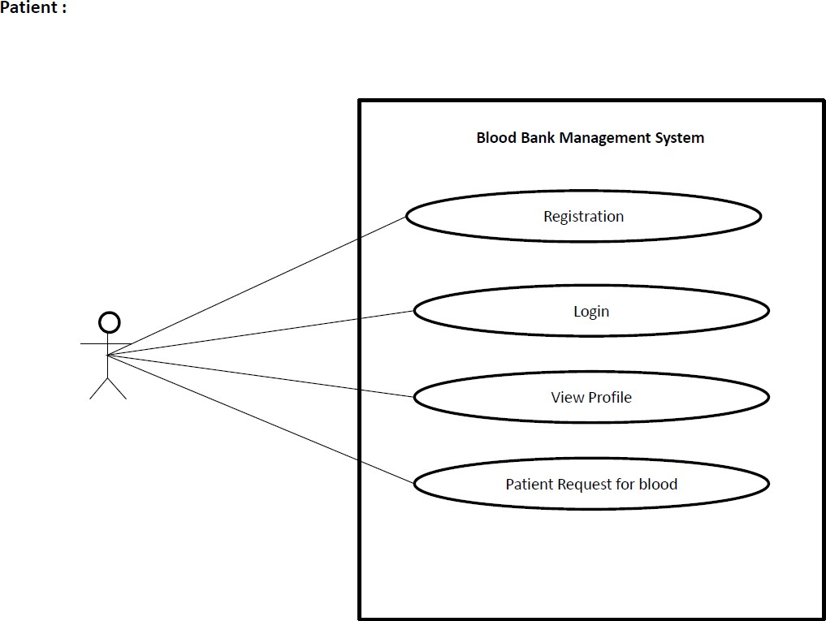

Figure 3.8: Use case Diagram

# Activity Diagram

## Admin :

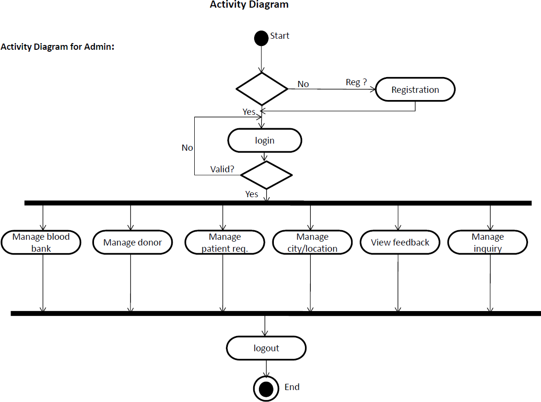

Figure 3.9: Activity Diagram

## Blood Bank :

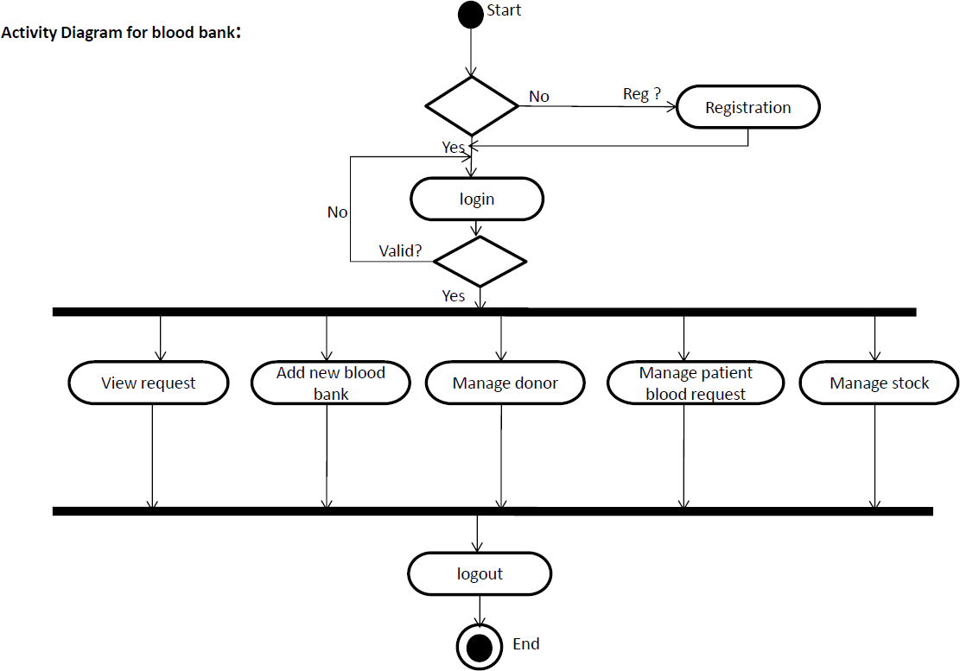

Figure 3.10: Activity Diagram

## Donor :

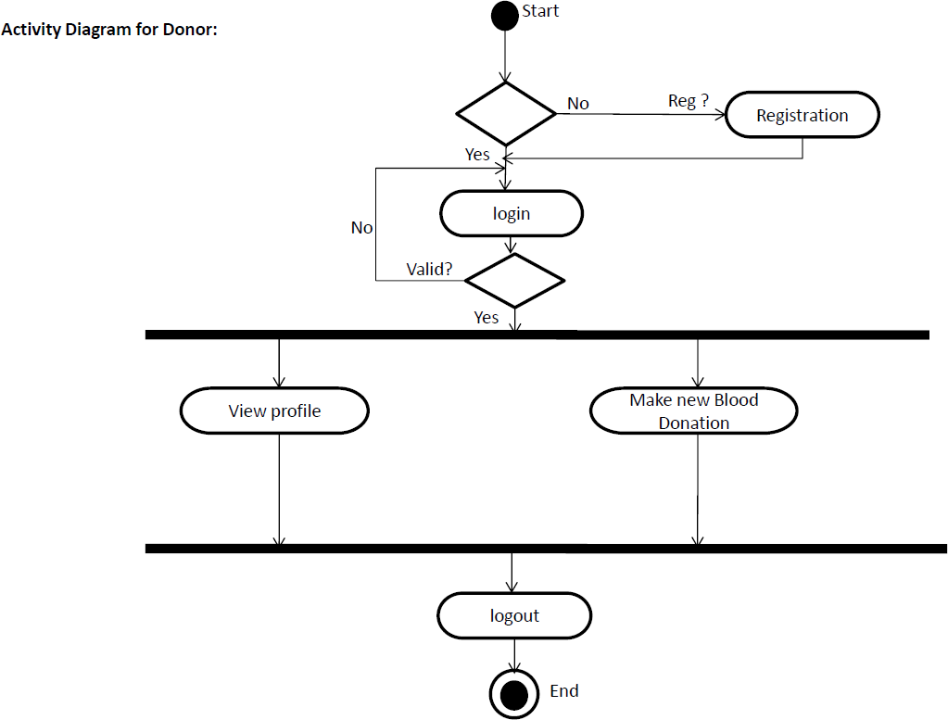

Figure 3.11: Activity Diagram

## Patient :

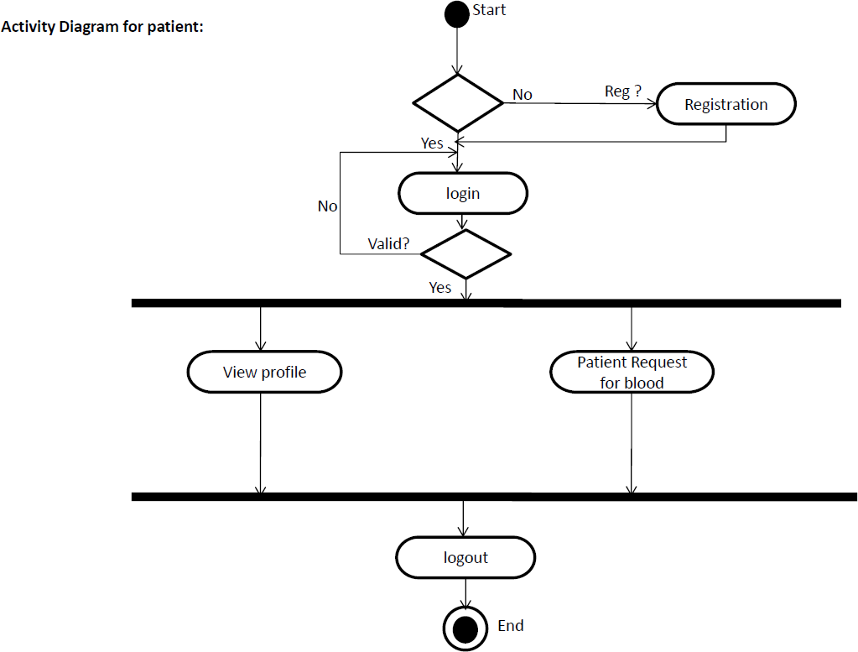

Figure 3.12: Activity Diagram

# 3.7 State Chart Diagram

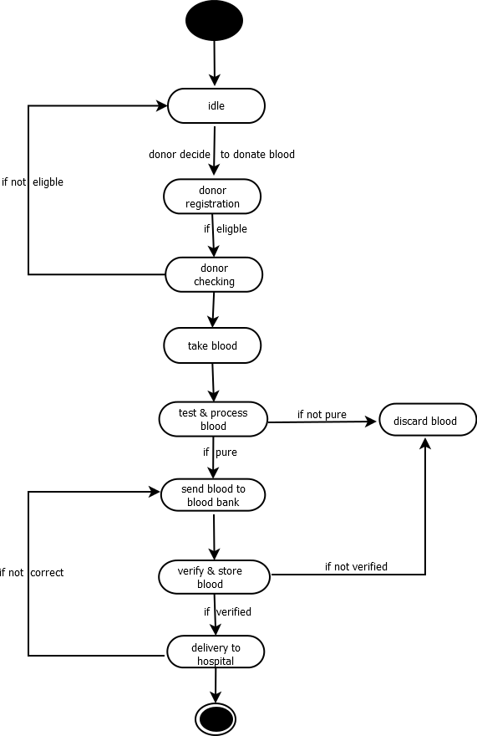

Figure 3.13: State chart Diagram

**Chapter 4 Snapshots**

# Home :

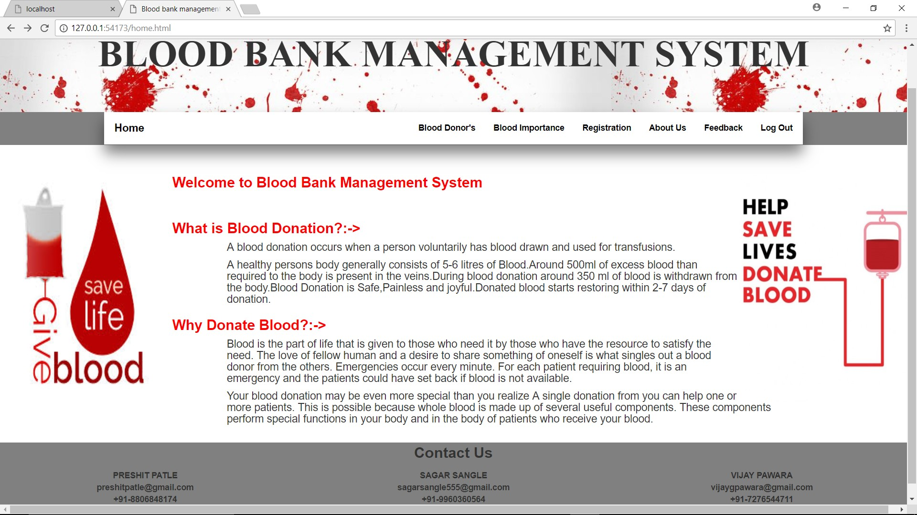

Figure 4.1: home

# Blood Donors :

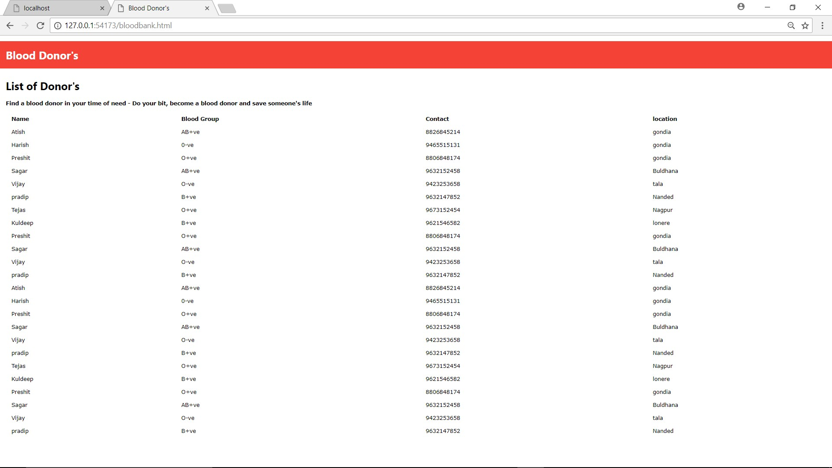

Figure 4.2: Blood Donors

# Blood Importance :

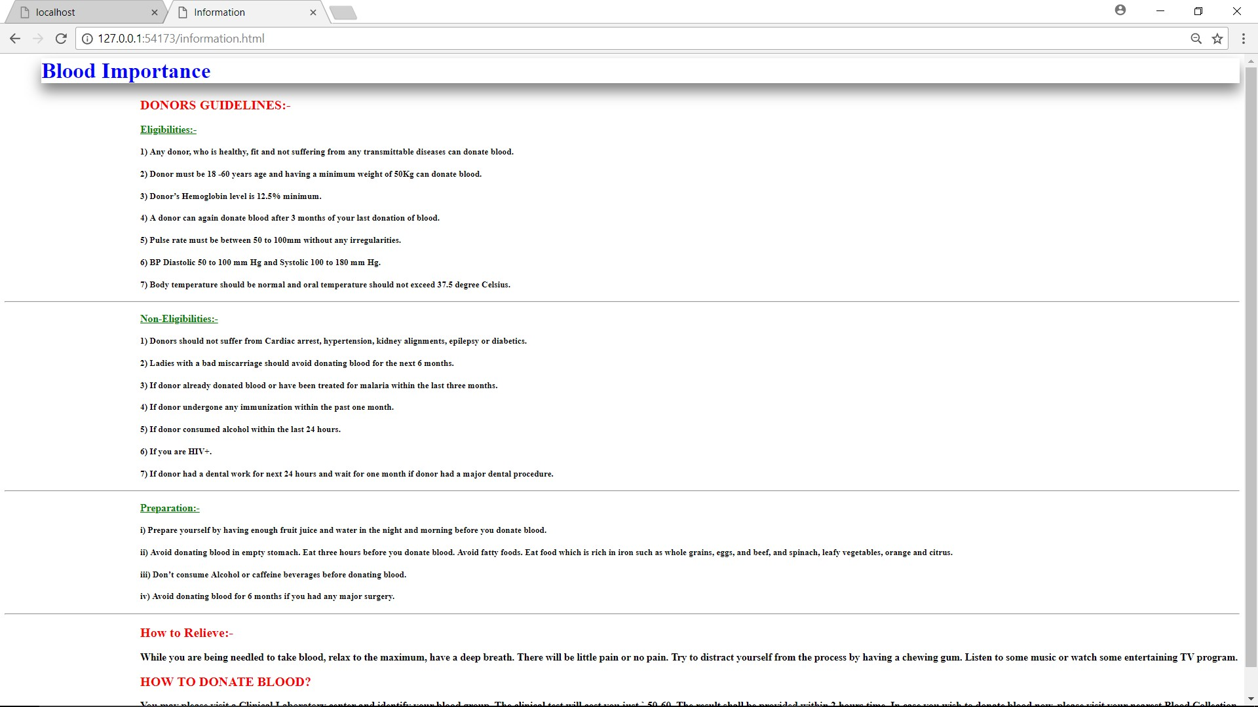

Figure 4.3: Blood Importance

# Registration Form :

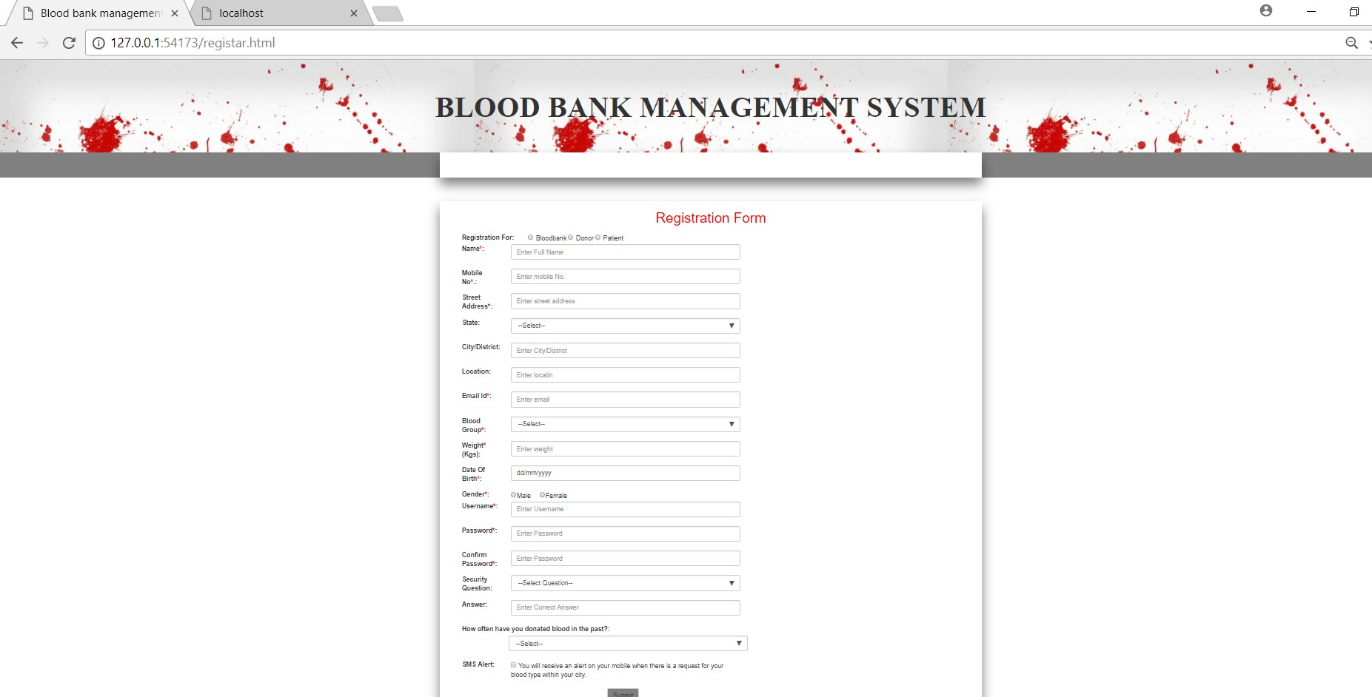

Figure 4.4: Registration Form

# About Us :

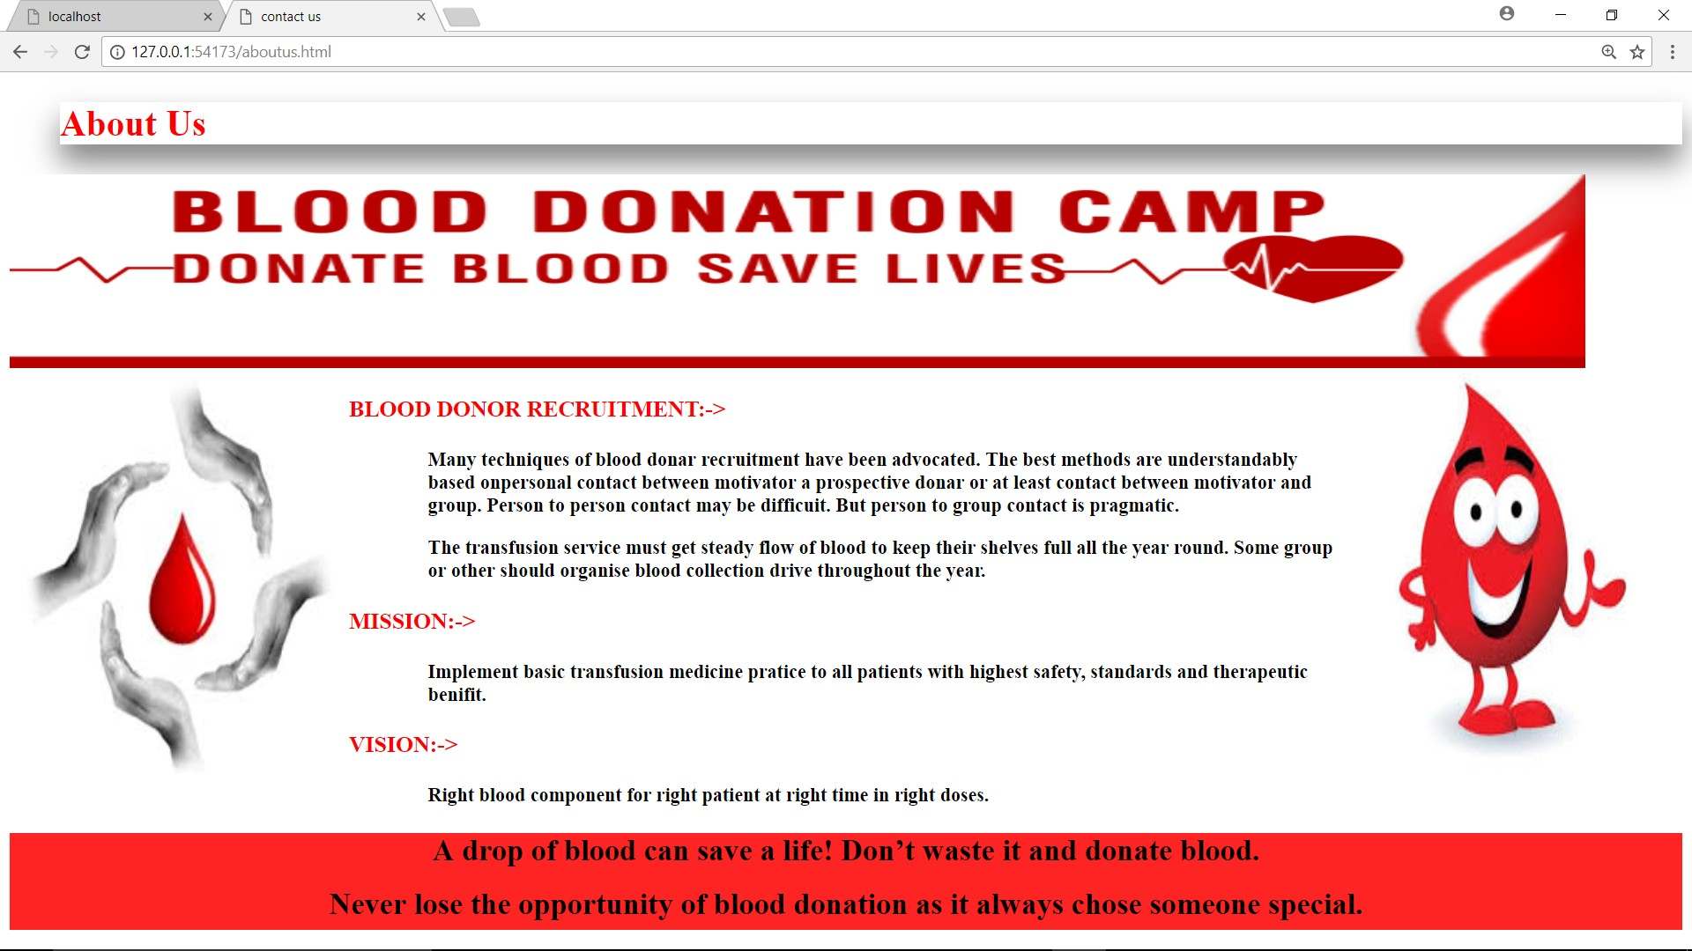

Figure 4.5: About Us

# Feedback Form :

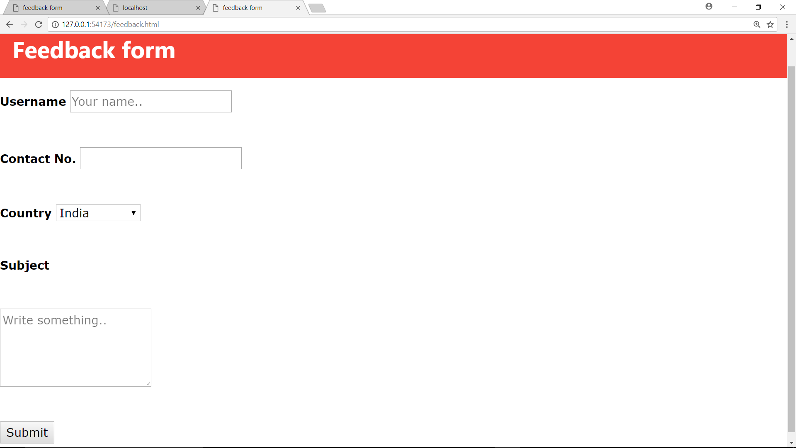

Figure 4.6: Feedback Form

# Log Out :

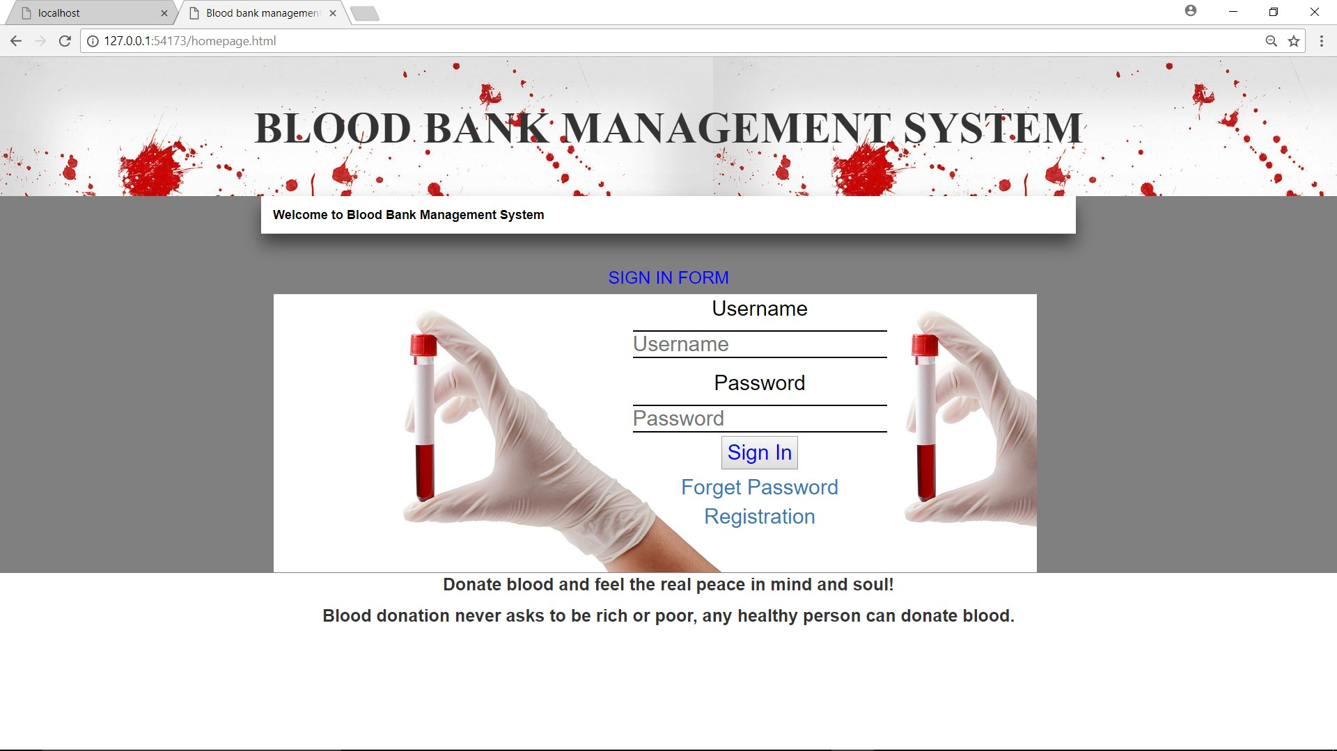

Figure 4.7: Log Out

**Chapter 5 Conclusion**

* This report present the Blood Bank Management System related issues.
* As the donor’s data is saved in the system we can reject those who have HIV or any other infections.
* As we have the contact number of the donor we can contact donor whenever necessary comes.
* Since we have the expiry data of packs we can have a proper storage management system.

**Chapter 6 References**

* + 1. h[ttps://www.w3sc](http://www.w3schools.com/bootstrap/bootstrapforms.asp)ho[ols.com/b](http://www.w3schools.com/bootstrap/bootstrapforms.asp)o[otstrap/b](http://www.w3schools.com/bootstrap/bootstrapforms.asp)o[otstrapforms.asp](http://www.w3schools.com/bootstrap/bootstrapforms.asp)
    2. h[ttps://www.w3sc](http://www.w3schools.com/css/)ho[ols.com/css/](http://www.w3schools.com/css/)
    3. h[ttps://www.tutorialsp](http://www.tutorialspoint.com/html)oin[t.com/h](http://www.tutorialspoint.com/html)tml online training index.asp
    4. h[ttps://www.tutorialsp](http://www.tutorialspoint.comPhpPHP-Home/)oin[t.comPhpPHP-Home](http://www.tutorialspoint.comPhpPHP-Home/)
    5. <http://www.bharatbloodbank.com/register.php>
    6. h[ttps://www.uml-diagrams.org/](http://www.uml-diagrams.org/)