*CREATE TABLE users*

*(*

*id INT,*

*name STRING,*

*salary INT,*

*unit STRING*

*) ROW FORMAT DELIMITED FIELDS TERMINATED BY '\t' stored as textfile ;*

*LOAD DATA LOCAL INPATH '/tmp/hive_data/users.txt' INTO TABLE users;*

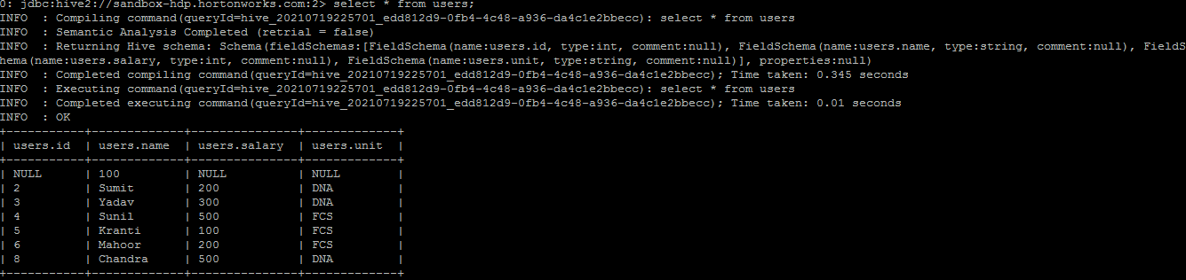

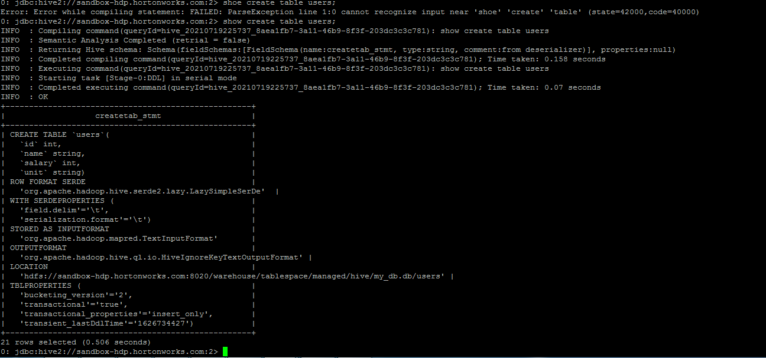

*CREATE TABLE locations*

*(*

*id INT,*

*location STRING*

*) ROW FORMAT DELIMITED FIELDS TERMINATED BY '\t' stored as textfile ;*

*LOAD DATA LOCAL INPATH '/tmp/hive_data/locations.txt' INTO TABLE locations;*

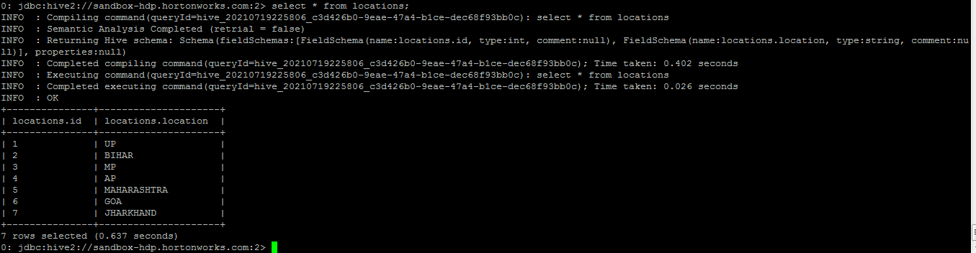

*CREATE TABLE buck_users*

*(*

*id INT,*

*name STRING,*

*salary INT,*

*unit STRING*

*) CLUSTERED BY (id) INTO 2 BUCKETS;*

*INSERT OVERWRITE TABLE buck_users*

*SELECT * FROM buck_users;*

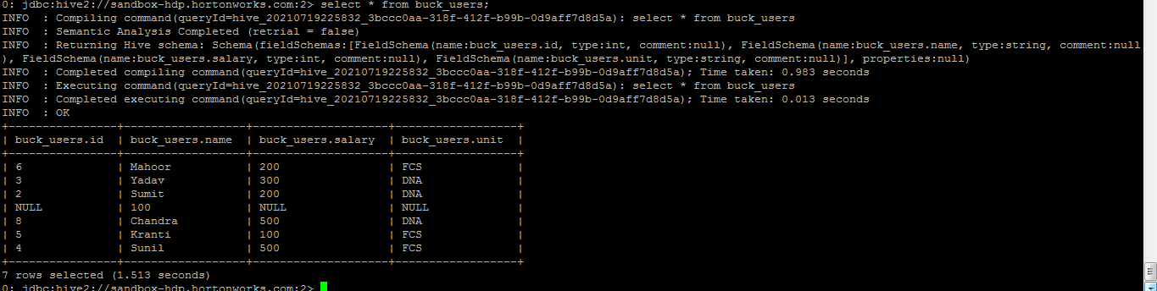

*CREATE TABLE buck_locations*

*(*

*id INT,*

*location STRING*

*) CLUSTERED BY (id) INTO 2 BUCKETS;*

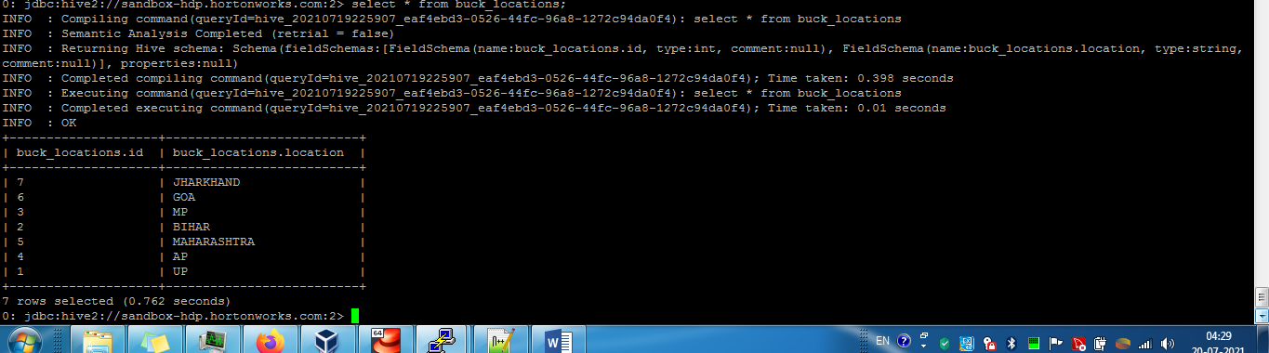

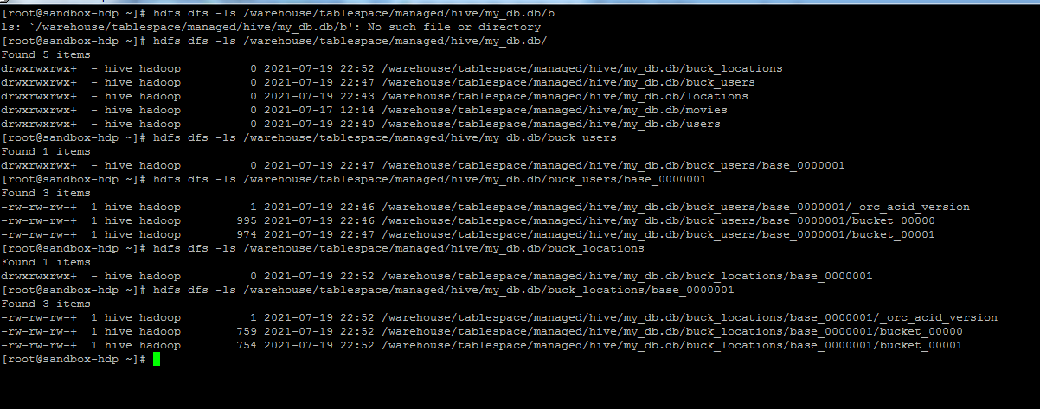

-------------------------------------------------------------------------------------------------------

Csvserde.txt

*CREATE TABLE csv_table(name string, location string)*

*ROW FORMAT SERDE 'org.apache.hadoop.hive.serde2.OpenCSVSerde'*

*WITH SERDEPROPERTIES (*

*"separatorChar" = ",",*

*"quoteChar" = "\"",*

*"escapeChar" = "\\"*

*)*

*STORED AS TEXTFILE*

*TBLPROPERTIES ("skip.header.line.count"="1");*

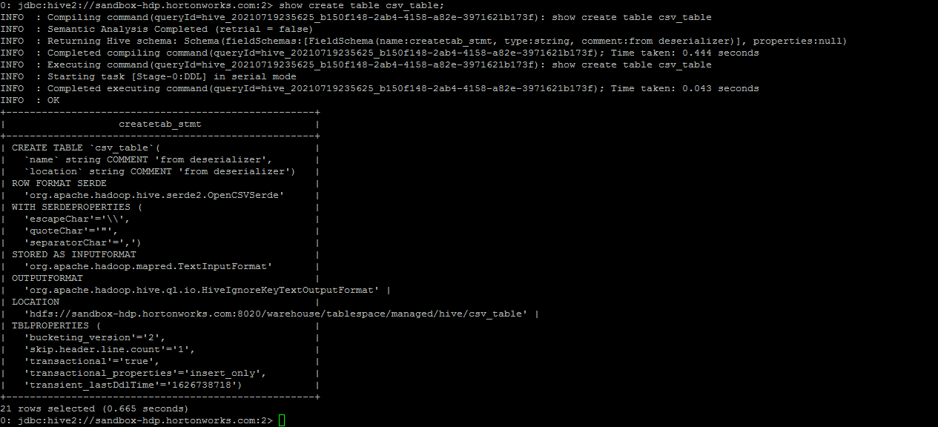

*select location from csv_table;*

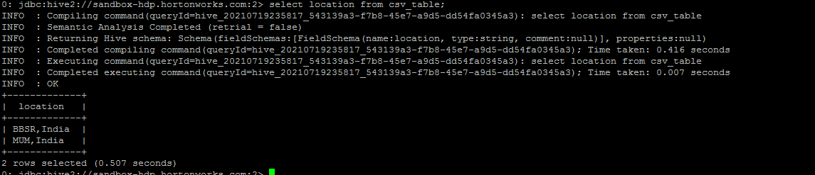

*select * from csv_table;*

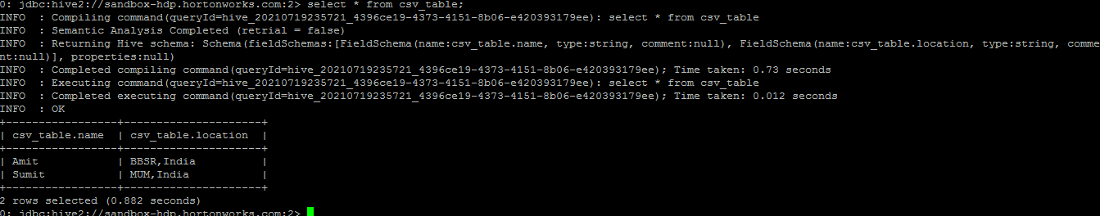

databaseddl

*CREATE DATABASE IF NOT EXISTS ineuron_db;*

*USE ineuron_db;*

**

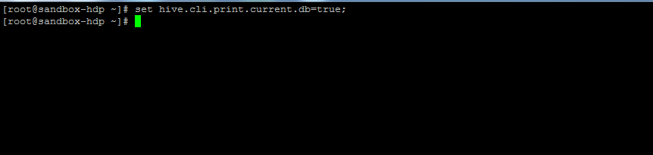

*create database if not exists a_newdb;*

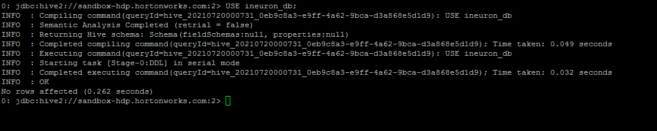

*SHOW DATABASES LIKE 'a.*';*

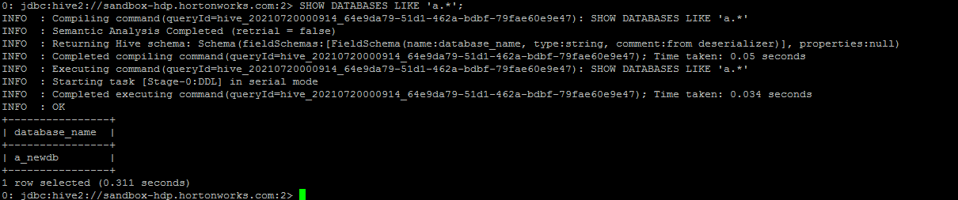

*SHOW CREATE TABLE emp_details1;*

**

*DROP DATABASE ineuron_db;*

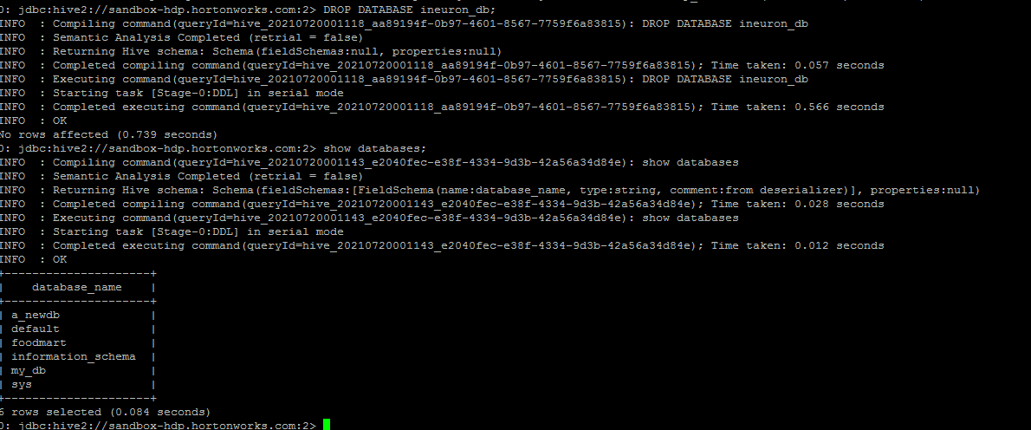

*su hdfs*

*hdfs dfs -mkdir /user/ineuron*

*hdfs dfs -chmod 777 /user/ineuron*

*CREATE DATABASE ineuron_db LOCATION '/user/ineuron/mydb';*

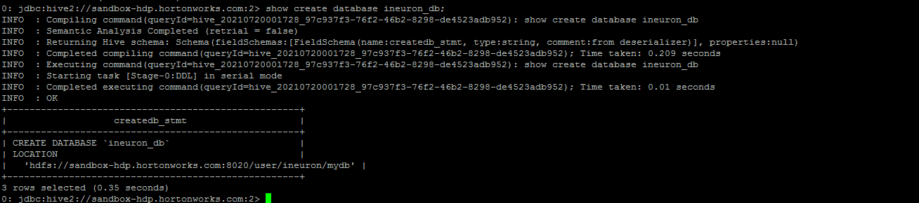

*DESCRIBE DATABASE ineuron_db;*

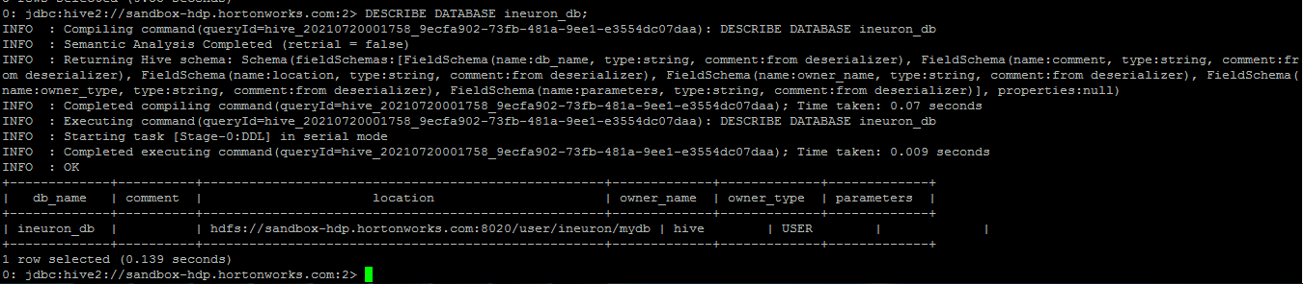

*DROP DATABASE IF EXISTS ineuron_db;*

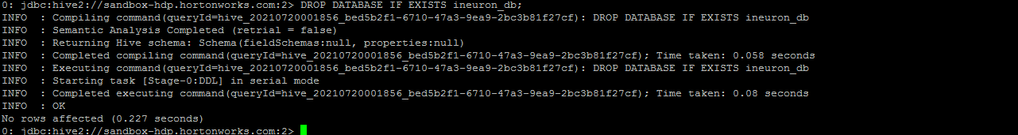

*DROP DATABASE IF EXISTS ineuron_db CASCADE;*

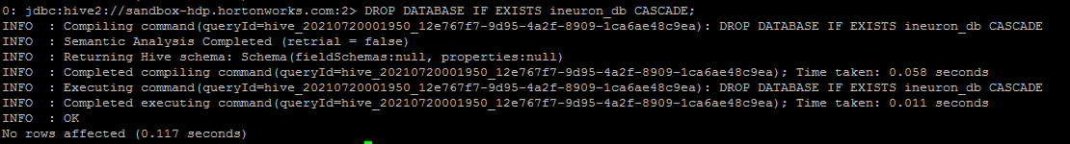

*create table emp_details1*

*(*

*emp_name int,unit string,exp int,location string*

*)*

*row format delimited*

*fields terminated by ',';*

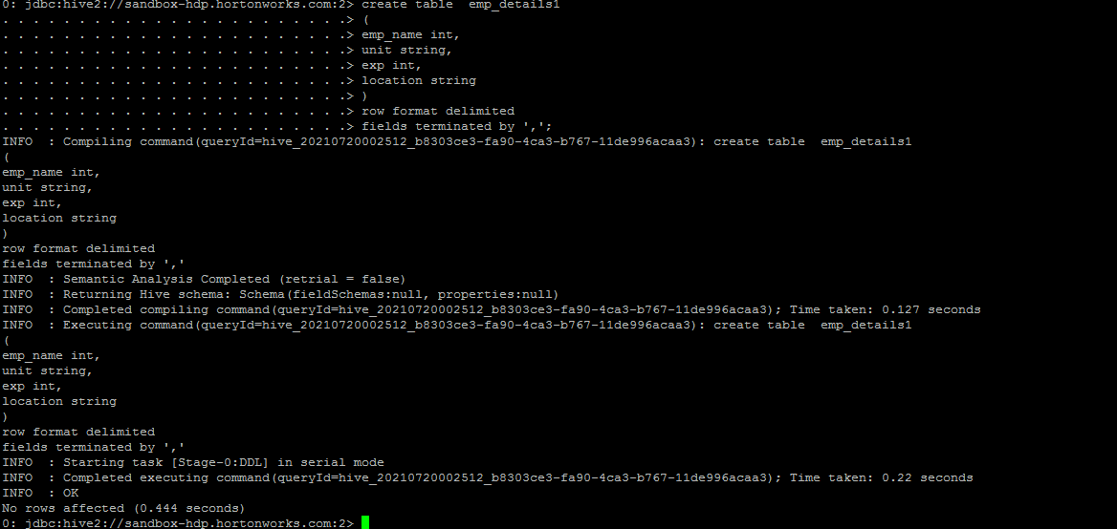

*DESCRIBE emp_details1;*

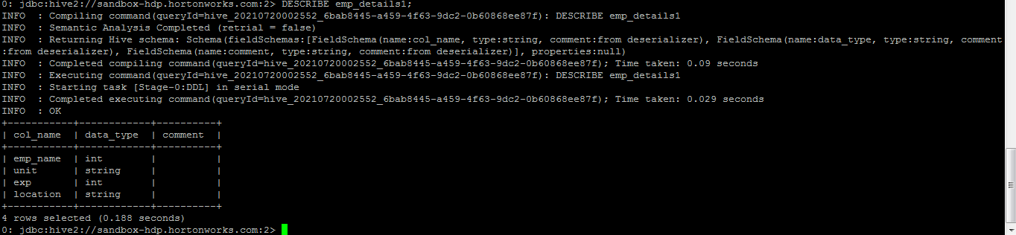

*describe formatted emp_details1;*

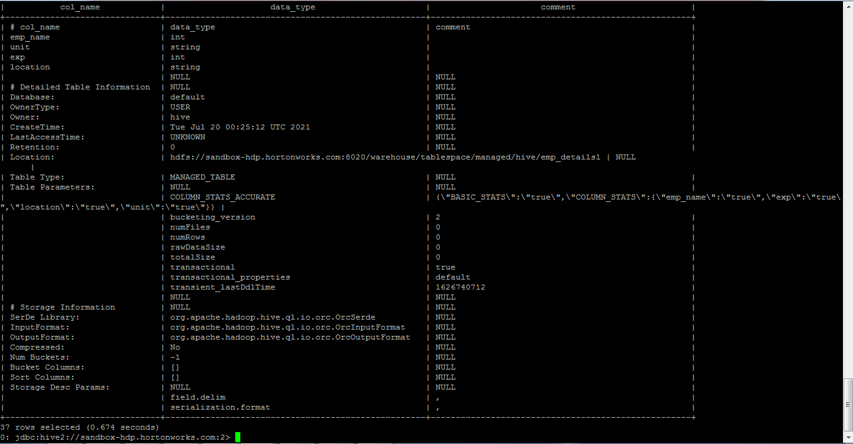

*SHOW TABLES LIKE '*emp*';*

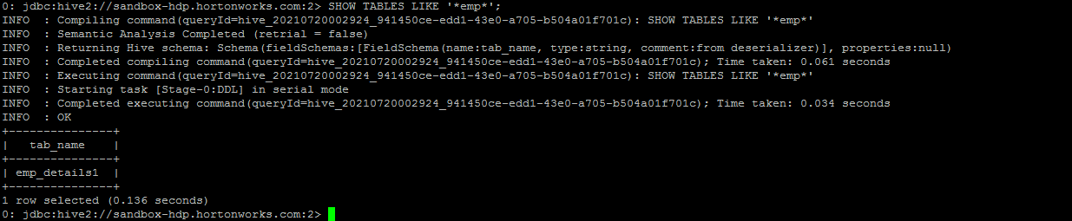

*DROP TABLE IF EXISTS emp_details1;*

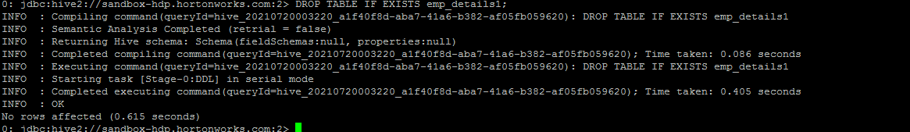

*create table emp_details1*

*(*

*emp_name int,*

*unit string,*

*exp int,*

*location string*

*)*

*row format delimited*

*fields terminated by ',';*

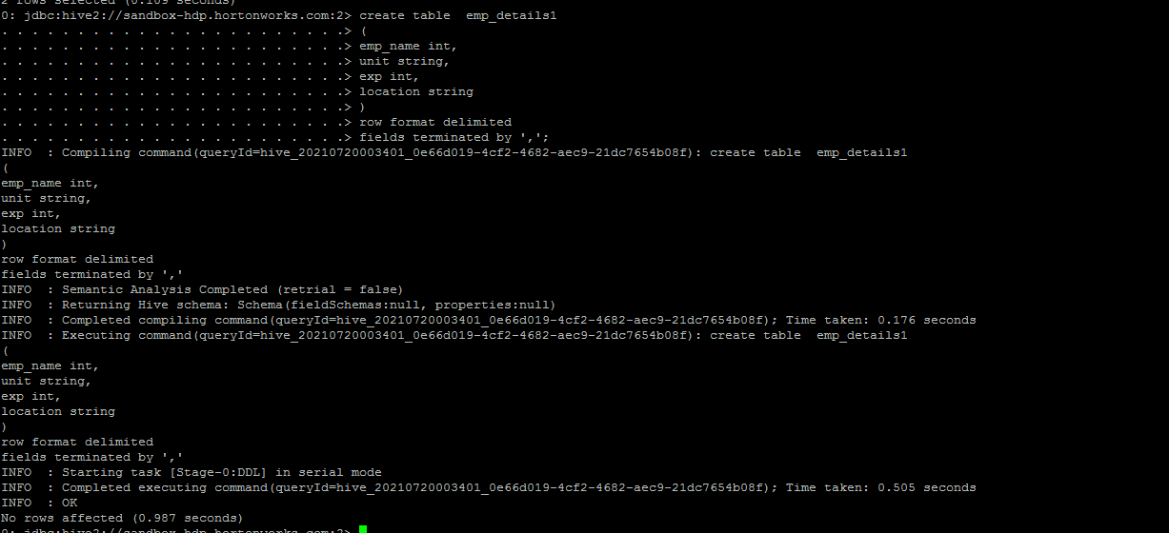

*ALTER TABLE emp_details1 RENAME TO employee_details;*

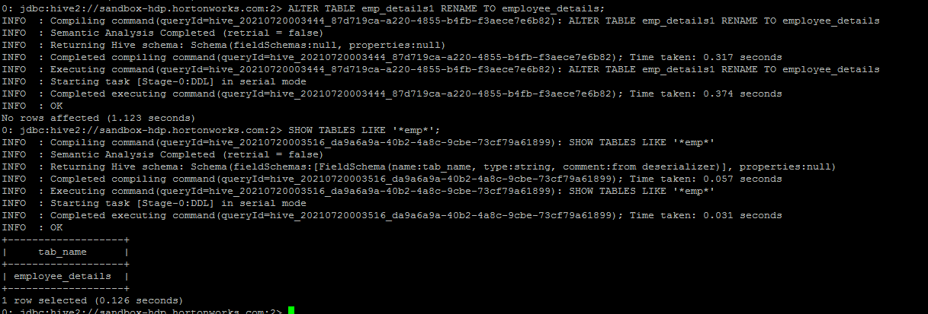

*ALTER TABLE employee_details*

*CHANGE COLUMN emp_name emppp_name STRING*

*COMMENT 'Employee Name';*

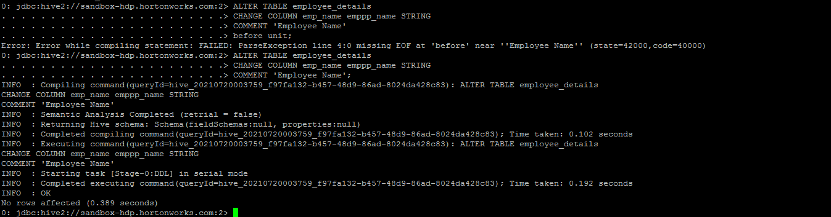

*DESCRIBE FORMATTED emp_details;*

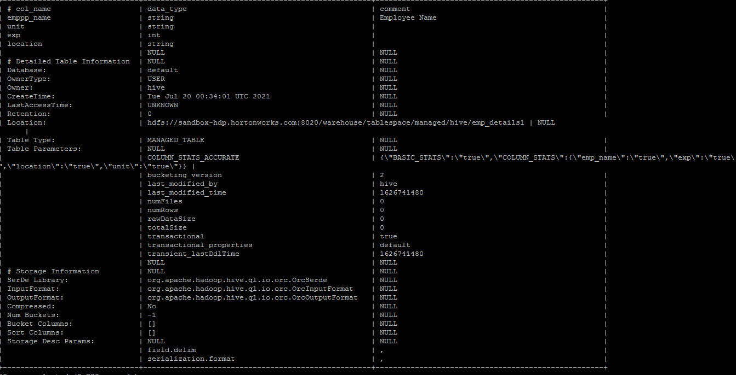

*CREATE VIEW emp_view1 AS SELECT emppp_name FROM employee_details limit 1;*

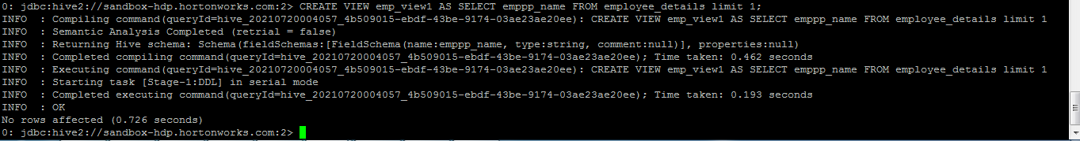

*SELECT * FROM emp_view1;*

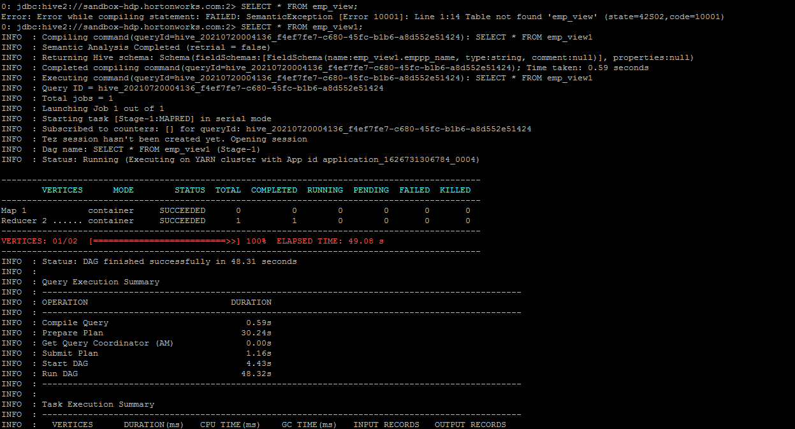

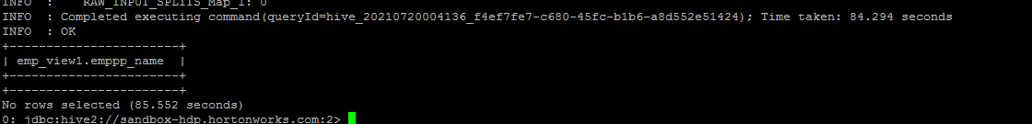

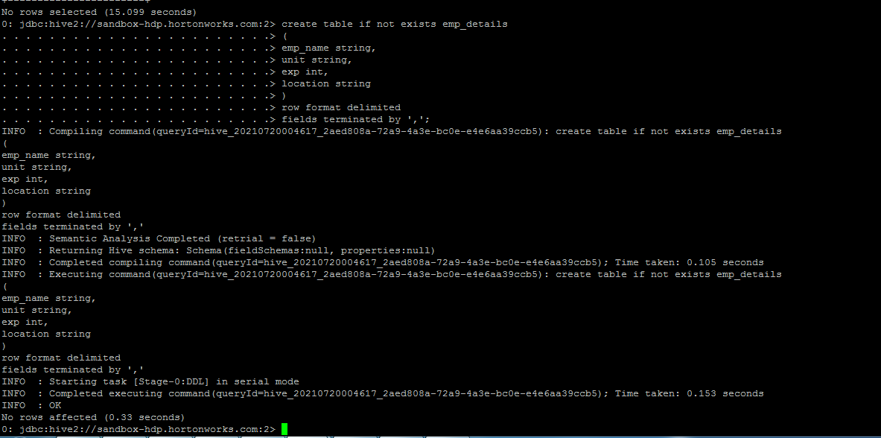

*LOAD DATA LOCAL INPATH '/tmp/hive_data/emp_details_gopal.txt' INTO TABLE emp_details;*

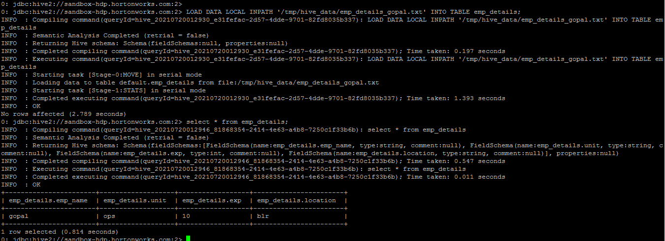

*drop table emp_details;*

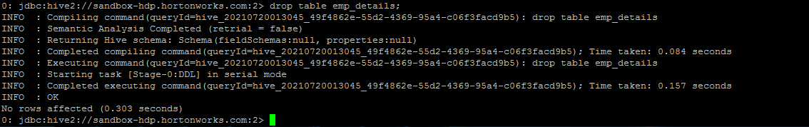

*create table emp_details2*

*(*

*emp_name string,*

*unit string,*

*exp int,*

*location string*

*)*

*row format delimited*

*fields terminated by ','*

*STORED AS TEXTFILE;*

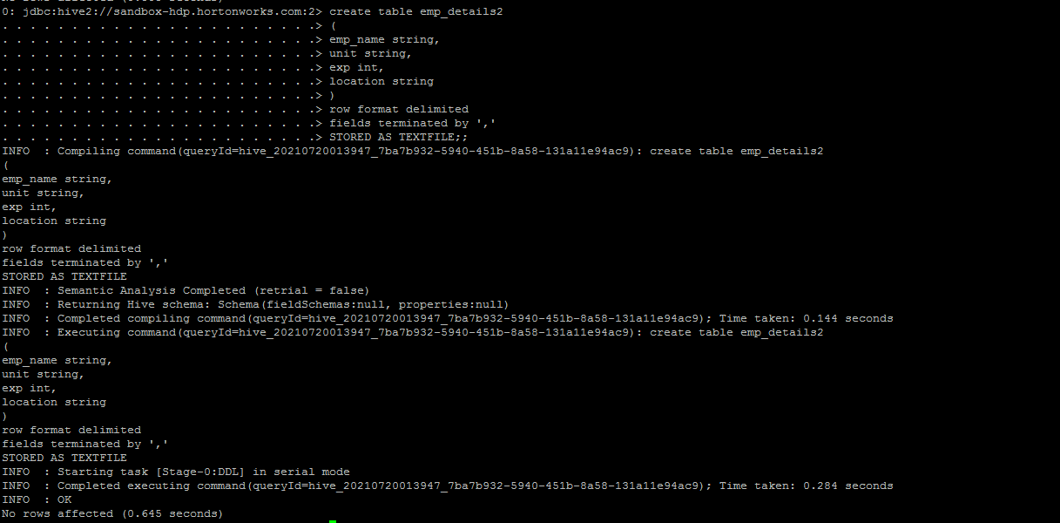

*LOAD DATA INPATH '/user/ineuron/hive1/emp_details_gopal1.txt' INTO TABLE emp_details2;*

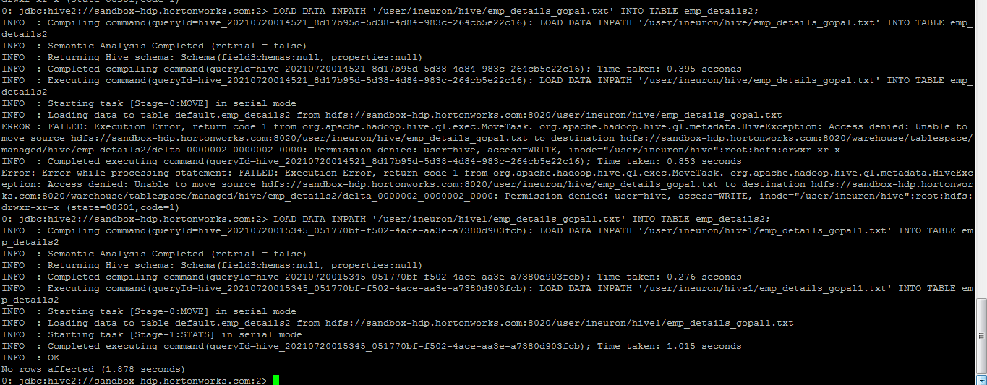

*INSERT OVERWRITE LOCAL DIRECTORY '/tmp/output'*

*ROW FORMAT DELIMITED*

*FIELDS TERMINATED BY '|'*

*SELECT * FROM emp_details2;*

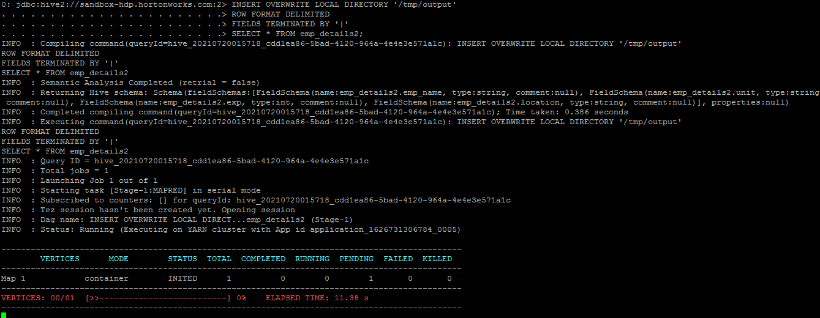

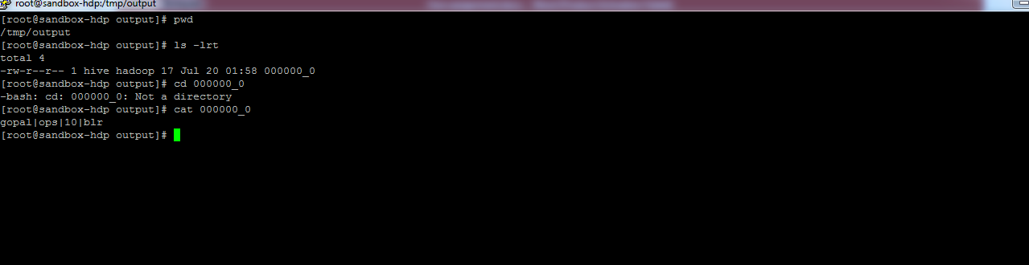

*SELECT * FROM emp_details2;*

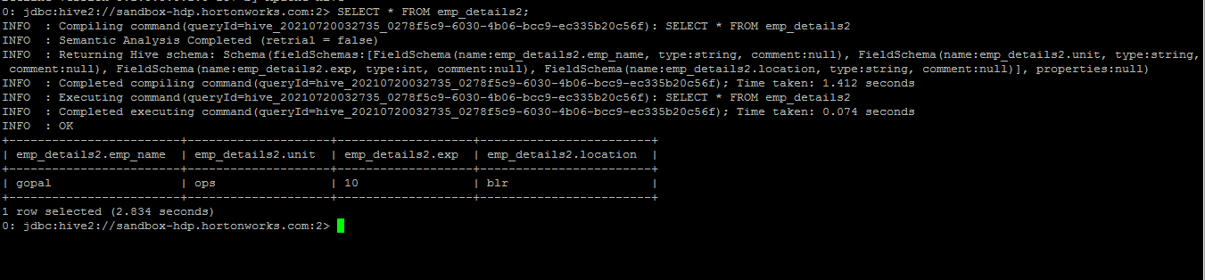

*SELECT emp_name FROM emp_details2;*

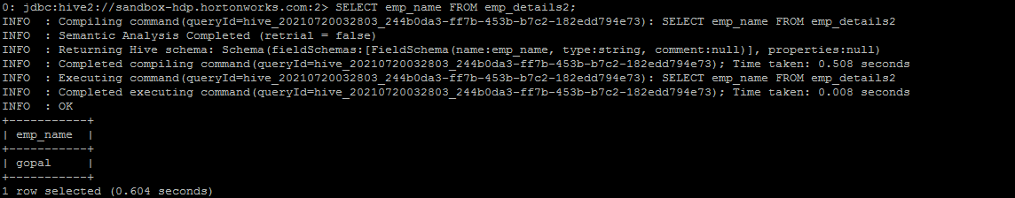

*SELECT e.emp_name FROM emp_details2 e;*

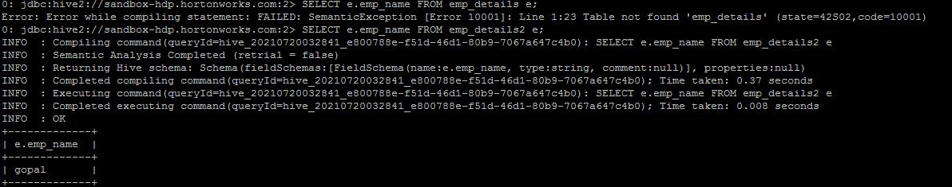

*select * from empp_details2 where exp > 2;*

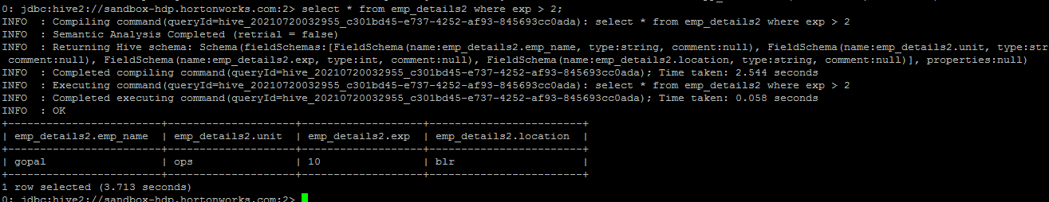

*SELECT * FROM emp_details2 WHERE unit like "%op%";*

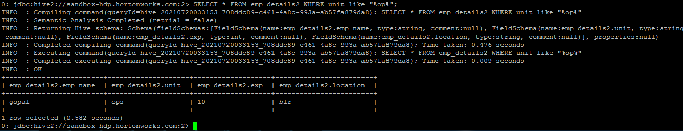

*SELECT * FROM emp_details2 WHERE emp_name RLIKE '.*(mi|ni).*';*

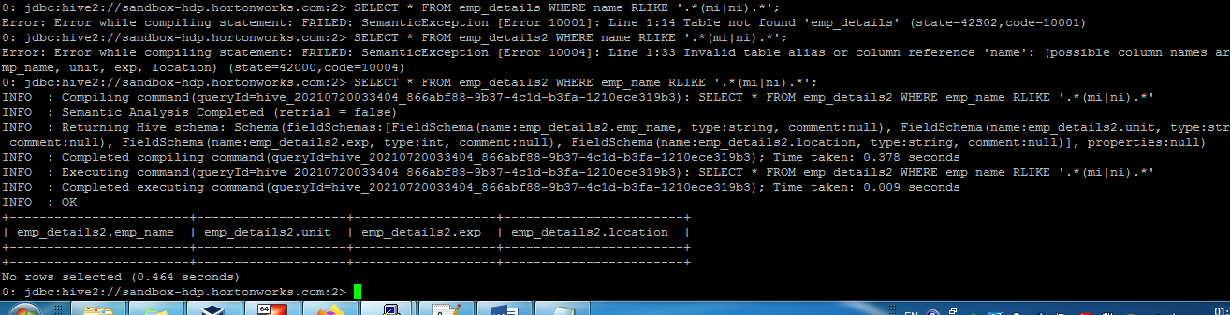

*SELECT location, COUNT(*) FROM emp_details2 GROUP BY location;*

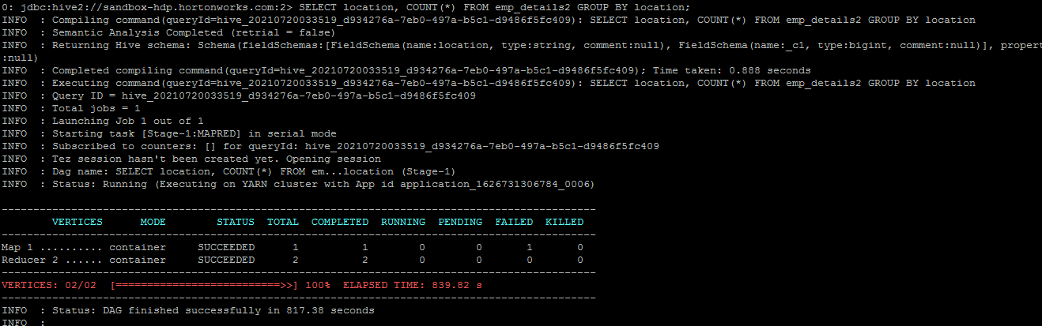

*SELECT location, COUNT(*) FROM emp_details2 GROUP BY location HAVING AVG(exp) > 1.5;*

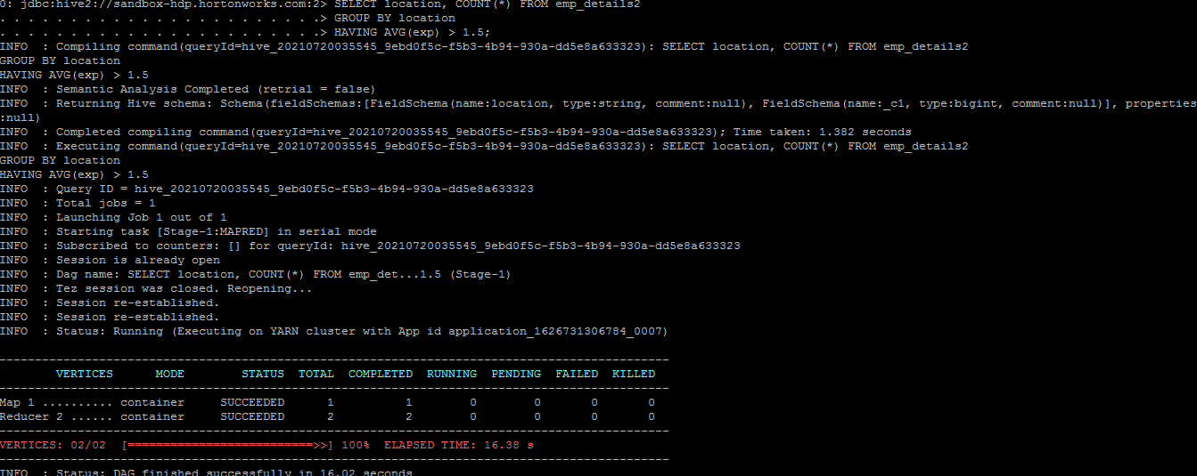

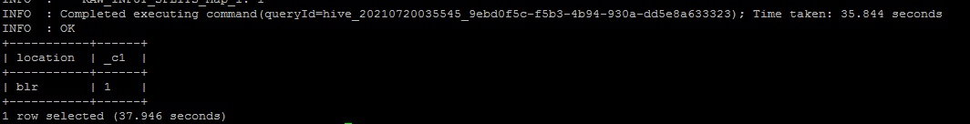

*SELECT * FROM emp_details2 ORDER BY exp;*

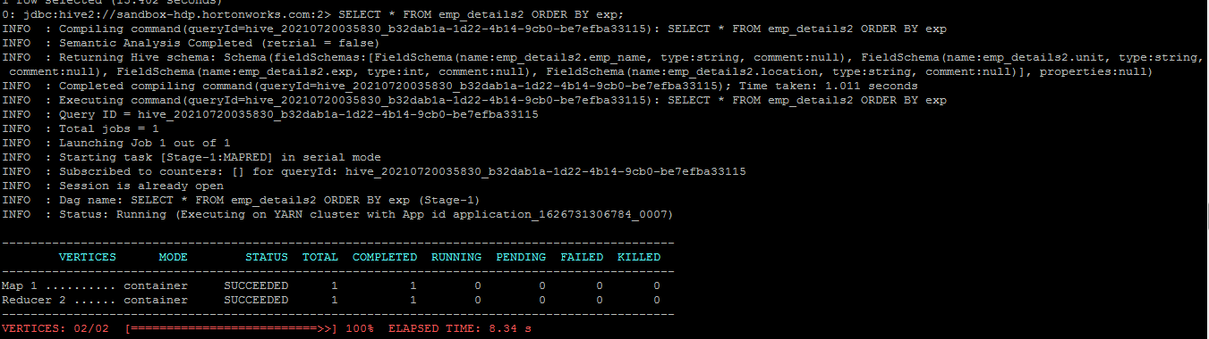

*Added few more rows in emp_details2*

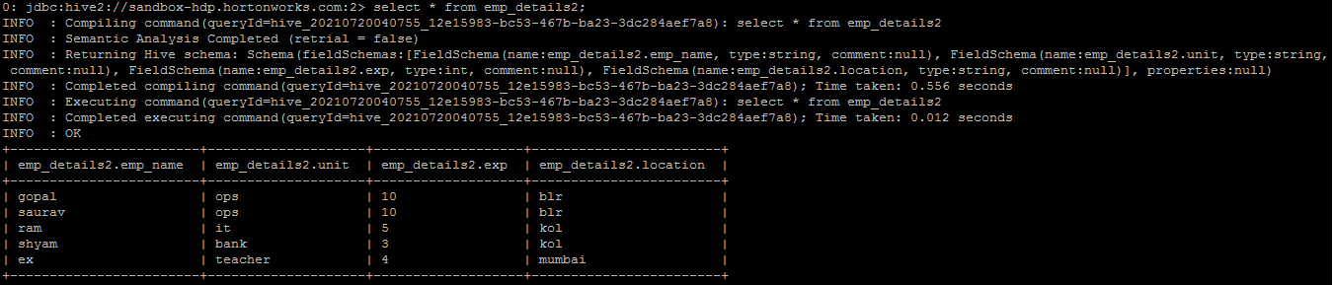

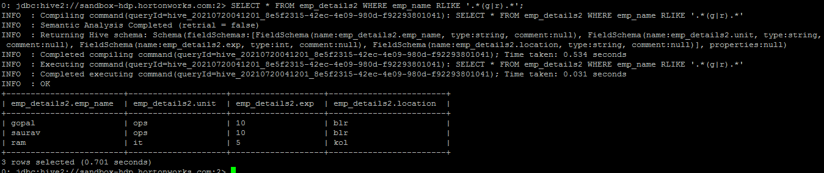

*SELECT location, COUNT(*) FROM emp_details2 GROUP BY location;*

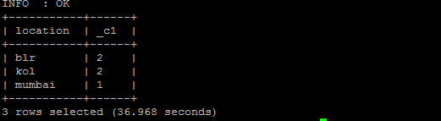

*SELECT location, COUNT(*) FROM emp_details2 GROUP BY location HAVING AVG(exp) > 2.5;*

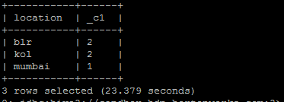

*SELECT * FROM emp_details2 ORDER BY exp;*

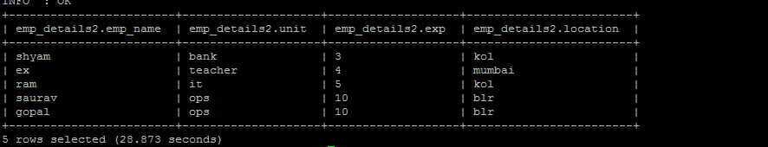

*SELECT * FROM emp_details2 ORDER BY exp desc;*

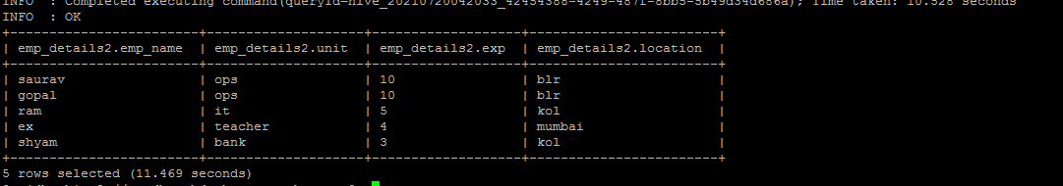

*explain select * from emp_details2;*

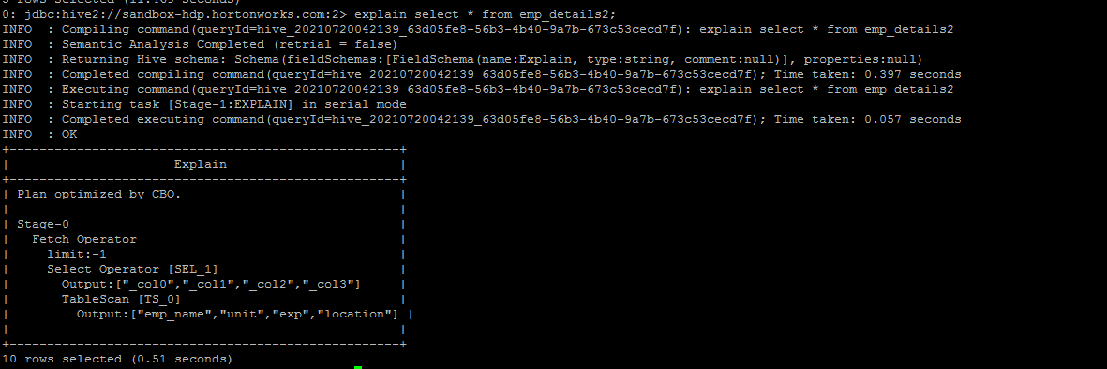

*EXPLAIN SELECT location, COUNT(*) FROM emp_details2 GROUP BY location;*

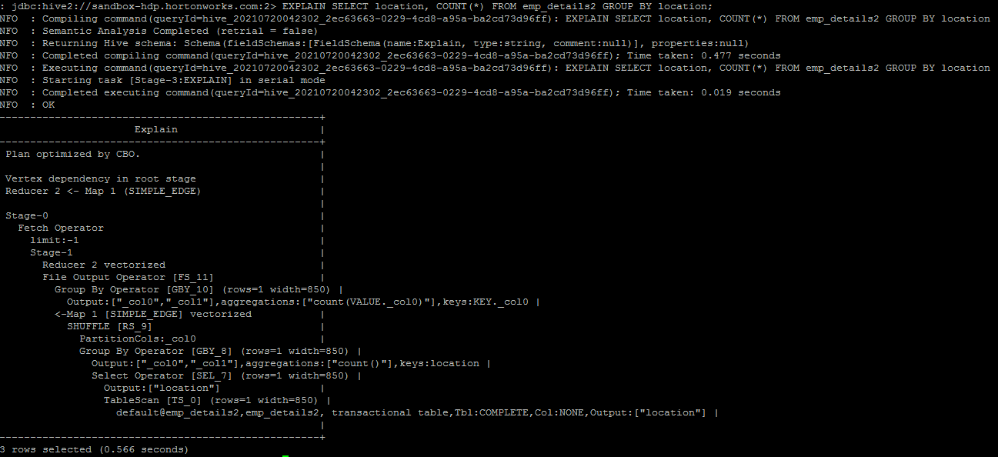

*EXPLAIN SELECT * FROM emp_details2 WHERE exp >= 2;*

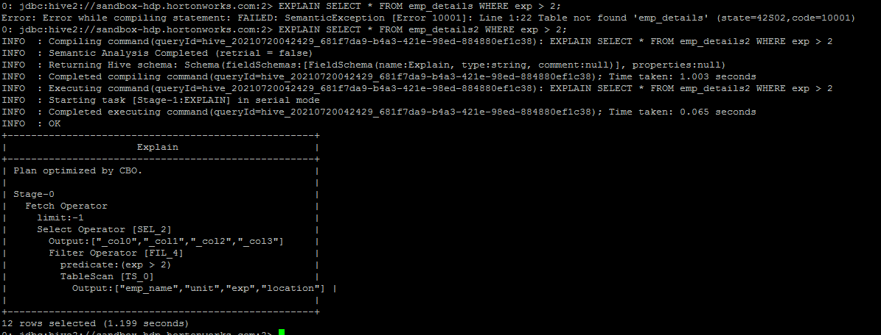

*EXPLAIN SELECT location, COUNT(*) FROM emp_details2 GROUP BY location;*

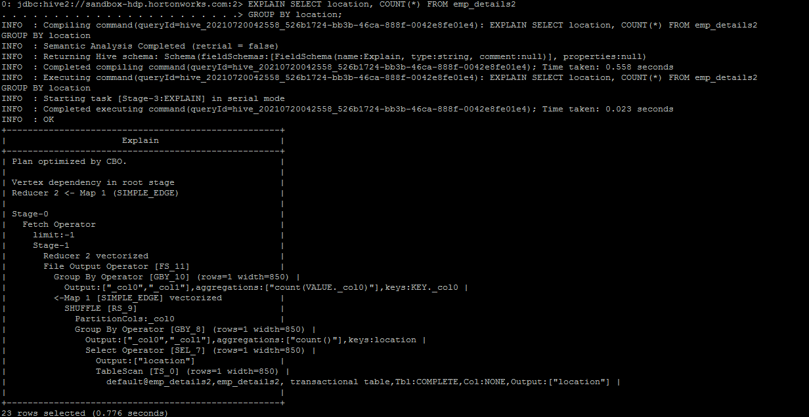

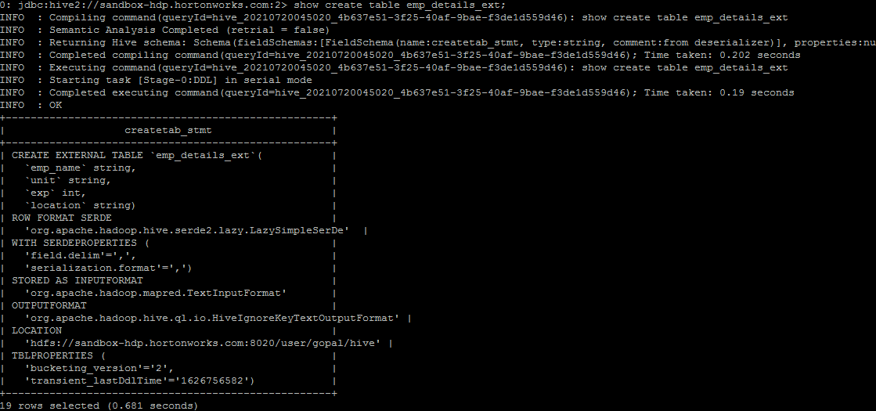

*select * from emp_details_ext;*

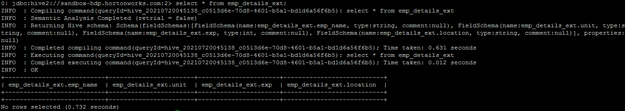

*create external table emp_details_ext*

*(*

*emp_name string,*

*unit string,*

*exp int,*

*location string*

*)*

*row format delimited*

*fields terminated by ','*

*location '/user/gopal/hive/';*

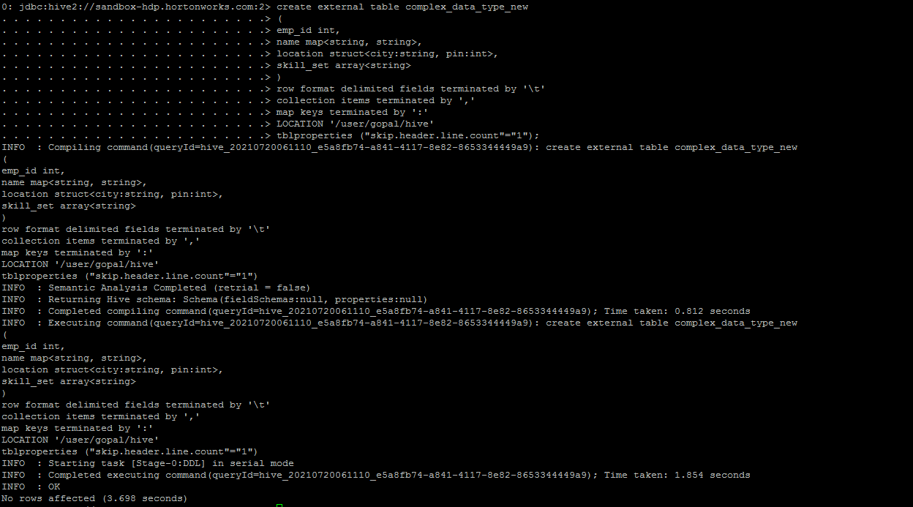

*LOAD DATA LOCAL INPATH '/tmp/hive_data/complex_data_type.txt'*

*OVERWRITE INTO TABLE complex_data_type_new;*

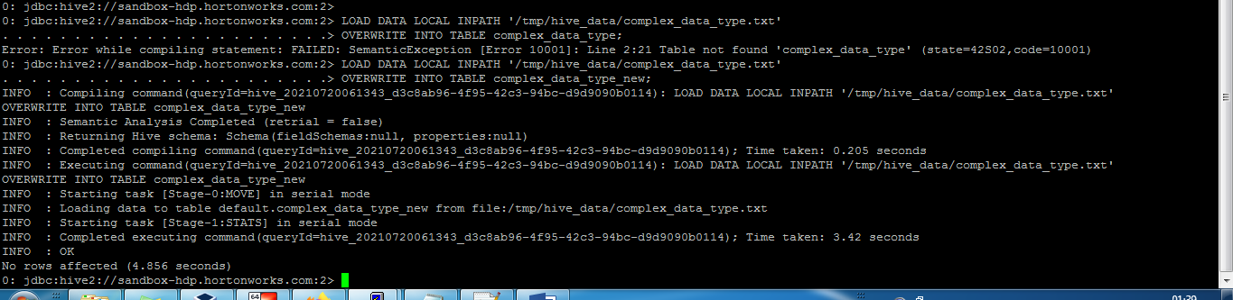

*SELECT emp_id, name, location, skill_set FROM complex_data_type_new;*

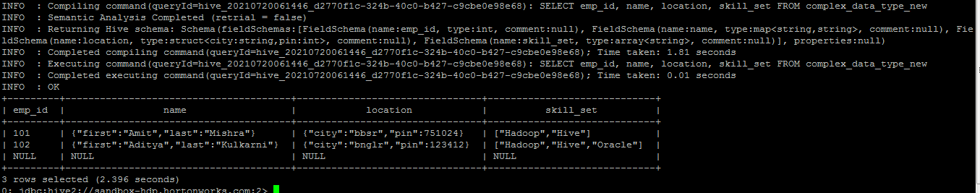

*SELECT emp_id, name['first'], location.city, skill_set[0] FROM complex_data_type_new;*

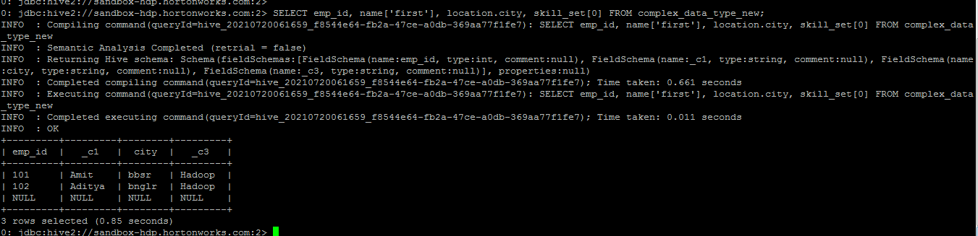

*hive -e "SELECT * FROM complex_data_type_new LIMIT 2";*

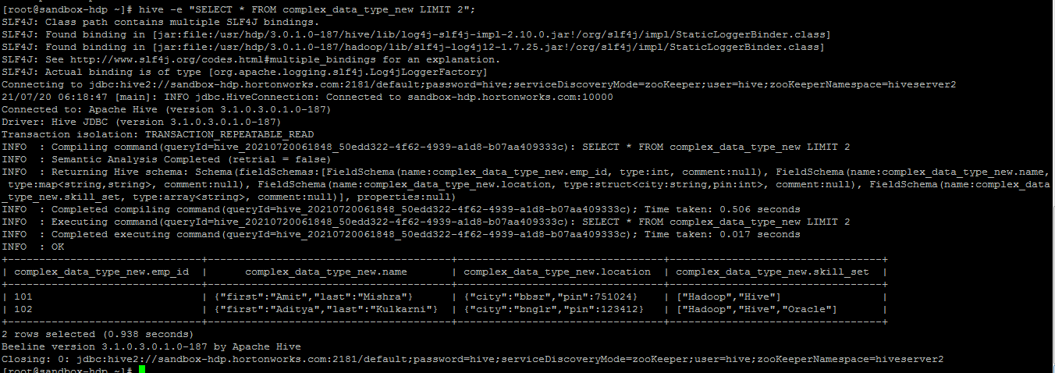

*hive --define ROWS=2 -S -e "select * FROM complex_data_type_new LIMIT ${ROWS}" > /tmp/hive_data/myquery*

*hive -f /tmp/hive_data/query.hql*

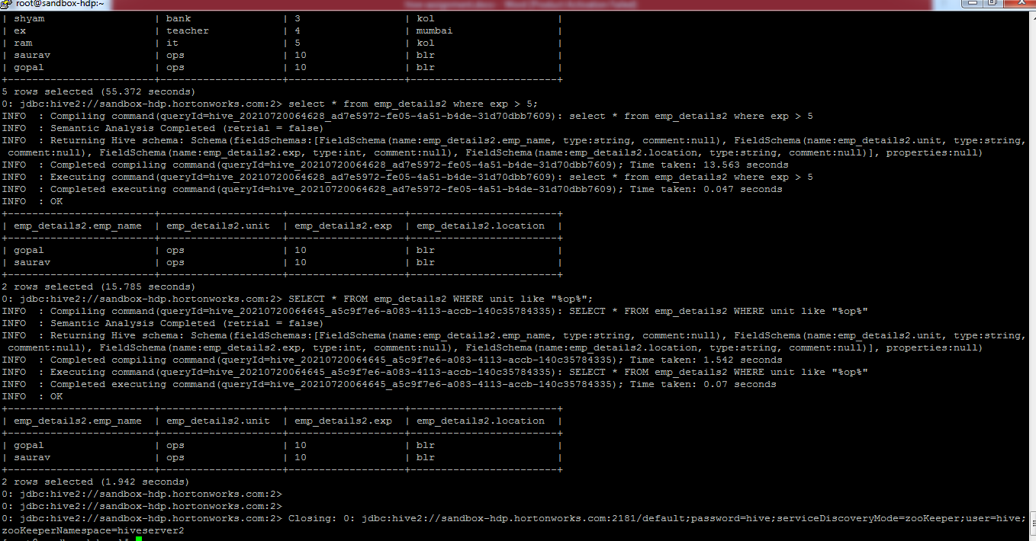

*Hive practical:*

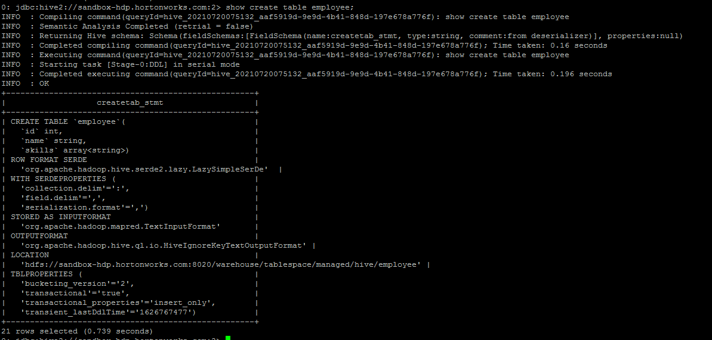

*LOAD DATA LOCAL INPATH '/tmp/hive_data/employee.csv' INTO TABLE employee;*

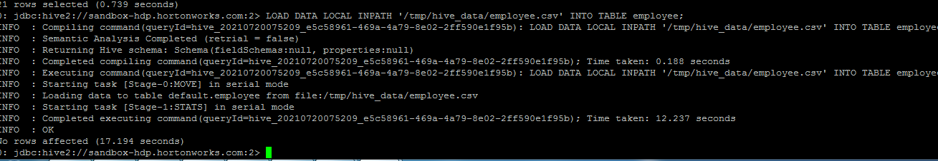

*SELECT*

*size(skills),*

*array_contains(skills, 'HADOOP'),*

*sort_array(skills),*

*concat_ws("|", skills)*

*FROM employee;*

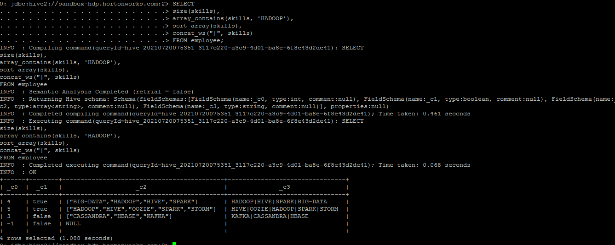

*SELECT explode(skills) AS skills FROM employee;*

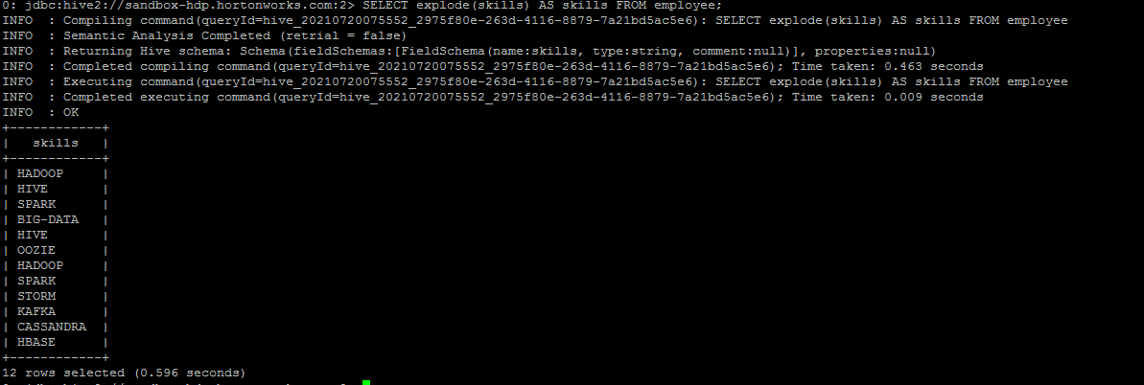

*SELECT id, name, skill*

*FROM employee LATERAL VIEW explode(skills) skill_set*

*AS skill;*

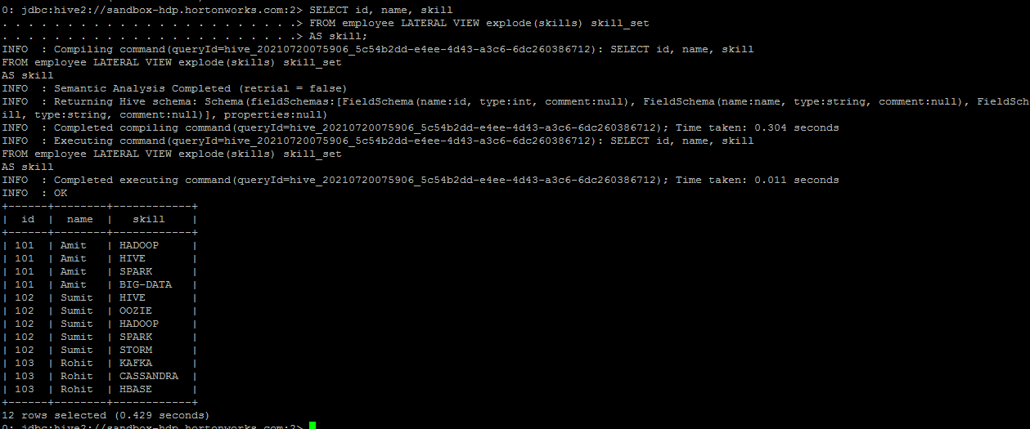

*SELECT * FROM my_db.users ORDER BY name ASC;*

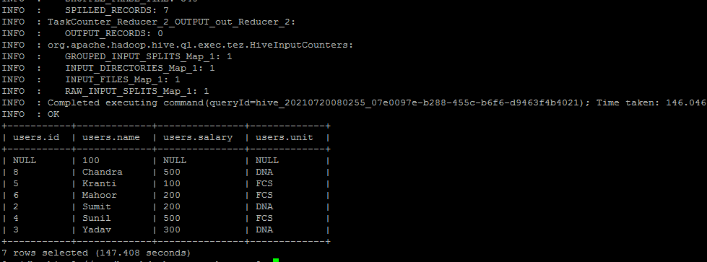

*SELECT * FROM my_db.users SORT BY name ASC;*

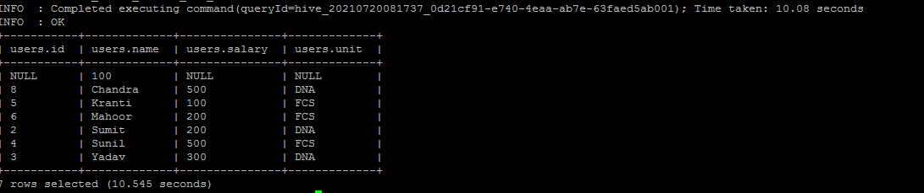

*set mapred.reduce.tasks=2;*

*SELECT * FROM my_db.users SORT BY name ASC;*

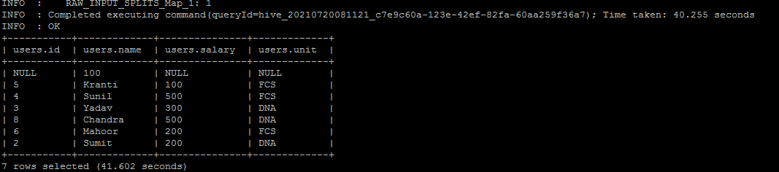

*SELECT * FROM my_db.users DISTRIBUTE BY unit SORT BY name ASC;*

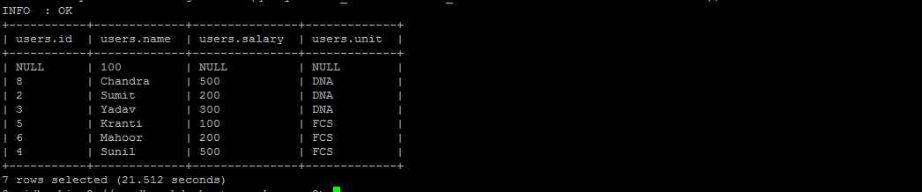

*SELECT * FROM my_db.users CLUSTER BY unit;*

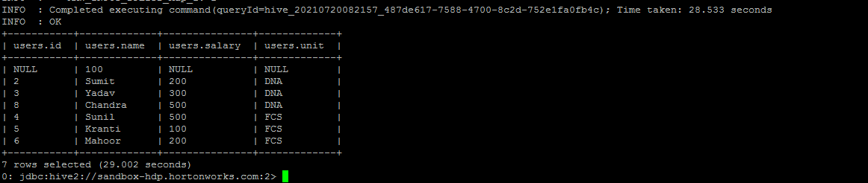

*SELECT * FROM my_db.buck_users u INNER JOIN my_db.buck_locations l*

*ON u.id = l.id;*

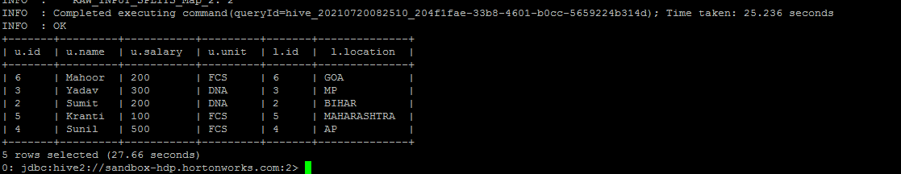

*SELECT * FROM my_db.buck_users u LEFT OUTER JOIN my_db.buck_locations l*

*ON u.id = l.id;*

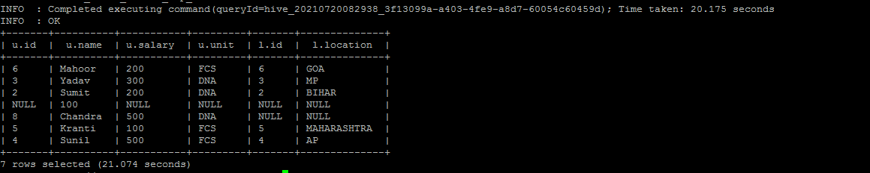

*SELECT * FROM my_db.buck_users u RIGHT OUTER JOIN my_db.buck_locations l*

*ON u.id = l.id;*

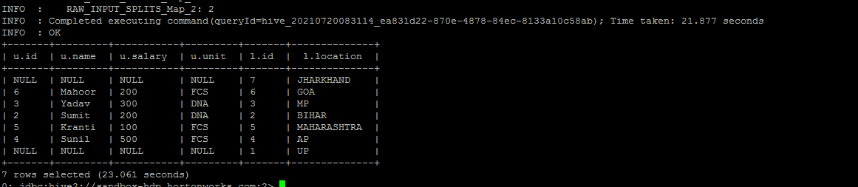

*SELECT * FROM my_db.buck_users u FULL OUTER JOIN my_db.buck_locations l*

*ON u.id = l.id;*

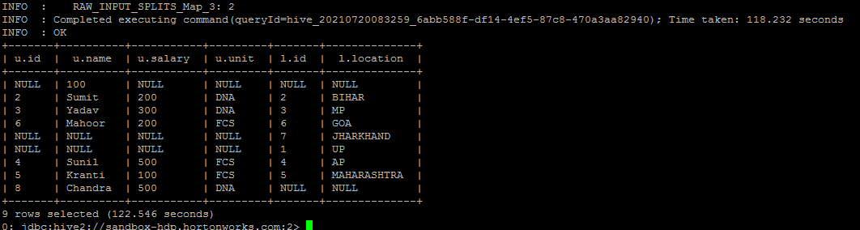

*SELECT * FROM my_db.buck_users u JOIN my_db.buck_locations l*

*ON u.id = l.id;*

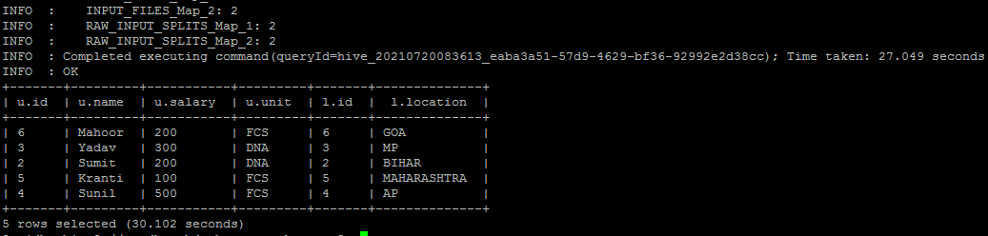

*create table emp_details*

*(*

*emp_name string,*

*unit string,*

*exp int,*

*location string*

*)*

*row format delimited*

*fields terminated by ','*

*STORED AS TEXTFILE;*

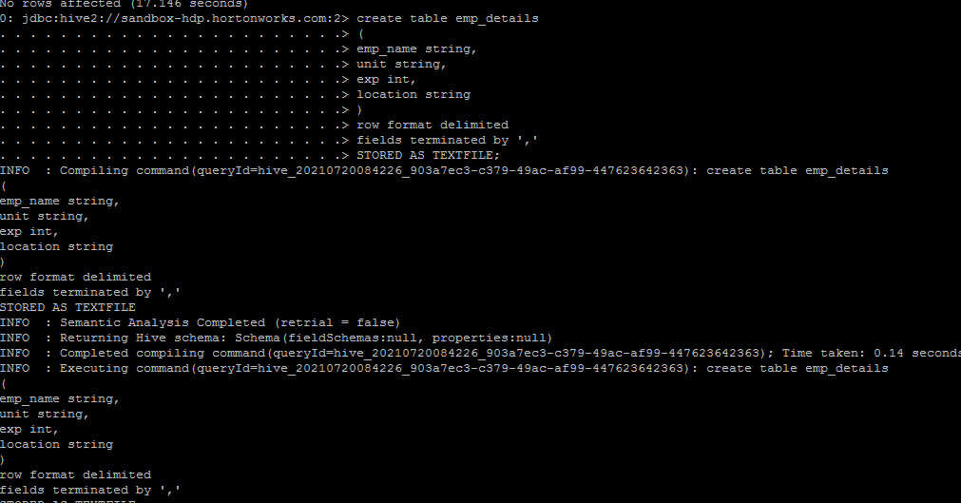

*load data local inpath '/tmp/hive_data/emp_details_gopal2.txt'*

*into table emp_details;*

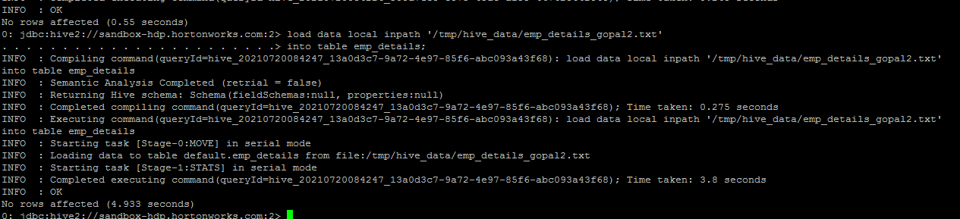

*describe formatted emp_details;*

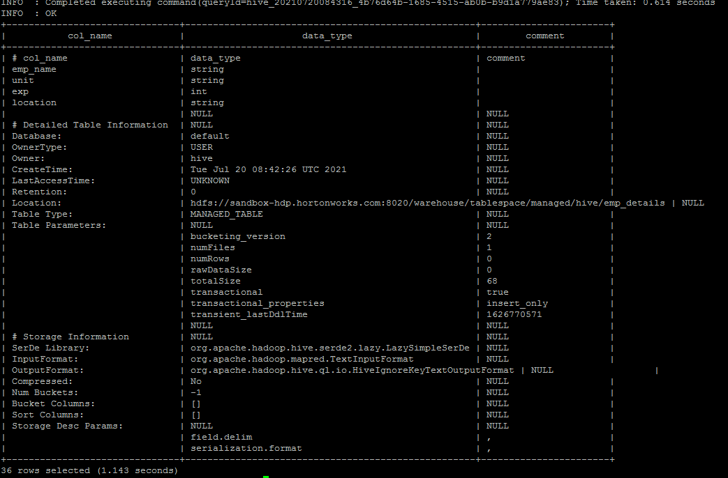

*hdfs dfs -ls hdfs://sandbox-hdp.hortonworks.com:8020/warehouse/tablespace/managed/hive/emp_details*

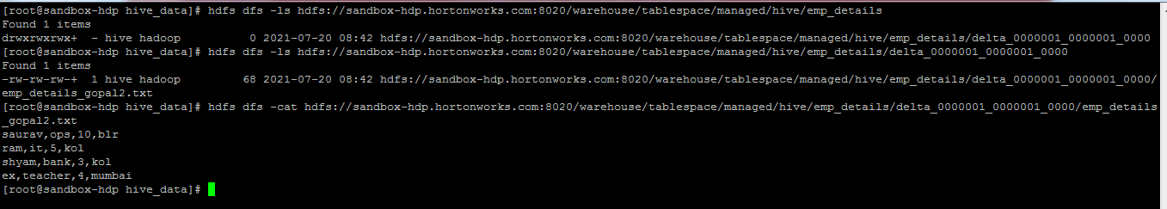

*create table emp_details_partitioned*

*(*

*emp_name string,*

*unit string,*

*exp int*

*)*

*partitioned by (location string);*

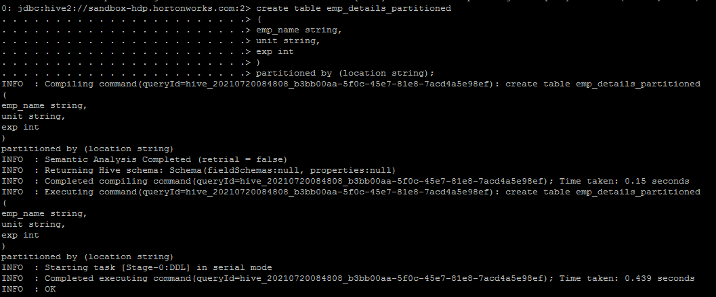

*insert overwrite table emp_details_partitioned*

*partition(location = 'BBSR')*

*select emp_name, unit, exp from emp_details*

*where location = 'BBSR';*

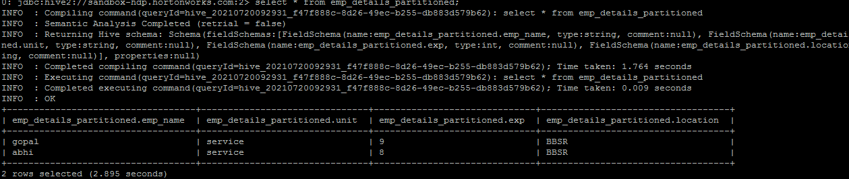

*insert overwrite table emp_details_partitioned*

*partition (location)*

*select * from emp_details;*

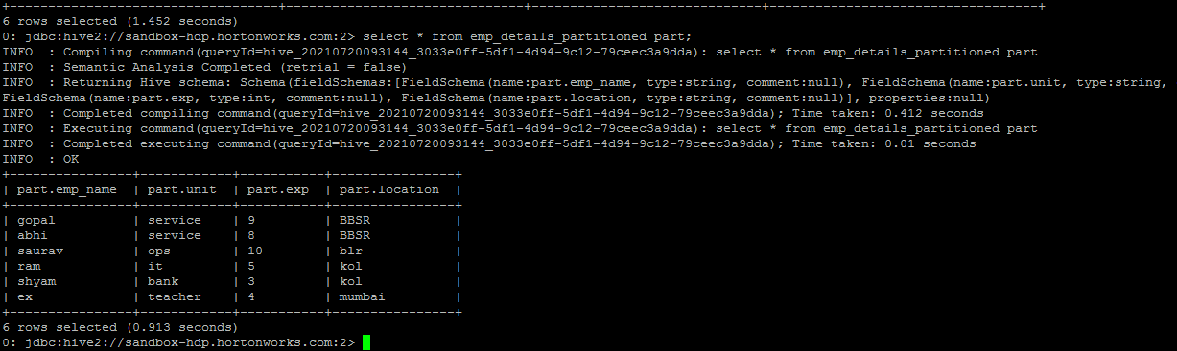

*select count(*) from emp_details where location='BBSR';*

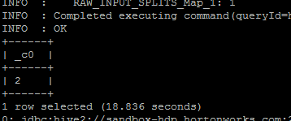

*select count(*) from emp_details where emp_name='saurav';*

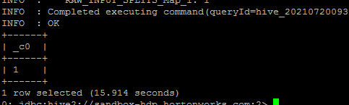

*alter table emp_details_partitioned drop partition(location='BBSR');*

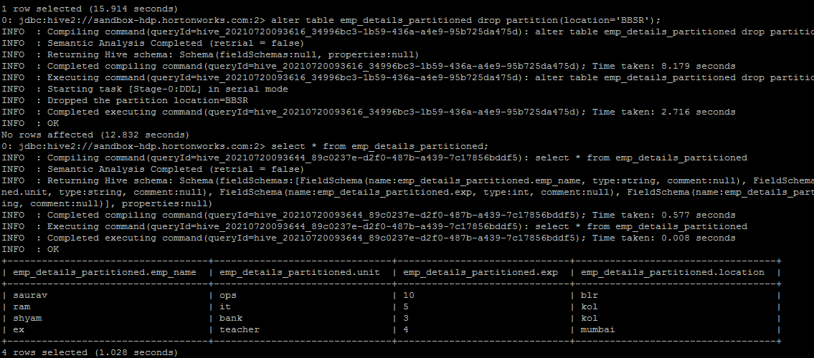

*SELECT * from my_db.users TABLESAMPLE(BUCKET 3 OUT OF 10 ON rand()) s;*

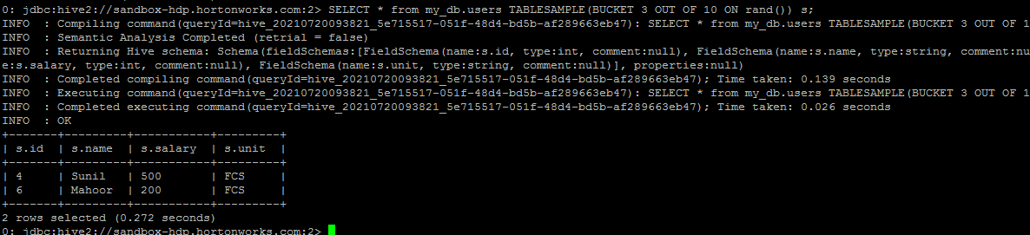

*SELECT * from my_db.users TABLESAMPLE(BUCKET 2 OUT OF 10 ON rand()) s;*

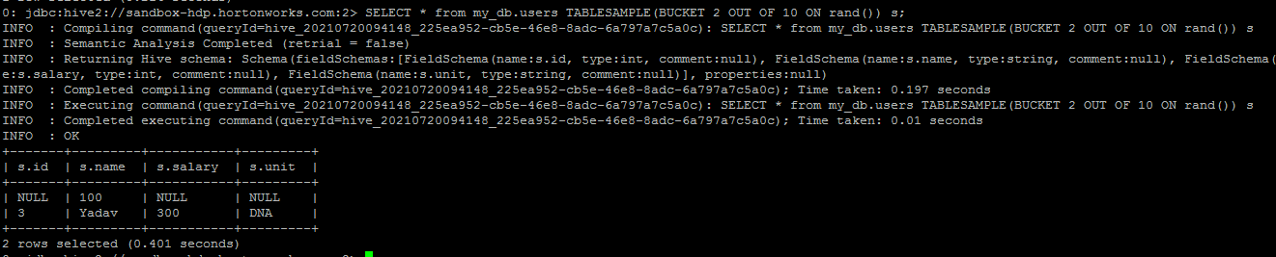

*SELECT * from my_db.users TABLESAMPLE(BUCKET 1 OUT OF 10 ON rand()) s;*

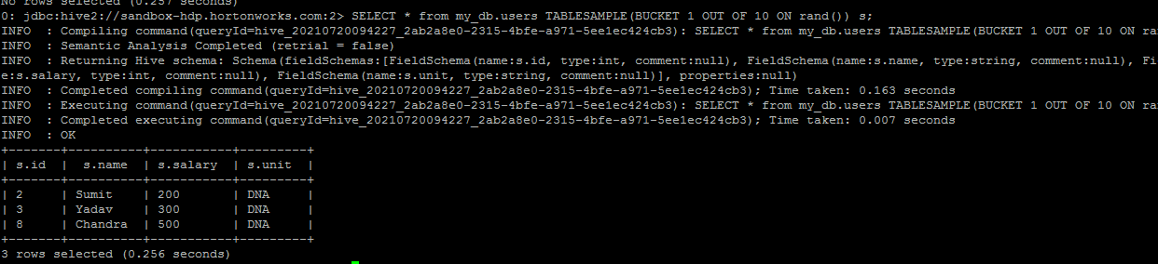

*load data local inpath '/root/hive/datasets_for_fileformats/ratings.dat'*

*into table text_table;*

*ADD JAR /tmp/hive_data/hive-hcatalog-core-0.14.0.jar;*

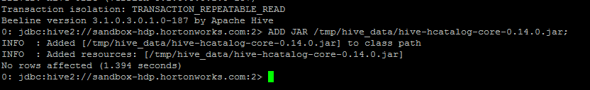

*CREATE TABLE json_table(name string, id bigint, skills array<string>)*

*ROW FORMAT SERDE 'org.apache.hive.hcatalog.data.JsonSerDe'*

*STORED AS TEXTFILE;*

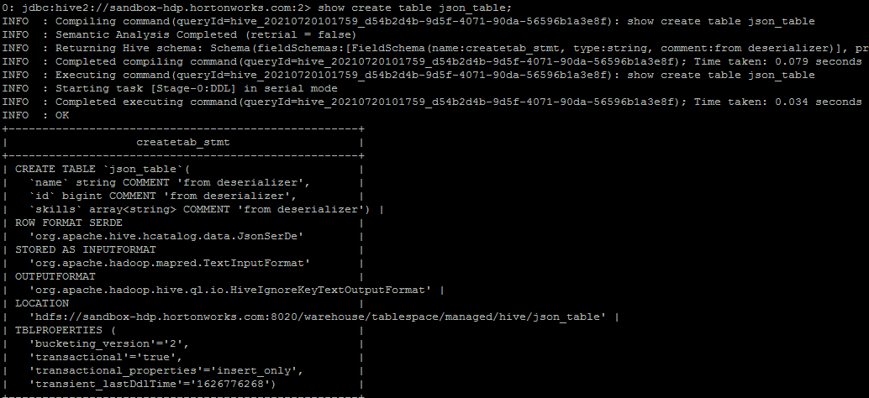

*LOAD DATA LOCAL INPATH '/tmp/hive_data/json_file.json'*

*OVERWRITE INTO TABLE json_table;*

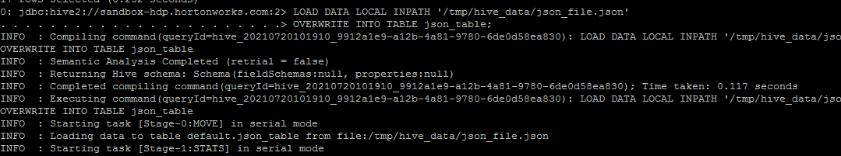

*select * from json_table;*

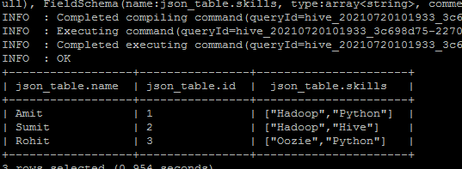

*select skills[0] from json_table;*

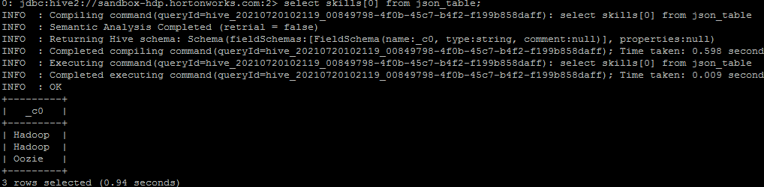

*SELECT * FROM my_db.users ORDER BY name ASC;*

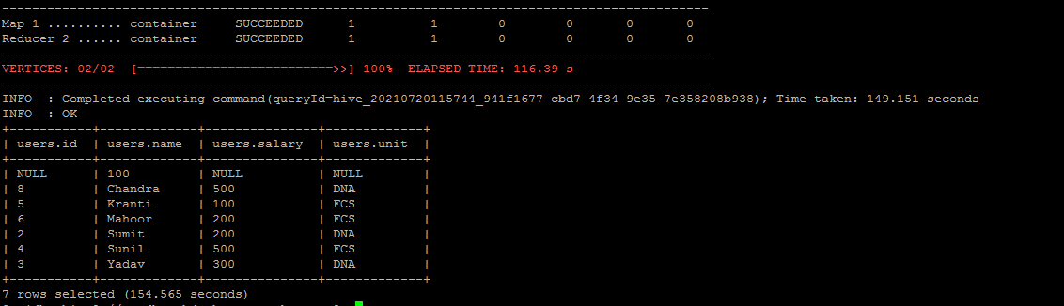

*SELECT * FROM my_db.users SORT BY name ASC;*

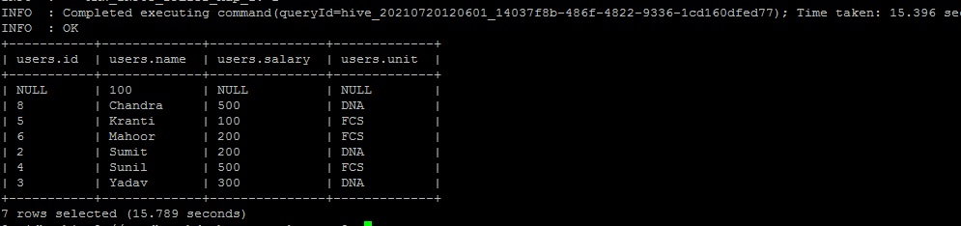

*set mapred.reduce.tasks=2;*

*SELECT * FROM my_db.users SORT BY name ASC;*

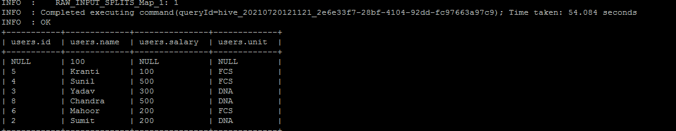

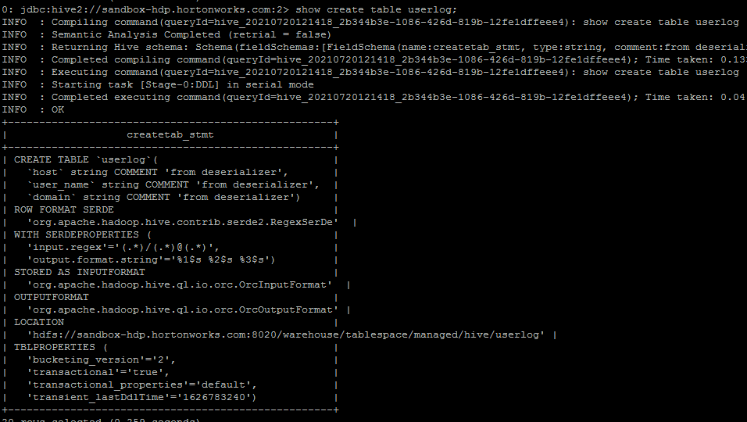

*select * from userlog;*

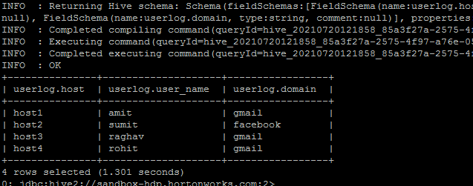

*SELECT host, user_name FROM userlog;*

