Word count –

hadoop jar /usr/hdp/current/hadoop-mapreduce-client/hadoop-streaming.jar \

-input /user/gopal/map-reduce-jobs/sample_data-word-count.txt \

-output /user/gopal/20072022-1 \

-mapper mapper.py \

-reducer reducer.py \

-file /root/gopal/map-reduce-jobs/word-count/mapper.py \

-file /root/gopal/map-reduce-jobs/word-count/reducer.py

Input –

I am created using browser to test hdfs. I am learning Hadoop.

Output –

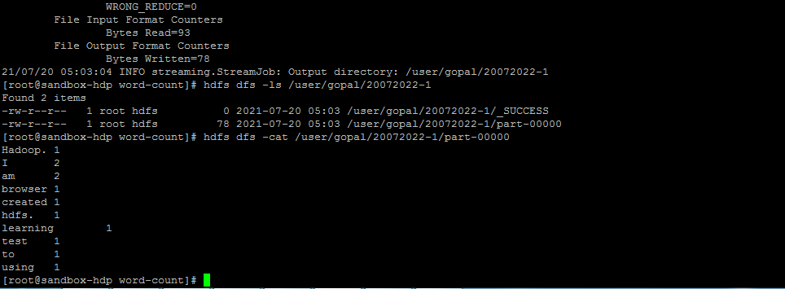

Max-temperature –

hadoop jar /usr/hdp/current/hadoop-mapreduce-client/hadoop-streaming.jar \

-input /user/gopal/map-reduce-jobs/sample_data_max-temperature.txt \

-output /user/gopal/20072022-2 \

-mapper mapper.py \

-reducer reducer.py \

-file /root/gopal/map-reduce-jobs/Maximum-temperature-year/mapper.py \

-file /root/gopal/map-reduce-jobs/Maximum-temperature-year/reducer.py

Input –

10-01-1990,123112,10

14-02-1991,283901,11

10-03-1990,381920,15

10-01-1991,302918,22

12-02-1990,384902,9

Output –

