**ASSIGNMENT**

**Statement:**

Showcase your technical design and implementation skills by architecting the infrastructure, deployment and release plan for a web service which has the following attributes

- SQL database

- RPS of 1000/sec

- Integration with external services

- Keep it simple

Ensure the web service is secure, highly available and fault tolerant.

**Solution**

**Overview:**

To design an infrastructure that meets the goals of **high throughput, high availability, security,** and **ease of maintenance** whileleveraging **modern cloud services** (AWS, GCP, Azure), and using **Infrastructure as Code (IaC)** with **Terraform**, we need to break the solution down into several key components. This would typically include setting up a **resilient architecture**, enabling **scalability**, ensuring **security**, and implementing a **CI/CD pipeline** for automated deployment.

**Architecture:**

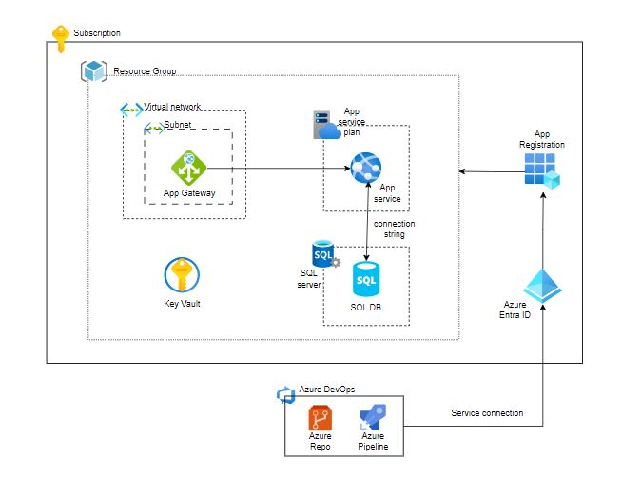

**IAC Code:** Repo link (<https://github.com/gopal1255/assignment/tree/main/IAC>)

**Structure:**

* **modules/**: Contains reusable and independent Terraform modules. Each subdirectory here represents a different module
* **terraform.tfvars**: Contains variable values for the entire project. This is where you can set values that override the default variables.tf.
* **provider.tf**: Contains configuration for the Terraform provider. You can specify different provider configurations for each environment.
* **variables.tf**: Defines input variables for the root configuration.
* **outputs.tf**: Defines output values that you want to export from your Terraform configuration.
* **main.tf**: The entry point of your Terraform configuration. It can include the resource definitions and calls to the modules.

**IAC Deployment pipeline:** Repo link: (<https://github.com/gopal1255/assignment/blob/main/CI-CD/infra-deployment.yaml> )

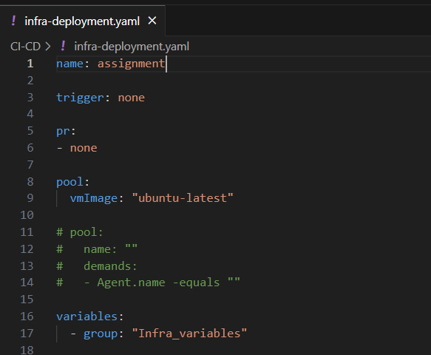

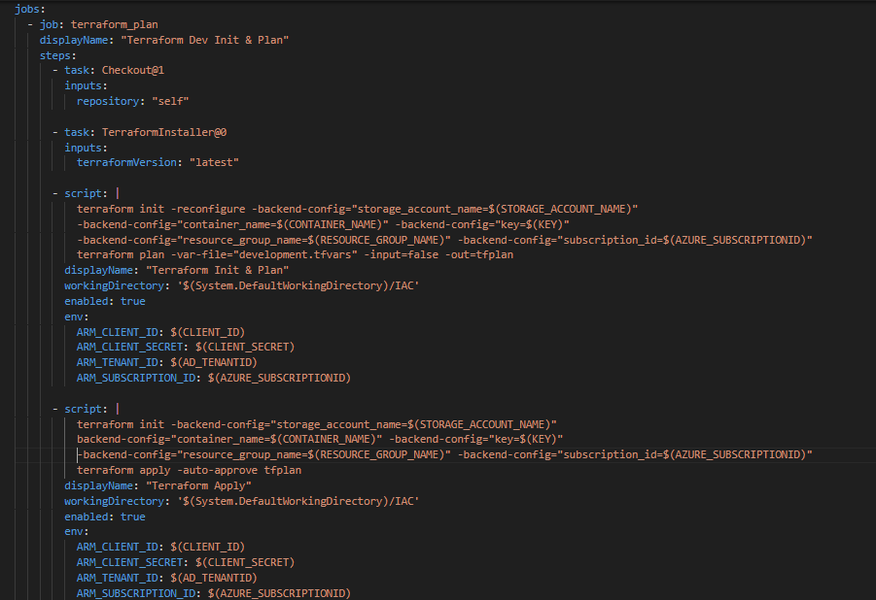

**Infra Deployment screenshots:** deployed infra and accessed web app from application gateway public IP

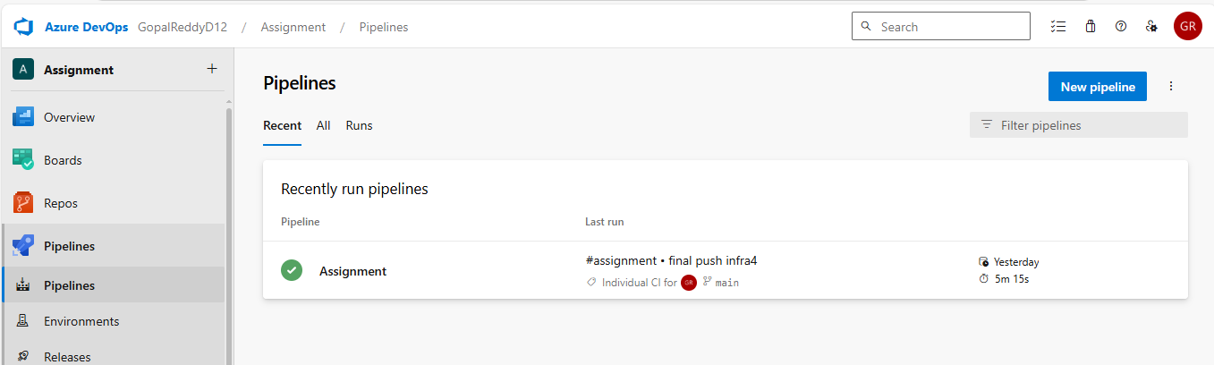

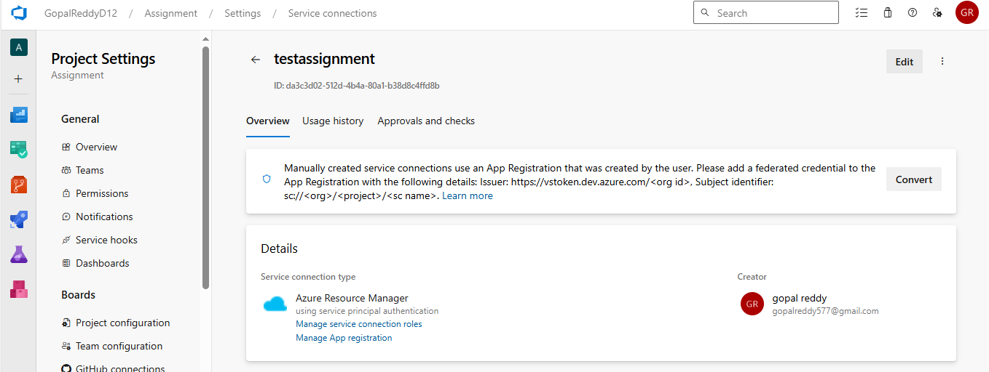

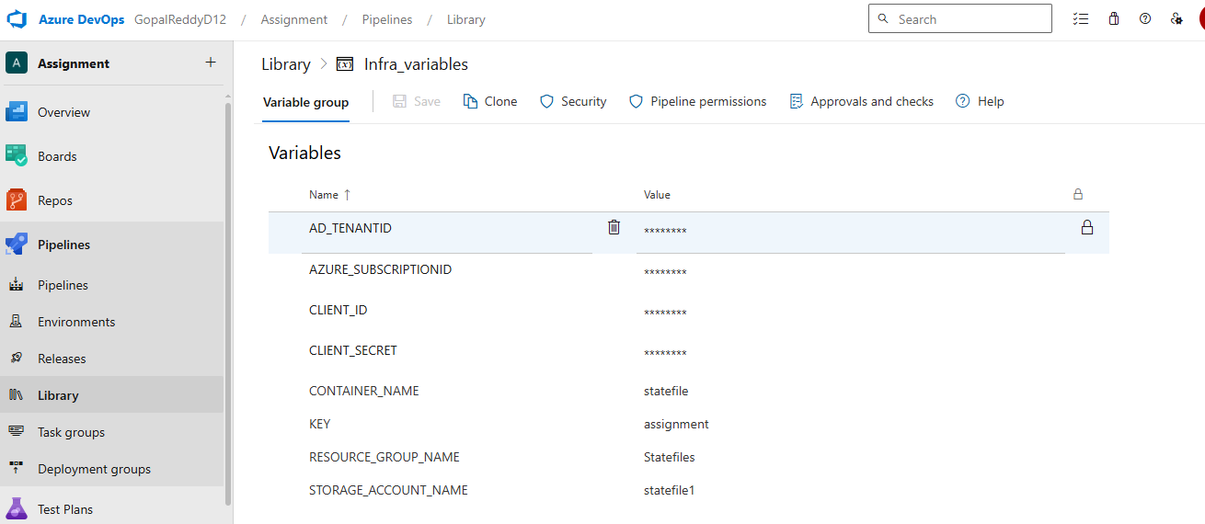

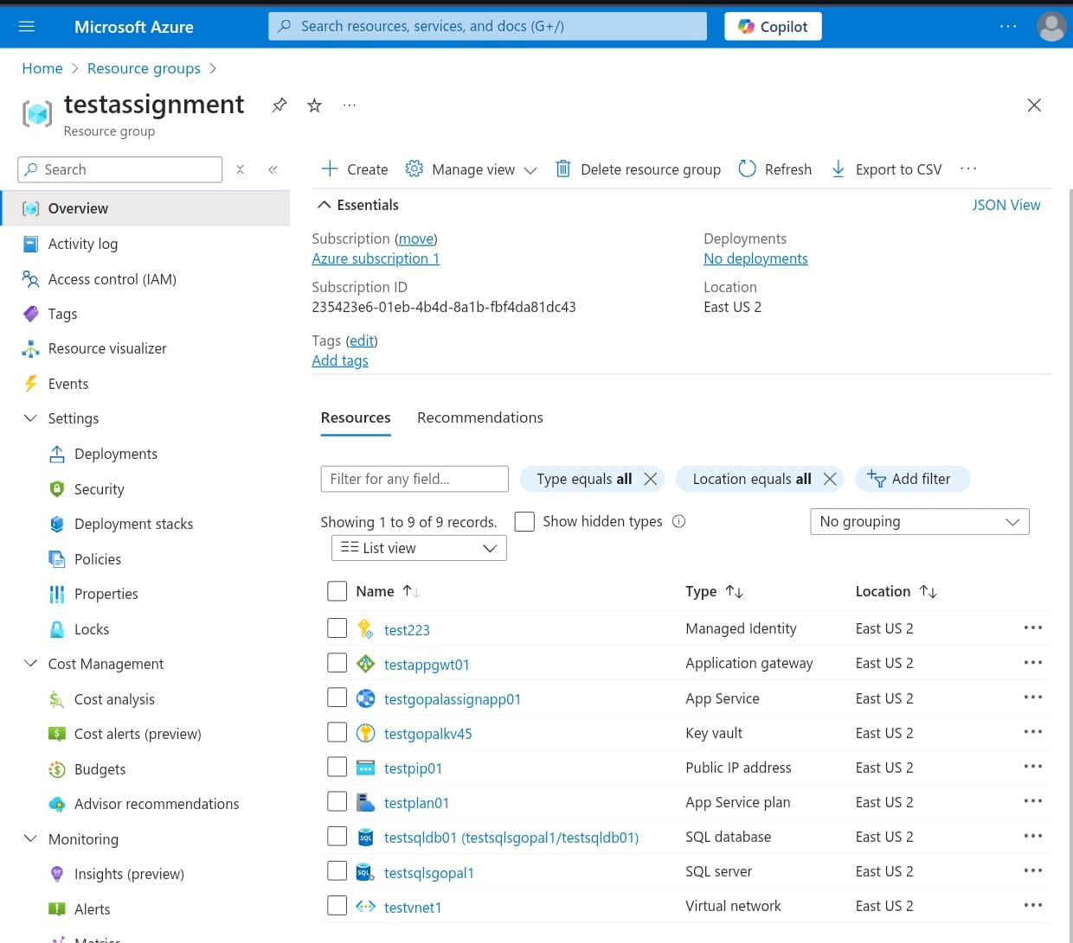

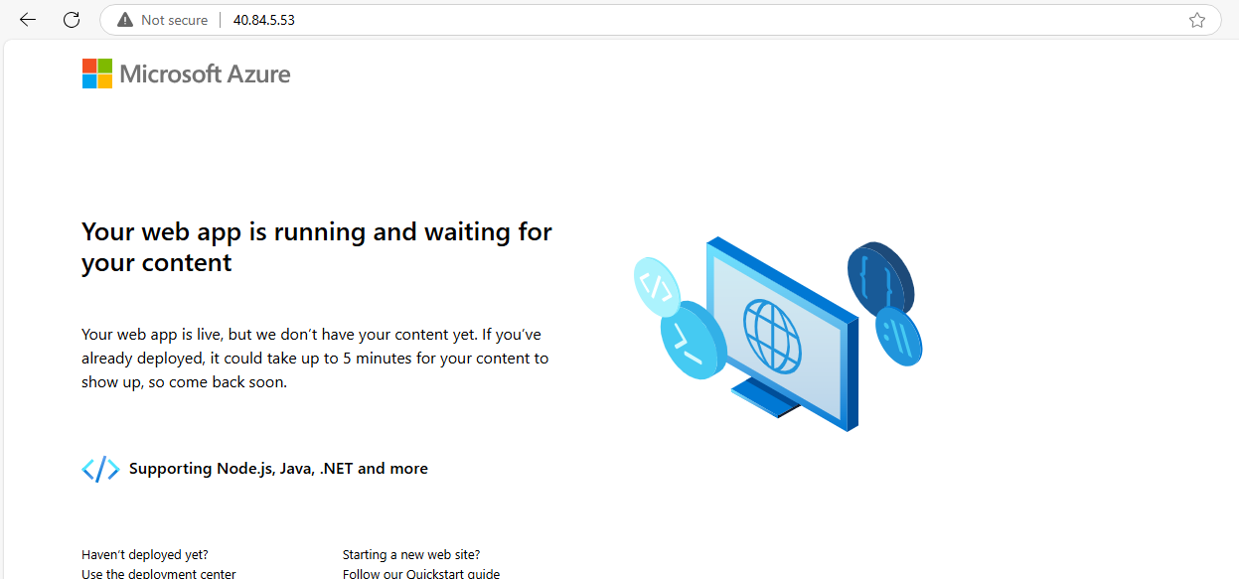

**Sample App: Repo link (**[**https://github.com/gopal1255/assignment/tree/main/application**](https://github.com/gopal1255/assignment/tree/main/application) **)**

**App Deployment pipeline: Repo link (**[**https://github.com/gopal1255/assignment/blob/main/application/app-deployment.yaml**](https://github.com/gopal1255/assignment/blob/main/application/app-deployment.yaml) **)**

