1. Building an entire CICD pipeline in Jenkins
2. Generate ssh key upload in GitHub

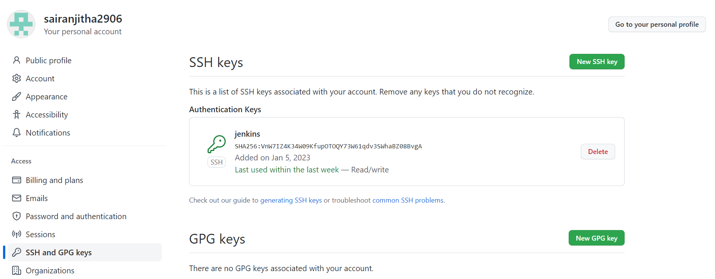

1. Create a Jenkins pipeline – integrate the private repo with Jenkins that will be first stage

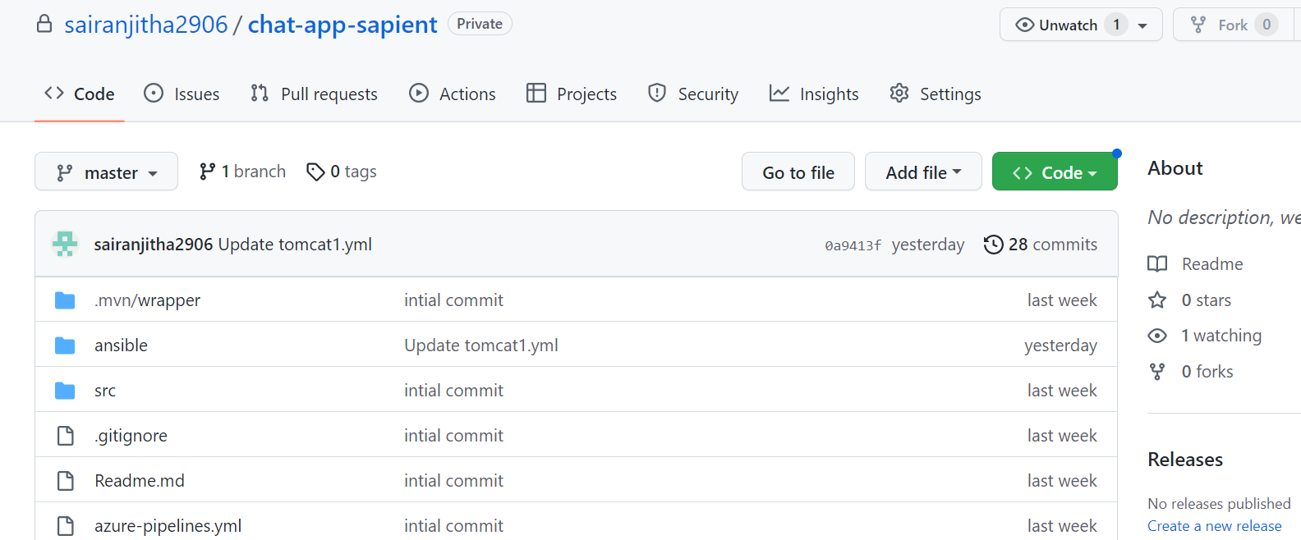

1. Second stage compile the project using maven but exclude test
2. Third stage do code testing using unittest checkstyle codecoverage
3. Add all this stages in the pipeline

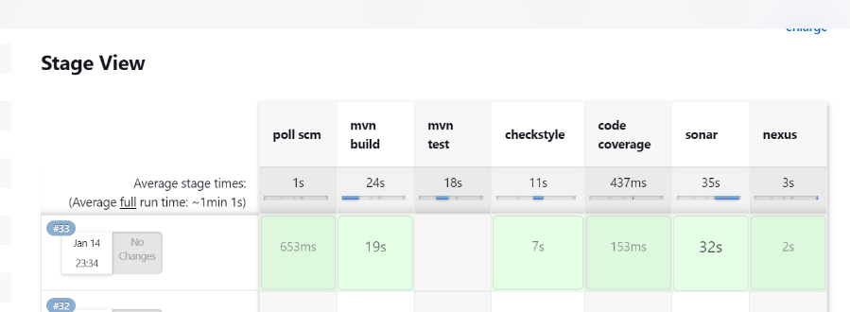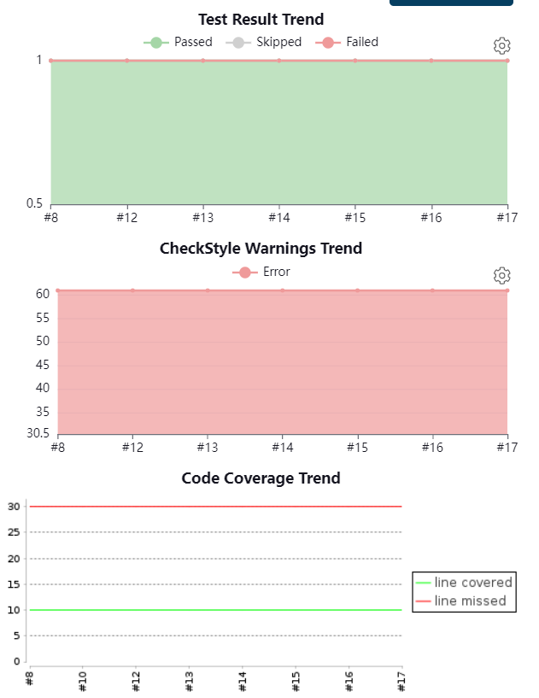

1. Then integrate Jenkins with SonarQube. Provide the difference between sonarqube testing and the previous testing framework

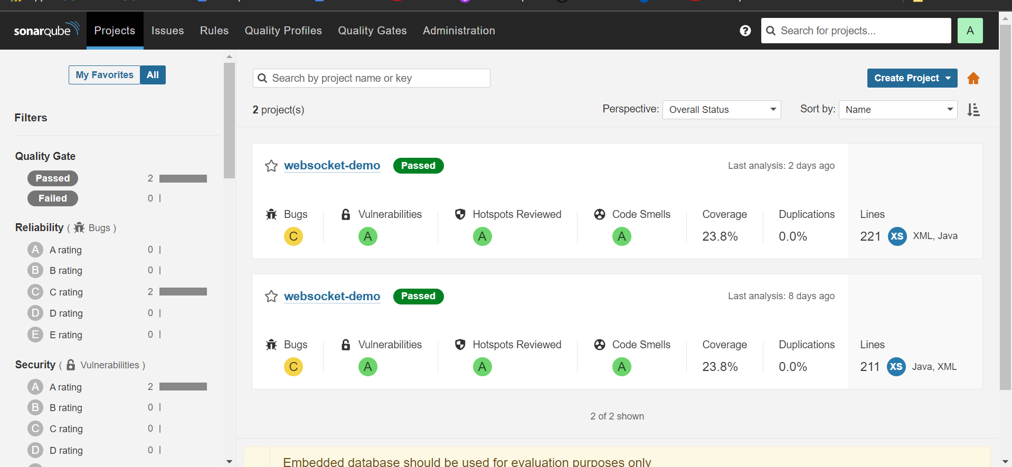

1. Finally upload the jar file inside nexus
2. While uploading jar file pipeline syntax generator provide you with static value.

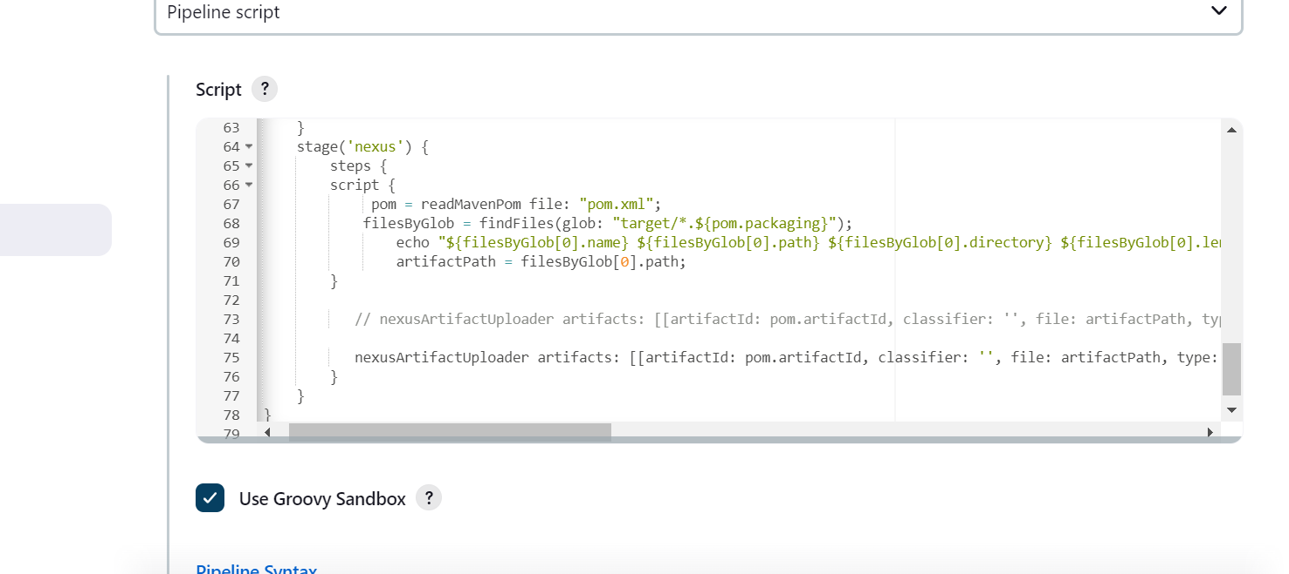

1. Automatically find out the jar file and upload the same

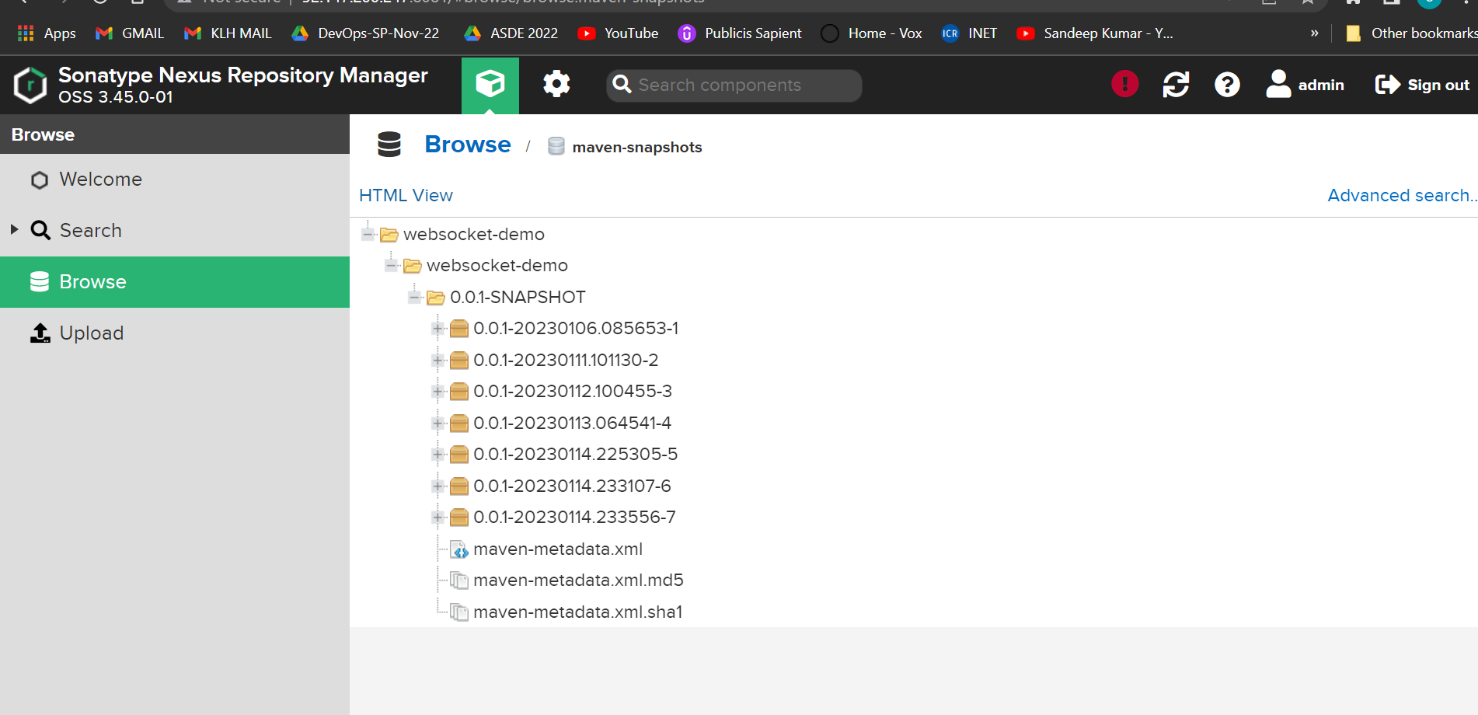

Jenkins pipelines in vm

