Jenkins CD-pipeline

1. Create an ansible playbook which install docker in Ubuntu system

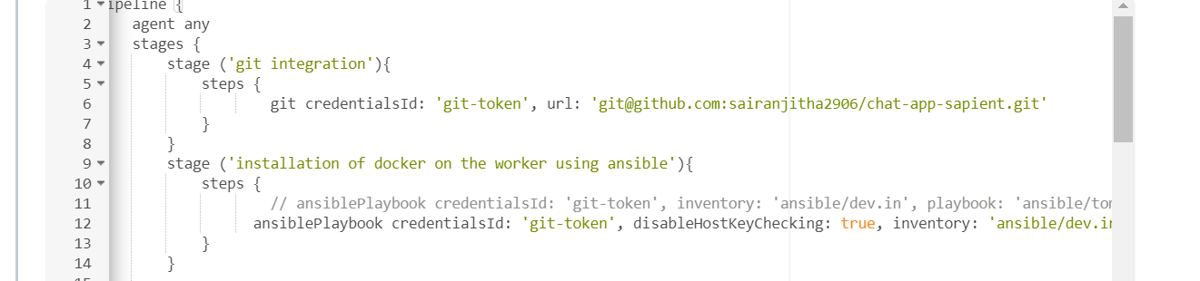

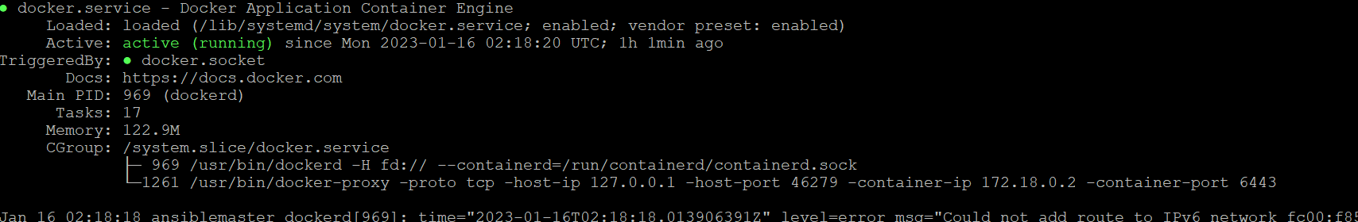

1. Create another ansible playbook which will deploy the private image from nexus repo

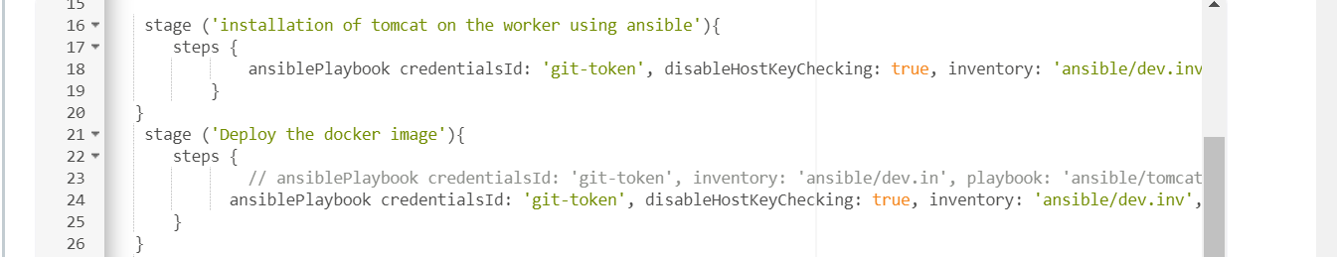

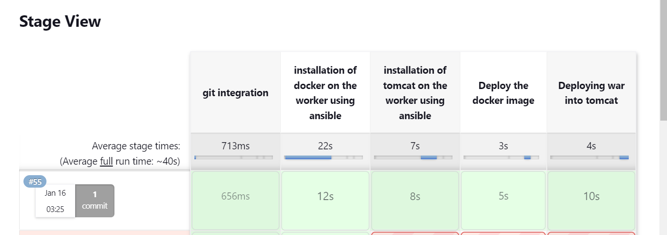

Jenkisn CD pipeline with tomcat.

1. Create an ansible playbook which will install tomcat

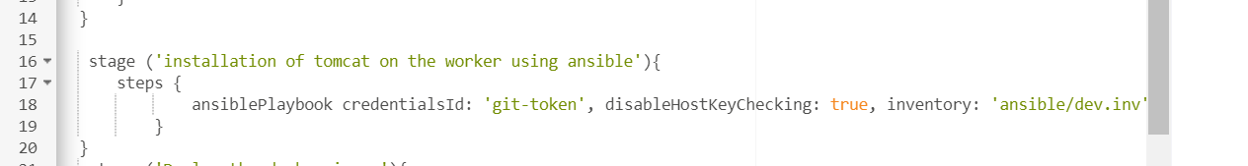

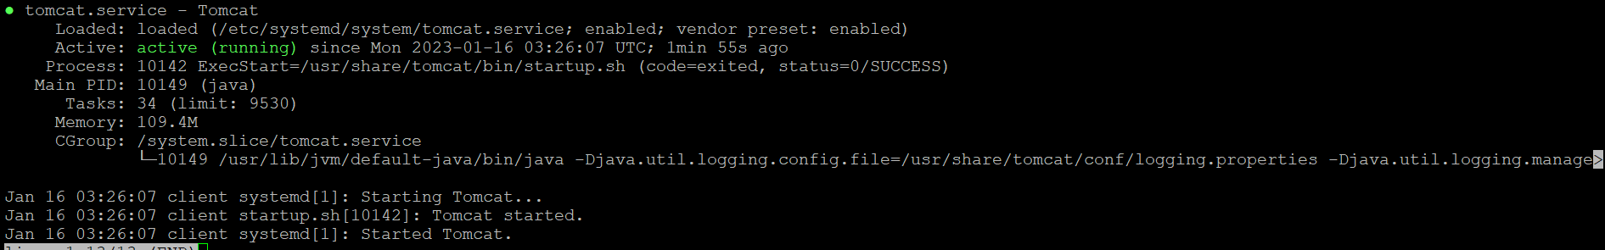



1. Deploy the jar file from nexus to tomcat using ansible.

