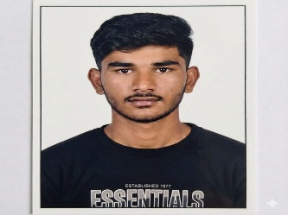
CURRICULUM VITAE

Gopal Murlidhar Landge gopalmurlidharlandge2004@gmail.com
9049597324

Objective:
Ambitious Computer Science and Engineering student (8th Semester) passionate about the intersection of software engineering and data analytics. Proficient in data visualization, statistical modeling, and algorithmic design. Aiming to secure a position where I can apply my analytical mindset to solve real-world problems and optimize business processes through data-driven insights.
Educational Qualification:

Sr. No | Name of exam | Board / University | School / College | Year of passing | Division
1 | BE  (Computer Science and Engineering) | SGBAU, Amravati | RSCE, Buldana | Apearing | --
2 | H.S.C | Maharashtra State Board of Secondary and Higher Secondary Education, Pune. | Shivsai Universal jr. college, Kolwad | 2022 | Amravati
3 | S.S.C | Maharashtra State Board of Secondary and Higher Secondary Education, Pune. | Vidya Vikas Vidyalaya, kolwad | 2020 | Amravati

Skills:

- Programming: Python (Expert), SQL (Advanced), Java, C++, R.
- Data Science: Data Pre-processing, Exploratory Data Analysis
- Libraries/Tools: Pandas, NumPy, Scikit-learn, Matplotlib, TensorFlow, Tableau

Personal Details:
Name : Gopal Murlidhar Landge
Father’s Name : Murlidhar Bhaskar Landge
Date of Birth : 27 December 2004
Nationality : Indian
Gender : Male
Marital Status : Single
Permanent Address : At Post Kolwad,
Tq. Dist. Buldana
443001
Languages Known : English, Hindi, and Marathi.

I hereby declare that the above information is true to the best of my knowledge.

Date: 02-01-2026
Place: Buldana

Gopal Murlidhar Landge

