## NAME:GOPALKRUSHNA SANTOSH DHOK

## PRN : 2124UMLM2006

## SET NO : 1

## SUBJECT:SPSS (STASTICAL PREDICTIVE SOCIAL SCIENCE)

PRACTICAL NO 1

SELECT THE VARIABLE VIEW

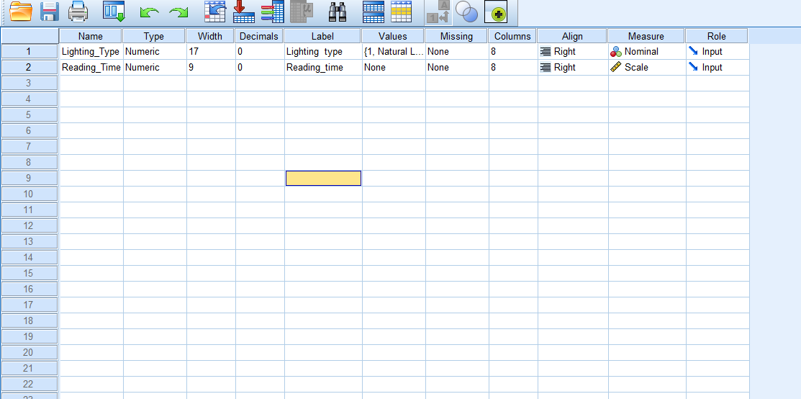

SELECT DATA VIEW

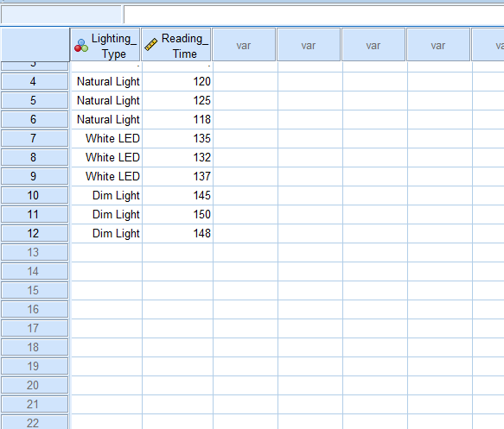

SELECT THE ANALYZE OPTION AND GO TO COMPER MEAN = AND GO TO ONW WAY ANOVA

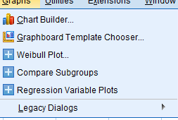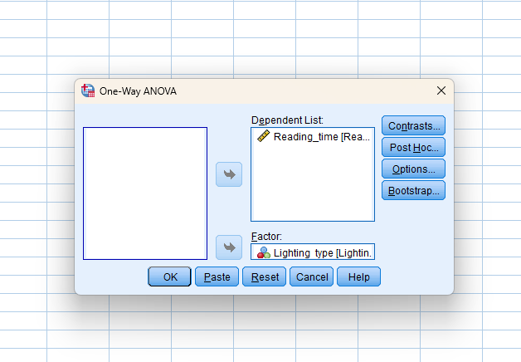

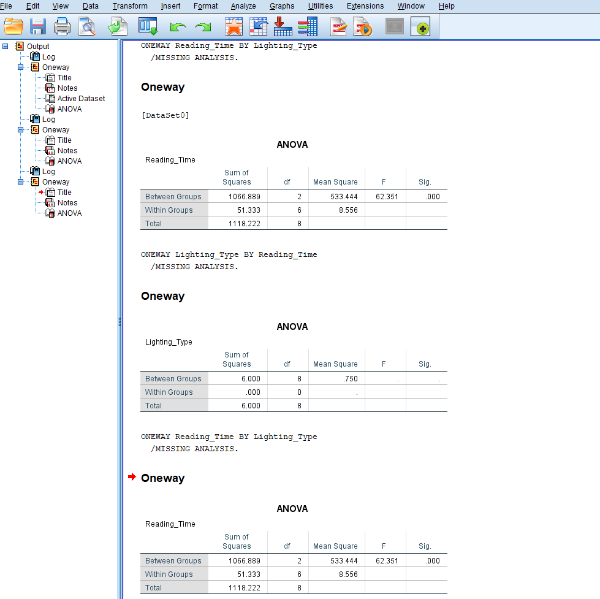

SELECT A GRAPH

