**OKRs Scorecard**

OKR grading scale:

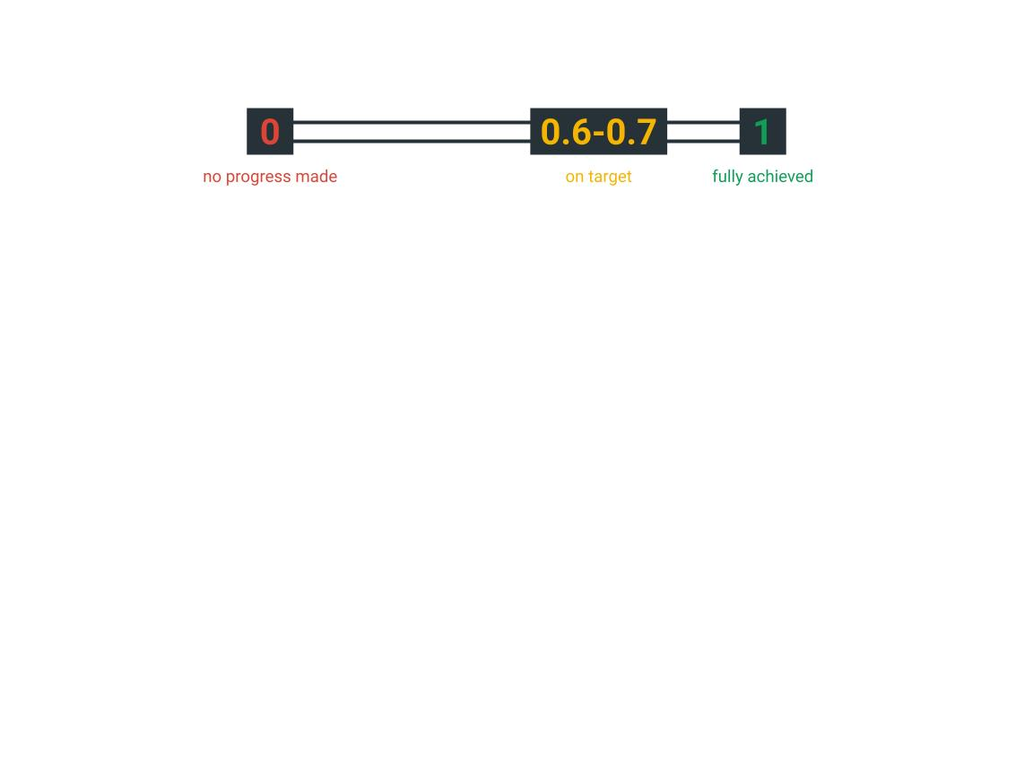

|  |  |
| --- | --- |
| **Objective** | |
| Overall score |  |
| **Key Results:** | |
|  |  |
|  |  |
|  |  |

|  |  |
| --- | --- |
| **Objective** | |
| Overall score |  |
| **Key Results:** | |
|  |  |
|  |  |
|  |  |