# How Google Maps Work

# C:\Users\Gopala Krishna\Desktop\gmaps.png

[Google Maps](https://www.google.com/maps" \t "_blank) has been a staple of the internet for over a decade now, but few actually know how it works. For the rest of us, Google Maps is pretty much one step away from magic.

For example, how does Google create such accurate maps for so many different regions? How can it collect so much data about so much of the world? Who works to keep the maps maintained and updated? And what about real-time traffic conditions, temporary speed limits, and operating hours for nearby businesses?

Somehow these entire complex features work damn well, which is why so many of us have come to [rely on Google Maps for everyday navigation](https://www.makeuseof.com/tag/13-google-maps-tips-use-often/). So isn’t it about time we learned how it all works? Keep reading to see the magic behind the curtain.

## Why Did Google Launch Maps?

Google’s public mission is to “organize the world’s information and make it universally accessible and useful”. Many, but not all, of the company’s present-day projects focus on this mission — a mission reliant on gathering, organizing, and interpreting millions of gigabytes of data.

But the information Google is trying to organize isn’t only online. Much of it’s offline. Speaking with [The Atlantic](http://www.theatlantic.com/technology/archive/2012/09/how-google-builds-its-maps-and-what-it-means-for-the-future-of-everything/261913/), Manik Gupta, senior product manager of Google Maps, explained: “Increasingly as we go about our lives, we are trying to bridge that gap between what we see in the real world and [the online world], and Maps really plays that part.”

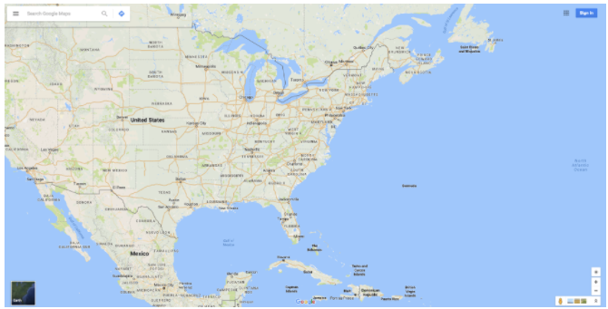

At a very basic level, Google Maps has taken a huge amount of offline information and published it online. We’re talking things like highway networks, road signs, street names, and business names. But as I hint below, Google hopes that Maps will be able to do a lot more in the future.

## Collecting Data for Google Maps

When it comes to collecting data to help maintain and improve Google Maps, it seems there can never be enough — and the impressive bit is that none of that information is over three years old. This is a project of immense scale.

### Map Partners

To help with this endeavour, Google partners with “the most comprehensive and authoritative data sources” via its [Base Map Partner Program](http://maps.google.com/help/maps/mapcontent/basemap/index.html). A huge number of agencies submit detailed vector data to Google, and these agencies include the USDA Forest Service, the US National Park Service, the US Geological Survey, various city and county councils, and so on.

This data is used to demarcate changing boundaries and waterways, display new bike paths, among other things, and this helps to keep the “base map” as up-to-date as possible.

### Street View

Google Street View is a never-ending road trip. With a massive squad of vehicles dispersed around the planet, their aim is to repeatedly drive around every accessible road they can find — all the while taking 360-degree photos everywhere they go.

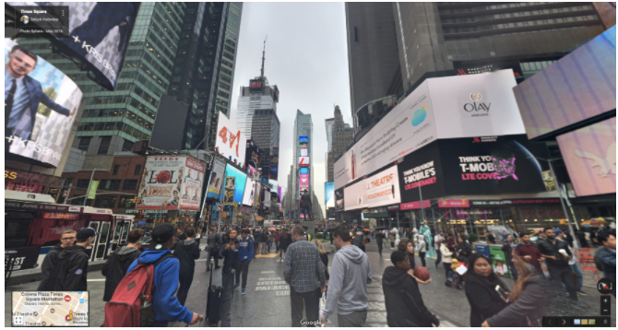

Based on the GPS coordinates of those vehicles, Google overlays its Street View images on top of its base map.

[Street View offers much more](https://www.makeuseof.com/tag/travel-back-time-google-street-view/) than just a stitched panorama of streets and destinations. Using ever-improving [optical character recognition (OCR)](https://www.makeuseof.com/tag/4-free-online-ocr-tools-put-ultimate-test/) capabilities, Google can “read” things like road signs, traffic signs, and business names.

These additional reads are processed and turned into navigational and directional data that Maps can incorporate into its database. If a road’s name has changed since the last time it was photographed, a more recent Street View photo will detect this. This is also (partly) how Google has built its huge database of local business details.

### Satellites

Another layer of Google Maps is its satellite view. This is a close collaboration with Google Earth, stitching together high-resolution photographs of the planet taken by satellites above.

These images are cross-checked with other layers of data, such as Street View as well as data submitted by external agencies. This helps Maps to pick up geological changes, new and altered buildings, etc.

### Location Services

There isn’t much information available about how exactly Google uses mobile location services to keep Maps up-to-date, but it clearly plays a large role.

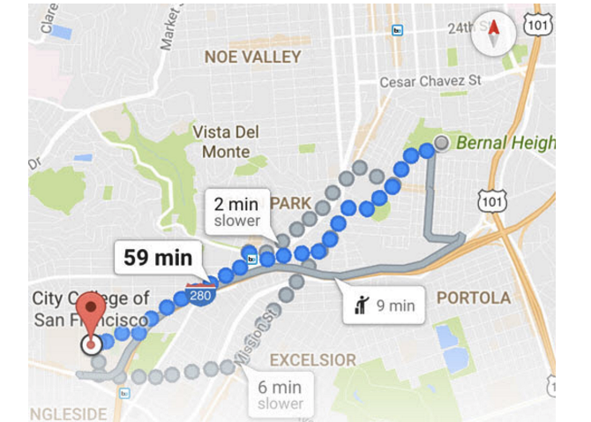

Yes, that’s right: if Google has access to the location data collected by your smartphone, then you’re part of Google’s crowd sourced operation to improve and expand Maps.

Your location data can be used for things like real-time traffic updates, estimating current traffic speeds, and pinpointing road diversions. If a busy route suddenly has no traffic, Maps can assume there’s a diversion and will adjust directions accordingly.

Google also uses this data to estimate the hours when individual businesses will be busy. It does this by keeping tabs on the foot traffic in individual buildings. A bit creepy perhaps, but it’s yet another attempt to bring that offline information online.

### Google Maps Users

[Google Map Maker](https://mapmaker.google.com) is another way in which Google is crowd sourcing its Maps operation, and this is a program that’s been around since 2008 ([among Google’s many others](https://www.makeuseof.com/tag/7-google-crowdsourcing-projects-help-us-today/)).

Working in much the same way as [OpenStreetMap](https://www.openstreetmap.org/), Google Map Maker allows anyone to contribute their local knowledge to Google Maps. The good news is that most of this functionality is being incorporated into Maps itself, and Map Maker will be shut down for good in 2017 once the transition is complete.

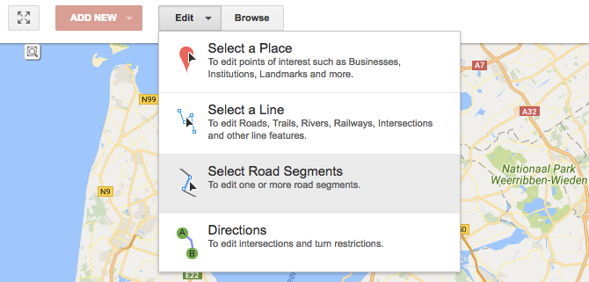

In short, users can edit Google’s maps with their own personal contributions. You’re able to add and edit places, new roads, building outlines, and hiking trails. And if you think you can get away with vandalism, think again: user edits can be reviewed by other users.

This means that there’s a huge army of public editors who keep Google Maps up to date 24/7. This is especially useful for mapping hard-to-reach places and for gathering knowledge that would otherwise be out of Google’s reach or awareness.

### Local Guides

As well as its army of editors, Google also has millions of so-called [Local Guides](https://maps.google.com/localguides/). Local Guides is a feature that will remind you of [Foursquare](https://foursquare.com/) and is Google’s attempt at collecting a layer of more subjective data to lay over its base map.

When you’re in Google Maps, go to **My Contributions** and you can search for different places in your area. By leaving a review, answering a few questions, and submitting a photo, you can contribute to this additional layer of data.



This local knowledge helps Maps to know things like the vibe of a cafe, whether a hotel has parking, or whether a restaurant has vegan options. In return for contributions, users can earn rewards like increased storage on Google Drive.

## Making Sense of the Data

As you can see, the amount of data being collected by Google is astonishing — and we haven’t even touched on some of the other service integrations, such as with Google’s business listings.

These layers of data, when processed, are what give us access to all the information found on Google Maps. But what actually goes into making sense of all that data?

This largely boils down to the kinds of algorithms that make up the [bedrock of Google as a company](https://www.makeuseof.com/tag/story-google-algorithm-functionality-updates/). These algorithms, which happen to be extremely complex and secretive, work to clean the data, spot inconsistencies, and link it all together to make it more useful.

For example, when Street View scans images for road signs and business names, algorithms may try to make sense of road networks by interpreting those road signs. At the same time, location data may be taken into account when calculating fastest routes from A to B.

Although algorithms are always improving, they can only do so much, so all of this data is also combined with a ton of human involvement. If there’s something Google’s algorithms can’t make sense of, a team member will manually look it over and set things straight.

Image Credit: [Google](https://www.google.co.uk/press/images.html)

Often, intersection logic is inputted manually and new roads are “massaged” into place. This is because sometimes the best way to understand what’s seen on the road is to [delegate the task to a human](https://www.makeuseof.com/tag/become-super-productive-outsourcing-day-day-tasks/).

This is without doubt a huge task. That’s why Google has teams around the world dedicated to keeping things up to date in every country in which it operates.

## When There’s a Mistake on Google Maps

Every day, masses of changes are made to Google Maps. Some of these may be the addition of new places and new roads while other changes may involve fixing mistakes.

Many of these are fixed by chance by members of the public: editing place descriptions, adding roads, and so on. Yet on top of this, Google has a large team of people working through the thousands of reports that are filed to Google each day.

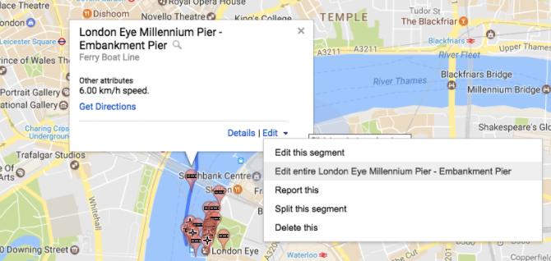

A good chunk of these reports are reviewed and acted on manually. This is done using Atlas, Google’s own map-editing program. New routes are drawn by hand, roads are connected, new buildings mapped out, etc.

This is a project that will never end. With thousands of new roads being built each day and cities changing traffic rules when necessary, Google Maps will always be fighting a battle to stay accurate.

## Google Maps: A Huge Undertaking

While Google Maps is often seen as “[just another map](https://www.makeuseof.com/tag/apple-maps-reliable-navigator-yet/),” there are a huge number of layers that we take for granted. These all work together to offer the service that so many have come to rely on — a service that far exceeds the depth or quality of its competitors.

From the driving of millions of miles, through the complex algorithms, to the huge amount of human input that’s required, Google Maps is something to be admired.

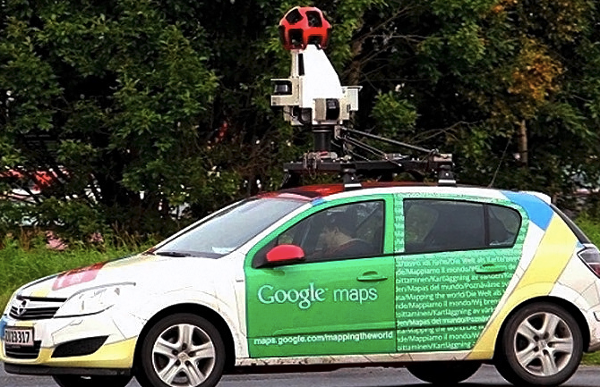Image Credit: [Gabriel Andres via Flickr](https://flic.kr/p/e35pm8)

Yet Google won’t stop here. Google Maps is already going to play an important role in the company’s [foray into self-driving cars](https://www.makeuseof.com/tag/how-close-are-we-to-self-driving-cars-being-available/). And as more subjective information, photos, and videos are linked to Maps, the app could go from being a map of the world to being a guide to the world.

**Did you know this much work went into maintaining Google Maps? And what other information do you wish you could make use of in Google Maps? If you don’t use Google Maps, why not?**