EmoScreen
End-to-End Testing Guide
A user-oriented walkthrough for recruitment, doctor sharing, parent completion, reports, and support tracking
Audience | Clinic teams, pediatricians, caregivers, support users, and UAT testers
Scope | Admin doctor recruitment, doctor Google-gated sharing, paid parent flow, free multilingual parent flow, self-screening, reports, and audit visibility
Environment | Written as a live-system walkthrough. Screenshots were captured from the local UAT system.
Guide date | June 19, 2026

How to read this guide
Follow the screens in order. On each screen, perform the listed action and confirm the expected result before moving ahead. For live production, use the production domain and authorized accounts. For local UAT, the payment screen uses the dummy payment button instead of live Razorpay.

1. Test Overview
This guide walks a tester through EmoScreen as separate real users experience it: public visitor, admin, recruited doctor, parent, and support user.
- Public visitors enter from the normal EmoScreen home page.
- Admins enter separately through Django admin and recruitment tools.
- Doctors do not use admin login for their clinical workflow; they open their clinic link and sign in with the registered Google email.
- Parents follow only the paid, free, or self-screening journey they received.
- Support users verify delivery, payment, submission, and report status in the workflow audit dashboard.
Role separation rule
Do not test doctor sharing from the Django admin dashboard. Admin is for recruitment/support. Doctor sharing starts from the doctor clinic link received after recruitment.

Payment note for UAT
The live system should use Razorpay for paid forms. In this local UAT guide, the screen uses Complete Dummy Payment so testers can validate the full journey without moving real money.

Entry points
User | Live-style entry | Purpose
Normal user / parent | https://emo.cpdinclinic.co.in/ | Public landing and patient start points
Admin / support | https://emo.cpdinclinic.co.in/admin/ | Django admin, doctor recruitment, reports, and staff-only tools
Doctor | https://emo.cpdinclinic.co.in/admin/bulk-upload/clinic/C488DF49/ | Google-gated clinic console sent to the recruited doctor

Sample UAT details
Doctor workspace | Dr Codex QA, doctor code C488DF49
Paid sample patient | Aarav Guide Test
Free sample patient | Meera Free Guide
Paid workflow case | WF72EFAA234D9C
Free workflow case | WF8A30966DCFCB

2. Public Entry

Public User Entry
What to do | Open the normal EmoScreen entry page. Use this only for public registration, public start, or self-screening routes.
Expected result | The public page is reachable without staff/admin credentials and does not replace the staff admin entry.

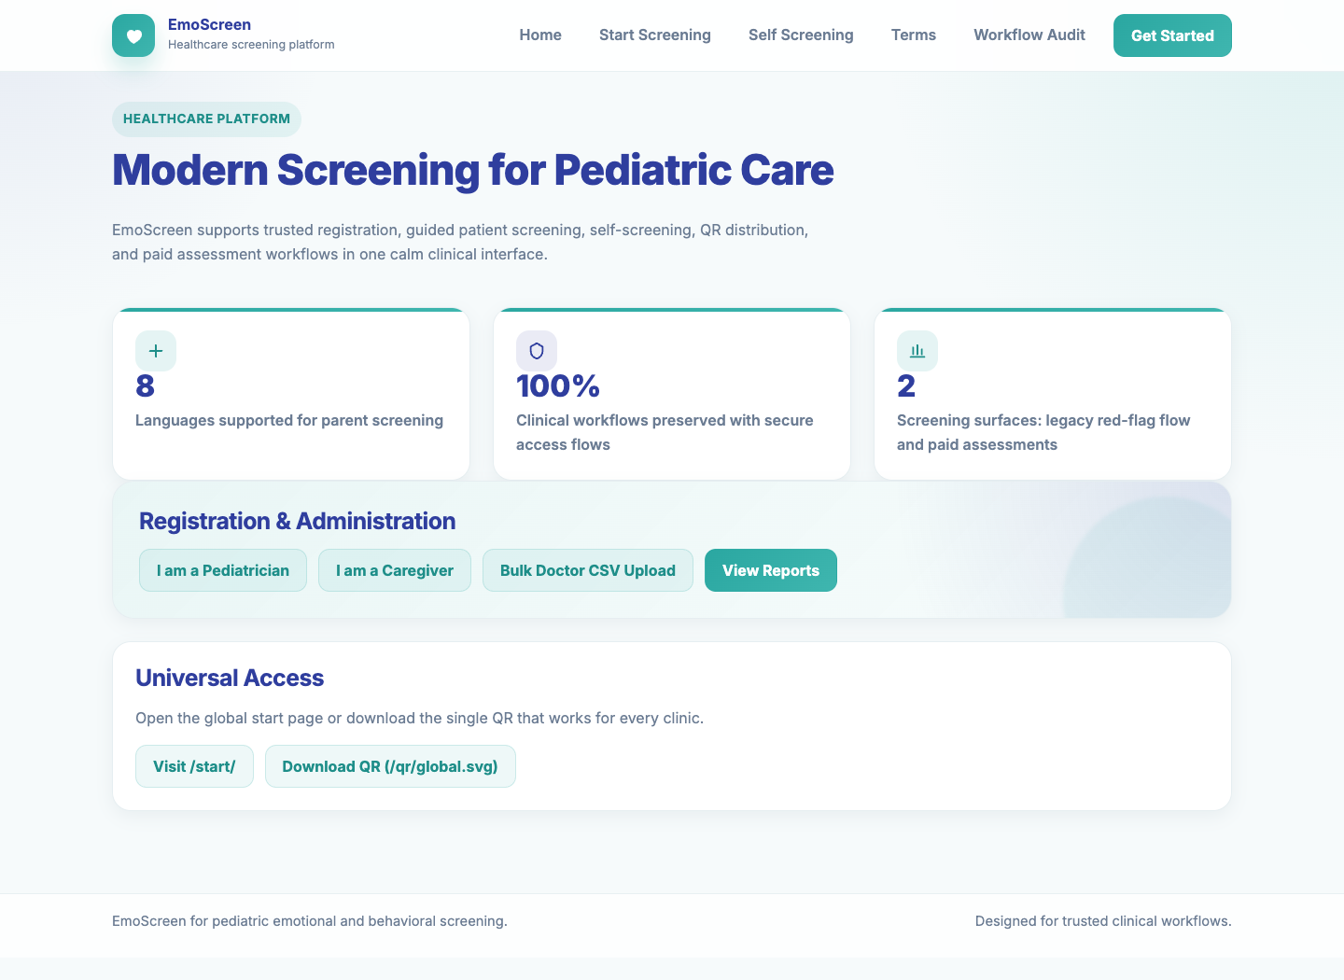
Screenshot: Public User Entry

3. Admin Recruitment Workflow

Admin Sign-In
What to do | Admin or support user signs in from the admin entry point using a staff account.
Expected result | The admin session is opened only for recruitment, reports, and support operations.

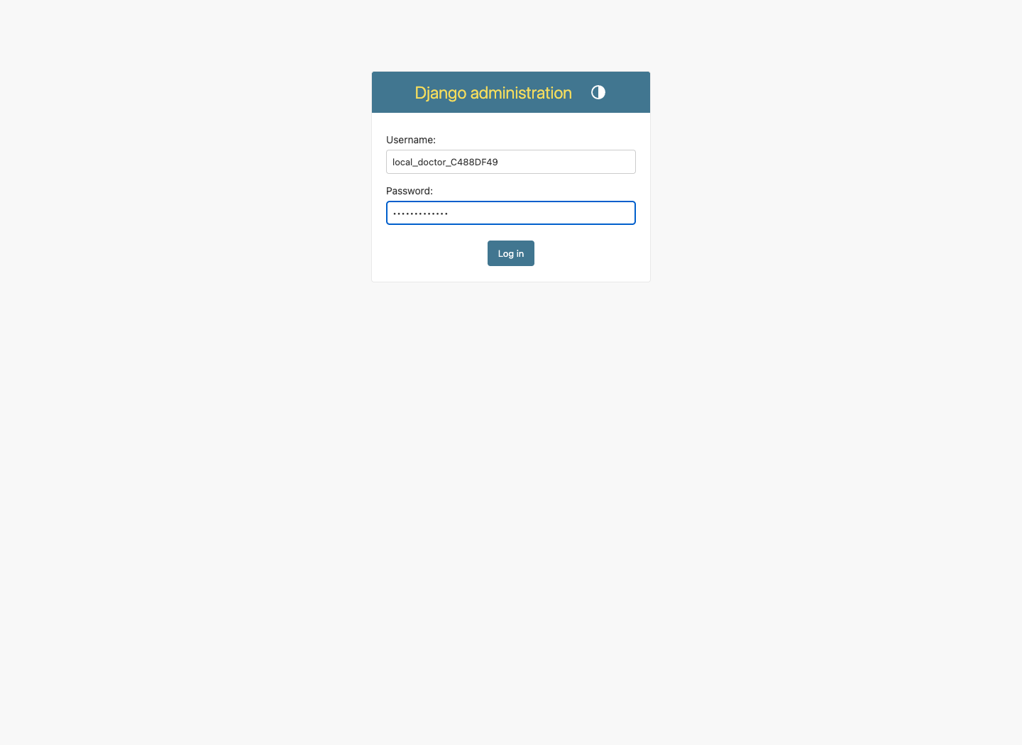
Screenshot: Admin Sign-In

Bulk Doctor Recruitment
What to do | Open the bulk doctor upload screen, choose a CSV with doctor details, and submit it.
Expected result | Valid doctors are created, duplicates are skipped, failures are shown, and a result CSV is available.

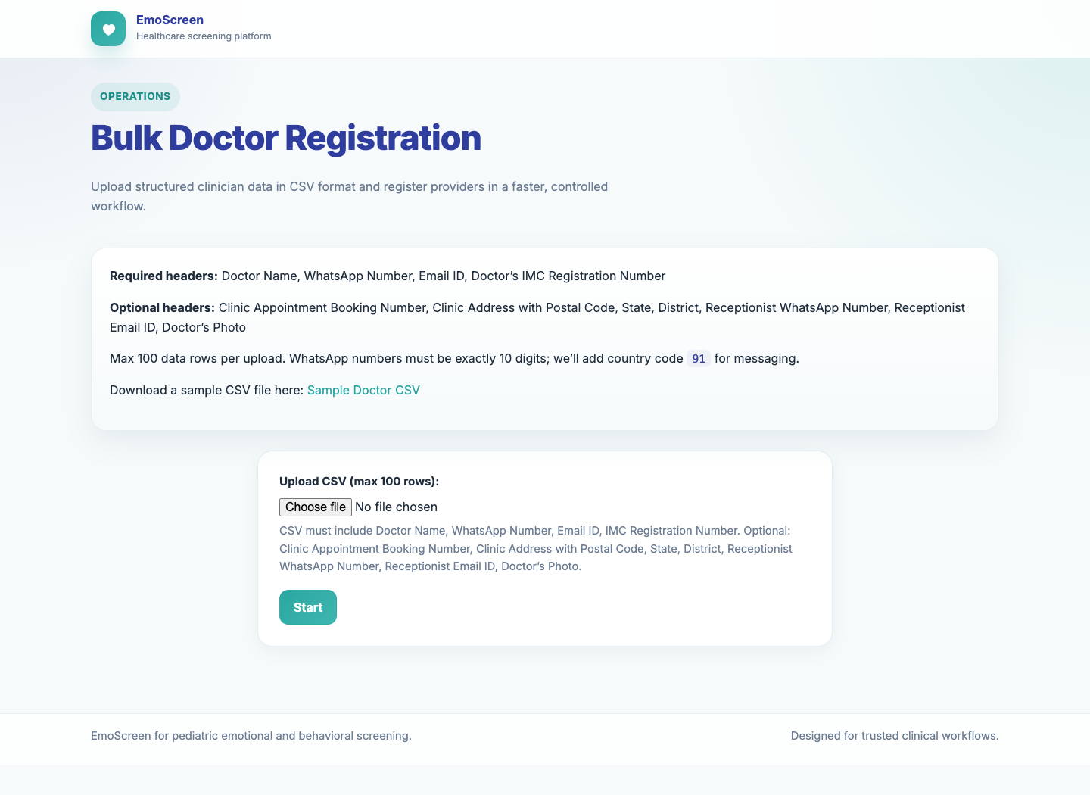
Screenshot: Bulk Doctor Recruitment
Doctor onboarding message
After recruitment the doctor receives WhatsApp/email copy like: Hello Dr Name. Thank you for registering for the Emotional & Behavioural Screening Tool - an initiative supported by SAPA. Your personalized screening tool is now ready. Clinic Link: https://emo.cpdinclinic.co.in/admin/bulk-upload/clinic/C488DF49/ How to Use Guide: https://bit.ly/43QkzpM.

4. Doctor Workflow
Doctor sign-in rule
In production the doctor opens the clinic link from the onboarding message and signs in with Google using the same email that was registered. If another Google account is used, access should be blocked.

Clinic Console
What to do | Doctor confirms the provider banner shows the correct clinic details. Use Send Form to Parent to share free or paid forms.
Expected result | The doctor sees only the clinic sharing workspace and can choose a parent WhatsApp number, form type, language, and QR/direct sharing options.

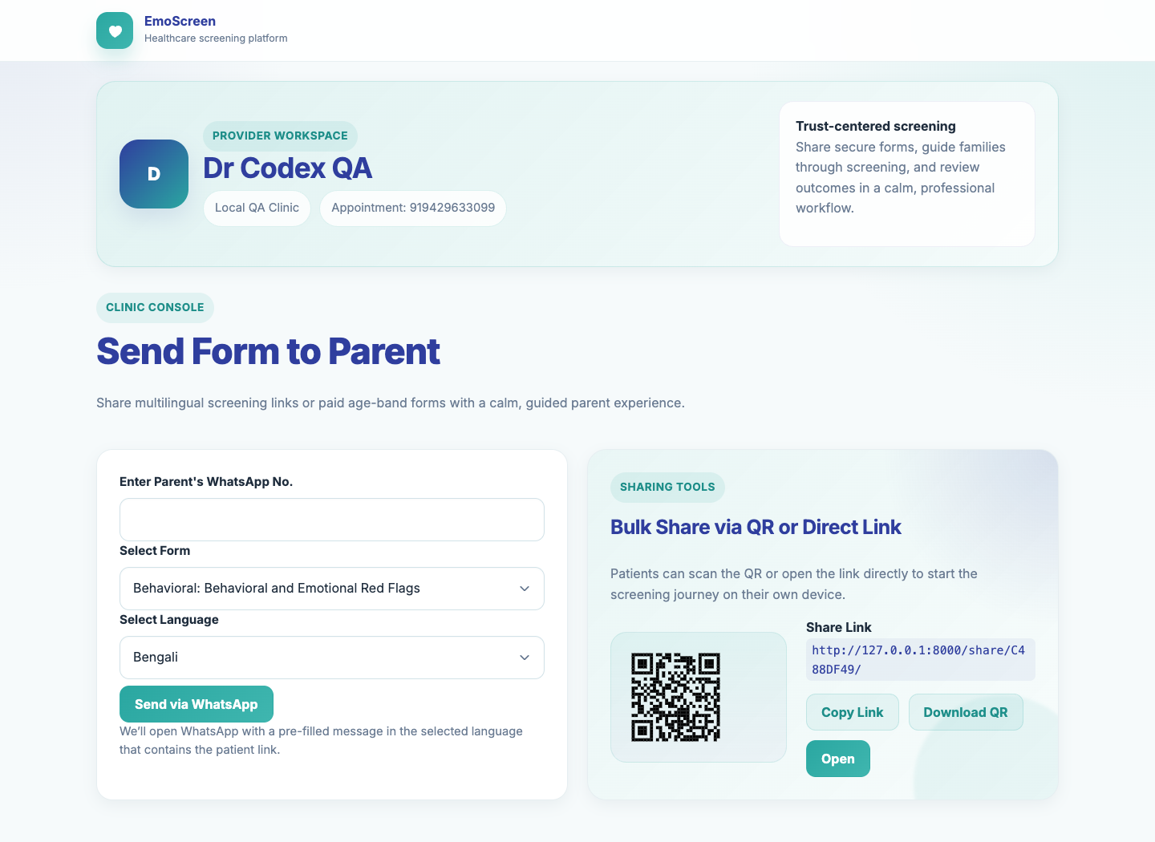
Screenshot: Clinic Console

Doctor Shares a Paid Form
What to do | Choose a paid age-band form, enter the parent's WhatsApp number, enter the patient name, choose the price, and send via WhatsApp.
Expected result | WhatsApp opens with a prepared message containing the paid parent link.

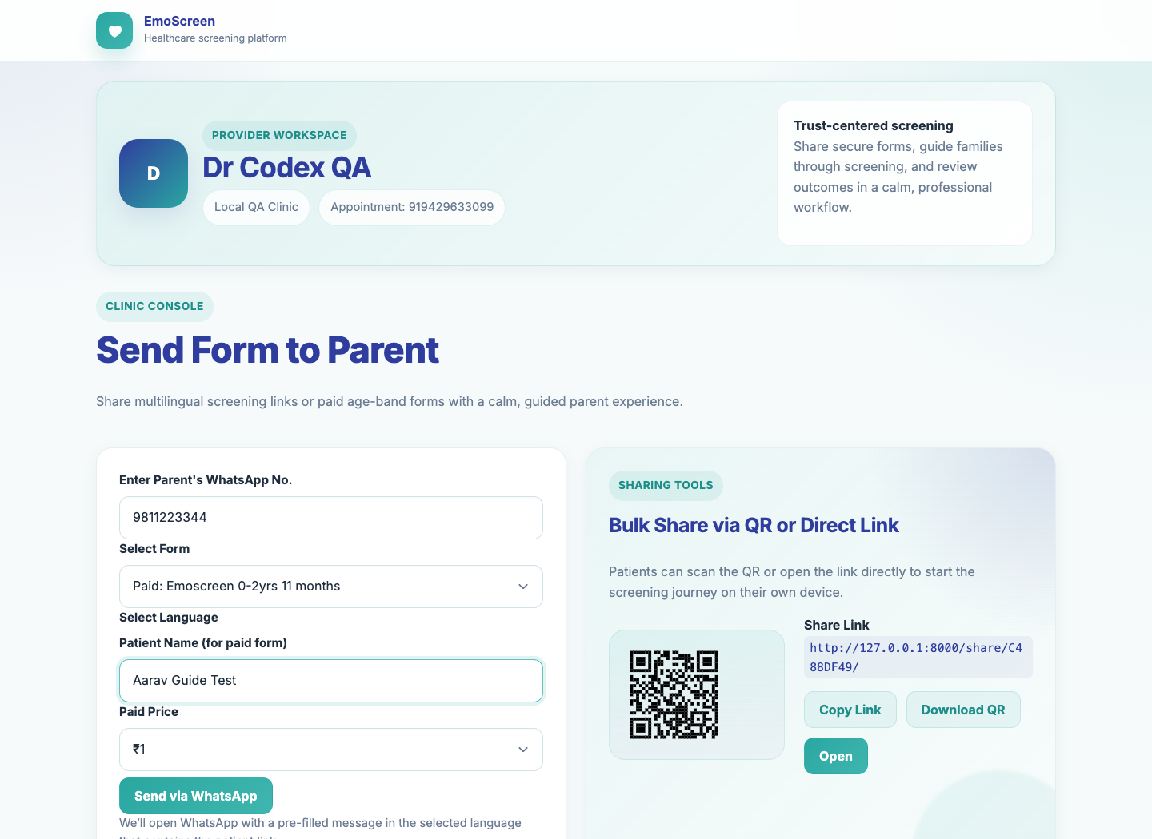
Screenshot: Doctor Shares a Paid Form

Doctor Shares a Free Form
What to do | Choose the Behavioral and Emotional Red Flags form, select the parent's preferred language, and send via WhatsApp.
Expected result | WhatsApp opens with a prepared message containing the verification link in the selected language.

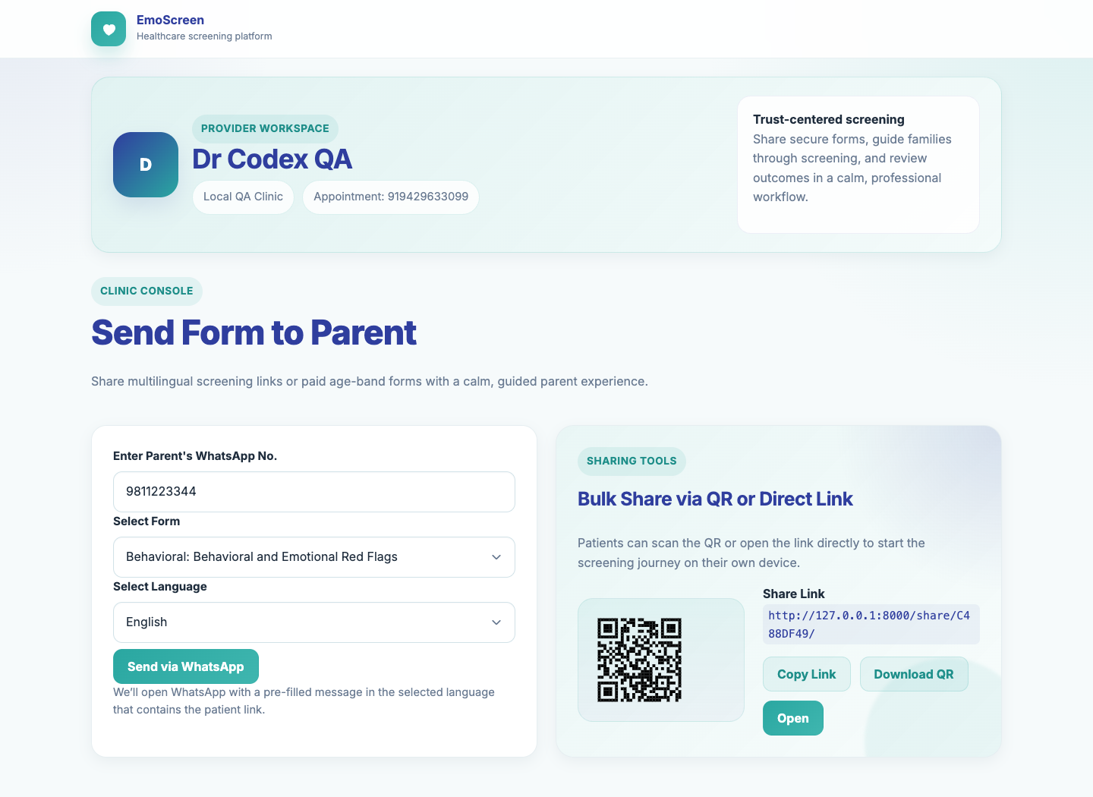
Screenshot: Doctor Shares a Free Form

5. Paid Parent Flow

Parent Opens Paid Order
What to do | Parent opens the paid link and confirms or enters their email address before continuing.
Expected result | The order page shows the prescribed form and payable amount.

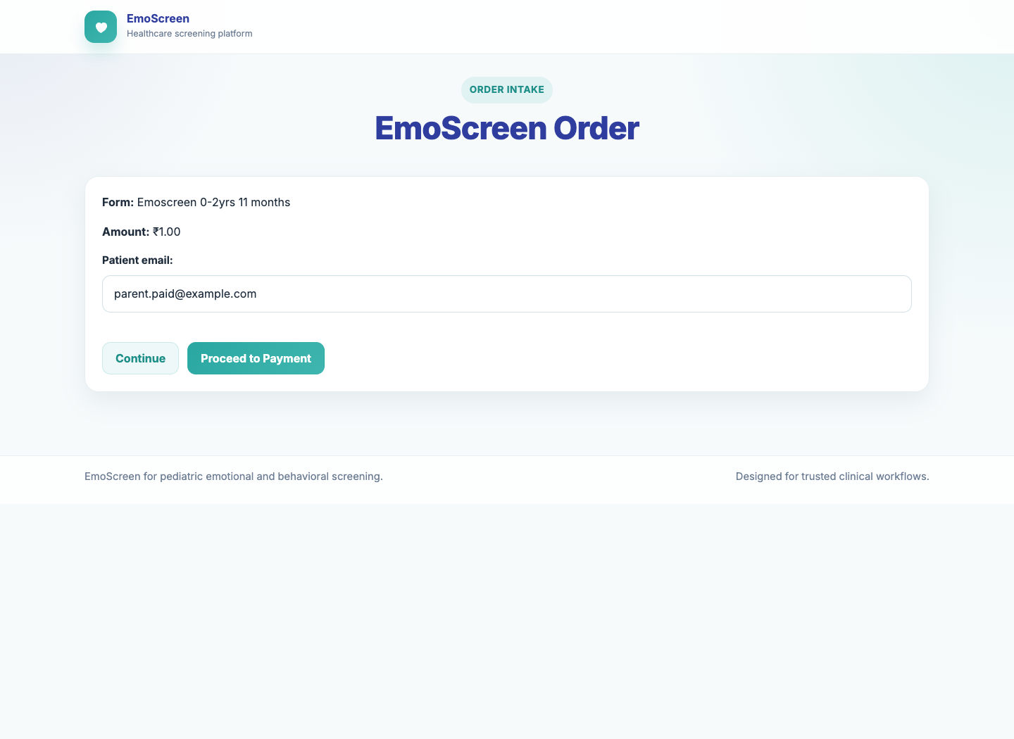
Screenshot: Parent Opens Paid Order

Payment Screen
What to do | For local UAT, click Complete Dummy Payment. In production, the parent should complete the Razorpay checkout.
Expected result | Payment is marked completed and the parent is allowed to proceed to the assessment.

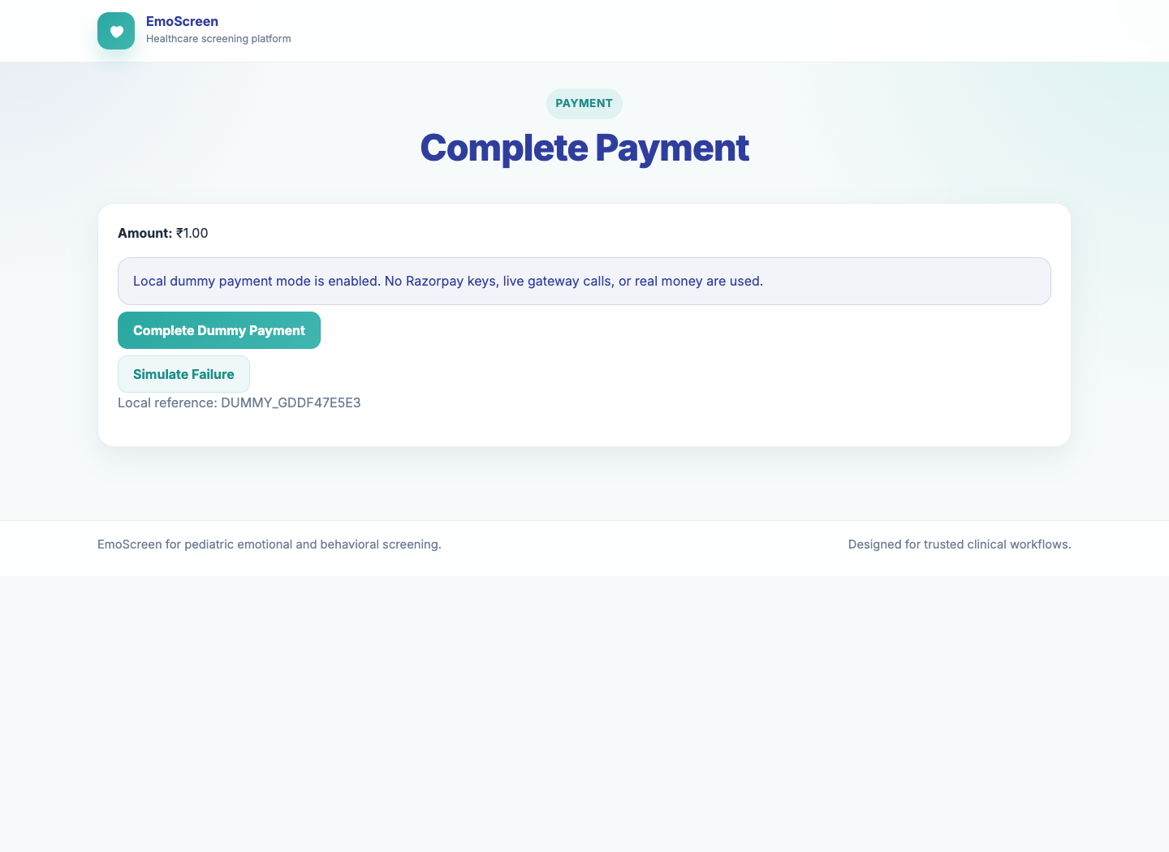
Screenshot: Payment Screen

Paid Assessment Form
What to do | Parent fills child details, confirms consent, answers all questions, and clicks Review.
Expected result | The Review screen opens only after required fields and questions are completed.

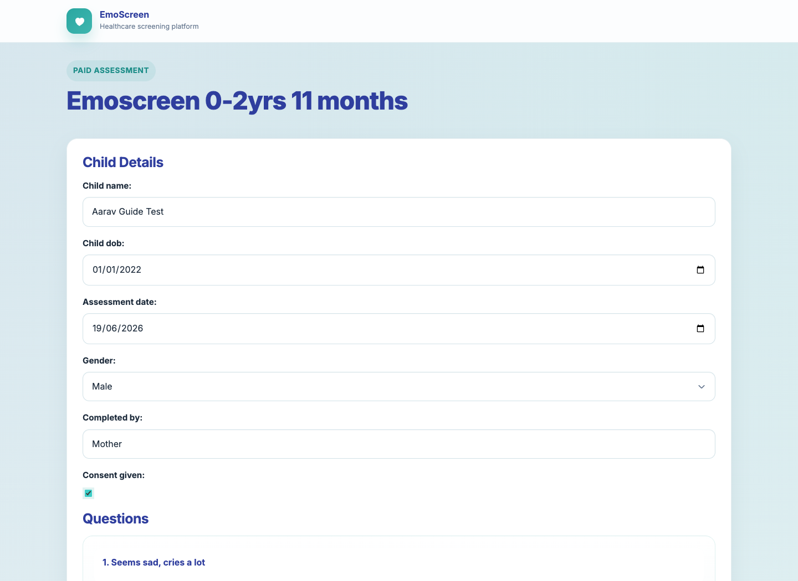
Screenshot: Paid Assessment Form

Review Answers
What to do | Parent reviews answers. If correct, click Submit Final. If incorrect, click Edit Answers.
Expected result | Final submission triggers report generation.

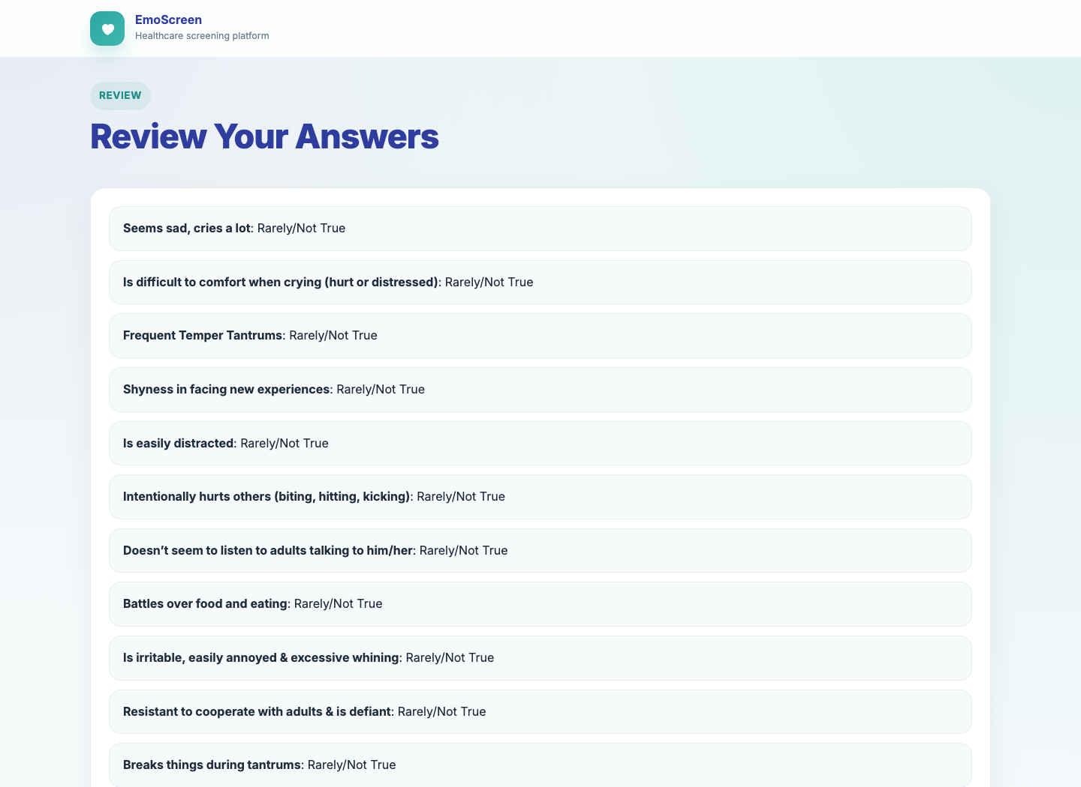
Screenshot: Review Answers

Paid Report Screen
In local UAT, email delivery may show FAILED when provider credentials are absent. In production, support should expect provider delivery status.
What to do | Confirm that the submission was accepted and the patient report screen is shown.
Expected result | The patient can download only the patient report. The doctor receives the doctor report and patient report by email. Reopening the paid link returns to this report screen instead of allowing another submission.

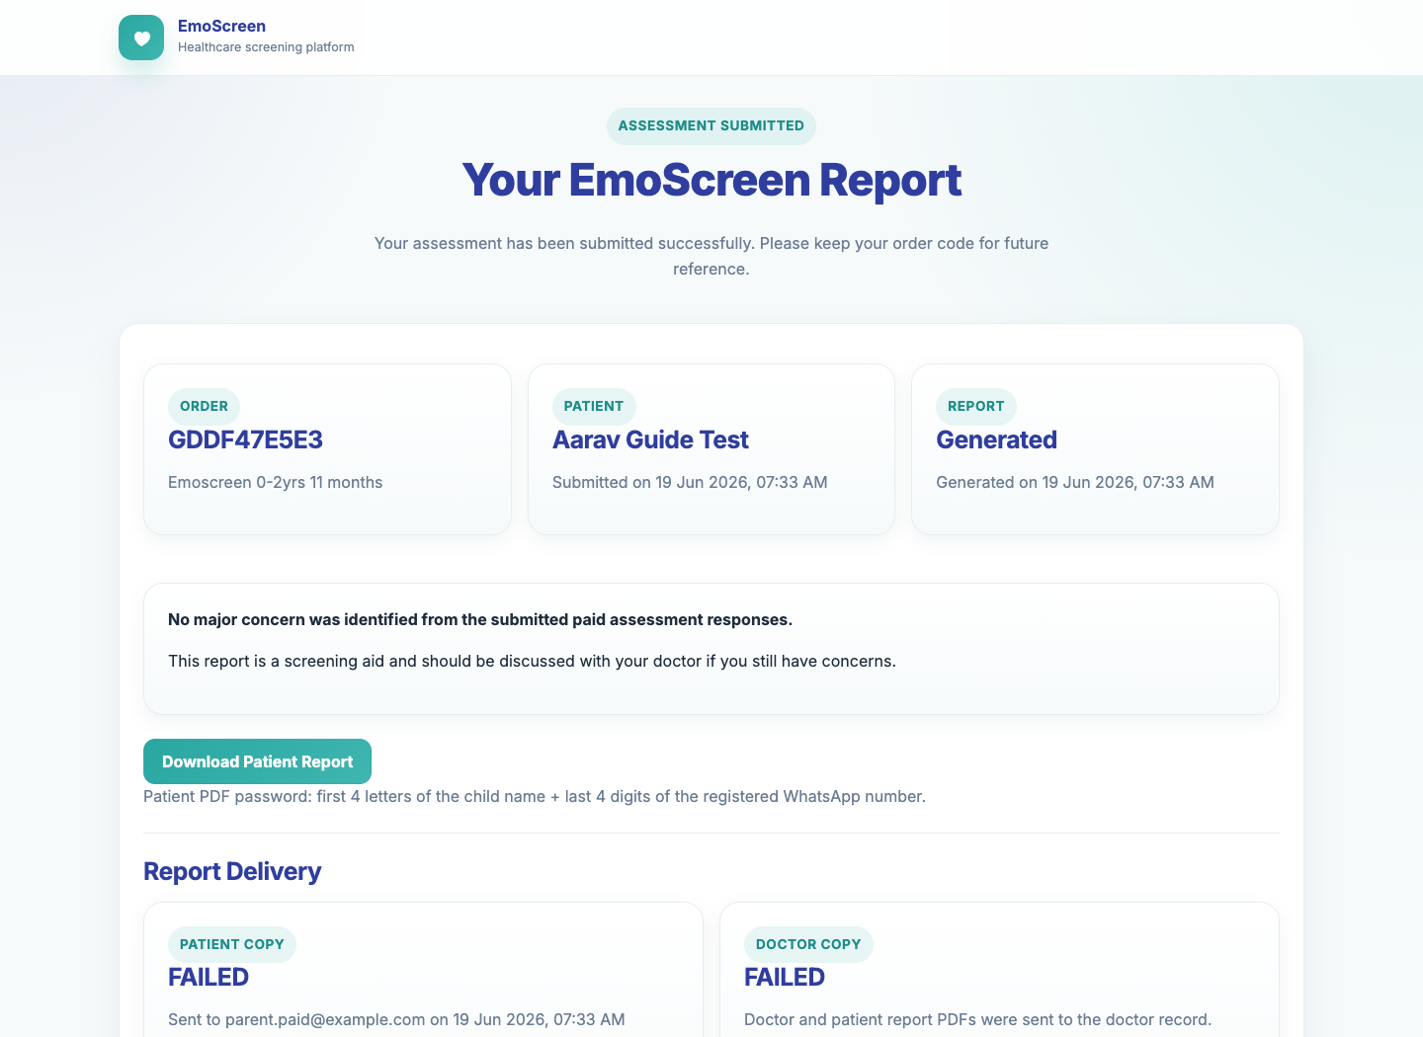
Screenshot: Paid Report Screen

6. Free Parent Flow

Phone Verification
What to do | Parent enters the same WhatsApp number that received the doctor message.
Expected result | The parent is verified and moved to language selection.

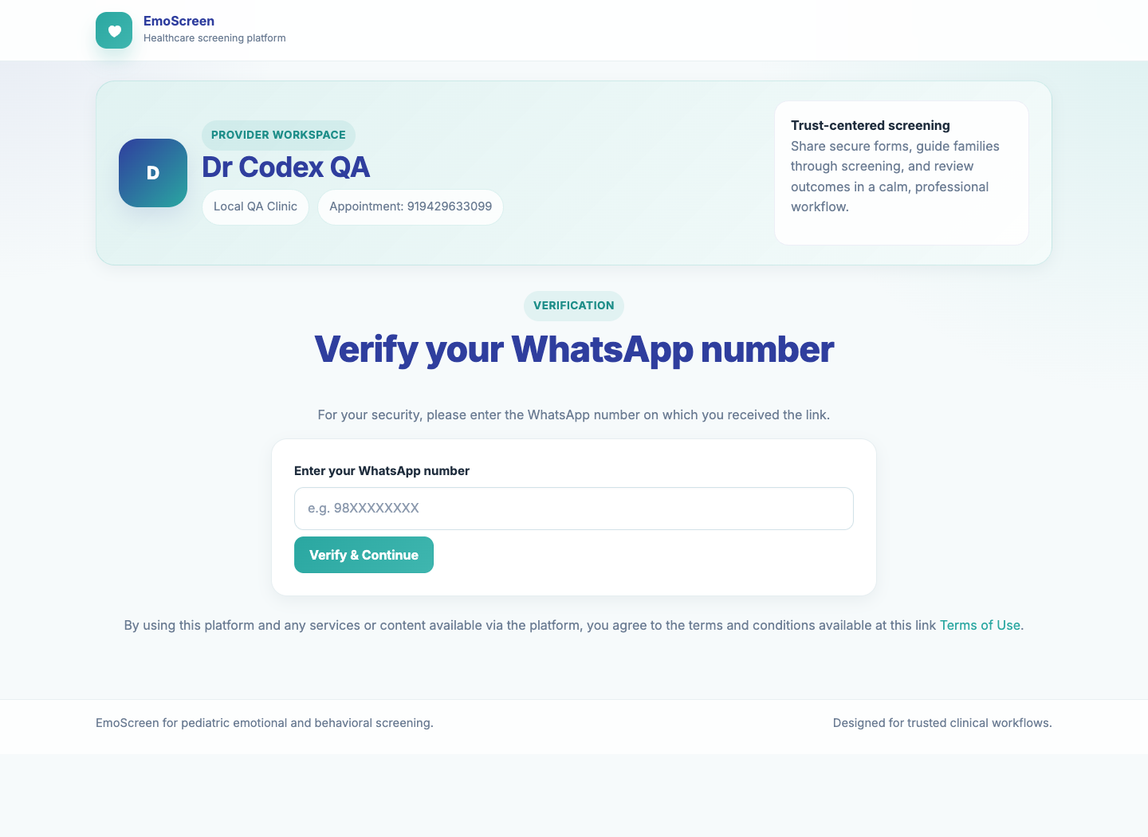
Screenshot: Phone Verification

Language Selection
What to do | Parent selects the language they are most comfortable using.
Expected result | The selected language opens the screening form.

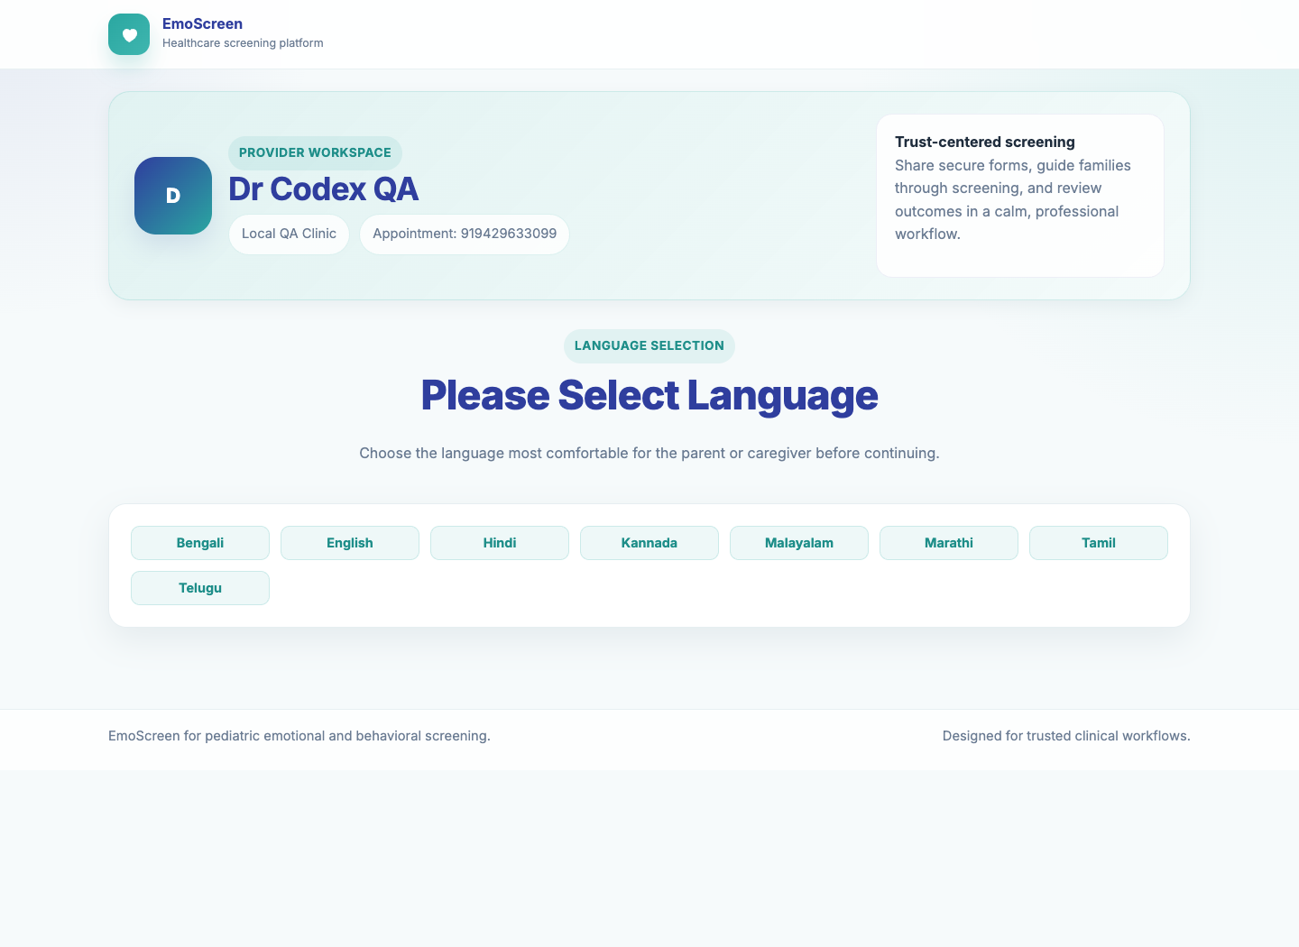
Screenshot: Language Selection

Free Screening Form
What to do | Parent enters patient details, answers every question, and submits the form.
Expected result | The result page opens after all required fields are complete.

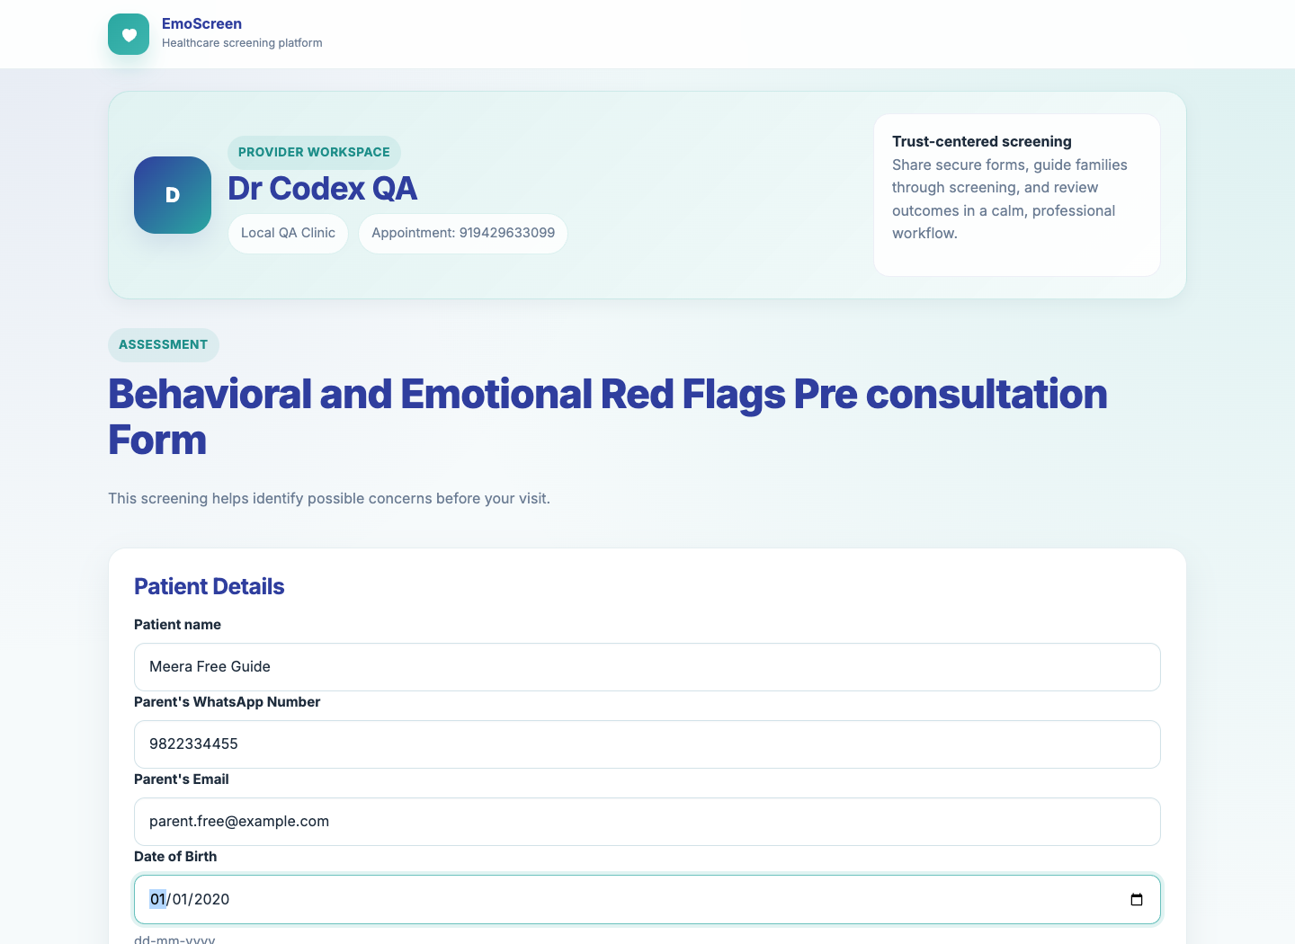
Screenshot: Free Screening Form

Free Result Screen
What to do | Parent reviews the result summary and keeps the report code for future reference.
Expected result | The result clearly shows whether warning signs were identified and shows next-step actions where applicable. Reopening the completed verified link returns to the existing report instead of accepting another submission.

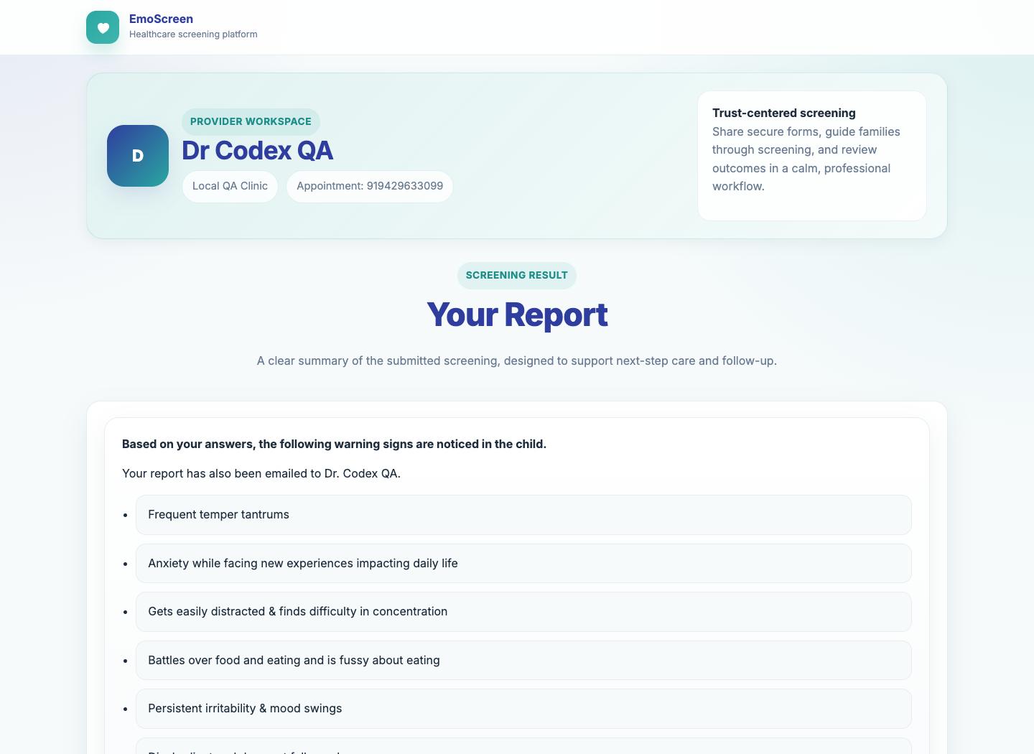
Screenshot: Free Result Screen

Language coverage checklist
Run the same free screening submission once in each supported language. The tester does not need to understand every translated question; the test is passed when the language-specific form loads, accepts answers, and opens the result screen.
Language | Screening link | Tester action | Expected result
English | Free form | Select English and submit all questions | Result page opens
Hindi | Free form | Select Hindi and submit all questions | Result page opens
Tamil | Free form | Select Tamil and submit all questions | Result page opens
Telugu | Free form | Select Telugu and submit all questions | Result page opens
Malayalam | Free form | Select Malayalam and submit all questions | Result page opens
Marathi | Free form | Select Marathi and submit all questions | Result page opens
Bengali | Free form | Select Bengali and submit all questions | Result page opens
Kannada | Free form | Select Kannada and submit all questions | Result page opens

7. Self-Screening Flow

Self-Screen Start
What to do | A parent without a doctor link starts from Self Screening and enters their WhatsApp number.
Expected result | The system routes the parent into the same guided screening experience without assigning a clinic doctor.

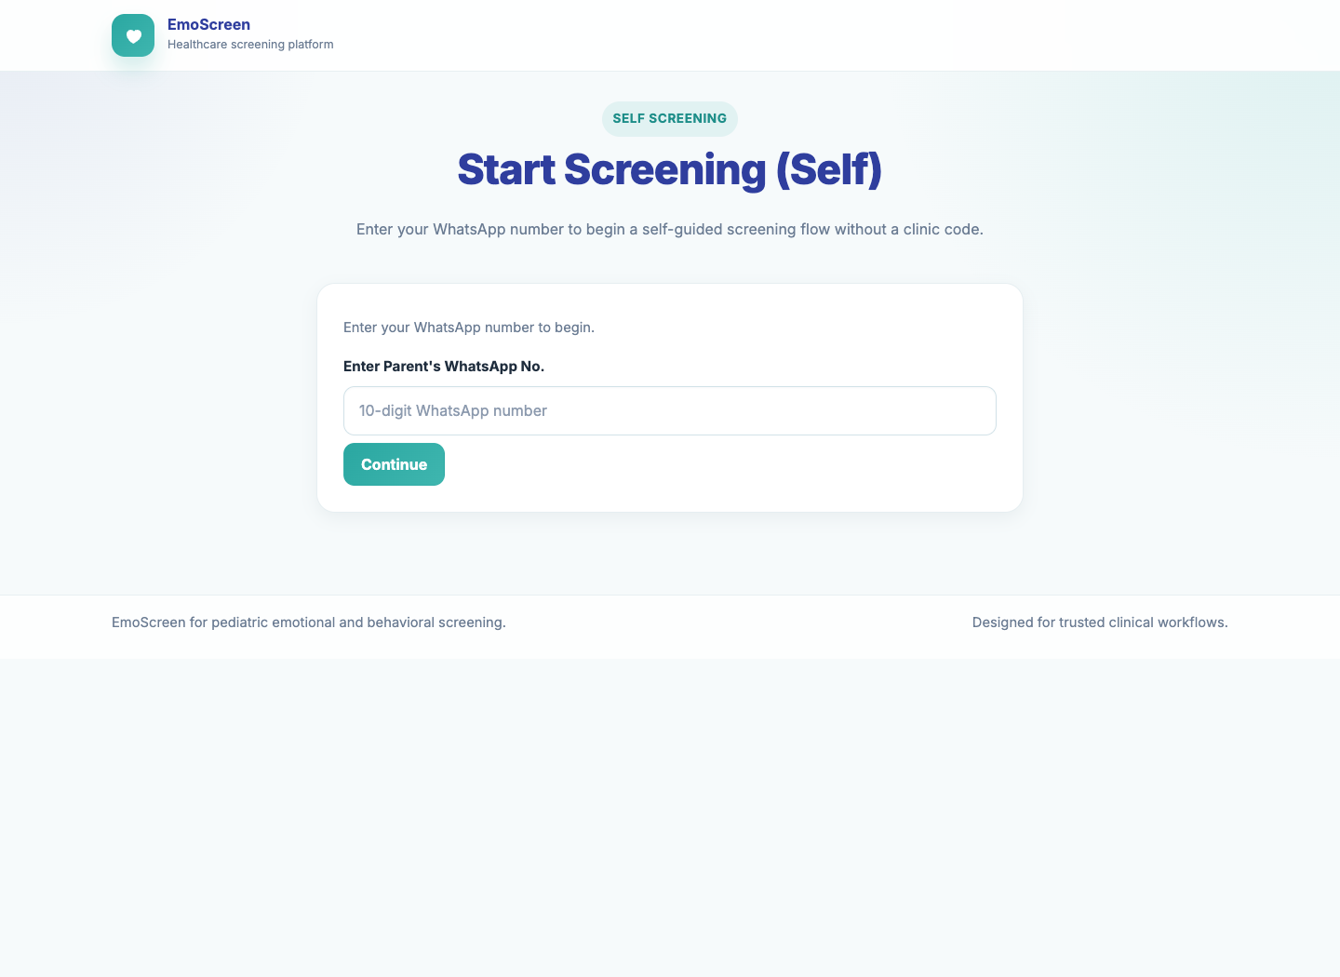
Screenshot: Self-Screen Start

8. Support and Audit Visibility

Workflow Audit Dashboard
What to do | Support opens the workflow dashboard and searches/filters by doctor, patient, form status, payment status, report status, or date range.
Expected result | Support can identify how many workflows are pending, completed, failed, paid, or submitted.

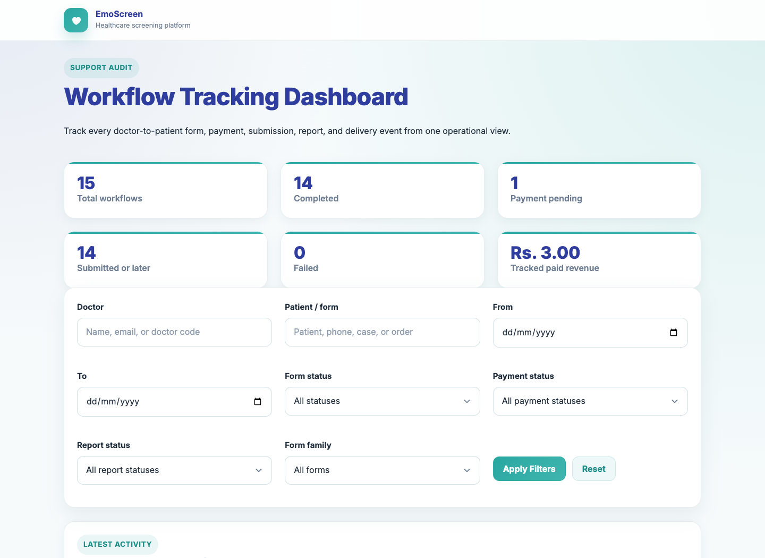
Screenshot: Workflow Audit Dashboard

Workflow Detail Page
What to do | Open a workflow case to inspect doctor, patient, payment, report, event timeline, and delivery attempts.
Expected result | Support can answer where the workflow currently stands and where it failed if any stage did not complete.

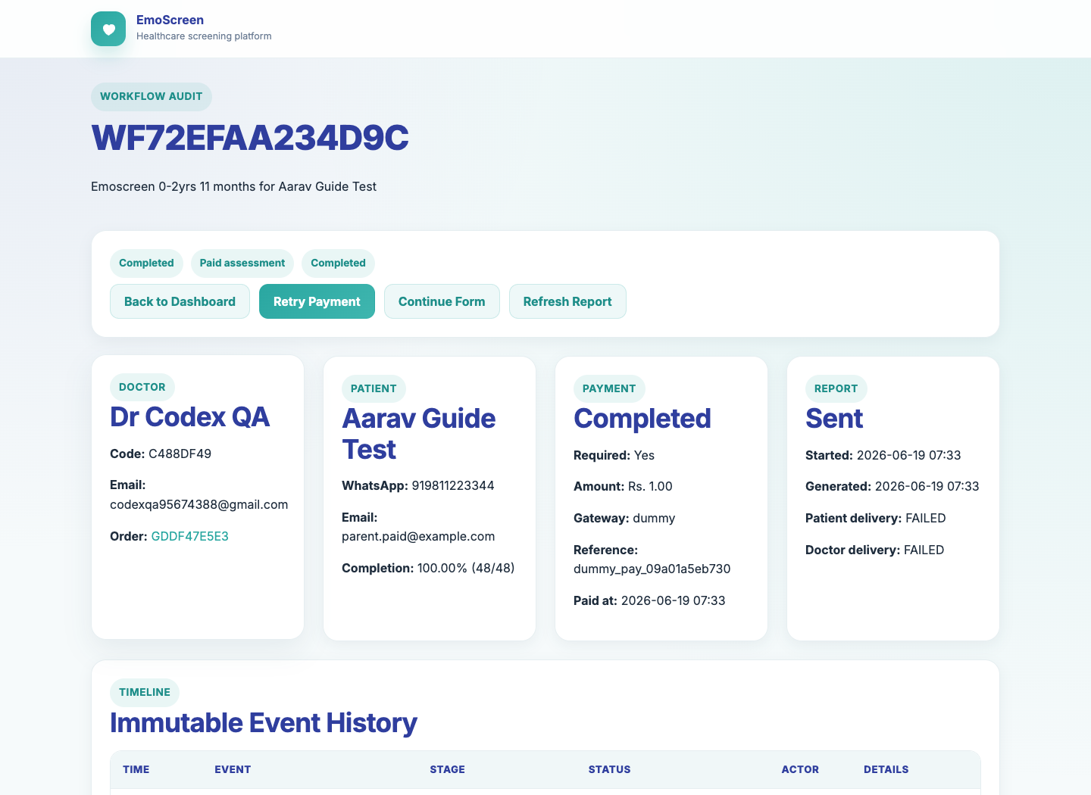
Screenshot: Workflow Detail Page

9. Final Pass Checklist
Use this checklist at the end of a full live or UAT pass.
Area | Tester action | Pass condition | Result
Admin recruitment | Upload or register doctors from admin tools | Doctor receives clinic link and how-to guide | Pass / Fail
Doctor access | Doctor opens clinic link and signs in with registered Google email | Doctor can see provider banner and sharing form | Pass / Fail
Paid form sharing | Select paid form and send link | Parent receives/opens payment and assessment link | Pass / Fail
Free form sharing | Select behavioral form and language | Parent verifies phone and reaches language/form flow | Pass / Fail
Payment | Complete payment | Payment status becomes completed before assessment opens | Pass / Fail
One-time use | Reopen a completed paid/free form link | Existing report opens; answers cannot be submitted again | Pass / Fail
Reports | Confirm paid and free result/report screens | Patient receives patient report; doctor receives doctor and patient reports where applicable | Pass / Fail
Audit trail | Open support workflow dashboard and detail page | Status, payment, report, event history, and delivery attempts are visible to support | Pass / Fail

10. Completion Criteria
- Normal public entry and admin entry are separate and both remain reachable.
- Admin can recruit doctors and the doctor receives the clinic link plus how-to guide.
- Doctor clinic workflow starts from the onboarding clinic link and requires the registered Google email.
- Doctor can share both paid and free links without confusion.
- Parent can complete payment before accessing a paid assessment.
- Parent can complete the paid form once and reach the patient-facing paid report screen.
- Paid report delivery sends one patient report to the patient and both patient and doctor reports to the doctor.
- Parent can complete the free form once in all supported languages.
- Self-screening starts without a doctor-specific link.
- Support can trace each workflow from creation through completion using the audit dashboard.
- Any failure state shows the stage, reason, and enough context for support to retry or escalate.

