WHO/UNICEF's 10 Steps to Successful Breastfeeding: A Detailed Review

Introduction [1]
The World Health Organization (WHO) and UNICEF developed the Ten Steps to Successful Breastfeeding as part of the Baby-Friendly Hospital Initiative (BFHI) to promote, protect, and support breastfeeding practices. These steps serve as evidence-based guidelines for healthcare facilities to create environments that enable mothers to initiate and sustain breastfeeding effectively. By following these steps, hospitals and clinics can significantly enhance maternal and neonatal health outcomes.

Detailed Explanation of the 10 Steps[2]

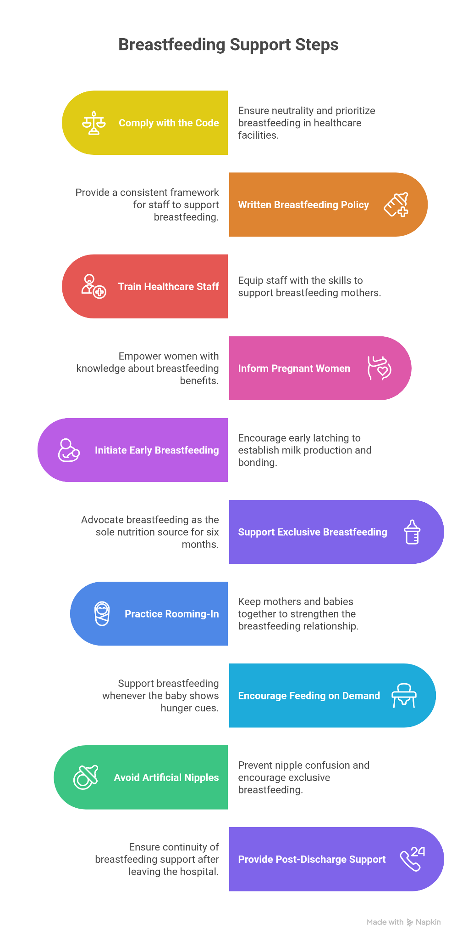
Step 1: Comply with the International Code of Marketing of Breastmilk Substitutes
- Objective: Ensure healthcare facilities maintain neutrality and prioritize breastfeeding.
Step 2: Have a Written Breastfeeding Policy
- Objective: Provide a consistent framework for staff to support breastfeeding.
Step 3: Train Healthcare Staff
- Objective: Equip all staff with the skills needed to support breastfeeding mothers.

Step 4: Inform Pregnant Women About Breastfeeding Benefits
- Objective: Empower pregnant women with knowledge about breastfeeding's nutritional and health benefits.
Step 5: Initiate Breastfeeding Within One Hour of Birth
- Objective: Encourage early latching to establish milk production and promote bonding.
Step 6: Support Exclusive Breastfeeding
- Objective: Advocate breastfeeding as the sole source of nutrition for the first six months.
Step 7: Practice Rooming-In
- Objective: Keep mothers and babies together to strengthen the breastfeeding relationship.
Step 8: Encourage Feeding on Demand
- Objective: Support breastfeeding whenever the baby shows hunger cues.
Step 9: Avoid Artificial Nipples and Pacifiers
- Objective: Prevent nipple confusion and encourage exclusive breastfeeding.
Step 10: Provide Breastfeeding Support Post-Discharge
- Objective: Ensure continuity of breastfeeding support after leaving the hospital.

Benefits of Following the 10 Steps
- For Infants [3]:
  - Reduced risk of neonatal mortality and morbidities such as diarrhea, respiratory infections, and allergies.
  - Enhanced cognitive development due to optimal nutrition and bioactive components in breastmilk.
- For Mothers [3]:
  - Reduced risk of postpartum hemorrhage due to oxytocin release during breastfeeding.
  - Long-term protection against breast and ovarian cancers, Type 2 diabetes, and osteoporosis.
- For Healthcare Systems [4]:
  - Decreased burden of preventable illnesses and hospital admissions related to malnutrition or formula feeding complications.
- For Communities [5]:
  - Economic savings due to reduced reliance on formula feeding and fewer healthcare costs.

Breastfeeding in the First 48 Hours
The first 48 hours after birth are critical for establishing successful breastfeeding. During this period, healthcare providers and mothers must collaborate to initiate and sustain effective breastfeeding practices. Below is a step-by-step guide:

Actions for Healthcare Providers

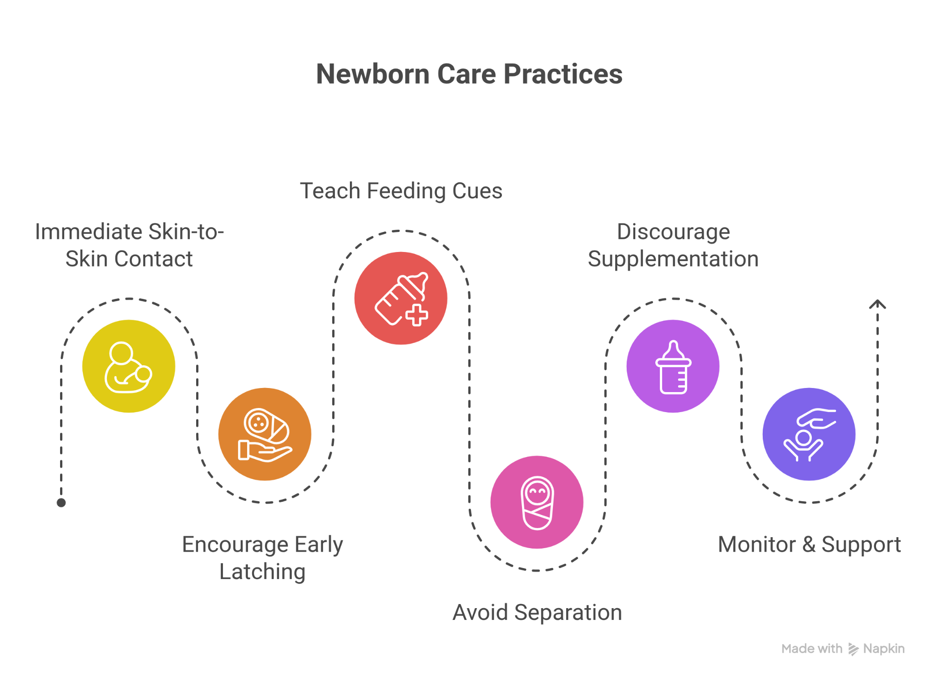
- Immediate Skin-to-Skin Contact:
  - Place the newborn on the mother’s chest immediately after delivery to promote bonding and initiate breastfeeding.
  - Ensure uninterrupted skin-to-skin contact for at least one hour or until the first breastfeeding session is complete.
- Encourage Early Latching:
  - Support the baby to latch onto the breast within the first hour of birth, taking into account the baby’s readiness and mother’s comfort.
  - Observe and assist with correct positioning and attachment to prevent nipple pain or poor milk transfer.
- Provide Clear Instructions:
  - Mothers are educated to identify early feeding cues, including rooting, hand-to-mouth movements, sucking on hands or fingers, smacking or licking of lips, and increasing alertness or restlessness, and were specifically informed that crying represents a late sign of hunger.
  - Mothers were advised to initiate breastfeeding within the first hour after birth and to breastfeed responsively on demand, aiming for approximately 8–12 feeds in each 24-hour period during the first 3 days and continuing through the early postnatal weeks, including night-time feeds.
- Avoid Separation:
  - Implement rooming-in policies to allow mothers and babies to stay together 24/7.
  - Conduct routine medical checks in the mother’s room to minimize disruptions to breastfeeding.
- Discourage Supplementation:
  - Avoid giving breastmilk alternative unless medically indicated. Reinforce the sufficiency of colostrum as the baby’s first food.
  - If supplementation is necessary, ensure the use of methods like cup feeding to prevent nipple confusion.
- Monitor and Support:
  - Observe breastfeeding sessions for any challenges, such as difficulty latching or low milk supply, and provide immediate support.
  - Reassure mothers, particularly first-time mothers, about their ability to breastfeed successfully.

Post-Discharge Support Map[6]
Breastfeeding support does not end at the hospital. Many mothers face challenges after discharge, such as difficulty with latching, concerns about milk supply, and the need for emotional support. A Post-Discharge Support Map connects mothers to essential resources in their region, ensuring they receive the continued guidance needed to sustain successful breastfeeding.

Components of the Post-Discharge Support Map

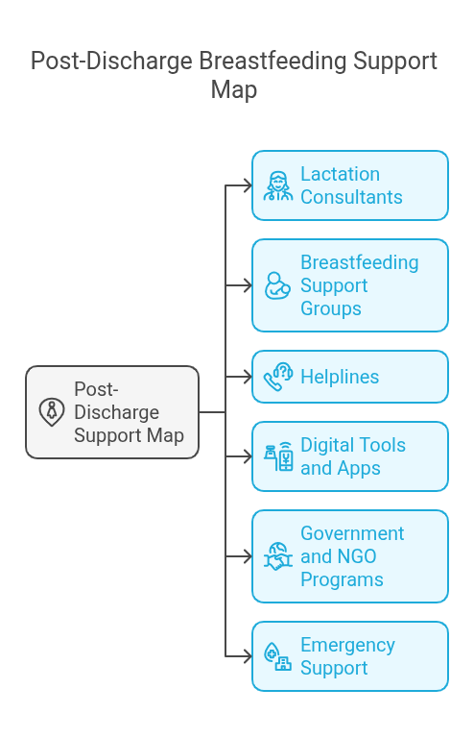
- Lactation Consultants:
  - A directory of certified lactation consultants (IBCLCs or other qualified professionals) who provide one-on-one consultations.
  - Include contact details, availability, and consultation modes (in-person, telehealth, or home visits).
- Breastfeeding Support Groups:
  - List local breastfeeding support groups, often facilitated by experienced mothers or healthcare providers.
  - Include meeting schedules and virtual support options for remote areas or mothers unable to travel.
- Helplines:
  - Provide toll-free breastfeeding helplines operated by trained counselors available 24/7.
  - Highlight government hospital , and non-governmental organization (NGO) resources.
- Digital Tools and Apps:
  - Recommend apps or online platforms offering breastfeeding tracking, tips, and expert advice (e.g., Milk Matters, Breastfeeding Friend by WHO).
- Government and NGO Programs:
  - Include resources like anganwadi centers, Accredited Social Health Activist (ASHA) workers, or programs under India’s National Nutrition Mission (POSHAN Abhiyaan) wherever necessary.
- Emergency Support:
  - Include information about local pediatricians and hospitals for managing feeding-related complications or urgent concerns.

Practical Recommendations for Implementation[7]
- Policy Advocacy:
  - Advocate for national and state governments to adopt the ‘WHO/UNICEF Ten Steps’ as mandatory guidelines for all maternity facilities.
- Training Programs:
  - Include comprehensive lactation training for medical and paramedical staff as part of ongoing professional development.
- Monitoring and Accreditation:
  - Regularly evaluate hospitals for compliance with BFHI standards and provide accreditation to facilities meeting all criteria.
- Community Outreach:
  - Conduct awareness campaigns through local media and community health programs to promote the importance of breastfeeding.

Conclusion

The WHO/UNICEF’s ‘Ten Steps to Successful Breastfeeding’ serve as a critical framework for improving breastfeeding initiation and sustainability, ultimately enhancing maternal and infant health outcomes. By ensuring healthcare facilities adopt evidence-based policies, provide proper training, and offer continuous post-discharge support, these guidelines help create an environment where breastfeeding can thrive. Successful implementation requires collaboration between healthcare systems, policymakers, and communities to overcome challenges and integrate breastfeeding support into routine maternal and child health services. Strengthening adherence to these ten steps globally can significantly reduce neonatal morbidity, improve child nutrition, and promote lifelong health benefits for both mothers and infants.

References

[1]Wikipedia contributors. (2024a, July 25). Baby Friendly Hospital Initiative. Wikipedia. https://en.m.wikipedia.org/wiki/Baby_Friendly_Hospital_Initiative

[2]Ten steps to successful breastfeeding. (n.d.). https://www.who.int/teams/nutrition-and-food-safety/food-and-nutrition-actions-in-health-systems/ten-steps-to-successful-breastfeeding

[3] World Health Organization: WHO. (2023, December 20). Infant and young child feeding. https://www.who.int/news-room/fact-sheets/detail/infant-and-young-child-feeding#:~:text=Exclusive%20breastfeeding%20for%206%20months,the%20national%20level.

[4]Sili, J., Sili, J., & Sili, J. (2018, October 19). WHO and UNICEF issue revised Ten Steps to Successful Breastfeeding | Bellies Abroad. Bellies Abroad |. https://www.belliesabroad.com/who-and-unicef-issue-revised-ten-steps-to-successful-breastfeeding/#:~:text=Breastfeeding%20is%20not%20only%20vital%20to%20a,cancer%2C%20heart%20disease%20and%20type%202%20diabetes.

[5]Biological, behavioural and contextual rationale. (n.d.). https://www.who.int/tools/elena/bbc/implementation-bfhi#:~:text=BFHI%20has%20been%20shown%20to,of%20infant%20abandonment%

[6]Smith, Helen et al. “Discharge preparation and readiness after birth: a scoping review of global policies, guidelines and literature.” BMC pregnancy and childbirth vol. 22,1 281. 5 Apr. 2022, doi:10.1186/s12884-022-04577-3

[7]https://www.who.int/news/item/11-04-2018-who-and-unicef-issue-new-guidance-to-promote-breastfeeding-in-health-facilities-globally

