Academic Stress, Appetite Loss, and Micronutrients

The Mechanistic Link Between Catecholamines and Taste Receptor Turnover

Introduction
Academic stress is increasingly recognized as a significant physiological challenge in children and adolescents. Beyond its effects on mental well-being and academic performance, sustained academic stress has important biological consequences that directly influence appetite, sensory perception, and micronutrient intake.
A growing body of evidence demonstrates that stress-induced neuroendocrine responses—particularly catecholamine and cortisol surges—alter taste receptor turnover and appetite regulation. These changes create a self-reinforcing cycle of appetite loss, micronutrient deficiency, and further impairment of taste and feeding behavior.

Defining Academic Stress
Academic stress refers to the psychological and physiological burden placed on students by academic demands such as examinations, coursework load, performance expectations from parents and teachers, and competitive educational environments. While mild stress is adaptive and often improves focus and motivation, excessive or prolonged academic stress activates maladaptive stress-response systems.
In susceptible children and adolescents, this stress response interferes with appetite regulation, sensory function, and nutrient intake. Importantly, not all students experiencing academic stress develop appetite loss or nutritional consequences; however, a significant subset does, particularly during examination periods or prolonged academic pressure.

Prevalence of Academic Stress Across Populations
Studies consistently demonstrate that academic stress is highly prevalent across educational levels and geographic regions. Among high-school and pre-university students in South Asia, approximately one-quarter to one-third report significant academic stress. Rates are substantially higher in health-science education, where up to eighty-five percent of medical undergraduates and postgraduates experience moderate to high stress.
Comparable prevalence rates have been reported in university populations in the Middle East and Africa. Overall, between twenty-five and eighty-five percent of students experience clinically meaningful academic stress, depending on academic intensity and assessment methods.

Academic Stress as a Physiological Stressor
Academic stress activates two major neuroendocrine systems: the hypothalamic–pituitary–adrenal (HPA) axis and the sympathoadrenal system. Activation of these pathways results in elevated circulating cortisol and catecholamines, including epinephrine, norepinephrine, and dopamine.
These hormonal changes are adaptive in the short term but become maladaptive when sustained, affecting gastrointestinal function, appetite regulation, and sensory perception.

Stress Response Pathways and Appetite Regulation
Psychological stress stimulates the hypothalamus to release corticotropin-releasing hormone, which activates the pituitary gland to secrete adrenocorticotropic hormone. This leads to cortisol release from the adrenal cortex.
Simultaneously, sympathetic nervous system activation triggers catecholamine release from the adrenal medulla. Blood flow is redirected from the gastrointestinal tract to skeletal muscles, reducing digestive activity.
Corticotropin-releasing hormone and norepinephrine suppress hunger by reducing ghrelin secretion and increasing leptin sensitivity. Reduced parasympathetic tone delays gastric emptying, creating a sensation of fullness. The combined effect is decreased meal initiation and reduced appetite under chronic academic stress.

Taste Bud Physiology and Renewal
Taste buds are dynamic sensory structures composed of fifty to one hundred receptor cells that renew every ten to fourteen days. This continuous turnover is essential for maintaining normal taste perception and food enjoyment.
Taste receptor renewal depends on adequate oxygen supply, trophic factors, neural signaling, and sufficient micronutrients—particularly zinc, vitamin A, and B-complex vitamins. Distinct receptors mediate sweet, salty, sour, bitter, and umami tastes, all of which contribute to appetite and dietary variety.

Impact of Stress on Taste Receptor Turnover
Chronic sympathetic activation causes oral vasoconstriction, reducing oxygen and nutrient delivery to taste bud progenitor cells. Beta-adrenergic signaling alters progenitor cell proliferation through cyclic adenosine monophosphate–protein kinase A–CREB pathways, reducing renewal rates.
Cortisol further inhibits cellular differentiation, particularly affecting sweet and umami receptor density. As these taste modalities are closely linked to food pleasure and palatability, their reduction leads to diminished enjoyment of food and progressive appetite loss.
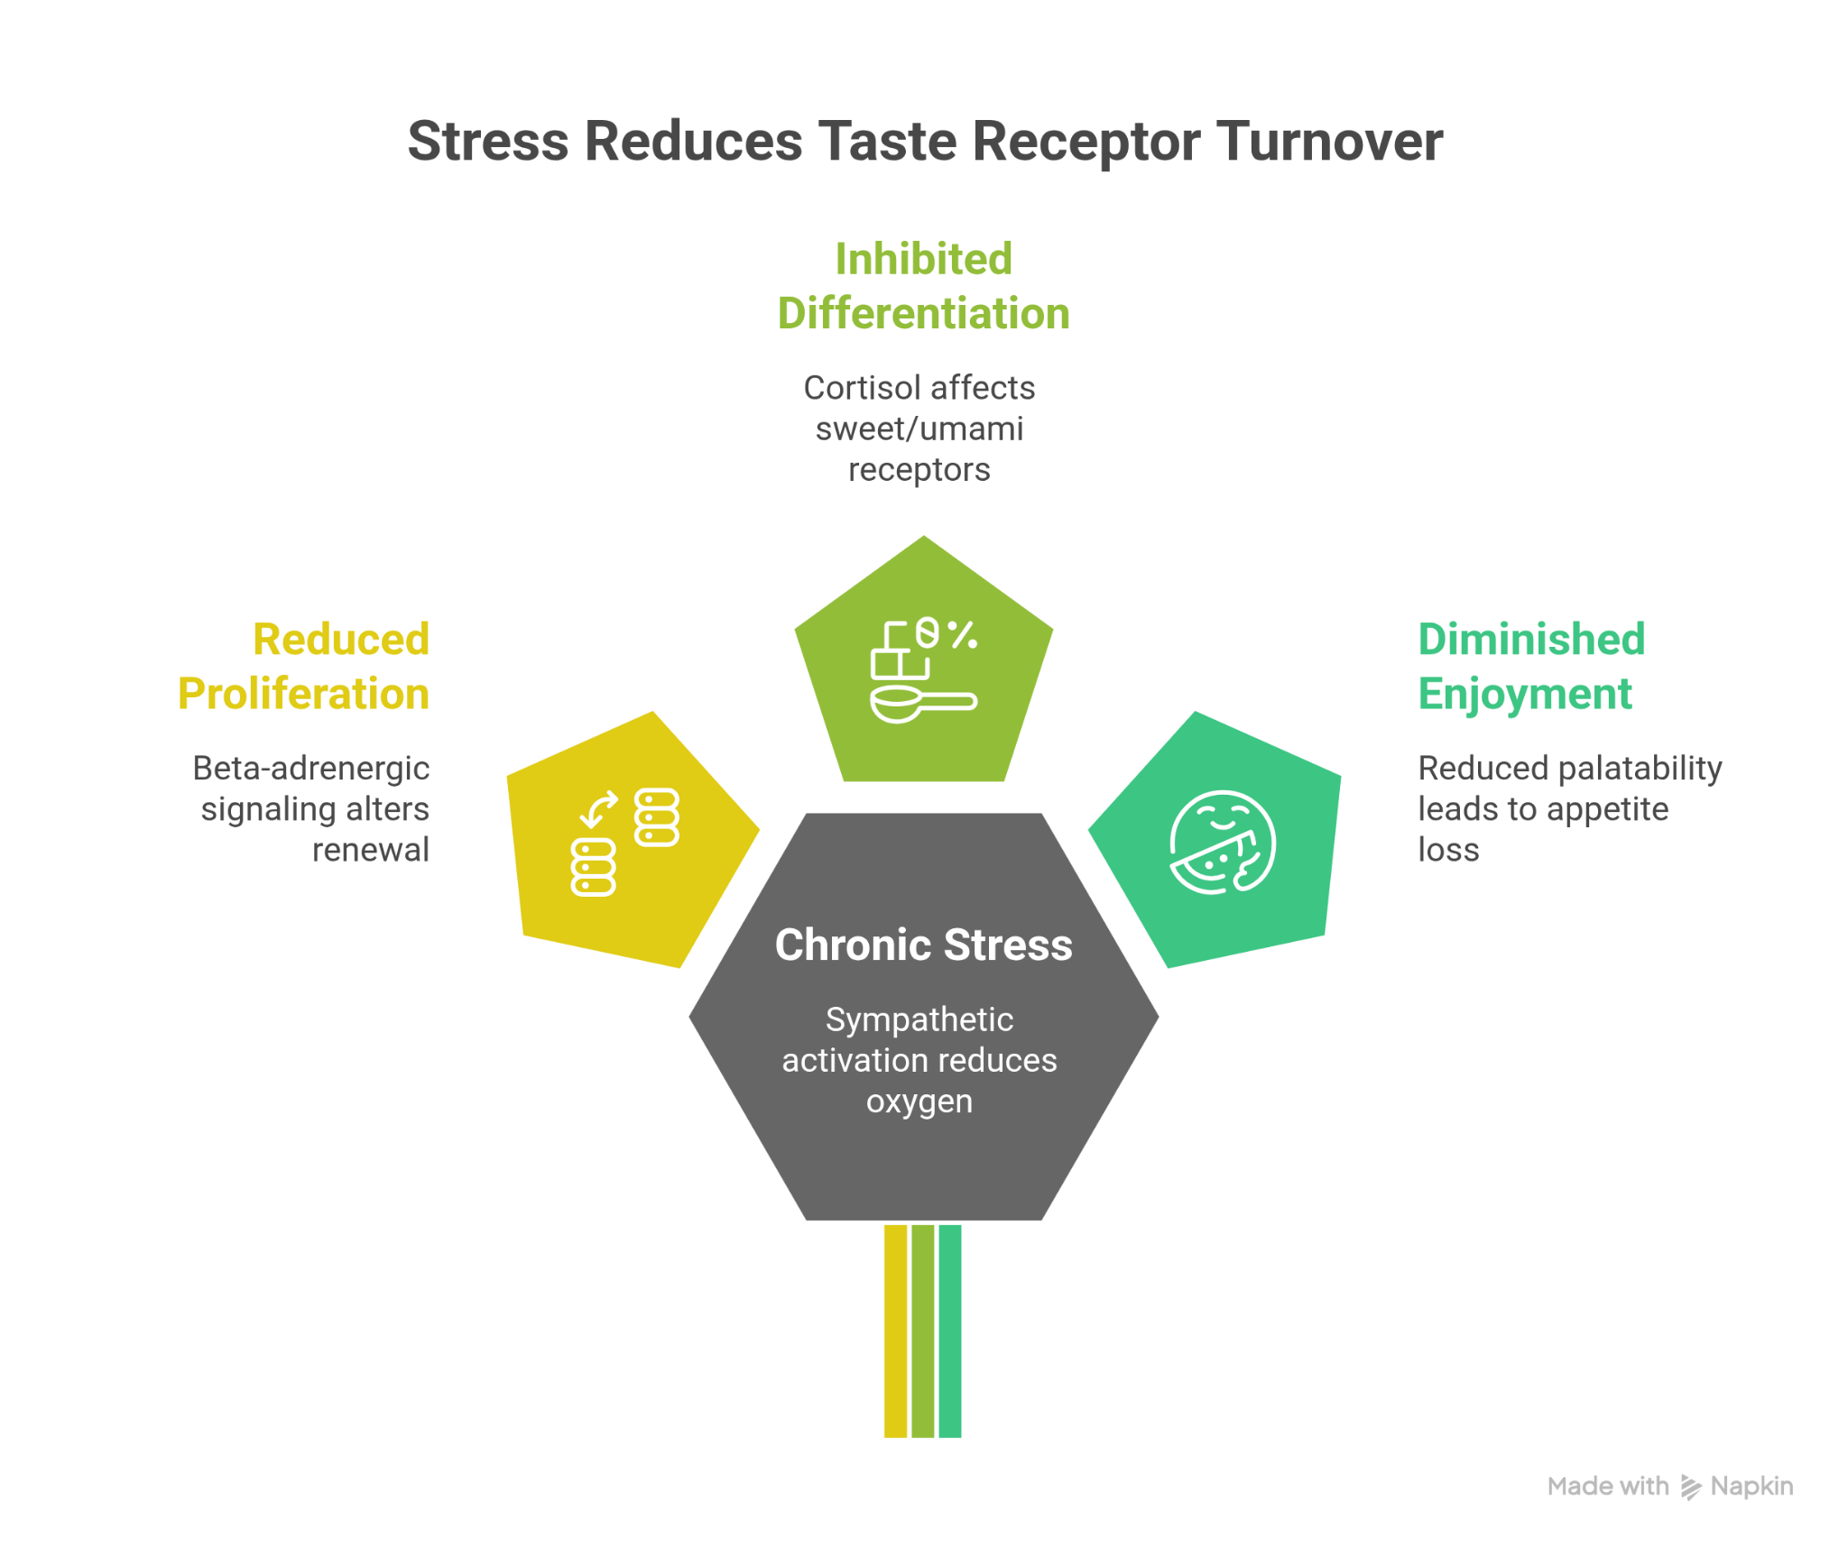

The Vicious Cycle of Stress, Appetite Loss, and Micronutrient Deficiency
Academic stress initiates a cycle characterized by elevated catecholamines and cortisol, impaired taste receptor regeneration, and reduced appetite. Decreased food intake leads to deficiencies in key micronutrients such as zinc, iron, vitamin A, B-complex vitamins, and magnesium.
These deficiencies further impair taste receptor renewal and neuroendocrine regulation, perpetuating appetite loss and reinforcing the stress–nutrition cycle.

Micronutrient Roles in Taste and Stress Physiology
Zinc is essential for the synthesis of gustin, a zinc-dependent protein critical for taste bud development and regeneration. Vitamin A supports epithelial differentiation and maintenance of sensory tissues. Iron plays a key role in neurotransmitter synthesis and oxygen delivery via hemoglobin, both necessary for neural and sensory function.
B-complex vitamins are required for catecholamine metabolism and neuronal energy pathways, while magnesium modulates adrenergic activity and adrenal medulla responsiveness. Deficiencies in these micronutrients amplify stress responses and sensory dysfunction.
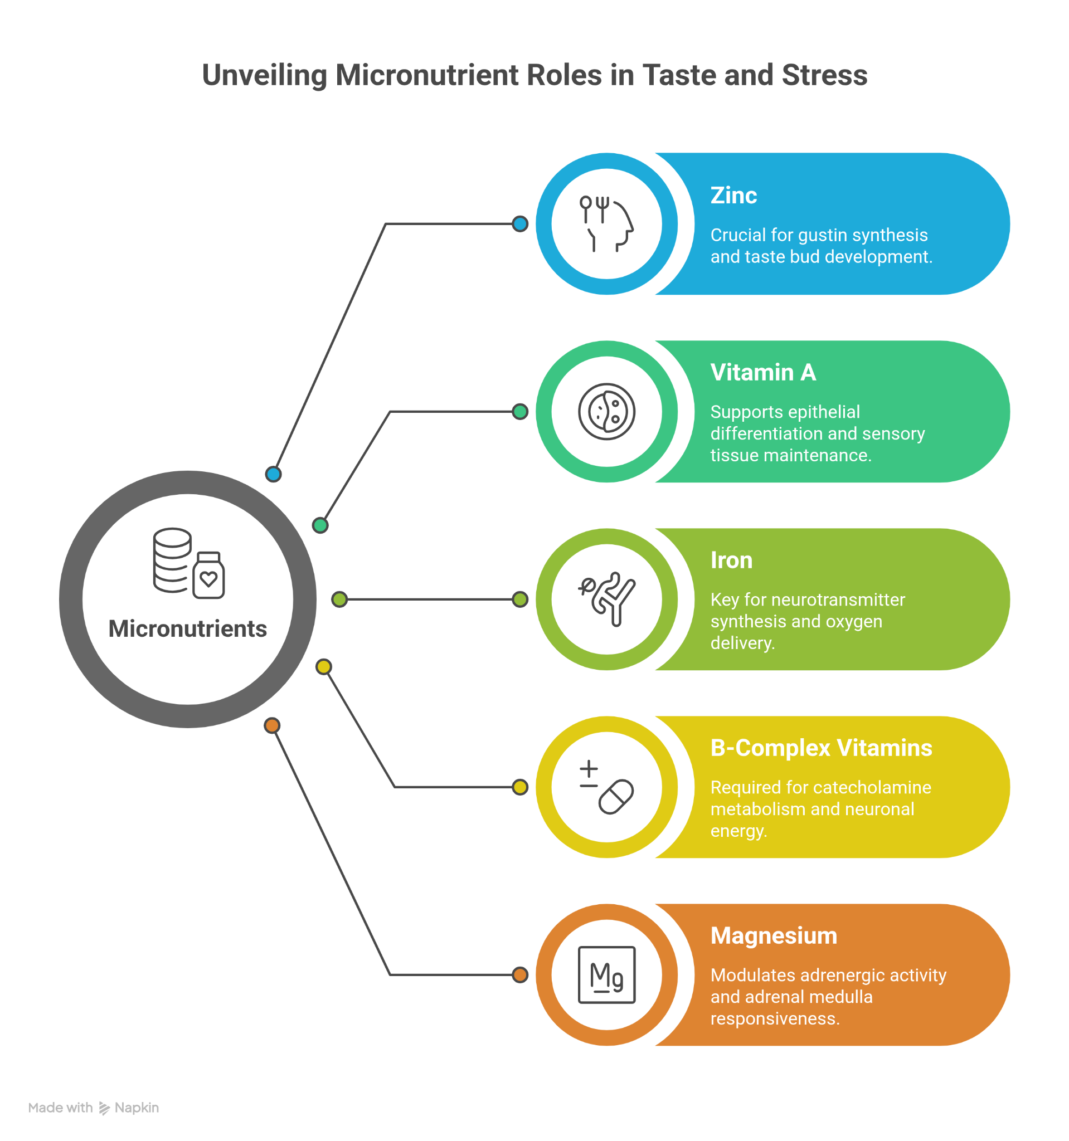

Evidence from Human and Experimental Studies
Human studies demonstrate that students undergoing examination stress exhibit reduced serum zinc levels and decreased appetite. Animal models show that chronic stress leads to reduced taste receptor density and impaired taste bud renewal.
In vitro studies further confirm that beta-adrenergic agonists suppress progenitor cell proliferation, providing mechanistic evidence linking catecholamines to impaired taste regeneration.

Clinical and Practical Implications
Recognition of appetite loss during academic stress should prompt evaluation for micronutrient deficiencies, particularly zinc and B-complex vitamins. Supportive nutritional interventions may help restore taste perception and appetite.
Stress management strategies—including adequate sleep, physical activity, structured routines, yoga, and mindfulness—play a complementary role. Nutritional screening and timely supplementation are especially important in adolescents and school-aged children experiencing sustained academic pressure.

Summary and Key Takeaways
Academic stress activates neuroendocrine stress pathways, leading to catecholamine and cortisol surges that impair taste receptor turnover. Reduced taste perception diminishes appetite, resulting in micronutrient deficiencies that further compromise sensory regeneration.
Breaking this cycle requires a combined approach addressing both stress physiology and micronutrient balance. Early recognition, nutritional support, and stress-mitigating strategies can restore appetite, improve dietary intake, and support overall health in academically stressed children and adolescents.

