Beyond Boil Water Advisories: Changing Epidemiology of Hepatitis A in Urban India

Introduction
Hepatitis A virus (HAV) accounts for the majority of acute viral hepatitis cases globally and remains the most common cause of acute hepatitis and acute liver failure in India and across Asia. HAV is a non-enveloped, single-stranded RNA virus belonging to the Hepatovirus genus of the Picornaviridae family. Importantly, only a single serotype exists, which has significant implications for immunity and vaccination strategies.
Hepatitis A is an inflammatory liver disease with a clinical spectrum ranging from mild, self-limited illness to severe disease. Most infected individuals recover completely and develop lifelong immunity. However, a small but clinically significant proportion progress to fulminant hepatitis, which can be life-threatening without timely intervention.
Given the ubiquitous risk of exposure in India, complete avoidance of infection is unrealistic. This necessitates a shift in prevention strategies—from short-term water safety advisories to long-term population protection through vaccination.

Hepatitis A Outbreaks in India: Surveillance Evidence
National surveillance data highlight the continued public health burden of hepatitis A. Between two thousand seventeen and two thousand twenty-one, eighty-four districts in India reported hepatitis A outbreaks under the Integrated Disease Surveillance Programme.
Subsequent outbreaks have continued to occur, most often linked to contaminated food and drinking water. A notable epidemiological shift is the age distribution of cases. Current outbreaks predominantly affect adolescents and young adults, rather than young children, indicating a major transition in disease epidemiology.

Transmission Dynamics in Urban India
Hepatitis A is transmitted via the fecal–oral route, primarily through contaminated water and food. In urban India, transmission is amplified by high population density, street food consumption, and variable hygiene practices.
Urban water distribution systems frequently experience pipeline leaks, intermittent supply, and negative pressure, allowing sewage to contaminate drinking water. Even in cities with treated water, these vulnerabilities sustain HAV transmission, particularly during monsoon seasons.

The Pre-Vaccine Era: High Endemicity and Natural Immunity
Historically, India was classified as a highly endemic country for hepatitis A. Most individuals acquired infection in early childhood, often asymptomatically or with mild illness.
This early exposure resulted in natural immunity across the population, reflected by high anti-HAV antibody positivity in serological surveys. Outbreaks occurred in cyclical patterns every ten to fifteen years, largely affecting children younger than fifteen years. Despite widespread transmission, disease severity and adult outbreaks were uncommon due to early immunity.

The WASH and Vaccine Era: Epidemiological Transformation
Over the past two decades, improvements in water quality, sanitation, and hygiene (WASH) have significantly altered HAV transmission, especially in urban and middle-class populations. Expanded access to treated water, improved sewage disposal, and hygiene education have reduced early childhood exposure.
Seroprevalence studies now demonstrate a decline in anti-HAV antibody positivity among children, indicating reduced natural infection. While this reflects progress in sanitation, it also signals increasing susceptibility in older age groups, marking a transition from high to intermediate endemicity.

The Epidemiological Paradox
The current epidemiology of hepatitis A presents a clear paradox. While childhood infection rates have declined, a large proportion of children remain non-immune, with studies indicating that two out of three children under ten years are now susceptible.
Infection has shifted to older children, adolescents, and young adults, in whom hepatitis A is more likely to be symptomatic and severe. Hospitalization rates and complication risks are higher in these age groups, fundamentally altering outbreak patterns and increasing healthcare burden despite lower overall childhood incidence.

Drivers of the Epidemiological Shift
Four key factors explain the transition from high to intermediate endemicity:
First, improved sanitation and hygiene reduce early-life transmission, delaying infection to later ages.
Second, gaps in vaccination coverage leave susceptible cohorts unprotected, particularly adolescents.
Third, age-related immune responses result in more severe disease when infection occurs later in life.
Fourth, seasonal monsoon contamination in cities such as Delhi, Pune, Hyderabad, and Bhubaneswar leads to sewage contamination of drinking water.
Urban infrastructure limitations necessitate continued reliance on boiling or filtering water, even in metropolitan settings.

Current Clinical Spectrum of Hepatitis A

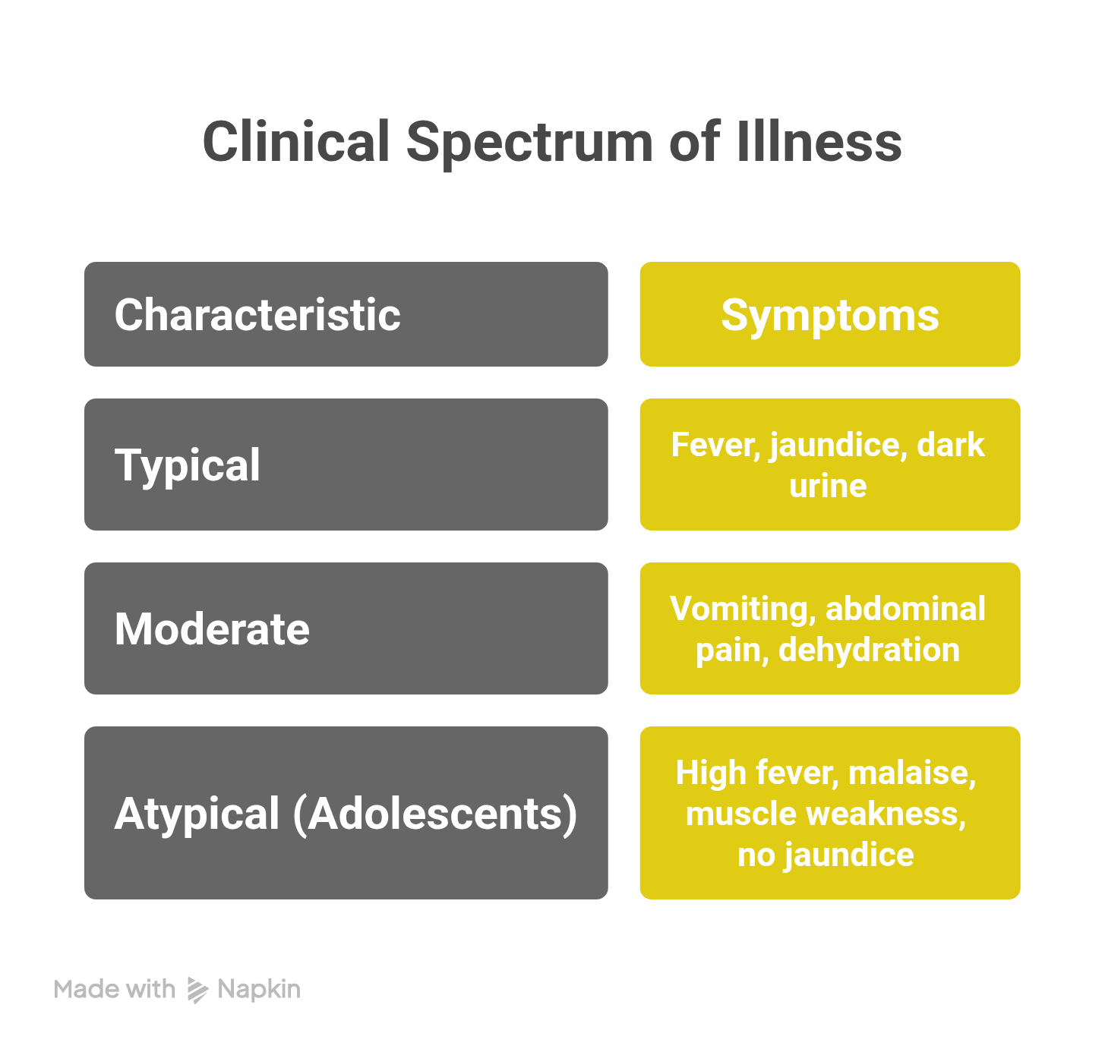

Typical Presentation
The classic presentation includes fever, jaundice, and dark urine, preceded by prodromal symptoms such as body ache and fever. A history of exposure at community gatherings or areas with poor sanitation is common. Management focuses on supportive care, hydration monitoring, liver function assessment, and vaccination of close contacts.

Moderately Severe Disease
Older children may present with persistent vomiting, abdominal pain, and fever, often following travel to inadequately sanitized areas. These cases frequently require hospitalization for intravenous fluids, monitoring of hydration status, and surveillance for complications such as hepatic encephalopathy.

Atypical Presentations in Adolescents
Adolescents may present without classical jaundice, instead exhibiting high fever, malaise, and marked muscle weakness. Diagnosis is often confirmed through serology. Such atypical presentations can mimic nonspecific viral illnesses, leading to delayed diagnosis. Rapid progression of liver involvement necessitates early referral to higher-level care.
Hepatitis A can have varied atypical presentations, leading to diagnostic dilemmas.Atypical presentations of Hepatitis A are varied and include cholestatic, relapsing, prolonged, and extra-hepatic manifestations.

Vaccination as the Cornerstone of Prevention
Vaccination is the most effective long-term strategy for hepatitis A prevention. Inactivated hepatitis A vaccines have demonstrated high efficacy in reducing disease incidence and severity.
The recommended schedule includes:
- Two doses of inactivated hepatitis A vaccine
- Initiation at twelve to eighteen months of age
- Doses administered six months apart
Booster doses may be considered in high-risk areas or populations, including susceptible adolescents, food handlers, and frequent travelers.

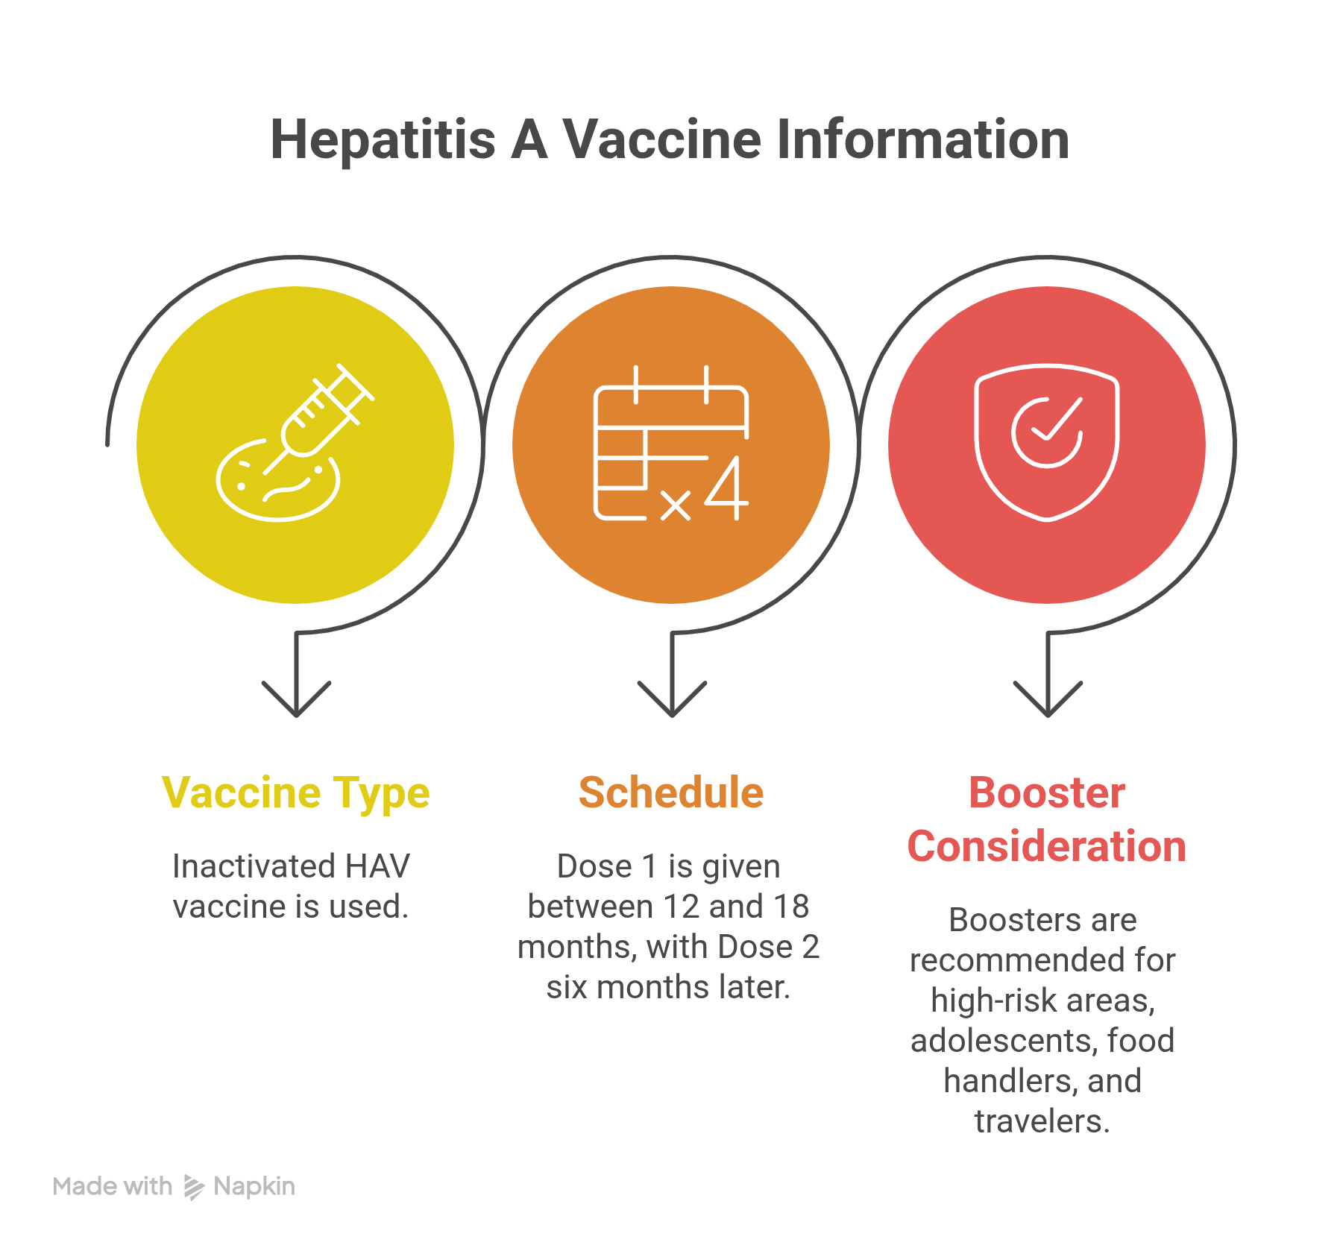

Targeted Vaccination and Resource Optimization
Given resource constraints, targeted vaccination strategies are essential. Priority populations include:
- Urban communities with inadequate sanitation
- Adolescents with declining seroprevalence
- Food handlers
- Individuals with frequent travel exposure
Public health efforts should integrate vaccination campaigns with education on hygiene and sanitation, particularly in high-density urban settings.

Beyond Water Advisories: A Comprehensive Prevention Strategy
Boiled water advisories are essential during outbreaks but provide only short-term protection. Sustainable control of hepatitis A requires a combined approach, integrating vaccination, infrastructure improvement, surveillance, and hygiene education.
High-risk urban communities and food preparation environments require focused interventions due to persistent fecal–oral transmission risk.

Vigilance, Case Management, and Long-Term Control
Ongoing vigilance is required in view of changing epidemiology. Early recognition, hydration monitoring, liver function assessment, and awareness of atypical presentations are critical to preventing complications.
Strict adherence to the two-dose inactivated vaccine schedule, with consideration of adolescent boosters in high-risk urban settings, forms the foundation of long-term prevention.

Conclusion
The epidemiology of hepatitis A in urban India has shifted from high to intermediate endemicity, increasing susceptibility among adolescents and young adults. Reliance on boil-water advisories alone is insufficient.
Vaccination beyond water advisories is essential. A comprehensive strategy combining timely vaccination, early clinical recognition, prompt management, and sustained hygiene and sanitation promotion is required to effectively control hepatitis A and reduce its long-term public health impact in India.

