Electrolyte Imbalance in Febrile Children: A Comprehensive Guide

Introduction
Electrolyte imbalance, particularly hyponatremia, is a significant concern in febrile children, as it can lead to severe neurological consequences, including seizures. This article aims to provide an in-depth review of subclinical hyponatremia in febrile children, drawing insights from Dr. Bhavana Lakhkar’s lecture. It will cover the pathophysiology, prevalence, clinical significance, diagnostic strategies, management protocols, and prevention methods, offering guidance for healthcare professionals who were unable to attend the session.

The Connection Between Fever and Electrolyte Imbalance
Fever often triggers physiological responses that can affect fluid and electrolyte balance, particularly sodium levels. Understanding the relationship between fever, sodium regulation, and electrolyte disturbances is crucial for the early recognition and management of potential complications.
- Non-Osmotic Diuresis and ADH Secretion: Fever leads to non-osmotic diuresis, where the kidneys excrete large volumes of water independent of osmotic pressure. At the same time, fever stimulates the antidiuretic hormone (ADH) secretion, leading to water retention in the body. This water retention can dilute serum sodium levels, resulting in dilutional hyponatremia.
- Inverse Relationship Between Temperature and Sodium: As body temperature rises, serum sodium levels typically fall. For instance:
  - Above 39°C, children exhibit an average serum sodium level of 134.6 mmol/L.
  - Afebrile children have an average serum sodium level of 138.5 mmol/L.
This inverse relationship is critical in understanding why febrile children are at increased risk for electrolyte imbalances.

Subclinical Hyponatremia: A Hidden Risk
Subclinical hyponatremia refers to a mild decrease in sodium levels, typically ranging between 131-134 mmol/L, that often does not present with obvious symptoms. However, even mild reductions in sodium levels can predispose children to neurological complications, including seizures, if not detected and managed promptly.
- Neurological Complications: Although subclinical hyponatremia may not present with overt symptoms, it can be a precursor to severe neurological events, especially if the condition worsens. Seizures are the most significant risk, and the threshold for seizure activity can lower even with mild hyponatremia.

Pathophysiology of Hyponatremia in Fever

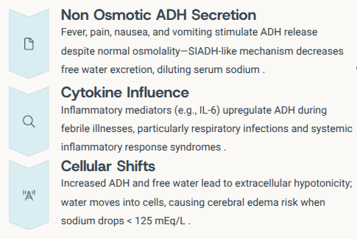
The pathophysiology of fever-related hyponatremia involves a combination of hormonal, metabolic, and inflammatory responses:
- Non-Osmotic ADH Secretion: Fever, pain, nausea, and vomiting trigger the release of ADH, leading to reduced excretion of free water. This results in dilution of sodium levels in the blood (dilutional hyponatremia).
- SIADH-Like Mechanism: The body’s response to fever often mimics the effects of Syndrome of Inappropriate Antidiuretic Hormone Secretion (SIADH), which involves inappropriate water retention without compensatory sodium retention.
- Increased Free Water Retention: The increased retention of free water shifts cellular water balance, putting the brain at risk for cerebral edema when sodium levels fall below 125 mmol/L.
- Inflammatory Mediators: During fever, inflammatory cytokines like IL-6 further enhance ADH secretion, which is especially prominent in conditions like respiratory infections or systemic inflammatory response syndrome (SIRS).

Prevalence of Hyponatremia in Febrile Children
Studies show that 30-66% of febrile children present with serum sodium levels below 134.5 mmol/L, making hyponatremia a common occurrence in this population. Meta-analyses indicate that:
- Febrile children have an average sodium level of 136.9 ± 6.5 mmol/L.
- Afebrile children typically have a mean sodium level of 138.5 mmol/L.
The prevalence of hyponatremia is higher in children with respiratory infections, with up to 40% of hospitalized patients exhibiting hyponatremia.

Clinical Consequences and Seizure Risk
Hyponatremia, particularly in febrile children, significantly increases the risk of febrile seizures.
- Increased Risk with Lower Sodium Levels: Children with serum sodium levels <134.5 mmol/L are at a 10-fold increased risk of developing febrile seizures.
- Seizure Type and Sodium Levels:
  - Complex seizures (e.g., >15 minutes or focal seizures) are associated with even lower mean sodium levels (134.0 ± 6.1 mmol/L).
  - Simple febrile seizures are associated with higher mean sodium levels (138.9 ± 6 mmol/L).
- Seizure Threshold: Even mild hyponatremia (sodium 131-134 mmol/L) can lower the seizure threshold, emphasizing the importance of early recognition and intervention.

Risk Stratification for Hyponatremia-Induced Seizures
Certain groups of children are at higher risk for hyponatremia-induced seizures:
- Age: Children aged 6-16 months with high fever are particularly vulnerable.
- Dehydration: Children who are dehydrated should undergo early sodium measurement.
- Respiratory Infections: Respiratory infections are frequently associated with hyponatremia and increased seizure risk.
- Recurrent Febrile Seizures: Children with a history of recurrent febrile seizures often have an underlying hyponatremic state.
Symptoms such as persistent vomiting, poor oral intake, lethargy, headache, nausea, and anorexia can signal hyponatremia, even in the absence of seizures.

Diagnostic Work-Up
A thorough diagnostic work-up is essential to identify hyponatremia in febrile children. Key tests include:
- Point-of-Care Testing: Tools like i-STAT analyzers provide rapid serum sodium measurement at the bedside.
- Laboratory Investigations: If sodium levels are <135 mmol/L, confirmatory tests should be performed. These tests include:
  - Serum Sodium, Potassium, Chloride, Bicarbonate, and Osmolality to classify dehydration as hypotonic, isotonic, or hypertonic.
  - Urine Analysis: For osmolality and sodium, particularly if urine osmolality is >100 mmol/kg and urine sodium is >40 mmol/L, which can suggest SIADH.

Initial Management Strategies

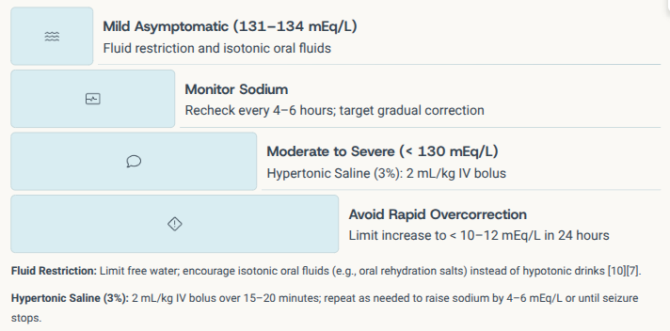
The management of hyponatremia in febrile children varies depending on severity:
- Mild, Asymptomatic Hyponatremia:
  - Restrict free water intake.
  - Encourage isotonic oral fluids such as oral rehydration solutions (ORS) instead of hypotonic fluids.
  - Monitor serum sodium every 4–6 hours, aiming for gradual correction.
- Moderate/Severe Hyponatremia (<130 mmol/L):
  - Administer a 3% saline solution (2 ml/kg IV bolus over 15-20 minutes), followed by gradual sodium adjustment.
  - Avoid rapid correction; the sodium level should be increased by no more than 10-12 mmol/L in 24 hours to prevent osmotic demyelination.

Prevention of Seizures in At-Risk Children
To prevent seizures in febrile children, particularly those at higher risk for hyponatremia, the following steps are recommended:
- Early Sodium Screening: Essential in children with high fever, ongoing gastrointestinal losses, or respiratory infections.
- Empirical Fluid Administration: Administer isotonic fluids (e.g., 0.9% sodium chloride) rather than hypotonic solutions in hospitalized febrile children.
- Parental and Staff Education: Train parents and healthcare staff to recognize the signs of hyponatremia and educate them on the importance of sodium monitoring.

Follow-Up and Long-Term Management
Long-term management involves:
- Recurrent Seizures: Monitor children with previous hyponatremic-related febrile seizures for future episodes and perform repeated sodium checks.
- Parental Counseling: Parents should be informed about the importance of maintaining isotonic fluid intake during febrile illnesses to prevent the use of hypotonic fluids.
- Management of Trigger Factors: Address triggers like pain and nausea that can exacerbate inappropriate ADH secretion.

Parental Counseling
Parental education plays a vital role in the prevention of hyponatremia and associated complications. Parents should be educated on:
- Recognizing symptoms of worsening hyponatremia, such as vomiting, headaches, and confusion.
- Seeking urgent medical care if these signs appear.

Conclusion
Understanding the relationship between fever and electrolyte imbalance in children is crucial for preventing serious complications like seizures. By identifying subclinical hyponatremia early, clinicians can provide effective management, thereby preventing adverse neurological outcomes. Proactive screening, appropriate fluid management, and parental education are essential in ensuring the safety and well-being of febrile children.

