Failure to Screen a Premature Infant for ROP: Case Summary and Ethical Guidelines in India
Case Summary: Missed ROP Screening Leading to Blindness
In the case the Maharashtra State Consumer Disputes Redressal Commission addressed a complaint filed by the parents of a premature infant, A., born on 26 November 2007 at 28–30 weeks' gestation with a birth weight of 1280 grams. The child was treated by pediatricians Dr. S.M. and Dr. P.S. at A.N.H. Premature infants, especially those with low birth weight, are at a high risk of developing Retinopathy of Prematurity (ROP), a preventable cause of childhood blindness. The parents alleged that the doctors failed to inform them about the risk of ROP and did not refer the child for ophthalmologic screening.
At six months, an ophthalmologist diagnosed Stage V ROP with total retinal detachment, leading to permanent blindness. In response, the parents filed a consumer complaint in 2009 seeking ₹63.6 lakh as compensation. The doctors defended themselves by claiming they verbally advised the parents to get an ENT and eye check-up after discharge. They argued that ROP was an inherent risk and that the parents failed to follow their advice, presenting expert affidavits in their support.
The Commission found that the discharge and treatment records did not include any written advice for ophthalmologic evaluation, and the verbal advice provided was unsupported by documentation. The Commission emphasized that, given the doctors' awareness of the ROP risk, they had a duty to inform the parents and refer them for screening within 4–5 weeks of birth. The explanation that "WNL" (Within Normal Limits) referred only to an external eye examination was found unsatisfactory. Relying on the V. Krishnakumar vs. State of Tamil Nadu case, the Commission held that failure to inform parents about the ROP risk constituted medical negligence.
The Commission ruled that the failure to document or communicate the necessary advice was a deficiency in service under Section 2(1)(g) of the Consumer Protection Act, 1986, and awarded partial compensation, as blindness was partly caused by an inherent risk. Dr. S.M. and Dr. P.S. were held liable and ordered to pay ₹5,00,000 as compensation and ₹10,000 as costs. However, Dr. H.M. (Gynecologist), C.H., and A.N.H. were not found negligent.
In the subsequent appeal before the National Consumer Disputes Redressal Commission (NCDRC) in 2013, the advocate of Dr. S.M. informed the Commission that the matter had been settled amicably out of court. Consequently, the appeal was dismissed as not pressed. The NCDRC directed the deposit of ₹1,25,000 to be released to the complainants on behalf of the child, A., and the statutory amount of ₹35,000 to be refunded to the appellant. Although the case was settled out of court, the State Commission's findings on partial deficiency remained intact, and the matter was resolved through mutual settlement.
Key Medico-Legal Takeaways:
1. Documentation of advice regarding ROP screening is essential for premature infants.
2. Verbal advice alone is insufficient to discharge the duty of care. 3. Even when inherent risks are involved, the duty to warn and refer remains binding.
4. Gynaecologists and hospitals were rightly found not negligent, as pediatric follow-up responsibility lies with the treating pediatricians.
Out-of-court settlements often bring closure while maintaining confidentiality and avoiding prolonged litigation.
—----------------------------------------------------------------------------------------------------------------------- What the forum actually punished—and what it didn’t
● Negligent act found: Failure to inform parents of ROP risk and failure to guide/refer to pediatric ophthalmology during NICU stay and at early follow-ups.
● Not strictly punished: Broader perinatal management, obstetric care, or hospital corporate liability (on the facts presented).
● Damages: Lump-sum ₹ 5 lakh considering the lapse; blindness wasn’t attributed solely to the lapse given ROP’s multifactorial nature.
—----------------------------------------------------------------------------------------------------------------------- Legal framing and precedents
● Duty to warn + refer in ROP: Courts have recognized failure to screen/warn for ROP in premature infants as negligence. The Supreme Court in V. Krishnakumar v. State of Tamil Nadu (2015) affirmed liability where a premature infant wasn’t warned/referred for ROP screening, resulting in blindness.
● Informed consent in treatment (non-research): Samira Kohli v. Dr. Prabha Manchanda (2008) remains the touchstone: valid consent requires adequate disclosure of nature, benefits, risks, and alternatives that a prudent patient would
want to know; undocumented or vague consent can fail.
● Professional conduct expectations: The National Medical Commission (NMC) RMP (Professional Conduct) Regulations, 2023 reinforce patient-centric disclosure, documentation, and clarity in communication/records.
—-----------------------------------------------------------------------------------------------------------------------
Key Risk Factors for Retinopathy of Prematurity (ROP)
● In addition to preterm birth, several factors increase the risk of developing Retinopathy of Prematurity (ROP).
● Excessive exposure to oxygen is a major cause of severe ROP.
● Other contributing factors include neonatal sepsis, intraventricular hemorrhage, and respiratory distress, all of which can compromise retinal vessel development. Failure to gain adequate weight and the need for multiple blood transfusions further heighten the risk. Together, these conditions make premature infants particularly vulnerable to ROP.
—-----------------------------------------------------------------------------------------------------------------------

Protocol for screening for ROP
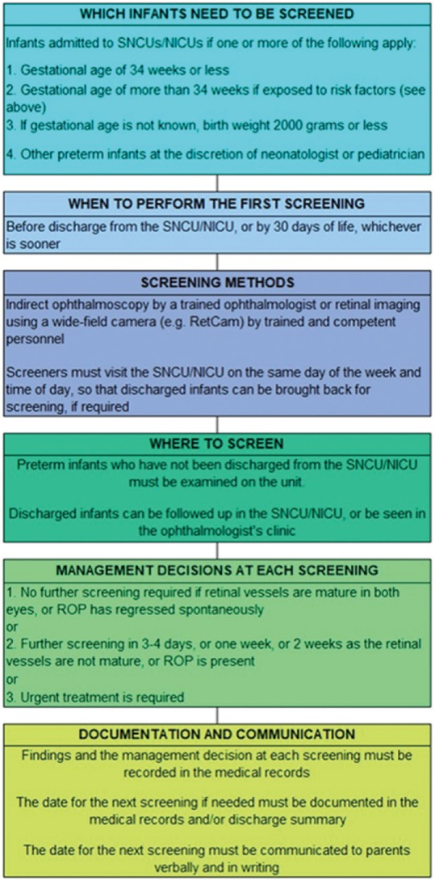

Steps to obtain informed consent in pediatric care (clinical practice)
1. Identify the decision-maker: Generally a parent or legal guardian for <18-year-olds; document status..
2. Explain condition & plan—in plain language: diagnosis/provisional dx, purpose of proposed treatment/procedure, expected benefits, material risks, alternatives (including no treatment).
3. Tailor risk disclosure to the child’s risk profile (e.g., prematurity → explicit ROP risk and timeline for eye exams). Document that this was done. (India ROP operational guidance.) Lippincott Journals
4. Check understanding: Ask the parent to teach-back key points; record this. (NMC 2023 emphasizes communication and record-keeping.)
5. Record consent: Use signed forms; add parent acknowledgment of referrals/follow ups (e.g., exact date/time/location for ROP screening).
6. Assent (when appropriate): For mature minors, seek age-appropriate assent even outside research when feasible; note in the chart. (ICMR age guidance for assent in research provides a practical benchmark.) ethics.ncdirindia.org
7. Provide take-home instructions (in local language) and emergency contact details; log any defaulter-tracking outreach.
—----------------------------------------------------------------------------------------------------------------------- Practical takeaways (for hospitals, NICUs, and counsel)
For clinicians/NICUs
● Embed a ROP risk banner on all preterm discharge summaries with: due date, place, contact, and “no-delay” warning.
● Co-sign the referral (pediatrician + NICU nurse) and give parents written & verbal instructions; get parent acknowledgment.
● Maintain a defaulter-tracking log (calls/SMS/WhatsApp) until screening is done; record attempts.
● Replace “WNL” with structured eye fields: “Dilated ROP exam: not done—referred to Dr. ____ on (date), appointment (date/time). Parent counselled (yes/no), leaflet given
(yes/no).”
● Audit compliance monthly; include in quality indicators.
—-----------------------------------------------------------------------------------------------------------------------
Screening Guidelines and monitoring Retinopathy of Prematurity (ROP) in infants.
Screening Guidelines:
● Birth Weight: All infants weighing less than 1250 to 1500 grams should undergo screening.
● Oxygen Supplementation: Larger premature infants who have received more than 50 days of supplemental oxygen should also be examined.
● Timing: Eye examinations should begin at 4 to 5 weeks of age.
Monitoring and Follow-Up
● Avascular Retina Assessment: The extent of the avascular retina is a crucial indicator. Wide avascular zones (zone 1 or posterior zone 2) suggest a high risk of ROP progression.
● Examination Frequency (Once Disease Detected):
● Weekly examinations are necessary to identify eyes that meet the "threshold" for treatment.
● Extremely severe cases (e.g., zone 1 + disease) may require examinations twice per week.
● Duration of Examinations: Examinations should continue until the retina has fully vascularized to the ora serrata (the extreme periphery).
● Timing without Disease: If no disease is present, the timing of follow-up examinations should be based on individual risk factors.
Sources:
- State Consumer Disputes Redressal Commission (Maharashtra). Akash M. Shridharani & Anr. vs Dr. Sharmila Mallya & Ors. (Complaint Case No. 47 of 2009, Judgment dated February 2, 2012) https://indiankanoon.org/doc/60366700/
- Case No. MA/736/2013 Judgement Order dated November 27, 2013 NCDRC https://e-jagriti.gov.in/judgement
- Times of India (Dhananjay Mahapatra). “Baby blinded by medical negligence in 1996, SC orders Rs 1.80 cr compensation in 2015.” The Times of India, 2 July 2015 – Report on the V. Krishnakumar vs State of TN case (Supreme Court)timesofindia.indiatimes.comtimesofindia.indiatimes.com.
- MCI Code of Ethics Regulations, 2002 – Regulation 7.16 (Consent for treatment/procedure on minors)emedinexus.com.
- Jaya Shankar Kaushik et al., “Informed Consent in Pediatric Practice,” Indian Pediatrics 2010;47:1039-46 – Legal requirements and ethical considerations for consent involving minorslegalserviceindia.comjournals.lww.com.
- Protocol for screening for ROP (flowchart) https://pmc.ncbi.nlm.nih.gov/articles/PMC7001189/?utm_source=chatgpt.com
  - Key Risk Factors for Retinopathy of Prematurity (ROP)
https://pmc.ncbi.nlm.nih.gov/articles/PMC7001189/?utm_source=chatgpt.com#re f14
- Bhabani S.T.P. Singh et al., “Informed Consent in Pediatric Patients” (Letter to Editor), Indian J. of Paediatric Dermatology 2024;25(3):262-264 – Discussion of consent capacity, who can consent, and elements of pediatric
a. consentjournals.lww.comjournals.lww.com.
- ICMR National Ethical Guidelines for Biomedical Research involving Children (2017) – Assent and consent framework for pediatric
a. researchclinregs.niaid.nih.govclinregs.niaid.nih.gov.
- ClinRegs – India (NIH: ClinRegs), Children/Minors section – Summary of Indian regulations on parental consent and child assent in clinical trials
  - clinregs.niaid.nih.govclinregs.niaid.nih.gov.
- Retina-Vitreous Surgeons of CNY. “Retinopathy of Prematurity – Stages and Treatment.” (Patient education material) – Explanation of ROP stages and prognosisrvscny.com.
- Delhi Medical Council – Guidelines on risk disclosure (cited in Singh et al. 2024) – Emphasis that remote or theoretical risks need not always be detailed to patients journals.lww.com.
- Medicolegal case analysis by Dr. Neeraj Nagpal, Journal of Indian Medico-Legal and Ethics Association (2017) – Recommendations on ROP screening and documentation. https://www.imlea-india.org/journal/Jan-Mar17.pdf
- The textbook Clinical Practice Principles and Practice of Ophthalmology Vol.4 (Edition 4/ 2022 March) by Daniel M. Albert and Frederick A Jakohiec , outlines key guidelines for screening and monitoring Retinopathy of Prematurity (ROP) in infants. https://indiankanoon.org/doc/60366700/
https://www.aao.org/education/topic-detail/retinopathy-of-prematurity--europe

