First-100-Days Micronutrient Gaps in Urban India

Why Zinc, Vitamin A, and Vitamin C Remain Critical Despite Fortified Cereals

Significance of the First 1,000 Days
The first one thousand days of life, spanning from conception through twenty-four months of age, represent a uniquely sensitive biological window. This period is characterized by rapid physical growth, immune system maturation, and brain development. Nutritional adequacy during this phase determines not only immediate survival but also long-term growth potential, neurodevelopmental outcomes, and resistance to infection.
Micronutrient sufficiency during this window plays a decisive role in preventing stunting, cognitive delays, and infection-related morbidity. Deficits acquired during this period are often difficult or impossible to reverse later, even with improved nutrition.

Preventing Early and Long-Term Deficits
Adequate intake of essential micronutrients during the first one thousand days directly reduces the risk of linear growth failure, impaired neurodevelopment, and recurrent infections. These nutrients support cellular differentiation, immune competence, epithelial integrity, and metabolic programming.
Failure to address micronutrient gaps early results in cumulative disadvantages that manifest as poorer educational outcomes, reduced productivity, and increased chronic disease risk in adulthood. Thus, early nutrition is both a child-survival and human-capital issue.

Maternal Nutritional Status and Early Infancy Outcomes
Micronutrient deficiencies often begin before birth. Maternal deficiencies, particularly iron and zinc deficiency during pregnancy, are strongly associated with low birth weight and impaired fetal growth. These prenatal deficits carry forward into early infancy, contributing to inadequate stores of critical vitamins such as vitamin A and vitamin C.
Infants born with compromised micronutrient reserves face increased susceptibility to infections, weaker immune responses, and delayed recovery from illness. Early infancy deficiencies are therefore a continuation of maternal nutritional inadequacy rather than isolated postnatal events.

Urban India: Dietary Diversity and Prevalence of Deficiencies
Despite economic growth and improved food availability, urban India—especially low-income and slum populations—continues to experience a high burden of micronutrient inadequacy. Dietary Diversity Scores among pregnant women in urban slums average approximately four out of ten, reflecting monotonous diets dominated by cereals and limited intake of fruits, vegetables, and animal-source foods.
More than sixty percent of pregnant women and young children fall below estimated average requirements for iron, zinc, vitamin A, and vitamin C. This highlights a critical gap between calorie sufficiency and micronutrient adequacy.

Coverage Gaps in Existing Nutrition Programs
Although national supplementation and fortification programs exist, coverage remains incomplete in urban settings. Vitamin A supplementation reaches only about seventy percent of eligible children. Zinc usage during diarrhoeal episodes remains markedly low, at approximately one-fifth of cases, despite its established therapeutic benefit.
Access gaps are particularly pronounced among migrant populations and residents of informal settlements, where service continuity and follow-up are weak.

Micronutrient Gaps Among Infants and Toddlers

Zinc Deficiency
Approximately one-third of urban toddlers have suboptimal serum zinc levels. These deficiencies are strongly associated with increased diarrhoeal morbidity and higher susceptibility to respiratory infections.

Vitamin A Deficiency
Subclinical vitamin A deficiency persists in roughly one-quarter of urban preschool children. While overt ocular signs are uncommon, functional deficiency significantly contributes to recurrent respiratory infections, diarrhoeal disease, and impaired growth.

Vitamin C Deficiency
Between one-quarter and one-third of urban infants consume less than recommended vitamin C intakes. This deficiency is linked to weakened immune responses, delayed wound healing, and increased infection burden.

Role and Limitations of Fortified Cereals and Staple Foods
Commercially fortified infant cereals commonly contain iron and zinc, and occasionally vitamin D. However, most provide minimal vitamin A and virtually no vitamin C due to cost considerations and nutrient stability challenges.
Staple food fortification programs focus primarily on iron, folic acid, and zinc. Vitamins A and C are largely absent from these interventions. In practice, many urban low-income families rely on inexpensive fortified biscuits and cereal mixes that lack provitamin A carotenoids and ascorbic acid, perpetuating hidden deficiencies despite fortification labels.

Why Zinc Remains Critical in Early Life
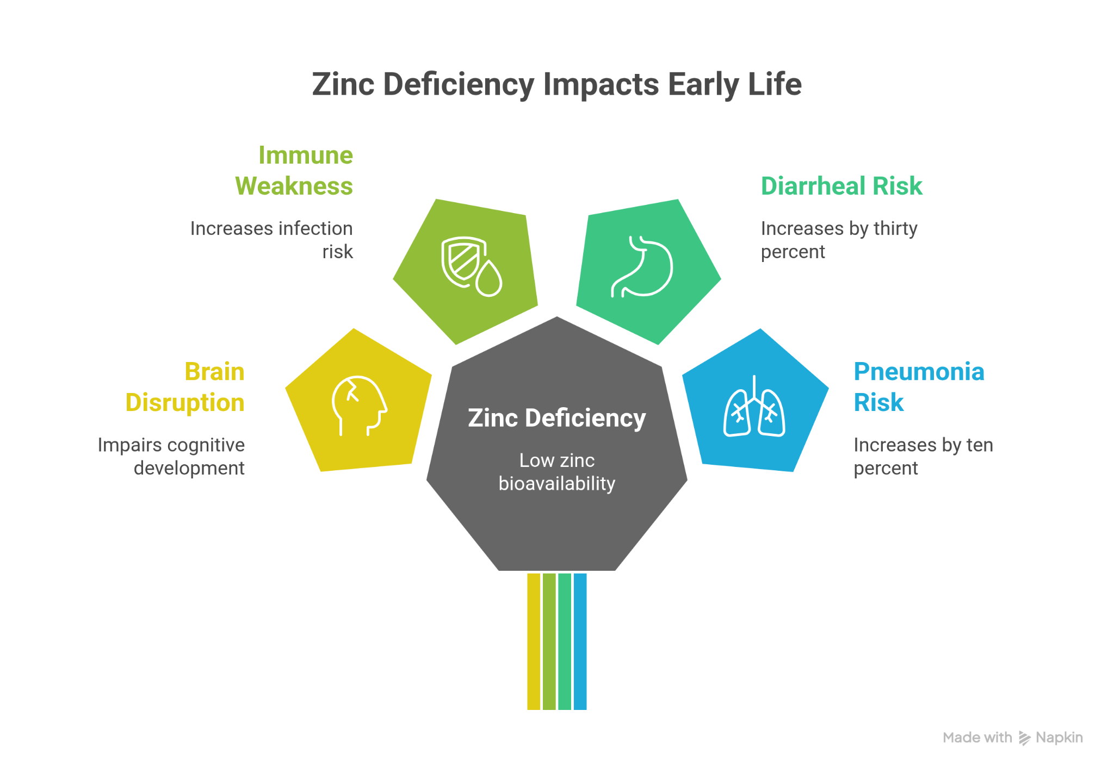
Zinc is essential for neurogenesis, immune maturation, thymic hormone activity, T-cell development, and intestinal barrier integrity. Prenatal zinc deficiency disrupts brain development and has lasting cognitive consequences.
Urban diets rich in phytates from rice and legumes significantly reduce zinc bioavailability. Empirical data from urban slum settings show that infants often consume less than half of recommended zinc intake. Zinc deficiency increases diarrhoeal risk by approximately thirty percent and pneumonia risk by over ten percent. Although fortified cereals provide zinc sulfate, irregular consumption limits population-level impact.

Importance of Vitamin A Beyond Vision
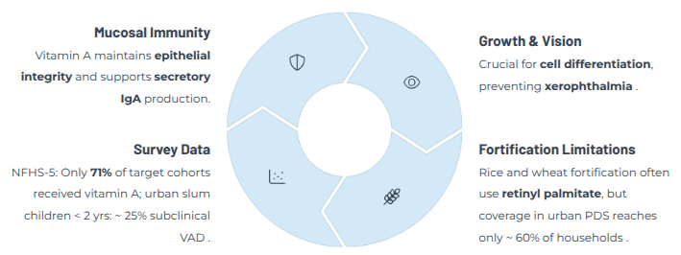

Vitamin A plays a central role in maintaining epithelial integrity and mucosal immunity through support of secretory immunoglobulin A production. It is also critical for normal growth, cellular differentiation, and immune regulation.
Urban fortification coverage using retinyl palmitate remains incomplete. Vitamin A deficiency triples measles-related mortality risk and doubles diarrhoeal mortality risk. Persistent deficiency during the first two years of life is associated with lower height-for-age outcomes. Bioavailability from fortified staples is inferior to that from leafy vegetables and animal-source foods.

Role of Vitamin C in Immune Function and Iron Utilization
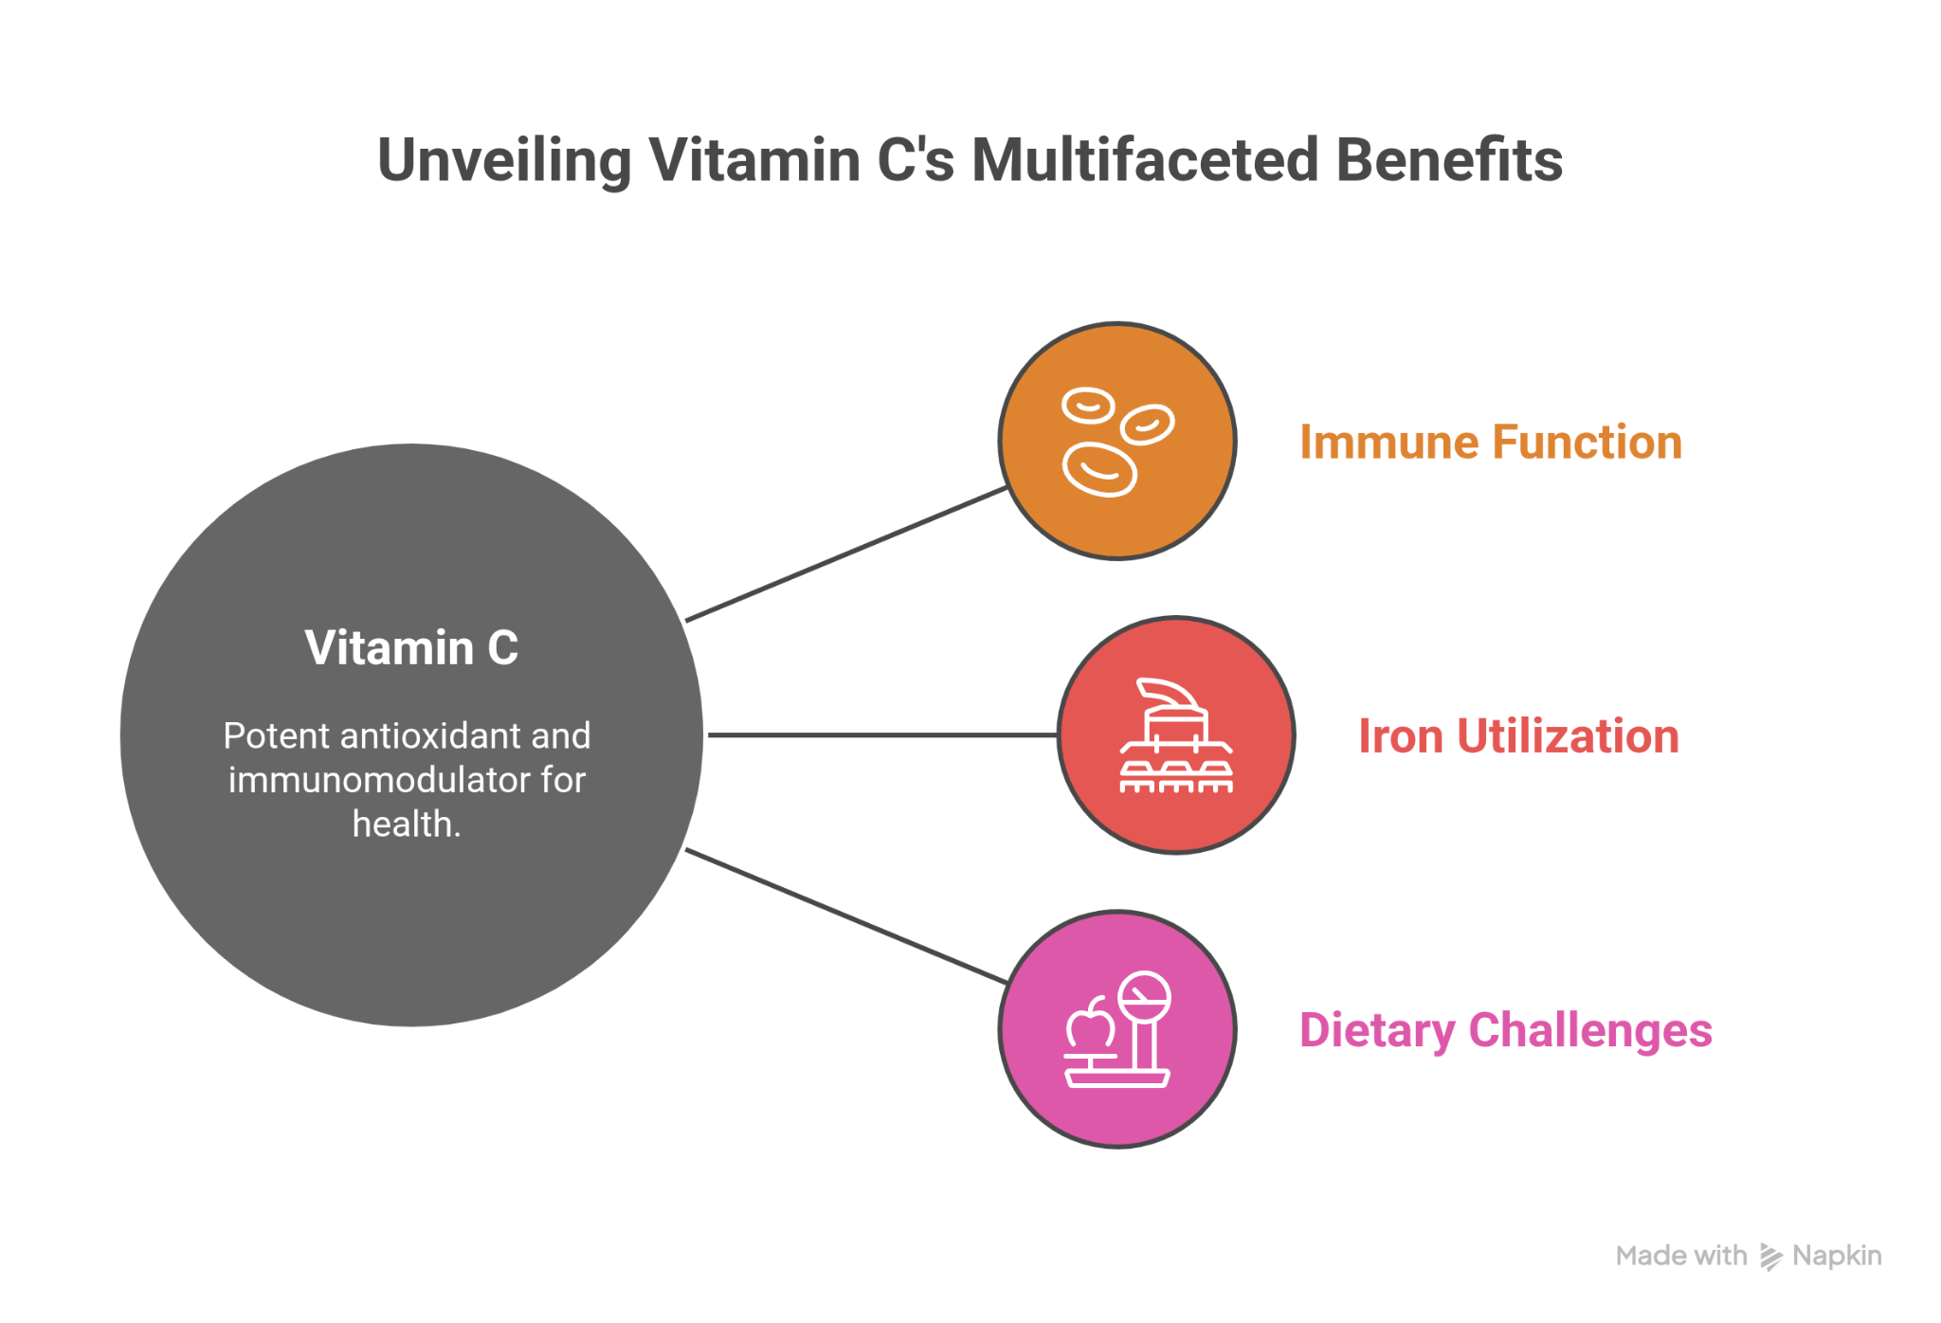
Vitamin C functions as a potent antioxidant and immunomodulator. It enhances neutrophil chemotaxis, supports nitric-oxide-mediated microbial killing, and regenerates vitamin E.
Importantly, vitamin C increases non-heme iron absorption two- to three-fold. Among iron-deficient urban toddlers, co-administration with iron improves hemoglobin levels substantially. However, urban infant diets often include fewer than two servings of fruits and vegetables daily, and fortified cereals contain no vitamin C, contributing to frequent respiratory infections.

Programmatic and Home-Based Supplementation Recommendations
Zinc supplementation is recommended at five milligrams per day for infants aged six to twelve months and eight to ten milligrams per day for children aged one to two years, particularly during and after diarrhoeal episodes.
Vitamin A high-dose prophylaxis is administered at nine months and repeated at eighteen months, with targeted dosing for children identified with deficiency.
Vitamin C supplementation of approximately twenty-five milligrams per day for infants and thirty milligrams per day for toddlers can be provided through pasteurized fruit juices or home-prepared fruit powders.

Complementary Feeding and Home Fortification Strategies
Home fortification using micronutrient powders containing zinc, vitamin A, and vitamin C can be added to porridges and mashed foods, improving intake without major dietary disruption.
Diet diversification should emphasize affordable, locally available foods such as pumpkin and carrots for beta-carotene, citrus fruits and guava for vitamin C, and small fish or eggs for bioavailable zinc and preformed vitamin A.

Implementation Challenges in Urban Poor Settings
Affordability remains the dominant barrier to micronutrient-rich diets, driving reliance on cheap, nutrient-poor staples. Caregiver awareness of optimal complementary feeding is limited, and early introduction of ready-to-eat snacks displaces nutrient-dense foods.
Program coverage remains incomplete, reaching only about sixty percent of urban households. Weak monitoring and enforcement of fortification standards result in inconsistent micronutrient content in commercially fortified products.

Opportunities and Scalable Solutions
Scaling up biofortified staples such as zinc-enriched rice and orange-fleshed sweet potatoes in urban markets offers a sustainable approach to improving intake.
Digital platforms can deliver real-time infant and young child feeding counseling, while community-level engagement through trained frontline workers can reinforce micronutrient-focused education and practical cooking demonstrations.
Addressing micronutrient gaps in the first one thousand days requires an integrated strategy combining supplementation, fortification, dietary diversification, and community-based delivery—particularly in rapidly growing urban populations.

