Comprehensive Guide to Meningococcal Disease
Bridging Knowledge and Action Against Meningococcal Disease: From Burden to Breakthroughs
BACKGROUND:
Meningococcal meningitis is a serious and potentially life-threatening infection caused by the bacterium Neisseria meningitidis, which inflames the meninges—the protective membranes covering the brain and spinal cord. This disease can progress rapidly, resulting in severe complications such as septicemia, neurological damage, or death if not promptly treated. Neisseria meningitidis is a gram-negative diplococcus that spreads through respiratory droplets and close personal contact, often colonizing the nasopharynx asymptomatically in many individuals before causing invasive disease^{.1,2}
CLINICAL PRESENTATION:^{3,4}
- Meningococcal disease occurs 1–10 days after exposure and presents as meningitis in ≥50% of cases
- Characterized by sudden onset of headache, fever, and stiffness of the neck, nausea, vomiting, photophobia, or altered mental status
- Approximately 40% of people with meningococcal disease present with meningococcemia
- Even with antibiotic treatment, case-fatality ratio of 10%–20%
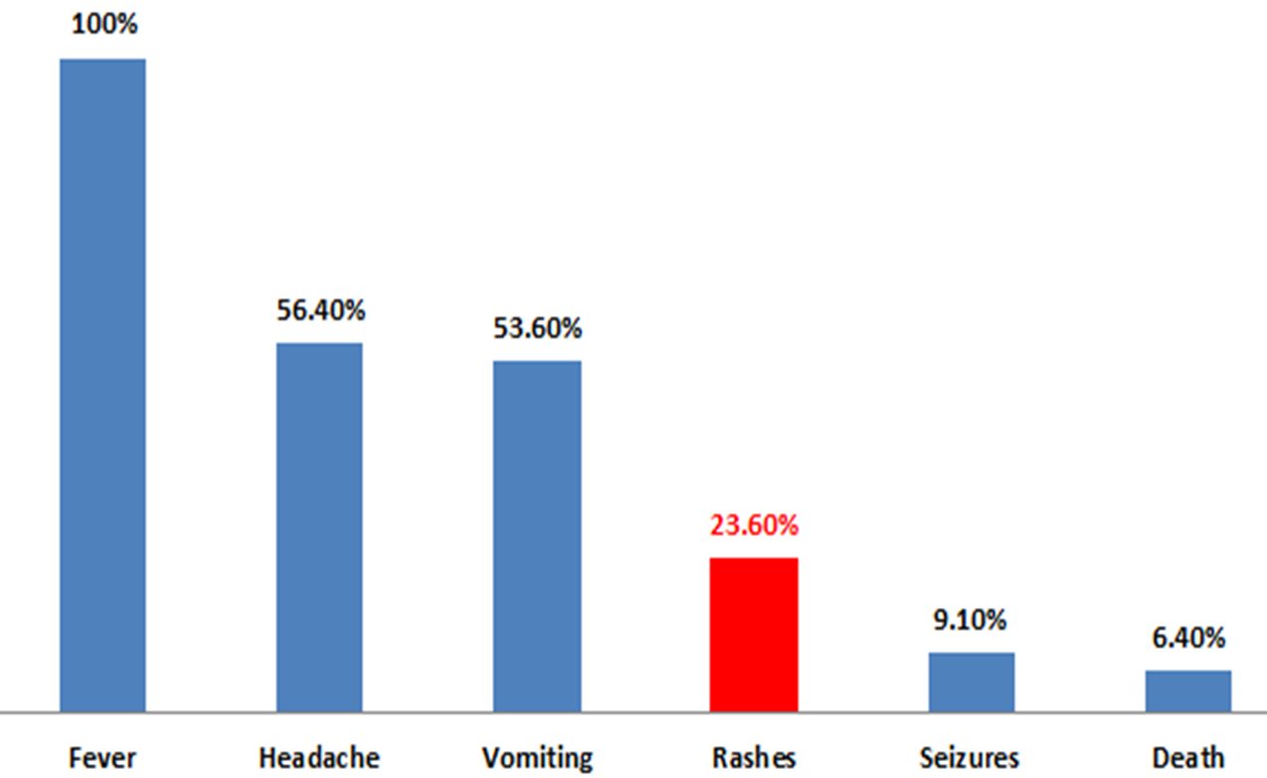

Disease spectrum
Asymptomatic transient bacteremia - Septicemia - Shock
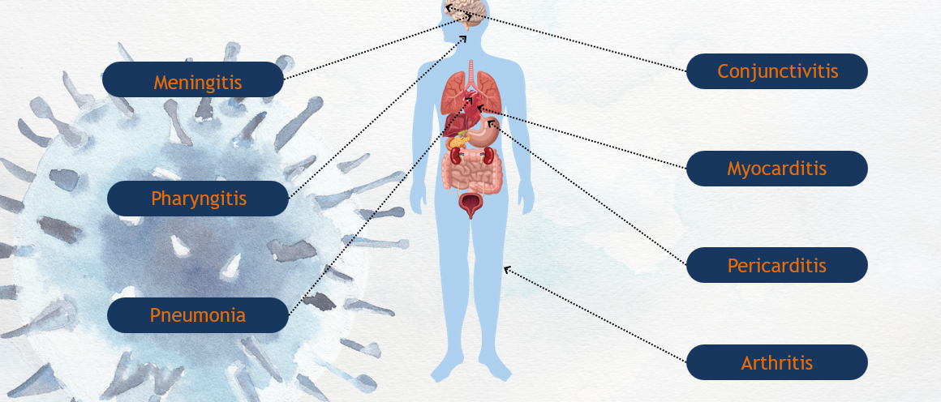
All meningococcal infections are not similar

EPIDEMIOLOGY & BURDEN
N. meningitidis is the 3rd most common cause of ABM in children <5 years.⁵
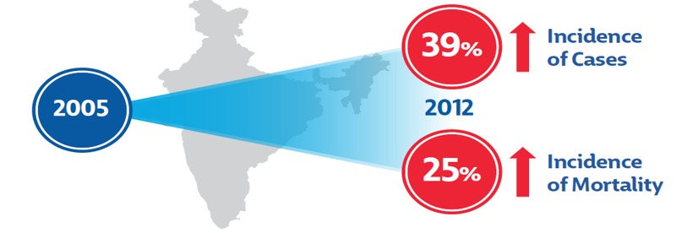
- Highest prevalence (55.3%) was observed among children 1 to 11 months.⁶
- 77% of bacterial meningitis cases are seen in children <2 years of age⁷
Indian Perspective of Invasive Meningococcal Disease (IMD)^{8,9}
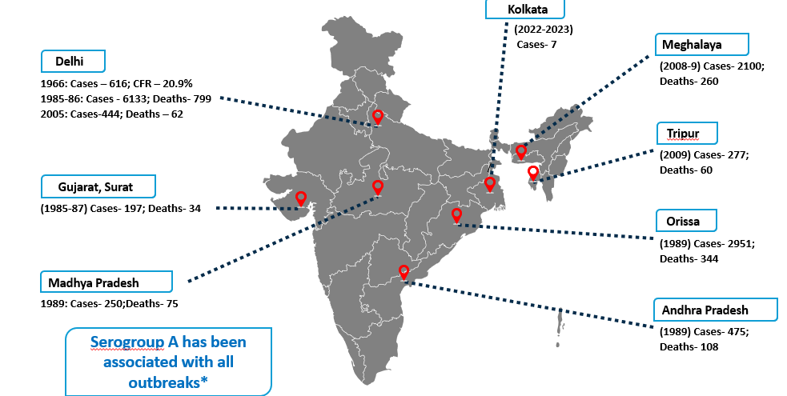
Meningococcal Meningitis Cases in India: Recent reports
National Health Profile¹⁰
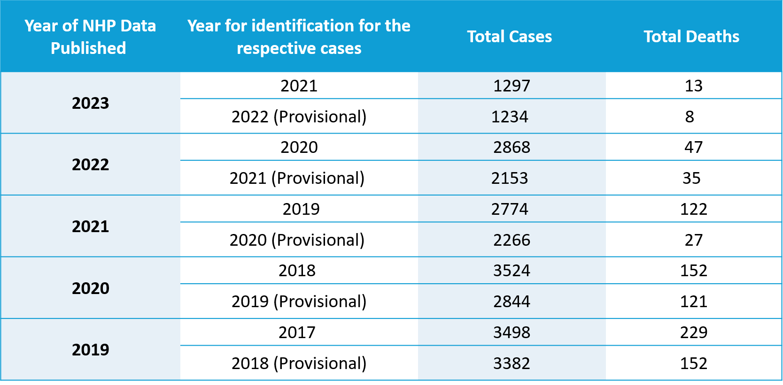

Sporadic Meningococcal Disease in India: Serogroup Insights
Sporadic meningococcal cases reported from different regions of India show that invasive meningococcal disease remains uncommon but clinically significant, with multiple serogroups contributing to isolated episodes. Recent case observations indicate circulation of serogroups C and W-135, along with severe presentations in neonates and children, suggesting a broader serogroup spectrum than historically recognized.
Although India traditionally reported predominance of serogroup A, contemporary sporadic cases highlight the presence of non-A serogroups, aligning with global patterns where serogroups A, B, C, Y, and W-135 together account for nearly 90% of invasive infections. Severe disease manifestations continue to be reported, consistent with known outcomes of invasive meningococcal disease, where mortality may reach 10–15% and long-term disabilities occur in 11–19% of survivors.¹¹⁻¹⁵
Clinically Significant Meningococcal Serogroups¹⁷
Serogroup | Characteristics
A | • Leading cause of epidemic meningitis worldwide  • Most prevalent serogroup in India, Africa and China
B | • Major cause of endemic disease in Europe and in America  • Predominant serogroup in infants
C | • Major cause of endemic disease in Europe and North America  • Multiple outbreaks in schools/communities
Y | • Emerged in the U.S. in the 1990s
W | • Global outbreak- 2000 Hajj pilgrimage
X | • Seen in <1% of cases in Meningitis belt and non-existent outside of it, where protection against serogroup X is not a public health concern; small outbreaks reported in Africa

Global Epidemiology of Meningococcal Disease Before and After COVID-19¹⁷
Five main disease-causing serogroups dominate globally: A, B, C, W, and Y; X remains rare outside Africa.
Pre-COVID trends:
- Serogroup A dramatically declined due to large-scale vaccination.
- Serogroup B was the most common in many regions (infants, adolescents, young adults).
- Serogroup C declined where MenC vaccines were introduced.
- Serogroup W increased in many regions due to hypervirulent cc11 lineages.
- Serogroup Y rose or stabilized in high-income countries.
COVID-19 impact:
- Global meningococcal disease incidence sharply decreased due to lockdowns, reduced social mixing, and travel restrictions.
- Routine immunization rates dropped in many countries, creating immunity gaps.
Post-pandemic resurgence:
- Incidence rebounded as social contacts increased.
- Resurgence is driven by the same dominant serogroups as pre-COVID (especially B, W, Y).
- Highest increases occur in under-vaccinated adolescents and young adults.

Main Serogroups Causing IMD
- Serogroup C was estimated to cause 21.7% of global IMD (mid-1990s to mid-2010s).
- A systematic review (2000–2017) estimated 48.5% of global IMD was caused by serogroup B.
- In China and Russia (late 2010s), serogroup A accounted for ≥10% of groupable cases; in Germany, Italy, and Spain it was <1%.

Asian Perspective of Invasive Meningococcal Disease (IMD)
The epidemiology of invasive meningococcal disease (IMD) across Asia is highly heterogeneous, reflecting substantial differences in geography, population structure, and surveillance capacity. Earlier reports generally highlighted serogroup A as a major contributor in several regions, while more recent data indicate a shift toward a broader mix of circulating serogroups, including notable increases in C, B, and W in parts of East Asia. This evolving pattern underscores the importance of continuous surveillance and region-specific vaccination strategies to address changing serogroup distributions.¹⁸
Serogroups in ASIA in order of prevalence
  - SG A > SG Y > SG C & W > SG B

Meningococcal Epidemics in Asian Countries
Country | Year of epidemic | Serogroup | Cases | CFR | Rate per 100,000
China | 1984  1977  1967  1959 | A  A  *  * | 3 million | ~ 5%  ~ 6%  ~ 10% | 11-7  59  150-800  ~ 55
India | 2006  2005  1985  1966 | A  A  A  * | 177  426  6 133  616 | 9-6%  13-6%  13%  20-9% | 13-23
Mongolia | 1994-1995  1973-1974 | A  A or B | 1 754 | 9-3_12-4% | 90 (overall)  179 (capital city)  359 (2-818 yr)  704 (<9 yr)
Nepal | 1982-1984 | A | 1 475 | 7-9%  26% | 103 (overall)  221 (<1 yr)
Pakistan | 1988 | A | 112 | 11%
Philippines | 2004-2005 | A | 98 | 33%
Taiwan | 1933-1946  1919-1926 | A  A
Vietnam | 1977-1979 | C |  | 27-4_34-7% | >20

IMD is difficult to diagnose and rapidly lethal^{19,20}
Invasive meningococcal disease (IMD) is challenging to diagnose early because its initial symptoms—fever, headache, irritability, vomiting, or myalgia—are nonspecific and easily mistaken for common viral illnesses. This subtle presentation often delays recognition.
Despite mild early signs, IMD can deteriorate within hours, rapidly progressing to septicemia, shock, purpura, and multi-organ failure. Even short delays in diagnosis or treatment significantly increase the risk of death, highlighting the disease’s aggressive and life-threatening nature.

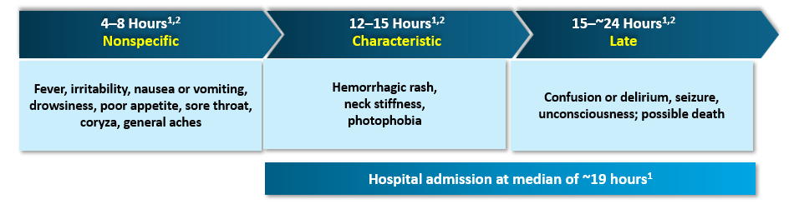

Challenges:¹⁹⁻²¹
- Early symptoms are nonspecific and easily mistaken for viral illnesses, leading to frequent failure to recognize cases.
- A non-blanching petechial rash appears in only ~25% of patients, reducing clinical suspicion.
- Meningococcal meningitis is clinically indistinguishable from meningitis caused by other bacteria.
- Neisseria meningitidis can undergo serotype switching, helping it evade immunity and complicating prevention strategies.
- The disease has a rapid clinical course, with deterioration occurring within hours, contributing to high mortality.
- Bacterial diagnosis is often missed, especially when antibiotics are given early or when laboratory capacity is limited.
- Management is challenging in critically ill patients, and even short delays in treatment worsen outcomes.
- Antimicrobial resistance, though still limited, is an emerging concern.
- Underreporting is common, with cases frequently missed by clinicians, leading to underestimation of true disease burden.
- Lack of universal meningococcal vaccination leaves populations at risk for outbreaks.
Clinical Severity and Prognostic Indicators in IMD²¹
- IMD showed extremely rapid progression, with death occurring in as little as 24 hours.
- At Aligarh Muslim University, the case fatality rate (CFR) was 16%.
- 28 of 40 deaths (70%) occurred within the first 24 hours of hospital admission, highlighting fulminant disease.
- Delayed presentation to the hospital was strongly associated with increased mortality, as many children arrived already critically ill.
- Altered consciousness at admission (lethargy, stupor, coma) was a major predictor of death.
- Shock or hypotension significantly increased fatal outcomes.
- Early seizures were linked to severe infection and higher mortality.
- Low CSF glucose levels indicated severe disease and poor prognosis.
- Elevated CSF protein served as another marker of severe infection.
- Presence of a purpuric rash often indicated disseminated disease and was associated with higher mortality.
- Overall, the study demonstrated that rapid disease progression + delays in seeking care drastically increased the risk of death, emphasizing the need for earliest possible diagnosis and treatment.

Long-Term Sequelae of IMD
- Patients suffer more during infancy and adolescence as compared to older age due to the increased incidence of adverse sequelae.²²
- Physical
  - Skin scarring, eczema, psoriasis, skin necrosis.
  - CV complications – symptoms consistent with Raynaud’s phenomenon, venous thrombosis, vasculitis.
- Neurological
  - Blindness, hearing loss, cranial nerve palsies, tinnitus.
- Psychological
  - Generalized anxiety, social anxiety disorder, specific phobias.

A district-wide study in Israel evaluated long-term
complications in IMD survivors and compared the data against incidence in the general pediatric populations.²³
General Paediatric  Population | IMD survivors  (Paediatric Population)
12.8% suffer from any disability | 33% suffer from disabilities such as neurologic deficits, hearing impairment, and other conditions such as limb amputation
0.3%–0.6% suffer from  hearing loss | 7% suffer from hearing loss

Disease with High case fatality rate
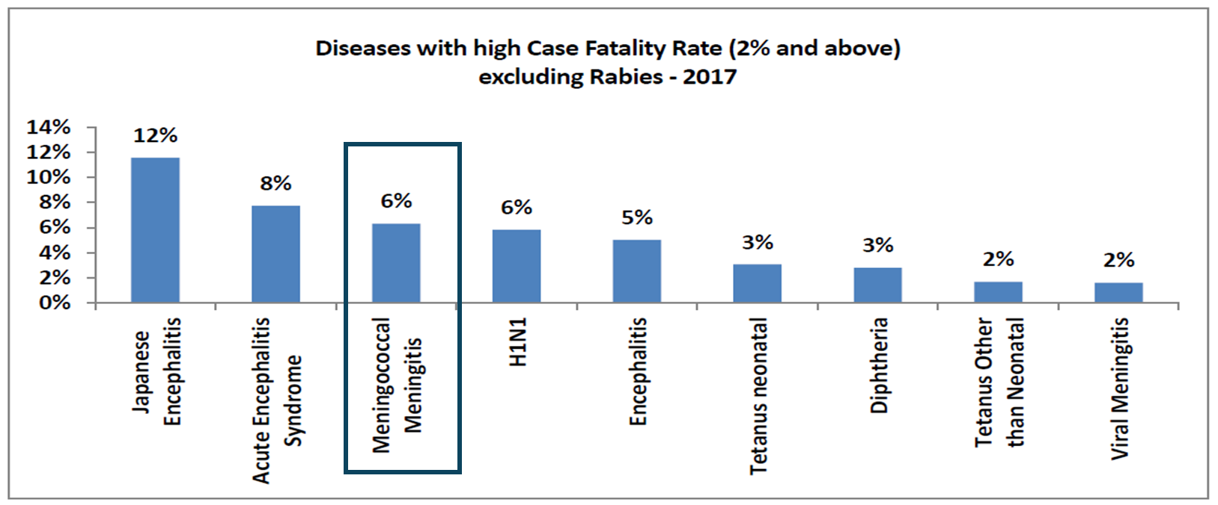

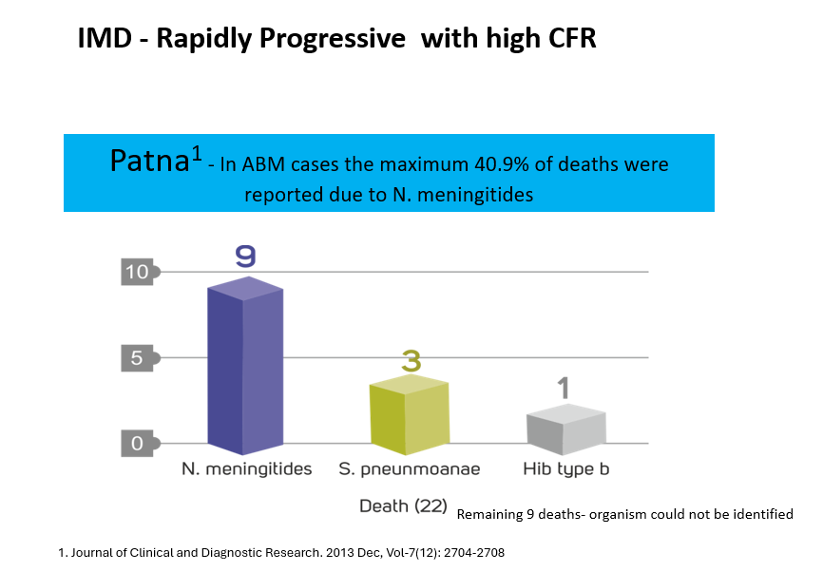

Despite treatment with appropriate antimicrobial agents and optimal medical care, the overall CFR is 9-12%, with a rate of up to 40 % among patients with meningococcal sepsis²³
11-19% of survivors will have sequelae like hearing loss, neurological disability, or loss of a limb.²⁴
Case studies:
Meningococcal Septicemia With Meningitis and Purpura Fulminans in a Child
Clinical Story
M……, a previously healthy 5-year-old boy from Pathankot, was brought to the hospital in August 2025 with a 4-day history of high-grade fever, followed by vomiting and loose stools for 3 days. In the hours preceding admission, his parents noticed that he had become increasingly irritable, eventually progressing to altered sensorium. Alarmed, they rushed him to the emergency department after observing a sudden onset of petechial and purpuric rash spreading across his body.
Upon arrival, he was found to be in profound septic shock. His extremities were cold, his pulses weak, and the purpuric rash rapidly evolved into large ecchymotic patches, raising immediate concern for purpura fulminans, a hallmark of fulminant meningococcemia.
Initial Assessment
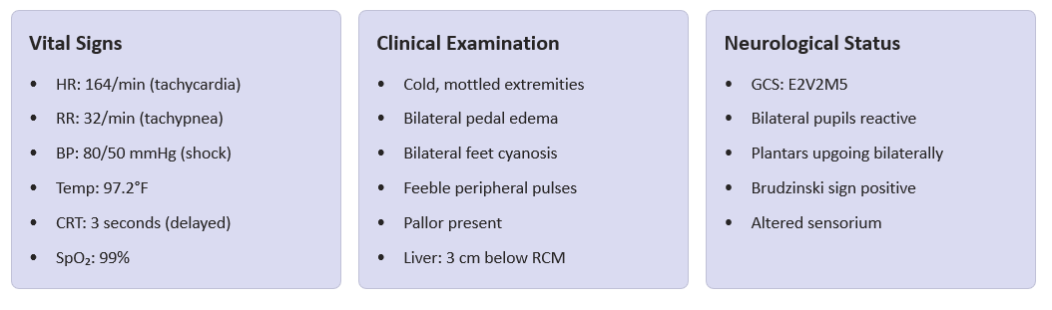
Differential Diagnosis
- Meningococcal Septicemia (strongest consideration)
- Bacterial Sepsis – S. pneumoniae / S. aureus
- Toxic Shock Syndrome
- Rickettsial Infection
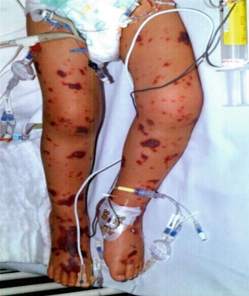
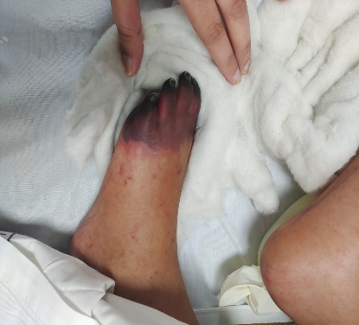
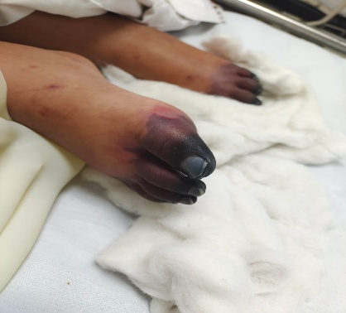

Emergency and Intensive Management
Initiated aggressive resuscitation:
- Rapid IV fluid boluses
- Inotropes to treat refractory shock
- Immediate broad-spectrum antibiotics (ceftriaxone, doxycycline, clindamycin, acyclovir)
- Due to worsening neurological status, he was transferred to the PICU, electively intubated, and placed on mechanical ventilation.
Investigations
- CBC and biochemistry showed features of sepsis and DIC.
- Coagulation profile: deranged.
- NCCT Head: Normal
- ECHO: Global LV hypokinesia, mild LV dysfunction
- Ultrasound Abdomen: Gallbladder sludge, diffuse edema, ascites, mild pleural effusion
Persistent fever and elevated procalcitonin prompted escalation to meropenem and teicoplanin.
Platelets and FFP were administered for coagulopathy, and 3% saline was started for neuroprotection.
Lumbar Puncture and CSF Findings
Once stable, lumbar puncture was performed.
CSF Analysis:
- Protein: 291.8 mg/dL (markedly elevated)
- WBC: 40 cells/mm³ (neutrophilic predominance)
- Glucose: Low
→ Highly suggestive of bacterial meningitis
Diagnosis Confirmation
Although the blood culture showed no growth, Film Array PCR tested positive for Neisseria meningitidis, rapidly confirming the diagnosis of:
Meningococcal meningitis with fulminant septicaemia and DIC.
Final Diagnosis
Severe meningococcal septicemia with meningitis, septic shock, DIC, purpura fulminans, multi-organ dysfunction, and bilateral lower-limb dry gangrene.
Clinical Course in PICU
Despite aggressive therapy, the purpuric rash continued to worsen. The child remained:
- Ventilator-dependent
- On high-dose inotropes
- Under continuous PICU monitoring
Peripheral perfusion progressively deteriorated. Over the next 48–72 hours, both feet developed bluish discoloration and swelling, which gradually evolved into dry gangrene, consistent with purpura fulminans and microvascular thrombosis.
Outcome and Discharge
After few weeks in intensive care, M…… gradually stabilized. His hemodynamics improved, neurological status recovered, and he was successfully weaned off both ventilator and inotropes. Despite systemic recovery, he was left with bilateral dry gangrene of the feet due to DIC-related vascular injury.
He was discharged on supportive medications and anticoagulation, with plans for regular wound care, surgical evaluation, physiotherapy, psychological support, and close follow-up to monitor limb outcomes and long-term sequelae.
Key Clinical Pearls

Case study 2:
Meningococcal Septicemia with Shock and ARDS in a Toddler
A 2-year-9-month-old girl presented with a 2-day history of high fever, followed by progressive deterioration of sensorium over 24 hours. Over the preceding 20 hours, she had no urine output, and a petechial–purpuric rash appeared 12 hours prior to admission. On arrival, she was in profound shock.
Initial Assessment
She was immediately intubated and ventilated due to impaired consciousness and respiratory distress. Laboratory investigations revealed:
- Hb: 9 g/dL
- WBC: 47,000/mm³ (Neutrophils 84%)
- Platelets: 46,000/mm³
- CRP: 40 mg/dL
- Urea: 102 mg/dL
- CSF: Normal
The combination of shock, rash, leukocytosis, thrombocytopenia, and altered sensorium suggested severe bacterial sepsis, and IV ceftriaxone + vancomycin were initiated immediately.
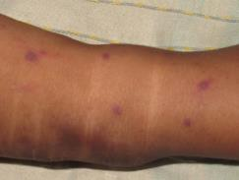
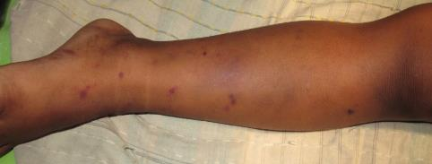
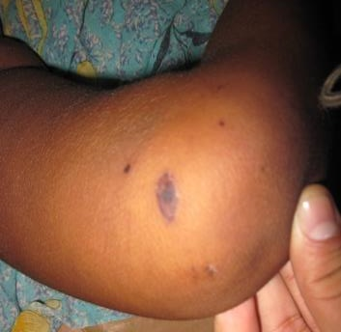


Diagnosis
Blood culture later confirmed Neisseria meningitidis, establishing a diagnosis of meningococcal septicemia. Despite normal CSF, the systemic presentation reflected early fulminant disease.
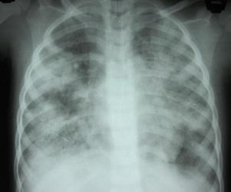
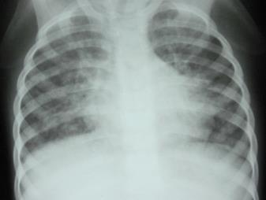

Clinical Course
The patient developed ARDS, requiring prolonged mechanical ventilation. She remained dependent on inotropic support to maintain perfusion. Broad-spectrum antibiotics were continued, along with intensive supportive care, fluid management, and close monitoring for complications.
Summary
This case illustrates the rapid progression and severity of meningococcal septicemia in young children, where shock, rash, and multiorgan dysfunction can evolve within hours. Early recognition, aggressive resuscitation, and prompt antimicrobial therapy were critical to management.

Case study 3:
Meningococcal Meningitis With Seizures and Periventricular Brain Lesions
An 8-year-old girl presented with a 7-day history of fever, initially managed symptomatically at home. On the day prior to admission, she developed generalized convulsions, followed by altered sensorium and the sudden appearance of a petechial–purpuric rash, prompting urgent medical evaluation.
Initial Assessment
On admission, the child was febrile and encephalopathic, with reduced responsiveness. The presence of seizures, rash, and acute neurological decline raised strong suspicion for central nervous system infection. She was stabilized and evaluated further.
Investigations
- MRI Brain: Showed multiple periventricular gliotic lesions, suggestive of inflammatory or infectious injury.
- CSF Examination: Biochemistry was supportive of bacterial etiology.
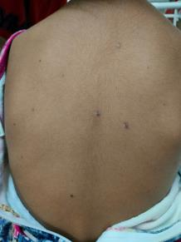
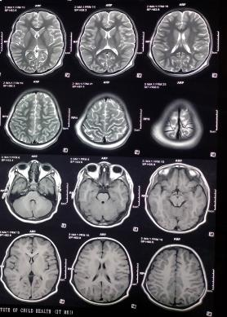
- CSF PCR: Positive for Neisseria meningitidis, confirming the diagnosis of meningococcal meningitis.

Diagnosis
Acute meningococcal meningitis with neurological involvement, complicated by seizures and radiological evidence of gliotic changes.
Management
The patient was initiated on:
- IV broad-spectrum antibiotics targeting meningococcal infection
- Anticonvulsants for seizure control
- Supportive measures including fluids, monitoring of neurological status, and management of raised ICP (if indicated)
Clinical Course
Over the following days, the fever gradually subsided. Seizure frequency reduced with appropriate therapy. Neurological status improved slowly, though MRI findings indicated the possibility of residual neuroinflammatory injury requiring long-term follow-up.
Summary
This case highlights the rapid neurological deterioration that can occur in meningococcal meningitis, where seizures, altered sensorium, and characteristic rash may develop suddenly after several days of nonspecific fever. Early recognition and confirmation through CSF PCR are crucial for timely treatment and prevention of long-term neurological sequelae.
Case study 4:
Rapidly Progressive Meningococcemia With Purpura Fulminans
A 4-year-old boy developed fever, headache, and myalgia early in the morning. By evening, he had progressed to a maculopapular rash but remained hemodynamically stable.
Day 2 – Morning
By the next morning, the fever persisted and the child appeared acutely ill. Examination showed an erythematous maculopapular rash over the trunk and lower limbs. His systemic condition was worsening.

Day 2 – Afternoon
Within hours, the rash evolved into petechiae and purpura, especially over pressure points—an alarming sign of early meningococcemia.
Laboratory tests:
- Hb: 11.4 g/dL
- WBC: 8,800/mm³ (N 68%, L 30%)
- Platelets: 160,000/mm³
- CSF: Normal; culture awaited
The rapid transition of rash raised strong concern for incipient Purpura Fulminans.
Day 2 – Evening: Rapid Deterioration
The child suddenly deteriorated:
- Ecchymosis and hemorrhagic bullae
- Blackish discoloration of toes → early skin necrosis
- Hypotension (BP 70/30 mm Hg)
- Oliguria
Repeat labs:
- Hb: 9 g/dL
- Platelets: 40,000/mm³
These changes indicated severe septic shock with disseminated intravascular coagulation (DIC). The dramatic worsening of skin lesions and peripheral ischemia was characteristic of Purpura Fulminans, a life-threatening complication of fulminant meningococcemia.
Summary
This case illustrates the classic rapid progression of meningococcal sepsis—from a nonspecific febrile illness to Purpura Fulminans, shock, DIC, and impending necrosis within less than 24 hours. The evolution from maculopapular rash to petechiae, purpura, bullae, and blackish discoloration is highly characteristic of meningococcal Purpura Fulminans, demanding immediate intensive management.

Case study 5:
Early Detection and Swift Intervention Saved a Toddler in a Meningococcal Outbreak
Patient Background
A 9-month-old boy was brought to the Department of Pediatrics, NEIGRIHMS, Shillong, with a two-day history of fever and running nose. On the day of admission, he was noted to be excessively sleepy and was not feeding well.
Examination and Initial Findings
On examination, his pulse rate was 160/min and weak, with a capillary refill time (CFT) of 4 seconds. He was only responding to painful stimuli, and a bulging anterior fontanelle was noted. He was diagnosed with bacterial meningitis and shock. Immediate management included fluid resuscitation and intravenous ceftriaxone, after which he was shifted to the pediatric intensive care unit (PICU).
Investigations
- CSF (Cerebrospinal fluid) Findings: Hazy appearance, normal opening pressure, total leukocyte count (TLC) 3000/μL with 78% polymorphs, protein 150 mg/dL, sugar 30 mg/dL (with concurrent RBS 120 mg/dL)
- Blood tests: TLC 3800/μL, 75% polymorphs, adequate platelets on smear, normal electrolytes
- After stabilization, Gram stain revealed Gram-negative diplococci, indicative of Neisseria meningitidis.
Clinical Course and Outcome
By the evening of admission, the child developed a widespread rash, confirming the diagnosis of meningococcal meningitis with meningococcemia. He was placed in isolation, and chemoprophylaxis was administered to close contacts and healthcare workers. Relevant health authorities and the Infectious Disease Surveillance team were notified of the case.
Outbreak and Public Health Response
This case was among the early cases traced to a 2008 outbreak in Meghalaya, which was rapidly confirmed as a meningococcal epidemic by NCDC, New Delhi. The hospital implemented formal reporting and interdepartmental coordination, chemoprophylaxis, and vaccination discussions, and improved case detection rates. Key challenges included atypical presentations, delayed diagnosis, recognition of rashes, and communication with the public.

Despite the identification of certain risk factors—such as complement deficiencies, asplenia, or close-contact exposure—the vast majority of invasive meningococcal disease (IMD) occurs in individuals with no prior medical problems.
Studies have consistently demonstrated that up to 90% of IMD cases arise in previously healthy people with no identifiable predisposing conditions.
Serogroup A is responsible for majority meningococcal meningitis outbreaks in india.
Prevention strategy
Prevention of meningococcal disease relies on a combination of vaccination, rapid case identification, contact prophylaxis, and public health surveillance. Because IMD progresses rapidly and carries high mortality, prevention remains the most effective and impactful intervention.
Vaccination – The Cornerstone of Prevention
Conjugate Vaccines (MenACWY)
Conjugate vaccines targeting serogroups A, C, W, and Y have significantly reduced disease burden worldwide.
- Introduced in Europe, North America, and parts of Africa, these vaccines have led to marked declines in IMD incidence, including herd protection effects.
- The WHO recommends MenACWY vaccination for high-risk populations, outbreak settings, and regions with high serogroup prevalence.

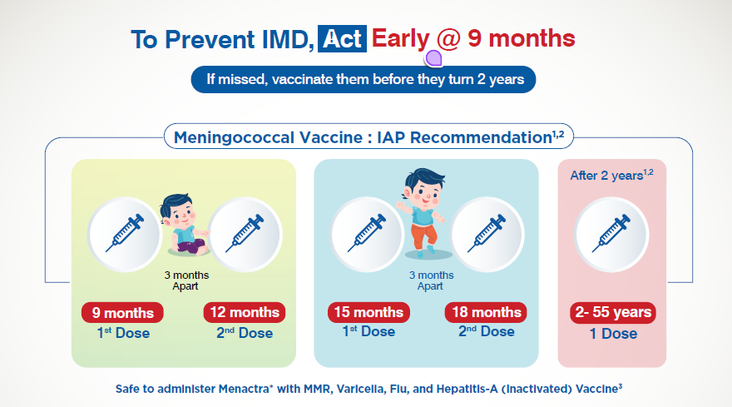
- Globally, 9 out of 12 major countries have an MCV recommendation at 9 months.²⁵
- WHO Position Paper recommends initiation at 9 months²⁵
- ACVIP recommends initiation of MCV at 9 months²⁶
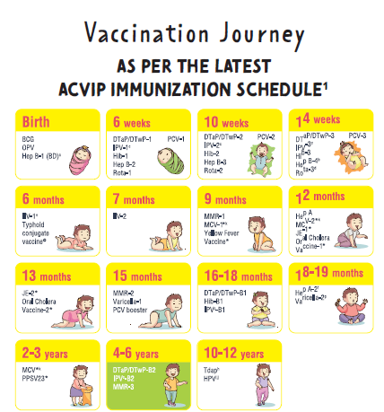

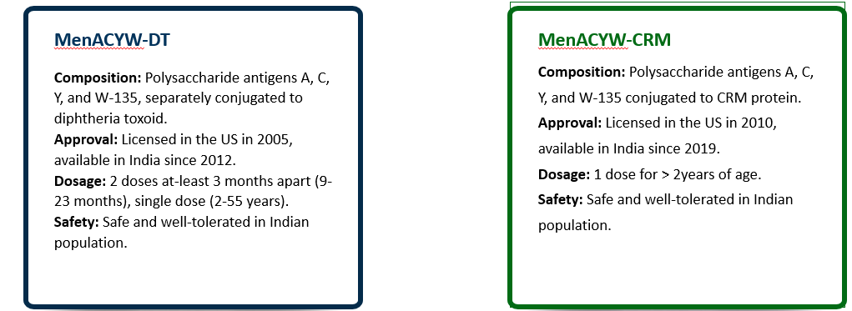
Quadrivalent Conjugate Vaccines Available in India^{25,27}

Clinical evidence
Two-dose Men-ACYW-D vaccine is safe and highly immunogenic in infants (9–17 months) in India²⁸
Background
- Invasive meningococcal disease (IMD) can be severe, with high morbidity and mortality, especially in young children.
- Serogroups A, C, W, and Y are responsible for a large proportion of cases globally.
- The Men-ACYW-D (Menactra) vaccine (quadrivalent, conjugated to diphtheria toxoid) is licensed in many countries, but at the time of this study, no such quadrivalent conjugate vaccine was licensed for broad use in infants < 2 years in India
Design: Open-label, single-arm, phase III trial at four sites in India.
Participants: 200 Indian children aged 9–17 months were enrolled.
Vaccination schedule: Two intramuscular doses (0.5 mL each) of Men-ACYW-D, given 3–6 months apart.
Immunogenicity measurement: Blood samples taken pre–first dose and 28 days after second dose; measured serum bactericidal assay with human complement (SBA-HC) for serogroups A, C, W-135, Y. Seroprotection defined as titer ≥ 1:8.
Safety assessment:
- Immediate adverse reactions monitored for 30 minutes post-injection.
- Solicited local (pain, erythema, swelling) and systemic (fever, irritability, etc.) reactions recorded for 7 days after each dose.
Key results:
After two doses, >95% of Indian infants achieved seroprotective SBA-HC titers against all four meningococcal serogroups (A, C, Y, W-135).
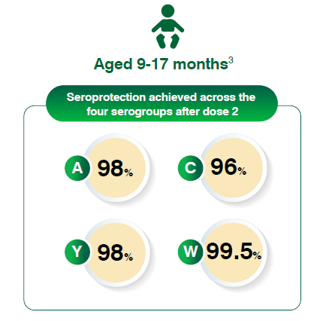

A strong immune boost was observed, with ≥4-fold rise in antibodies in 86–97% of children across the serogroups.

Conclusion:
The two-dose Men-ACYW-D vaccine in Indian infants aged 9–17 months was well tolerated with no major safety concerns.
It induced strong immunogenicity: >95% of children achieved seroprotective titers for all four meningococcal serogroups (A, C, Y, W) after the second dose.

Single-dose quadrivalent Men-ACYW-DT vaccine is safe and immunogenic in Indian children, adolescents, and adults²⁹
Objective
To assess the safety and immunogenicity of a single dose of the quadrivalent meningococcal conjugate vaccine (Men ACYW-DT, covering serogroups A, C, Y, and W) in healthy Indian participants aged 2–55 years.
Background
- Meningococcal disease (caused by Neisseria meningitidis) is a serious condition, and prevention via vaccination is critical.
- Conjugate vaccines (polysaccharide linked to a protein carrier like diphtheria toxoid) elicit better immune memory than plain polysaccharide vaccines.
- There was limited data from India for a quadrivalent conjugate meningococcal vaccine (A, C, Y, W) among different age groups, hence this bridging study.
Methods
- Design: Multicenter, open-label, non-randomized, Phase III clinical trial.
- Setting: Three medical college hospitals in India — New Delhi, Bengaluru, and Mumbai.
- Participants: 300 healthy, vaccine-naïve people divided into three age-cohorts:
  - Children: 2–11 years (n = 100)
  - Adolescents: 12–17 years (n = 100)
  - Adults: 18–55 years (n = 100)
- Intervention: One intramuscular dose (0.5 mL) of MenACYW-DT, containing 4 µg polysaccharide of each serogroup (A, C, Y, W-135) conjugated to ~48 µg diphtheria toxoid.
- Immunogenicity measurement: Serum bactericidal antibody titers (SBA) using rabbit complement (SBA-BR) measured before vaccination and ~30 days after.
- Safety assessment: Solicited local and systemic adverse reactions, unsolicited adverse events, and serious AEs monitored post-vaccination.
Key results:
Key Results
- Immunogenicity:
  - Geometric Mean Titers (GMTs) by SBA-BR rose substantially for all four serogroups 30 days after vaccination in all age groups.
  - In adolescents, ~96.9% achieved SBA-BR titers ≥ 1:8 for serogroups A and C, and 100% for Y and W-135.
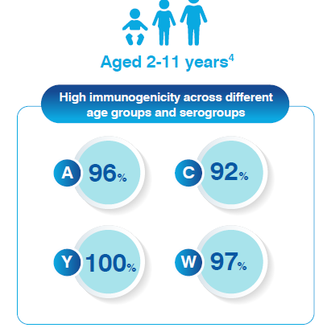
A 4-fold (or more) rise in antibody titers (from baseline) was seen in 68% to ~97% of participants, depending on serogroup and age group.

Safety:
- Most solicited reactions (e.g., local pain, systemic symptoms) were mild and short-lived.
- Unsolicited adverse events were uncommon and not related to the vaccine.
Conclusion
Men-ACYW-DT conjugate vaccine was well tolerated and induced a strong bactericidal immune response against meningococcal serogroups A, C, Y, and W in Indian individuals aged 2 to 55 years.

Single-dose MenACWY-CRM vaccine is safe and immunogenic in healthy Indian people aged 2–75 years³⁰
To evaluate the safety and immunogenicity of a single dose of the quadrivalent meningococcal ACWY conjugate vaccine (MenACWY-CRM, also called Menveo) in healthy Indian individuals aged 2 to 75 years.
Background
- Neisseria meningitidis serogroups A, C, W, and Y cause significant invasive meningococcal disease.
- Conjugate vaccines (with CRM197 carrier) can induce stronger and more durable immune responses than plain polysaccharide vaccines.
- At the time, there was limited immunogenicity and safety data for MenACWY-CRM in the Indian population across a wide age range, which was needed for licensure in India.
Methods
- Design: Phase III, multicenter, open-label study.
- Participants: 180 healthy Indian subjects divided into three age cohorts — 60 children (2–10 years), 60 adolescents (11–18 years), and 60 adults (19–75 years).
- Intervention: Single intramuscular dose (0.5 mL) of MenACWY-CRM.
- Immunogenicity assessment: Human complement serum bactericidal assay (hSBA) measured before vaccination and 1 month after vaccination.
- Safety assessment: Adverse events (AEs) were recorded for 29 days post-vaccination.

Key Results
- Immunogenicity:
  - After vaccination, 72%, 95%, 94%, and 90% of participants achieved hSBA ≥ 8 for serogroups A, C, W, and Y respectively.
  - Geometric mean titers (GMTs) increased by 7- to 42-fold from baseline for the four serogroups.
  - Serogroup-specific seroresponse (≥ 4-fold rise) rates were 72% (A), 88% (C), 55% (W), and 71% (Y).
- Safety:
  - The vaccine was well tolerated; no major safety issues reported during the 29-day follow-up.
Conclusion:
The MenACWY-CRM vaccine in healthy Indian individuals aged 2–75 years was safe and induced a robust immune response against meningococcal serogroups A, C, W, and Y.
KEYPOINTS:
- IMD progresses with alarming speed, often causing septic shock, DIC, and multi-organ failure within hours, making rapid recognition and treatment essential.
- Early symptoms are nonspecific, and a petechial/purpuric rash appears in only ~25% of cases, leading to frequent delays in diagnosis.
- Up to 90% of IMD cases occur in previously healthy individuals with no identifiable risk factors, underscoring the unpredictable nature of the disease.
- Infants face the highest risk, especially between 3–11 months, and 9 months is the optimal age for vaccination as immunity is strong, and disease risk is high.
- During epidemic conditions in India, meningococcal meningitis has shown a case fatality rate (CFR) of 12.8%, reinforcing the critical need for timely vaccination and outbreak preparedness.
- Because of its unpredictable onset, rapid deterioration, and high fatality, routine meningococcal vaccination remains the most effective and essential prevention strategy.
- Meningococcal conjugate vaccines (MenACWY) provide strong, long-lasting protection across all age groups and are highly effective in preventing severe, rapidly progressing invasive meningococcal disease.

References:
- Harrison LH, Trotter CL, Ramsay ME. Global epidemiology of meningococcal disease. Vaccine. 2009;27 Suppl 2:B51-63.
- Meningococcal Disease (Neisseria meningitidis Infection). In: Bennett JE, Dolin R, Blaser MJ, editors. Mandell, Douglas, and Bennett's Principles and Practice of Infectious Diseases. 9th ed. Philadelphia: Elsevier; 2020. p. 2577-2585.
- Hazarika RD et al, Indian J Pediatr 2012
- Mbaeyi SA, et.al. Meningococcal Disease, CDC Yellow Book. Available at: Infants and children aged <2 years have nonspecific symptoms and symptoms which are difficult to diagnose like neck stiffness. As accessed on: 10 Jan 2022
- Ghia CJ et al Microbiol Insights. 2021 Nov 29;14:11786361211053344.
- Jayaraman et al. PLOS ONE, 2018
- Jayaraman et al. Vaccine 39 (2021) 3737–3744
- CD Alert. Meningococcal Disease: Need to remain alert. Available at: https://ncdc.gov.in/WriteReadData/linkimages/OCT-NOV_098132922884.pdf
- Few cases if B, C & W is **CD Alert. Meningococcal Disease: Need to remain alert. Available at: https://ncdc.gov.in/WriteReadData/linkimages/OCT-NOV_098132922884.pdf
- https://cbhidghs.mohfw.gov.in/index1.php?lang=1&level=1&sublinkid=75&lid=1135
- Kumar D. Fulminant meningococcemia with meningococcal meningitis in the neonate: a case report. [Journal name not provided].
- Vasandhi K. Meningococcal meningitis C in Tamil Nadu: public health perspectives. [Journal name not provided].
- Poovazhagi V, Devasena N. Neisseria meningitidis due to W135 strain from South India. J Infect Dis Ther. 2014;2(5):1000165. doi:10.4172/2332-0877.1000165
- Dinkar A. Self-mutilating behaviour in severe meningococcal infection: an interesting association. [Journal name not provided].
- Khatua P, et al. [Title not provided]. Asian J Med Sci. 2024;15(3).
- Nancy Messonnier. Epidemiology of Meningococcal Disease. SAGE 2011.
- Shen S, et al. Global Epidemiology of Meningococcal Disease-Causing Serogroups Before and After the COVID-19 Pandemic: A Narrative Review. Infect Dis Ther. 2024 Dec;13(12):2489-2507.
- Vyse et al, Epidemiol. Infect. (2011), 139, 967–985.
- Thompson et al. Lancet. 2006;367(9508)
- Branco et al. J Pediatr (Rio J). 2007;83(2 suppl)
- Fakhir S., Ahmad S.H., Ahmad P. Ann Trop Paediatr. 1992;12:149–154.
- Olbrich KJ, et al. Infect Dis Ther. 2018;7(4):421–438.
- Stein-Zamir C, et al. Pediatr Infect Dis J. 2014;33(7):777–779.
- V Manchanda et al. Indian J Med Microbiol 2006;24(1): 7-19.
- Balasubramanian S, et al. Indian Pediatrics, 2018;55:1066-1074
- Kasi SG, et al. Indian Pediatr. 2021;58(1):44–53
- Vashishtha VM, et al. Indian Pediatr., 2014;51(10):785–800.
- Javaddekar B, Ghosh A, Kompithra RZ, et al. Indian Pediatr. 2018 Dec 15;55(12):1050-1055
- Yadav S, et al. Indian Pediatr 2014. Jun;51(6):451-6.
- Lalwani et al; International Journal of Infectious Diseases 38 (2015) 36–42

