Introduction to Micronutrient "Relay Teams" in Innate Immunity
This article discusses the critical roles of lysine and zinc in pediatric immunity, focusing on their synergistic actions in modulating innate immune responses. Lysine and zinc act as integral components of the immune system, enhancing both innate and adaptive immunity. The primary objective is to explore how these two micronutrients function together to support immune responses and improve pediatric health outcomes.

Lysine’s Role in Immune Response

Lysine and mTORC1 Activation
Lysine is a key player in immune function due to its ability to activate mTORC1 (mechanistic target of rapamycin complex 1). This complex is a central regulator of protein synthesis, cell growth, and metabolism, essential for immune responses. When pathogens are detected, mTORC1 activates the translation of cytokines such as IL-6 and TNF-α, which are critical in mounting an effective immune response.
The activation of mTORC1 by lysine ensures rapid production of immune cells and antimicrobial peptides necessary for pathogen defense. However, when lysine levels are inadequate, mTORC1 activity is impaired, which in turn affects the efficiency of immune responses.

Lysine’s Effect on IRF3 Methylation
In addition to activating mTORC1, lysine plays a role in modulating the SMYD3-IRF3 pathway. Lysine methylation of IRF3 at position K39 is a regulatory mechanism that ensures balanced immune responses. This methylation prevents excessive immune activation by controlling the production of type I interferons, which are essential for antiviral defense. By fine-tuning these responses, lysine helps avoid inflammation that could lead to tissue damage or chronic inflammatory diseases.

Zinc in Innate Immunity

TLR4 and TCR Signaling Pathways
Zinc is vital for modulating immune cell function, particularly in regulating key signaling pathways. Zinc plays a central role in the activation of TLR4 (Toll-like receptor 4) in macrophages and TCR (T-cell receptor) in T lymphocytes. These pathways are essential for initiating immune responses to infection.
- TLR4 Modulation: Zinc prevents the dephosphorylation of critical signaling molecules in macrophages, ensuring that LPS (lipopolysaccharide)-stimulated macrophages continue their effective immune response.
- TCR Signaling: Zinc regulates TCR signaling, which is crucial for activating T-cells and driving adaptive immune responses.

Zinc as an Antioxidant
In addition to its role in immune signaling, zinc is an essential cofactor for Cu/Zn-SOD1 (superoxide dismutase), an enzyme that protects immune cells from oxidative stress during pathogen encounters. This antioxidant function helps maintain immune cell integrity, allowing cells to respond efficiently during the respiratory burst—a rapid release of reactive oxygen species used to eliminate pathogens.

Zinc in Cytokine Regulation and Adaptive Immunity

Cytokine Production
Zinc plays a pivotal role in regulating cytokine production. By influencing enzymes that control cytokine synthesis, zinc ensures that cytokine levels remain balanced during infection. Proper regulation of cytokines is essential to avoid the overproduction of inflammatory molecules, which could lead to excessive tissue damage.

Zinc and Th1/Th2 Balance
Zinc is crucial in maintaining the balance between Th1 and Th2 immune responses. Deficiency in zinc can lead to a skewed immune response, with reduced IFN-γ (interferon-gamma) secretion and impaired pathogen clearance. Zinc deficiency, therefore, contributes to a weakened ability to fight infections, particularly those involving intracellular pathogens, in pediatric populations.

The "Relay Team" Model: Lysine and Zinc in Sequence
The "Relay Team" model highlights the sequential roles of lysine and zinc in supporting immune responses:
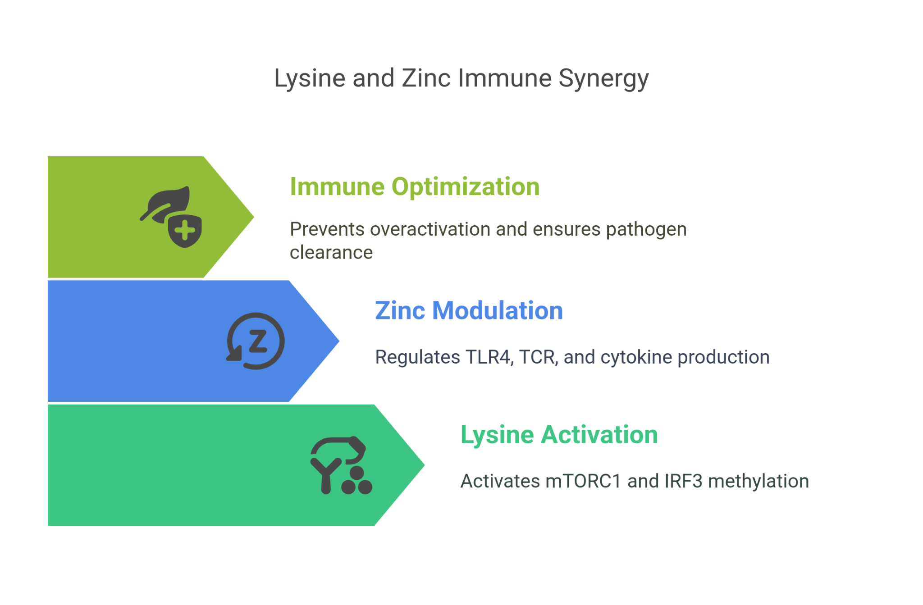

Phase I: Lysine Activation
Lysine’s role in activating mTORC1 primes the immune system by enhancing protein synthesis and cytokine translation. This phase ensures that immune cells are prepared to respond rapidly when pathogens are detected. Lysine also regulates the activity of IRF3, setting “brakes” on overactivation to ensure that immune responses remain controlled and do not lead to excessive inflammation.

Phase II: Zinc Modulation
Following the priming action of lysine, zinc plays a critical role in controlling immune signaling. Zinc gates the function of TLR4 in macrophages and TCR in T lymphocytes, ensuring that immune responses are strong enough to fight infections but also tightly regulated to prevent overreaction. This synergy between lysine and zinc enables the immune system to respond effectively while minimizing the risk of collateral damage to tissues.

Clinical Evidence Supporting Lysine and Zinc Supplementation

Zinc Supplementation in Pediatric Populations
Clinical studies have shown that zinc supplementation significantly reduces the incidence of pneumonia in children. A meta-analysis of randomized controlled trials found that zinc supplementation (10–20 mg/day for 10–14 days) reduced the incidence of pneumonia by approximately 13%. When only clinically confirmed pneumonia cases were analyzed, the reduction was even more significant (~21%). These findings suggest that zinc supplementation can play a crucial role in reducing respiratory infections and improving overall pediatric health outcomes.

Lysine Supplementation for Growth and Immune Health
In addition to zinc, L-lysine supplementation has been shown to improve growth, appetite, and immune markers in adolescents. Trials demonstrate that lysine supplementation supports bone health and enhances immune function, particularly in children experiencing growth retardation or poor nutritional intake. However, further research is needed to fully understand its long-term effects on pediatric immune function.

Infographic 2: Clinical Evidence and Impact of Lysine and Zinc Supplementation in Pediatric Populations
- Zinc Supplementation
  - A meta-analysis of 6 RCTs showing a 13% reduction in pneumonia incidence with zinc supplementation.
  - A 21% reduction in clinically confirmed pneumonia cases in children aged 2-12 years.
  - Dosage recommendations for zinc: 10-20 mg/day for 10-14 days.
- Lysine Supplementation
  - Benefits in adolescent growth: Improvement in appetite, bone health, and immune markers.
  - Need for further study on lysine’s role in pediatric immune outcomes.
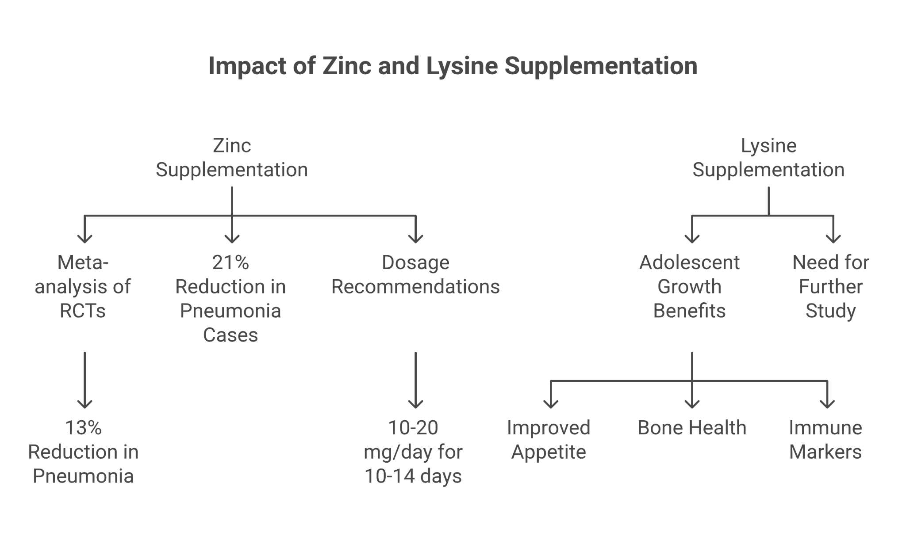

Pediatric Syrup Formulation: Application and Dosing

Syrup Formulation
A pediatric syrup containing both lysine and zinc has been developed to provide a convenient and effective way to enhance immune function in children. The formulation includes:
- 500 mg of lysine HCl and 25 mg of zinc gluconate (elemental zinc) per 5 mL dose.

Dosing Recommendations
- For children aged 2–12 years, the recommended dose is 5 mL once daily after meals.
- Convalescent adults may follow the same regimen.

Safety and Monitoring
The syrup is generally well-tolerated, though mild gastrointestinal upset may occur in some children. It should be avoided in patients with Wilson’s disease, a genetic disorder that affects copper metabolism. For prolonged use (more than six months), it is recommended to monitor serum zinc levels and track growth Z-scores and infection frequency on a quarterly basis.

Case Study
A 4-year-old child, previously experiencing six upper respiratory tract infections (URTIs) per year, began using the syrup daily. After three months, the number of infections dropped to three, and the child gained 0.5 kg in weight. These outcomes suggest a 40% reduction in infections and a 10% improvement in growth over six months, highlighting the potential benefits of lysine and zinc supplementation in improving pediatric health.

Conclusion: Enhancing Pediatric Immunity through Micronutrients
Lysine and zinc play complementary roles in supporting pediatric immunity. Lysine primes the immune system by activating mTORC1 and controlling immune activation through IRF3 methylation. Zinc then fine-tunes immune responses by modulating TLR4 and TCR signaling, ensuring potent yet controlled immune activation.
Clinical evidence supports the use of lysine and zinc supplementation to enhance immune responses and reduce the incidence of infections like pneumonia. The development of a pediatric syrup formulation offers a practical and evidence-based approach to improving pediatric immune health, with proven benefits in reducing infections and supporting growth.

