Neonatal Immune Education: Zinc’s Role in Thymic Maturation and Vaccine Responsiveness

Overview of Neonatal Immune Development
Neonatal immune development begins in utero and continues actively after birth. During this period, the thymus functions as the central organ responsible for educating naïve T lymphocytes to distinguish self from non-self. This education process is fundamental for the development of adaptive immunity and effective vaccine responses in early life.
Although the thymus is proportionally largest at birth, its functional maturation extends across the first few months of life. The quality of thymic development during this period determines the size, diversity, and competence of the infant T-cell repertoire.

Thymic Structure and Postnatal Maturation
At term, the neonatal thymus contains abundant thymocytes and supporting stromal cells. However, these cellular populations are functionally immature. Full maturation of the cortical and medullary architecture occurs gradually during early infancy.
Proper organization of these regions is essential for positive and negative selection of T cells. This process ensures the generation of a broad, self-tolerant T-cell repertoire capable of responding to novel antigens, including those presented during routine immunization.

Zinc as a Critical Micronutrient for Thymic Function
Zinc is indispensable for normal thymic development. It maintains thymic epithelial cell integrity, supports thymocyte proliferation, and enables physiological thymic growth. Both experimental and human studies demonstrate that zinc deficiency leads to thymic atrophy, lymphopenia, and impaired T-cell maturation.
Without adequate zinc, thymic output declines, compromising adaptive immune responses during a period when immune education is most active.

Zinc-Dependent Transcription Factors and Thymic Hormones
Several zinc-dependent transcription factors, particularly zinc-finger proteins such as GATA-3, regulate thymic epithelial cell function and thymocyte lineage commitment. These transcriptional processes guide differentiation into functional CD4⁺ and CD8⁺ T cells.
Zinc also stabilizes thymulin, a thymic hormone essential for T-cell differentiation and maturation. Zinc deficiency reduces thymulin activity, directly impairing thymic signaling and diminishing thymic output.

Features of Thymic Atrophy in Zinc Deficiency
Animal models of perinatal zinc deficiency consistently demonstrate profound thymic atrophy. Hallmark features include reduced cortical thickness, decreased numbers of CD4⁺CD8⁺ double-positive thymocytes, and increased apoptosis of immature T cells.
Human infants born to zinc-deficient mothers exhibit smaller thymic indices on ultrasound and lower circulating naïve T-cell counts, indicating that these experimental findings translate into clinically relevant immune impairment.
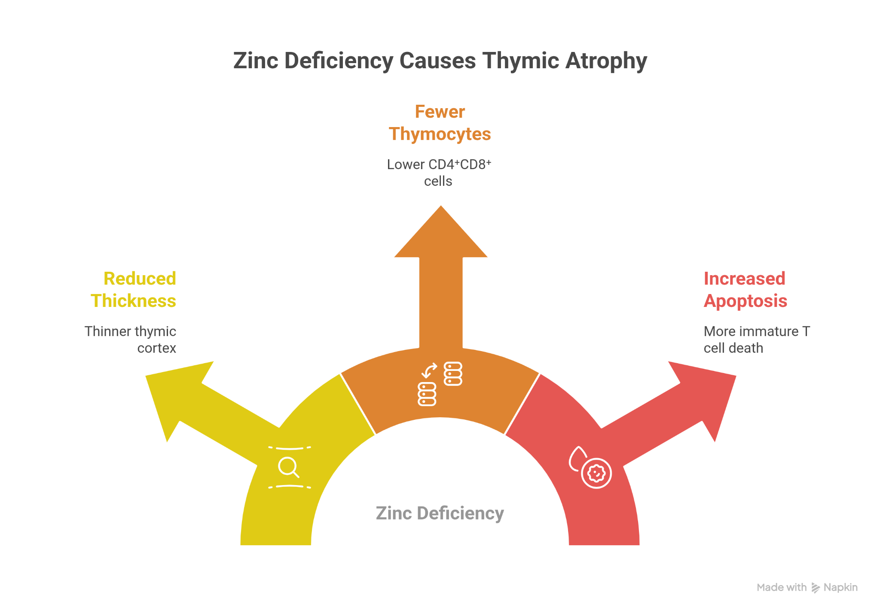

Immune Reprogramming and Hormonal Effects
Zinc deficiency is associated with increased endogenous glucocorticoid production. Elevated glucocorticoids accelerate thymic involution and further suppress thymocyte survival.
At the hematopoietic level, zinc deficiency skews cell differentiation toward myeloid lineages at the expense of lymphopoiesis. This shift further compromises adaptive immunity and reduces the pool of antigen-responsive T cells in early life.

Thymic Output, TCR Diversity, and Vaccine Responsiveness
Adequate thymic output is necessary to maintain a diverse T-cell receptor (TCR) repertoire. TCR diversity enables recognition of a wide range of vaccine antigens and supports effective primary immune responses and immunological memory formation.
Zinc-deficient neonates show reduced TCR diversity, fewer naïve CD4⁺ and CD8⁺ T cells, and impaired memory development, resulting in suboptimal vaccine responses.
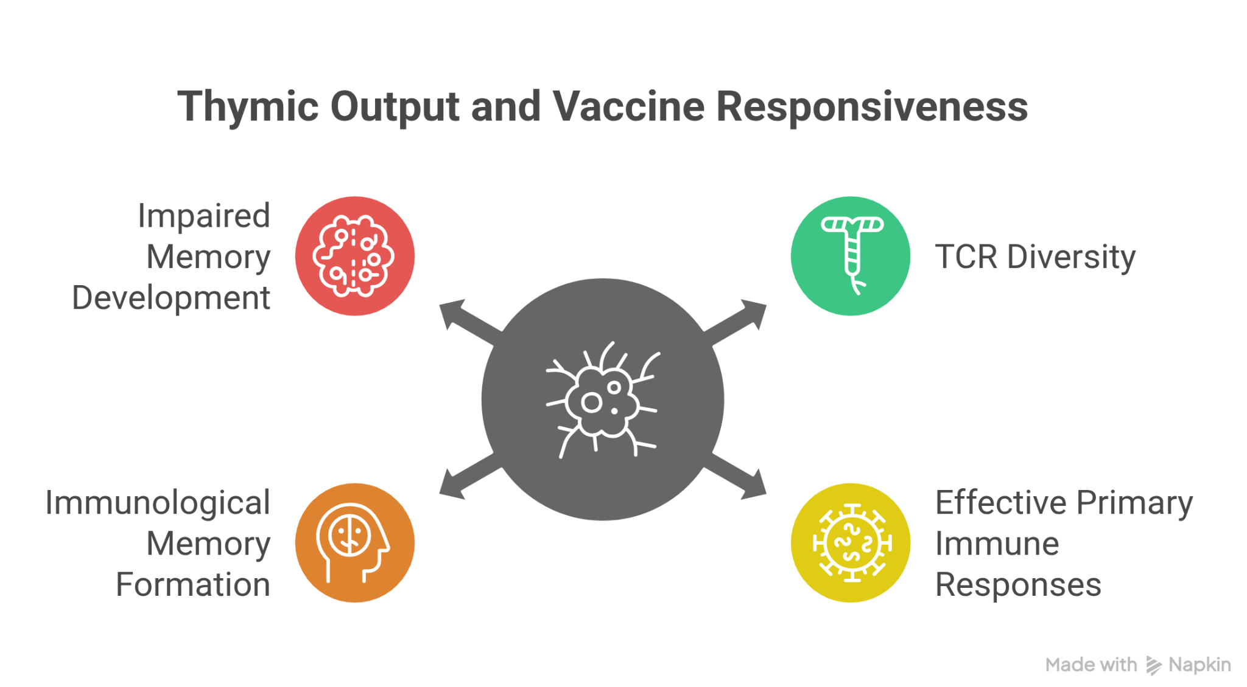

Evidence from BCG Vaccination and Cellular Immunity
Antenatal zinc supplementation has been shown to enhance T-helper one–biased responses to Bacillus Calmette–Guérin vaccination. Infants with adequate zinc status demonstrate higher interferon-gamma production around ten weeks of age, reflecting stronger cell-mediated immunity.
These findings indicate that zinc status during gestation and early infancy directly influences vaccine-induced immune programming.

Zinc and Responses to Conjugate and Toxoid Vaccines
For pneumococcal conjugate vaccines, protection depends on achieving adequate serotype-specific immunoglobulin G concentrations. Zinc-supplemented infants show significantly higher antibody titers to less immunogenic serotypes such as six-B and twenty-three-F.
Similarly, zinc-deficient infants exhibit lower seroconversion rates following diphtheria, tetanus, and pertussis vaccination, along with reduced antigen-specific CD4⁺ T-cell proliferation. These findings highlight zinc’s role in both humoral and cellular immunity.

Clinical Evidence from Animal and Human Studies
In animal models, zinc supplementation from birth to weaning prevents thymic atrophy and restores normal thymocyte populations. Zinc-repleted neonatal animals show improved splenic T-cell counts and stronger recall responses to antigens.
Human randomized trials demonstrate that antenatal zinc supplementation improves neonatal thymic size and vaccine responsiveness. Postnatal zinc supplementation increases seroprotection rates after oral polio vaccination and enhances antibody responses to pneumococcal conjugate vaccines.

Antenatal Zinc Supplementation: Rationale and Dosing
Maternal zinc supplementation, typically at approximately twenty-five milligrams of elemental zinc daily from mid-gestation until delivery, improves neonatal immune parameters. Benefits include larger thymic indices at birth and improved early vaccine responses.
This strategy is particularly relevant in populations with a high prevalence of zinc deficiency.

Neonatal and Early Infant Zinc Supplementation
Postnatal zinc supplementation supports ongoing thymic maturation and immune development. From birth to six months of age, a commonly used regimen is two milligrams per kilogram per day of elemental zinc, divided into two doses and administered alongside breastfeeding.
Beyond six months, zinc supplementation during diarrhoeal episodes remains essential for immune recovery and mucosal integrity.

Zinc in Diarrhoea and High-Risk Infants
After six months of age, a ten-milligram daily zinc dose for ten to fourteen days is recommended during acute diarrhoea. High-risk infants—such as those born preterm, with low birth weight, or to malnourished or HIV-positive mothers—may benefit from prolonged low-dose zinc supplementation to support immune resilience.
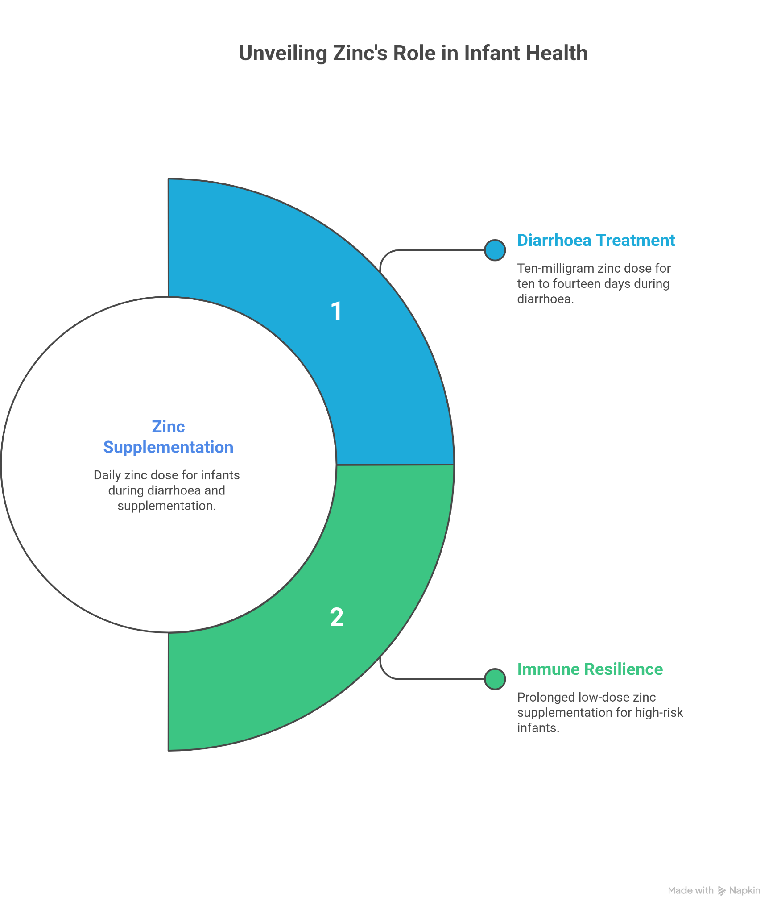

Identifying High-Risk Neonatal Groups
High-risk neonates include preterm infants, low-birth-weight babies, and infants born to mothers with micronutrient deficiencies or chronic illness. Where feasible, zinc status assessment or use of proxy indicators such as thymic ultrasound indices can guide supplementation decisions.

Program Integration and Delivery Platforms
Zinc supplementation can be effectively integrated into existing maternal and child health programs, including integrated management of neonatal and childhood illness frameworks and routine immunization services.
Community health workers can distribute zinc syrups or dispersible tablets and link supplementation with vaccination visits at six, ten, and fourteen weeks, improving uptake and adherence.

Monitoring, Safety, and Outcome Assessment
Thymic index measured by ultrasound at birth and follow-up visits serves as a non-invasive marker of thymic maturation and immune potential. Larger thymic indices correlate with improved vaccine responsiveness.
Zinc supplementation at recommended doses is generally safe. Mild gastrointestinal discomfort may occur. Prolonged high-dose supplementation requires monitoring, as excessive zinc intake can interfere with copper absorption.

Demonstrated Benefits on Infections and Vaccine Outcomes
Zinc supplementation improves seroconversion rates and antibody responses following BCG, oral polio, diphtheria-tetanus-pertussis, and pneumococcal vaccination. It also reduces infectious morbidity, particularly diarrhoeal disease and lower respiratory tract infections, and enhances thymic size and naïve T-cell output in early life.

Implementation Challenges and Practical Solutions
Key challenges include limited access to zinc testing, resource constraints, and maintaining caregiver adherence. Practical solutions include flavor-masked syrups, caregiver education, synchronizing supplementation with immunization visits, and embedding zinc delivery into national child health policies.

Research Gaps and Future Directions
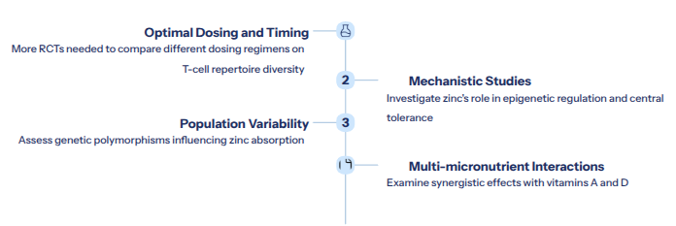
Ongoing research aims to define optimal zinc dosing, timing, and duration for immune outcomes. Areas of interest include zinc’s role in epigenetic regulation of thymic epithelial cells, interactions with vitamins A and D, genetic variability in zinc absorption, and long-term effects on immunological memory.

Summary and Key Take-Home Message
Neonatal thymic maturation depends critically on adequate zinc availability. Zinc supports thymic epithelial integrity, thymulin activity, T-cell differentiation, and maintenance of a diverse T-cell receptor repertoire necessary for effective vaccine responses.
Targeted antenatal and early postnatal zinc supplementation, integration into maternal and child health programs, and alignment with routine immunization schedules can significantly reduce infectious morbidity and optimize immune development in early life.

