PROPHYLAXIS VERSUS TREATMENT: DOSING ALGORITHMS FOR PRETERM, LOW BIRTH WEIGHT, AND RECURRENT HIGH-RISK INFANTS

INTRODUCTION
High-risk infants—including preterm babies (<37 weeks, especially <29 weeks), low birth weight (LBW <2,500 g), very low birth weight (VLBW <1,500 g), extremely low birth weight (ELBW <1,000 g), and those with recurrent lower respiratory tract infections (LRTI: ≥3 episodes per year or ≥2 hospitalizations annually)—face disproportionate vulnerability to infections.

Causes of High Risk
- Immature immunity: reduced maternal antibody transfer, low IgG/IgA, poor complement proteins, impaired neutrophil/macrophage function
- Weak physical barriers: thinner skin, mucosal immaturity, poor mucociliary clearance
- Invasive interventions: IV lines, catheters, ET tubes
- Nutritional issues: delayed or inadequate feeding, low protein and micronutrients
- Altered microbiota: antibiotic exposure, cesarean sections, colonization imbalance
These combined deficits heighten susceptibility to infection, sepsis, and mortality.
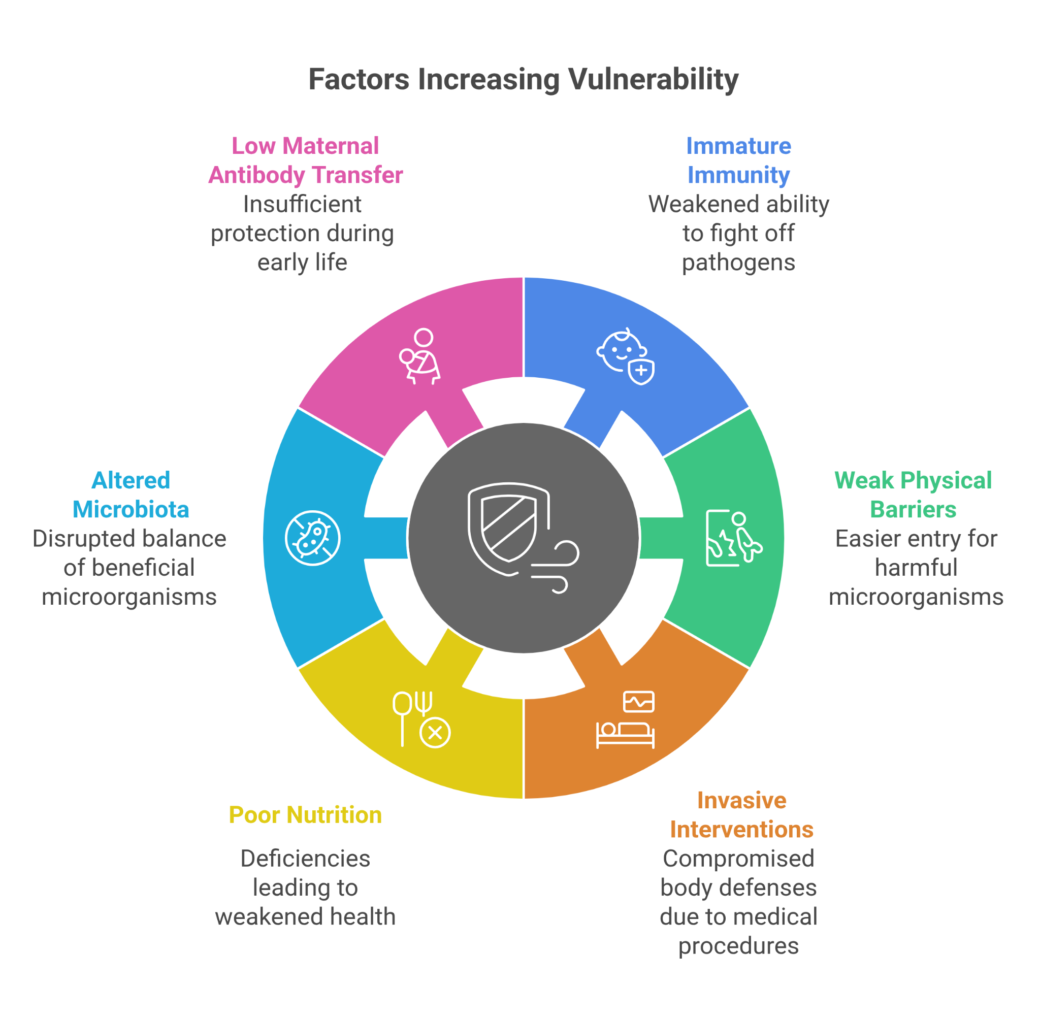

DEFINITION AND ROLE OF PROPHYLAXIS
Prophylaxis refers to interventions taken before symptoms arise, aiming to prevent disease.

Preventive Strategies in High-Risk Infants
- Vaccines: Influenza, Pneumococcal, Hib, BCG
- Monoclonal antibodies: Palivizumab, Nirsevimab for RSV
- Nutritional supplements: Vitamins A, D, K; zinc for immune support
- Environmental measures: Smoke avoidance, good hygiene practices
The goal is reduced incidence, reduced severity, and fewer complications.

DOSING ALGORITHMS
Dosing algorithms are standardized, evidence-based frameworks used to determine drug, dose, route, and duration based on:
- Weight
- Gestational age
- Clinical status

Benefits
- Improve accuracy and safety
- Reduce under/overdosing
- Minimize toxicity
- Ensure better outcomes

COMMON PATHOGENS AND TARGETS
- Respiratory syncytial virus (RSV)
- Influenza
- Bordetella pertussis
- Pneumococcus
- Group B Streptococcus (GBS)
Pharmacological targets:
- Prophylaxis: Palivizumab, Nirsevimab, Influenza vaccine, Pneumococcal vaccine
- Treatment: Antibiotics, antivirals, oxygen, ventilation

RSV PROPHYLAXIS

Palivizumab
- Indications:
  - Infants <29 weeks, <12 months during RSV season
  - Infants <32 weeks with CLD requiring oxygen ≥28 days post-birth
  - Infants <12 months with significant CHD
- Dosing: 15 mg/kg IM monthly, max 5 doses/season; stop if child turns >12 months
- Efficacy: ~55% reduction in RSV hospitalizations (IMpact-RSV Study)

Nirsevimab
- Indications:
  - All infants <8 months entering first RSV season
  - Infants 8–19 months with CLD/CHD entering second RSV season
- Dosing: 50 mg IM (<5 kg) or 100 mg IM (≥5 kg), single dose/season
- Efficacy: ~70% reduction in medically attended RSV LRTI; mild local adverse effects

ACTIVE IMMUNIZATION

Pneumococcal Vaccines (PCV13/PCV20)
- Schedule same for preterm/LBW infants; efficacy slightly reduced but protective

Influenza Vaccine
- Inactivated quadrivalent vaccine from 6 months of age (chronological)
- High-risk infants should begin promptly at 6 months postpartum

Other Vaccines
- Hib: prevents invasive infections and pneumonia
- BCG: provides indirect protection by reducing TB-related LRTIs

TREATMENT ALGORITHMS

Hospitalized Infants (PSBI, WHO Guidelines)
- Ampicillin: 50 mg/kg IV/IM q12h (1st week), q8h (2nd–4th week)
- Gentamicin:
  - VLBW (<1,500 g): 3 mg/kg once daily
  - Normal BW: 5 mg/kg once daily
- Duration: 7–10 days for sepsis/pneumonia
Alternatives:
- Amoxyclav (50–100 mg/kg) + Gentamicin
- Ceftriaxone (50 mg/kg daily × 7 days)
- Oseltamivir for influenza (<12 mo: 3 mg/kg BID × 5 days)

Non-Severe Pneumonia (Community, WHO CMC)
- Oral Amoxicillin 50 mg/kg twice daily × 5 days
- For preterm/LBW 0–59 days without PSBI: same regimen, close monitoring

Adjunctive Care
- Adequate hydration and nutrition
- Zinc 10 mg/day × 14 days to improve recovery
- Oxygen for SpO₂ <90% (neonates: nasal cannula 0.5–2 L/min to maintain >92%)
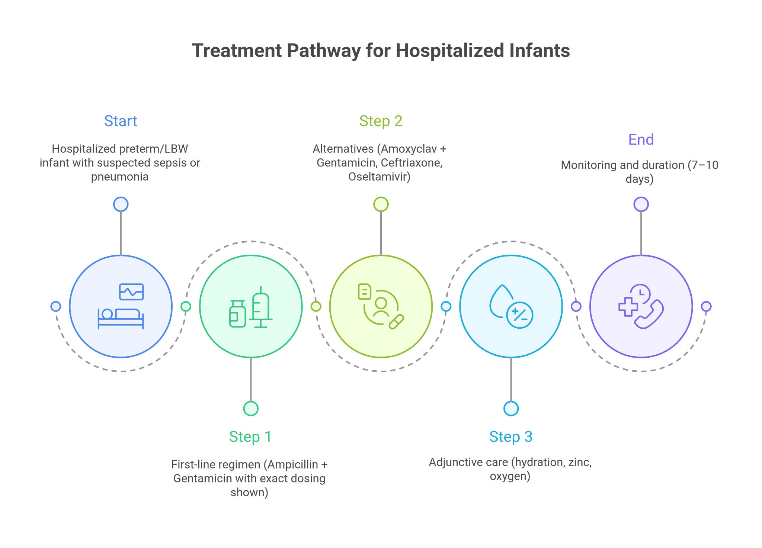

MANAGEMENT OF RECURRENT LRTI INFANTS

Prophylaxis
- Palivizumab or Nirsevimab based on RSV risk (prematurity, CLD, CHD)
- Influenza and Pneumococcal vaccination
- Zinc supplementation:
  - 10 mg/day × 14 days during acute illness
  - 5 mg/day × 3 months maintenance for recurrence prevention

Treatment
- Hospital-based algorithm for severe episodes
- Macrolides (e.g., Azithromycin 10 mg/kg daily × 5 days) for atypical pathogens like Mycoplasma
- Pulmonary hygiene: chest physiotherapy, saline nebulization

COMPARISON: PROPHYLAXIS VS TREATMENT
- Prophylaxis advantages: safer, reduces hospital/ICU admissions, avoids antibiotic complications, and prevents long-term sequelae.
- Treatment role: crucial when prevention is not possible; must be timely, precise, and strictly weight-adjusted.

PRACTICAL CHALLENGES
- Cost barriers:
  - Palivizumab: up to ₹1,00,000 for 5 doses
  - Nirsevimab: ~₹20,000 per dose
- Parental adherence: limited awareness and compliance
- Dosing errors: risks of under- or over-dosing
- Limited access: especially in low-resource settings

MONITORING AND FOLLOW-UP

During Hospitalization
- Monitor vitals (RR, HR, SpO₂) every 4 hours
- Assess feeding and hydration; IV fluids if oral intake poor
- Repeat CBC/blood culture at 48 hours if no improvement

After Discharge
- Review at 48–72 hours for recovery and adherence
- Ensure vaccine catch-up
- Plan RSV prophylaxis scheduling before the next season
- For recurrent LRTI: investigate immunodeficiency or airway anomalies; consider pulmonology referral

SUMMARY AND KEY TAKEAWAYS

Preterm and low birth weight infants, along with those experiencing recurrent LRTIs, represent one of the most vulnerable pediatric groups. Prophylaxis, through immunization, monoclonal antibodies, nutrition, and environmental measures, offers the most effective protection, but it must be delivered in a timely and structured manner. When infection does occur, evidence-based treatment protocols with precise dosing are essential to improve survival and recovery.
Ultimately, success lies in a comprehensive approach that balances prevention with prompt and precise treatment, reinforced by close monitoring and follow-up. In high-risk infants, prevention is not only better than cure—it is the foundation for survival and healthier outcomes.

