Post-COVID Immune Lag in Children

Introduction
COVID-19, caused by variants of the coronavirus since 2019, primarily affects the respiratory system but is increasingly recognized as a multi-system disease. While many children infected with COVID remain asymptomatic, this does not mean they are unaffected. Even mild or moderate illness can trigger long-term consequences, particularly a state described as post-COVID immune lag—a period of delayed immune recovery despite apparent clinical improvement.

Long COVID in Children
Long COVID refers to the persistence of symptoms beyond the acute phase of illness. These symptoms can last weeks, months, or even years. Some children experience improvement after three months, while others may take up to six months or longer. Long COVID can present with a wide spectrum of symptoms and may result in disability in severe cases.
In children, long COVID often manifests as immune lag, which is characterized by prolonged fatigue, recurrent infections, poor appetite, and delayed weight gain. Children with underlying conditions or nutritional vulnerabilities are especially prone to this complication.

Post-COVID Immune Lag: Definition and Features
Immune lag represents the delayed normalization of immune responses after COVID infection. Even when the illness is mild, immune function recovery can remain impaired. The major features in children include:
- Fatigue persisting beyond recovery
- Recurrence of upper respiratory or gastrointestinal infections
- Poor appetite and faltering growth
- Exacerbation of underlying nutritional or chronic health problems

Evidence of Immune Dysregulation
Scientific studies have identified persistent abnormalities in the immune system following COVID:
- T-cell imbalance and CD8+ T-cell exhaustion, confirmed by recent immunological studies (Nature Immunology, 2024).
- Elevated inflammatory cytokines such as IL-6, TNF-alpha, and CXCL-10.
- Research in MIS-C and pediatric long COVID cases shows delayed normalization of these immune parameters, leaving children vulnerable for extended periods.
These findings explain the increased susceptibility to infections, poor recovery rates, and the micronutrient imbalances observed in children after COVID.

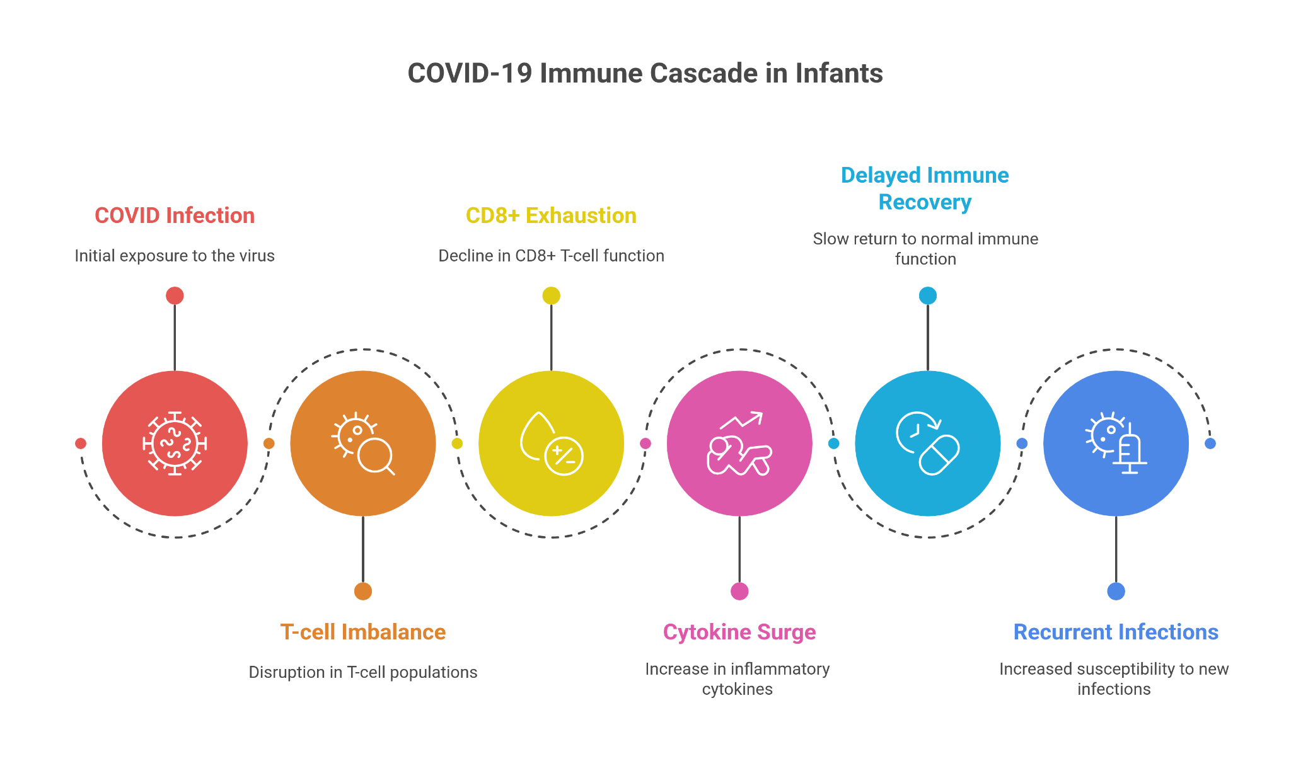

Mechanisms of Micronutrient Depletion
Micronutrient imbalance in post-COVID states arises from multiple mechanisms:
- Fever and anorexia reduce oral intake while increasing metabolic demand.
- Inflammation disrupts absorption of vitamins and minerals.
- Gut-lung axis disruption interferes with absorption and utilization of zinc, vitamin A, and vitamin D.
This depletion worsens immune dysfunction and delays recovery.

Micronutrient Repletion Protocol
Restoration of micronutrients is critical for recovery. Evidence-based supplementation protocols recommend:
- Vitamin D3: 1000–2000 IU/day
- Vitamin A: 1000–2000 IU/day (retinol equivalent)
- Vitamin C: 250–500 mg/day
- Zinc: 5–10 mg/day (elemental)
- Iron: 3 mg/kg/day, especially if anemia is present
- Selenium: 20–40 mcg/day
- Omega-3 fatty acids: 250–500 mg/day
This combination helps restore immune balance, reduces infection recurrence, and supports growth.

Supportive Measures
Beyond supplementation, supportive care forms the foundation of post-COVID recovery in children:
- Probiotics such as Lactobacillus rhamnosus GG or Saccharomyces boulardii at 5–10 billion CFU/day may aid microbiota recovery.
- Adequate fluids exceeding 50 ml/kg/day to maintain hydration.
- Protein intake of 1–1.5 g/kg/day to rebuild immune and muscle reserves.
- Sufficient sleep of 9–11 hours daily.
- Outdoor physical activity for at least 30 minutes per day to enhance immunity and recovery.

Monitoring and Follow-up
Ongoing monitoring ensures safe and effective recovery:
- Laboratory assessments: Complete blood count, ferritin, CRP, and selective vitamin D and zinc levels.
- Nutritional reassessment after four weeks to adjust supplementation.
- Clinical evaluation of appetite, energy levels, and frequency of infections as markers of progress.

Conclusion
Post-COVID immune lag is an emerging pediatric concern with implications for long-term health. It arises from immune dysregulation, inflammatory stress, and micronutrient depletion. Management requires a structured approach combining micronutrient repletion, supportive lifestyle measures, and careful monitoring.
With timely intervention, most children can achieve full recovery, reducing the risks of recurrent infections, growth delays, and long-term complications.

