Sports vs Fever: Same Sweat, Different Cytokines

Tailoring Rehydration Composition to the Inflammatory Milieu in Children

Introduction and Clinical Rationale
Sweating is a shared physiological response during both physical exertion and fever, yet the biological drivers and downstream consequences differ substantially. While both scenarios result in fluid and electrolyte loss, the underlying cytokine profiles, hormonal responses, and fluid distribution patterns are distinct.
Conventional rehydration strategies often focus narrowly on replacing water and electrolytes, overlooking cytokine-driven changes in vascular permeability, antidiuretic hormone activity, and osmotic balance. Understanding these differences is essential to avoid inappropriate fluid therapy, particularly in children, where misaligned rehydration can worsen hyponatraemia or delay recovery.

Sweat Composition and Cytokine Profile During Exercise
During physical activity, sweating is primarily a thermoregulatory process mediated by eccrine sweat glands. Sweat produced during exercise consists largely of water with predictable electrolyte losses, mainly sodium and chloride, with smaller amounts of potassium and metabolic byproducts.
In moderate to intense exercise, sweat sodium concentrations typically range from approximately ten to sixty millimoles per litre, while potassium loss averages around two to five millimoles per litre. These losses are influenced by intensity, duration, acclimatization, and individual variability.
Exercise induces a characteristic cytokine response dominated by myokines released from contracting skeletal muscle. Interleukin-six rises markedly, sometimes up to one hundred-fold, acting largely in an anti-inflammatory and metabolic regulatory role. In contrast, tumour necrosis factor alpha and interleukin-one beta show only minor or blunted increases in uncomplicated exercise.

Sweat Composition and Cytokine Profile During Fever
In fever, sweating occurs as part of thermoregulatory heat dissipation during inflammatory illness. Unlike exercise, sweat gland activity in fever is modulated by inflammatory mediators that also affect vascular permeability and fluid distribution.
Interleukin-one beta and interleukin-six act as central pyrogens, while tumour necrosis factor alpha contributes to endothelial activation and capillary leak. In febrile children, antidiuretic hormone secretion increases, leading to water retention and dilution of extracellular sodium.
As a result, sweat sodium concentrations during fever are generally lower, typically around ten to thirty millimoles per litre. Cytokine peaks in fever are higher and more pro-inflammatory than those seen in exercise, with cytokine levels rising during the febrile episode itself rather than resolving quickly.

Cytokine Signatures: Exercise Versus Fever
Exercise and fever produce distinct cytokine signatures with important physiological implications. Exercise-induced interleukin-six rises rapidly during activity and is followed by increases in anti-inflammatory mediators such as interleukin-ten and interleukin-1 receptor antagonist. Tumour necrosis factor alpha remains minimal unless there is heat strain or tissue injury.
In contrast, fever is characterized by early and robust increases in interleukin-1 beta and tumour necrosis factor alpha, triggering hypothalamic prostaglandin E₂ synthesis. Interleukin-6 rises subsequently, sustaining the inflammatory response. These higher pro-inflammatory peaks alter vascular permeability and fluid compartment shifts.
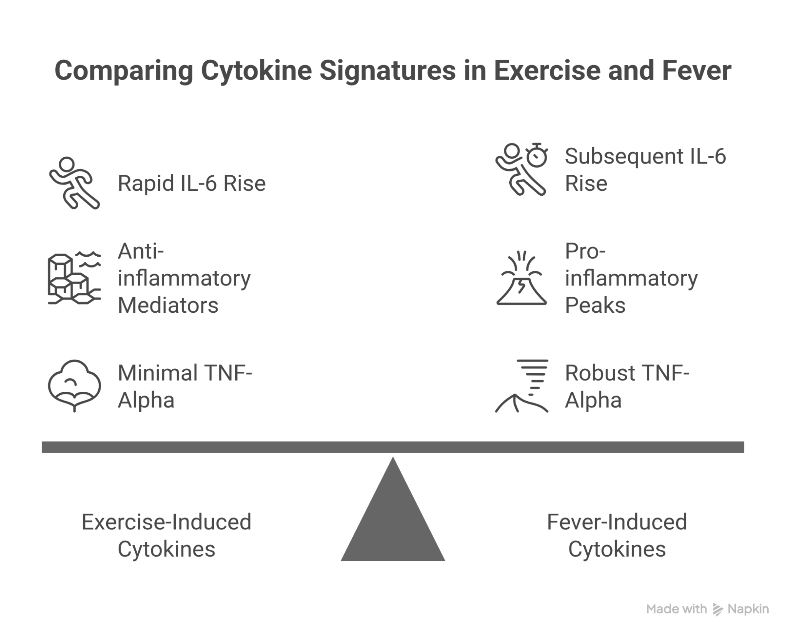

Implications for Fluid Distribution and Electrolyte Needs

Exercise Context
Rapid sweat loss during exercise leads to a hypertonic extracellular fluid state with significant sodium and chloride depletion. Interleukin-six helps preserve capillary integrity, limiting excessive fluid shifts into interstitial spaces. The primary clinical need is restoration of plasma volume and sodium balance.
Isotonic rehydration with adequate sodium concentration is therefore required to replace extracellular losses and support circulatory stability.

Fever Context
In fever, tumour necrosis factor alpha and interleukin-one beta increase vascular permeability, while elevated antidiuretic hormone promotes water retention. These mechanisms dilute serum sodium and increase the risk of dilutional hyponatraemia.
Even modest hypotonic fluid intake can worsen hyponatraemia in febrile children. Sodium replacement must therefore be cautious, and fluid composition should prioritize controlled osmolarity rather than aggressive volume replacement.

Quantitative Differences in Sweat and Fluid Loss
After exercise, typical sweat composition includes sodium concentrations around forty to sixty millimoles per litre and potassium around three to five millimoles per litre. In fever, sweat sodium loss is roughly half that seen with exercise, averaging around twenty millimoles per litre, while potassium loss is slightly lower at two to three millimoles per litre.
Carbohydrate needs also differ. Exercise rehydration benefits from carbohydrate concentrations of approximately six to eight percent to support energy expenditure and fluid absorption. In contrast, febrile children generally require lower carbohydrate concentrations, around two to four percent, to avoid excessive osmolar load and hyperglycaemia.
Tailoring Rehydration—Key Formulation Differences
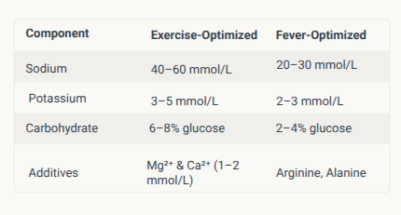

Role of Specialized Rehydration Formulations
Customized rehydration strategies improve outcomes in both contexts. Amino acid–enhanced oral rehydration solutions act as non-glucose osmolytes, improving sodium and water absorption without excessive glucose load. Such formulations have demonstrated benefits in shortening diarrhoeal duration and improving fluid uptake.
Electrolyte balance studies in elite athletes show that individualized sports drinks reduce muscle cramps and improve performance by matching actual sodium losses. A six percent glucose solution with appropriate sodium content maximizes fluid absorption during exercise, whereas hypertonic formulations exceeding eight percent glucose reduce gastric emptying and absorption.

Key Formulation Principles for Rehydration
Several principles emerge from evidence across exercise and febrile contexts:
Osmolyte addition using amino acids enhances sodium-coupled water absorption.
Low-glucose formulations reduce the risk of hyperglycaemia, particularly in febrile illness.
In fever, antidiuretic hormone–mediated water retention necessitates careful sodium and fluid balance to avoid dilutional hyponatraemia.
Minimal but adequate supplementation of magnesium and zinc supports cellular and enzymatic function without increasing osmolar stress.

Implementation Strategies and Clinical Adjuncts
Effective implementation requires assessment of the underlying inflammatory context, distinguishing exercise-induced fluid loss from infection-driven fever. Where feasible, cytokine patterns and clinical features guide decision-making.
Point-of-care electrolyte testing every four to six hours helps prevent rapid shifts in serum sodium and osmolarity. In exercise, fluid osmolarity losses around two hundred sixty to three hundred milliosmoles per kilogram should be matched. In fever, a lower target range of approximately two hundred forty to two hundred sixty milliosmoles per kilogram, using amino-osmolytes, is more appropriate.
Adjunctive measures such as omega-three fatty acids, vitamin C, and probiotics may support gut barrier integrity and reduce secondary complications during febrile illness.

Summary and Key Takeaways
Although exercise and fever both produce sweating, they are driven by fundamentally different cytokine environments. Exercise-related sweating reflects myokine-dominant physiology with predictable sodium loss and preserved vascular integrity. Fever-related sweating occurs in a pro-inflammatory milieu with altered vascular permeability, antidiuretic hormone activity, and increased risk of hyponatraemia.
Rehydration strategies in children must therefore be context-specific rather than formulaic. Tailoring fluid composition to cytokine-driven physiology optimizes plasma volume restoration in exercise and prevents dilutional electrolyte disturbances in fever, improving safety and clinical outcomes.

