THE ALLERGY–ASTHMA LINK: IDENTIFYING THE ATOPIC MARCH EARLY

Introduction
The atopic march describes the characteristic way allergic diseases emerge and evolve through childhood. It reflects a predictable pattern in which early skin inflammation and immune dysregulation in infancy progress into food allergies, allergic rhinitis, and asthma as the child grows. This progression represents the movement of allergic disease across different organs over time, highlighting that these conditions are interconnected rather than isolated.
Understanding the atopic march is essential because early manifestations—especially eczema and food allergy—serve as important warning signs for later respiratory allergic disease. Recognising and addressing these early clues allows health systems to intervene at the earliest stage, potentially modifying the long-term trajectory of allergic disease.

The Classical Sequence of Atopic Diseases

1. Atopic Dermatitis (Eczema)
Atopic dermatitis is the earliest and most recognisable sign of future allergic disease. It often appears in infancy with typical distribution patterns on the cheeks, scalp, and extensor surfaces. Children with early-onset or moderate–severe eczema carry a significantly higher risk of developing food allergies, allergic rhinitis, and asthma.
Eczema is therefore considered the entry point into the atopic march.

2. Food Allergy
Food allergies commonly develop along with or shortly after eczema. Infants may react to allergenic foods such as milk, egg, wheat, peanut, or soy. The coexistence of eczema and food allergy strongly suggests heightened future risk of airway allergies.

3. Allergic Rhinitis
As children move into preschool and school age, inflammation often shifts to the upper airways. Nasal itching, sneezing, rhinorrhoea, and nasal congestion become prominent. Allergic rhinitis may initially be seasonal but can become perennial depending on local allergens such as dust mites or cockroach exposure.

4. Asthma
Lower airway involvement commonly appears last. Early clues include recurrent wheezing, viral-triggered cough, night cough, and exercise intolerance. Asthma often arises in children who previously had eczema or allergic rhinitis, completing the march from skin to airways.
While this sequence is typical, many children develop overlapping conditions. The progression may be linear, but multimorbidity is increasingly common, meaning eczema, asthma, and allergic rhinitis may coexist.

Pathophysiology of the Atopic March
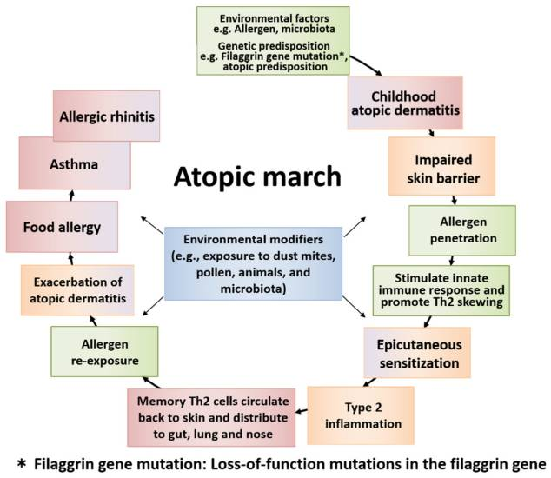
The atopic march arises from a combination of genetic susceptibility, environmental exposure, and immune system development.

Skin Barrier Dysfunction and Genetic Predisposition
Mutations in genes such as filaggrin impair the integrity of the skin barrier. When the barrier is damaged, allergens penetrate more easily, triggering inflammatory responses. Infants with compromised skin barriers are more prone to eczema and subsequent sensitisation.

Epicutaneous Sensitisation and Immune Memory
When allergens penetrate broken skin:
- The innate immune system is activated
- Type 2 (Th2) inflammation becomes dominant
- Allergen-specific memory T and B cells are formed
These immune cells travel beyond the skin and settle in the airways and gut. Thus, exposure to allergens later in childhood may manifest as asthma or allergic rhinitis. This systemic distribution explains why different allergic diseases appear at different ages but share a common immune foundation.

Allergic Diseases as a Unified Process
Eczema, food allergy, allergic rhinitis, and asthma are not separate conditions—they represent different expressions of the same allergic pathway at different stages of life. Effective management must therefore focus on underlying inflammation and disease modification rather than simply treating symptoms.

Sri Lankan Disease Burden and Regional Variation
Sri Lankan epidemiological data strongly support the atopic march pattern and demonstrate how environment and urbanisation affect disease manifestation.

Younger Children (6–7 Years)
Across districts such as Kandy, Anuradhapura, and Western Province, asthma, allergic rhinitis, and eczema commonly appear during early school years.
- Western Province: highest prevalence
- Kandy: intermediate
- Anuradhapura: lowest
Urbanisation and environmental exposures—especially in coastal and urbanised regions—contribute to higher allergic disease prevalence.

Older Children (13–14 Years)
By adolescence, allergic rhinitis becomes more common than asthma or eczema, particularly in highly urbanised districts. Rhinitis is also frequently comorbid with asthma.

Local Sensitisation Patterns
A Colombo tertiary centre showed sensitisation patterns in children with asthma:
- House dust mite: 37.8%
- Cockroach: 23.7%
- Mold: 5.8%
- Cat and dog dander: lower percentages
These findings highlight that inhalant allergens, especially dust mites and cockroaches, are important drivers of airway disease in Sri Lankan children.

Environmental Exposures and Risk Factors
Environmental factors strongly influence the onset and progression of allergic disease.

Indoor Air Pollution
Biomass fuel use remains common in many households. Indoor air pollution from these fuels is associated with increased respiratory symptoms in young children and contributes to wheeze severity and frequency.

Tobacco Smoke Exposure
A significant number of Sri Lankan children are exposed to secondhand smoke at home and in enclosed public spaces. Smoke exposure heightens airway inflammation and increases asthma risk.

Urban Air Quality
Traffic-related air pollution contributes to higher asthma and allergic rhinitis prevalence in urban districts compared to rural areas.
These environmental influences interact with genetic susceptibility to accelerate the atopic march.

Early Red Flags at Each Age

Infancy and Toddler Period
Key warning signs include:
- Persistent or moderate–severe eczema
- Early-onset eczema
- Confirmed food-triggered reactions
- Strong family history of atopy
- Feeding difficulties and poor weight gain
These children are considered high risk for future allergic disease.

Preschool Years
Common early manifestations of airway involvement:
- Recurrent wheezing episodes
- Viral-induced cough
- Night-time cough without infection
- Activity limitation
- Persistent eczema
These symptoms often indicate developing asthma.

School Age
At this stage, classic airway allergies emerge:
- Nasal itching, sneezing, and rhinorrhoea
- Eye itching and tearing
- Seasonal pattern of symptoms
- Increasing coexistence of asthma and rhinitis
Recognising these patterns enables timely and targeted intervention.

Unified Airway Concept
The upper and lower airways are part of a single, interconnected system. Inflammation in one area influences the other. A child with both rhinitis and wheezing is experiencing a unified airway inflammatory process.

Management Implications
- Treat both rhinitis and asthma as part of one disease continuum
- Intranasal corticosteroids form the first-line treatment for persistent allergic rhinitis
- Non-sedating antihistamines assist with nasal and ocular symptoms
Effective management of allergic rhinitis can improve asthma outcomes by reducing overall airway inflammation.

Case-Finding Strategies for Clinical Practice
Early identification requires structured and systematic approaches appropriate for community and primary care settings.

1. Structured Questioning
Using standardised tools helps ensure key symptoms are not missed. Questions should address:
- Wheeze episodes
- Night cough
- Sneezing and itchiness
- Eczema history
- Food reactions

2. Focused Physical Examination
Look for:
- Eczema severity and distribution
- Allergic shiners
- Dennie–Morgan folds
- Pale or swollen nasal mucosa
- Mouth breathing or allergic gape
- Allergic salute
- Cobblestone appearance of the pharynx
- Growth parameters
These signs reflect systemic allergy involvement.

3. Targeted Testing
In resource-limited settings, test selectively:
- Skin prick tests
- Specific IgE for dust mites, cockroach, moulds, pets
Testing must align with actual local exposures. Sensitisation alone does not equal disease; results must be interpreted with clinical findings.

Prevention and Risk Modification

Strategies with Limited Evidence
Some previously suggested strategies—like maternal food avoidance, hydrolysed formula, or vitamin D supplementation—have not consistently shown benefit in preventing allergic disease.

Skin Barrier Care
Early eczema management remains important. Although universal neonatal moisturisation has mixed evidence, maintaining good skin care in infants with eczema may reduce sensitisation.

Early Introduction of Allergenic Foods
Current evidence supports:
- Early peanut introduction (around 4–6 months)
- Early introduction of well-cooked egg
Delaying introduction increases food allergy risk.

Environmental Measures
Practical steps include:
- Eliminating tobacco smoke exposure
- Improving ventilation
- Reducing dust mite exposure
- Implementing cockroach control
- Minimising biomass smoke exposure
These are achievable even in resource-constrained settings and significantly modify allergy risk.

Key Takeaways and Clinical Practice Implications
- Sri Lankan data clearly demonstrate the atopic march with high comorbidity of allergic rhinitis and asthma.
- Regional variation underscores the impact of environment and urbanisation.
- Indoor exposures (dust mites, cockroaches, biomass smoke, tobacco smoke) are modifiable targets for prevention.
- Early eczema and food reactions should trigger structured allergy evaluation.
- Managing rhinitis and asthma together following the unified airway principle improves outcomes.
- Early introduction of allergenic foods and environmental risk mitigation can help break the progression of the atopic march.
The atopic march represents a window of opportunity. By identifying early red flags and applying evidence-based prevention and management strategies, healthcare providers can meaningfully alter the trajectory of allergic diseases across childhood.

