Toddler Nutrition: The Role of Fortified Diets
Introduction
The toddler stage (2-5 years) is a critical period of physical and cognitive development. Inadequate nutrition in early childhood (6–59 months) is linked to stunted linear growth, delays in cognitive and socio-emotional development, and greater susceptibility to infections. Fortified milk & foods in addition to regular diets, provide a practical solution to these challenges. In India, 67% of children under five are anemic, and 35.5% are stunted, according to NFHS-5 (2019–21) [1]. Public health initiatives like Anemia Mukt Bharat emphasize fortification as a key strategy to address these deficiencies [2].

Prevalence of Nutritional Deficiencies
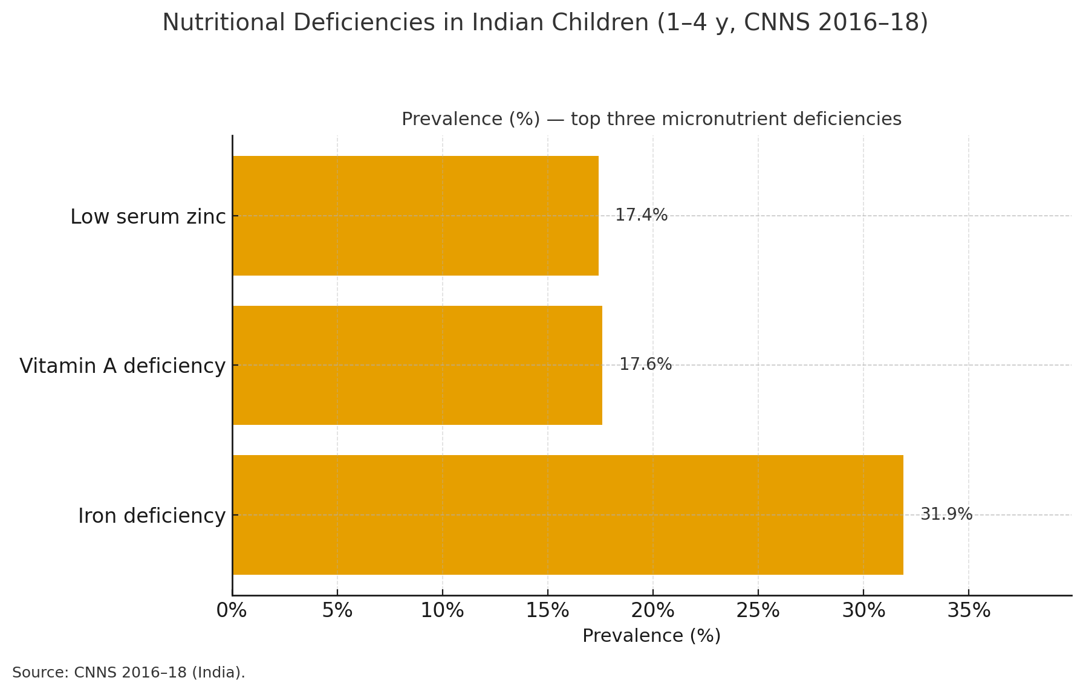

Developmental domains at 2–5 years (diet quality matters)
- Physical growth & motor: Protein, calcium, and vitamin D drive linear growth, bone mineralization, and strength; greater diet diversity is linked with better linear growth. [3,4]
- Cognitive & language: Adequate iron, DHA, iodine, and zinc support myelination, synaptogenesis, and language/learning; chronic iron deficiency is associated with lower cognitive scores, and trials suggest potential benefits of DHA in early life. [5,6]
- Immune function: Vitamins A & D, zinc, and iron shape innate/adaptive immunity and mucosal barriers; shortfalls raise infection risk. [7]
- Socio-emotional & self-regulation (food autonomy era): Rising picky/fussy eating and preference for snack/UPF options displace nutrient-dense foods; Indian preschool data show high picky-eating prevalence with growth impact, while UPF-heavy patterns are linked to adverse health/behavioral risks. [8,9]
Physiological and Nutritional Needs of Toddlers
- Growth and Cognitive Development:
○ Why these nutrients matter: Toddler brains are wiring at warp speed; iron, DHA and zinc support myelination and synaptogenesis, while calcium and vitamin D underpin bone growth and immune function.
○ Indian RDAs for 1–3 years (ICMR-NIN 2020): Iron 8 mg/day, Calcium 500 mg/day, Vitamin D 600 IU/day. [10]
- Current gaps in India (ages ~1–3):
○ Iron (Fe): National CNNS biomarker data show iron deficiency in 31.9% of children 1–4 y (ferritin, inflammation-adjusted). That makes ID a moderate public-health problem in preschoolers. [11]
○ Calcium (Ca): Large compilations of NNMB/ICMR intake surveys indicate ~80–90% of Indian children aged 1–3 y consume <50% of the calcium RDA, reflecting very low milk/milk-product intake in many states. This signals widespread dietary inadequacy, even if we don’t use a blood “deficiency” test for calcium. [12]
○ Vitamin D: CNNS national estimates show, in the 0–4 y group, ~14% deficient (25(OH)D < 12 ng/mL) and ~49% insufficient (12–20 ng/mL)—meaning a large share of toddlers likely fall short of adequacy. [13]
○ DHA (omega-3): No national toddler-specific prevalence yet, but multiple Indian datasets show low omega-3 (including DHA) intakes and low plasma DHA in children, driven by cereal-heavy diets, high n-6:n-3 ratios, low fish intake, and limited preformed DHA in common foods. Evidence from India includes low plasma DHA and low n-3 intakes in schoolchildren, and population notes that plasma DHA levels are low in India due to diets poor in DHA-rich foods; together, this strongly suggests risk of habitual inadequacy in younger children too. [14][15]

○ Zinc, vitamin A, and vitamin D strengthen immune defenses and reduce the risk of infections.

● Physical growth & muscle strength:
○ Calcium and vitamin D support bone mineralisation and neuromuscular function, while adequate protein drives muscle protein synthesis and lean mass accrual (e.g., milk/curd/paneer, ragi, eggs/daal, fish).
● Dietary Challenges in India:
● Cultural/regional patterns and taboos narrow diets: Cereal/legume-heavy plates with low animal-source foods (eggs, fish, meat) are common in many Indian settings, and traditional beliefs (e.g., “hot/cold” foods or food restrictions during/after illness) further cut variety and reducing bioavailable iron, zinc, B12 and DHA in preschoolers. [16–18]
● Tea/coffee with meals blocks iron. Widely offered beverages to children or preschoolers contain tannins that inhibit non-heme iron absorption; guidance advises avoiding them around meals. [18,19]
● “Milk-as-meal” misperception displaces iron-rich foods. High cow’s-milk intake in toddlers/preschoolers is flagged as a risk for iron deficiency because of low iron, poor bioavailability, and possible occult GI blood loss—plus it fills kids up before they eat solids. [20]
● Fussy/picky eating is common and impacts growth. Indian preschool data show ~59% prevalence of picky eating, with lower mean height/weight among picky eaters—worsening gaps for iron, zinc, and variety. [8]

Key Micronutrients provided by Fortified foods and milk to support complete nutrition
Fortified foods: general vs toddler needs (2–5 years)
- Population-level design: In India, fortification levels for staples (atta/maida, rice, oil, milk, salt) are standardized for the general population, and on-pack %RDA is calculated using adult RDAs and a 2,000-kcal reference, not preschooler needs. Smaller toddler portions therefore deliver proportionately less of the targeted micronutrients per day. [29, 21]
- Toddler RDAs are different: For 1–3 y, RDAs are iron 8 mg/d, calcium 500 mg/d, vitamin D 600 IU/d; adult-oriented fortified staples alone rarely meet these amounts for 2–5 y unless paired with diverse, nutrient-dense foods or child-formulated options. [22]
- Child-specific fortification exists: Under ICDS/Poshan 2.0, THR for 6–36 m and hot cooked meals for 3–6 y are formulated for children to bridge gaps; by contrast, mass fortification (e.g., fortified rice in safety-net schemes) is a population strategy, not a toddler-dosage product. [23, 24]
- Practical note for caregivers/clinicians: Check mg/IU per serving (not just %RDA), since %RDA is adult-based; prefer child-formulated foods/supplements when indicated, alongside age-appropriate complementary diets. [29,3]
- The American Academy of Pediatrics (AAP) recommends limiting cow’s milk intake to 500 per day for children aged 2 –5 years to prevent nutritional deficiencies [30].

- Iron:
○ Role: Essential for oxygen transport, immune function, and neural development. Deficiency leads to anemia and cognitive delays [25].
○ Fortified Sources: Iron-fortified cereals, multinutrient fortified milk,.
○ Enhancers: Vitamin C-rich foods (e.g., citrus fruits, tomatoes) enhance the absorption of Iron, Vitamin D would increase the absorption of calcium [26].
- Vitamin D:
○ Role: Facilitates calcium absorption and supports bone strength and immunity.
○ Fortified Sources: Natural foods contain little vitamin D. Consistent sunlight exposure is difficult for many people; individuals with darker skin often need longer exposure, and urban air pollution reduces ultraviolet B needed for synthesis. Regular consumption of vitamin D fortified foods such as milk and breakfast cereals should therefore be prioritized. If dietary intake remains insufficient, supplementation under clinical supervision is appropriate.

- Zinc:
○ Role : Critical for immune function, linear growth, and wound healing, and for maintaining the intestinal barrier by stabilizing epithelial tight junctions and mucosal integrity.
○ Fortified Sources : Fortified milk and fortified breakfast cereals (age-appropriate).
○ Challenges : Diets high in phytates inhibit absorption [27].
- Calcium:
○ Role: Necessary for bone health
○ Fortified Sources : Fortified milk and fortified cereals (e.g., wheat flour/atta or rice).
- Vitamin A:
○ Role: Vision maintenance and immunity.
○ Fortified Sources : milk and cereals (e.g., fortified milk, fortified breakfast cereals).
- Omega -3 Fatty Acids (DHA):
○ Role: Supports brain and cognitive development.
○ Fortified Sources: DHA-enriched milk and eggs..
7. Protein
○ Role: Supports growth, muscle strength, and immunity.
○ Fortified foods: Fortified milk; fortified cereals.
○ India: Protein quality is often low in preschoolers especially those on a vegetarian diet; adding milk/egg improves adequacy. [28, 29]
8. Probiotics (e.g., L. reuteri DSM 17938; B. lactis BB-12)
○ Role: Support gut health/barrier; may aid stool regularity in constipation.
○ Fortified foods: Probiotic milks/yogurts; some child cereals with pre/probiotics.
○ Evidence: Useful adjunct (with fiber/fluids); mixed results for standalone therapy. [31, 32]

2. Table: Recommended Daily Allowances (RDAs) for Toddlers Design Structure [10, 29]:
Nutrient | RDA 2–3 y | RDA 4–5 y* | Common fortified sources in India
Iron | 8 mg/day | 11 mg/day | Fortified breakfast cereals; fortified wheat flour/atta & rice (iron+folic acid+B12)
Zinc | 3 mg/day | 4.5 mg/day | Fortified breakfast cereals; fortified atta/rice
Vitamin D | 600 IU/day | 600 IU/day | Fortified milk (A & D); some fortified breakfast cereals
Calcium | 500 mg/day | 550 mg/day | Milk/dairy (intrinsic Ca; many milks fortified with Vit D); some fortified cereal porridges
Vitamin A (RAE) | 300 µg/day | 400 µg/day | Fortified milk (Vit A); some fortified breakfast cereals
*4–5 y uses the ICMR-NIN 4–6 y bracket. Values drawn from the ICMR-NIN 2020 RDA summary (Annexure IA). FSSAI Fortified source categories per FSSAI Fortification Regulations (milk/oil with A & D; atta/maida and rice with iron+folate+B12).
Summary
Fortified milk & foods play an important role in supporting the nutritional needs of toddlers, supporting optimal growth, immunity, and cognitive development. During 2–5 years, growing food autonomy, picky/fussy eating, and a tilt toward unhealthy options often reduce diet quality and widen nutrient gaps, undermining physical growth, cognitive development, immune function, and socio-emotional development.

References:
- International Institute for Population Sciences (IIPS) and ICF. National Family Health Survey (NFHS-5), 2019–21: India. Mumbai: IIPS; 2021–2022. [Internet]. Available from: https://dhsprogram.com/pubs/pdf/FR375/FR375.pdf
- Ministry of Health & Family Welfare, Government of India. Anaemia Mukt Bharat—Intensified National Iron Plus Initiative (I-NIPI). [Internet]. Available from: https://nhm.gov.in/index1.php?lang=1&level=3&sublinkid=1022&lid=604
- ICMR-NIN. Dietary Guidelines for Indians. Hyderabad: National Institute of Nutrition; 2024. [Internet]. Available from: https://www.nin.res.in/dietaryguidelines/pdfjs/locale/DGI_2024.pdf
- World Health Organization. Child feeding: Minimum dietary diversity (6–23 months)—Indicator metadata. Geneva: WHO; 2021. [Internet]. Available from: https://www.who.int/data/gho/indicator-metadata-registry/imr-details/6130
- Gingoyon A, Borkhoff CM, Koroshegyi C, et al. Chronic iron deficiency and cognitive function in early childhood. Pediatrics. 2022;150(6):e2021055926. doi:10.1542/peds.2021-055926.
- Gould JF, Smithers LG, Makrides M. The effect of maternal omega-3 (n-3) LCPUFA supplementation during the first 1000 days on later neurodevelopment: A review of randomized controlled trials. Nutrients. 2021;13(2):415. doi:10.3390/nu13020415.
- Pai UA, Khadilkar V, Pandit D, et al. The role of nutrition in immunity in infants and toddlers: An expert panel opinion. Clin Epidemiol Glob Health. 2018;6(4):155-159. doi:10.1016/j.cegh.2017.11.004.
- Kumar KP, Srikrishna S, Pavan I. Prevalence of picky eating behaviour and its impact on growth in preschool children. Int J Contemp Pediatr. 2018;5(3):714-719.
- Calcaterra V, et al. Ultra-processed food, reward system and childhood overweight/obesity. Children. 2023;10(5):804. doi:10.3390/children10050804.
- Food Safety and Standards Authority of India. Direction under Section 16(5) regarding Recommended Dietary Allowances (RDA): Annexure IA—Summary of RDA for Indians—2020. New Delhi: FSSAI; 16 Jul 2021.
- Kulkarni B, Peter R, Ghosh S, Pullakhandam R, Thomas T, Reddy GB, et al. Prevalence of iron deficiency and its sociodemographic patterning in Indian children and adolescents: CNNS 2016–18. J Nutr. 2021;151(8):2422-2434. doi:10.1093/jn/nxab145.
- Harinarayan CV, Akhila H, Shanthisree EM, Nithya N, Reddy PA, Kamma S. Modern India and dietary calcium deficiency—half a century nutrition data—retrospect–introspect and the road ahead. JBMR Plus. 2021;5(4):e10405.
- Mustafa A, Shekhar C. Concentration levels of serum 25-hydroxyvitamin D and vitamin D deficiency among children and adolescents of India: CNNS 2016–18. BMC Pediatr. 2021;21:334. doi:10.1186/s12887-021-02803-z.
- Parasannanavar D, Gaddam I, Bukya T, Ibrahim SA, Reddy KS, Banjara SK, et al. Omega-3 PUFA intake and plasma fatty acids of school-going Indian children—A cross-sectional study. Prostaglandins Leukot Essent Fatty Acids. 2021;170:102294.
- Khandelwal S, Kondal D, Chaudhry M, Patil K, Swamy MK, Metgud D, et al. Effect of maternal DHA supplementation on offspring neurodevelopment at 12 months in India: DHANI trial. Nutrients. 2020;12(10):3041. doi:10.3390/nu12103041.
- Sharma S, Akhtar F, Singh RK, Mehra S. Dietary intakes, patterns, and determinants of children under 5 years from marginalized communities in Odisha: a cross-sectional study. J Epidemiol Glob Health. 2020;10:315-325.
- Sahota R, Sandalinas F, Chagumaira C, et al. Vitamin A deficiency in India and seasonality of vitamin A-rich food consumption. Br J Nutr. 2025;133(12):1522-1531. doi:10.1017/S0007114525103681.
- Paintal K, Aguayo VM. Feeding practices for infants and young children during and after common illness: evidence from South Asia. Indian J Pediatr. 2016;83(12):1251-1259.
- Indian Council of Medical Research–National Institute of Nutrition. Dietary Guidelines for Indians: A Manual. Hyderabad: ICMR-NIN; 2011. (See section on tea/coffee and iron absorption). [Internet]. Available from: https://www.nin.res.in/downloads/DietaryGuidelinesforNINwebsite.pdf
- Bharadva K, Mishra S, Tiwari S, et al. Prevention of micronutrient deficiencies in young children: Consensus statement from IYCF Chapter of IAP. Indian Pediatr. 2019;56:577-586.
- Food Safety and Standards Authority of India. Direction on labelling of per-serve %RDA (based on adult RDAs; 2,000-kcal reference). New Delhi: FSSAI; 03 Feb 2022.
- ICMR-NIN. A Brief Note on Nutrient Requirements for Indians: RDA 2020. Hyderabad: National Institute of Nutrition; 2022. [Internet]. Available from: https://www.nin.res.in/rdabook/brief_note.pdf
- NITI Aayog; World Food Programme. Take-Home Ration (THR) in ICDS: Good Practices. New Delhi: NITI Aayog; 30 Jun 2022.
- Department of Women & Child Development, Govt. of NCT of Delhi. Mission Saksham Anganwadi and Poshan 2.0 Guidelines. 01 Mar 2021.
- Georgieff MK. Long-term brain and behavioral consequences of early iron deficiency. Nutr Rev. 2011;69(Suppl 1):S43-S48. doi:10.1111/j.1753-4887.2011.00432.x.
- Hurrell R, Egli I. Iron bioavailability and dietary reference values. Am J Clin Nutr. 2010;91(5):1461S-1467S. doi:10.3945/ajcn.2010.28674F.
- Kulkarni G, Dekhne J, Rajsekhar B, Kumar AS, Anand T, Garg LK, et al. Noninvasive colour-based card for risk assessment of anaemia in children: PAN-India user experience. Med Res Arch. 2024;12(7). doi:10.18103/mra.v12i7.5465.
- Bandyopadhyay S, Shivakumar N, Thomas T, et al. Protein intakes of pregnant women and children in India—protein quality implications. Matern Child Nutr. 2020;16(S3):e12952.
- Food Safety and Standards Authority of India. Compendium: Food Safety and Standards (Fortification of Foods) Regulations. New Delhi: FSSAI; 30 Sep 2021. [Internet]. Available from: https://www.fssai.gov.in/jtc/public/fssai/food-safety-and-standards-regulations
- DiMaggio DM, Cox A, Porto AF. Updates in infant nutrition. Pediatr Rev. 2017;38(10):449–460. doi: 10.1542/pir.2016-0239.

- Wallace C, Tabbers MM, Benninga MA. Probiotics for treatment of chronic constipation in children. Cochrane Database Syst Rev. 2022;(3):CD014257. doi:10.1002/14651858.CD014257.pub2.
- Kubota M, Ito K, Tomita K, et al. Lactobacillus reuteri DSM 17938 vs magnesium oxide in young children with functional constipation: randomized clinical trial. Pediatr Int. 2020;62(5):544-551. doi:10.1111/ped.14189.

