When food tastes like cardboard: hypo-zinc related ageusia and anorexia in children

Introduction
An increasing clinical concern: children presenting with the complaint that food “tastes like cardboard.” This symptom, which is prevalent among picky eaters, is often linked to zinc deficiency. Zinc plays a critical role in both taste perception (ageusia) and appetite regulation (anorexia), and its deficiency can have profound effects on a child's nutrition, growth, and overall health.

Role of Zinc in Taste and Appetite
Zinc is a vital trace element with a multifaceted role in the body:
- Gustin Co-factor in Saliva: Zinc is crucial for the activity of gustin, a protein that promotes the development and function of taste buds. A lack of zinc impairs the proper maturation of these taste buds.
- Taste-Bud Enzyme Function: Zinc is also an essential component of alkaline phosphatase, an enzyme present in taste bud membranes. Deficiency of zinc leads to fewer taste bud microvilli, impairing taste sensitivity.
- Neurotransmitter Modulation: Zinc influences the hypothalamic regulation of appetite via neuropeptide Y and leptin, two key neurotransmitters involved in hunger signaling. This regulation helps shape a child's food intake behavior and overall appetite.

Clinical Presentation and Consequences
Children with zinc deficiency often exhibit the following:
- Blunted or Altered Taste Perception (Ageusia/Hypogeusia): Many children report that foods, especially meat (a key source of zinc), "taste like cardboard" or "have no flavor."
- Anorexia and Food Avoidance: Diminished taste perception can lead to food aversions, especially towards zinc-rich foods like meats, making children more selective and resistant to eating.
- Growth Issues: Zinc deficiency is linked to poor weight gain, delayed growth (both linear and height), and frequent infections due to impaired immune function.
- Risk Factors: Children with diets low in zinc, poor absorption abilities, those born prematurely, or those on exclusive breastfeeding without zinc supplementation are at higher risk. Additionally, periods of rapid growth further increase the body's zinc requirements.

Pathophysiology
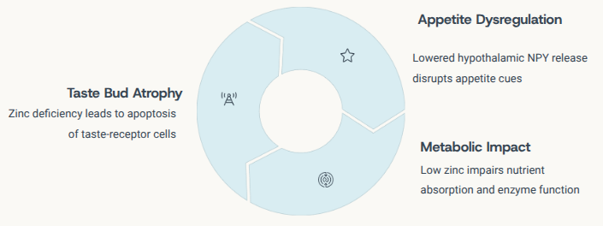
Zinc deficiency disrupts several key physiological functions:
- Taste Bud Atrophy: Zinc deficiency leads to the loss and atrophy of taste receptor microvilli, which directly impairs the child’s ability to perceive taste.
- Appetite Dysregulation: Reduced hypothalamic signaling due to inadequate zinc impairs the regulation of appetite, leading to decreased food intake.
- Metabolic Disruption: Zinc is essential for nutrient absorption and enzyme activity; deficiency compromises these processes, leading to decreased nutritional status and growth retardation.
- Immune Function: Zinc also plays a pivotal role in the immune system. Deficiency weakens immune responses, making the child more susceptible to infections.

Diagnosis
Diagnosing zinc deficiency involves a comprehensive evaluation:
- Dietary and Growth History: A detailed history focusing on eating habits, food aversions (especially towards meat and protein), and growth patterns is essential.
- Physical Examination: Signs such as dermatitis, brittle nails, delayed wound healing, and oral lesions may indicate zinc deficiency.
- Growth Monitoring: Monitoring height and weight percentiles can help track growth patterns and identify faltering growth trajectories.
- Laboratory Tests: A serum or plasma zinc level below 70 µg/dL suggests zinc deficiency. Alkaline phosphatase levels can also be checked, as they are sometimes lower in deficiency.

Management and Treatment
The treatment for zinc deficiency involves several approaches:
- Dietary Intervention:
  - Increase the intake of zinc-rich foods such as beef, poultry, shellfish, eggs, and legumes. Animal sources of zinc are particularly bioavailable.
  - Pair zinc-rich foods with vitamin C (e.g., citrus fruits, bell peppers) to enhance zinc absorption.
- Supplementation:
  - Zinc supplementation should be age-appropriate and typically continues for 8-12 weeks, with improvement often observed within 4-6 weeks.
  - Example dosages: Infants (6-12 months): 2 mg/day, Toddlers (1-3 years): 3 mg/day, Children (4-8 years): 5 mg/day.
  - Monitor for potential side effects like nausea or gastric upset.
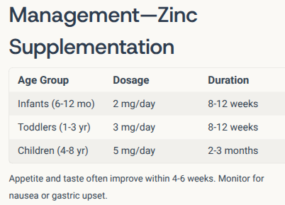
- Supplemental Foods:
  - Use fortified foods like cereals and nut butters to ensure sufficient zinc intake.
- Sensory Rehabilitation:
  - Gradually introduce mildly flavored foods once taste begins to recover. This helps reintegrate a broader range of textures and flavors into the child’s diet.
- Multidisciplinary Support:
  - Nutritionists can guide meal planning, while speech and occupational therapists can help address persistent sensory aversions in children.
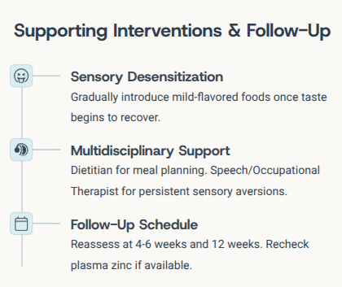

Follow-Up and Prognosis
Follow-up assessments should be conducted every 4–6 weeks and again after 3 months to monitor improvements in taste, appetite, weight gain, and growth. Zinc supplementation generally leads to:
- Restoration of Taste: Most children report that “food tastes like food, not cardboard” after 4-6 weeks of supplementation.
- Improved Appetite and Growth: As appetite normalizes, dietary variety increases, leading to catch-up growth and improved overall health.
- Long-Term Outlook: The prognosis is excellent if the deficiency is treated effectively, and recurrence is prevented through ongoing education and dietary management.

Prevention and Caregiver Education
Preventing zinc deficiency requires a multifaceted approach:
- Caregiver Education: Teach caregivers to incorporate zinc-rich foods into the diet, and encourage supplementation in high-risk groups. Educating parents about the signs of zinc deficiency and when to seek medical advice is crucial.
- Public Health Initiatives: In regions with high prevalence of subclinical deficiency, fortifying staple foods with zinc can be a significant public health strategy to reduce the burden of deficiency.

Key Takeaways
- Zinc is vital for both the development of taste and the regulation of appetite, making it essential for children's growth and development.
- Symptoms such as food tasting bland, persistent picky eating, poor growth, and frequent infections should prompt clinicians to consider zinc deficiency.
- A combination of dietary intervention, supplementation, and caregiver education can effectively resolve issues related to zinc deficiency, including growth and appetite restoration.

