Mini Case Study 1

Recurrent Preschool Wheeze With Caregiver Steroid Hesitancy

Introduction

Recurrent wheeze in preschool children lies on a spectrum ranging from episodic viral wheeze to early asthma. The presence of frequent exacerbations, interval symptoms, and bronchodilator responsiveness indicates persistent airway inflammation rather than transient bronchospasm. In this subgroup, daily inhaled corticosteroids are the most effective controller therapy, significantly reducing exacerbation frequency and need for systemic steroids. Despite this, caregiver steroid-phobia remains a major barrier to sustained treatment, leading to repeated acute presentations and preventable morbidity.

Background

A four-year-old male with recurrent wheezing episodes since early toddlerhood. Inhaled corticosteroids were prescribed twice previously but discontinued prematurely due to parental concerns regarding growth suppression and long-term steroid dependence.

Presenting Symptoms
• Recurrent wheeze triggered by viral upper respiratory infections
• Nocturnal cough between acute episodes
• Reduced exercise tolerance
• Two emergency department visits and one course of systemic corticosteroids in the preceding six months

Investigations

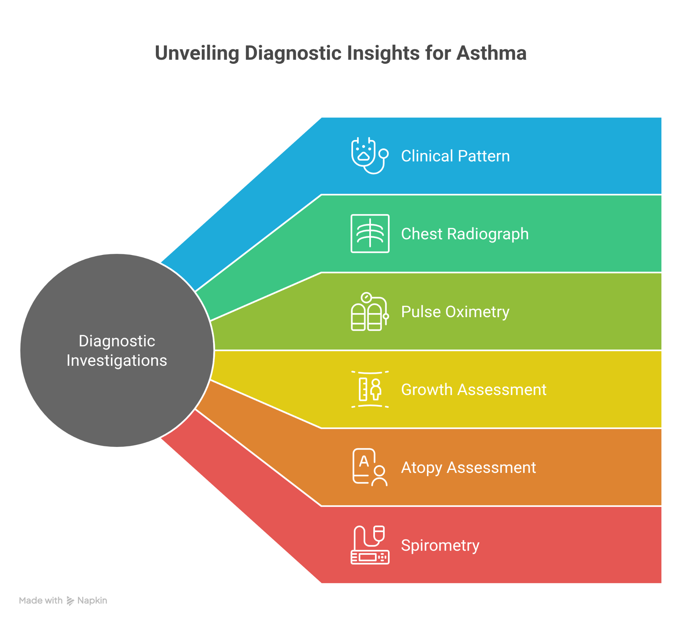

• Clinical pattern: Recurrent wheeze with interval symptoms and documented bronchodilator responsiveness, suggesting asthma phenotype.
• Chest radiograph: Normal lung fields; no focal consolidation, hyperinflation, or air trapping; no features suggestive of foreign body or structural lung disease.
• Pulse oximetry: Normal baseline oxygen saturation, excluding chronic hypoxemia.
• Growth assessment: Height and weight appropriate for age with normal growth velocity, providing baseline for future monitoring during ICS therapy.
• Atopy assessment: History suggestive of atopic tendency; formal allergy testing deferred as it would not alter initial management.
• Spirometry: Not performed due to age-related unreliability in preschool children.

Differential Diagnosis
• Episodic viral wheeze: Unlikely due to presence of interval symptoms including nocturnal cough and activity limitation.
• Protracted bacterial bronchitis: Excluded due to absence of chronic wet cough and lack of persistent symptoms between infections.
• Foreign body aspiration: Unlikely given gradual symptom onset, no choking history, and normal chest imaging.

Final Diagnosis

Preschool asthma with recurrent viral-triggered exacerbations and interval symptoms.

Treatment and Management
• Controller therapy:
Daily low-dose inhaled corticosteroid to suppress airway inflammation and prevent exacerbations.
Example: Budesonide inhalation zero point five milligrams once daily or Fluticasone one hundred micrograms twice daily via spacer.
• Reliever therapy:
Short-acting beta-agonist for symptomatic bronchoconstriction.
Example: Salbutamol two puffs as needed via spacer.
• Treatment rationale:
Continuous ICS therapy reduces exacerbation frequency, improves symptom control, and limits exposure to systemic corticosteroids, which carry greater growth and metabolic risks.
• Adherence strategy:
Caregiver counselling focused on the anti-inflammatory role of ICS, dose-dependent and non-progressive growth effects, and the risks of intermittent therapy.

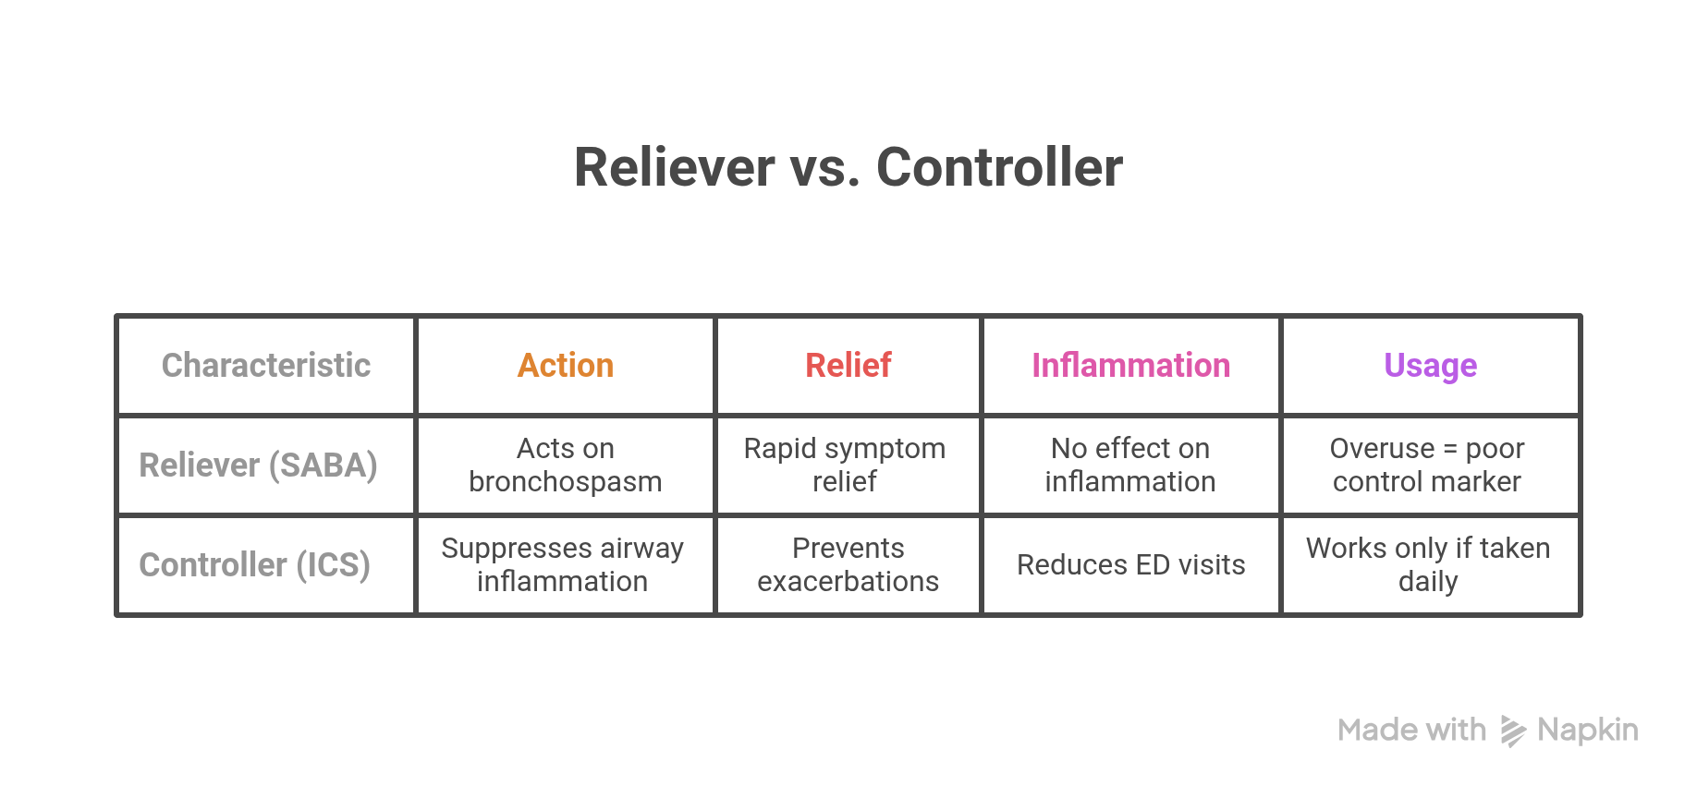

Follow-Up

Monthly follow-up over three months showed resolution of nocturnal symptoms, reduced reliever use, no further emergency visits, and maintenance of normal growth velocity.

Conclusion

Steroid-phobia resulted in undertreatment of persistent airway inflammation, leading to recurrent exacerbations. Addressing safety concerns and reinforcing the rationale for continuous inhaled corticosteroid therapy enabled adherence and achieved sustained asthma control.

Mini Case Study 2

Moderate Atopic Dermatitis With Topical Steroid Avoidance

Introduction

Atopic dermatitis is a chronic, relapsing inflammatory skin disorder characterised by epidermal barrier dysfunction and immune dysregulation. Effective management requires timely suppression of inflammation during flares, followed by barrier repair and maintenance therapy. Inadequate use or avoidance of topical corticosteroids during active disease perpetuates inflammation, leading to chronic pruritus, sleep disturbance, secondary skin changes, and increased caregiver distress. Steroid-phobia is a common contributor to undertreatment, resulting in prolonged disease activity despite availability of safe, low-potency anti-inflammatory therapy.

Background

A two-year-old female with eczema since infancy. Caregivers avoided topical corticosteroids due to concerns about skin thinning and systemic absorption, relying exclusively on emollients for several months.

Presenting Symptoms
• Persistent pruritus with frequent scratching
• Erythematous, excoriated lesions over flexural areas
• Lichenification indicating chronic inflammation
• Significant sleep disturbance affecting child and caregivers

Investigations

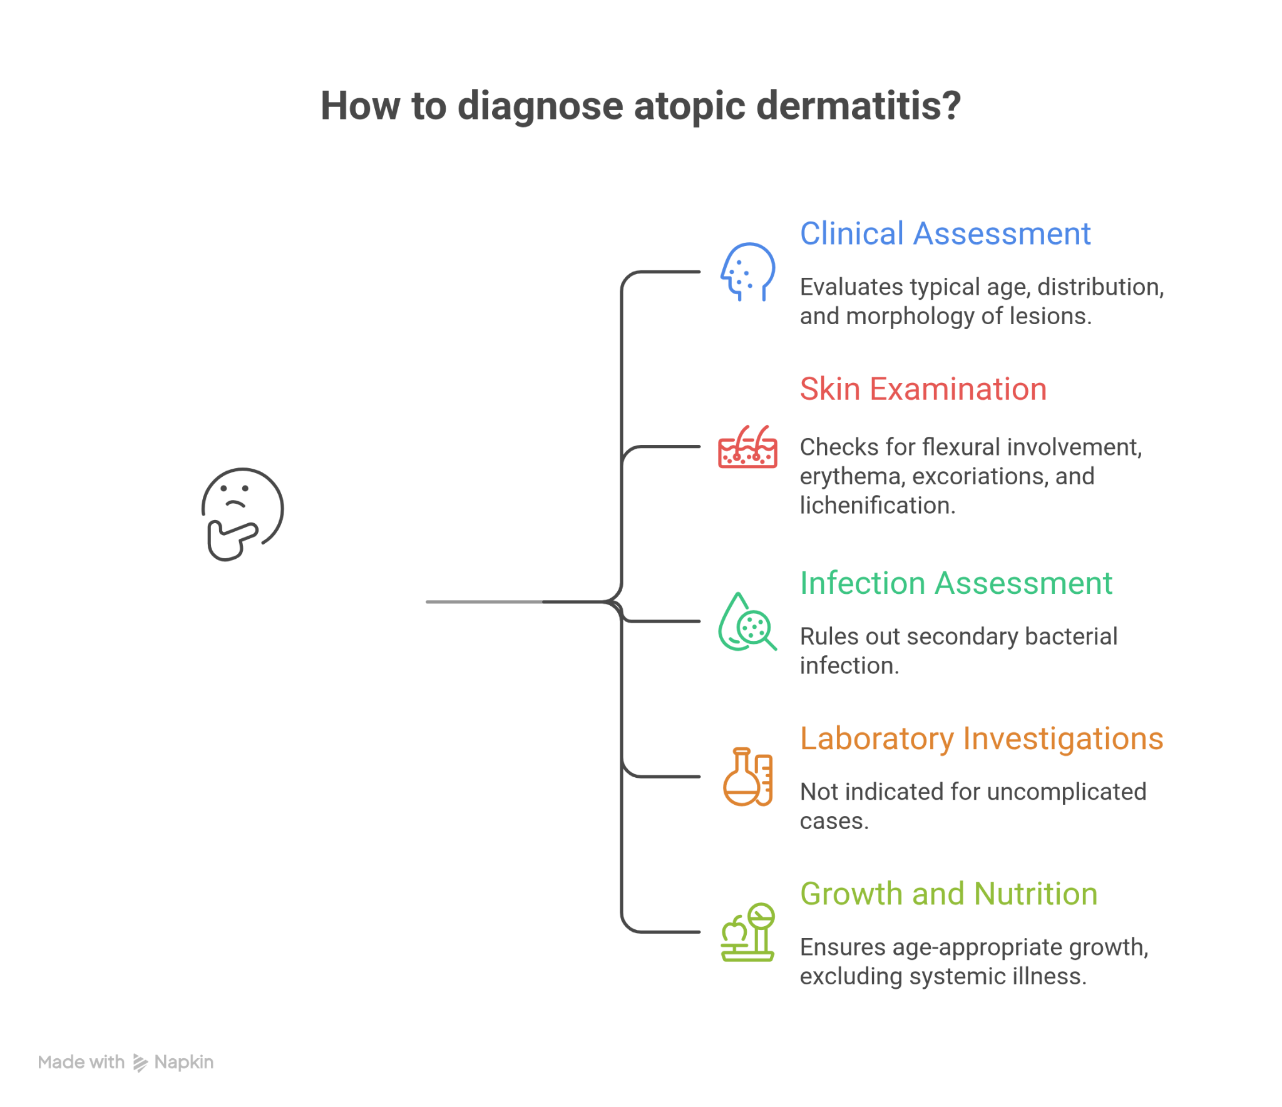
• Clinical assessment: Typical age, distribution, and morphology of lesions consistent with atopic dermatitis.
• Skin examination: Flexural involvement with erythema, excoriations, and lichenification; no vesiculation or sharply demarcated lesions.
• Infection assessment: No signs of secondary bacterial infection (no oozing, crusting, or pustules).
• Laboratory investigations: Not indicated; diagnosis remains clinical in uncomplicated atopic dermatitis.
• Growth and nutrition: Age-appropriate growth, excluding systemic illness contributing to skin disease.

Differential Diagnosis
• Allergic contact dermatitis: Unlikely due to chronic relapsing course and age-appropriate flexural distribution rather than localized exposure pattern.
• Irritant contact dermatitis: Excluded due to persistent inflammation despite avoidance of irritants and widespread involvement.
• Seborrheic dermatitis: Less likely given severe pruritus, flexural distribution, and chronicity beyond infancy.

Final Diagnosis

Moderate atopic dermatitis with uncontrolled inflammatory flares due to inadequate anti-inflammatory therapy.

Treatment and Management
• Anti-inflammatory therapy (for flares):
Short course of low-potency topical corticosteroid applied to active lesions.
Example: Hydrocortisone one percent cream, applied once or twice daily for five to seven days.
Rationale:
Corticosteroids suppress cutaneous inflammation, reduce cytokine-driven pruritus, and allow restoration of epidermal barrier function. Short, appropriate courses prevent progression to chronic lichenified disease.
• Barrier repair therapy:
Liberal and frequent application of emollients to all skin surfaces.
Rationale:
Emollients restore barrier integrity, reduce transepidermal water loss, and decrease frequency of flares but are insufficient alone during active inflammation.
• Step-down strategy:
Discontinuation of topical steroid once erythema and pruritus resolve, continuing emollient-only maintenance.
Rationale:
Prevents unnecessary prolonged steroid exposure while maintaining disease control.
• Caregiver education:
Demonstration of fingertip-unit dosing (One fingertip unit is the amount of ointment or cream expressed from a standard tube, extending from the tip of an adult index finger to the first distal crease.) and reassurance regarding low risk of skin atrophy when low-potency steroids are used correctly on appropriate sites.

Follow-Up

At two weeks, significant reduction in erythema and pruritus with improved sleep. At six weeks, sustained control on emollient maintenance with intermittent short steroid courses for minor flares. No evidence of skin atrophy or adverse effects.

Conclusion

Steroid avoidance resulted in prolonged uncontrolled inflammation and increased disease burden. Appropriate, time-limited use of low-potency topical corticosteroids restored disease control, improved quality of life, and reduced caregiver anxiety without added risk.

