**Beginners Guide to Options and Variants**

What are Options and Variants?

In simple terms O&V’s are a way to control what Items are displayed in an assembly based upon some values. They are not to be confused with Revision Rules. Revision Rules control what ItemRevisions are displayed in the PSE.

The following is a very simple example of a Pen. Pens come in all shapes and sizes and in this case Colours. Now, if you wanted to create a Blue pen you would need to create an assembly complete with all the Blue components. Later on you decide that you also need a Red pen. So, do you create a new assembly with only Red components OR do you somehow utilise the Blue assembly, after all, it’s almost exactly the same?

Need-less-to-say you can utilise the Blue assembly. Rather than create two separate assemblies you need only create one. This common assembly includes ALL components, both Red & Blue.

At this point this common assembly is pretty overcrowded, confusing and in this state not very useful...this is where O&V’s come in.

We can now apply ‘Options’ to the Top Level of the pen assembly, for instance: This pen can be either ‘Blue’ or ‘Red’

Then we can apply ‘Variants’ to each of the Components, for instance, Component A is ‘Blue’, and Component B is ‘Red’

Once you’ve created your O&V’s you can then configure your assembly to only display the components that meet your criteria along with all components that has not been configured by O&V’s.

**Here’s how....**

* Create the following components in Teamcenter

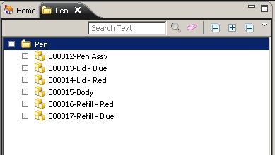

* Send your Top Level assembly to Structure Manager
* Add all the components to the Top Level assembly ‘Pen Assy’

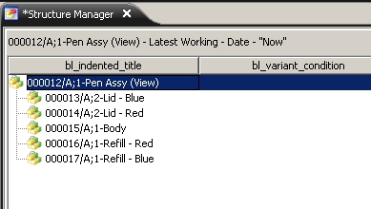

* Within the PSE open the Data Panel
* Ensure the ‘Variants’ Pane is viewable in the Data Panel

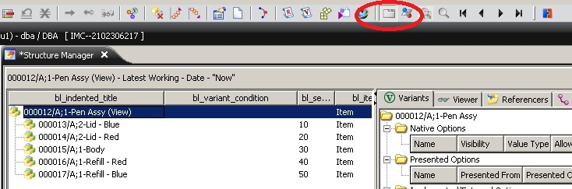

* Create an Option by clicking the ‘**Create a New Option’** button

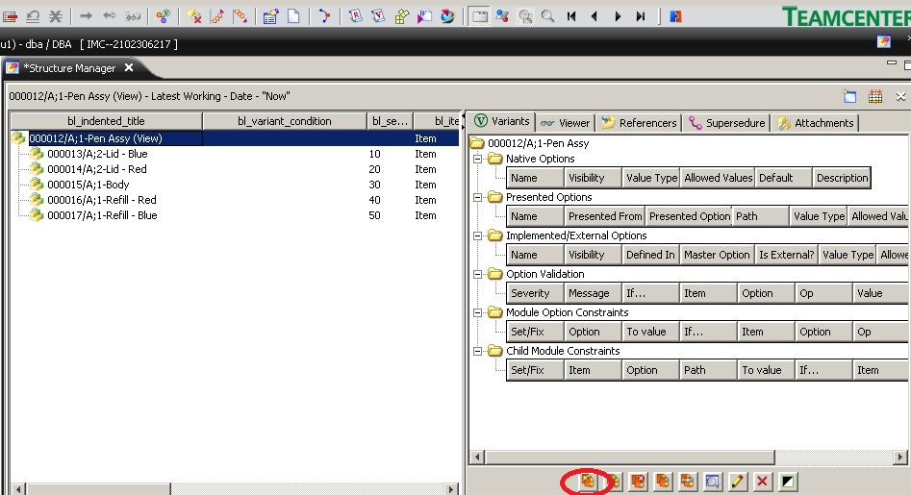

* Select ‘**Just let me ....**’ in the Wizard.
  + Note: The guide only Creates the option but does not allow you to add any values, not very useful.
* **Finish**

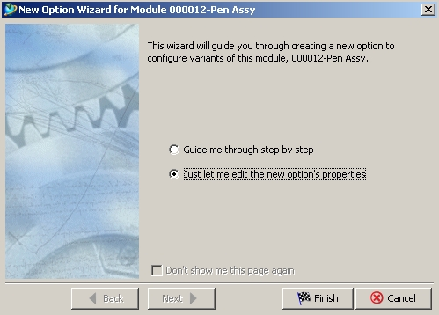

* Give your Option a meaningful name, such as ‘Colour’
* Add **Red** & **Blue** to the ‘Allowed Values’ box.
  + This part is important. You are now defining how your assembly can be configured...either **Red** OR **Blue**
* **Ok**

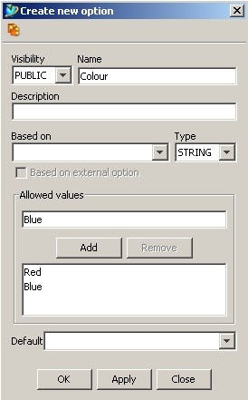

* Notice in the Variants Pane your option is now defined with two values.
  + You now need to define your components as Variants.

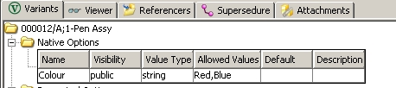

* Select the first ‘Blue’ component in Structure Manager.
* Push the Variant Icon on the toolbar: 

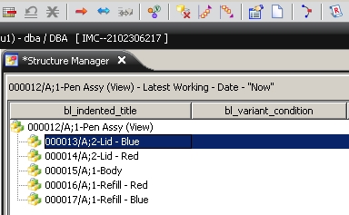

* Complete the dialogue as below.

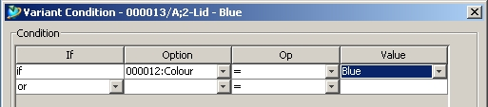

* + You are now defining your component as ‘Blue’

You are saying:

* + - I have an assembly complete with components.
    - When I configure my assembly as ‘Blue’ I want to see *this* component.
    - I do NOT want to see other variants, such as Red. Red components will not be displayed in the PSE!!!
    - I also want to see ALL components that are NOT configured.
* Your component in the PSE is now defined as a Variant. It now includes a new Icon: C:\Users\wheelerw\Desktop\OV\ScreenShot 070 OV.docx - Microsoft Word.jpg
  + For more information you can also enable the PSE column: bl_variant_condition.

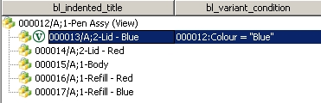

* Create Variants for all components in your assemble.
  + Note: **Body** is NOT a variant. It does not have a colour and therefore remains un-configured.

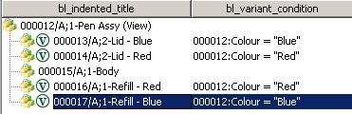

* Ensure that the menu ‘**Show Unconfigured Variants’** is un-selected.
  + Failure to unselect this feature will not allow you to see your Variants update in the PSE. This can be confusing!!

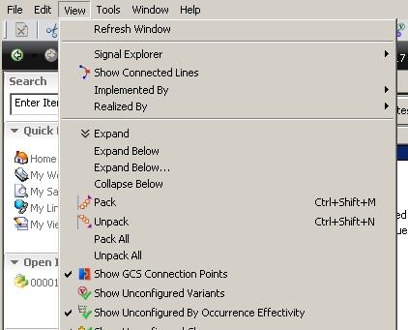

* Now it’s time to configure your assembly.
* Click the Icon...

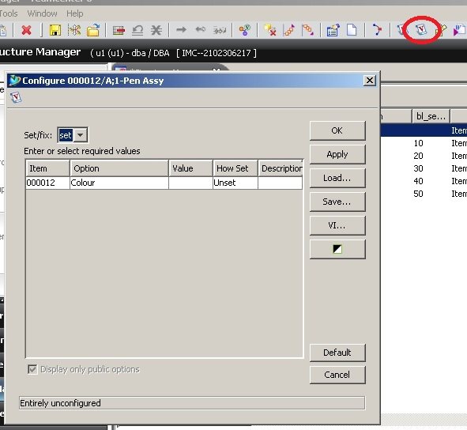

* From the dialogue choose ‘**Red’** from the value field.
* Click **Apply** and watch in the PSE as your assembly updates to show only unconfigured components and ‘**Red’** variant components.

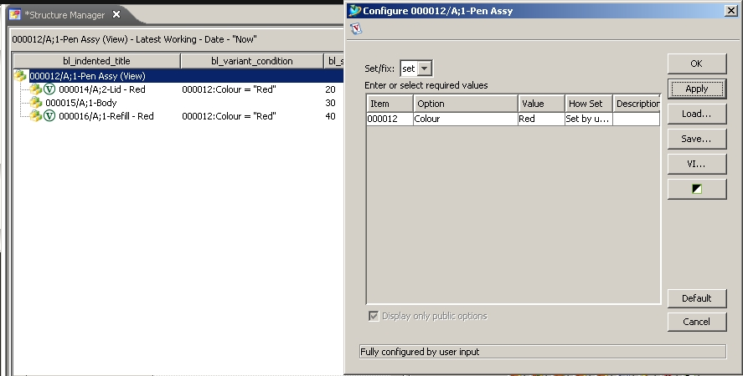

Bill Wheeler EMEA TC_North