Remediation Plan
Generator
Solution Design Document

Document version history
Revision history by author is indicated below:
Version | Date | Author | Comments
1.0 | 22 June 2026 |  | Initial draft, subject to revision.

Review & approvals
All design documents must be reviewed and signed off:
Version | Date | Preparer | Reviewer | Comments | Sign Off
1.0 | 22 June 2026 | Gopal Chettri

Acronyms and abbreviations
Acronyms and abbreviations used in this document are defined below:
Acronym | Definition
AI | Artificial Intelligence
API | Application Programming Interface
DBA | Database Administrator
JSON | JavaScript Object Notation
LLM | Large Language Model
SDD | Solution Design Document
SSE | Server-Sent Events
TSG | Threat Scenario Generator
UTC | Coordinated Universal Time

Table of Contents
Overview 1
Key terms 1
Dependencies 1
1. Plan generation 1
How it works 1
Key rules 1
When things go wrong 1
2. Review, versions and reporting 1
How it works 1
Plans and scenario versions 1
Key rules 1
When things go wrong 1
3. Governance 1
What the model sees 1
Redaction and the free-text cap 1
Server-owned fields 1
Moderation 1
Retries and the retry cap 1
The staleness window 1
Audit events 1

Overview
The Remediation Plan Generator is an AI-assisted capability that creates a reviewable risk treatment plan for an accepted threat scenario. It uses the scenario context, the library controls already mapped to the scenario, and the risk register information supplied by the platform to identify controls that still need to be implemented and to generate a dated list of remediation actions.
A reviewer can approve, reject or regenerate the plan.

2. Functional Description
The solution has two functional components that run in sequence for an accepted scenario: 1. Plan Generation and
2. Review and Versioning.

2.1 Plan Generation
The Plan Generation component creates a remediation plan for the accepted threat scenario. The request includes the risk register's existing controls, ratings, risk level and assessment window. The module combines these values with the scenario's asset context, threat, supporting systems and mapped library controls.
AI proposes the controls that still need to be implemented and generates a remediation action plan. Recommended controls are accepted only when their control code matches a control already mapped to the scenario from the approved Control Library.
The generated plan is validated before it is stored.

2.2 Review and Versioning
The platform displays the generated plan for review. A reviewer can approve or reject the active plan or regenerate a new plan version. Every plan version is retained.
A plan remains bound to the exact scenario version from which it was generated. If a different scenario version becomes accepted, the previous plan is no longer shown on the active plan board. Historical plan versions remain available for audit.

3. Architecture Description
This section describes how the remediation plan is generated and how the plan lifecycle is managed. The workflow is driven as follows —

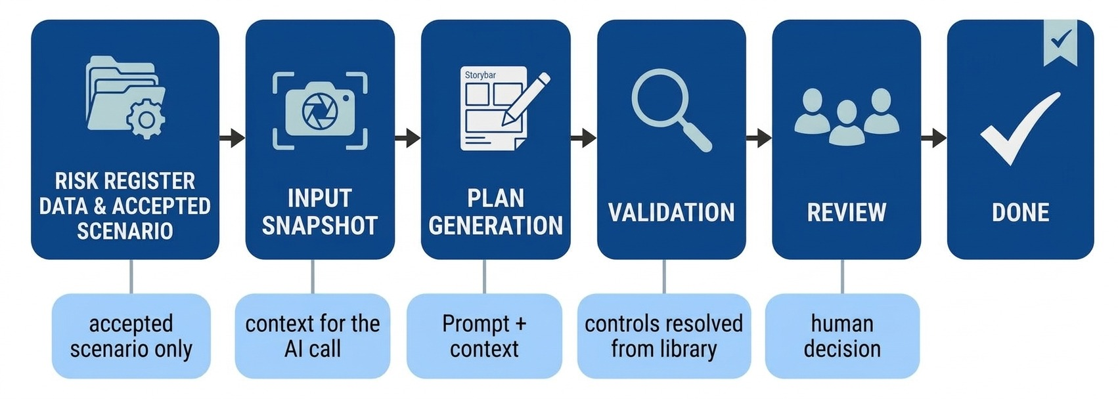

3.1 Plan Generation
Plan generation begins when the platform requests a plan for an accepted scenario version. The API validates the request, creates a snapshot input, stores a RUNNING plan row and queues background processing. The worker then generates, validates and stores the plan.
[1] Request Validation: The API authenticates the caller, verifies the entity scope, validates the request body and confirms that the scenario version has been accepted.
[2] Input Snapshot: The API combines the asset context, supporting systems, threat and actors, scenario text, scenario controls and risk register data into one context.
[3] Plan Creation: Only one active plan is allowed for accepted threat scenario. The request returns the plan identifier, and processing continues in the background.
[4] AI Generation: The worker claims the plan row and makes one AI call using a fixed system instruction and the input snapshot i.e. context.
[5] Validation and Grounding: The AI response is checked for the required structure. Recommended controls are resolved against the approved controls mapped to the threat scenario.
[6] Completion: Advisory checks are applied to the completed response and the plan is stored.

Accepted scenario + risk register data
│
▼
[1] REQUEST VALIDATION authenticate · entity scope · accepted scenario
│
▼
[2] INPUT SNAPSHOT scenario context + mapped controls + register data
│
▼
[3] PLAN CREATION RUNNING · one active plan per scenario version
│
▼
[4] AI GENERATION fixed prompt + JSON snapshot · one AI call per attempt
│
▼
[5] VALIDATION structure check · control-code resolution · advisory checks
│
▼
[6] COMPLETE / store result · audit · live result
Fig 1: Logical Architecture of Plan Generation

The plan response contains the recommended control gaps, the remediation action plan, the overall mitigation timeline, the mitigation owner, applicability to all supporting systems, and the risk owner and impacted business division copied from the server-owned request data.

3.2 Review, Versions and Reporting
After generations, the platform follows the active plan through status, review and reporting operations. The plan remains tied to its scenario version, and every version is retained for traceability.
[1] Status and Read: The platform can poll the active plan for status, progress, error reason and review status, and can retrieve the plan content and scenario context.
[2] Review: A reviewer approves or rejects an active plan. The review records the plan version, reviewer identity, timestamp and optional comment.
[3] Regeneration: Regeneration retires the active plan and creates a new version using the data from the original request.

4. Platform Integration
The Remediation Plan Generator is accessed through authenticated API endpoints and is scoped to the caller's entity. The platform supplies the accepted threat scenario, and the risk register data, while the module returns the plan and its lifecycle state through the API.

4.1 Plan Request
The platform requests a plan for an accepted scenario version. The request supplies existing controls, likelihood rating, impact rating, final risk rating, risk level and, where available, the risk identification date, owner, impacted business division and mitigation window.
The API returns immediately with a plan identifier after the request is accepted and queued. The plan is then generated in the background. A scenario that is not accepted cannot receive a plan.

4.2 Plan Review
The platform displays the active plan and its validation warnings for review. Review decisions apply to the exact plan identifier that the reviewer viewed. Users can approve or reject a COMPLETE plan, regenerate it when a new version is required, or cancel a running generation.
Only accepted scenario versions are shown on the active plan board. The platform can also retrieve historical versions, audit activity and the evidence associated with a plan, including the frozen input snapshot and AI-call records.

5. Governance

5.1 Security
The Remediation Plan Generator uses the security controls shared by TSG, including authentication, authorization, entity isolation, AI input redaction, AI-call limiting and secure data storage.
The model receives the frozen input snapshot as structured JSON. Reviewer warnings, risk-owner identity fields and database identifiers are excluded from the AI input. Free-text values are redacted and capped before they reach the model.
Controls returned by the model are not trusted directly. The worker resolves control codes against the approved Control Library and takes the control identifier, canonical code and domain from the library record.

5.2 Explainability and Auditability
The solution provides traceability for every plan generation and review action. The input snapshot is retained with the plan, and each AI call records the prompt, raw response, model information and prompt version in Prompt_Log.
Plan requests, generation outcomes, cancellations, review decisions and version restorations are recorded as append-only audit events. Every event is associated with the relevant session, entity, scenario and plan where applicable.

5.3 Performance and Scalability
The system is designed to handle multiple users concurrently. Plan requests are accepted immediately and processed in the background by worker processes, allowing the API to remain responsive while AI generation is running.
- Requests are processed asynchronously by a worker pool.
- Each plan is tied to the correct user, entity and scenario version.
- Only one active plan version is allowed for a scenario version.
- Transient AI-capacity and database failures can be retried within the configured retry limit.
- Capacity can be increased by adding worker instances and providing additional processing and GPU capacity.

