Threat Scenario
Generator
Solution Design Document

Document version history
Revision history by author is indicated below:
Version | Date | Author | Comments
1.0 | 22 June 2026 |  | Initial draft, subject to revision.

Review & approvals
All design documents must be reviewed and signed off:
Version | Date | Preparer | Reviewer | Comments | Sign Off
1.0 | 22 June 2026 | Gopal Chettri

Acronyms and abbreviations
Acronyms and abbreviations used in this document are defined below:
Acronym | Definition
AI | Artificial Intelligence
API | Application Programming Interface
CII | Critical Information Infrastructure
CSV | Comma-Separated Values
CTI | Cyber Threat Intelligence
EY | Ernst & Young
FTE | Full-Time Equivalent
IT | Information Technology
JSON | JavaScript Object Notation
KPI | Key Performance Indicator
LLM | Large Language Model
OT | Operational Technology
PDF | Portable Document Format
STRIDE | Spoofing, Tampering, Repudiation, Information Disclosure, Denial of Service, Elevation of Privilege
UI | User Interface
UTC | Coordinated Universal Time

Table of Contents
1. Overview 5
2. Functional Description 5
2.1 Asset Context Resolution 5
2.2 STRIDE Threat Identification 5
2.3 Threat Scenarios 6
3. Architecture Description 7
3.1 Asset Context Resolution 7
3.2 STRIDE Threat Identification 7
3.3 Threat Scenario 8
4. Platform Integration 9
4.1 Asset Selection 9
4.2 Threat Scenario Review 9
5. Governance 9
5.1 Security 9
5.2 Explainability and Auditability 10
5.3 Performance and Scalability 10

1. Overview
The Threat Scenario Generator is an AI-assisted capability that helps users create consistent and reviewable threat scenarios for Critical Information Infrastructure (CII) assets. It combines the selected asset's information, its supporting system context, the STRIDE threat model, an approved Threat Library, and an approved Control Library to produce a complete, reviewable set of threat scenarios for the asset. The user reviews and accepts the AI's output.
The goal is to make threat modelling faster, more consistent, and easier to govern. Instead of writing threat scenarios from scratch, the user works on one selected asset at a time. When the asset is selected, the system resolves its supporting systems, services, and sector, sub-sector directly from platform data. That context is then used to identify relevant STRIDE-aligned threats, to generate threat scenario narratives, and to recommend controls from the approved Control Library.
AI output never becomes final automatically. Nothing is finalized without an explicit human decision. The user reviews the generated scenarios and decides on each one individually. Only user-accepted content is saved and carried forward, which keeps the final output controlled, validated, and suitable for downstream risk assessment.

2. Functional Description
The solution has three functional components that run in sequence for the selected asset: Asset Context Resolution, STRIDE Threat Identification, and Threat Scenario Generation.

2.1 Asset Context Resolution
When a session is created, the system resolves the asset's supporting systems, services, and business context (sector, subsector, criticality) directly from platform data. This is a deterministic, code-driven step — no AI is involved.

2.2 STRIDE Threat Identification
The STRIDE Threat Identification component identifies relevant STRIDE-aligned threats for the selected asset from the approved Threat Library.
STRIDE is the authoritative model for the Threat Category, while the Threat Library is the source of truth for Threat Type, Threat Name, and Threat Actor. If an AI-proposed threat cannot be confirmed against the Threat Library, it is kept but marked unverified, so the reviewer can see it. It is never added to the library automatically: a reviewer must first promote it from an accepted scenario, and the admin then accepts or rejects it.

2.3 Threat Scenarios
The Threat Scenario Generation component generates the final threat scenario narratives.
For each selected threat, the AI uses the asset context, prompt, and the validated STRIDE threat attributes to generate a scenario narrative. The narrative covers the scenario title, scenario statement, and risk statement. Controls are then matched to the scenario from the approved Control Library.
The generated scenarios are displayed to the user, who can accept all, accept a subset, reject scenarios, or regenerate specific scenarios. Only accepted scenarios are made available downstream.

3. Architecture Description
This section describes how each component is built and how data flows through it. The whole workflow is driven as follows —
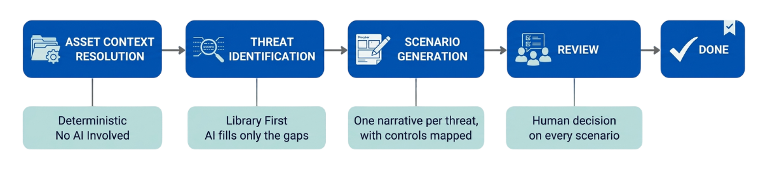

3.1 Asset Context Resolution
Asset Context Resolution runs inside the session-creation request. It reads the platform's own records for the selected assets, the asset entry, the supporting systems chosen for the assessment, and the sector and service structure — and assembles them into one context document. The platform data are read-only to this module: it never creates or modifies platform data.
The assembled context is saved. Every later stage reads this saved context.

3.2 STRIDE Threat Identification
Using the asset context, this process identifies a set number of threats, spread across the six STRIDE categories. It is library-first: the large language model (LLM) only fills with what the Threat Library cannot.
[1] Threat Library Retrieval: This step finds the library threats that are most relevant to the selected asset and its supporting systems. The system creates one search query for the asset and one for each supporting system, using their available context. Each query is embedded once using Qwen3-Embedding-8B.
The system searches for the Threat Library using both BM25 keyword matching and cosine similarity for semantic matching. The results are combined using Reciprocal Rank Fusion (RRF). Results from the asset and supporting-system queries are then combined, and the best-ranked results are retained. The top 100 threats form the candidate pool for the next step.
[2] Relevance Gate: The Qwen3-Reranker-8B scores each candidate against the asset and supporting-system search context on a 0–100 relevance scale. Candidates scoring at or above the configured relevance threshold (default 50) form the relevant pool. Candidates scoring below the threshold form the backfill pool.
[3] STRIDE Balancing: The relevant threats are distributed across the six STRIDE categories to provide balanced threat coverage. For each category, the system selects the highest-ranked relevant library threat that belongs to that category.
The system then calculates the gap, which is the larger of:
- the number of threats still required to reach the requested count; or
- the number of STRIDE category slots that remain unfilled.
If the gap is zero, the required threat count and STRIDE coverage have been satisfied, and no LLM call is required. If the gap is greater than zero, the remaining requirement is passed to LLM Gap Generation.
[4] LLM Gap Generation: When a gap remains, the system makes LLM call to generate additional threat candidates. The request contains the asset context, threats already selected, the STRIDE categories requiring additional coverage, and approved Threat Type names to encourage reuse of library terminology.
[5] Deterministic Grounding: Each AI-generated threat is checked against the approved Threat Library. Threats with an invalid STRIDE category are discarded.
The system first looks for the closest Threat Type using semantic similarity and then checks the Threat Name within the matched Threat Type using the re-ranker.
- Type and Name confirmed: the library wording and identifiers are adopted. The threat is verified (fully matched).
- Type confirmed only: the library Type is kept. The threat is unverified (not fully matched).
- No Type match: the LLM's wording is kept. The threat is unverified.
[6] Threat Actor Resolution: Threat Actors are resolved from the approved Threat Library. If there are none, or no Type was confirmed, it takes the closest library actors.
[7] Deduplication: This step stops the same threat appearing twice. A generated threat is dropped if it matches a threat already held or retrieved, either by identity (the same library entry, or the same Threat Type and Name) or by meaning.
Output: The threats are saved as verified or unverified and passed to Threat Scenario Generation. Unverified threats still get scenarios. A threat enters the library only when a reviewer promotes it from an accepted scenario, and it stays inactive until an admin approves it.

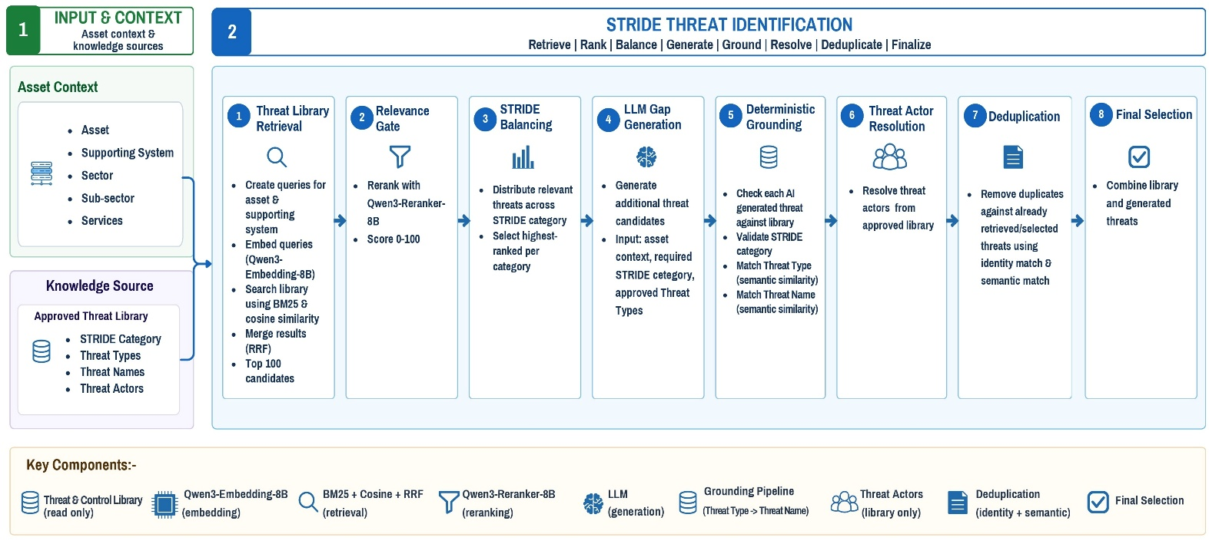
Fig 1: Logical Architecture of the STRIDE Threat Identification

3.3 Threat Scenario
Threat Scenario Generation receives the asset context, the validated and selected STRIDE threats, and a prompt. For each selected threat it invokes the LLM once to generate a scenario narrative in a fixed response format, validates it, and stores it per threat.
Controls are then mapped for each stored scenario: the threat and the scenario's own text form the query, candidate controls are retrieved from the approved Control Library, re-ranked, and attached. The user reviews the generated scenarios and can accept all, partially accept selected scenarios, reject, or regenerate them; regeneration retires the old version and keeps it in the scenario's history. Only accepted scenarios proceed to downstream risk assessment.
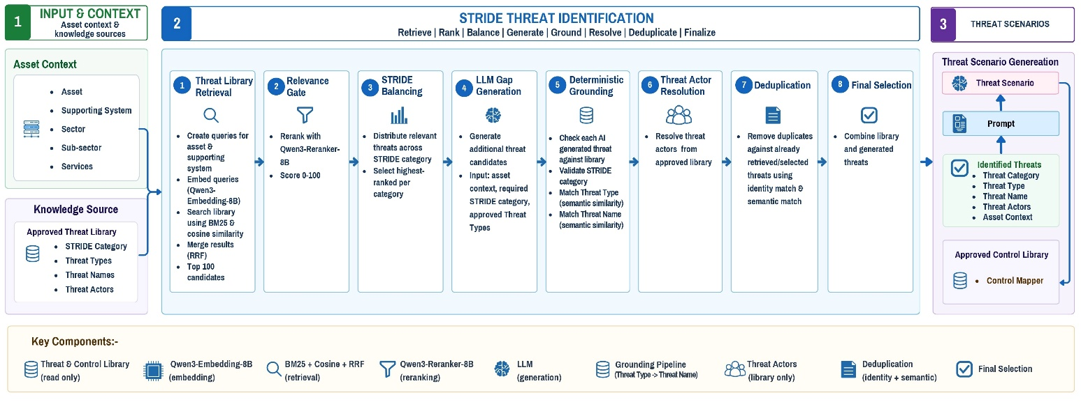

Fig 2: Logical Architecture of the Threat Scenario Generator

4. Platform Integration
This section describes how the user interacts with the module through the platform. The module is reached through a set of API endpoints; every call is authenticated and scoped to the caller's own entity.

4.1 Asset Selection
The user starts by selecting a single asset. When the session is created, the system automatically identifies the related supporting systems and services and retrieves the associated context, including asset type, sector, subsector, entity, and service.
The platform uses this information to automatically pre-fill the relevant fields for the user. The same resolved context is also used as input for the AI, ensuring that the information shown to the user and the information provided to the AI always remain consistent.

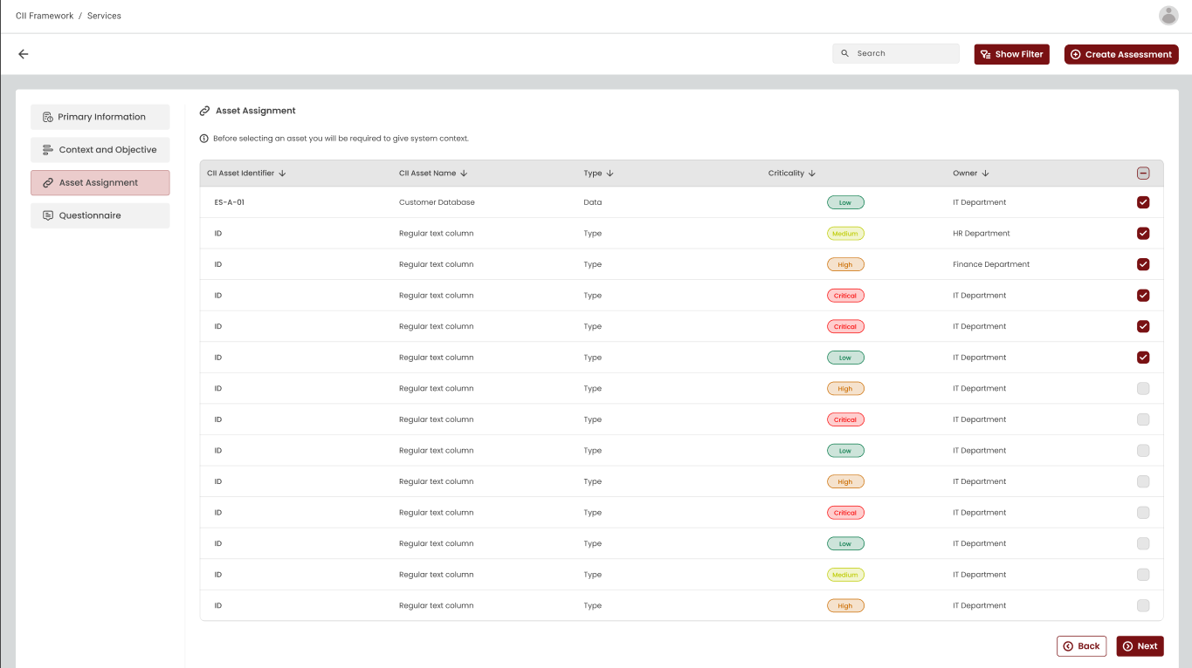

4.2 Threat Scenario Review
The platform displays AI-generated threat scenarios for user review. Users can accept all scenarios, accept selected ones, or regenerate them. Only accepted scenarios are sent for downstream risk assessment.
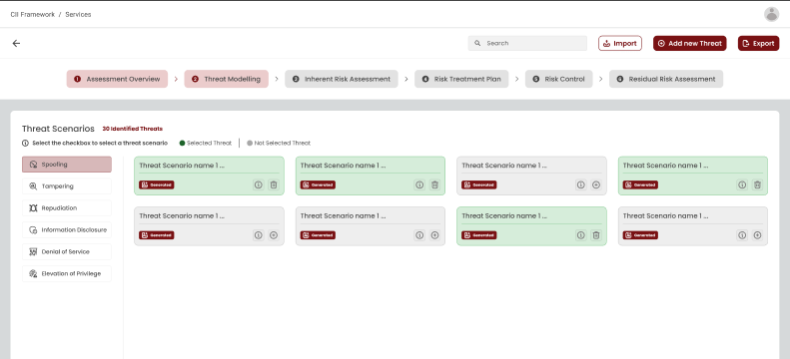

5. Governance

5.1 Security
The Threat Scenario Generator applies security controls across authentication, authorization, data protection, tenant isolation, AI input handling, AI response validation, and data storage. Sensitive information such as credentials, API keys, secrets, environment variables, internal configuration is never sent to the AI model.
The platform authenticates callers with issued API keys, each verified against a stored one-way hash — the key itself is never stored. Administrative functions sit behind a separate administrative key.
System prompts are fixed, and cannot be modified at runtime, which helps prevent prompt injection and unauthorized changes to safety rules.

5.2 Explainability and Auditability
The solution provides traceability for every threat scenario generation request.
For every AI call, the exact prompt sent and the raw response received are retained, together with the model’s name, model version, and prompt. The platform maintains append-only logs.

5.3 Performance and Scalability
The system is designed to handle multiple users at once. When a user requests a scenario, the system accepts the request immediately and does the work in the background. The finished result appears once it is ready.
Key points:
- Requests are accepted straight away and processed in the background by a pool of workers.
- Each request of work is kept separate and clearly tied to the right user and entity, and one asset has at most one assessment in progress at a time.
- Multiple users can work at the same time without their requests interfering with each other.
- Overall performance and the number of users the system can support at the same time depend on the underlying hardware provided. Capacity is scaled by adding worker instances; more processing power, memory, and GPU capacity allow the system to handle higher load and produce results faster.

