Threat Scenario
Generator
Solution Design Document

Document version history
Revision history by author is indicated below:
Version | Date | Author | Comments
1.0 | 22 June 2026 |  | Initial draft, subject to revision.
1.1 | 26 October 2026 |  | Updated to match the implemented design.

Review & approvals
All design documents must be reviewed and signed off:
Version | Date | Preparer | Reviewer | Comments | Sign Off
1.0 | 22 June 2026 | Gopal Chettri
1.1 | 26 October 2026 | Gopal Chettri

Acronyms and abbreviations
Acronyms and abbreviations used in this document are defined below:
Acronym | Definition
AI | Artificial Intelligence
API | Application Programming Interface
ATT&CK | Adversarial Tactics, Techniques, and Common Knowledge
BM25 | Best Matching 25
CII | Critical Information Infrastructure
CISA | Cybersecurity and Infrastructure Security Agency
CSV | Comma-Separated Values
CTI | Cyber Threat Intelligence
EPSS | Exploit Prediction Scoring System
EY | Ernst & Young
FIRST | Forum of Incident Response and Security Teams
FTE | Full-Time Equivalent
GPU | Graphics Processing Unit
ICS | Industrial Control Systems
IT | Information Technology
JSON | JavaScript Object Notation
KEV | Known Exploited Vulnerabilities
KPI | Key Performance Indicator
LLM | Large Language Model
MB | Megabyte
NIST | National Institute of Standards and Technology
NVD | National Vulnerability Database
OT | Operational Technology
PDF | Portable Document Format
RRF | Reciprocal Rank Fusion
SSE | Server-Sent Events
STRIDE | Spoofing, Tampering, Repudiation, Information Disclosure, Denial of Service, Elevation of Privilege
UI | User Interface
UTC | Coordinated Universal Time

Table of Contents
1. Overview 5
2. Functional Description 5
2.1 Asset Context Resolution 5
2.2 STRIDE Threat Identification 5
2.3 Threat Scenarios 5
2.4 Open-Source Threat Data 6
3. Architecture Description 6
3.1 Asset Context Resolution 6
3.2 STRIDE Threat Identification 7
3.3 Threat Scenario 8
3.4 Open-Source Threat Data 9
4. Platform Integration 10
4.1 Asset Selection 10
4.2 Threat Scenario Review 10
4.3 Session Control 11
4.4 Library Curation 11
5. Governance 11
5.1 Security 11
5.2 Explainability and Auditability 12
5.3 Performance and Scalability 12
5.4 Reliability 12

1. Overview
The Threat Scenario Generator is an AI-assisted capability that helps users create consistent and reviewable threat scenarios for Critical Information Infrastructure (CII) assets. It combines the selected asset's information, its supporting system context, the STRIDE threat model, an approved Threat Library, and an approved Control Library to produce a complete, reviewable set of threat scenarios for the asset. The user reviews and accepts the AI's output.
The goal is to make threat modelling faster, more consistent, and easier to govern. Instead of writing threat scenarios from scratch, the user works on one selected asset at a time. When the asset and its supporting systems are selected, the system resolves their recorded facts, the asset's critical services, and its sector and subsector directly from platform data. That context is then used to identify relevant STRIDE-aligned threats, to generate threat scenario narratives, and to recommend controls from the approved Control Library.
Each scenario is written from the platform's data. Open-source threat data (MITRE, CISA, FIRST and NIST) keeps the described attack realistic and, when a record matches, adds a one-line real-world example with its source link.
AI output never becomes final automatically. Nothing is finalized without an explicit human decision. The user reviews the generated scenarios and decides on each one individually. Every written scenario is saved for review, but only user-accepted content is carried forward, which keeps the final output controlled, validated, and suitable for downstream risk assessment.

2. Functional Description
The solution has three functional components that run in sequence for the selected asset: Asset Context Resolution, STRIDE Threat Identification, and Threat Scenario Generation.

2.1 Asset Context Resolution
When a session is created, the system resolves the context of the asset and its chosen supporting systems, the asset's services, its sector and subsector directly from platform data. This is a deterministic, code-driven step — no AI is involved.

2.2 STRIDE Threat Identification
The STRIDE Threat Identification component identifies relevant STRIDE-aligned threats for the selected asset from the approved Threat Library.
STRIDE is the authoritative model for the Threat Category, while the Threat Library is the source of truth for Threat Type, Threat Name, and Threat Actor. Library threats are judged first. The AI proposes a threat of its own only for a STRIDE category in which no library threat applies, and only under a Threat Type the library already holds. Such a threat is kept but marked unverified, so the reviewer can see it. It is never added to the library automatically: a reviewer must first promote it from an accepted scenario, and the admin then accepts or rejects it.
Every threat has exactly one acting Threat Actor, chosen from the actors the Threat Library links to its Threat Type. A threat that no linked actor could plausibly carry out is not used. A threat that applies as more than one kind of attack gets one attack path for each STRIDE category it applies to.

2.3 Threat Scenarios
The Threat Scenario Generation component generates the final threat scenario narratives.
For each selected threat, and for each STRIDE category it applies to, the AI uses the asset context, prompt, and the validated STRIDE threat attributes to generate a scenario narrative. The narrative covers the scenario title, scenario statement, and risk statement. Controls are then matched to the scenario from the approved Control Library.
The generated scenarios are displayed to the user, who can accept all, accept a subset of scenarios, or regenerate specific scenarios. Only accepted scenarios are made available downstream.
The user can also ask for the next set and regenerate a scenario.

2.4 Open-Source Threat Data
The system keeps an up-to-date copy of open-source threat data from six sources:
- MITRE ATT&CK Enterprise and ICS: the methods attackers use against IT and OT systems, and the known groups that have used them.
- CISA KEV: vulnerabilities that have been used in real attacks.
- FIRST EPSS: how likely each of those vulnerabilities is to be used in an attack.
- NIST NVD: how severe each of those vulnerabilities is, and the products and versions it affects.
- CISA ICS advisories: vulnerabilities and fixes for industrial control products.
For each threat, the system picks the records that match it best; a vulnerability is picked only when it affects a product the asset records. The records are used in two ways:
- They are given to the AI that writes the scenario, so the attack it describes stays realistic.
- The scenario ends with one sentence about a real-world case from one record, with a link to its source.
When only a loosely related record is found, that sentence says it is related. When no record fits, no sentence is added. This can be switched off.

3. Architecture Description
This section describes how each component is built and how data flows through it. The whole workflow is driven as follows —
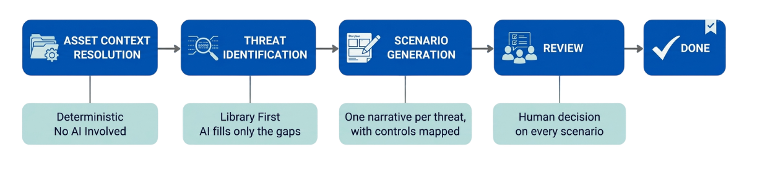

3.1 Asset Context Resolution
Asset Context Resolution runs inside the session-creation request. It reads the platform's own records for the selected assets, the asset entry, the supporting systems chosen for the assessment, and the sector and service structure — and assembles them into one context document. The platform's asset data are read-only to this module: it never creates or modifies them.
The assembled context is saved. Every later stage reads this saved context.
The saved context never changes for the life of the session, so a later edit of platform data never mixes into a running assessment. The AI never sees a database identifier: the planning prompts name each supporting system by an alias (SYS1, SYS2, and so on), and the writing prompts by its name. The asset's other supporting systems are recorded by name only. The request is refused when the asset belongs to another entity, a supporting system is not linked to it, a service or sector does not exist, a sector sent is not the subsector's parent, or a required property is not recorded; a service the asset is not linked to is still used, and logged. An asset has at most one session in progress at a time.

3.2 STRIDE Threat Identification
Using the asset context, this process identifies every library threat that applies to the asset and its supporting systems, across the six STRIDE categories. It is library-first: the large language model (LLM) only proposes a threat for a category the Threat Library cannot cover.
[1] Library Pre-filter: This step keeps the library threats filed under at least one STRIDE category whose asset type (IT, OT or IT\OT) fits the asset or one of its chosen supporting systems (a threat with no asset type fits everywhere), and whose Threat Type links at least one Threat Actor. There is no shortlist: every remaining library threat is judged in the next step.
[2] Relevance Gate: The LLM judges every candidate of each STRIDE category, in batches of ten, with the six categories judged at the same time. For each candidate it states whether the threat applies, which supporting systems it involves and through which of them an attacker could get in, its impact (high, medium or low), its confidence on a 0–100 scale, a one-sentence reason, anything the threat needs that no recorded fact mentions, and the most plausible attacker among the actors linked to its Threat Type. Every answer is checked by code; a malformed answer is asked again once, with its problems listed.
[3] Code Checks: A threat is kept only where an attacker could get in through a supporting system, or the asset itself, that its asset type fits. A threat that needs a component, device, or technology that no recorded fact mentions is refused under every STRIDE category.
[4] LLM Gap Generation: When a STRIDE category has no library threat that applies, the system makes one LLM call to propose at most one additional threat for it. The request contains the asset context, the category, and the library threats already judged not to apply, so they are never proposed again.
[5] Deterministic Grounding: Each AI-generated threat is checked against the approved Threat Library using the re-ranker and the configured similarity threshold (default 75). A proposal that matches a library threat already judged is discarded. A proposal whose Threat Type matches no library Threat Type is discarded. A kept proposal takes the library Threat Type and is judged by the relevance gate like a library threat. The threat is unverified (not fully matched).
[6] Threat Actor Resolution: The attacker the relevance gate chose acts, with its reason. When the gate gave no usable choice, the linked actor that ranks first for the threat acts. When the gate found no linked actor plausible, or the Threat Type links none, the threat is not used.
[7] Deduplication: This step stops the same threat appearing twice. A generated threat is merged into a threat already held when it matches it, either by identity (the same library entry, or the same Threat Type and Name) or by meaning. A threat found under two STRIDE categories becomes one threat with both categories.
[8] Ranking and Selection: Each threat gets one attack path for each STRIDE category it applies to. The paths are ranked by impact, then confidence, then STRIDE order, with library threats before AI threats on a tie, and each threat's strongest category comes before any threat's second one, so a scenario count leaves out second categories first. The paths are then dealt in turns across the supporting systems, so that each system takes its turn as the entry point. When the deployment sets a scenario count, only that many of the best paths are selected; the rest stay in the plan. The first set is passed to Threat Scenario Generation.
Output: The threats are saved as verified or unverified and passed to Threat Scenario Generation. Unverified threats still get scenarios. A threat enters the library only when a reviewer promotes it from an accepted scenario, and it stays inactive until an admin approves it.
The plan is saved with a trace of how it was made: how many candidates each step took in and let out, and why each one was left out (up to 300 are listed). The session fails at once, without a retry, when no Threat Type links an active Threat Actor, and it fails as "AI unavailable" when the AI could not judge any candidate after its retries.

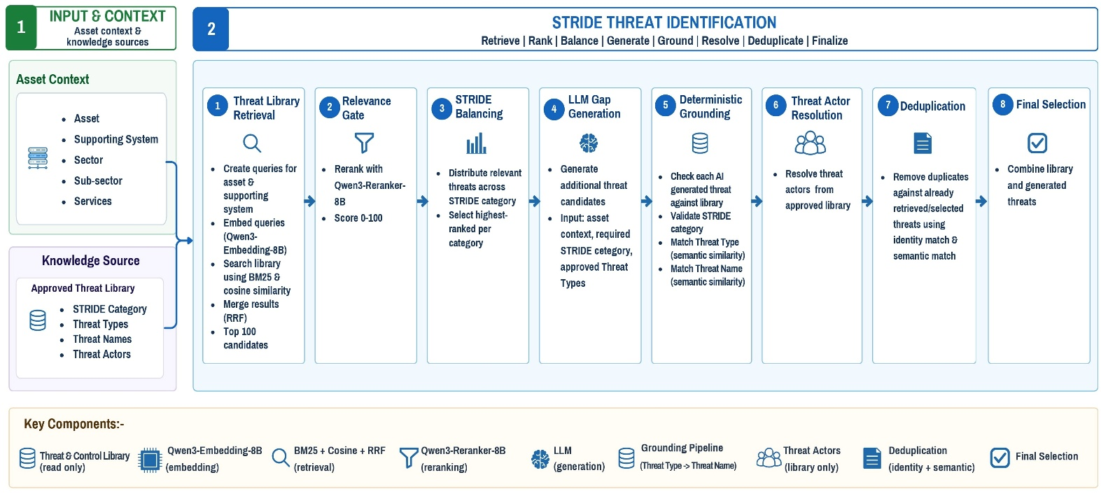
Fig 1: Logical Architecture of the STRIDE Threat Identification

3.3 Threat Scenario
Threat Scenario Generation receives the asset context, the validated and selected STRIDE threats, and a prompt. For each selected attack path it invokes the LLM once to generate a scenario narrative in a fixed response format, checks it, and stores it per attack path.
For each attack path the system builds a brief: the recorded facts of the asset and its systems, the attacker, the threat and why it applies, the entry point, and every supporting system marked as applicable or not. The brief carries names only, never database identifiers. The LLM is asked to return the scenario title, scenario statement, risk statement, assumptions, entry point, one sentence for each supporting system, and why the threat applies, and to keep within the configured word limits (150–200 words for the scenario statement and 100–150 words for the risk statement).
Each scenario is then checked. Fixed code rules block internal labels, advisory numbers the brief did not supply, citation markers, and repeated instructions. A second LLM call then reviews the scenario against its plan: when the scenario describes another threat, or the risk another impact, it is blocked; any other finding is kept as a note for the reviewer. A blocked scenario is kept for audit only, and a spare attack path takes its place when one is left. A scenario that describes the same threat as the same kind of attack as one already written in the session is given up, and titles are unique within a session.
A path the AI could not write gets a visible failure card that says why. After an AI outage the path stays open for a later set, up to five attempts, and regenerating its card writes it again. A path with an unusable answer, a missing fact, or a threat or attacker that has left the library since planning is given up, and a spare may take its place.
A set holds six attack paths by default and is written six at a time. Each scenario is saved as soon as it is written, and its controls are mapped in the background.
Controls are then mapped for each stored scenario: the threat and the scenario's own text form the query, candidate controls are retrieved from the approved Control Library, re-ranked, and attached. The user reviews the generated scenarios and can accept all, partially accept selected scenarios, reject, or regenerate them; regeneration retires the old version and keeps it in the scenario's history. Only accepted scenarios proceed to downstream risk assessment.
Controls: The query is built from the scenario's category, threat, attacker, title, asset, supporting systems, scenario statement, and risk statement. Only controls whose asset type fits the scenario's systems are searched (when none fits, the nearest of another type are offered with a warning), and controls of the AI domain only for a threat about AI. The re-ranker scores each candidate on a 0–100 scale: every control at or above the configured threshold (default 50) is kept, up to five; with fewer than three, the nearest are added to reach three; with none at the threshold, the three nearest are kept and flagged. Controls are never written by the AI.
Regeneration: The new version is asked to differ from the earlier ones. When the new version is blocked, the old version stays current and shows why. An attack path has at most one accepted version; a newer version replaces an accepted one only when the user asks for it.
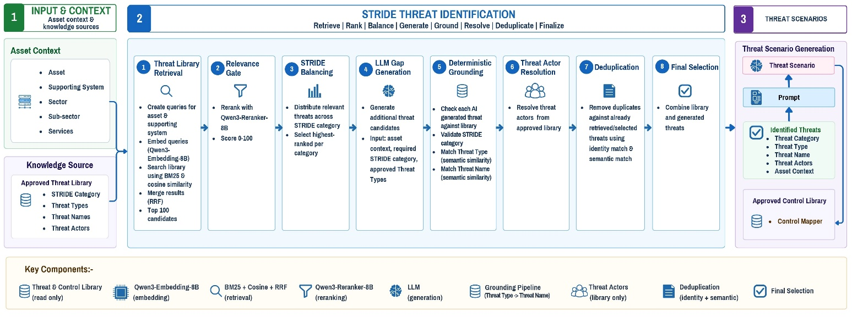

Fig 2: Logical Architecture of the Threat Scenario Generator

3.4 Open-Source Threat Data
The approved sources are imported in the background: the system checks every hour which source is due (daily, or weekly for MITRE ATT&CK). Every text is cleaned: a sentence of a description that reads as instructions to an AI is removed, and a record whose other text reads so is quarantined and never used. The current records form one active evidence snapshot, which every worker follows.
For each threat, the system searches the snapshot with the embedding model (Qwen3-Embedding-8B) and BM25 keyword matching, combined using Reciprocal Rank Fusion (RRF), and limited to the asset's IT or OT type and to approved sources. The re-ranker (Qwen3-Reranker-8B) scores the best 30 candidates, and those at or above the configured evidence threshold become evidence. A vulnerability or advisory is used only when it concerns a product the asset records. Up to three records are kept for each threat and given to the writer as plain facts, marked as untrusted data, with no identifier or link, and the writer writes one passage from the entry marked as cited. The system adds that passage to the end of the scenario statement with its citation marker, or its own sentence from the same record when the reviewer cannot confirm the passage; the scenario shows the one entry it cites. Every search is recorded on the scenario.
Evidence is searched when a set is written, for all of its threats at once. When the search cannot be made, the paths wait and are tried again. A source not refreshed for 48 hours marks the searches as stale, and its data is still used. While the open-source data is switched on, the deployment's country is given to the AI as a fact.
A session is refused while the open-source data is switched on but nothing has been imported yet. An admin can switch it off at runtime, start an import of one source or of all of them, read each source's health, withdraw a source (its data is deleted), and approve it again. Outside development the evidence threshold must be set explicitly, since each re-ranker scores on its own scale.

4. Platform Integration
This section describes how the user interacts with the module through the platform. The module is reached through a set of API endpoints; every user call is authenticated and scoped to the caller's own entity, and administrative calls use the administrative key.
Each user call sends the caller's API key and the user, entity, and tenant headers; the entity is the one the calling platform names. Starting a session accepts an Idempotency-Key, so a retried request never starts a second session. Long-running work answers at once with an identifier; the platform then follows its status by polling, or through live updates (Server-Sent Events, SSE), until it reads awaiting review, awaiting next set, complete, error, or cancelled.

4.1 Asset Selection
The user starts by selecting a single asset and one or more of its supporting systems. When the session is created, the system checks that each system is linked to the asset and retrieves the associated context, including asset type, sector, subsector, entity, and service.
The platform uses this information to automatically pre-fill the relevant fields for the user. The same resolved context is also used as input for the AI, ensuring that the information shown to the user and the information provided to the AI always remain consistent.

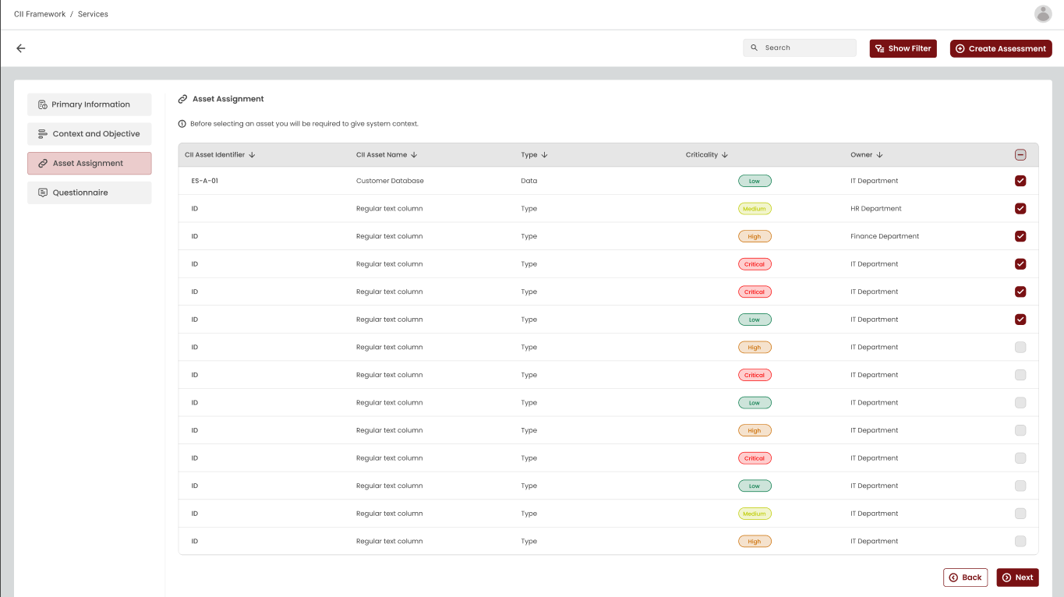

4.2 Threat Scenario Review
The platform displays AI-generated threat scenarios for user review. Users can accept all scenarios, accept selected ones, reject them, regenerate them, ask for the next set, or propose an accepted scenario's AI-written threat to the Threat Library. Only accepted scenarios are sent for downstream risk assessment.
Each scenario carries flags for the reviewer: an AI-proposed threat, a nearest or missing control, or a note from the review. A scenario can be accepted while its controls are still being mapped, but not once its library threat has been retired. When nothing is left to write, the platform is told why: everything is written, the scenario count was reached, or the remaining paths were given up.
The accepted scenarios of every session of the entity can be listed for downstream use, and the trace of how a session's plan was made can be read.
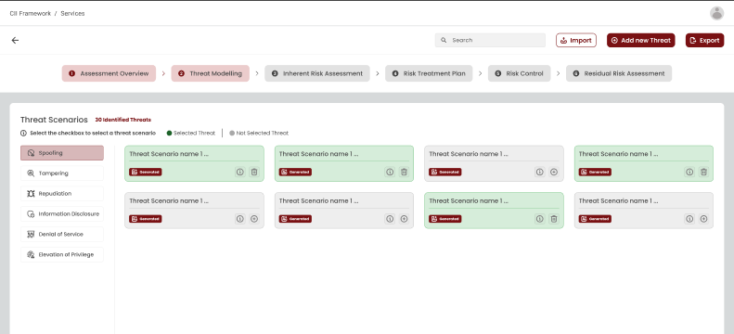

4.3 Session Control
The user can list the entity's sessions and plans still in progress, cancel a session, and delete a session with its scenarios. A cancelled session keeps what is already written, and a next set or a regenerate resumes it, unless it was cancelled before its threats were identified. A session still at work must be cancelled before it is deleted.

4.4 Library Curation
The admin lists the threats proposed to the Threat Library and approves or rejects them. An approved threat joins the live library, and a new Threat Type goes live with its first approved threat. A rejected threat is never proposed again. The admin can also build the library's search vectors at once; they are otherwise built after each library change and every 30 minutes.

5. Governance

5.1 Security
The Threat Scenario Generator applies security controls across authentication, authorization, data protection, tenant isolation, AI input handling, AI response validation, and data storage. Sensitive information such as credentials, API keys, secrets, environment variables, internal configuration is never sent to the AI model.
The platform authenticates callers with issued API keys, each verified against a stored one-way hash — the key itself is never stored. Administrative functions sit behind a separate administrative key.
System prompts are fixed, and cannot be modified at runtime, which helps prevent prompt injection and unauthorized changes to safety rules.
Only names and recorded facts reach the AI, never database identifiers, and free text is cleaned of secrets, e-mail addresses, and internal host names before it is sent. Platform data and open-source records are marked as data, never as instructions, and a scenario that repeats an instruction is blocked. Every user call is scoped to the caller's own entity. An admin issues the API keys, each shown once, and can revoke them: a revoked key stops working within a minute and ends its open live-update streams. Outside development the administrative key must be at least 32 characters long. Requests larger than the configured limit (default 2 MB) are refused. Asset data and the Threat Library are reached only through stored procedures; the only data this module writes there are the threats proposed to the Threat Library and the admin's decisions on them.
In this release, the administration calls for the open-source threat data take no key, and every change they make is audited. Health checks and metrics need no key.

5.2 Explainability and Auditability
The solution provides traceability for every threat scenario generation request.
For every chat call to the LLM that is answered, the prompt sent and the raw response received are retained, together with the model's name; the fixed system prompt is retained as a fingerprint of its versioned text. These records are kept for 14 days. The platform maintains append-only audit logs of who did what to which record, kept for one year.
Each session keeps a trace of how its threats were chosen. Each scenario keeps the findings of its checks and the version of the prompt that wrote it, and its controls keep what they were searched with and the score of every candidate.
An admin can see every job of every kind, with its status, error, retry, and worker, and the backlog of each queue. Every request carries a request id that also appears in the logs of the work it started, and the system exports metrics for monitoring.

5.3 Performance and Scalability
The system is designed to handle multiple users at once. When a user requests a scenario, the system accepts the request immediately and does the work in the background. The finished result appears once it is ready.
Key points:
- Requests are accepted straight away and processed in the background by a pool of workers.
- Each request of work is kept separate and clearly tied to the right user and entity, and one asset has at most one assessment in progress at a time.
- Multiple users can work at the same time without their requests interfering with each other.
- Work runs in stages (threats, scenarios, and controls) on separate worker queues, and scenarios are written set by set.
- AI calls are limited across all workers (by default 16 at a time), and the limit is lowered automatically when the AI service reports that it is busy; a fallback model, when one is configured, answers when the first one is busy or down.
- The Threat Library and Control Library are held in memory and refreshed within a minute of a change; their search vectors are rebuilt after each change and every 30 minutes.
- Overall performance and the number of users the system can support at the same time depend on the underlying hardware provided. Capacity is scaled by adding worker instances; more processing power, memory, and GPU capacity allow the system to handle higher load and produce results faster.

5.4 Reliability
When a store or the AI service is unavailable, the work waits and tries again (after 15, 30, 60, and 120 seconds, up to five tries), and the session shows what it is waiting for. Work whose worker stops is picked up by another worker. A cancelled session makes no further AI calls. A retry reuses the threat judgements already received and never rewrites a scenario already saved. Control mapping that fails is tried again, up to five times, by a sweep every five minutes.

