Threat Scenario Generator

Solution Design Document

Document version history
Revision history by author is indicated below:
Version | Date | Author | Comments
1.0 | 22 June 2026 |  | Initial draft, subject to revision.

Review & approvals
All design documents must be reviewed and signed off:
Version | Date | Preparer | Reviewer | Comments | Sign Off
1.0 | 22 June 2026 | Gopal Chettri

Acronyms and abbreviations
All design documents must be reviewed and signed off:
Acronym | Definition
AI | Artificial Intelligence
API | Application Programming Interface
CIA | Confidentiality, Integrity, Availability
CII | Critical Information Infrastructure
CSV | Comma-Separated Values
CSF | Cybersecurity Framework
CTI | Cyber Threat Intelligence
DREAD | Damage, Reproducibility, Exploitability, Affected Users, Discoverability
 | Ernst & Young
FTE | Full-Time Equivalent
IEC | International Electrotechnical Commission
ISO | International Organization for Standardization
IT | Information Technology
JSON | JavaScript Object Notation
KPI | K Performance Indicator
NIST | National Institute of Standards and Technology
OT | Operational Technology
PDF | Portable Document Format
SAP | Systems, Applications, and Products (in Data Processing)
STRIDE | Spoofing, Tampering, Repudiation, Information Disclosure, Denial of Service, Elevation of Privilege
UI | User Interface
UTC | Coordinated Universal Time

Table of Contents
1.Overview…………………………………………………………………………………………………………………………………………………. 4
2. Functional Description………………………………………………………………………………………………………………………….. 4
2.1 Asset Decomposition………………………………………………………………………………………………..………………… 4
2.2 STRIDE Threat Identification…………………………………………………………………………………………………………. 4
2.3 Threat Scenario…………………………………………………………………………………………………………..…………………. 5
3. Architecture Description………..……………………………………………………………………………………………………………. 5
3.1 Asset Decomposition…………………………………………………………………………………………………………………… 5
3.2 STRIDE Threat Identification…………….…………………………………………………………………………………………… 6
3.3 Threat Scenario……………………………………………………………………………………………………………………………… 7
4. Platform Integration….…………………………………………………………………………………………………………………………. 8
4.1 Asset Selection………………………………………………………………………………………………………………………………. 8
4.2 Threat Scenario Review…………………………………………………………………………………………………………………. 9
5. Governance………………………………………………………………………………………………………………………..………………….10
5.1 Security….……………………………………………………………………………………………………………………………………….10
5.2 Explainablility and Auditability……………………………………………………………………………………………………… 10
5.3 Performance and Scalability…………………………………………………………………………………………………………. 10

1.Overview
The Threat Scenario Generator is an AI-assisted capability that helps users create consistent and reviewable threat scenarios for Critical Information Infrastructure (CII) assets. It combines the selected asset's information, its supporting system context, the STRIDE threat model, and an approved Threat Library to produce a complete, reviewable set of threat scenarios for the asset. The user reviews and accepts the AI's output before anything is saved.
The goal is to make threat modelling faster, more consistent, and easier to govern. Instead of writing threat scenarios from scratch, the user works on one selected asset at a time. When the asset is selected, the system resolves its supporting system, services, and business context (sector, subsector, services). That context is then used to generate a supporting system description, to identify relevant STRIDE-aligned threats, and to generate threat scenario narratives.
AI output never becomes final automatically. Nothing is finalized without an explicit human decision. The user reviews and accepts the complete generated flow once, at the final review. Only user-accepted content is saved and carried forward, which keeps the final output controlled, validated, and suitable for downstream risk assessment.

2. Functional Description
The solution has three functional components that run in sequence for the selected asset: Asset Context Resolution, STRIDE Threat Identification, and Threat Scenario Generation
2.1 Asset Context Resolution
When a session is created, the system resolves the asset's supporting systems, services, and business context (sector, subsector, criticality) directly from platform data. This is a deterministic, code-driven step — no AI is involved. The resolved context is frozen into an auditable snapshot, so the record of "what the model saw" never changes even if the source data does later.
2.2 STRIDE Threat Identification
The STRIDE Threat Identification component identifies relevant STRIDE-aligned threats for the selected asset.
Using the accepted supporting system description, the asset, the supporting system, the service, and an approved prompt, the AI proposes candidate threat attributes: Threat Type, Threat Name, and Threat Actor. These proposals are suggestions only.
Every proposed threat is then validated against the approved Threat Library before it is used further. STRIDE is the authoritative model for the Threat Category, while the Threat Library is the source of truth for Threat Type, Threat, Threat Actor. If an AI-proposed threat cannot be confirmed against the Threat Library, it is not silently accepted: it is flagged for review by the admin, but it is never added to the library automatically. The admin can accept, reject individual flagged threat.
2.3 Threat Scenarios
The Threat Scenario Generation component generates the final threat scenario narratives.
For each selected threat, the AI uses the asset context, prompt, and the accepted STRIDE threat attributes to generate a scenario narrative. The narrative covers the scenario title, scenario statement, risk statement and controls. Suggested controls are validated against the approved control library.
The generated scenarios are displayed to the user, who can accept all, accept a subset, reject everything, or regenerate specific scenarios. Only accepted scenarios are made available downstream.

3. Architecture Description
This section describes how each component is built and how data flows through it. The whole workflow is driven by as follows -
CONTEXT RESOLUTION →THREAT IDENTIFICATION → SCENARIO GENERATION → REVIEW → DONE.
3.1 STRIDE Threat Identification
The STRIDE Threat Identification process receives the approved supporting system description, along with the related asset, supporting system, service details, and an approved prompt. It then uses the LLM to generate possible STRIDE threat attributes.
Each generated threat is validated through a deterministic grounding process to ensure it aligns with the approved Threat Library.
The validation process works as follows:
- The generated threat text is converted into embeddings using the gwen3-embedding-8b model.
- The system compares these embeddings with the Threat Library entries using cosine similarity.
- The closest matching threat entries are retrieved from the library.
- These shortlisted matches are then reordered using the re-ranker (qwen3-reranker-8b) to improve relevance.
- A confidence threshold is applied to select the best validated match.
- Inference model is glm-5

This process ensures that all AI-generated threats are validated against the approved Threat Library whenever a matching threat is found. If no suitable match is available in the library, the generated threats are still used to create threat scenarios, but the remain subject to user review and validation.

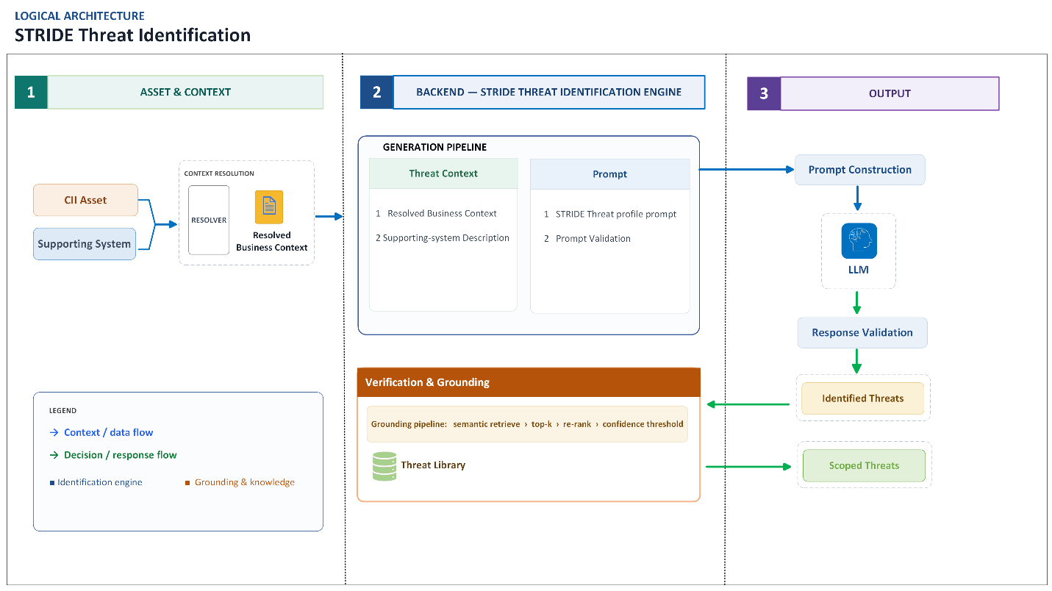
Fig 1: Logical Architecture of the STRIDE Threat Identification

3.2 Threat Scenario
Threat Scenario Generation receives the accepted asset context, the supporting system description, the validated, selected STRIDE threats and a prompt. For each selected threat it invokes the LLM once to generate a scenario narrative in a fixed response format, validates it, and stores it per threat.
The user reviews the generated scenarios and can accept all, partially accept selected scenarios, or regenerate them. Only accepted scenarios proceed to downstream risk assessment engines. The final approved scenarios are then stored in the platform.
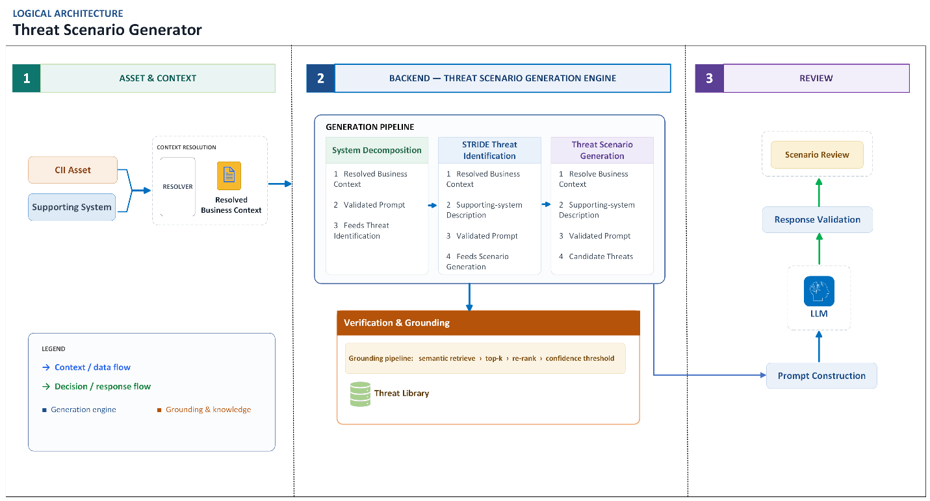
Fig 2: Logical Architecture of the Threat Scenario Generator

4. Platform Integration
This section describes how the user interacts with the module through the platform. The module is reached through a set of API endpoints.

4.1 Asset Selection
The user starts by selecting a single asset. When the session is created, the system automatically identifies the related supporting systems and services and retrieves the associated context, including asset type, sector, subsector, entity, and service.
The platform uses this information to automatically pre-fill the relevant fields for the user. The same resolved context is also used as input for the AI, ensuring that the information shown to the user and the information provided to the AI always remain consistent.

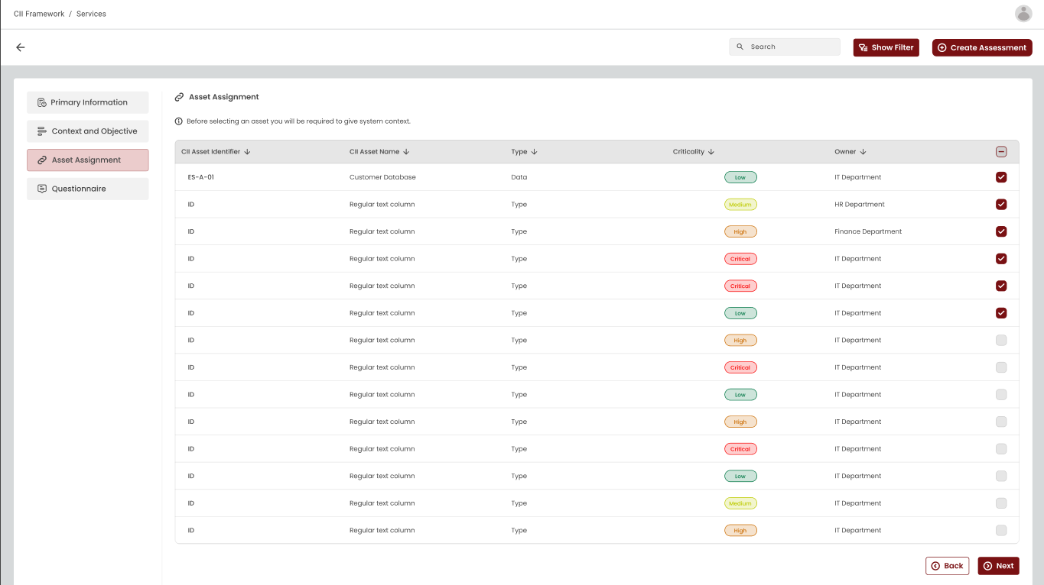

4.2 Threat Scenario Review
The platform displays AI-generated threat scenarios for user review. Users can accept all scenarios, accept selected ones, or regenerate scenarios. Only accepted scenarios are stored and sent for downstream risk assessment.

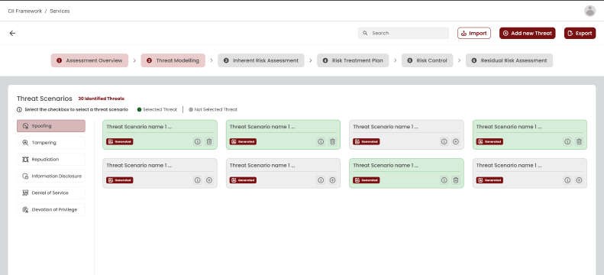

5. Governance
5.1 Security
The Threat Scenario Generator applies security controls across authentication, authorization, data protection, tenant isolation, AI input handling, AI response validation, and data storage. Sensitive information such as credentials, API ks, secrets, environment variables, internal configuration, and data from other tenants is never sent to the AI model, logged, or stored in audit records. The system also prevents AI-generated content from including exploit instructions, attack payloads, bypass techniques, executable code, or offensive guidance.
The platform uses verified JWT tokens to identify users and tenants, ensuring users can access only their own data.
System prompts are fixed, and cannot be modified at runtime, which helps prevent prompt injection and unauthorized changes to safety rules.
Accepted outputs are stored securely within the correct tenant scope.

5.2 Explainability and Auditability
The solution provides full traceability for every threat scenario generation request. Every major step in the process is recorded, including the input context, supporting system description, threat grounding and scenario generation.
The platform maintains an append-only audit trail that records details such as the stage name, subsystem, event type, user details, task ID, model information, and prompt, while excluding secrets and sensitive configuration data.

5.3 Performance and Scalability
The system is designed to handle multiple users at once. When a user requests a scenario, the system accepts the request immediately and does the work in the background. The finished result appears once it is ready.
K points:
- Requests are accepted straight away and processed in the background.
- Each request of work is kept separate and clearly tied to the right user and entity.
- Multiple users can work at the same time without their requests interfering with each other.
- Overall performance and the number of users the system can support at the same time depend on the underlying hardware provided. More processing power, memory, and GPU capacity allow the system to handle higher load and produce results faster.

