NextReel — UML Diagrams
Movie Recommendation & Sentiment Analysis System

1 Movie Recommendation System

1.1 Sequence Diagram
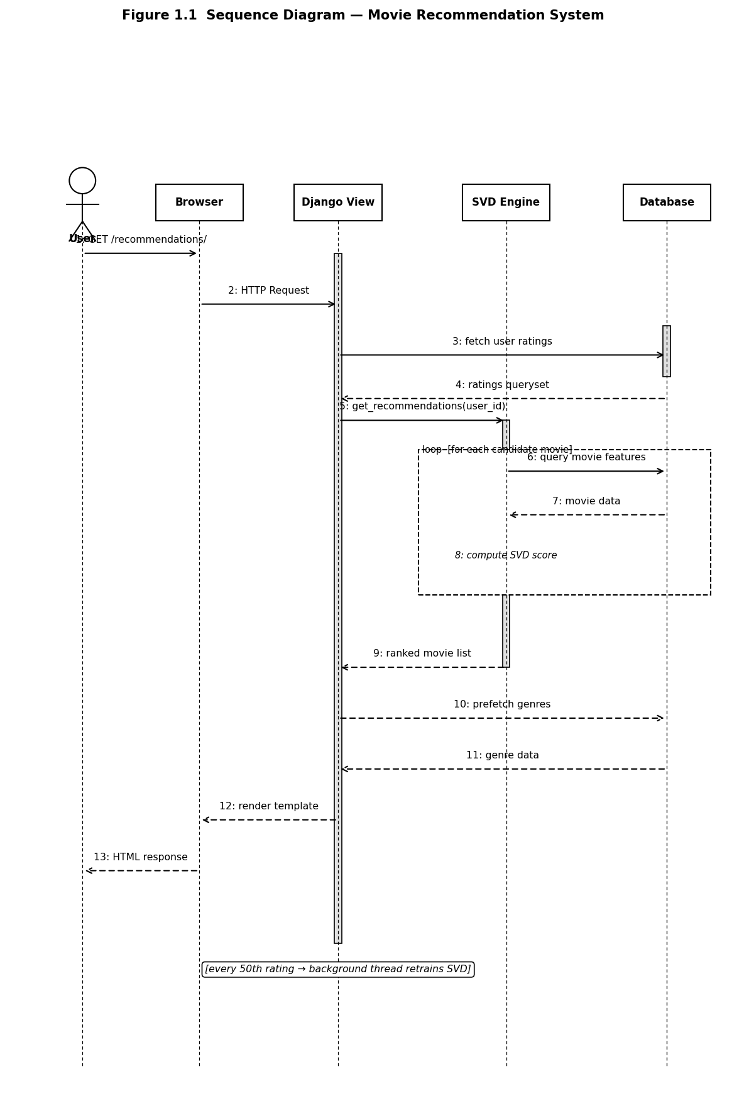
Figure 1.1 — Sequence Diagram: Movie Recommendation System

1.2 State Diagram
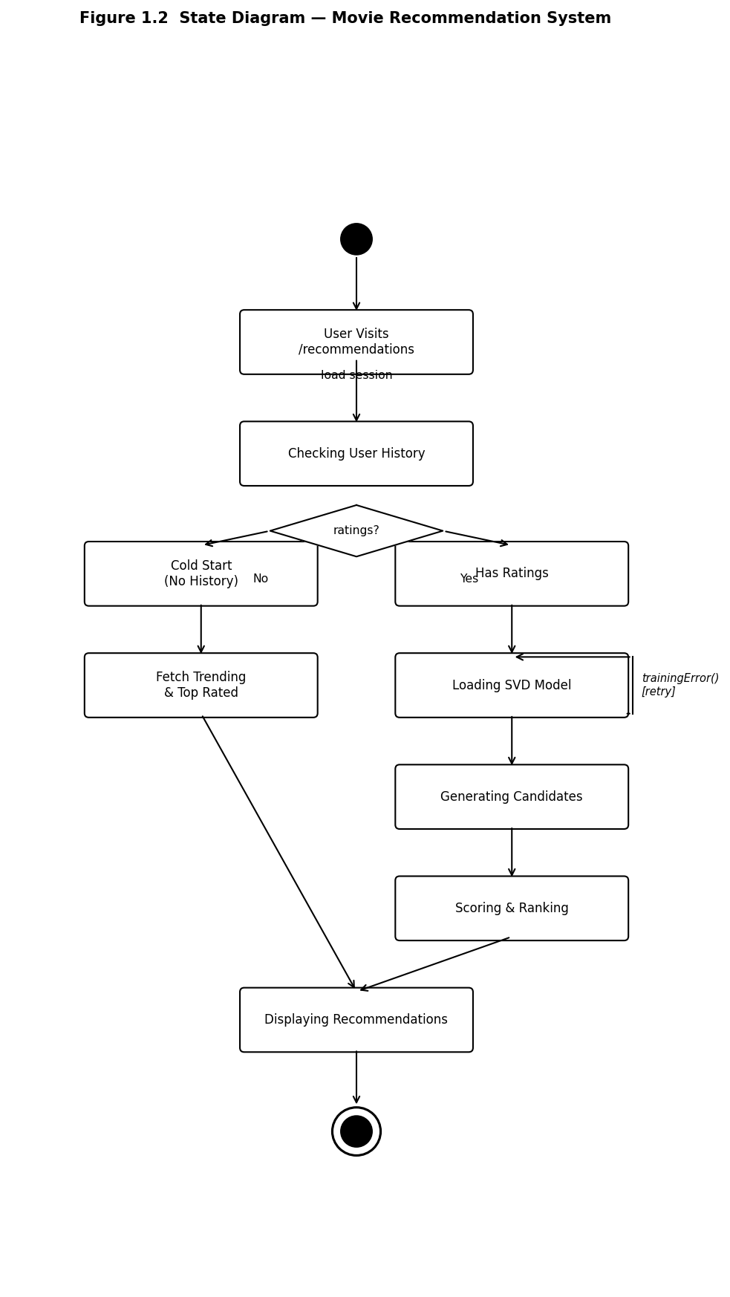
Figure 1.2 — State Diagram: Movie Recommendation System

1.3 Activity Diagram
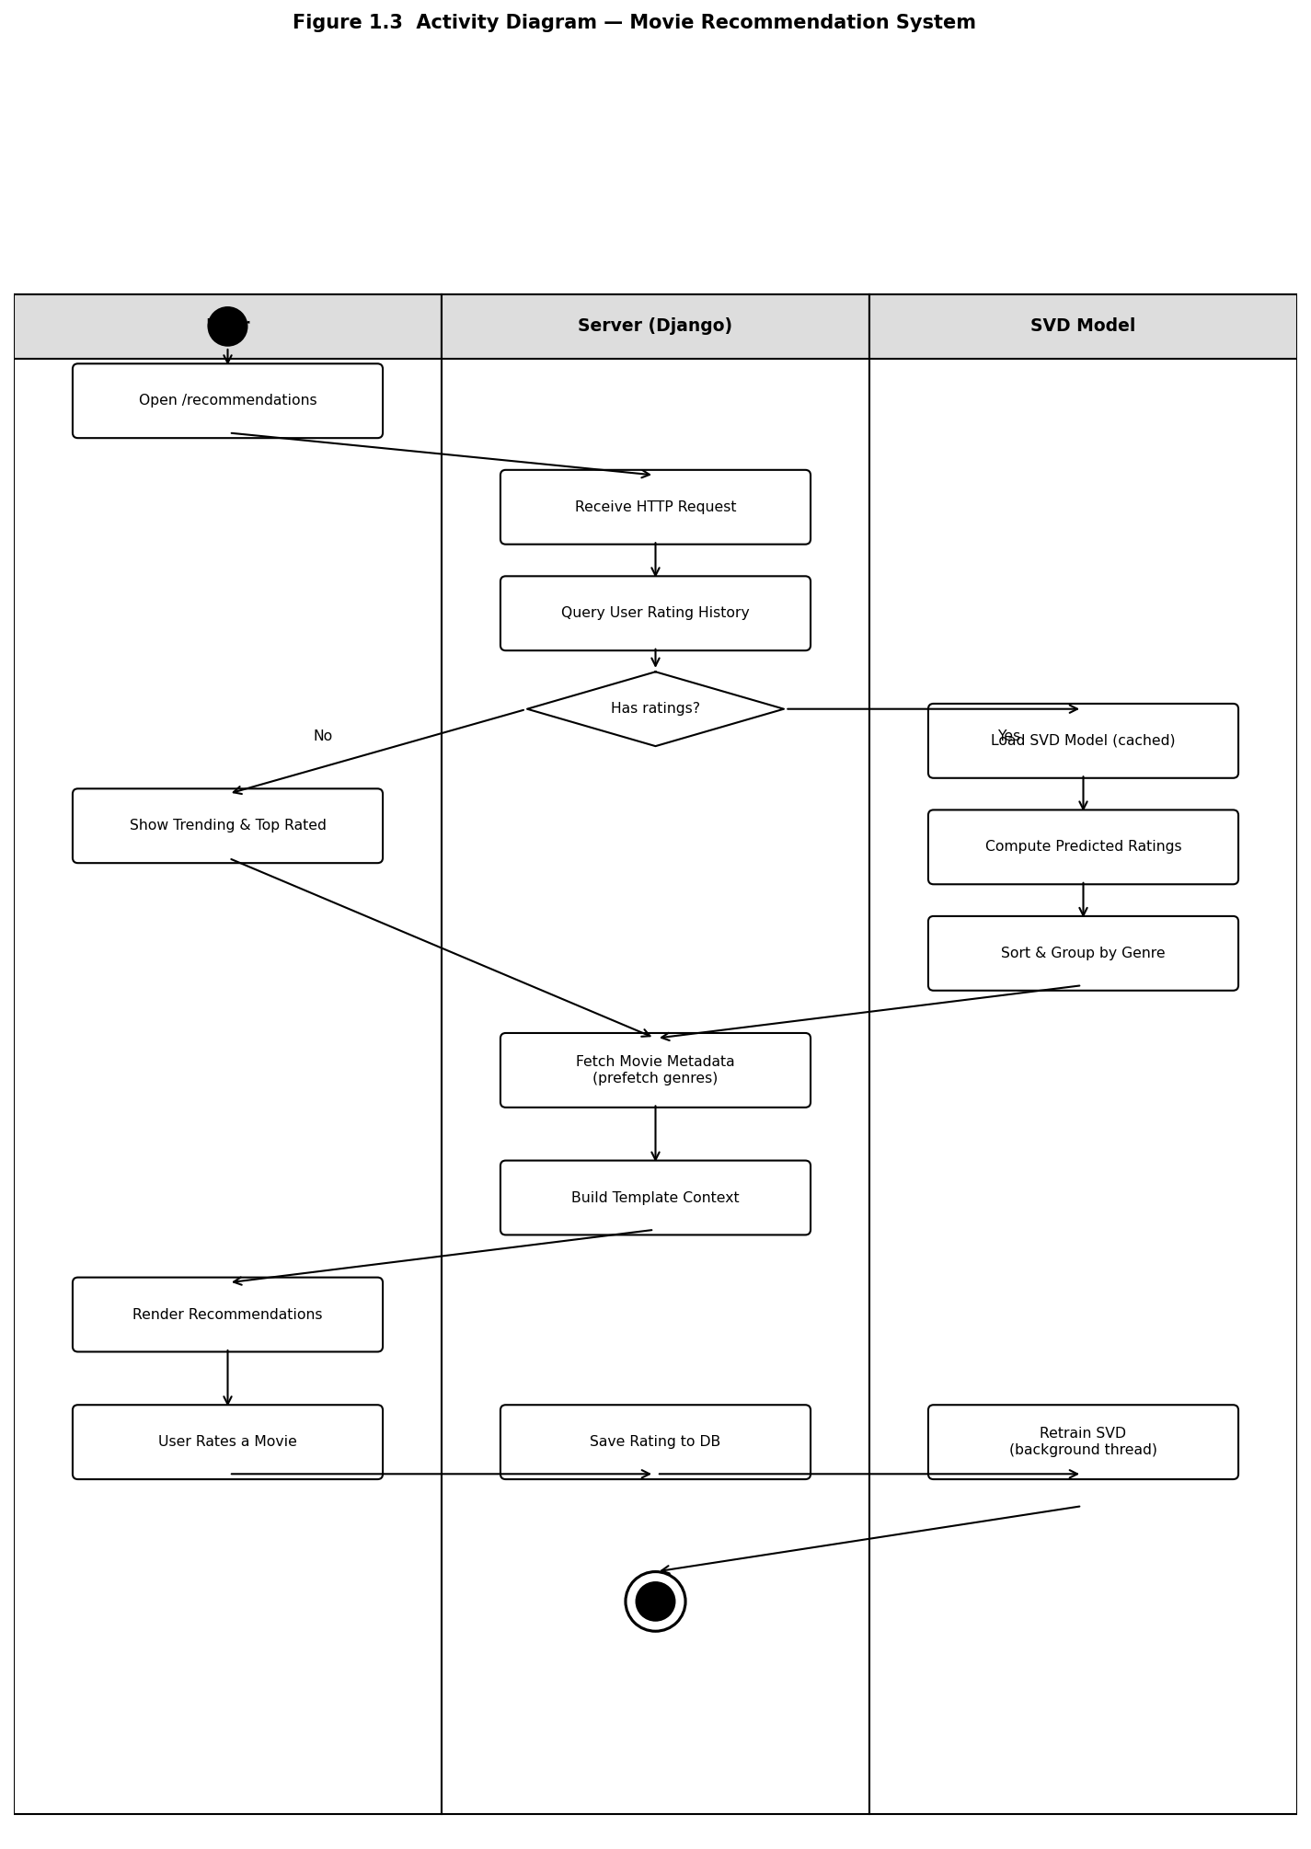
Figure 1.3 — Activity Diagram: Movie Recommendation System

2 Sentiment Analysis System

2.1 Sequence Diagram
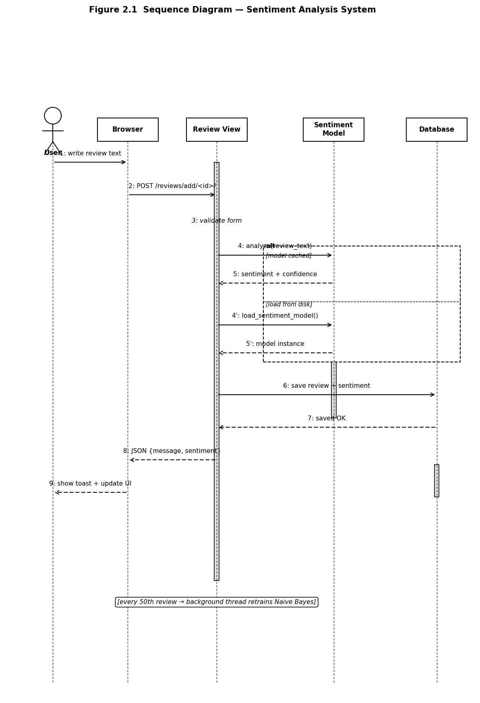
Figure 2.1 — Sequence Diagram: Sentiment Analysis System

2.2 State Diagram
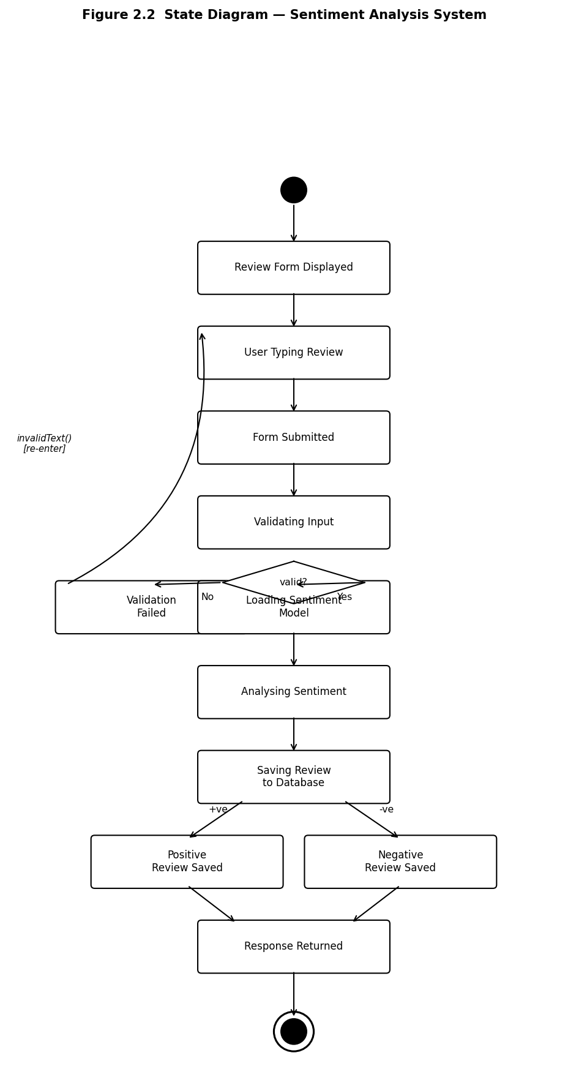
Figure 2.2 — State Diagram: Sentiment Analysis System

2.3 Activity Diagram
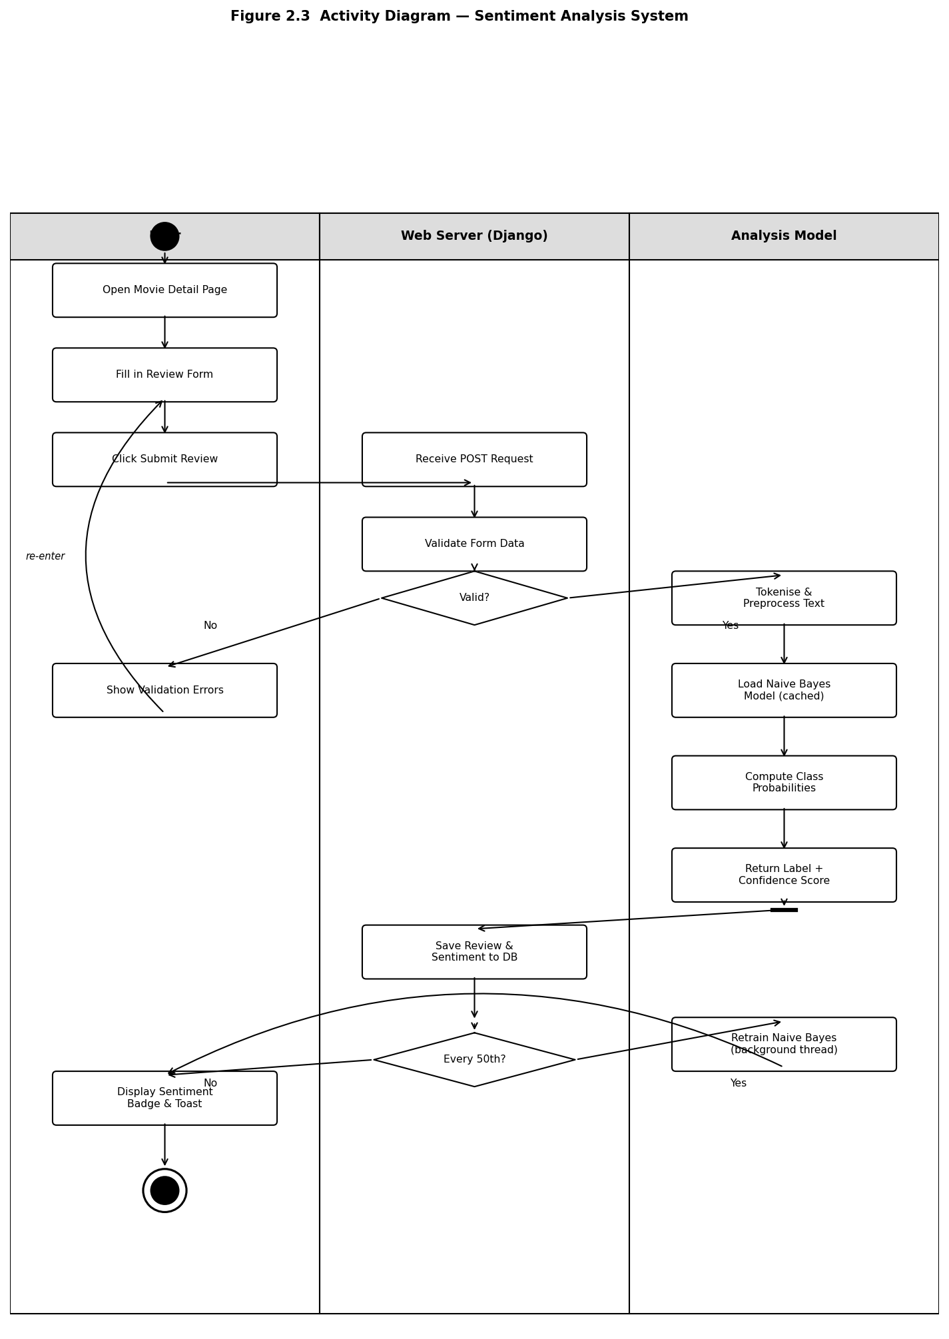
Figure 2.3 — Activity Diagram: Sentiment Analysis System

