**SUBJECTIVE ANSWER EVALUTION SYSTEM**

**A major project report submitted**

**In partial fulfillment of the Requirement For the award of the degree of**

**BACHELOR OF TECHNOLOGY**

**In**

**Electronics and Communication Engineering By**

**Gopal Jha Atul Rai Gagan Mittal (00714807320) (00314807320) (00614807320)**

**Under the supervision of**

**Mr. Nitin Sharma, Assistant Professor**



**To**

**MAHARAJA AGRASEN INSTITUTE OF TECHNOLOGY SECTOR 22, ROHINI, DELHI**

**CERTIFICATE**

Certified that **Atul Rai (00314807320) , Gopal Jha (00714807320) , Gagan Mittal (00614807320)** has/have carried out the major project work presented in this report entitled “Title of the project” for the award of Bachelor of Technology in Electronics and Communication Engineering from Maharaja Agrasen Institute of Technology affiliated to GGSIP University, Delhi under my/our supervision. The report embodies results of original work and studies as carried out by the student(s) himself/herself.

Prof. (Dr.Sunil Mathur)

Professor & HOD, ECE Assistant Professor, ECE Date:

**SUBJECTIVE ANSWER EVALUTION SYSTEM**

**ABSTRACT**

Personal robotic assistants help reducing the manual efforts being put by human in their day-to-day tasks. In this paper, we develop a voice-controlled personal assistant robot. The human voice commands are given to the robotic assistant remotely, by using a smart mobile phone. Smart Traffic Control Robot Using Voice Assistant has been developed by using multiple features of hardware components in IoT. Traffic optimization is achieved using IoT made robot for efficient utilizing allocating varying time to all traffic signal according to available vehicles count in road path. Smart Traffic Management System is implemented to deal efficiently with problem of congestion and perform re-routing at intersections on a road. This research presents an effective solution for rapid growth of traffic flow particularly in big cities which is increasing day by day and traditional systems have some limitations as they fail to manage current traffic effectively. Keeping in view the state-of-the-art approach for traffic management systems, a smart traffic management system is proposed to control road traffic situations more efficiently and effectively.

**ACKNOWLEDGEMENTS**

I express our deep gratitude to **Dr.Nitin Sharma**, our project Mentor, Department of Electronics & Communication Engineering for her valuable guidance and suggestion throughout my project work. I am thankful to my friends, Project Coordinators, for their coordination. I would like to extend my sincere thanks to Head of the Department, **Dr.Sunil Mathur** sir. This work could be possible due to the guidance and support of many people.

|  |  |  |
| --- | --- | --- |
| Gopal Jha | Atul Rai | Gagan Mittal |
| (00714807320) | (00314807320) | (00614807320) |

TABLE OF CONTENTS

|  |  |  |
| --- | --- | --- |
| **S NO.** | **TITLE** | **PAGE NO.** |
| **Ch-1** | Introduction | 3 |
| **1.2** | Objective | 3 |
| **1.3** | Five reasons to use Subjective Answer Evaluation System. | 4 |
| **Ch-2** | Thesis Overview | 5 |
| **Ch-3** | Project requirements | 7 |
| **3.1** | Libraries required | 7 |
| **3.1.1** | Tenser Flow | 7 |
| **3.1.2** | Render | 9 |
| **3.1.3** | React.js | 10 |
| **3.1.4** | Github | 11 |
| **3.1.5** | Vite | 14 |
| **3.2** | Netilfy | 15 |
| **3.2.3** | Node JS | 16 |
| **3.2.4** | MongoDB | 17 |
| **Ch-4** | Working | 19 |
| **4.1** | Working structure | 19 |
| **4.2** | Working principle of TenserFlow | 20 |
| **4.3** | Natural Language Processing(NLP) | 22 |
| **Ch-5** | Project Code | 23 |
| **5.1** | JavaScript Code | 23 |
| **5.2** | React Libaries | 29 |

|  |  |  |
| --- | --- | --- |
| **5.3** | User Interface code | 35 |
| **5.3.1** | Front End Code | 35 |
| **5.3.2** | Back End Code | 36 |
| **Ch-6** | Project images | 37 |
| **6.1** | Files Structure Images | 38 |
| **6.2** | Software Images | 39 |
| **Ch-7** | Conclusion and Future plans | 40 |
| **7.1** | Conclusion | 40 |
| **7.2** | Future Plans | 40 |
| **Ch-8** | References | 41 |

## CHAPTER -1 INTRODUCTION

* 1. **INTRODUCTION**

The subjective answer assessment system is an advanced instrument created to evaluate and score answers to open-ended questions, essays, and other types of subjective writing. To provide a trustworthy and impartial evaluation of subjective responses, it combines cutting-edge natural language processing (NLP) methods with machine learning algorithms.

Traditional approaches to subjective answer evaluation frequently rely on human judgement, which can be arbitrary, laborious, and inconsistent. By leveraging the power of natural language processing and machine learning, the subjective answer evaluation system revolutionizes the way we evaluate subjective answers. It streamlines the evaluation process, enhances efficiency, and promotes fairness, ultimately benefiting both educators and learners in their pursuit of knowledge and excellence.

By automating the evaluation process, the subjective answer evaluation system seeks to get beyond these restrictions and enable quicker and more consistent assessments.

This system is based on a solid foundation of in-depth linguistic knowledge and contextual sensitivity. The system may offer thorough feedback on the calibre, depth, and effectiveness of a written response by examining several linguistic elements like grammar, syntax, coherence, and vocabulary.

The subjective answer evaluation system's capacity to deliver immediate feedback and cut down on the time and labour needed for manual grading is one of its main advantages. It increases productivity and enables educators, examiners, and evaluators to provide learners with rapid feedback by allowing them to evaluate a high volume of responses quickly.

The subjective answer evaluation system can be used in a variety of contexts, including job applications, content moderation, and research evaluations, in addition to educational settings. It is a great tool for any situation requiring the examination of subjective written responses because to its adaptability and versatility.

The subjective answer evaluation system reinvents itself by utilising the power of natural language processing and machine learning.

##### OBJECTIVE

In order to ensure justice, consistency, and efficiency in the assessment process, the subjective answer evaluation system aims to provide an automated and trustworthy technique for reviewing and evaluating subjective written responses. The following objectives are pursued by the system:

Standardisation: By following to predetermined assessment criteria, the method aims to establish a standardised and consistent way to evaluating subjective responses. This goal makes ensuring that every response is evaluated using the same criteria, preventing biases and fostering fairness.

Efficiency: By using the subjective answer evaluation technique, human grading time and effort should be drastically decreased. By automating the evaluation process, educators, examiners, and evaluators are better equipped to handle a huge number of responses quickly and give learners feedback on time. Objectivity: The system seeks to analyse subjective responses in a fair and objective manner by utilising cutting-edge natural language processing (NLP) strategies and machine learning algorithms. It examines linguistic elements including grammar, syntax, coherence, and vocabulary to reduce the influence of judgement and produce a more accurate evaluation.

Feedback generation: The method aims to provide learners with thorough and helpful feedback. It seeks to highlight areas for improvement, offer advice for boosting coherence, organisation, and clarity, and offer suggestions for boosting the general calibre of subjective replies.

The subjective answer evaluation system strives to be flexible enough to accommodate many settings and domains. It ought to be able to support a range of evaluation standards and rubrics, enabling customisation according to particular needs in academic, professional, or research environments.

Enhancing Learning Outcomes: In the end, the subjective response evaluation system's goal is to help students learn more effectively. It aids learners in understanding their strengths and shortcomings by giving immediate feedback that is constructive, allowing them to improve their writing and their performance as a whole.

By pursuing these goals, the subjective response assessment system seeks to transform the evaluation procedure, improve effectiveness, advance fairness, and eventually support learners' growth and development in their pursuits of further education, the workforce, and personal fulfilment.

##### FIVE REASONS TO USE SUBJECTIVE ANSWER EVALUTION SYSTEM

* + 1. Consistency and Standardisation: Ensuring consistency and standardisation in the evaluation process is one of the main justifications for employing a subjective answer evaluation system. Inconsistent grading might result from individual biases or subjective judgements among human evaluators. By using an automated system, responses are assessed in accordance with predetermined criteria, removing subjectivity and delivering uniform evaluations.
    2. Efficiency in Time and Resources: Manual subjective answer evaluation frequently takes a lot of time and resources. The evaluation procedure can be expedited by employing an automated system, enabling instructors and examiners to evaluate a greater number of responses in less time. This effectiveness improves production, offers prompt feedback to students, and optimises resource use.
    3. Objective Evaluation: Due to the nature of subjective responses, it can be difficult to assess them objectively. Advanced natural language processing (NLP) methods and machine learning algorithms are used in a subjective answer evaluation system to analyse linguistic characteristics, coherence, and other factors objectively. This neutrality guarantees fair and unbiased assessments, giving a more precise appraisal of the calibre of responses.
    4. Immediate Feedback: The capacity of a subjective response evaluation system to give learners immediate feedback is a big advantage. The learning process can be hampered by delays in feedback due to waiting for manual grading. Automated systems provide real-time evaluations, allowing students to quickly pinpoint areas for development, correct errors, and deepen their grasp of the material.
    5. Subjective answer evaluation systems are scalable and flexible enough to be applied to a variety of educational contexts and fields. They can manage high numbers of responses without sacrificing the accuracy of the evaluation. These systems can also be customised in accordance with particular needs by supporting a variety of evaluation criteria and rubrics. The system is ideal for a variety of applications due to its scalability and flexibility, including those in educational institutions, competitive tests, job evaluations, and research assessments.
    6. In conclusion, consistency and standardisation, time and resource efficiency, objective assessment, instant feedback, and scalability and adaptability are the five main reasons for establishing a subjective answer evaluation system. Such methods contribute to a fair and effective evaluation of subjective written responses by resolving these issues, greatly improving the review process and learning outcomes.

## CHAPTER – 2 THESIS OVERVIEW

###### 2.1 ORGANIZATION OF THESIS

The thesis is organized into eight chapters including the chapter of introduction and references. Each chapter is different from the other and is described along with the necessary theory required to comprehend it.

**CHAPTER – 1 INTRODUCTION:** This chapter gives the description of the project and introduce the with brief explanation.

**CHAPTER – 2 THESIS OVERVIEW:** This chapter deals with how the project report is formatted and organized and gives information about all the chapters present in the report.

**CHAPTER – 3 PROJECT REQUIREMENTS:** In this chapter all the details of the hardware required in this project and also talk about the software required in this chapter and provide enough information about each topic.

**CHAPTER – 4 WORKING:** This chapter deals with all the working principle of the project and how the data is flowing in the project with the help of flow chart explanation.

**CHAPTER – 5 PROJECT CODE:** This chapter shows the entire source code of the project which are implemented in the project.

**CHAPTER – 6 PROJECT IMAGES:** In this chapter the project’s software and hardware images are shown.

**CHAPTER – 7 CONCLUSION AND FUTURE PLANS:** This chapter provide the conclusion of the project and also explain future implementation of the project.

**CHAPTER – 8 REFERENCES:** This chapter deals with the sources for this project which provide idea and formation of the project.

## CHAPTER – 3 PROJECT REQUIREMENTS

##### LIBRARIES REQUIRED

* + 1. **TENSORFLOW**

A Google created the open-source machine learning framework known as TensorFlow. It offers a whole ecosystem of resources, tools, and libraries for creating and implementing machine learning models. For its support of deep learning methods and neural networks, TensorFlow is particularly well-known.The term "tensor," which describes multi-dimensional arrays used in mathematics and physics, is where the name "TensorFlow" comes from. Tensors in TensorFlow stand in for the basic data structures that move along the computing graph. The graph represents a sequence of operations or calculations on these tensors that result in the development of machine learning models.

Flexibility: You may create and train a wide range of machine learning models using TensorFlow, from straightforward linear models to intricate deep neural networks.

Scalability: TensorFlow offers methods for dividing training across numerous CPUs or GPUs, allowing for effective use of computing power and the training of larger models.

High-level APIs: TensorFlow provides high-level APIs, such as Keras, that make it easier to create and train neural networks. The development of models is simplified by these APIs, which abstract away numerous difficulties.

Optional deployment platforms include desktops, servers, mobile devices, and even embedded systems. TensorFlow is compatible with these platforms. Because of their adaptability, models can be used in a variety of settings.

TensorFlow offers visualisation tools like TensorBoard that let you see and analyse the neural network's internal representations, model performance, and training process.

TensorFlow has become more well-known as a result of the wide-ranging community support, comprehensive documentation, and several pre-trained models made available via TensorFlow Hub. For many different applications, including as image identification, natural language processing, recommendation systems, and others, it has received widespread adoption.

**3.1.2 :-RENDER**

Developers have always been forced to pick between two extremes of cloud infrastructure: expensive yet inflexible platforms that fail to scale, or complex large clouds that impose steep learning curves and massive operations teams.

Render offers the best of both worlds — incredible ease of use coupled with immense power and scalability to power everything from a simple HTML page to complex applications with hundreds of microservices.

**3.1.3:- REACT.JS**

The open-source JavaScript package React.js, sometimes known as React, is used to create user interfaces (UIs) for web applications. Facebook created it, and it was published in 2013. With React, developers can easily manage the state of the application and construct reusable UI components.

React is fundamentally a declarative framework for creating user interfaces. According to the state of the application, developers specify how the user interface (UI) should appear and function, and React handles updating the UI to reflect those changes. Complex user interfaces are simpler to maintain and reason about when written in a declarative language.

React.js's salient features include:

Component-Based Architecture: React encourages programmers to separate the user interface into reusable components, each of which contains its own logic and UI elements. The modular design encourages code reuse and maintainability.

Virtual DOM: React makes use of the Virtual DOM, a digital replica of the real Document Object Model (DOM). React updates the virtual DOM and effectively applies the necessary modifications to the actual DOM when the state of a component changes, minimising needless re-rendering and enhancing efficiency.

JSX: React makes use of the JSX syntax extension, which enables programmers to write HTML-like code inside of JavaScript. This makes the process of developing and composing components more natural.

React adheres to a unidirectional data flow, commonly referred to as one-way binding. Data flows from the parent component to child components in a single route, ensuring predictable state management and minimising problems.

React Hooks: Hooks are functions that let developers leverage state and other React features in functional components. They were first introduced in React 16.8. Hooks offer a less complex alternative to class components and make managing stateful logic simpler.

Due to its effectiveness, scalability, and community support, React.js has become incredibly popular among developers. To create strong online applications, it is frequently used in

##### 3.1.4:- GITHUB

Software development and project management are made easier by GitHub, a web-based platform for version control and collaboration. Git repositories, which are frequently used to manage code changes and coordinate the work of numerous developers, are hosted by it.

Here are some essential GitHub features and ideas:

Git: Git is a distributed version control system that enables programmers to manage source code, track changes, and communicate. GitHub offers an internet infrastructure for hosting Git repositories and expands on Git's features.

Repository: A repository, often known as a "repo," is a group of documents and directories that make up a project. It includes every version of the project's files as well as a detailed history of all the changes made to them.

Version Control: Managing and tracking changes made to project files is known as version control. Developers can generate and manage several versions of their codebase using Git, which is integrated with GitHub. This makes it simpler to collaborate, roll back changes, and keep a clear development history.

Collaboration is made easier by GitHub, which lets several developers work on the same project at once. It offers tools like pull requests, code reviews, and problem tracking to facilitate efficient team cooperation and communication.

Pull Requests: A feature of GitHub that enables developers to propose modifications they have made in their own copies (branches) of a repository is called a pull request. If the modifications are accepted, other team members can examine them, offer suggestions, and merge them into the main branch.

Issue Tracking: GitHub has an integrated issue tracking system where team members can discuss enhancements, report errors, and suggest new features. Work may be more easily organised and prioritised because to the ability to assign, classify, and comment on issues.

Continuous Integration and Deployment: GitHub connects with many CI and CD solutions, enabling developers to automate the process of building, testing, and deploying their projects.

3.1.5:- VITE

An open-source framework for creating web applications called Vite seeks to make the development process quicker and more effective. It is generally utilised for creating cutting-edge online applications, especially progressive web apps (PWAs) and single-page applications (SPAs).

Evan You, the same programmer who made the well-known JavaScript framework Vue.js, is the creator of Vite, which translates to "fast" in French. Vite is made to take advantage of the native ES module system of contemporary web browsers to accelerate build and development times.

Vite's main characteristics and advantages include:

Instant Server Startup: Vite uses ES module imports to adopt a dev server that starts up very immediately, enabling developers to observe changes immediately without having to wait for the server to reload.

Lightning-Fast Hot Module Replacement (HMR): Vite offers an incredibly effective HMR system that makes it possible to quickly replace modules while developing, giving developers immediate feedback when they edit the code.

Built-in Support for Vue.js: Vite has seamless integration with Vue.js, allowing developers to leverage its powerful features, such as single-file components, reactivity, and component-based architecture.

Optimized Build Process: Vite optimizes the build process by leveraging ES module bundling during production builds. This results in smaller bundle sizes and faster load times for users.

Flexible Plugin System: Vite provides a plugin system that enables programmers to increase its functionality and modify the construction procedure to meet their own needs.

##### 3.2:- Netify

##### The most well-liked method for creating, deploying, and scaling modern online applications is Netlify. Developers adore Netlify for its robust yet user-friendly processes, which make it simple for them to integrate the tools of their choice and work with their team to quickly provide the greatest online experiences.

##### Today, Netlify is the platform of choice for running modern Jamstack web applications in production, from large corporate websites to complex e-commerce and SaaS systems. It is home to millions of developers and thousands of businesses.

##### The San Francisco-based software startup Netlify, which was founded in 2014, has a worldwide staff.

##### Publish amazingly fast webpages and programmes directly from GitHub. The Netlify platform links your repositories to a single workflow for continuous integration, worldwide CDN deployment, and automatic (and cost-free) HTTPS. On specialised build infrastructure, Netlify builds your site, prerenders markup, and optimises assets each time you make changes. Any site generator, including Gatsby, Hugo, and Jekyll, can easily be the centre of a fully automated workflow.

##### Launch your website immediately from GitHub

##### Install your website on a highly redundant global CDN that has been designed specifically for delivering pages and assets swiftly and reliably.

##### deploy automatically

##### When you push to your Git repository, Netlify's integrated Continuous Deployment automatically executes your build scripts and deploys the outcome.

##### 3.2.3:- Node JS

An open-source, cross-platform runtime environment and library for JavaScript is called Node.js, and it is used to run web applications outside of the client's browser. It was created in 2009 by Ryan Dahl, and version 15.14 of it was made available in April of 2021. Node.js is used by developers to build server-side web applications, and because it employs an asynchronous, event-driven approach, it is ideal for data-intensive applications.

After learning more about Node, let's examine why it is used so frequently in web development.

NodeJs is constructed using the V8 engine from Google Chrome, which results in an extremely speedy execution time.

Developers can import any of the more than 50,000 bundles in the Node Package Manager at any moment in accordance with their required functionality, saving a significant amount of time.

NodeJs is highly helpful for developing real-time and data-intensive web apps because it does not require waiting for an API to return data. Because of its wholly asynchronous nature, it is completely non-blocking.

NodeJs has a better synchronisation of the code between the client and server, which decreases the amount of time that an audio or video takes to load.

Single Threaded Architecture: NodeJs adheres to a single threaded architecture with event looping, which increases NodeJs' scalability. They create fewer threads than other servers do in order to process requests. The NodeJS servers respond in a non-blocking or asynchronous way for the event-driven mechanism, which makes NodeJS more scalable. NodeJs can be said to handle more requests when compared to other conventional servers like Apache HTTP servers. NodeJS runs a single threaded programme, which enables it to handle a large number of requests.

Scalable: The majority of businesses today want scalable software. Scalability, one of the most important issues in software development, is addressed by NodeJs. Using NodeJs, concurrent requests may be managed quite effectively. NodeJs uses a cluster module to manage load balancing across all of the active CPU cores. The most compelling aspect of NodeJs is its ability to partition programmes horizontally, which is primarily made possible by the usage of child processes. With the use of this feature, separate app versions are offered to the various target markets, and it also enables customization so they may accommodate to the tastes of the users.

**3.2.4:- MongoDB**

* 1. **SOFTWARE REQUIRED**

**3.2.1 C++**

C++ is one of the world's most popular programming languages. It can be found in today's operating systems, Graphical User Interfaces, and embedded systems. It is an object-oriented programming language which gives a clear structure to programs and

allows code to be reused, lowering development costs. It is portable and can be used to develop applications that can be adapted to multiple platforms.

It is fun and easy to learn. It is regarded as a middle-level language, as it comprises a combination of both high-level and low-level language features. It is used by hundreds of thousands of programmers in essentially every application domain. It is being highly used to write device drivers and other software that rely on direct manipulation of hardware under real-time constraints. It is widely used for teaching and research because it is clean enough for successful teaching of basic concepts.

EXAMPLES: -

* Bloomberg (financial formation),
* Amazon (Web commerce), Google (Web search)
* Facebook (social media)

###### THE ARDUINO INTEGRATED DEVELOPMENT ENVIROMENT

Writing and compiling the code into the Arduino Module is done by an open-source software that is Arduino IDE. The Arduino software makes code compilation very easy that even a common person with no prior technical knowledge can understand.

It is easily available for operating systems such as MAC, Windows, Linux and runs on the Java Platform which comes with inbuilt functions and commands that play a important role for editing, debugging and compiling the code There are different types of Arduino modules such as Arduino Leonardo, Arduino Micro, Arduino Uno, Arduino Mega, and many more. Each of them has a microcontroller which is programmed and accepts the information in the form of code.

The main code known as a sketch which when created on the IDE platform will generate a Hex File which is then transferred and uploaded in the controller. There are two main parts of the IDE: Editor and Compiler in which former is used for writing the

required code and later is used for compiling and uploading the code which is given into the Arduino Module. The IDE supports both C and C++ languages.

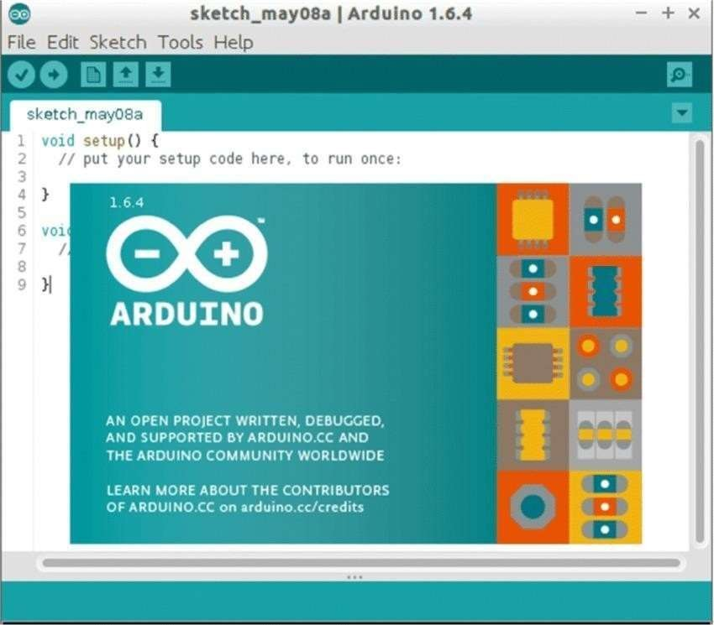

FIG: 7 ARDUINO IDE

###### NODE.JS

Node.js (Node) is an open source, cross-platform runtime environment for executing JavaScript code. Node is used extensively for server-side programming, making it possible for developers to use JavaScript for client-side and server-side code without needing to learn an additional language. Node is sometimes referred to as a

programming language or software development framework, but neither is true; it is strictly a JavaScript runtime.

A Node application runs in a single process. Node does not create a new thread for every request, as is often the case with traditional server-side programs. In this way, a Node server can handle thousands of concurrent connections without having to contend with thread concurrency issues or the overhead multithreading brings.

Node.js is event-driven and runs asynchronously. Code written for the Node environment does not follow the traditional model of receive, process, send, wait and receive found in other systems. Instead, Node implements an event loop that processes incoming requests as they stack up in the event queue, handling small requests one after the other without waiting for responses.

###### MONGODB

MongoDB, the most popular NoSQL database, is an open-source document-oriented database. The term ‘NoSQL’ means ‘non-relational’. It means that MongoDB isn’t based on the table-like relational database structure but provides an altogether different mechanism for storage and retrieval of data. This format of storage is called BSON (similar to JSON format).

Features of MongoDB: -

**Document Oriented:** MongoDB stores the main subject in the minimal number of documents and not by breaking it up into multiple relational structures like RDBMS. For example, it stores all the information of a computer in a single document called Computer and not in distinct relational structures like CPU, RAM, Hard disk, etc.

**Indexing:** Without indexing, a database would have to scan every document of a collection to select those that match the query which would be inefficient. So, for efficient searching Indexing is a must and MongoDB uses it to process huge volumes of data in very less time.

**Scalability:** MongoDB scales horizontally using sharing (partitioning data across

various servers). Data is partitioned into data chunks using the shard key, and these data chunks are evenly distributed across shards that reside across many physical servers. Also, new machines can be added to a running database.

**Replication and High Availability:** MongoDB increases the data availability with multiple copies of data on different servers. By providing redundancy, it protects the database from hardware failures. If one server goes down, the data can be retrieved easily from other active servers which also had the data stored on them.

**Aggregation:** Aggregation operations process data records and return the computed results. It is similar to the GROUPBY clause in SQL. A few aggregation expressions are sum, avg, min, max, etc.

## CHAPTER – 4 WORKING

* 1. **WORKING STRUCTURE**

In the Behavior Construction model, aiming at further analyzing and studying the behaviors of the AGV agent and Traffic agent, the state enumeration and action enumeration are conducted. The state enumeration analyzes and defines all the conditions that the AGV might encounter during the material handling process, such as working, moving, collision, and idle. And the action enumeration analyzes and defines all the actions that the AGV might take in case of various states, such as accepting tasks, collision avoidance and loading or unloading. Then the BTs of the AGV agent and Traffic agent are developed. In BTs, the states and actions of the agents can be organized

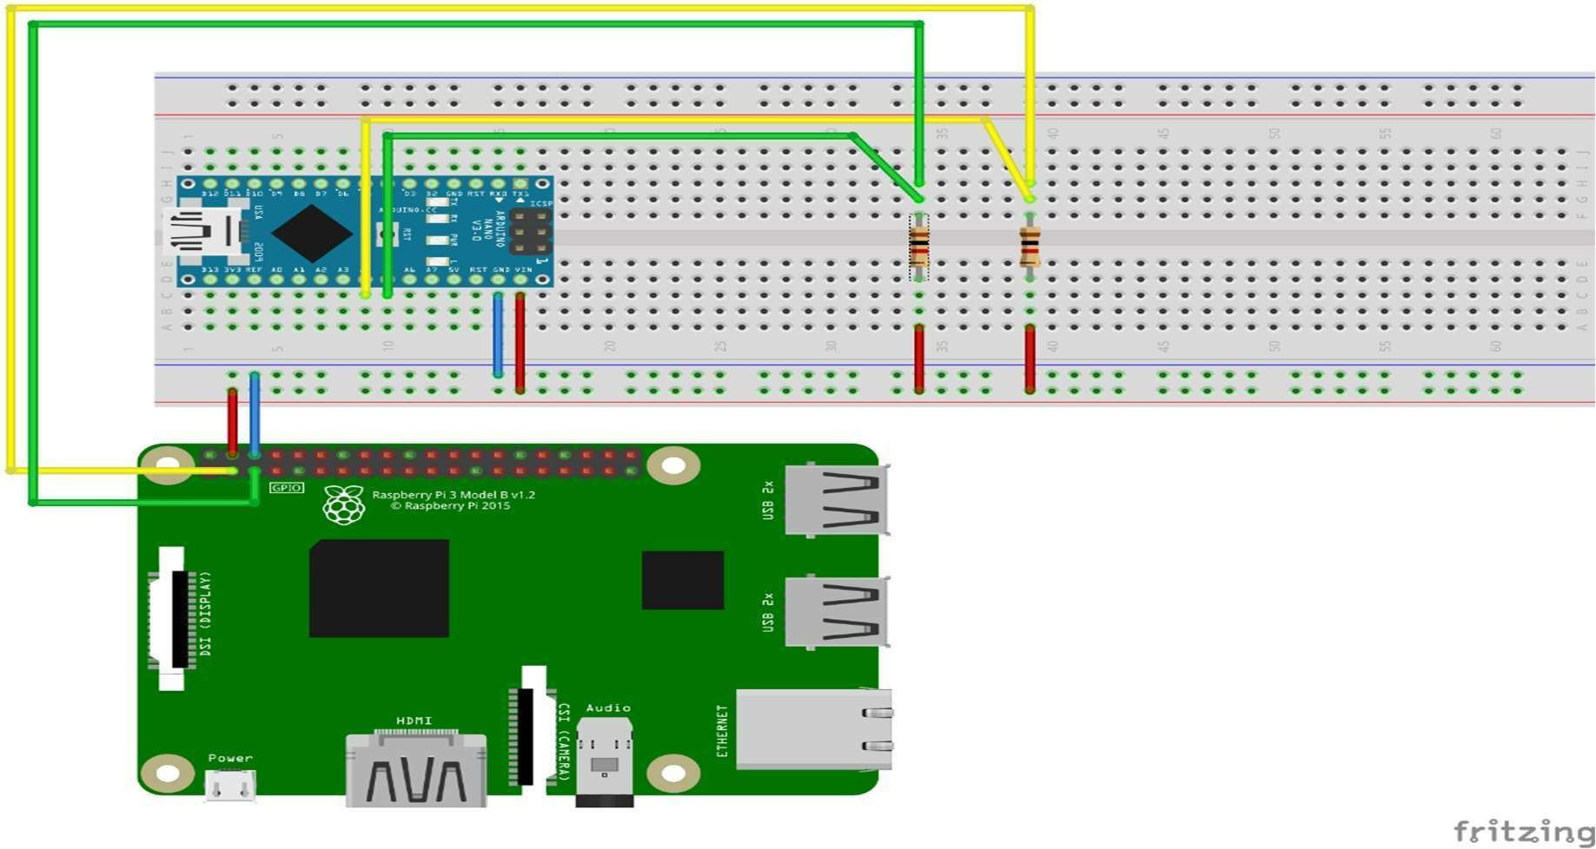

FIG: 8 CIRCUIT DIAGRAM

in a structure manner. In the Behavior Learning model, the MDP model of AGV motion is established for describing the decision-making problem of the AGVs traffic control in material handling. The MDP model mainly consists of three parts, namely state space, action space, and reward function. Moreover, RL process is further investigated based on

the MDP model. An RL algorithm, namely Q-learning, is designed to achieve the self- adaptive decision-making mechanism of collision avoidance for the AGVs. Finally, the optimized strategies would be recorded in BTs to control the AGVs

##### WORKING PRINCIPLE OF RASPBERRY Pi

The Raspberry pi is a single computer board with credit card size, that can be used for many tasks that your computer does, like games, word processing, spreadsheets and also to play HD video. It was established by the Raspberry pi foundation from the UK. It has been ready for public consumption since 2012 with the idea of making a low-cost educational microcomputer for students and children. The main purpose of designing the raspberry pi board is, to encourage learning, experimentation and innovation for school level students. The raspberry pi board is a portable and low cost. Maximum of the raspberry pi computers is used in mobile phones. In the 20th century, the growth of mobile computing technologies is very high, a huge segment of this being driven by the mobile industries. The 98% of the mobile phones were using ARM technology.

The raspberry pi comes in two models, they are model A and model B. The main difference between model A and model B is USB port. Model A board will consume less power and that does not include an Ethernet port. But the model B board includes an Ethernet port and designed in China. The raspberry pi comes with a set of open-source technologies, i.e. communication and multimedia web technologies. In the year 2014, the foundation of the raspberry pi board launched the computer module, that packages a model B raspberry pi board into module for use as a part of embedded systems, to encourage their use.

The raspberry pi board comprises a program memory (RAM), processor and graphics chip, CPU, GPU, Ethernet port, GPIO pins, Xebec socket, UART, power source connector. And various interfaces for other external devices. It also requires mass storage, for that we use an SD flash memory card. So that raspberry pi board will boot from this SD card similarly as a PC boots up into windows from its hard disk.

Essential hardware specifications of raspberry pi board mainly include SD card containing Linux OS, US keyboard, monitor, power supply and video cable. Optional hardware specifications include USB mouse, powered USB hub, case, internet connection, the Model A or B: USB WIFI adaptor is used and internet connection to Model B is LAN cable.

The raspberry pi model Aboard is designed with 256MB of SDRAM and model B is designed with 51MB.Raspberry pi is a small size PC compare with other PCs. The normal PCs RAM memory is available in gigabytes. But in raspberry pi board, the RAM memory is available more than 256MB or 512MB

The Central processing unit is the brain of the raspberry pi board and that is responsible for carrying out the instructions of the computer through logical and mathematical operations. The raspberry pi uses ARM11 series processor, which has joined the ranks of the Samsung galaxy phone.

The GPU is a specialized chip in the raspberry pi board and that is designed to speed up the operation of image calculations. This board designed with a Broadcom video core IV and it supports OpenGL

The Ethernet port of the raspberry pi is the main gateway for communicating with additional devices. The raspberry pi Ethernet port is used to plug your home router to access the internet.

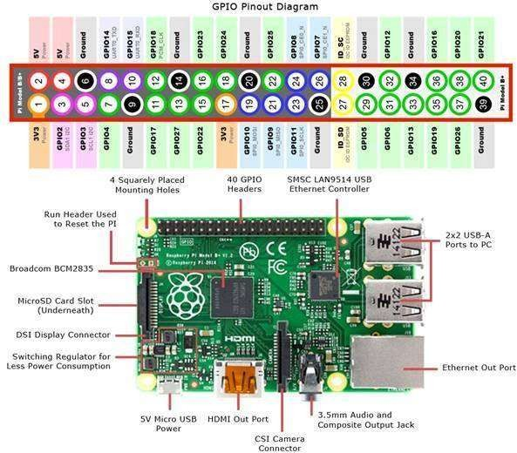

FIG: 9 Raspberry Pi 4

##### Raspberry Pi Camera

The Raspberry Pi Camera Module 2 replaced the original Camera Module in April 2016. The v2 Camera Module has a Sony IMX219 8-megapixel sensor (compared to the 5- megapixel Omni Vision OV5647 sensor of the original camera).

The Camera Module 2 can be used to take high-definition video, as well as stills photographs. It’s easy to use for beginners, but has plenty to offer advanced users if you’re looking to expand your knowledge. There are lots of examples online of people using it for time-lapse, slow-motion, and other video cleverness. You can also use the libraries we bundle with the camera to create effects.

You can read all the gory details about IMX219 and the Exmor R back-illuminated sensor architecture on Sony’s website, but suffice to say this is more than just a resolution upgrade: it’s a leap forward in image quality, color fidelity, and low-light performance. It supports 1080p30, 720p60 and VGA90 video modes, as well as still capture. It attaches via a 15cm ribbon cable to the CSI port on the Raspberry Pi.

The camera works with all models of Raspberry Pi 1, 2, 3 and 4. It can be accessed through the MMAL and V4L APIs, and there are numerous third-party libraries built for it, including the Pi camera Python library. See the Getting Started with Pi camera resource to learn how to use it.

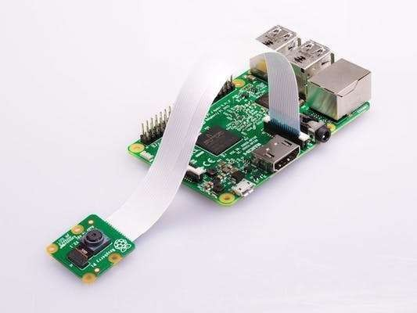

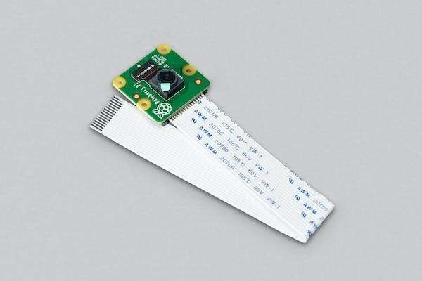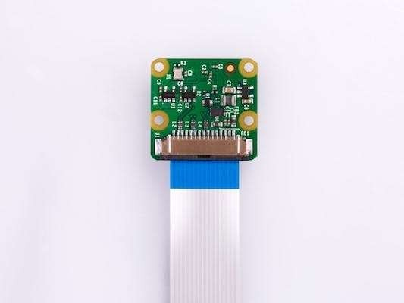

FIG: 10 PI CAMERA

* 1. **PYTHON CODE**

## CHAPTER – 5 PROJECT CODE

import speech_recognition as sr # voice recognition library import random # to choose random words from list

import pyttsx3 # offline Text to Speech

import datetime # to get date and time

import webbrowser # to open and perform web tasks

import serial # for serial communication

import pywhatkit # for more web automation import subprocess

import time import os

# Declare robot name (Wake-Up word) robot_name = 'sanjay' time=time.strftime("%I:%M %p") date=datetime.date.today()

hi_words = ['hi', 'hello', 'radhe radhe', 'hai'] bye_words = ['bye', 'tata', 'hasta la vista'] r_u_there = ['are you there', 'you there']

# initilize things

engine = pyttsx3.init() # init text to speech engine #voices = engine.getProperty('voices') #check for voices #engine.setProperty('voice', voices[1].id) # female voice

listener = sr.Recognizer()

# initialize speech recognition API

# connect with NiNi motorcan't find ' main ' module in '' driver board over serial communication

try:

port = serial.Serial("COM3", 9600) print("Phycial body, connected.")

except:

print("Unable to connect to my physical body") def listen():

try:

with sr.Microphone() as source: talk("How can I help you sir")

# get input from mic

print("Talk>>")

voice = listener.listen(source) # listen from

microphone

command = listener.recognize_google(voice).lower() # use google API # all words lowercase- so that we can process easily

'number'):

#command = command.lower() print(command)

# look for wake up word in the beginning if (command.split(' ')[0] == robot_name):

# if wake up word found....

print("[wake-up word found]") process(command)

elif command in hi_words: talk("Haare krishna") port.write(b'h')

elif(command.split(' ')[0] == 'my') and (command.split(' ')[1] ==

port.write(b'u')

talk("8745977703")

'hand'):

'up'):

'head'):

elif(command.split(' ')[0] == 'rotate') and (command.split(' ')[1] ==

port.write(b'w')

talk("ok boss")

elif(command.split(' ')[0] == 'shut') and (command.split(' ')[1] ==

port.write(b'x')

talk("ok boss , sorry for disturbing you ")

elif(command.split(' ')[0] == 'rotate') and (command.split(' ')[1] ==

port.write(b'x')

talk("ok boss")

elif (command.split(' ')[0] == 'open') and (command.split(' ')[1] ==

'my') and (command.split(' ')[2] == 'github'):

port.write(b'u')

talk("ok boss ") url1="https://github.com/gopaljha11321?tab=repositories" webbrowser.open(url1)

# read from result

elif(command.split(' ')[0] == 'open') and (command.split(' ')[1] ==

'chrome'):

port.write(b'u')

subprocess.call('C://Program

Files//Google//Chrome//Application//chrome.exe')

talk("ok boss")

elif(command.split(' ')[0] == 'open') and (command.split(' ')[1] ==

'matlab'):

port.write(b'u') subprocess.call('C://Program Files//scilab-

6.1.0//bin//WScilex.exe')

talk("ok boss")

elif(command.split(' ')[0] == 'open') and (command.split(' ')[1] ==

'file'):

port.write(b'u')

os.system("explorer")

'world'):

talk("ok boss , opening file explorer")

elif(command.split(' ')[0] == 'open') and (command.split(' ')[1] ==

port.write(b'u') subprocess.call('C://Program Files//Microsoft

Office//root//Office16//WINWORD.EXE')

talk("ok boss")

elif(command.split(' ')[0] == 'open') and (command.split(' ')[1] ==

'id'):

port.write(b'u')

subprocess.call('C://Program Files (x86)//Arduino//arduino.exe') talk("ok boss")

elif(command.split(' ')[0] == 'nothing'): port.write(b'u')

talk("ok sir") elif(command.split(' ')[0] == 'date'):

port.write(b'w') talk(date) print(date)

elif(command.split(' ')[0] == 'time'): port.write(b'w')

talk(time)

print(time)

elif(command.split(' ')[0] == 'open') and (command.split(' ')[1] ==

'calculator'):

port.write(b'u') subprocess.call('calc.exe') talk("ok boss")

elif(command.split(' ')[0] == 'who') and (command.split(' ')[1] ==

'are') and (command.split(' ')[2] == 'you') :

port.write(b'w')

talk("I am sanjay robotic AI created by gopal jha robo robo i am

sanjay robo")

elif(command.split(' ')[0] == 'i') and (command.split(' ')[1] == 'am') and (command.split(' ')[2] == 'happy') :

port.write(b'w')

talk("me to sir , today is the happiest day of my life , boss")

elif(command.split(' ')[0] != robot_name): talk("I Cant Understand Sir")

except:

pass

def process(words):

""" process what user says and take actions """ print(words) # check if it received any command # break words in

word_list = words.split(' ')[1:] # split by space and ignore the wake-up word

if (len(word_list)==1):

if (word_list[0] == robot_name): talk("How Can I help you?") #.write(b'l')

return

if word_list[0] == 'play':

"""if command for playing things, play from youtube""" talk("Okay boss, playing")

extension = ' '.join(word_list[1:]) # search without the command word

port.write(b'u') pywhatkit.playonyt(extension) port.write(b'l')

return

elif word_list[0] == 'search':

"""if command for google search""" port.write(b'u')

talk("Okay boss, searching") port.write(b'l')

extension = ' '.join(word_list[1:]) pywhatkit.search(extension)

return

elif word_list[0] == 'where':

"""if command for google search""" port.write(b'u')

talk("I am in your heart sir") port.write(b'l')

return

if (word_list[0] == 'get') and (word_list[1] == 'info'): """if command for getting info"""

port.write(b'u')

talk("Okay, I am right on it") port.write(b'u')

extension = ' '.join(word_list[2:]) # search without the command words

inf = pywhatkit.info(extension)

talk(inf) # read from

result

return

if (word_list[0] == 'who') and (word_list[1] == 'created'): """if command for getting info"""

port.write(b'u')

talk("gopal Jha create me I like to work with gopal jha ") if (word_list[0] == 'who') and (word_list[1] == 'is'):

"""if command for getting info""" port.write(b'')

talk("gopal jha create me he is a ece student whom get diploma in ece and pursuing btech he like He like to study in robotics and automation ")

elif (word_list[0] == 'my') and (word_list[1] == 'number'):

"""if command for getting info""" port.write(b'u')

talk("8745977703") # read

from result

return

elif (word_list[0] == 'open') and (word_list[1] == 'my') and (word_list[2] == 'site'):

"""if command for getting info""" port.write(b'u')

talk("ok boss ")

url1="https://gopaljha11321.wixsite.com/gopaljha"

webbrowser.open(url1) # read

from result

return

elif (word_list[0] == 'open') and (word_list[1] == 'my') and (word_list[2] == 'channel'):

"""if command for getting info""" port.write(b'u')

talk("ok boss ") url1="https://[www.youtube.com/channel/UCFQoBrQOuTbjh6nfK_8zCBQ](http://www.youtube.com/channel/UCFQoBrQOuTbjh6nfK_8zCBQ)" webbrowser.open(url1)

elif (word_list[0] == 'open') and (word_list[1] == 'youtube'): """if command for getting info"""

port.write(b'u')

talk("ok boss ") url1="https://[www.youtube.com](http://www.youtube.com/)"

webbrowser.open(url1) # read

from result

return

elif (word_list[0] == 'open') and (word_list[1] == 'whatsapp'): """if command for getting info"""

port.write(b'u')

talk("ok boss , opening whatsapp ") url1="https://web.whatsapp.com/"

webbrowser.open(url1) # read

from result

return

elif (word_list[0] == 'open') and (word_list[1] == 'facebook'): """if command for getting info"""

port.write(b'u')

talk("ok boss , opening facebook ") url1="https://[www.facebook.com/](http://www.facebook.com/)"

webbrowser.open(url1) # read

from result

return

elif (word_list[0] == 'open') and (word_list[1] == 'my') and (word_list[2] == 'project'):

"""if command for getting info""" port.write(b'u')

talk("ok boss ")

url1="https://gopaljha11321.github.io/fp_Vitality/"

webbrowser.open(url1)

from result

return

elif word_list[0] == 'open':

"""if command for opening URLs""" port.write(b'l')

talk("Opening, sir")

# read

url = f"http://{''.join(word_list[1:])}" # make the URL

webbrowser.open(url)

return

elif word_list[0] == 'uppercut': port.write(b'U')

elif word_list[0] == 'confuse': port.write(b's')

elif word_list[0] == 'punch': port.write(b'p')

# now check for matches for word in word_list:

if word in hi_words:

""" if user says hi/hello greet him accordingly""" port.write(b'h') # send command to wave hand talk(random.choice(hi_words))

elif word in bye_words:

""" if user says bye etc"""

talk(random.choice(bye_words))

def talk(sentence):

""" talk / respond to the user """ engine.say(sentence) engine.runAndWait()

# run the app while True:

listen();

##### ARDUINO CODE

#include<Servo.h>

#define echoPin 8

#define trigPin 9

Servo head; Servo l_hand; Servo r_hand; int po=0;

// define sonar sensor's pins int trig = 9;

int echo = 8; long duration; int distance;

// received data byte val = "";

void setup() {

// put your setup code here, to run once: head.attach(10);

l_hand.attach(12); r_hand.attach(11); pinMode(trigPin, OUTPUT); pinMode(echoPin, INPUT);

Serial.begin(9600);

// for communicating via serial port with Python

}

void standby(){

head.write(0);

l_hand.write(30); r_hand.write(30); return;

}

void hi(){

// all motors to these positions

int i = 0;

for(i=30; i<= 170; i++){

r_hand.write(i);

delay(5);

}

for(i=170; i>= 100; i--){

r_hand.write(i);

delay(5);

}

for(i=100; i<= 170; i++){

r_hand.write(i);

delay(5);

}

for(i=170; i>= 30; i--){

r_hand.write(i);

delay(5);

}

standby();

}

void hands_up(){ int i;

for(i=30; i<= 170; i++){

r_hand.write(i);

delay(10);

}

delay(60);

for(i=170; i>= 30; i--){

int r_pos = i; r_hand.write(r_pos); delay(10);

}

}

void weight_lift(){

// lift weight using both hands int i = 0;

for(i=30; i<= 170; i++){

int r_pos = i;

int l_pos = map(r_pos, 0, 180, 180, 0);

l_hand.write(l_pos); r_hand.write(r_pos); delay(5);

}

for(int count=0; count<=4; count++){ for(i=170; i>= 60; i--){

int r_pos = i;

int l_pos = map(r_pos, 0, 180, 180, 0);

l_hand.write(l_pos); r_hand.write(r_pos); delay(5);

}

for(i=60; i<= 170; i++){

int r_pos = i;

int l_pos = map(r_pos, 0, 180, 180, 0);

l_hand.write(l_pos); r_hand.write(r_pos); delay(5);

}

}

for(i=170; i>= 30; i--){

int r_pos = i;

int l_pos = map(r_pos, 0, 180, 180, 0);

l_hand.write(l_pos); r_hand.write(r_pos); delay(5);

}

}

void excited(){ return;

}

void look_left(){

// rotate hed to left head.write(0); delay(200); head.write(110); delay(500);

}

void confused(){

for(int count=0; count<=1; count++){ head.write(30); r_hand.write(170);

delay(700); r_hand.write(30); head.write(120); l_hand.write(30); delay(700); l_hand.write(160);

}

standby();

}

void double_punch(){

// do a punch int i = 0;

for(i=30; i>= 0; i--){ int r_pos = i;

int l_pos = map(r_pos, 0, 180, 180, 0);

l_hand.write(l_pos); r_hand.write(r_pos); delay(5);

}

delay(2000);

int r_pos = 80;

int l_pos = map(r_pos, 0, 180, 180, 0); l_hand.write(l_pos); r_hand.write(r_pos);

delay(500);

standby();

}

void r_upper_cut(){

// make right upper-cut int i = 0;

for(i=30; i<= 170; i++){

int r_pos = i;

r_hand.write(r_pos);

delay(10);

}

for(int count=0; count<=4; count++){ int i = 0;

for(i=170; i>= 60; i--){

r_hand.write(i);

delay(5);

}

for(i=60; i<= 170; i++){

r_hand.write(i);

delay(5);

}

}

standby();

delay(100);

}

void smash(){ int i = 0;

for(i=30; i<= 170; i++){

int r_pos = i;

int l_pos = map(r_pos, 0, 180, 180, 0);

l_hand.write(l_pos); r_hand.write(r_pos); delay(5);

}

delay(2000); for(i=170; i>= 0; i--){

int r_pos = i;

int l_pos = map(r_pos, 0, 180, 180, 0);

l_hand.write(l_pos); r_hand.write(r_pos); delay(1);

}

delay(300);

int r_pos = 180;

int l_pos = map(r_pos, 0, 180, 180, 0);

l_hand.write(l_pos); r_hand.write(r_pos); delay(1000); standby();

}

void eye_detect(){ digitalWrite(trigPin, LOW); delayMicroseconds(2);

digitalWrite(trigPin, HIGH); delayMicroseconds(10); digitalWrite(trigPin, LOW); duration = pulseIn(echoPin, HIGH); distance= duration*0.034/2; Serial.println(distance);

}

void rotate_head(){ head.write(150); hands_up(); hands_up(); delay(300);

}

void rotate_hand(){ hands_up(); delay(200); hands_up();

delay(200);

}

void loop() {

// put your main code here, to run repeatedly:

standby();

while(Serial.available() > 0) //look for serial data available or not

{

val = Serial.read(); //read the serial value

if(val == 'h'){

// do hi hi();

}

if(val == 'p'){

// do hi

double_punch();

}

if(val == 'u'){ hands_up();

}

if(val == 'l'){ standby(); look_left(); delay(2000);

}

if(val == 'U'){

// uppercut r_upper_cut(); delay(2000);

}

if(val == 's'){ standby(); confused();

}

if(val == 'x'){ rotate_head(); delay(2000);

}

if(val== 'w'){ rotate_hand(); delay(2000);

}

if(val=='e')

{

eye_detect();

}

}

}

* 1. **USER INTERFACE CODE**
     1. **Front-End Code**

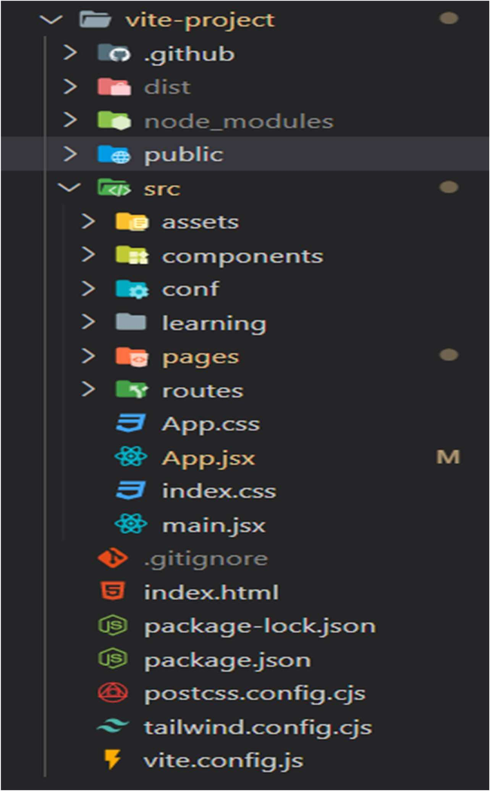

#### FIG: 11 FILE ARCHITECTURE OF FRONT-END CODE

##### Code Repository

https://github.com/gopaljha11321/TrafficWarriorFrontEnd

### 5.3.1 Back-End Code

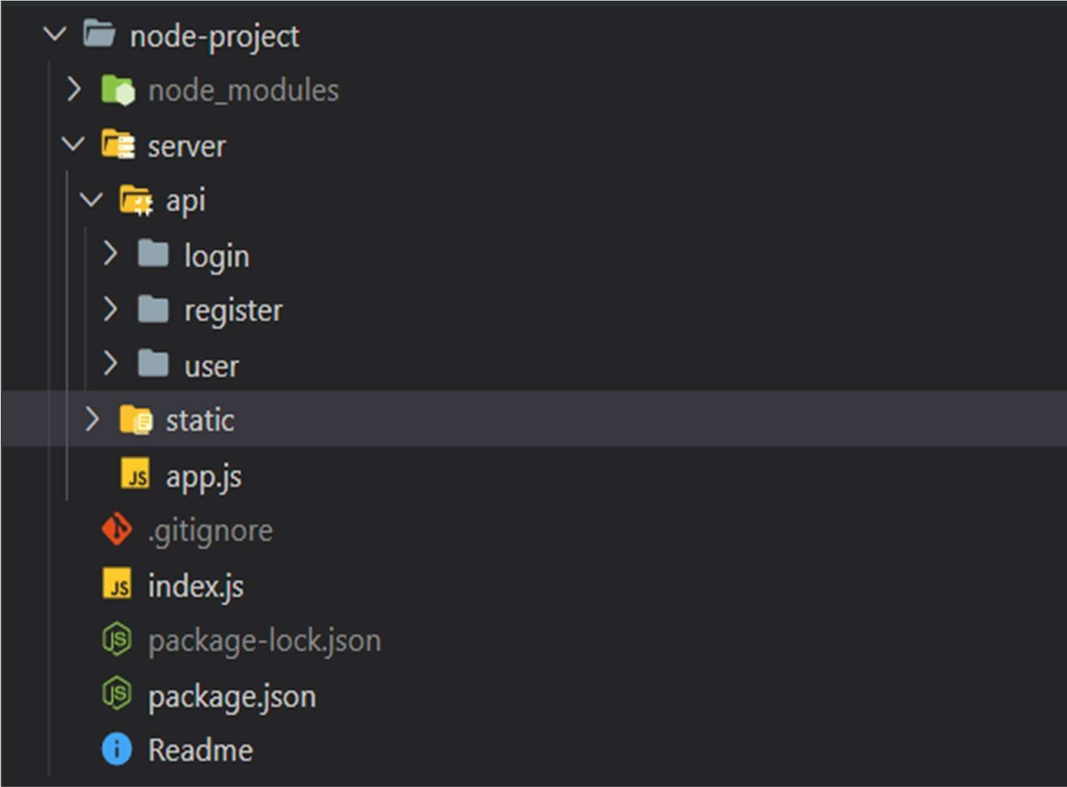

#### FIG: 12 FILE ARCHITECTURE OF BACK-END CODE

##### Code Repository

https://github.com/gopaljha11321/TrafficWarriorBackEnd

# CHAPTER – 6 PROJECT IMAGES

### HARDWARE IMAGES

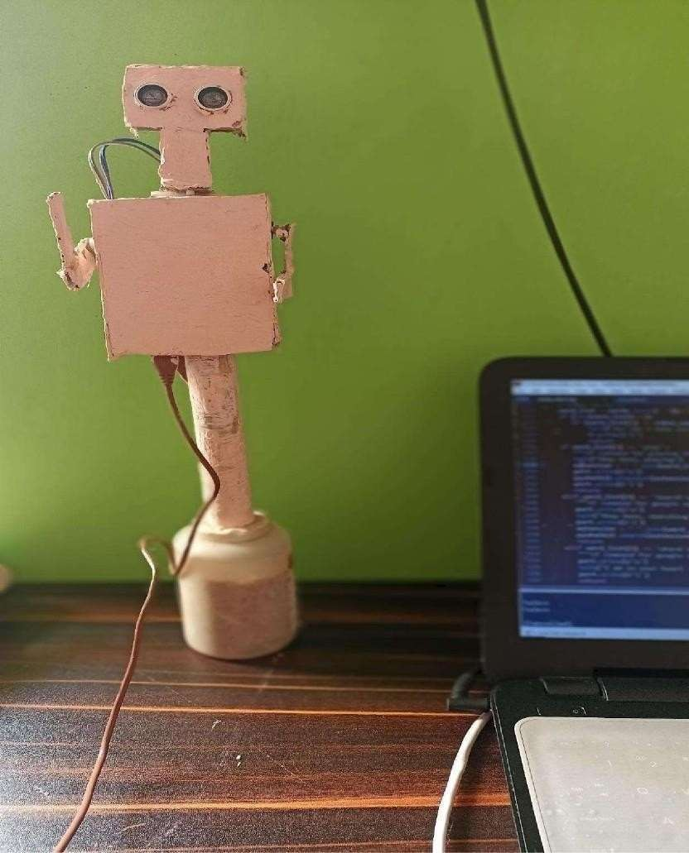

FIG: 13 WHEN PROJECT IS WORKING

### SOFTWARE IMAGES

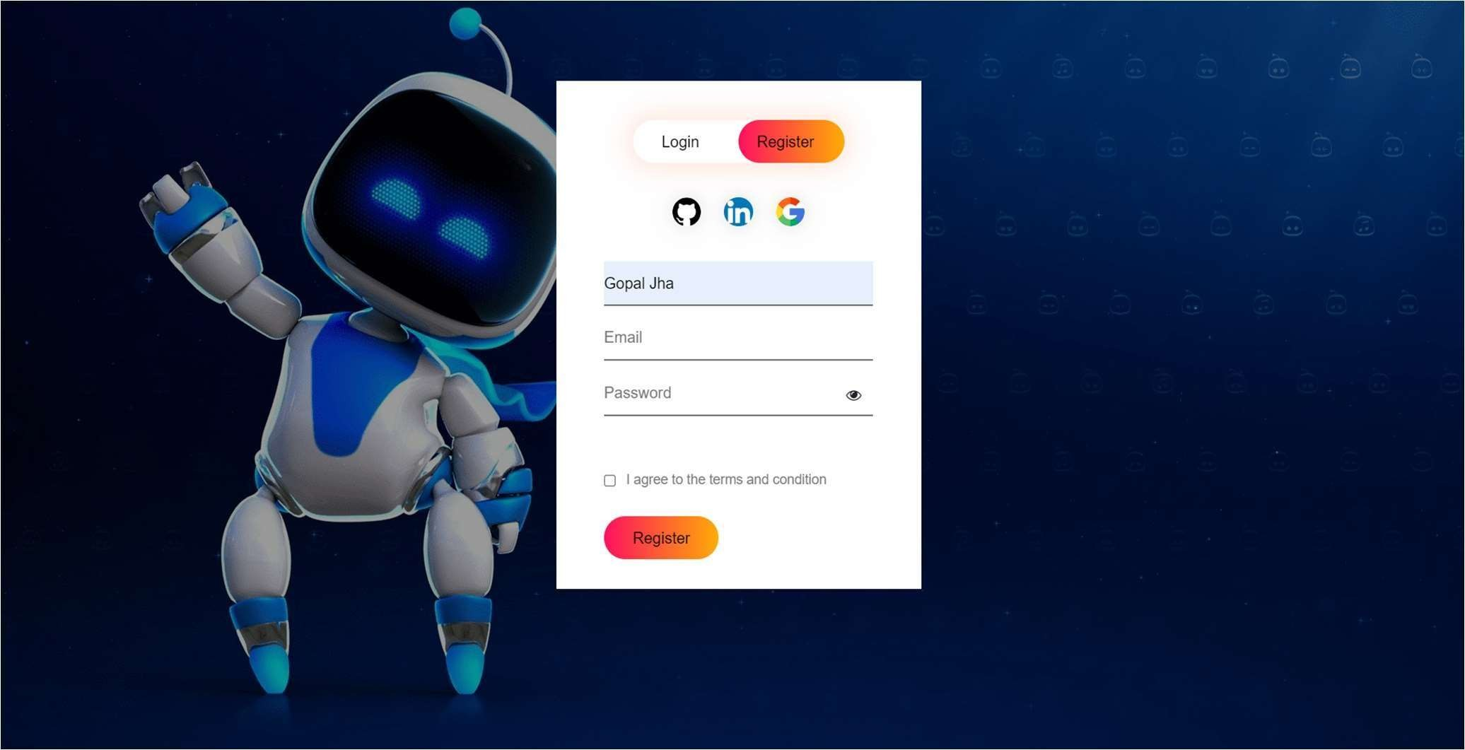

FIG: 14 LOGIN PAGE

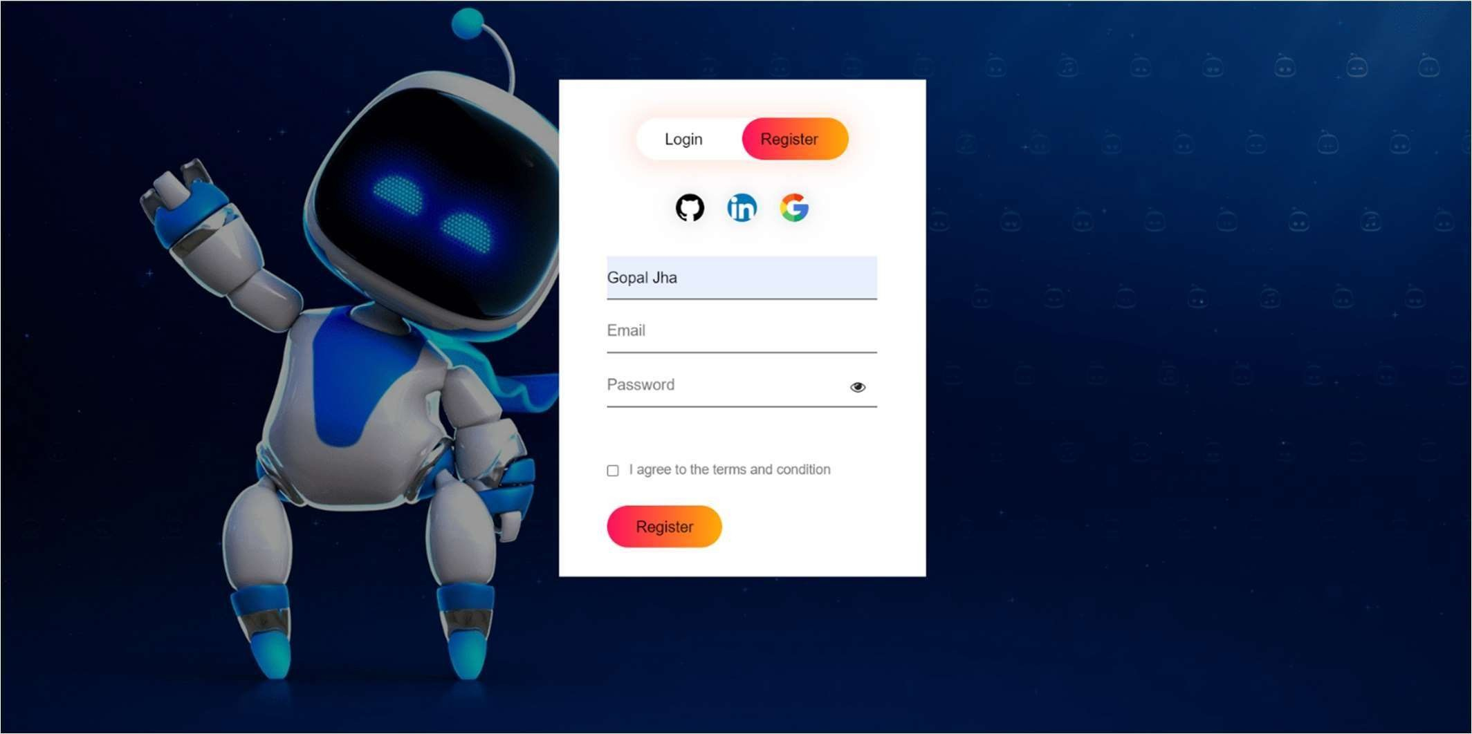

FIG: 15 REGISTER PAGE



FIG: 16 Dashboard Image

# CHAPTER – 7 CONCLUSION AND FUTURE PLANS

### CONCLUSION

Smart Traffic Control Robot Using Voice Assistant has been developed by using multiple features of hardware components in IoT. Traffic optimization is achieved using IoT made robot for efficient utilizing allocating varying time to all traffic signal according to available vehicles count in road path. Smart Traffic Management System is implemented to deal efficiently with problem of congestion and perform re-routing at intersections on a road. This research presents an effective solution for rapid growth of traffic flow particularly in big cities which is increasing day by day and traditional systems have some limitations as they fail to manage current traffic effectively. Keeping in view the state-of-the-art approach for traffic management systems, a smart traffic management system is proposed to control road traffic situations more efficiently and effectively

### FUTURE PLANS

* We will implement it on cloud server.
* To generate a login credential for the users so that they can check theirattendance whenever they want.
* We will secure the html page by using https protocol.
* To send a notification to the users when they are not present.
* Connect with Government site to fetch the challan receipt.

# CHAPTER – 8 REFERENCES

#### Bali, V., Mathur, S., Sharma, V., & Gaur, D. (2020). Smart Traffic Management System using IoT Enabled Technology. In Proceedings - IEEE 2020 2nd International Conference onAdvances in Computing, Communication Control and Networking, ICACCCN 2020 (pp. 565–568). Institute of Electrical and Electronics Engineers Inc. https://doi.org/10.1109/ICACCCN51052.2020.9362753

1. Singha, H., Kumar Nath, K., Basumatary, B., Swargiary, J., & Baruah, M. P. (2019). SMART TRAFFIC MANAGEMENT SYSTEM USING INTERNET OF THINGS (IoT) Final Year Project report submitted to.

#### Islam, M. R., Shahid, N. I., Ul Karim, D. T., Mamun, A. A., & Rhaman, M. K. (2016). An efficient algorithm for detecting traffic congestion and a framework for smart traffic control system. In International Conference on Advanced Communication Technology, ICACT (Vol. 2016-March, pp. 802–807). Institute of Electrical and Electronics Engineers In