**Gas Leak Emergency Broadcast System on Android Application**

Gopalji Gaur1, Ankit Kumar2, Godfrey Paul Joseph3

UG Scholar, Department of Electronics and Communication, Vellore Institute of Technology (Deemed to be University), Vellore, Tamil Nadu, India1,2,3

**Abstract:**

*We come across various gases in our day to day lives. While some of them are useful, like LPG in our cylinders at home which we use for cooking, some are harmful to us like Carbon Monoxide which is released as a product of various industrial processes. These harmful gases, if inhaled, can damage the respiratory system of living beings. Some of these gases are highly inflammable which can catch fire even by a slightest electrical spark, in case of a leakage. We deal with a lot of harmful gases in our lives, mostly in the case of industrial processes. Industrial processes release harmful and inflammable gases such as carbon monoxide, methane, alcohol, etc. At our homes, we have LPG cylinders, which can leak the gas. Many incidents have been reported in which there was an explosion due to leakage of LPG gas from the cylinder. Therefore, we plan to implement a fast and localized emergency broadcast system which will detect the leakage of the harmful gases using a MQ-5 gas sensor. We are going to implement ESP8266 Wi-Fi module to collect data from the MQ-5 gas sensor and host it on its own server on the local Wi-Fi. The data from the ESP8266 server will be collected by the android application on the smartphone, which will also be connected to the same network, and alert the user of the gas leakage. This project is an implementation of IoT (Internet of Things), which refers to connection between various devices.*

**Keywords:** MQ-5 gas sensor, ESP8266, Emergency Broadcast, Wi-Fi (Wireless Fidelity), Android Application, IoT

**Introduction:**

Natural gases can be found everywhere, from our homes to various factories, which employ these gases as fuels in production. Also, some of these gases are end-products of industrial and mining processes. Natural gas and methane are released when drilling for petroleum is done in mines. LPG is widely used in households as cooking gas due to its low cost and high calorific values and cost-effectiveness. It is cheaper than other fuels such as petrol and diesel. However, these gases have few drawbacks such as highly inflammable nature of LPG and poisonous nature of carbon monoxide gas. This elevates the need of using a system to keep the leakage of gases like these in check. This can be done by installing several sensors along the pipeline which detect the leakage and an emergency broadcast system delivers the updates to the residents of the building.

**Literature Survey:**

[1] In this paper, a system is proposed which will use an Arduino Nano microcontroller, gas sensor and a XBee to develop a gas leakage detection system. The sensor node will sense even miniscule concentration of the gas according to sensor’s voltage output and collects the gas leakage data. So, the specific area of the sensor node can be located. XBee sends the data from gas sensor to the monitoring system that is displayed on LabVIEW GUI. A GSM module is used as a communication unit between the microcontroller and mobile phone. Mobile phone gets an emergency update in the form of SMS.

[2] This is the cheap proposed system to detect the gas leakage and variation to alert and stop the gas supply. The MQ-2 sensor detects the leakage and sends the information that is displayed on the LCD. If any leakage is found the supply id shut down at the same time. Then SMS is sent to the user in order to alert the user. The GSM technology is user to get the better output. The WGSN could be used for wide range of monitoring.

[3] In this method it gives message to user about the leakage but also turns off the supply. In this method GSM module is used to give the alert message to the user. This method gives more emphasis on household and other problems related to LPG gas leakage. This method also monitors the level of LPG present in the container and gives the alert when the amount of LPG reaches the fixed limit that the user has set by the help of GSM module that provides safety. PIC microcontroller is used in this method by the help of Keil software. This method fails when the household supply is connected to gas cylinders, but not directly connected to main power supply. But it can detect the leakage by the leak detection module that is MQ-6 gas sensor that detects the amount of combustible gas present in that surrounding. Whenever the leakage is detected the ARM 7 controller sends the leakage message to the LCD that displays " GAS LEAKAGE DETECTED". It develops a gas detection and response system which detects the leakage and turns off the main power supply.

ARM method is to alert the user when the level of leakage is beyond the limit set by the user. The user gets the alert by SMS and the gas supply is stopped and the exhaust fan are brought into action.

[4] In this system the monitoring of CO2 gas is done. The sensors array of this gas detector are used to detect and locate the position and the other required information. In this system no internet is required and it just raises the alarm and it does not perform further action. Thus, the user gets alerted and the damage can be reduced. This system is divided into 3 steps. The MQ6 sensor senses any leakage in the surrounding. ARM microcontroller receives the MQ6 output. Then, the microcontroller sends its output to the connected devices. In last step the remedial action like buzzer, sprinklers, exhaust fan and activation of GSM that alerts the user are brought into action.

[5] This system carries sensor to detect the leakage, and infrared, Wi-Fi module, sensors that can detect the gas. The project deals with long range IOT communication that is based on IEEE802.11ah WIFI protocol. In this system the WIFI is used to send the data on the internet. Whenever the device is turned on, the WIFI gets connected to the internet and the stored data is shared. this project has flexibility in long range, economical and useful for the purpose of safety.

[6] The gas leakage detection system is made for household and commercial use. this method uses sensors to detect the leakage of any gas in the surrounding and then if any leakage then alerts the user by sending a SMS. and, an emergency measure is made to stop the supply to prevent from any damage. this project is made using 8051 processor and stimulated using Keil software. it is cheaper than the detectors that are available in the market and have a high efficiency.

[7] This system deals with the detection of gas leakage and alerting the user. this project directs towards pushing IOT technology to next level. The working principle of IOT based this project and monitoring system is shown by Raspberry pi 3 model attached with embedded system that requires the input as the amount of gas and the output gas level by the help of the sensors used in the system. this system is connected to common free IOT based web page that is specially designed for notifying or emailing the user to reduce the stress of regular monitoring.

[8] The sensors are used to detect any type of leakage in the system. Whenever there is any leakage, the sensors come into action and senses the gas leakage and then the sensors pass on the leakage information to the microcontroller. Microcontroller processes the input and then passes the information to the solenoid valve to close the knob in order to cut off the supply so that the further leakage could be stopped. also, the exhaust fan is started to disperse the gas. the information is further sent to the alarm in order to alert the present user get alert. The GSM sends the message to the user so that they got aware about the leakage and could do necessary action against the leakage and preservation steps. This system can also be used to book the cylinder when the gas amount is gets lower than the limiting value that is set by the user.

[9] This system works on detection of Gas Leakage and stopping the gas supply whenever gas leakage is detected. Whenever Gas Leakage is detected its stops the supply and activates the alarm and sends alert message to the workers in a short span of time. This system is economical and can be used for both household and commercial use. This System is cheaper than the sensors available in market. It uses MQ5 sensor for gas detection leakage and then transfers the information to Arduino and the further information is used by ESP module and by the help of IOT the alert message is send to the users to control or to stop the gas leakage.

[10] This model works on computing technique for pipeline supervision, this model detects the leakage and locates the leakage based on online analysis of signals originated from pressure, flow and temperature acquired by SCADA. The SCADA system transfers the acquired data from pipeline system to transient simulation model for every 30 seconds. The information to SCADA system is given by the sensors monitoring the pipeline system. Whenever the gas leakage is detected give an alarm and warning message and parameter values that includes all details like pressure, temperature, density and so on. So, this program turns to be a useful tool in automatic supervision of gas pipelines in commercial use.

[11] This paper works as an advance and innovative approach for LPG gas detection and automatic booking for refill and automatically switches of the power supply and hence avoids any type of damage. MQ6 sensor is used to detect any type of leakage where load cell L6D is used as weight sensor. GSM module SIMCOM300 and LCD to display the output. Microcontroller ATMega16 gives the output of the gas sensors. Whenever the MQ6 sensor detects the leakage passes the information to microcontroller which furthers activates the alarm and stops the main power supply. The weight sensor continuously monitors the weight of gas present in the container and whenever the gas reaches the lower limit gives the alarm for refill.

**Proposed usage of localhost for emergency broadcast:**

In this system we have proposed to use a local server and a connected android application to implement the architecture of emergency broadcast to the local clients (Android devices). Methods used earlier were usage of GSM or online cloud services to send the emergency broadcasts to the mobile phones. However, we plan to get rid of drawbacks of the methods. Since we are using localhost as the emergency broadcast server, it will be faster than SMS broadcast. On the other hand, the device doesn’t need to have working internet access to receive the emergency updates, which is a drawback of the project which use third party cloud servers to send the updates.

**Flowchart for the proposed system:**

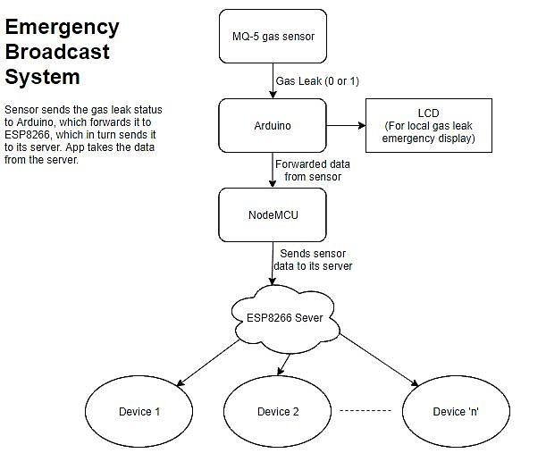

**Figure1.** *Block Diagram of the Gas Leakage Emergency Broadcast System*

**Components:**

* Arduino Uno, for interfacing the sensor and LCD
* NodeMCU 0.9 for hosting a web server
* MQ-5 gas sensor
* Android Smartphone, to run the application

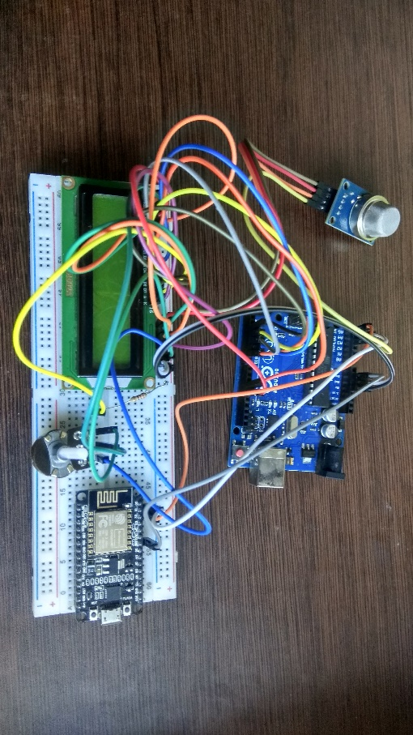

**Figure2.** *Set-up for the proposed emergency broadcast system*

**Design Methodology:**

The proposal that we have put forward in this paper is to implement the Internet of Things in detecting the gas leakage and broadcasting it to several devices that are connected to the same Wi-Fi network. The data is read from the sensor at periodic intervals and sent to the ESP8266 server, which acts as a localhost. The android app gets its instruction based on the data it receives from the server.

We begin the design by interfacing the MQ-5 gas sensor to Arduino. The MQ5 gas sensor is highly sensitive to LPG, Natural Gas, Town gas, alcohol and carbon monoxide. It also shows some sensitivity towards smoke, so some of its applications also include smoke detection.

Structure of MQ-5 sensor is explained as follows. The sensor consists of micro Al2O3 ceramic tube, SnO2 sensitive layer, measuring electrode and heater. All these components are implanted into a crust made by plastic and stainless-steel net. The heater provides necessary work conditions for work of sensitive components. The enveloped MQ-5 has 6 pins ,4 of them are used to fetch signals, and other 2 are used for providing heating current.

We are going to receive data from the digital and analog pins of the MQ-5 sensor. Analog data collected from the sensor can be calibrated for 1000ppm H2 or LPG concentration in air and using value of Load resistance (RL) about 20 KΩ (10KΩ to 47KΩ). But, in this project we are concerned only with the gas leakage detection aspect of the sensor. For this, we have connected the digital out pin of the sensor to the Arduino digital pin.

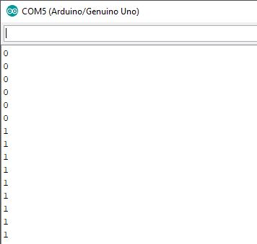

**Figure3.** *Output of serial monitor for sensor data*

To display the information about the leakage of gas, we have also used a 16x2 LCD screen to display whether the gas levels are normal, or if there is a gas leak.

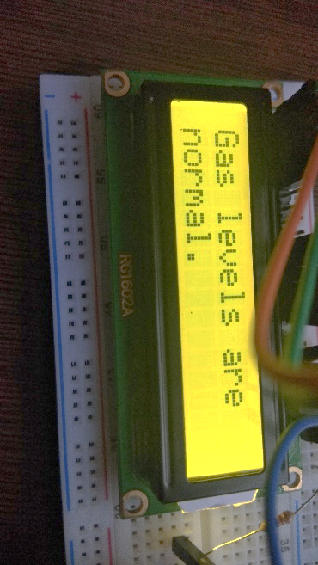

**Figure4.** *LCD display when gas levels are normal*

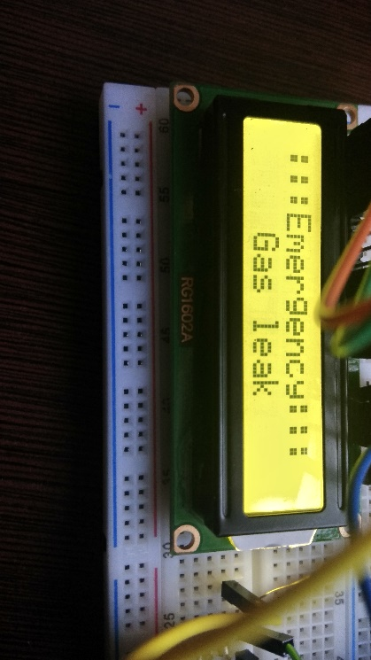

**Figure5.** *LCD display when there is a gas leak*

From **Figure4** and **Figure5**, we can see that the LCD displays: ‘Gas levels are normal.’ if the sensor sends a 0 signal i.e. there is no gas leakage. The LCD displays “:::Emergency::: Gas leak” if the sensor data is 1 i.e., there is a leakage detected by the sensor.

The Arduino is programmed so that it collects data from the digital pin (to which the digital output of sensor is connected) and it sends the data to the NodeMCU and displays the respective message on the LCD connected to it.

After this, the data is sent to the NodeMCU, which is an open source IoT platform. Its firmware is known as ESP8266. This board contains a Wi-Fi enabled chip. This chip is developed by Espressif Systems and operates on TCP/IP protocol. It is mostly used for development of IoT embedded applications. It is capable of transmitting 2.4GHz Wi-Fi (802.11 b/g/n, supporting WPA/WPA2 protocols), GPIO (General Purpose Input Output Pins), I2C (Inter-Integrated Circuit) serial communication protocol, ADC conversion, SPI serial communication protocol, I2S (Inter-IC Sound) interfaces with DMA (Direct Memory Access), UART (Universal Asynchronous Receiver and Transmitter) and PWM (Pulse Width Modulation). To communicate with ESP8266 module, the microcontroller must use AT commands. The microcontroller will communicate with ESP8266 module using UART. Generally, we use 115200 Baud rate to communicate with NodeMCU.

In this system, we have used Wi-Fi connection and the I2C serial connection capability of NodeMCU. We programmed the NodeMCU to connect to the local Wi-Fi network. For that we provide the network SSID and password of the Wi-Fi network to which we want it to connect. One important thing to be noted is that this will be the same network to which our Android devices will be connected. As soon as the NodeMCU gets connected to the Wi-Fi network, it hosts its own server.

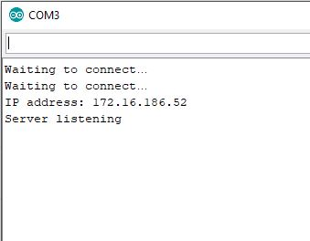

**Figure6.** *Output of serial monitor from NodeMCU*

In the **Figure6**, we can see that once NodeMCU is connected to the Wi-Fi, it hosts its own server on an IP address. The server can be accessed only on this IP address.

In the ESP8266 code, we specify various functions which will handle the requests is sent to the server. These are the various function which will handle the server requests from the client (web browser or the Android application, in this case):

* **Void handleRootPath()**: This function handles the root path for the server requests, i.e. just the server URI. It displays “Test Successful” if the root path is requested.
* **void handleProject():** This function handles the requests which end with /project. This function is the one which will be accessed by our android application. It is on this handle that the sensor data is sent. The android app just accesses this data.
* **void handleNotFound():** This function handles all other requests. It just displays “No incoming data”, for miscellaneous requests.

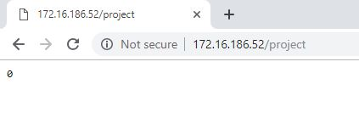

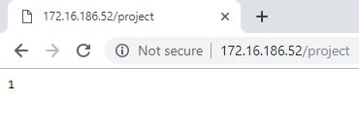

**Figure7.** *Data sent by the server on accessing /project path*

After the data starts getting transmitted to the NodeMCU server successfully, we can use the android application to acquire this data and display an emergency alert in case of a gas leakage.

**Android Application:**

The system that we have proposed in this paper makes use of the android application which connects to the local W-Fi network and access the local server of the hardware setup. In the systems which have been developed, make use of GSM or online services to send the alerts to the mobile phone. Whereas, in our paper, we have put forward a proposal to make use of the localhost to send the emergency updates locally to the smartphone through the android application. Wi-Fi is a commonly used service everywhere, whether it be schools, offices, factories, homes etc. We have Wi-Fi enabled buildings which are covered by Wi-Fi signals. Since, the Wi-Fi is available throughout the building, so building an emergency broadcast system for a building will be much faster as gas leak is harmful for individuals in that building. So, we combined both these technologies to develop a fast and reliable method to inform us in case a gas leak is detected. The android application just needs to connect the local Wi-Fi network of the factory or home where this setup needs to implemented. All the devices connected to the WLAN will get an alert simultaneously in case of a gas leak.

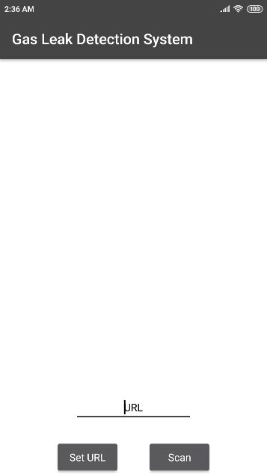

**Figure8.** *Unconnected application*

Users need to connect to the local Wi-Fi network to use the application. This is the same network to which the NodeMCU is connected.

The above screenshot is of the application when it is disconnected. Users are required to input the IP address of the NodeMCU server in the ‘URL’ box and click on ‘Set URL’ to connect the web interface of the application to the server of the NodeMCU. In case of use of the application in industries or factories, inputting the IP address manually becomes tedious. For that, there is a ‘Scan’ button provided, which leads to another screen for scanning QR code through the phone’s camera. A QR code containing the IP address of the NodeMCU can be displayed at the entrance of the building. Users can easily scan this QR code and connect to the server.

After the application gets connected to the server, it starts receiving data from the server. The application is programmed to keep collecting data from the web server at regular intervals. The application accesses the ‘/project’ handle of because this is the handle on which the sensor values are sent.

If the value 0 is received from the server then the then the application just displays ‘Gas levels are normal’. Also, this means that the application is successfully connected to the ESP8266 server. The application keeps refreshing every 100 milliseconds so it is always updated. Low refresh interval will improv the reaction time of the application. Fetching data from the local server is much faster processer than sending the broadcast through SMS. Also, SMS cannot be sent in the case of weak cellular signals, which is common in industrial areas.

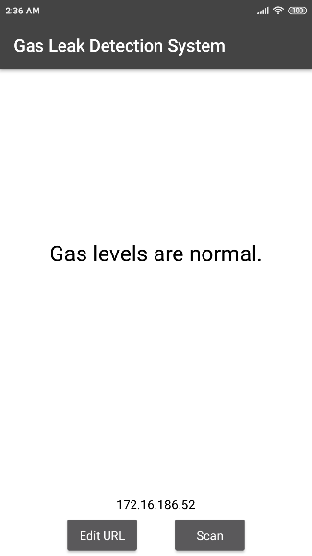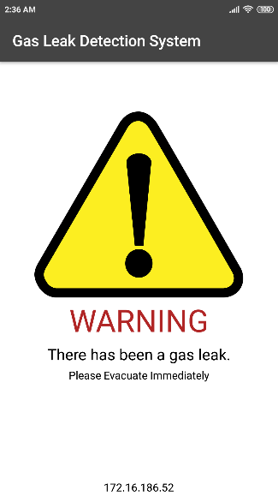

**Fig. (a) Fig. (b)**

**Figure9.** *Fig. (a): when there is no gas leakage*

*Fig. (b): Emergency display in case of gas leakage*

From the **Figure9.**  we can see how the application works. While it receives ‘0’ from the web server it displays the normal screen (shown in Figure 10(a)). As soon as it receives the value ‘1’ from the web server, it means that there was a leak and thee application shows the Emergency screen (shown in Figure 10(b)). In addition to emergency display, the application plays an alarm sound to notify the user in case he/she doesn’t notice the emergency screen.

**Conclusion:**

A complete methodology for implementing an IoT based Emergency Broadcast System has been proposed in this paper. MQ-5 gas sensor is very quick and effective to detect gases which are used in household and industries. An LCD was used to display the gas leakage status near the sensor. We used the NodeMCU module to host a local server and implemented it to receive data via I2C serial communication protocol from Arduino. We also made an Android application which connects to the server and displays an Emergency Broadcast and sounds an alarm in case of a gas leak.

This method aims to reduce the emergency alerting time required by the existing methodologies. Most of the proffered methodologies use GSM for alerting the users. Some systems also make use of cloud services such as, Google Cloud console, ThingSpeak, etc. However, in this project we have put forward a proposal to use a local server to send the gas leakage emergency updates to the android application. Implementation of such a system is expected to cut down the time required for alerting the people in a building by sending the updates over the local WLAN. Hence, in this paper we have put forward a new approach of implementing a gas leak emergency broadcast system.

**References:**

[1] T.H.Mujawar, V.D.Bachuwar, M.S.Kasbe, Deshmukh, “Development of wireless sensor network system for LPG gas leakage detection system”, *International Journal of Scientific & Engineering Research, ISSN 2229-5518,pp.558-563, Volume 6, Issue 4, April-2015.*

[2] Mr. Muthuvinayagam, M.Meganathan S, Jankiraman S, Dineshraja S, “Industrial Gas Monitoring with Safety Closure”, *International Journal of Engineering Research & Technology (IJERT), ISSN: 2278-0181,Vol. 3 Issue 3, March - 2014*

[3] Geeta Loshali, Rohit Basera, Lalit Darmwal and Sachin Varma, “Design and Implementation of LPG Gas Detector Using GSM Module”, *International Journal on Emerging Technologies (Special Issue NCETST-2017)*

[4] Harshada Navale, Prof. B.V. Pawar, “ARM Based Gas Monitoring System”, *International Journal of Scientific & Technology Research, Volume 3, Issue 6, June 2014*

[5] Ruthber Rodriguez Serrezuela, Miguel Ángel Tovar Cardozo, Denicce Licht Ardila and Carlos Andrés Cuellar Perdomo, “Design of a Gas Sensor Based on the Cocept of Digital Interconnecion IoT for the Emergency Broadcast System”, *ARPN Journal of Engineering and Applied Sciences, Vol. 12, No. 22, November 2017*

[6] O. Mohan Chandrika, B. Alekya Hima Bindu,“Automatic Gas Alerting System”, *Imperial Journal of Interdisciplinary Research (IJIR) Vol-2, Issue-6, 2016*

[7] Manish Verma, Lumesh Kumar Sah, Rohan Chandra Pandey, Saurabh Deshmukh, “IoT Based Gas Leakage and Alerting System with MQ-6 Sensor”, *IJCRT, Volume 6, Issue 1 January 2018*

[8] Srinivasan. A, Leela. N, Jeyabharthi V., Kirthika R., Rajasree D., “Gas Leakage Detection and Control”, *International Journal of Advance Engineering and Research Development Volume 2, Issue 3, March -2015*

[9] V.Naren, P.Indrajith, R.Arvind Prabhu, C S Sundar Ganesh, “Intelligent Gas Leakage Detection System with IoT Using ESP 8266 Module”, *International Journal of Advanced Research in Electrical, Electronics and Instrumentation Engineering, Vol. 7, Issue 12, December 2018*

[10] Zhao Yang, Mingliang Liu, Min Shao, Yingjie Ji, “Research on Leakage Detection and Analysis of Leakage Point in the Gas Pipeline System”, *Open Journal of Safety Science and Technology, 2011*

[11] B.B.Didpaye, Prof. S. K. Nanda, “Automated unified system for LPG using microcontroller and GSM module- A Review”, *International Journal of Advanced Research in Computer and Communication Engineering Vol. 4, Issue 1, January 2015*