Data Display of Remote Sensor Network

Displaying gathered weather data from around campus

A CS404 Project Proposal

by Gopal Krishan Aggarwal

20-Oct-2015

## Executive Summary

The goal of the parent project, under which this projects comes, is to build and deploy a remote data network to gather environmental data from around campus and display it on a standard web interface. It will be based on a model using a central server with sensors (temperature, humidity, pressure, etc.) attached to remote clients. The clients will use either wifi or Ethernet to report data back to the server. A wide range of remote clients will be considered ([BeagleBone](http://beagleboard.org/), [Arduino](https://www.arduino.cc/), [ESP8266](http://www.tenettech.com/product/7286/sparkfun-esp8266-thing), etc.) making it easy to interface other types of clients in the future.

The server will run open-source data gathering software (such as [Phant](http://phant.io/), [mqtt](http://mqtt.org/) or [ThingSpeak](https://thingspeak.com/)) and will present the data in graphical form on a web server ([Plotly](https://plot.ly/javascript/), [Flot](http://www.flotcharts.org/), [Google Charts](http://phant.io/graphing/google/2014/07/07/graphing-data/), [Initial State](https://www.initialstate.com), etc.).

The system will be designed to be robust, gathering data 24/7.  
Displaying the gathered data in the most usable forms is the goal of the sub-project - ‘Data Display of Remote Sensor Network’.

## Current State

A simple prototype of the parent project has been built by Prof. Yoder that has been gathering temperature and pressure data on a BeagleBone and logging the data on a separate server since 18-Aug-2015.

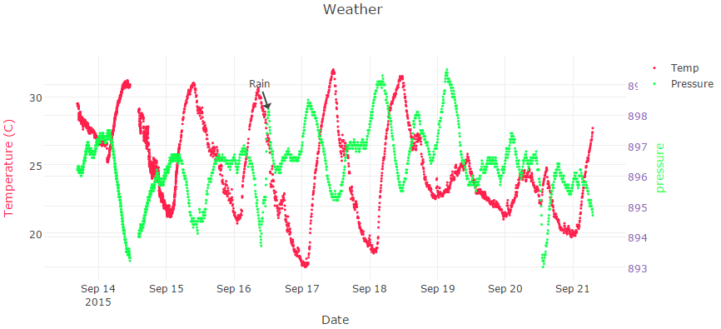

The current data can be seen [here](http://10.8.7.185/weather/plotWeather.html).

The goals of this sub-project are to

* investigate other plotting packages for presenting the data and
* creating an interactive interface so the data is more easily explored.

## Team Structure

We are a team of three members. Following are the team details:

|  |  |
| --- | --- |
| Gopal Krishan Aggarwal | B13121 |
| Gadipalli Siddhartha | B13211 |
| Katta Guru Sri Venkat | B13213 |

More details can be seen from here: <https://goo.gl/jhQZq1>

### Our Team: Team Display

We will look into displaying the sensor data gathered and archived by the other two teams. Currently Prof Yoder is using Google Charts, but there are other web browser-based graphing tools to be explored. We will

* propose a GUI for displaying the data being collected,
* implement and evaluate graphing tools such as [Plotly](https://plot.ly/javascript/), [Flot](http://www.flotcharts.org/), [Google Charts](http://phant.io/graphing/google/2014/07/07/graphing-data/), [Initial State](https://www.initialstate.com), etc,
* recommend and implement one for the project.

## Equipment needed

Data display team does not need any equipment other than our laptops. We expect to receive a soft copy of data from server team.