 | Contents | Signature
1 | Write A Program for DDA Line Drawing Algorithm
2 | Write A Program for Draw Line With Bresenham Algorithm
3 | Write A Program to Draw Circle with Mid Point Circle Algorithm
4 | Write A Program for 2D Translation
5 | Write A Program for 2D Rotation
6 | Write A Program for 2D Scaling
7 | Write A Program for 2D Reflection
8 | Write A Program For Clipping Algorithm
9 | Write A Program For Area Filling Algorithm
10 | Write A Program for Bazier Curve
INDEX

/* Write A Program for DDA Line Drawing Algorithm*/

# include <graphics.h>
# include <conio.h>
# include <iostream.h>
void main()
{
int gdriver=DETECT,gmode;
int x1,x2,y1,y2,dx,dy,step,incx,incy,x,y,i;
initgraph(&gdriver,&gmode,"c:\TURBOC3");
clrscr();
setbkcolor(0);
cout<<endl<<"Enter x1 : ";
cin>>x1;
cout<<"Enter y1 : ";
cin>>y1;
cout<<endl<<"Enter x2 : ";
cin>>x2;
cout<<"Enter y2 : ";
cin>>y2;
dx = x2 - x1;
dy = y2 - y1;
if (dx>dy)
{
step = dx;
}
else
{
step = dy;
}

incx = dx/step;
incy = dy/step;

x = x1;
y = y1;
putpixel(x,y,0);
for (i=1; i<=step; i++)
{

x=x+incx;
y=y+incy;
putpixel(x,y,0);

}
getch();
}

/* Write A Program for DDA Line Drawing Algorithm */

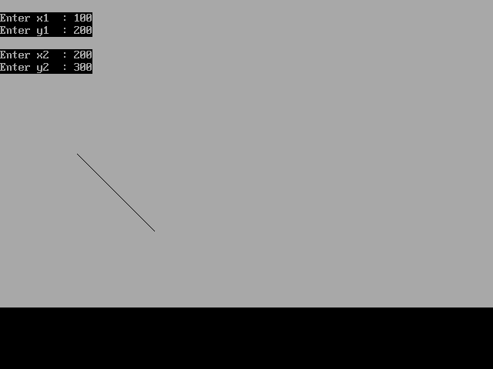

/* Write A Program for Draw Line With Bresenham Algorithm */

# include <graphics.h>
# include <conio.h>
# include <iostream.h>
void main()
{
int gdriver=DETECT,gmode;
int x1,x2,y1,y2,dx,dy,x,y,i,p,ddy,ddyx,xend;
initgraph(&gdriver,&gmode,"c:\TURBOC3");
clrscr();
setbkcolor(0);
cout<<endl<<"Enter x1 : ";
cin>>x1;
cout<<"Enter y1 : ";
cin>>y1;
cout<<endl<<"Enter x2 : ";
cin>>x2;
cout<<"Enter y2 : ";
cin>>y2;
dx=x1-x2;
dy=y1-y2;
p=2*(dy-dx);
ddy=2*dy;
ddyx=2*(dy-dx);
if(x1>x2)
{
x=x2;
y=y2;
xend=x1;
}
else
{
x=x1;
y=y1;
xend=x2;
}
putpixel(x,y,0);
for(i=x;i<xend;i++)
{
x=x+1;
if(p<0)
{
p=p+ddy;

}
else
{
y=y+1;
p=p+ddyx;
}
putpixel(x,y,0);
}
getch();
}

/* Write A Program for Draw Line With Bresenham Algorithm */

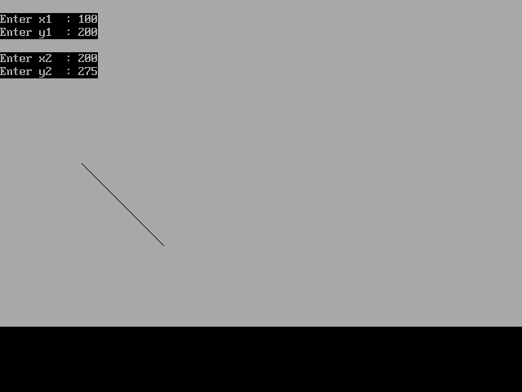

/* Write A Program to Draw Circle with Mid Point Circle Algorithm */

#include<iostream.h>
#include<conio.h>
#include<graphics.h>
void ppoint(int xc,int yc,int x,int y);
void main()
{
int gdriver=DETECT,gmode;
int p,r,xc,yc,x,y;
initgraph(&gdriver,&gmode,"c:\TURBOC3");
clrscr();
cout<<"Enter The Value of X::";
cin>>xc;
cout<<"\nEnter The Value of Y::";
cin>>yc;
cout<<"\nEnter The Value of Radius::";
cin>>r;
x=0;
y=r;
ppoint(xc,yc,x,y);
p=(1-r);
while(x<y)
{
if(p<0)
{
x=x+1;
}
else
{
x=x+1;
y=y-1;
}
if(p<0)
{
p=(p+(2*x)+1);
}
else
{
p=(p+(2*x)-(2*y)+1);
}
ppoint(xc,yc,x,y);
}
getch();

}
void ppoint(int xc,int yc,int x,int y)
{
putpixel(xc+x,yc+y,0);
putpixel(xc-x,yc+y,0);
putpixel(xc+x,yc-y,0);
putpixel(xc-x,yc-y,0);
putpixel(xc+y,yc+x,0);
putpixel(xc-y,yc+x,0);
putpixel(xc+y,yc-x,0);
putpixel(xc-y,yc-x,0);
}

/* Write A Program to Draw Circle with Mid Point Circle Algorithm */

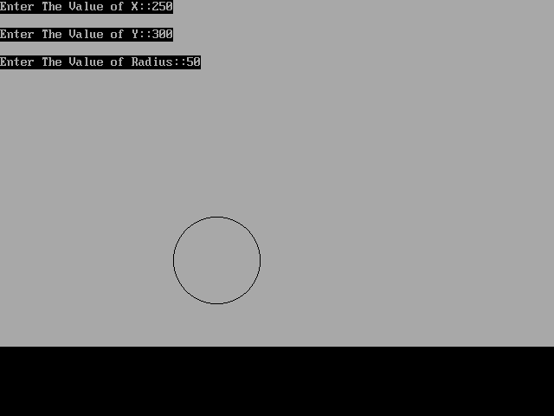

/* Write A Program for 2D Translation */

# include <graphics.h>
# include <conio.h>
# include <iostream.h>
void main()
{
int gdriver=DETECT,gmode;
int x1,x2,y1,y2,tx,ty;
initgraph(&gdriver,&gmode,"c:\TURBOC3");
clrscr();
setbkcolor(0);
cout<<endl<<"Enter x1 : ";
cin>>x1;
cout<<"Enter y1 : ";
cin>>y1;
cout<<endl<<"Enter x2 : ";
cin>>x2;
cout<<"Enter y2 : ";
cin>>y2;
line(x1,y1,x2,y2);
cout<<endl<<"Enter Tx Factor : ";
cin>>tx;
cout<<"Enter Ty Factor : ";
cin>>ty;
x1=x1+tx;
x2=x2+tx;

y1=y1+ty;
y2=y2+ty;
line(x1,y1,x2,y2);
getch();
}

/* Write A Program for 2D Translation */

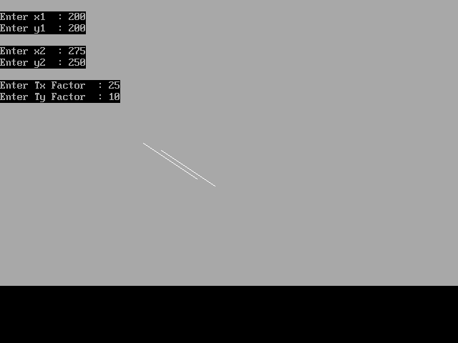

/* Write A Program for 2D Scaling */

# include <graphics.h>
# include <conio.h>
# include <iostream.h>
void main()
{
int gdriver=DETECT,gmode;
int x1,x2,y1,y2,tx,ty;
initgraph(&gdriver,&gmode,"c:\TURBOC3");
clrscr();
setbkcolor(0);
cout<<endl<<"Enter x1 : ";
cin>>x1;
cout<<"Enter y1 : ";
cin>>y1;
cout<<endl<<"Enter x2 : ";
cin>>x2;
cout<<"Enter y2 : ";
cin>>y2;
line(x1,y1,x2,y2);
cout<<endl<<"Enter Tx Factor : ";
cin>>tx;
cout<<"Enter Ty Factor : ";
cin>>ty;
x1=x1*tx;
x2=x2*tx;

y1=y1*ty;
y2=y2*ty;
line(x1,y1,x2,y2);
getch();
}

/* Write A Program for Scaling */

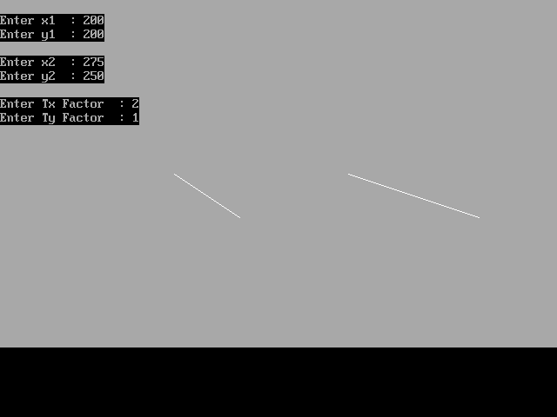

/* Write A Program For 2D Rotation */

# include <graphics.h>
# include <conio.h>
# include <iostream.h>
#include<math.h>
void main()
{
int gdriver=DETECT,gmode;
int x1,x2,y1,y2,q;
double si,co;
initgraph(&gdriver,&gmode,"c:\TURBOC3");
clrscr();
setbkcolor(0);
cout<<endl<<"Enter x1 : ";
cin>>x1;
cout<<"Enter y1 : ";
cin>>y1;
cout<<endl<<"Enter x2 : ";
cin>>x2;
cout<<"Enter y2 : ";
cin>>y2;
line(x1,y1,x2,y2);
cout<<endl<<"Enter Angle of Rotation : ";
cin>>q;
si=sin(q);
co=cos(q);
x1=(x1*co)+(y1*si);
y1=(-x1*si)+(y1*co);
x2=(x2*co)+(y2*si);
y2=(-x2*si)+(y2*co);
line(x1,y1,x2,y2);
getch();
}

/* Write A Program For 2D Rotation */

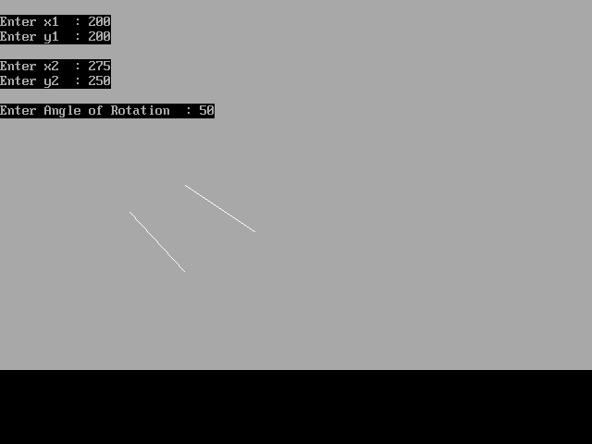

/* Write A Program For 2D Reflection */

# include <iostream.h>
# include <conio.h>
# include <graphics.h>
# include <math.h>

char IncFlag;
int PolygonPoints[3][2] =
{{10,100},{110,100},{110,200}};

void PolyLine()
{
int iCnt;
line(0,240,640,240);
line(320,0,320,480);
for (iCnt=0; iCnt<3; iCnt++)
{
line(PolygonPoints[iCnt][0],PolygonPoints[iCnt][1],
PolygonPoints[(iCnt+1)%3][0],PolygonPoints[(iCnt+1)%3][1]);
}
}
void Reflect()
{
float Angle;
int iCnt;
int Tx,Ty;
cout<<endl;
for (iCnt=0; iCnt<3; iCnt++)
PolygonPoints[iCnt][0] = (640 - PolygonPoints[iCnt][0]);
}

void main()
{
int gDriver = DETECT, gMode;
int iCnt;
initgraph(&gDriver, &gMode, "C:\TURBOC3");
for (iCnt=0; iCnt<3; iCnt++)
{
PolygonPoints[iCnt][0] += 320;
PolygonPoints[iCnt][1] = 240 - PolygonPoints[iCnt][1];
}
PolyLine();
getch();
Reflect();
PolyLine();
getch();
}

/* Write A Program For 2D Reflection */

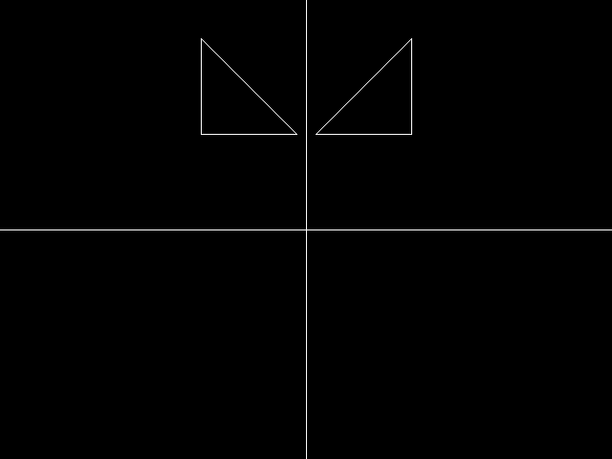

/* Write A Program For Area Filling Algorith */

#include<iostream.h>
#include<conio.h>
#include<graphics.h>
#include<dos.h>
void fill(int x, int y,int fcolor,int bcolor);
void main()
{
int gdriver=DETECT,gmode;
int x,y,fcolor,bcolor;
initgraph(&gdriver,&gmode,"c:\TURBOC3");
cout<<"Enter the value of X::";
cin>>x;
cout<<"\nEnter the value of Y::";
cin>>y;
cout<<"\nEnter the value of Fill Color::";
cin>>fcolor;
cout<<"\nEnter the value of Background Color::";
cin>>bcolor;
setbkcolor(bcolor) ;
setcolor(fcolor);
circle(x,y,30);
fillellipse(x,y,30,30);
fill(x,y,fcolor,bcolor);
getch();
}
void fill(int x,int y,int fcolor,int bcolor)
{
int curr=getpixel(x,y);
if(curr!=fcolor && (curr!=bcolor))
{
putpixel(x,y,fcolor);
fill(x+1,y,fcolor,bcolor);
fill(x-1,y,fcolor,bcolor);
fill(x,y+1,fcolor,bcolor);

fill(x,y-1,fcolor,bcolor);
}
}

/* Write A Program For Area Filling Algorithm */

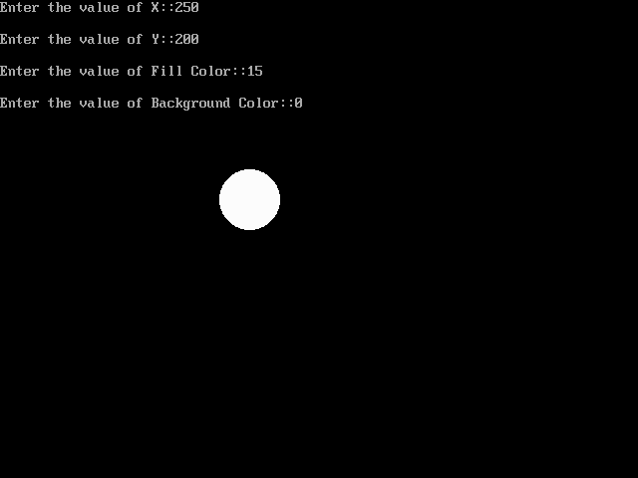
/* Write a Program for Bazier Curve*/

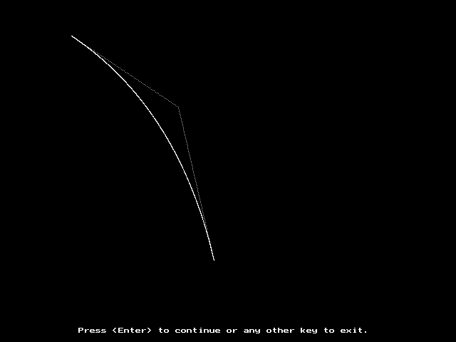

/* Write a Program for Bazier Curve*/

# include <iostream.h>
# include <graphics.h>
# include <conio.h>
# include <math.h>

void Bezier_curve(const int,const int *);

double nCr(int,int);
double factorial(int);

void Dashed_line(const int,const int,const int,const int,const int=0);

int main( )
{
int driver=VGA;
int mode=VGAHI;

int n;

do
{
gotoxy(8,10);
cout<<"Degree of Bezier Curve : n :";

gotoxy(8,11);
cout<<"ÍÍÍÍÍÍÍÍÍÍÍÍÍÍÍÍÍÍÍÍÍÍÍÍÍÍÍÍ";

gotoxy(12,13);
cout<<"Enter the value of n (n>=2) = ";
cin>>n;

int *control_points=new int[((n*2)+2)];

for(int count=0;count<=n;count++)
{
gotoxy(8,18);
cout<<"Coordinates of Point-"<<count<<" (x"<<count<<",y"<<count<<") :";

gotoxy(8,19);
cout<<"ÍÍÍÍÍÍÍÍÍÍÍÍÍÍÍÍÍÍÍÍÍÍÍÍÍÍÍÍÍÍÍÍÍ";

gotoxy(12,21);
cout<<"Enter the value of x"<<count<<" = ";
cin>>control_points[(count*2)];

gotoxy(12,22);
cout<<"Enter the value of y"<<count<<" = ";
cin>>control_points[((count*2)+1)];

gotoxy(8,18);
cout<<" ";

gotoxy(12,21);
cout<<" ";

gotoxy(12,22);
cout<<" ";
}

initgraph(&driver,&mode,"..\\Bgi");

setcolor(15);
Bezier_curve(n,control_points);

delete control_points;

setcolor(15);
outtextxy(110,460,"Press <Enter> to continue or any other key to exit.");

int key=int(getch( ));

if(key!=13)
break;
}
while(1);

return 0;
}

void Bezier_curve(const int n,const int *cp)
{
int color=getcolor( );

setcolor(7);

for(int count=0;count<n;count++)
Dashed_line(cp[(count*2)],cp[((count*2)+1)],
cp[((count+1)*2)],cp[(((count+1)*2)+1)]);

double x;
double y;

for(float u=0.0005;u<=1;u+=0.0005)
{
x=0;
y=0;

for(int k=0;k<=n;k++)
{
x+=(cp[(k*2)]*nCr(n,k)*pow(u,k)*powl((1-u),(n-k)));
y+=(cp[((k*2)+1)]*nCr(n,k)*pow(u,k)*powl((1-u),(n-k)));
}

putpixel((int)(x+0.5),(int)(y+0.5),color);
}
}
double nCr(int n,int r)
{
double nf;
double rf;
double nrf;
double ncr;

nf=factorial(n);
rf=factorial(r);
nrf=factorial((n-r));

ncr=(nf/(rf*nrf));

return ncr;
}

double factorial(int number)
{
double factorial=1;

if(number==0 || number==1);

else
{
for(int count=1;count<=number;count++)
factorial=factorial*count;
}

return factorial;
}
void Dashed_line(const int x_1,const int y_1,const int x_2,
const int y_2,const int line_type)
{
int count=0;
int color=getcolor( );

int x1=x_1;
int y1=y_1;

int x2=x_2;
int y2=y_2;

if(x_1>x_2)
{
x1=x_2;
y1=y_2;

x2=x_1;
y2=y_1;
}

int dx=abs(x2-x1);
int dy=abs(y2-y1);
int inc_dec=((y2>=y1)?1:-1);

if(dx>dy)
{
int two_dy=(2*dy);
int two_dy_dx=(2*(dy-dx));
int p=((2*dy)-dx);

int x=x1;
int y=y1;

putpixel(x,y,color);

while(x<x2)
{
x++;

if(p<0)
p+=two_dy;

else
{
y+=inc_dec;
p+=two_dy_dx;
}

if((count%2)!=0 && line_type==0)
putpixel(x,y,color);

else if((count%5)!=4 && line_type==1)
putpixel(x,y,color);

else if((count%10)!=8 && (count%10)!=9 && line_type==2)
putpixel(x,y,color);

else if((count%20)!=18 && (count%20)!=19 && line_type==3)
putpixel(x,y,color);

else if((count%12)!=7 && (count%12)!=8 &&
(count%12)!=10 && (count%12)!=11 && line_type==4)
putpixel(x,y,color);

count++;
}
}

else
{
int two_dx=(2*dx);
int two_dx_dy=(2*(dx-dy));
int p=((2*dx)-dy);

int x=x1;
int y=y1;

putpixel(x,y,color);

while(y!=y2)
{
y+=inc_dec;

if(p<0)
p+=two_dx;

else
{
x++;
p+=two_dx_dy;
}

if((count%2)!=0 && line_type==0)
putpixel(x,y,color);

else if((count%5)!=4 && line_type==1)
putpixel(x,y,color);

else if((count%10)!=8 && (count%10)!=9 && line_type==2)
putpixel(x,y,color);

else if((count%20)!=18 && (count%20)!=19 && line_type==3)
putpixel(x,y,color);

else if((count%12)!=7 && (count%12)!=8 &&
(count%12)!=10 && (count%12)!=11 && line_type==4)
putpixel(x,y,color);

count++;
}
}
}

