**Microservices**

**What is microservice:**

* Microservices is a method of developing software system that tries to focus on building single-function modules with well-defined interfaces and operations i.e. you can build the application in the form of small autonomous services.
* Unlike microservices, a monolith application is built as a single, autonomous unit i.e. an application and all it’s feature/functionalities are stored at one place. This make changes to the application slow as it affects the entire system.  A modification made to a small section of code might require building and deploying an entirely new version of software and perform regression testing of complete application.  Scaling specific functions of an application, also means you have to scale the entire application.
* Microservices solve these challenges of monolithic systems.
* In the simplest form, they help build an application as a suite of small services, each running in its own process and are independently deployable.
* These services may be written in different programming languages and may use different data storage techniques.
* Microservices are often connects via APIs, and can leverage many of the same tools and solutions that have grown in the RESTful and web service ecosystem.
* In short, we can say, **Microservices are always integrated using REST over HTTP (RESTful APIs)**
* In integrations, sometime lightweight messaging protocols are used such as Protobuf or Thrift
* [Testing these APIs](https://smartbear.com/solutions/api-testing/) can help validate the flow of data and information throughout your microservice deployment.
* Just as there is no formal definition of the term microservices, there’s no standard model that you’ll see represented in every system based on this architectural style
* Microservices may or may not provide some form of user interface
* <https://www.youtube.com/watch?v=j1gU2oGFayY>
* Mini applications or services are technically called Microservices.
* Microservices are way of breaking of your applications or services down to into Standalone and independent mini applications or services which can be deployed and execute/run on different hardware or servers. All these mini applications/services talk to each other over REST APIs altogether to provide the functionality of your Product/Application.

**Benefits of Microservices:**

* Deployment Flexibility
* Technology Flexibility
* Can scaled separately

**Disadvantages:**

* Deployment/architecture complexity
* Service discovery

**Microservices Testing Methods/Strategies:**

<https://martinfowler.com/articles/microservice-testing/>

<https://www.simform.com/microservice-testing-strategies/>

<https://www.infosys.com/de/documents/microservices-testing-strategies.pdf?soc=tw10205>

<https://www.freecodecamp.org/news/these-are-the-most-effective-microservice-testing-strategies-according-to-the-experts-6fb584f2edde/>

<https://docs.pact.io/>

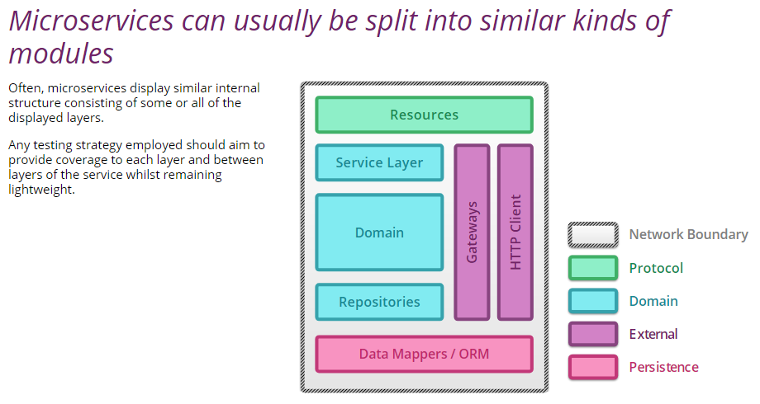

**Resources:** Resources act as mappers between the application protocol (exposed by service) and messages to objects representing the domain. Typically, they are thin, with responsibility for sanity checking the request and providing a protocol specific response according to the outcome of the business transaction.

**Domain**: Almost all of the service logic resides in a Domain model; represents business domain

**Service layer**: Services coordinates across multiple domain activities

**Repositories**: Repositories act on collection of domain entities and are often persistence backed

* **Unit Testing**:
  + Unit testing focus on smallest part of testable component to make sure if it’s working as expected.
  + Two categories:
    - **Sociable Unit Testing**: This method tests the behavior of modules by observing changes in their state
    - **Solitary Unit Testing**: This method focus on the interactions and collaborations between an Object and its dependencies, which are replaced by test doubles
  + Drawback:
    - For user-facing features they are difficult to mock and may skip important part of system
    - Does not cover interaction between different components or services
* **Integration Testing:**
  + It tests communication paths and interactions between components i.e. tests the interaction between microservice and external services like another microservice or datastore
  + Drawback:
    - Error prone and costly, in terms of man-hours
    - Testing of each individual interaction between components become verify complicated, complex
    - Because of complications, Testing coverage can be less
* **End-To-End Testing**:
  + It involves testing of every moving part of the microservice, ensuring that it can achieve the goal you built it for.
  + Drawback:
    - Can be difficult task
    - Time consuming

**Challenges of Testing Microservices:**

* **Availability**: Since different teams manage their own microservices, it’s difficult to find the time when all microservices are available to test
* **Fragmented and Holistic testing**: Microservices are built to work alone and together with other loosely coupled services. We need to test every component separately, as well as everything together.
* **Knowledge gap**: particularly with Integration testing, whoever conducts the tests, will need to have strong understanding of each service in order to write test cases effectively
* Have to manage multiple repositories and branches, each with their own database schemas
* While working with microservices, we have to keep in mind about API stability and versioning
* We have to create solid set of integration tests for microservice APIs.

**Microservice Testing Strategies for startups:**

* **The Documentation-First Strategy**:
  + Before anybody writes any API changes or either a new API or changes to an API, update the documentation first,
  + have that change reviewed to make sure that it conforms with API conventions and standards which are all documented, and
  + make sure that there’s no breaking change introduced here.
  + Further, you can perform API Contract testing; which involves writing and running tests that ensure the explicit and implicit contract of a microservice works as it should.
* **The full stack in-a-box strategy**:
  + In The full stack in-a-box strategy, we replicate a cloud environment locally and testing everything all in one vagrant instance(“$ vagrant up”).
  + But it’s extremely tricky and
  + difficult to scale up
* The AWS testing strategy:
  + It involves spinning up an Amazon Web Services (AWS) infrastructure for each engineer to deploy and run tests on
  + More scalable approach
  + Everyone has their own AWS account
  + You can push the code that’s on your laptop up into AWS in about ten minutes and just run it in like a real system

**API:**

* Application Programming Interface (API) is the connecting tissue between different Systems or application layers. (in another words, an **Interface** where you tell the **Program** to run in an **Application**)
* It’s being used to connect and transfer data and logic across systems and applications
* It is a set of procedures and functions which allow the consumer to use the underlying microservices/services of an application.
* Application often have three layers:
  + A data layer
  + A service (API) layer
  + A presentation (UI) layer
* The API layer contains the business logic of an application - the rules of how users can interact with services, data, or functions of the app
* API is just a program; we just have to use it on out program e.g. you can use Google search API or Amazon shopping or travel booking APIs in your program
* APIs are platform independent; that can be run on any type of devices or in any program (language barrier is not there)
* API testing generally consists of make requests to a single or multiple API endpoints and validate the responses - whether for performance, security, functional correctness, or just a status check
* API testing puts much more emphasis on the testing of business logic, data responses and security, and performance bottlenecks.
* Major component of API: Request, Response, a Program
* E.g. 1) Search a term ‘testing’ in Google Search page on your machine. Google search page sends the request with search term to Google server, Program gets executed on Google server, and Google server sends the response back to your computer. Here Program location is mentioned into the URL. E.g. [www.google.com/search?q=testing](http://www.google.com/search?q=testing)

Meaning of the url is that, Goto Google server over the internet, goto ‘search’ folder and execute the program / query(q=) with the parameter(?) ‘testing’.

Here, we have used Google Search page to send the request.

Sometimes, API is used directly in our program behind the scene and send the request to server for the information.

**Benefits of API Testing:**

* Earlier Testing: With API testing, once the logic is designed, tests can be built to validate the correctness in responses and data. We don't have to wait for various teams to finish their work or for full applications to be built - test cases are isolated and ready to build immediately
* Easier Test Maintenance: UIs are constantly changing and moving around. API changes are much more controlled and infrequent - often times API definitions files like OpenAPI Spec can help make refactoring tests only a seconds of work.
* Faster time to resolution: When API tests fail, we know exactly where our system broke and where the defect can be found. This helps reduce time triaging bugs
* Speed and coverage of testing: it’s faster than UI/functional testing

**Types of API Testing:**

* Unit Testing: Testing a single endpoint, with a single request; looking for a single response or set of responses. Many times, this type of testing can be done manually via the command line and something like a cURL command or with lightweight tools like SoapUI.
* Integration Testing: It is most often used form of API testing; as APIs are at the center of most integrations between internal and third party services.
* End-To-End Testing: End-to-End testing can help us validate the flow of data and information between a few different API connections
* Performance testing: Previously, load testing was kept in the hands of the few and was difficult to execute in a CI/CD environment. LoadUI Pro is a performance testing tool for RESTful, SOAP, and other web services that enables nearly any team member to embed performance tests into their CI/CD pipeline.

**Web Services:**

* Web (Internet) Services (API): API that uses the internet
* Not all APIs use Web i.e. all Web Services are APIs; But Not all APIs are web services i.e. not all APIs uses Web (internet)
* Web services enables communication (exchange data/info) between two applications over internet (web)
* It provides standard protocol/format for communication (it’s platform independent communication)
* Web Services Use:
  + **XML** or **JSON** **format** of the data over internet
  + **REST, SOAP, or XML/RPC Protocols** to transfer the data over internet
  + **HTTP** used to send a request and receive a response
* In another words, Web services uses **HTTP as medium** and **XML/JSON format** to communicate data between Client and server
* And Web services are implemented in major two types i.e.
  + **SOAP** (Simple Object Access Protocol)
    - It uses medium: HTTP (POST method)
    - and Format: XML
  + **REST** (REpresentational State Transfer)
    - It uses medium: HTTP (GET, POST, PUT, DELETE,… methods)
    - and Format: XML/JSON/TEXT…

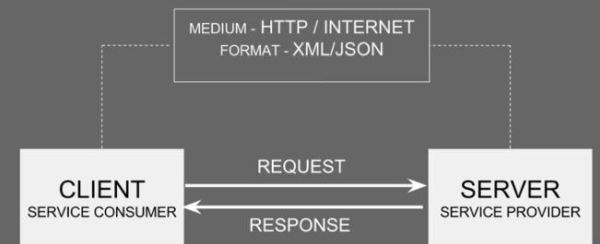

* To make use of Web services at Client side (Consumer), Consumer needs to know:
  + What are the services available
  + What are the request and response parameters
  + How to call the web service
* For this, every service provider publishes description (an interface, *not UI*) of it’s web services where all the attributes, features and functionalities of web services are described.
* And This is an XML based interface and is called “**WSDL**” (Web Services Description Language)
* In another words, **“WSDL” is an XML based interface that is used to describe the attributes, features and functionalities of the web services**
* WSDL is the interface of the web service; service provider creates WSDL for it’s web service and consumer can get that WSDL and use it to get web service request and response
* Consumer can get this WSDL from service provider by two ways:
  + If consumer and service provider knows each other then, service provider can directly handover this **WSDL** to consumer for it’s use
  + Another way is that, service provider publishes his web service (thru WSDL) on an online directory from where consumers can query and search the web services. This Online registry/directory is call **UDDI** (Universal Description, Discovery & Integration)
  + UDDI is an XML based standards for publishing and finding web services

**HTTP (Hyper Text Transfer Protocol):**

* ‘www.google.com’ is a simple set of words; HTTP makes its special
* Hyper Text, meaning sends this url to somewhere else over the internet;
* Components of HTTP:
  + **Start Line** (it’s mandatory part)
  + **Headers**
  + **Blank Line**
  + **Body**
* See below table what can contains in to HTTP parts in Requests and Response, as an example

|  |  |  |
| --- | --- | --- |
| **HTTP** | **Requests** | **Response** |
| **Start Line** | HTTP Version#, Method Info (like GET, POST, PUT, DELETE), folder info and parameter in url e.g. /search?q=testing | HTTP Vesion#, Status Code (e.g. 200 (successful), 400 (failure in sending/receiving path), 500 (Failure at server side) |
| **Headers** | Host (url domain i.e. www.abc.com),  Token | Cookies,  File size, what is sending back i.e. HTML type |
| **Blank Line** | It’s nothing, it’s just separator |  |
| **Body** | Information which you are sending | HTML web page with requested info |

**Details of Start Line:**

|  |  |  |
| --- | --- | --- |
|  | **Request** | **Response** |
| What’s Name? | Start Line, Request Line | Start Line, Response Line, Status Line |
| Contains HTTP version? | Yes, HTTP/1.1 | Yes, HTTP/1.1 |
| Contains Methods? | Yes (GET, POST, PUT, DELETE, etc.) | No |
| Contains API program folder location? | Yes (e.g. /Search) | No |
| Contains Parameters? | Yes (e.g. ?q=testing | No |
| Contains Status code? | No | Yes (e.g. 200 = success, 400 = client error, 500 = server error) |
| Format | Method(space)API Program folder Location+Parameters(space)HTTP version  Note: API Program folder location and Parameters are optional | HTTP version(space)Status code |
| Example | GET /search?q=testing HTTP/1.1 | HTTP/1.1 200 OK |

What is **idempotence**?

Can do as many times as you want and result stays same; in other words, ‘safe’ to repeat.

This is related to Start line methods.

|  |  |
| --- | --- |
| **Methods** | **Idempotent? (safe to repeat?)** |
| GET (read) | Yes |
| POST (create) | No |
| PUT (modify) | Yes |
| DELETE (delete) | Yes |

**XML (eXtensible Markup Launguage)**

* One of the field in HTTP Header line is ‘Content-Type’ which tells you what type of data is there in Request or Response.
* There can be many; one of the majorly used as “Application/XML”
* XML holds the data in request/response
* Actual XML content resides into HTTP Body
* XML uses tags in <>; similar to HTML
* E.g. <button>Click Me!</button>
* Here, <button> tag has meaning in HTML. It describes that it’s a button having name “Click Me”
* But, in XML, it just a information type. It can be anything in XML. In HTML, it cannot be anything.
* HTML and XML standards are set by W3C (World Wide Web Consortium)
* XML example
* 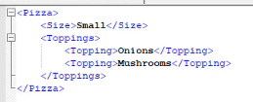

**JSON (JavaScript Object Notion):**

* One of the field in HTTP Header line is ‘Content-Type’ which tells you what type of data is there in Request or Response.
* There can be many; one of the majorly used as “Application/json”
* JSON holds the data in request/response
* Actual JSON content resides into HTTP Body
* JSON uses “Key” : “Value” pair
* JSON example
* 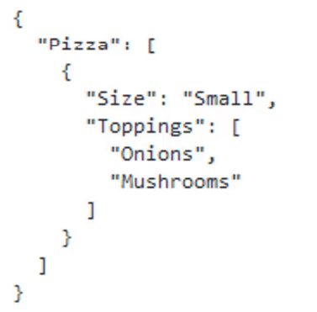
* XML is more powerful than JSON; able to transfer xml data to another xml, more security, more capabilities
* JSON is more simple and lightweight than XML

**SOAP and REST:**

* These are the ways to form HTTP request and response

**SOAP (Simple Object Access Protocol):**

* It’s a way to access Web Service (API over internet) by following some rules (protocols) which are used to form HTTP request/response
* Web services uses SOAP
* Every SOAP API is a web service
* WSDL describes the web services as a SOAP Web Service
* XML content type is always used in HTTP body of SOAP; In Header Line, Content Type is always ‘text/xml’
* SOAP Web Services are the web services which comply the SOAP standards/rules/specifications
* These standards/rules/specifications are written by a internationally central body W3C
* Basic Set of specifications include:
  + SOAP
  + WSDL
  + UDDI
* SOAP is a protocol which defines how the applications talk to each other.
* To talk to each other these application have to follow common format
* And that Format is “XML”
* And XML has to follow “SOAP Message” Standards in SOAP web services
* And SOAP Message Structure consists of:
  + Envelope
    - It’s root element of a soap message. This is the basic unit of the XML document which contains other units like Header & Body
  + Header
    - Header element provides information about the message itself.
    - Header might include authentication, complex types, routing info etc
  + Body
    - Body contains actual data of request which is being sent to server
  + 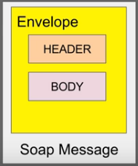
  + Example of SOAP message:
  + 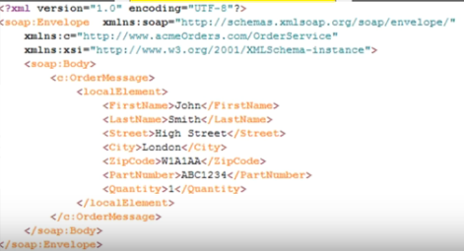

**REST (REpresentational State Transfer)**

* A Web service that communicates information between two applications using REST architecture/principles is called **RESTful Web Services**
* **What is REST?**
  + It is an architectural style
  + Like SOAP, it’s NOT a protocol; it hasn’t any strict specifications; there is no central body to control this
  + It’s just a design principle
  + We can use these principles to design any service for communication of two applications
  + When we apply these principles while designing web service (for client-server communication), we get RESTful Web Service.
* What are the **REST architecture/principles/rules** which make the web service as RESTful web service?
  + **Uniform Interface**
    - **Resource**
      * Everything is a Resource; like every module, information, data, image, entity, document or etc… can be defined as resource
      * There is no specific rule as such
      * Like below screenshot, Employees, departments module can be defined as resource
      * 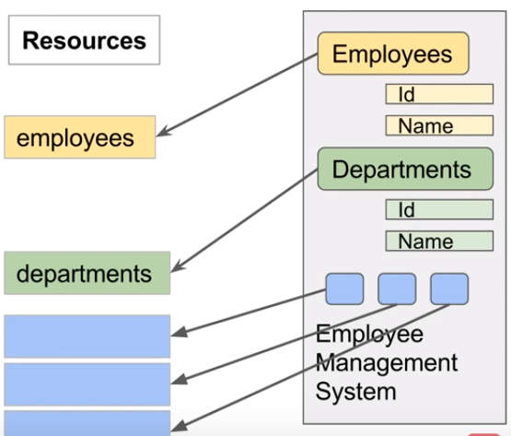
    - **URI (Uniform Resource Identifier)**
      * You can access any Resource/data using URI (by URI)
      * If you want to access the employees from the above Employee Management System, you can use URI-

<http://example.com/employees/10> (get employee details which has ID 10)

<https://example.com/department/123/employess> (get all employees from department ID 123)

* + - **HTTP:**
      * How we can use HTTP in REST; we can use HTTP methods in REST
      * 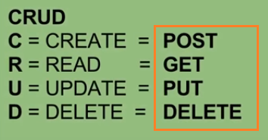
      * Using HTTP methods along with URI, we can access/modify any resource or resource info
      * 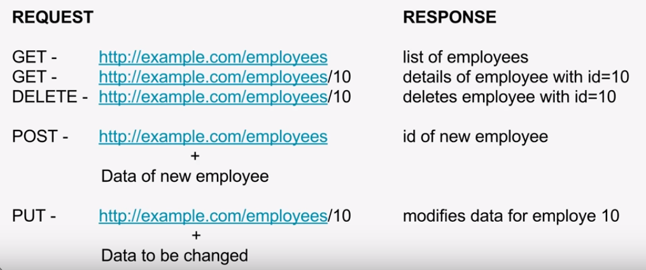
    - 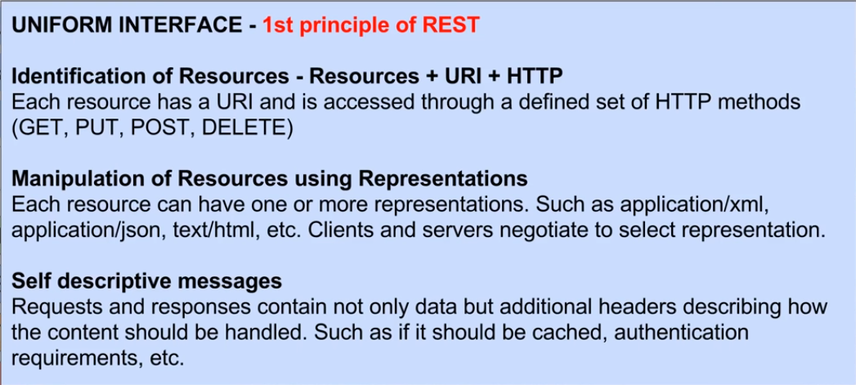
    - In another words, Resource represents API/Collection which can be accessed from the server
    - Let’s there are few URLs like Google.com/maps, Google.com/docs, google.com/search, google.com/images

Here, google.com is a base URL/URI and ‘maps’, ‘docs’ are the APIs or resources.

So, request goes to google.com server first and then based on resource, decide which API has to use.

* + - When we send a request to server Base URL+Resource is mandatory
    - Along with that sometime we have to send different Parameters based on type of requests. What are these Parameters?
      * **Path Parameters**
        + Path Parameters are variable parts of a URL path. They are typically used to point to a specific resource within a collection that specific resource is identified by ID
        + E.g. <https://www.google.com/images/12341>
        + Here 12341 is ID of the image which you are requesting for
        + Here, we drill down to sub-resource to find out specific item
      * **Query Parameters**
        + Query Parameter is used to sort/filter the resource
        + Query parameter is identified with “?”
        + E.g. <https://www.amazon.com/orders?sort_by=2/20/2020>
        + Here, unlike path parameter, we don’t goto sub-resource; rather we apply filter on resource or collection itself
    - So, End Point Request URL can be constructed as:

Base URL/resource/Parameters (Path/Query)

* + - E.g. if you want to get employee id 123 details from above system –
    - SOAP request will be

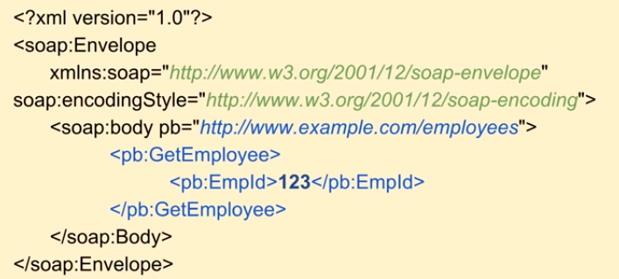

* + - For same, REST request will be simple URL



* + **Stateless**:
    - All client-server communications are stateless; meaning server does not maintain any state of the system
    - i.e. each request from Client to Server much be complete, independent and contains all the data that is required for a request. Server should not maintain any state/status of previous or current request or session
    - If required, client has to maintain the session or store info
    - Because of this, it improves web services performance
  + **Cacheable**
    - Happens at Client side
    - When server sends response to Client, that response may contained some entities/info which are labeled as Cacheable or non-Cacheable; meaning server tells client which data needs to be cached at client side
    - Into the response header, ‘Cache-control’ field is available which tells how long the response need to be stored in Client’s cache
  + **Layered System**
    - Multiple layers can exists between Client and Server
    - These layers are HTTP intermediaries
    - Can be used for message translation / improving performance with caching etc.
    - It includes:
      * **Proxies**
        + A client may send a request to Proxy server instead of main server
        + Proxy server evaluates the request to simplify or control its complexity, etc
      * **Gateways**
        + Gateways may be used for managing traffic on the network, protocol translation etc.
  + **Code On Demand** (optional)
    - Ability to download and execute code at client side
    - For an example, client request a resource and server returns a resource with some java-script which runs on client side
* Every Resource can be represented in multiple ways; so a resource may have a representation in XML or JSON format and whenever there is request from client, representation of a current state of the resource is being transferred between server and client
* Representation = description/presentation of current state of resource
* And that can be in many formats like XML, JSON, Image, HTML, etc
* In another words, REST is nothing but Set Of Rules of communicating data between client and server; i.e. the rules/principles, how the data/information (STATE) of a resource is transferred using Representations.

**End Point / Base URI:**

* Address where API/Web service is hosted on server
* In testing, we hit to the end point to check response from API/Web service

**Contracts:**

* API contracts are nothing but the documentation which includes details of the API e.g. API behavior, Base URL/end points, Resources, Parameters, HTTP methods, expected response etc.
* To Start with API testing, we need to know about Contract first.
* Generally developer provides API contracts to tester so that he can start testing

**REST Assured:**

* REST Assured is a JAVA DSL (library) which helps to simplify testing of REST based web services.
* It supports POST, GET, PUT, DELETE, PATCH and HEAD requests
* It can be used to validate and verify response of a request

**REST API Manual Testing (POSTMAN):**

* You should get a contract document from dev team before start testing as below:
* 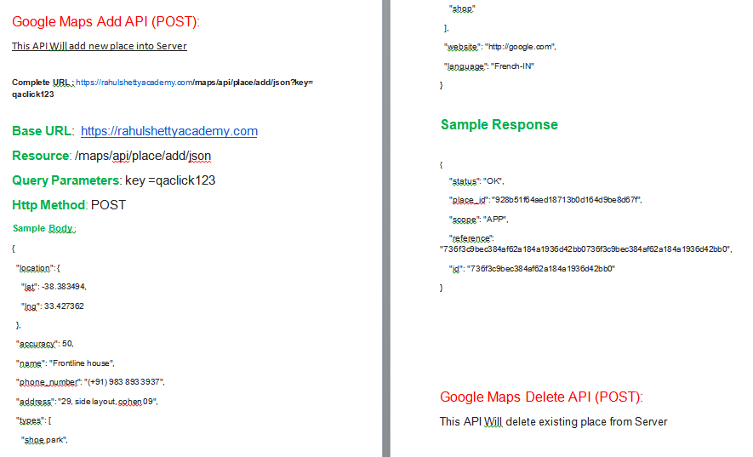
* Create new Collection (it’s like a project) in POSTMAN application
* And under it, create new Request
* 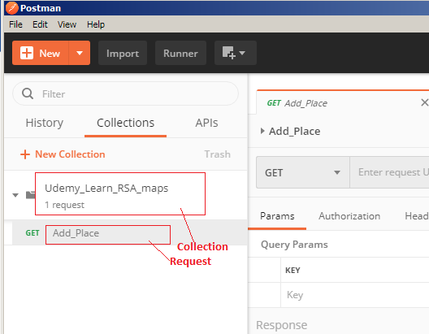
* Into the ‘Enter request section’, Enter your Base URL and the Resource
* Into the PARAMs, enter Query Parameters

POST Method (ADD):

* Select HTTP Method (here, POST)
* Enter sample Body from contract into ‘Body’ section and Select ‘JSON’ format (Raw)
* It’s Sample body, you can change the value inside whatever you want
* Into Header, enter ‘Content-Type’ and it’s value as ‘application/Json’. It’s Format of the body
* Once, click on Send button, request will be sent to the server and you should get a response
* 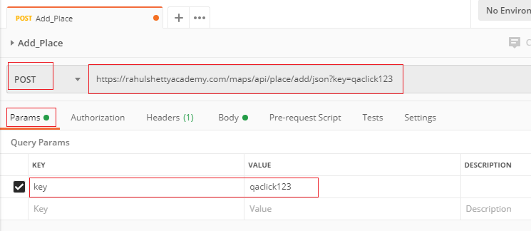
* 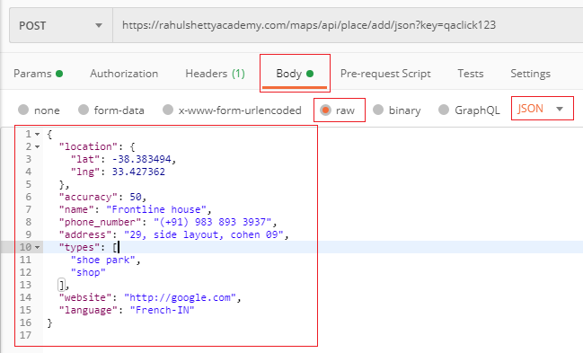
* 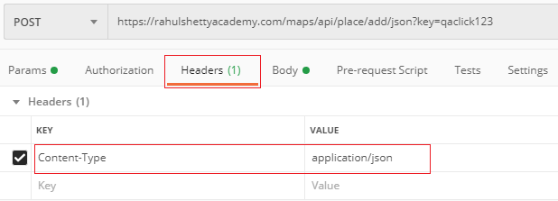
* You will get the response as below with status 200 (OK):
* 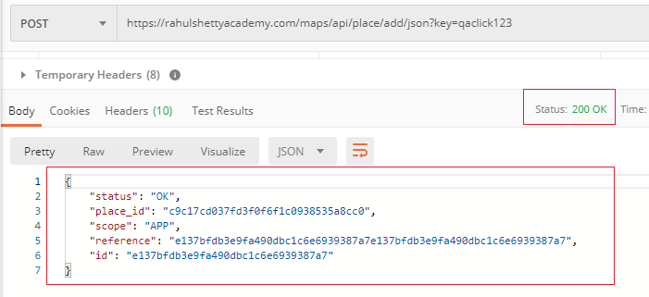

GET Method (Retrieve):

* Let’s consider this is a contract for GET request:

*Google Maps get Place API (GET):*

***This API Will get existing place details from Server***

***Complete URL :*** *http://rahulshettyacademy.com/maps/api/place/get/json?place_id=xxxx&key=qaclick123*

***Base URL****:*  [*https://rahulshettyacademy.com*](https://rahulshettyacademy.com/)

***Resource****: /maps/api/place/get/json*

***Query Parameters****: key, place_id //( place_id value comes from Add place response)*

***Http request****: GET*

*Note: Key value is hardcoded and it is always qaclick123*

***Sample Response for the Provided Place_Id***

*{*

*"location":{*

*"lat" : -38.383494,*

*"lng" : 33.427362*

*},*

*"accuracy":50,*

*"name":"Frontline house",*

*"phone_number":"(+91) 983 893 3937",*

*"address" : "29, side layout, cohen 09",*

*"types": ["shoe park","shop"],*

*"website" : "http://google.com",*

*"language" : "French-IN"*

*}*

* Note that, when we send GET request, we don’t need to send the body; we send everything as part of URL.
* After you send this request, you should get response with expected info and status code as 200.
* 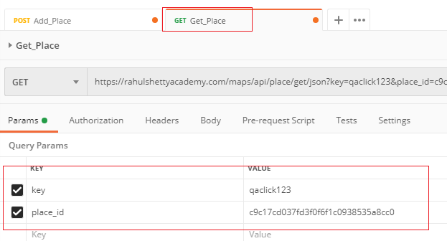

**DELETE method:**

* It’s similar to POST. As per the contract, Enter baseURL/Resource, Add Body Format, Enter Content-Type in Header, add Query Parameter
* Select Method type as DELETE or POST (here, POST method also works for delete since into the resource, it (should) redirects to Delete API)

**PUT method (Update):**

* It’s similar to POST. As per the contract, Enter baseURL/Resource, Add Body Format, Enter Content-Type in Header, add Query Parameter
* Select Method type as PUT or POST (here, POST method also works for modify since into the resource, it (should) redirects to PUT API)

**REST API Automation:**

Setup:

* Install JAVA
* Setup Environment variables for JAVA
* Install Eclipse (Java editor)
* Create new Java Project in Eclipse
* Download all JARs from Rest-Assured.io > Docs > Downloads
  + Rest-assured…
  + Json-path…
  + Xml-path…
  + Json-schema-validator…
  + Spring-moc-mvc…
  + Scala-support…
  + Kotlin-extensions…
  + Spring-web-test-client…
* Import all these JARs into Java Project (using Add External JAR libraries)
* Goto eclipse menu >Windows >Preferences > Java > Editor > Typing > “Escape Text when pasting into string literal”.. select this option.

This setting will be useful when you paste a JSON file body into string double quote( “”).

**Start with Automation:**

* Let’s consider below is API contract for POST method:

This API Will add new place into Server

**Complete URL :** [https://rahulshettyacademy.com](https://rahulshettyacademy.com/)**/maps/api/place/add/json?key=** **qaclick123**

**Base URL**:  [https://rahulshettyacademy.com](https://rahulshettyacademy.com/)

**Resource**: /maps/api/place/add/json

**Query Parameters**: key =qaclick123

**Http Method**: POST

**Sample Body** :

{

"location": {

"lat": -38.383494,

"lng": 33.427362

},

"accuracy": 50,

"name": "Frontline house",

"phone_number": "(+91) 983 893 3937",

"address": "29, side layout, cohen 09",

"types": [

"shoe park",

"shop"

],

"website": "http://google.com",

"language": "French-IN"

}

**Sample Response**

{

"status": "OK",

"place_id": "928b51f64aed18713b0d164d9be8d67f",

"scope": "APP",

"reference": "736f3c9bec384af62a184a1936d42bb0736f3c9bec384af62a184a1936d42bb0",

"id": "736f3c9bec384af62a184a1936d42bb0"

}

* There are three main sections into Java program that we have to include for testing APIs
  + **given()** :mention all given inputs here (e.g. parameters, headers, body)
  + **when()** :submit the api (e.g. here goes – resource, http method)
  + **then()** :validate the response
* all these three methods goes in concatenation (to each other by dot (.)
* Assign BaseURI

RestAssured.*baseURI* = "https://rahulshettyacademy.com";

* Add static Package manually (**import** **static** io.restassured.RestAssured.*;)
* 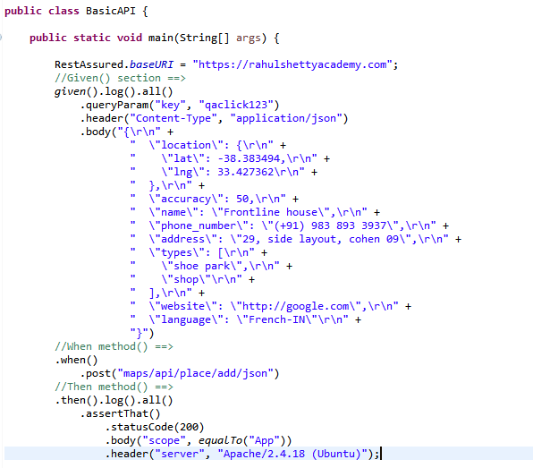
* given().log().all() 🡺 prints all the logs for given() section in output pane
* .then().log().all() 🡺 prints all the logs for then() section in output pane
* .assertThat() 🡺 assert (verify) expected values with actual response after running this program
* In above program:
  + We are providing known parameters in “.given()” section
    - Query parameter
    - Header
    - Body
  + We are doing POST operation in this example (in “.when()” section)
    - Providing ‘Resource’ there
* In above program, we are validating in “.then()” section:
  + .statusCode(200)
  + . body(“scope”, equalTo(“App”))
  + .header(“server”, “Apache/2.4.18 (Ubuntu”)
* .statusCode(200) 🡺 verify expected status code
* .body(“scope”, equalTo(“App”)) 🡺 verify if ‘scope’ value is ‘App’ in Response Body
  + Note that, here to use ‘equalTo()’ method, we have to import another static package manually .. **import static org.hamcrest.Matchers.*;**
* .header(“server”, “Apache….”) 🡺 verify if ‘server’ value is expected in Response Header
* **To extract the Response in a string as print it in console, use**
* **.extract().response().asString();**
* 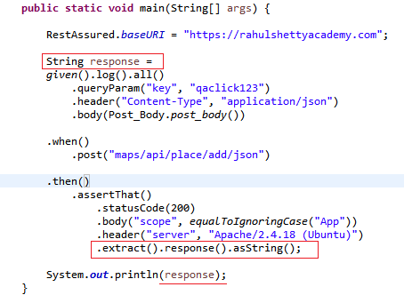
* Note that, here we used “.asString()”; not “.toString()”.

Output will be as below:

{"status":"OK","place_id":"1be6f99850655094e1321d4650fa05f5","scope":"APP","reference":"01e6c96860f6dc00a39c3ef739f9565e01e6c96860f6dc00a39c3ef739f9565e","id":"01e6c96860f6dc00a39c3ef739f9565e"}

* Now, from this output if you just need to get/take out ‘Place_id’ and print it, we have to parse this this above string in JSON; as below:

JsonPath js = **new** JsonPath(response);

String getPlaceID = js.getString("place_id");

* 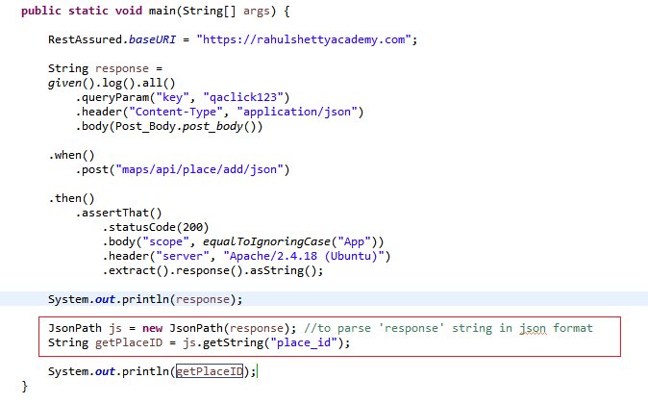
* Similarly, we can use **PUT** method
* 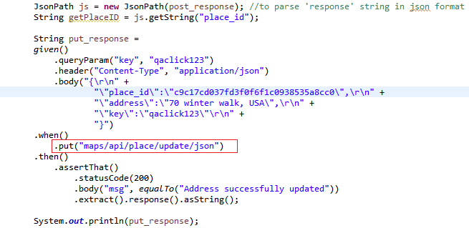
* We can replace ‘place_id’ here with the variable
* 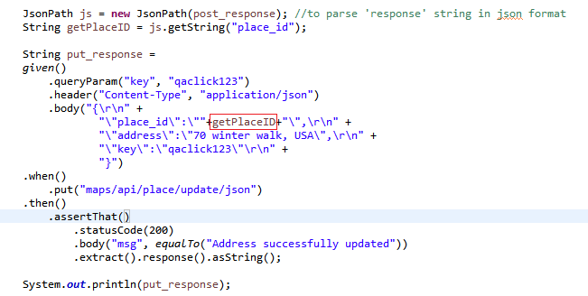
* Output will be
* {"msg":"Address successfully updated"}

- Similarly, we can use GET method

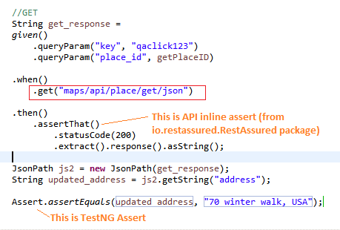

* Here, in ‘given()’ section, we just used query parameter since we don’t have to provide Body and Header parameters in GET
* Using

JsonPath js2 = **new** JsonPath(get_response);

String updated_address = js2.getString("address");

We are fetching ‘address’ from the response

Now let’s look how to get the info from little complex JSON file. Let’s consider below json file:

{

"dashboard": {

"purchaseAmount": 910,

"website": "rahulshettyacademy.com"

},

"courses": [

{

"title": "Selenium Python",

"price": 50,

"copies": 6

},

{

"title": "Cypress",

"price": 40,

"copies": 4

},

{

"title": "RPA",

"price": 45,

"copies": 10

}

]

}

This is a mock json file (Mock means, it’s not actual coming from real API response; It’s a sample response which is expected similar from real API response and it is given by Dev team before development.). As a tester, we can start building automation suite with this mock response in json format.

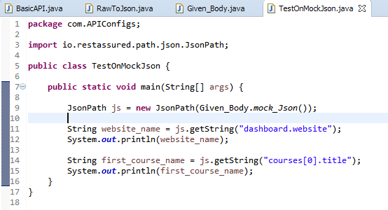

* Here, above mock json response body is stored in to another class ‘Given_Body’ and static method ‘mock_Json()’.
* We are getting that json body as string from that method and converting /parsing into json using: **JsonPath js = new JsonPath(Given_Body.*mock_Json*());**
* Get website name as below:

String website_name = js.getString("dashboard.website");

* Get First course title as below:
* String first_course_name = js.getString("courses[0].title");
* Note, using variable: js.getString("courses["+i+"].title");
* Get number course (count) in response
* **int** courseCount = js.getInt("**courses.size()**");
* Note that, “.size()” can be applied on Array only. Here, ‘courses[]’ is an array in given json
* Now, you get how to fetch field values from complex Json.

**Dynamic and Parameterized JSON Payload:**

* Create different Class which contains JSON files (request body/response body) as a string inside class methods (methods which returns String)
* Also, create DataProvider with set of test data and send it to Test class (Parameterization)
* Use those methods into Test Class
* E.g. Create separate class which contains request/response JSONs

Public Class Payload

{

Public static String addBook_Json(String **myISBN**, String **myAISLE**)

{

String payload = *“{*

*"name":"Learn Appium Automation with Java",*

*"isbn":*”+**myISBN+ “**,

*"aisle":”+* **myAISLE+ “**,

*"author":"John foe"*

*}* ”;

Return payload;

}

}

* Create separate class which contains reusable methods like process json response file and get any parameter value:

public class RawToJson {

public static String getJsonParameterValue(String response, String js_Parameter)

{

JsonPath js = new JsonPath(response);

String parameter_Value = js.getString(js_Parameter);

return parameter_Value;

}

Public static String readAsStringFromJsonFile (String mypath)

{

Return **new String (Files.readAllBytes(Paths.get(mypath)));**

}

}

* Use above methods into test class

Public Class TestAPI

{

@Test (**dataProvider = “BooksData”**)

Public void addJsonTest(String **myISBN**, String **myAISLE**)

{

RestAssured.baseURI = “… *BaseURI*…”;

String response =

Given()

.header(“Content-type”,”application/json”)

.body(**Payload. addBook_Json(**String **myISBN**, String **myAISLE)**)

.when()

.post(“…*resource*…”)

.then()

.assertThat()

.statusCode(200)

.extract().response().asString();

String actualID = **RawToJson. getJsonParameterValue**(response, “ID”);

String expectedID = “*abc123*”;

Assert.assertTrue(actualID,expectedID);

}

@Test

Public void UpdateJsonTest()

{

RestAssured.baseURI = “… *BaseURI*…”;

String response =

Given()

.header(“Content-type”,”application/json”)

**.**body**(RawToJson. readAsStringFromJsonFile(“C:\\UpdateBook.json”);**

.when()

.post(“…*resource*…”)

.then()

.assertThat()

.statusCode(200)

.extract().response().asString();

String actualID = **RawToJson. getJsonParameterValue**(response, “ID”);

String expectedID = “*abc123*”;

Assert.assertTrue(actualID,expectedID);

}

**@DataProvider (name=”BooksData”)**  
 public Object[][] myDataProviderMethod()

{

Return new Object[][] {

{“ISBN1”,”AISLE1”},

{“ISBN2”,”AISLE2”},

{“ISBN3”,”AISLE3”}

};

}

}

NOTE:

You can use <https://freeformatter.com/json-escape.html> for converting a JSON format to Java understandable format; so that it can directly be used in Java editor.

**Use of external JSON file:**

* Instead of using JSON string in code itself, we can import and use external .json file
* In above code, “**readAsStringFromJsonFile**()” is used to read a JSON file
* And it is used in body() method inside UpdateJsonTest() test method
* This method can be used to test Static Json file.
* If you wanted to test different parameters or dynamic json, then don’t use this; use parameterization method and use the JSON into code itself like previously explained.

**Examples with JIRA APIs:**

* **Cookie-bases-sessions:**
* JIRA is API based automation tool, meaning, you can create/modify/delete entries in JIRA from it’s APIs
* Let’s say if you have to create some defect into JIRA thru APIs (not from UI) then we need corresponding POST method and API body to push it, ofcourse.
* However, we need authentication to the site; in another words, we have to login to the JIRA using username/password. Then how to do that using APIs.
* We will have to get or find corresponding POST method and API request body thru which we will post username and password and will get back with ‘session id’
* Then we can use that session id for further requests. That is call cookie-based-session.
* For JIRA cookie-based-authentication API, you can find more info at: <https://developer.atlassian.com/server/jira/platform/cookie-based-authentication/>
* For all other JIRA APIs, you can get more info at: <https://docs.atlassian.com/software/jira/docs/api/REST/7.6.1/>
* See below screenshot of creating login session using POSTMAN 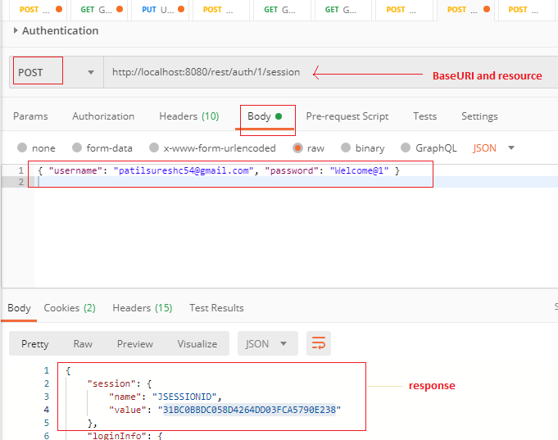
* and then using that session in another POST request for creating a bug into JIRA
* 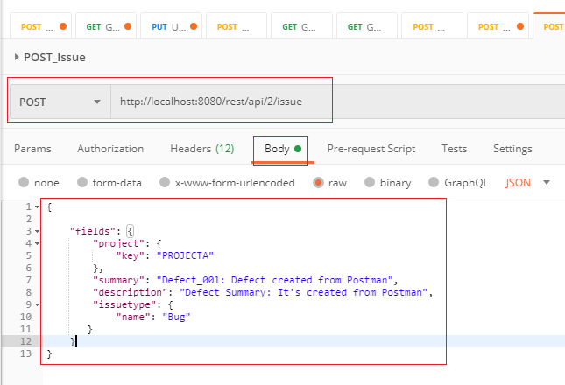
* 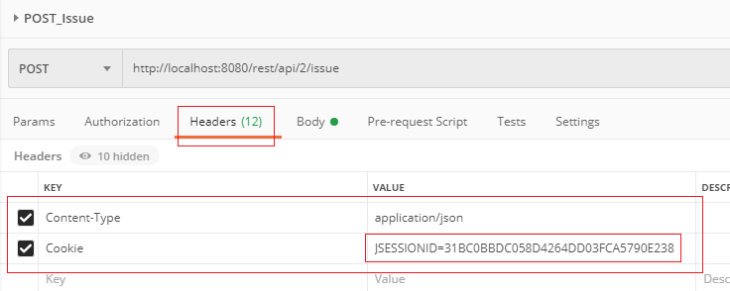
* Similarly we can use that session id for other requests like get Issue details, attach document to issue, delete issue etc.
* Now, lets see for similar activity thru automation scripts
* In below script, I have logged in to JIRA and using the logged in sessionID, I have added comments for existing created Issue.
* 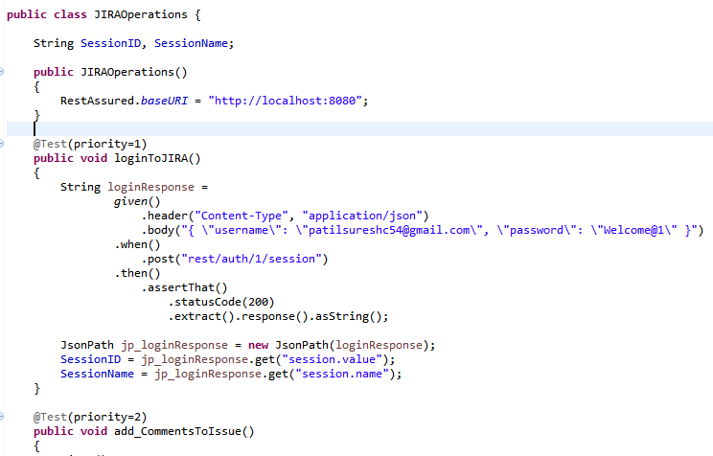
* 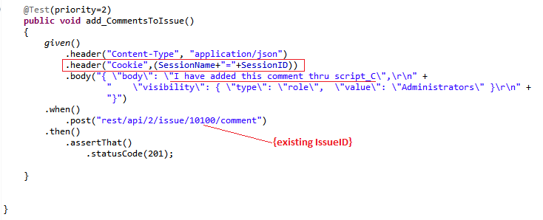
* Here, we have get SessionID and SessionName from login API response and then used it into another test while adding comment
* There is another way to do that; instead of getting sessionID and use it, we can create session object of class which will store the creates session in login API script and can be used same in another API scripts.

SessionFilter session = **new** SessionFilter();

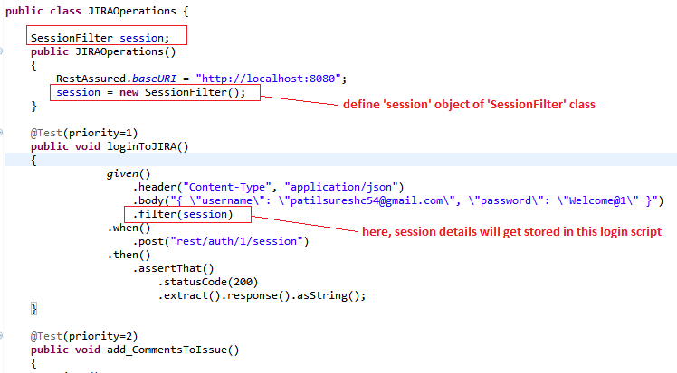

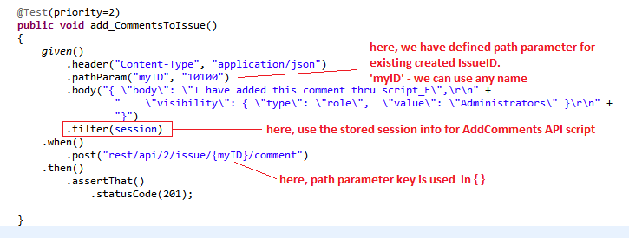

* In above example, we have used another feature **“Path Parameter”**
* Path parameter can be used in Resource URL inside { }.
* **How to Attach Document to JIRA Issue:**
* We have to try to understand given API contract for the Add Attachment first
* For JIRA, they have given contract as below
* 
* It’s not in a regular format; it’s in a curl command format. Some of the contracts can be found in this command format.
* Now try to understand this above curl command
  + -D- : different parameters are following which we need to pass
  + -u: user login:password for login to JIRA.
  + -X: HTTP Method to be used. Here POST method has to be used
  + -H: Header. Here, ‘X-Atlassian-Token’ is a key and ‘no-check’ is value to be used in Header
  + -F: File. Here, ‘file’ is a key and ‘@myfile.ext’ is filename
  + <http://myhost/rest/api>....: it is baseURI and resource
* 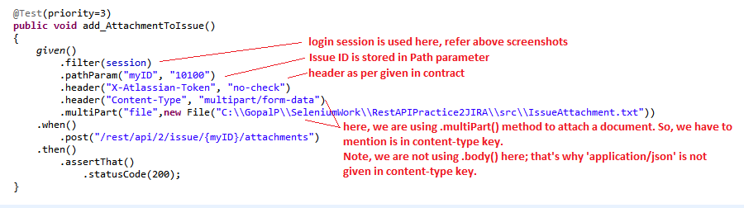
* **How to get only fewer parameters in Response json file?**
* For some API response , we get a lot information. We can restrict it by using .queryParam() method under given() part.
* Let’s see below example; It’s given contract for JIRA Get Issue API
* 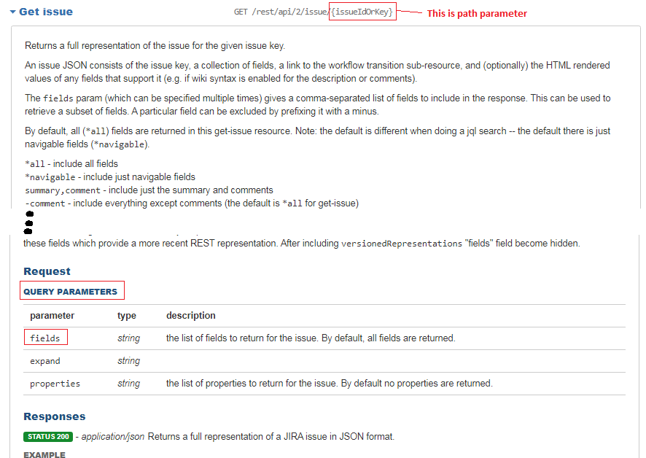
* Below is the script where we are getting only issue ‘Comments’ in the response; instead of getting whole details and all fields for issue.
* If .queryParam() is not used, then we will get all fields of the issue10100 in the response
* 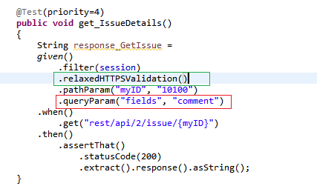
* Note: how to get fieldname from the complete response
  + Run the script without .queryParam(); you will get all fields in response
  + Get the json response and use it in <https://jsoneditoronline.org/> where it will show in readable node format. Here you will get all field name which are present into the response
* **.relaxedHTTPSValidation():**
* This means that you'll trust all hosts regardless if the SSL certificate is invalid
* Sometime you may not get response if SSL certificate is invalid, then using this method, SSL certificate validation will be ignore while playing with APIs.
* See above script to check where and how to use it.

**OAuth 2.0:**

* It is the industry standard protocol for authorization
* When you get the response from an API, you have to authorize yourself first to get the response; everyone cannot see the response; only authorized person/account can see the API response
* It’s implemented for data security purpose
* We can achieve the access to response using different OAuth2.0 methods i.e. Grant Types
* OAuth Grant Types:
  + **Authorization Code**
  + **Client Credentials**
  + Implicit
  + Password Credential
* ‘Authorization Code’ and ‘Client Credentials’ are commonly used
* ‘**Authorization code’**: It’s multi step process where you have to get Code from authorization server, the using this code you have to get access token from resource server, and using the access token you can successfully get response or hit to the required API
* You can see example of Authorization Code
* **Client Credentials:** it’s just need to get access token from resource server and using the access token you can successfully get response or hit to the required API
* E.g. you have your own website and you have to get tweets from your own tweeter account and display in your own website then to hit tweeter, you can use Client Credential. There is no 3rd party involve in this so Authorization Code step is excluded.
* Example of OAuth2.0: you might observe that when you login to some website like job portals or udemy etc, it gives option to login using google account or facebook accout etc. Meaning, you don’t need to create separate account with these job portals (and such sites). Here, OAuth2.0 mechanism is used. In such cases, mostly ‘Authorization Code’ grant type has been used.
* Here, we have to test (let’s say if you are working on any job portal website) if an user can successfully login using google or facebook accout.
* Now, lets understand few concepts used in OAuth2.0 (e.g. ‘BookMyShow.com’ uses OAuth2.0 with grant type ‘Authorization Code’ for login)
  + Client: It’s application which is going to use OAuth2.0. here, BookMyShow.com
  + ClientID: BookMyShow has to register with Google to get used google account for login. Google provides unique ClientID for it.
  + ClientSecretID: it’s same as above. Google provides ClientSecretID to BookMyShow
  + Resource Owner: Here, it’s Human.
  + Resource/Authorization server: here, Resource server and Authorization server is Google. (Resource server and Authorization server can be different)
* Now, let’s understand, how OAuth2.0 works:
  + When user click on ‘Sign in with Google’ button while login to BookMyShow, Google Authorization server get hits and it gets the Code (like OTP)
  + Application (BookMyShow) uses this Code and hits Resource Server (Google Resource Server) and gets AccessToken from Google
  + And then using that AccessToken, Application grants user (Human-Resource Owner) to use application and book the shows.
  + Once, AccessToken expired or invalided, user cannot book the ticket and Application asks him to login again.
* Now, let’s understand what we need for API testing for OAuth2.o
  + We need to get AccessToken (like Login Session which we saw earlier)
  + For that, we have to hit Authorization server to get Code (like OTP)
  + And then using the Code hit Resource Server to get AccessToken
* Let’s see how it works step by step in Postman
* **Step1**: Get Code from Authorization server:
  + Followings are **Mandatory Query Parameters** in this request, get it from dev team:
    - **Scope**: it tells which resource endpoint you want to target. Here it’s targeting for userinfo.email
    - **Auth_URL**: it’s hitting server url where you will get authorization code back, Google or facebook will provide that url. This is the end point.
    - **Client_id**: it’s client id. When you registered on Google or facebook, they provide unique Client Id for your application to access their server
    - **Response_type**: what’s you are getting back from authorization server as response. Here we are getting ‘Code’.
    - **Redirect_url**: this is the url where goolge/facebook want to redirect you after authorization
  + Also, get the baseURL (e.g. <https://accounts.google.com/o/oauth2/v2/auth>)
  + Enter all these details in Postman and create the hitting URL.
  + OR you can directly get that URL from Dev team (e.g. <https://accounts.google.com/o/oauth2/v2/auth?scope=https://www.googleapis.com/auth/userinfo.email&auth_url=https://accounts.google.com/o/oauth2/v2/auth&client_id=692183103107-p0m7ent2hk7suguv4vq22hjcfhcr43pj.apps.googleusercontent.com&response_type=code&redirect_uri=https://rahulshettyacademy.com/getCourse.php>)
  + NOTE1: this url is nothing but the one where your test application asks user to login thru google or facebook account.
  + NOTE2: here, we don’t need to hit the request in Postman; it’s just to get the URL using different parameters (if url is not obtained from dev team)
  + 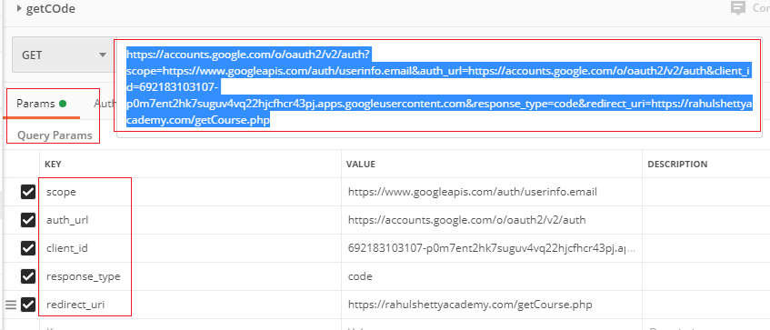
  + **Get that URL and browse it in a browser.** Once it gets hit, it will open below page
  + 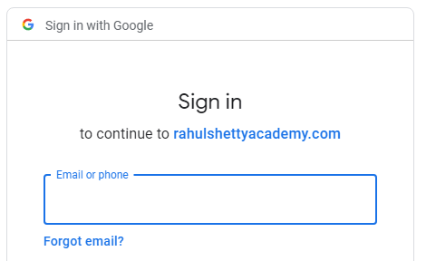
  + It will ask user to use Google or facebook account to login
  + Enter valid Goolge or Facebook account details and proceed
  + After that, whatever URL you will get, Copy that URL and enter that url in another postman request.
  + E.g. [https://rahulshettyacademy.com/getCourse.php?code=4%2FyQFPuCnEzRA4GYBDVKvP5eZBq0dX7kmT4IYNEDIRxPGLA-Ek_zYhjRoN-rIp4rToF9RS0kw3w7t4k2hjh3vNnCI&scope=email+https%3A%2F%2Fwww.googleapis.com%2Fauth%2Fuserinfo.email+openid&authuser=0&prompt=consent#](https://rahulshettyacademy.com/getCourse.php?code=4%2FyQFPuCnEzRA4GYBDVKvP5eZBq0dX7kmT4IYNEDIRxPGLA-Ek_zYhjRoN-rIp4rToF9RS0kw3w7t4k2hjh3vNnCI&scope=email+https%3A%2F%2Fwww.googleapis.com%2Fauth%2Fuserinfo.email+openid&authuser=0&prompt=consent)
  + 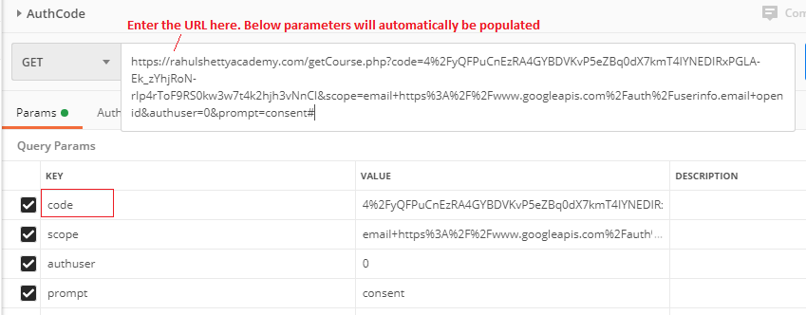
  + This URL contains a Code which you get from Authorization server.
  + When you paste this url in another postman request, check Query Parameter section, you will see “**code**” there. Copy this code and use in next step
* **Step-2**: Hit the Resource Server to get Access Token (using above ‘code’):
  + Followings are the Mandatory parameters for Get Access Token request:
    - Code:
    - Client_Id:
    - Client_secret: When you registered on Google or facebook, they provide unique Client secret for your application to access their server. It’s similar to Client_Id however, client_id is like of public or username and client_secret is like a private or password
    - Redirect_url:
    - Grant_type: Grant type is ‘**authorization_code’**.
  + Here, end point is ‘Access Token URL’
  + Create another Postman request with “**POST**” method
  + Enter base URL (e.g. <https://www.googleapis.com/oauth2/v4/token>) and add mandatory parameters
  + 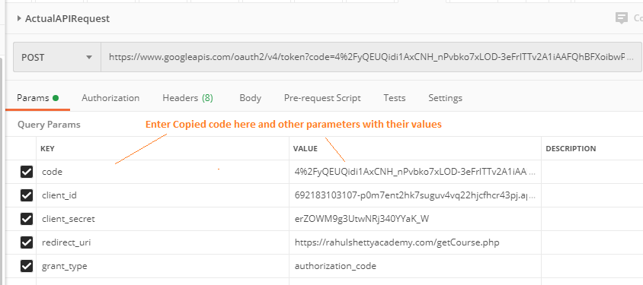
  + Hit the POST request in Postman
  + You will get the Access Token in response.
  + 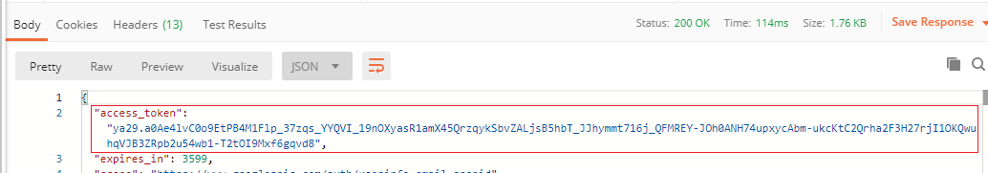
  + Copy the Access Token from here and use it in next step of actual Test API request
* **Step-3**: Hit the website using access token and get requested info:
  + Create another request To Test actual request
  + Enter Base URL (here, <https://rahulshettyacademy.com/getCourse.php>)
  + Add Query Parameter ‘access_token’ which is got from above step with it’s value
  + And hit the GET request
  + You will get the response (here, all course details from base URL)
  + 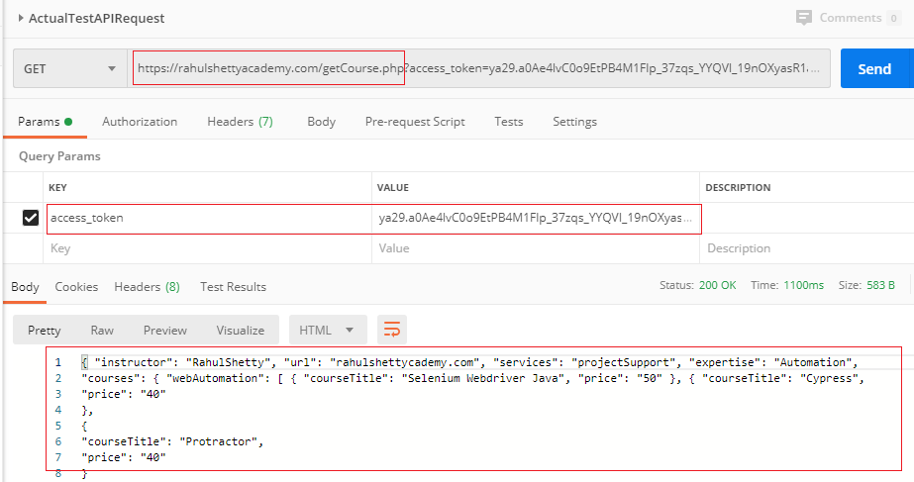
  + Contract Details for above example:

|  |  |
| --- | --- |
| GrantType | authorization_code |
| redirect URL/Callback URL | https://rahulshettyacademy.com/getCourse.php |
| Authorization server url | https://accounts.google.com/o/oauth2/v2/auth |
| Access token url | https://www.googleapis.com/oauth2/v4/token |
| Client ID | 692183103107-p0m7ent2hk7suguv4vq22hjcfhcr43pj.apps.googleusercontent.com |
| Client Secret | erZOWM9g3UtwNRj340YYaK_W |
| Scope | https://www.googleapis.com/auth/userinfo.email |
| State | Any random string |
| How to pass oauth in request | Headers |

* As you see, we have to perform two steps before hitting actual test API. i.e. we have to perform total three different steps for final response.
* However, we can do it **different way** also in Postman (shortcut way)
* Let’s see what is the different way to perform same task:
* Steps:
  + Create a Postman request with GET method
  + Enter Base URL (here, <https://rahulshettyacademy.com/getCourse.php>)
  + Goto ‘Authorization tab’
  + Select Type = OAuth 2.0
  + 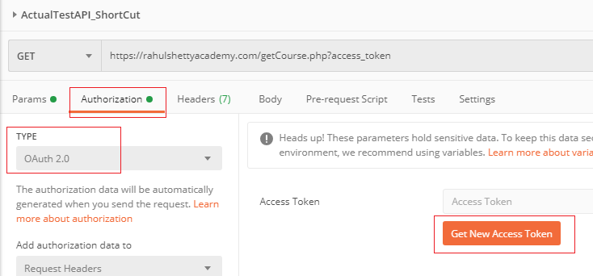
  + Click on ‘Get New Access Token’
  + Enter all the information given in your API Contract document
  + 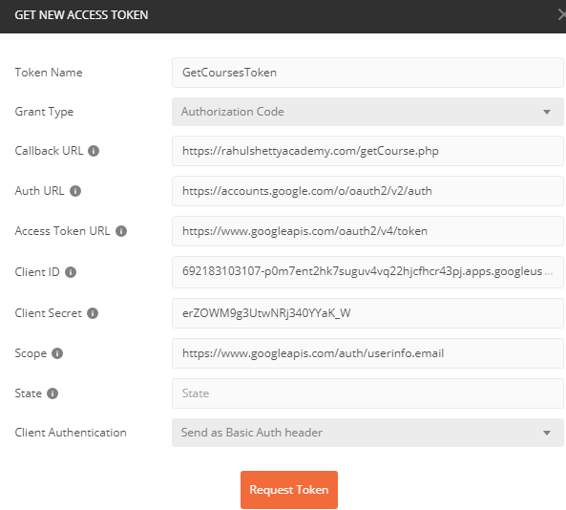
  + Token Name: give any name
  + State: optional. You can keep it blank
  + Client Authorization: select ‘Send as Basic Auth Header’ since we are sending parameters in header; not in a body (for this example)
  + When you click on ‘Request Token’, Postman automatically perform Step1 (get authorization code) and Step2 (get Access token). We don’t need to perform these two steps manually
  + When you click on ‘Request Token’, Postman will open the another window where it prompts to ask you your Google or Facebook account details
  + 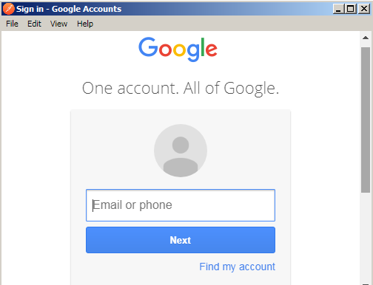
  + Enter your Google account details for login
  + You will get the Access Token
  + Copy the Access Token and Create an Query Parameter ‘access_token’ and enter the copied token in it’s value.
  + And Hit the Request.
  + NOTE: in case if you don’t get expected response, then just create another request and hit the API from new request (don’t create token in new request; just copy the token from previous request)

Now Let’s see how to perform similar activities using **Automation:**

* **Step-1**: Get Code from Authorization server
  + For you we have to hit Google server (by the given link )
  + Login to google server
  + Get the URL after login
  + And from the URL, get the Code
  + These steps will be perform using Selenium_Java
  + 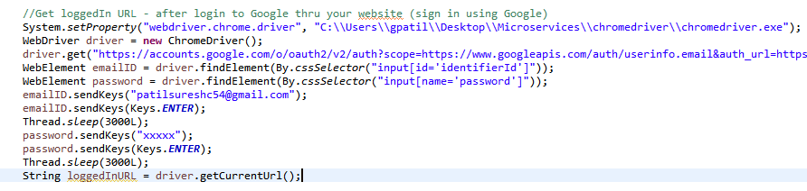
  + You will get the URL in ‘loggedInURL’ variable as: [https://rahulshettyacademy.com/getCourse.php?code=4%2FyQFkp9gfS1cgPmzpeUZIurrG6ULEpOaGOX0h_USeJ5wrE2rbF4jnZOHA0kMqyI4byRkVAU_x0nf1tOdBY65qCqc&scope=email+https%3A%2F%2Fwww.googleapis.com%2Fauth%2Fuserinfo.email+openid&authuser=0&prompt=none#](https://rahulshettyacademy.com/getCourse.php?code=4%2FyQFkp9gfS1cgPmzpeUZIurrG6ULEpOaGOX0h_USeJ5wrE2rbF4jnZOHA0kMqyI4byRkVAU_x0nf1tOdBY65qCqc&scope=email+https%3A%2F%2Fwww.googleapis.com%2Fauth%2Fuserinfo.email+openid&authuser=0&prompt=none)
  + We have to get the code from this URL
  + 
  + **NOTE**: After Jan2020, Google does not allow to login using automated script. So above code may not work. So, for now you have to perform this step manually and get the LoggedInURL. And the perform split() as usual on the URL.
* **Step-2**: Hit the Resource Server to get Access Token (using above ‘code’):
  + 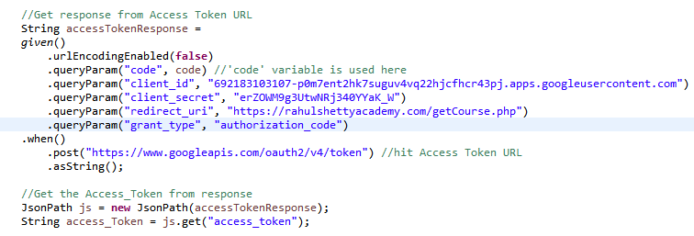
  + Into ‘code’ there could some special characters like %# etc. When we add that code in .queryParam, rest assured convert them into some numerical format;

We don’t want to get the code change

* + So, here, we have used **.urlEncodingEnabled(false)**
* **Step-3**: Hit the website using access token and get requested info:
  + 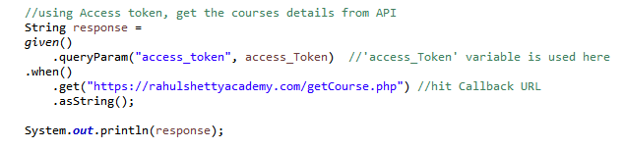
  + Now, you can perform validation on response into .then() part or by using JsonPath.

**POJO Classes :**

* POJO stands for ‘Plain Old Java Object’
* POJO is usually used to describe a class that does not need to be a subclass of anything or implement specific interfaces or follow a specific pattern
* It has properties, getters and setters for respective properties
* It is used to parse the JSON response or to build JSON Body for a request in web services automation; not only JSON, but also XML response/request body.
* There are different ways we saw earlier to handle JSON body for a request
  + Into JAVA code, you can directly add JSON body into given().body(“{“ID”: “123”, “name”: “abc”}) ; something like that
  + You can also save JSON body into a separate .json file and give the path of the file into given().body(filepath)
  + You can save json body into different class method and return it as string. Call that method into your main class like .given().body(differentClass.methodJson())
  + Using POJO class, (Serialization) (how, we will see it next)
* Similarly, there are different ways to parse the JSON response
  + Using JsonPath class object
  + Using assertThat() into .then()
  + Using POJO class (de-serialization) (how, we will see next)

**Serialization**:

* In Rest Assured perspective, it’s a process of converting a Java Object into Request body (payload)

**Deserialization**:

* It’s a process of converting Response body into a Java Object

**Advantages** of Serialization/Deserialization:

* Easy to parse and extract response (JSON/xml) values if they are wrapped as Java Object
* User friendly methods can be created which makes code more readable

**Design approach**:

* Java object constructed with support of POJO classes
* POJO classes are created based on request/response payload

**Additional Libraries (JARs)** required:

* For JSON, we required Either Jackson databind, Jackson2, Gson or Johnzon JARs in the classpath;
* And for XML, we need JAXB
* Download these jars from Maven Repository
* **NOTE**: when you download Jackson databind jar from maven repository, you have to download two more jars (on Jackson databind maven repository page > navigate to down to the page > you can see ‘Compile Dependencies’ section > you can see two dependency jars ‘jackson-annotation’ and ‘jackson-core’ of same version to Jackson databind > get both of them and import those three external jars into your eclipse java project
* You need these four jars
  + jackson-core.jar
  + jackson-annotations.jar
  + jackson-databind.jar
  + gson.jar

**Basics: constructions of POJO**:

* Let’s say below is simple JSON file
* 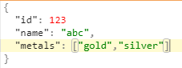
* See below POJO class for this JSon:
* 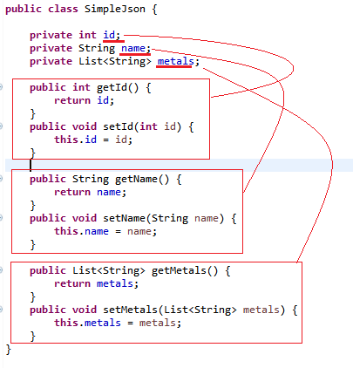
* For each key in json file, we have to define them in pojo class with ‘private’ access modifier
* Here, we defined ‘id’, ‘name’, ‘metals’ with their respective data types
* **NOTE**, here these properties/keys should have exact same name as in json file and all of them have to be defined
* For each property/key, we have to set getters and setters methods as shown here; getID()/setID(), getName()/setName().
* It’s auto created in eclipse editor if you just select defined properties/keys and Alt+Shift+S and select ‘Generate getters and setters’
* When we send a body into a request, we use Setters method (Serialization)
* When we parse a received response, we use Getters method (De-Serialization)
* We can use the object of this class ‘SimpleJson’ into given().body(m) method or wherever required.

**De-Serialization example:**

* Let’s consider below is expected response from GET method as per contract and we have to test that response (note: this json is not complete as shown in udemy course, here I have taken it with few keys only for an example)

{

"url": "rahulshettyacademy.com",

"expertise": "automation",

"courses": {

"webAutomation" :[

{

"couseTitle": "Selenium Webdriver Java",

"price": "40"

},

{

"couseTitle": "RPA UiPath",

"price": "50"

},

{

"couseTitle": "Protractor",

"price": "45"

}

],

"api" :[

{

"couseTitle": "Rest Assured Automation with Java",

"price": "35"

},

{

"couseTitle": "SOAPUI Automation",

"price": "30"

}

],

"mobile" :[

{

"couseTitle": "Appium-Mobile Automation",

"price": "35"

}

]

},

"linkedIn": "https://www.linkedin.com/in/abc"

}

* If you read this json into ‘jsoneditoronline.org’ then you can see this tree structure as below:
* 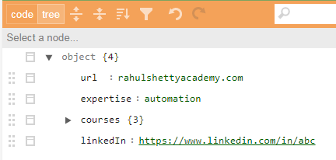
* You can see there are 4 keys at top level; where ‘url’, ‘expertise’, ‘linkedin’ has simple key-value pair.
* ‘courses’ has 3 more child keys i.e. it has nested json i.e. ‘webautomation’, ‘api’, ‘mobile’
* 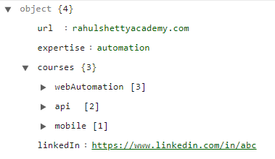
* 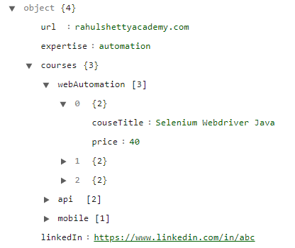
* ‘webautomation’, ‘api’, ‘mobile’ has array
* NOTE: {} represents json body and [] represents array
* Once we understand the JSON file, now construct POJO classes
* 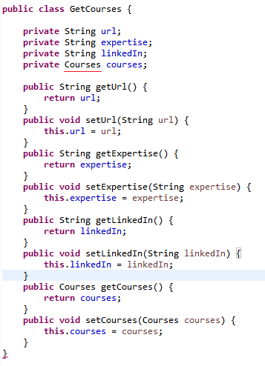
* We created a class ‘GetCourses’ with keys/properties ‘url’, ‘expertise’, ‘linkedIn’, ‘courses’
* Since ‘url’, ‘expertise’, ‘linkedIn’ have simple string values, we declared them with String data type
* ‘courses’ is not key-value here; it has nested JSON; that’s why we created another Class for it with the name ‘Courses’
* And here in above code, we defined ‘courses’ as an object of class ‘Courses’
* And then created Getter and Setter methods for these keys/properties
* Now, let’s see ‘Courses’ class
* 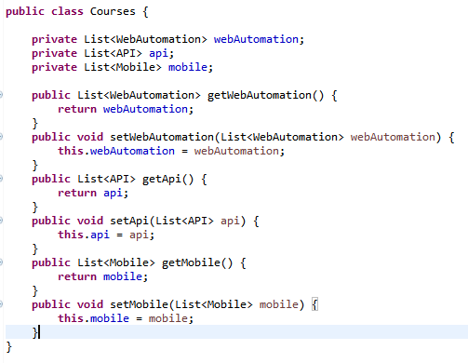
* Into json, we have three keys in under ‘courses’ i.e. webAutomation, api, mobile
* We have to define them as keys/properties in the ‘Courses’ class
* But if you see, there are also nested json there with array
* So we defined another classes as ‘WebAutomation’, ‘API’, ‘Mobile’
* And here in above code, given data type as those Classes for the webAutomation, api, mobile keys
* Since we are expecting list (arrays) under this classes, we defined these keys with **LIST** type
* created Getter and Setter methods for these keys/properties
* See below the classes for webAutomation, api and mobile keys
* 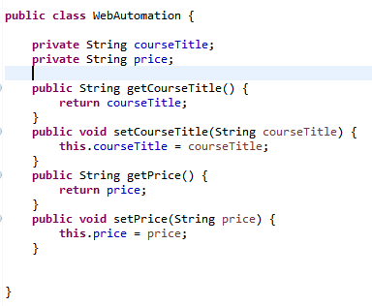
* 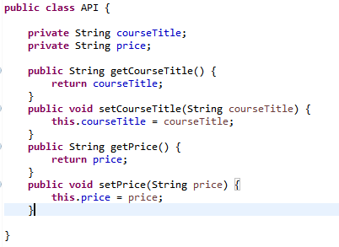
* 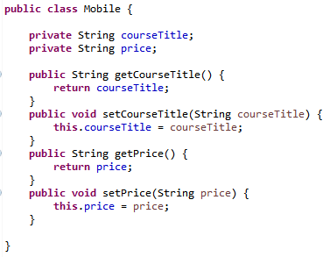
* In above three classes, ‘courseTitle’ and ‘price’ is a simple keys-value, we defined them as String and there is no further class created
* created Getter and Setter methods for these keys/properties
* Here, we are done developing POJO classes.
* Now, how to use these class objects in our API test, let’s see.
* 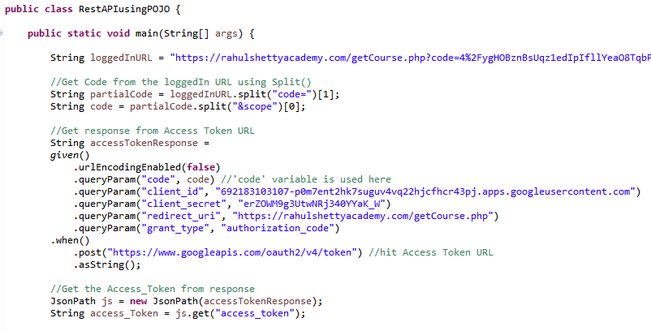
* Here in above code, it just get Access Token (OAuth2.0) to hit the callback url for a response.
* Continuation of above code….
* 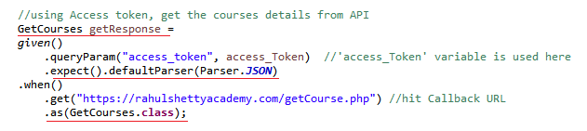
* Here we are hitting callback url using access_token
* And instead of saving the response as a string (as seen earlier), we are saving the string as an object of a ‘GetCourses’ class
* Here, we have to explicitly tell RestAssured that you will get response in JSON format and has to parse that JSON into Class Object
* Continuation of above code….
* 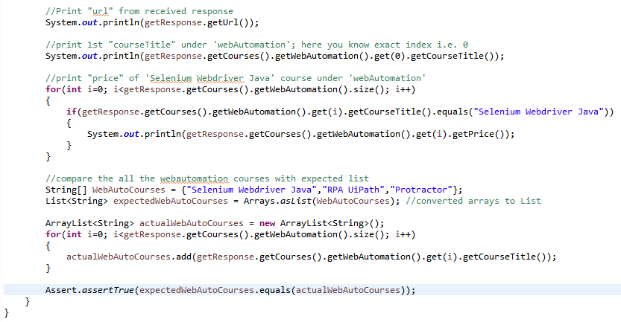
* We are using ‘getResponse’ object of ‘GetCourses’ class and get different information from the received API Response in JSON format.

//Print "url" from received response

System.***out***.println(getResponse.getUrl());

* This code simply navigates to ‘getUrl()’ under ‘GetCourses’ class and return ‘url’ value from the object which is carrying json response
* 
* This code navigates to ‘getCourses()’ under ‘GetCourses’ class; since return type ‘courses’ is object of ‘Courses’ class. So, it further navigates to ‘Courses’ class and try to get info from ‘getWebAutomation()’; but again it’s return type is ‘List<WebAutomation>’ class object; it further navigates to ‘WebAutomation’ class and since it’s contains array/list, we are picking first list item (index=0) and getting course title of it.
* 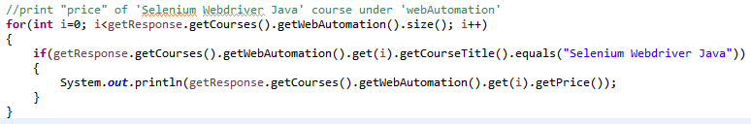
* Using this code, we are trying to get the price of the course ‘Selenium Webdriver Java’
* 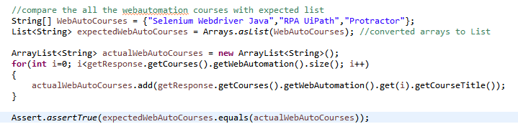
* Here, we are comparing expected course list with actual ones under WebAutomation. First, created a array of expected courses and converted that array into a LIST since we are going to compare list in next step. Next, adding each course into the list under for loop and lastly, comparing expected list with actual one.
* Here in this API test code, we have used just print statement; however we can use different validations/Assertion against expected values to perform actual test.

Serialization example:

* Into serialization, we set a key-values into java classes and provide that object in RestAssured .given.body() method
* We don’t provide json file or body directly into the code
* Below is sample api contract with json body that we have to POST to callback url

*Google Maps Add API (POST):*

*This API Will add new place into Server*

***Complete URL :***[*https://rahulshettyacademy.com*](https://rahulshettyacademy.com/)*/maps/api/place/add/json?key= qaclick123*

***Base URL****:*  [*https://rahulshettyacademy.com*](https://rahulshettyacademy.com/)

***Resource****: /maps/api/place/add/json*

***Query Parameters****: key =qaclick123*

***Http Method****: POST*

***Sample Body*** *:*

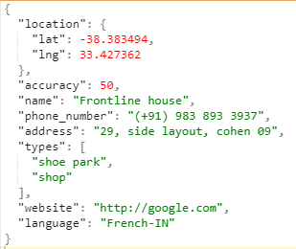

***Sample Response***

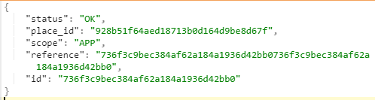

* Now, create POJO classes as per above sample JSON file.
* Below created Main POJO class ‘AddNewPlace’ where all keys are created with their Getter/Setter methods

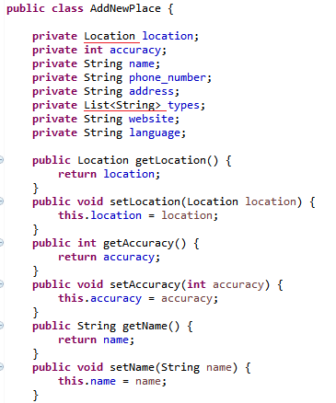

* 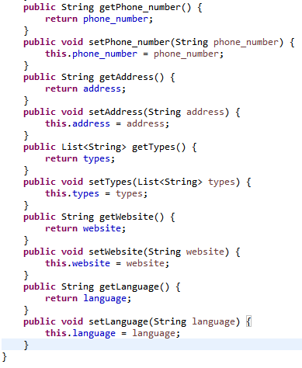
* As per sample JSON, ‘location’ key does not have direct value; it has nested JSON
* So, create another class with name ‘Location’ with corresponding keys
* 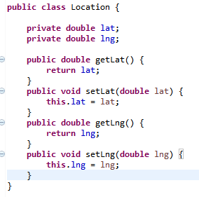
* Now, create a class where we have to test API. New class created ‘RestAPISerialization’
* 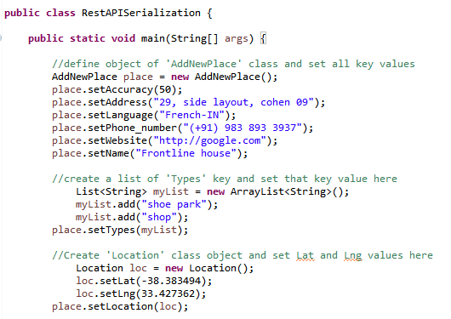
* Here, we created object of ‘AddNewPlace’ main pojo class and set all the key values using setter methods
* While setting location values, we create an object of ‘Location’ class and set the corresponding values; and provided that object to ‘setLocation’ setter method.
* Continuation of above code…
* 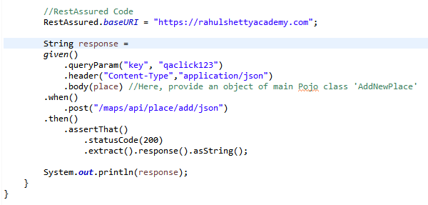
* Here we have provided object of ‘AddNewPlace’ main pojo class into the given().body() method
* That’s it.

**Request/Response Spec Builder:**

* We use it to optimize the code
* We take out separately commonly used part from a request in RequestSpecification object and use it in the Rest Assured given() part.
* E.g. BaseURI, Header(ContentType.JSON), QueryParam(), etc. are a common part in different requests of GET, POST, DELETE; So instead of writing this common part again and again in every test case or request, we simply use this RequestSpecification object.
* Similarly, StatusCode(200), Header(ContentType.JSON), etc. are common part in different responses; so instead of writing this common part again and again in every test case or response, we simply use this ResponseSpecification object.
* This is helpful in creating framework;
* Let’s see an example for Request/Response Spec Builder
* This is similar example as above (pojo class); I just copy pasted above code here just to compare how we built Request/Response Spec
* 
* Now, start building Request/Response Spec
* 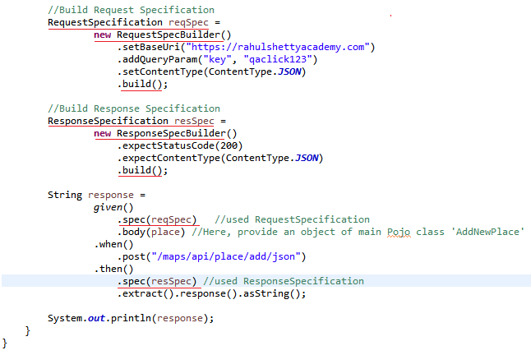
* We can use those Request/Response object wherever required instead of writing common part again and again in different request/responses or test cases
* Note: here ‘ContentType’ is optional part in this example; we have just taken to add more specs.
* We can **break given(), when()** part instead of writing in sequence. Let’s see how…
* 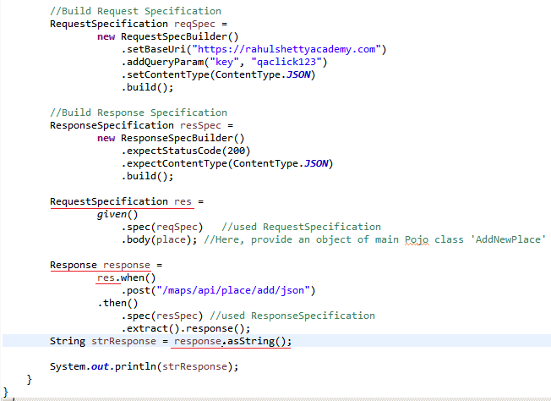

**Cucumber BDD API Framework Development:**

* To start with this framework development, we have knowledge of followings:
  + Rest Assured Testing Basics
  + Serialization and De-Serialization using POJO classes
  + Request and Response Spec Builder
  + Understanding of Cucumber Framework
  + Maven – build Management tool basics