***Scheduler***

This task deletes files older than a specified period from a directory in the AEM repository.

***CASE-1:***

***For scheduler task we need to implement the “Runnable” class ,It provides run() method .***



public void run() { };

***CASE-2:***

***Here we right cron expressions and giving the name to scheduler .***

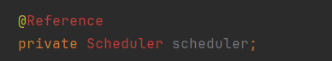

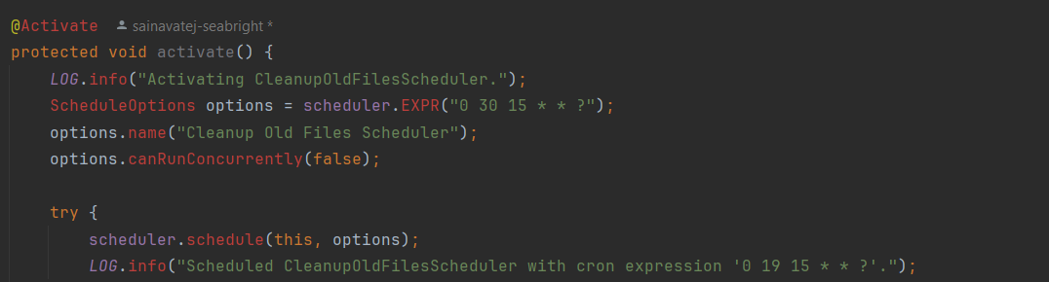

***options:***

***This is an argument passed to the schedule method. It likely contains configuration settings or parameters that dictate how and when the task should be executed.***

***CASE-3:***

***Here we are getting the ‘geeksserviceuser’***

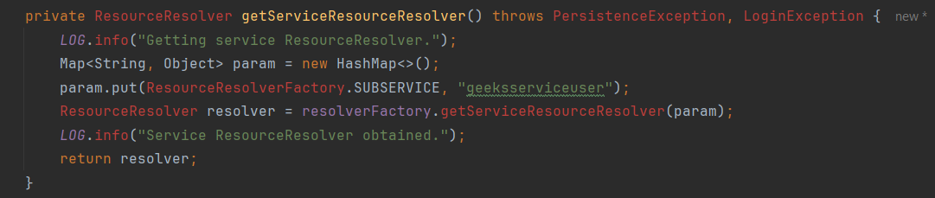

***CASE-4:***

***Here we are getting the path and we are getting the child nodes under the path***

private static final String *FILES_PATH* = "/content/dam/dq-aem";

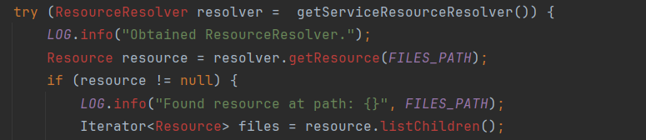

***CASE-5:***

***DAYS_THRESHOLD=0 means it delete the files from today itself and if you set ‘DAYS_THRESHOLD=10 ‘ means ,it deltes the 10 days back created files .***

private static final int *DAYS_THRESHOLD* = 0;



***CASE-6:***

***This part of code find the lastmodified date based on that it deletes the files.***

